HoloLens CPR Training App - Setup and Usage Guide

Part 1: Installation Instructions

Prerequisites
- Microsoft HoloLens 2 device
- Microsoft account for HoloLens sign-in
- Stable Wi-Fi connection
- App installation package

Installation Steps
- Power on the HoloLens
- Press and hold the power button for 2 seconds
- Sign in with Microsoft Account
- Follow the on-screen prompts to sign in
- Connect to Wi-Fi
- Settings -> Network & Internet -> Select your Wi-Fi network
- Turn on Developer mode (If this is not done already)
- Settings -> Update and Security -> for developers and turn on Developer Mode
- Install the CPR App
- Connect your Holo lens 2 to your PC via USB-C cable
- Add files to the Holo lens 2
  - Unzip application file and drag + drop them into the Holo Lens 2
  - Do this in the Holo lens 2 tab found on your file explorer
- Install application
  - Go back to the Holo lens 2 interface and open the File Explorer found in “All apps”
  - On the left hand side select the all files icon. The file explorer puts you in the recent files menu by default, make sure to switch the menu to all files
  - Find the application folder with the same name as the one you dragged + dropped
  - Open it and click the “brown box”. This will begin the installation
  - Once opened enter the passcode for the device and click install found on the bottom right
- Run Application
- Once installation process has begun the application may start right away
- You can also find the application in the All Apps menu
- You may delete any old applications by holding down on their respective icons and clicking delete/remove

Part 2: Using the CPR Training App

Starting the Application
- Launch the App
  - Find and select “CPR Training App” from the app list
- Initial Setup
  - Select your role: Nurse or Doctor

Understanding the Hand Menu
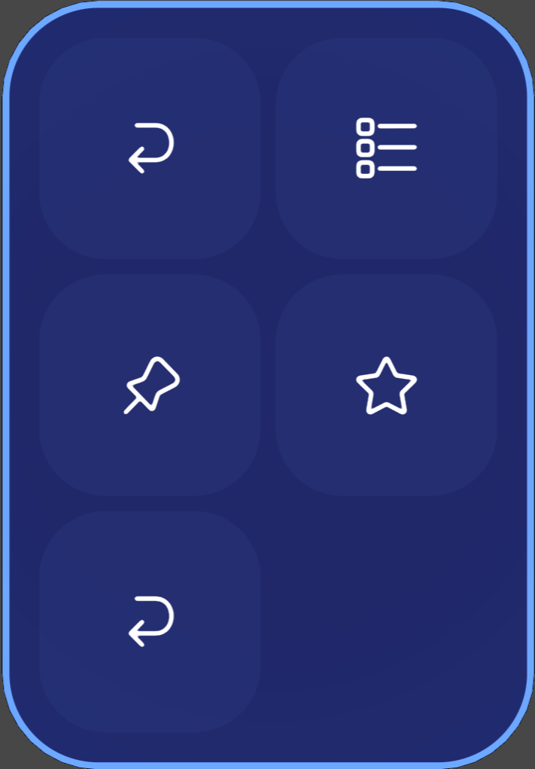

For Nurse Role (5 buttons):
- Pen Mode: Toggle between object manipulation and gaze interaction
- Sessions: Show/hide the session list and refresh active sessions
- Save Position: Save the current UI/object layout as a preset
- Load Position: Restore the previously saved layout preset
- Reset Position: Reset the layout back to default

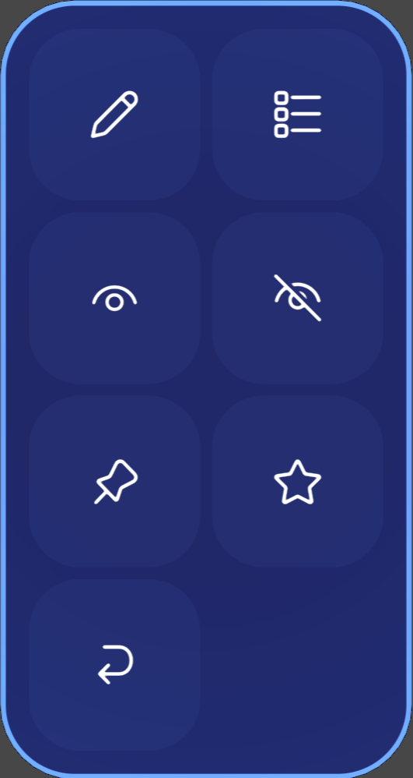

For Doctor Role (7 buttons):
All nurse buttons plus: - Minimize Medication: Hide the medication panel - Maximize Medication: Show the medication panel

Working with Holograms

Placing Holograms
- Initial Placement
  - Holograms will appear in front of you when the app starts
  - Use air tap and hold to grab a hologram
  - Move your hand to reposition
  - Release to place
- Adjusting Hologram Position
  - Enable Pen Mode from the hand menu
  - Look at the hologram you want to adjust
  - Air tap to select
  - Use the manipulation handles to:
    - Move (grab center)
    - Rotate (grab corners)
    - Resize (pinch corners)
- Setting Anchor Points
  - Position all holograms where desired
  - Click Save Position in the hand menu
  - This saves your layout for future sessions

Managing Sessions
- Viewing Active Sessions
  - Click Sessions button in hand menu
  - A list of available CPR sessions will appear
  - Air tap on a session to join
- Session Interface
  - Current task displays at the top
  - Next task shown below
  - Timer shows elapsed time
  - Medication status updates in real-time

CPR Procedure Elements
- Compressions Counter
  - Displays compression count
  - Shows compression rate
  - Visual feedback for depth/rate quality
- Medication Panel (Doctor only)
  - Shows medication schedule
  - Highlights when medications are due
  - Tap to confirm administration
- Notifications
  - Appear as floating text
  - Important alerts highlighted in red
  - Tap to dismiss non-critical notifications

