|  |
| --- |
|  |
|  |

**Migration tools**

**Document version: 1.1**

**Compiled by Mihails Sotnicoks**



**TABLE OF CONTENTS**

General information 3

Modern Pages 4

Files 5

Left navigation 5

# General information

Migration tools are PowerShell scripts to copy following content from one SharePoint site to another:

* Modern Pages
* Left Navigation
* Files

There are two scripts for each type:

* Export
* Import

Prerequisites: Latest installation (Min. December 2018 version) of [PNP PowerShell](https://github.com/SharePoint/PnP-PowerShell/releases)

Import scripts will process SharePoint site or sub web (as per specified in parameters) and save data as files to local disk. Import scripts have to use these files as input.

Example: Single script run in Windows PowerShell window

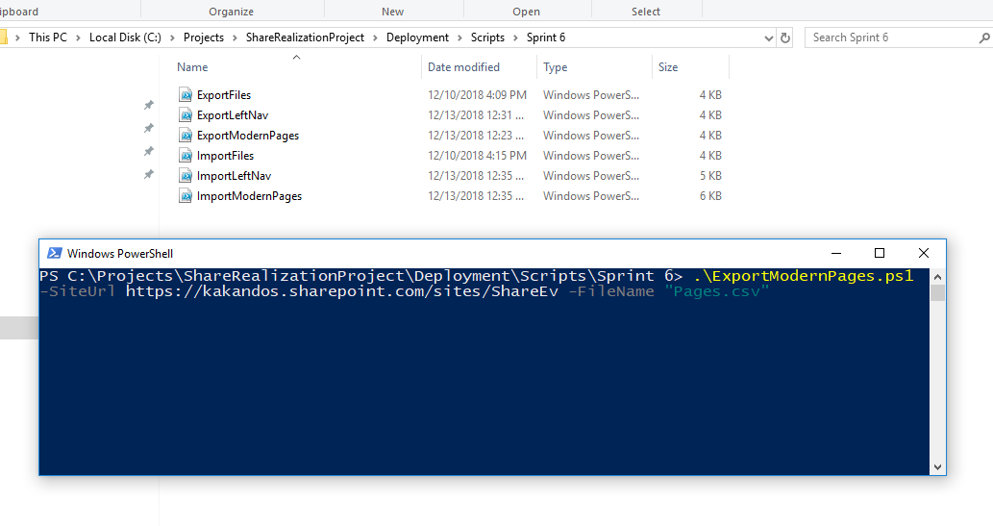

Scripts can be combined in loop, for example to process a set of site collections and/or sub webs. That will require additional scripting.

Each script has input parameters, some of them are common for all:

* SiteUrl - URL of site collection or web
* Login (optional) – user name (email) with corresponding permissions
* Password (optional) – plain text password

If Login and Password are not specified, then Credential window will popup.

All scripts have description and example at beginning of the file.

## Modern Pages

ExportModernPages.ps1

Extracts data from every Modern page in given SharePoint Web - File Name, Title, Layout type and content. Uses "Site Pages" library. Considers folder structure.

Parameters:

* SiteUrl
* FileName
* Login
* Password

ImportModernPages.ps1

Creates modern pages in given Web. Uses CSV file as data source.

Parameters:

* SiteUrl
* FileName
* Login
* Password
* ReplaceLinks if $true script will automatically fix URLs, replacing original site url to current one.
* Owerwrite – if $true, script will re-create items if they already exist with same name

Note that path of images are not exported/imported when running this script. As a result, image in target site is still linked to source site. If image is deleted in source site it will disappear in target site. Workaround would be to update image in target site manually. Applicable for every web part type where image is present – image web-part, image gallery, quick links, hero, page header etc.

## Files

ExportFiles.ps1

Script to export files from any SharePoint web folder. Can take images used for modern pages (they are in “SiteAssets/SitePages” folder)

Parameters:

* SiteUrl
* SiteFolder – Source folder inside of web to take files
* Login
* Password
* Path – destination folder to store the files. It can be relative (e.g. 'Files') or absolute (e.g. "C:\Files")

ImportFiles.ps1

Uploads files from folder in disk to specified folder inside of SharePoint web. Include folder structure (sub folders)

Parameters:

* SiteUrl
* SiteFolder – is folder inside of Web. For "SitePages" folder in "Site Assets" library use "SiteAssets/SitePages"
* Login
* Password
* Path – source file

## Left navigation

ExportLeftNav.ps1

Extracts data from site left navigation - Quick Launch. Supports 3 levels.

Parameters:

* SiteUrl
* FileName
* Login
* Password

ImportLeftNav.ps1

Creates left navigation node (Quick Launch) in given Web

Parameters:

* SiteUrl
* FileName – source file (csv)
* Login
* Password
* ReplaceLinks - if $true script will automatically fix URLs, replacing original site URL to current one.
* Overwrite – if $true, all exsiting nodes will be removed