WEEK-1

I. Perform the following DB operations using MongoDB.
1. Create a database “Student” with the following attributes Rollno, Age, ContactNo, Email-
Id.
ANS-db.createCollection("Student");
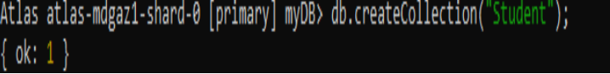

2. Insert appropriate values

ANS-db.Student.insert({RollNo:1,Age:21,Cont:9876,email:"antara.de9@gmail.com"});

db.Student.insert({RollNo:2,Age:22,Cont:9976,email:"anushka.de9@gmail.com"});

db.Student.insert({RollNo:3,Age:21,Cont:5576,email:"anubhav.de9@gmail.com"});

db.Student.insert({RollNo:4,Age:20,Cont:4476,email:"pani.de9@gmail.com"});

db.Student.insert({RollNo:10,Age:23,Cont:2276,email:"rekha.de9@gmail.com"});
db.Student.find()
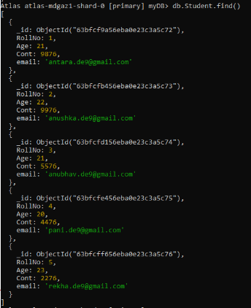
3. Write query to update Email-Id of a student with rollno 10.
ANS-db.Student.update({RollNo:10},{$set:{email:"Abhinav@gmail.com"}})
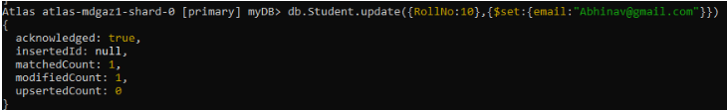

4. . Replace the student name from “ABC” to “FEM” of rollno 11
ANS-db.Student.insert({RollNo:11,Age:22,Name:
"ABC",Cont:2276,email:"rea.de9@gmail.com"});
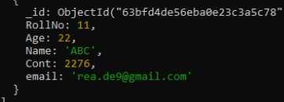
db.Student.update({RollNo:11,Name:"ABC"},{$set:{Name:"FEM"}})
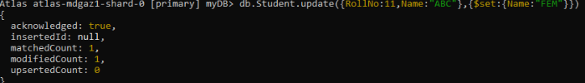
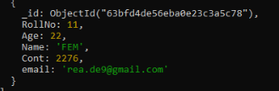

5. Display Student Name and grade(Add if grade is not present)where the _id column is 1.

db.students.aggregate([
{ $match: { _id: 1 } },
{ $project: { Name: 1, grade: { $ifNull: ["$grade", "A"] } } }
])

6. Update to add hobbies

db.students.updateMany(
{},
{ $set: { hobbies: ["Reading", "Swimming"] } }
)

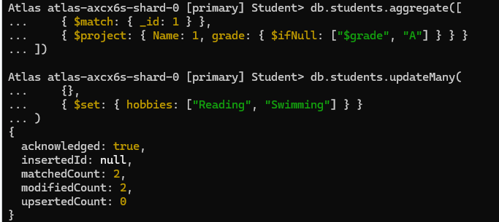

7. Find documents where hobbies is set neither to Chess nor to Skating

db.students.find({ hobbies: { $nin: ["Chess", "Skating"] } })

8.Find documents whose name begins with A

db.students.find({ Name: /^A/ })

II. Perform the following DB operations using MongoDB.

1. Create a collection by name Customers with the following attributes.
Cust_id, Acc_Bal, Acc_Type
ANS-1.db.createCollection(“Customer”);

2. Insert at least 5 values into the table
ANS-2.db.Customers.insert({Cust_id:1,Acc_Bal:2000,Acc_Type:"Savings"});
db.Cusotmers.insert({Cust_id:2,Acc_Bal:3000,Acc_Type:"Savings"});
db.Customers.insert({Cust_id:3,Acc_Bal:1500,Acc_Type:"Savings"});
db.Customers.insert({Cust_id:4,Acc_Bal:1000,Acc_Type:"Current"});
db.Customers.insert({Cust_id:5,Acc_Bal:2000,Acc_Type:"Current"});
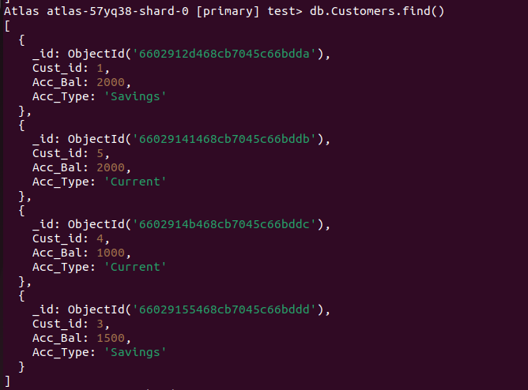
3. Write a query to display those records whose total account balance is greater than
1200 of account type ‘Z’ for each customer_id.
ANS-3. db.Customers.find({
Acc_Bal: { $gt: 1200 },
Acc_Type: "Current"
})
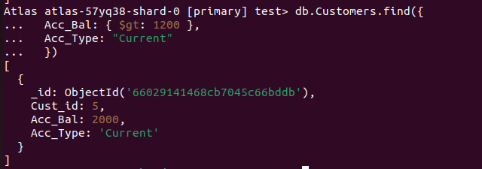

4. Determine Minimum and Maximum account balance for each customer_i

ANS-4 db.Customers.aggregate([ { $group: { _id: "$Cust_id", min_balance: { $min: "$Acc_Bal" }, max_balance: { $max: "$Acc_Bal" } } }] )

5. Sort the documents based on Customer ID in ascending order and Account Balance in descending order

db.Customers.aggregate([
{
$match: {
Acc_Type: "Current"
}
},
{
$group: {
_id: "$customer_id",
min_balance: { $min: "$Acc_Bal" },
max_balance: { $max: "$Acc_Bal" }
}
},
{
$sort: {
"_id": 1,
"max_balance": -1
}
}
])

6.Display only 2nd and 3rd records from the collection

db.Customers.find().skip(1).limit(2)
