WEEK-2

Perform the following DB operations using MongoDB
Create a collection by the name blogPosts and it has 3 fields id, title and comments.
In the collection the comments field is an array which consists of user details. Each collection consists of two user details inside the comments array- user name and text

db.createCollection("blogPosts")

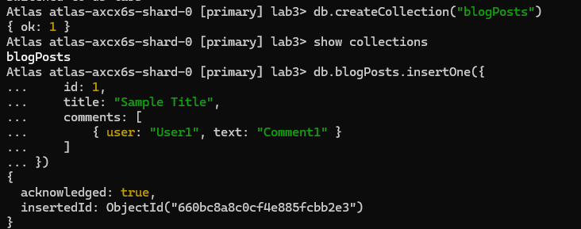
Demonstrate the following
- Adding an element into array

db.blogPosts.insertOne({
id: 1,
title: "Sample Title",
comments: [
{ user: "User1", text: "Comment1" }
]
})

(Similarly, Insert 4 ids)

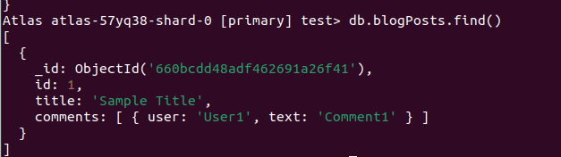
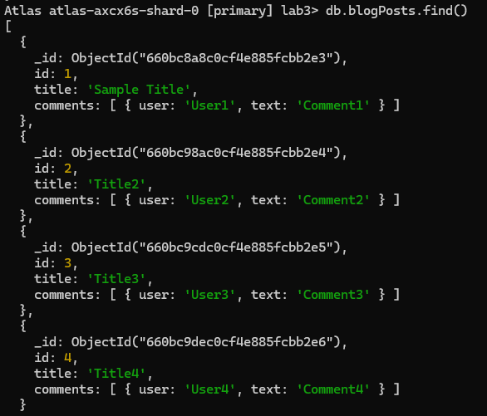

- Display second element

db.blogPosts.find().skip(1).limit(1)

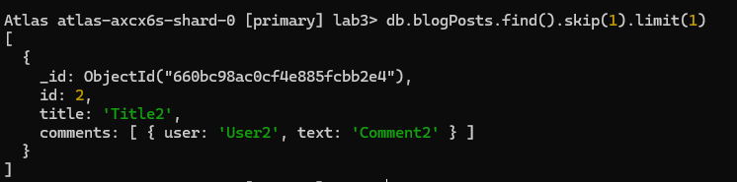

- Display size of the array

db.blogPosts.aggregate([
{ $project: { commentsCount: { $size: "$comments" } } }
])

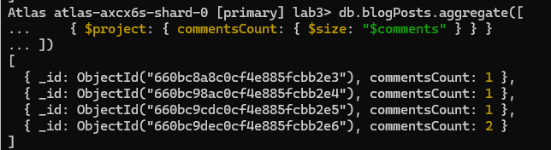

- Display first two elements of the array

db.blogPosts.aggregate([
{ $project: { firstTwoComments: { $slice: ["$comments", 2] } } }
])

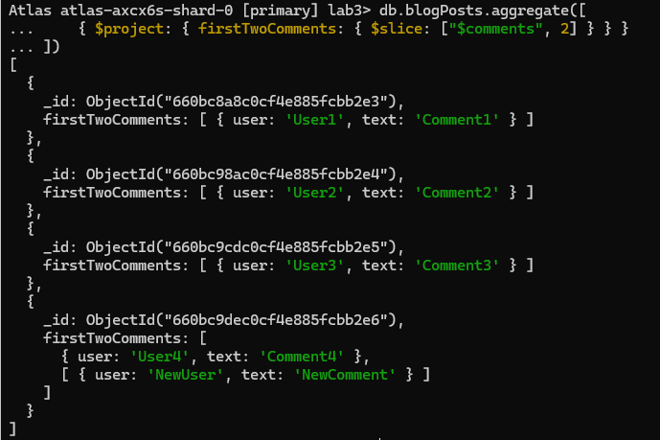

- Update the document with id 4 and replace the element present in 1st index position of the array with another array

db.blogPosts.updateOne(
{ id: 4 },
{ $set: { "comments.1": [{ user: "NewUser", text: "NewComment" }] } }
)

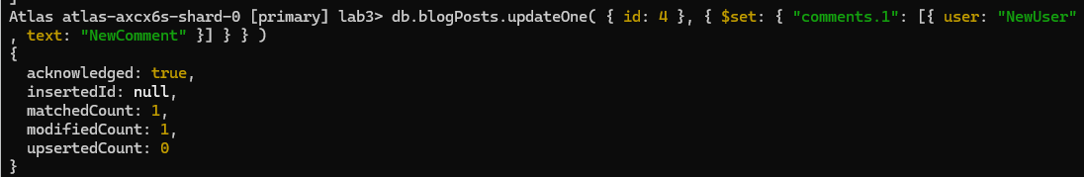
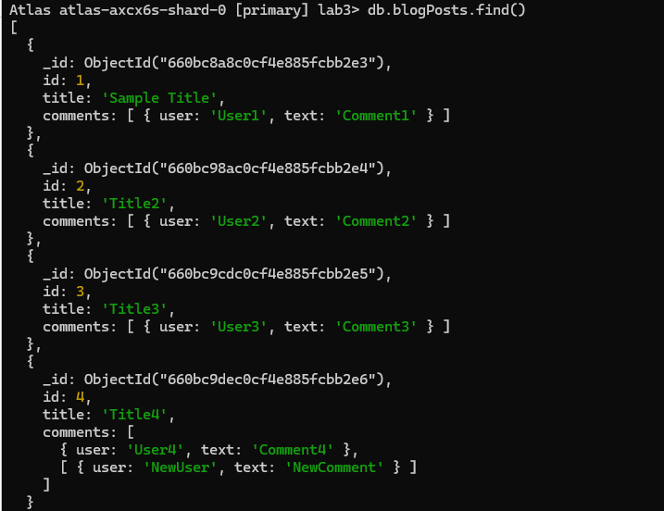

Cassandra basics
Learn Cassandra Tutorial - javatpoint
- Execute the following

Create KeySpace :

CREATE KEYSPACE Students WITH REPLICATION = {'class':'SimpleStrategy','replication_factor':1};

Describe the existing Keyspaces:

DESCRIBE KEYSPACES;

For More details on existing keyspaces:

SELECT * FROM system.schema_keyspaces;

use the keyspace “Students”:

USE Students;

To create table (column family) by name Student_Info:

CREATE TABLE Students_Info (Roll_No int PRIMARY KEY, StudName text, DateOfJoining timestamp, last_exam_Percent double);

Lookup the names of all tables in the current keyspaces
DESCRIBE TABLES;

Describe the table information

DESCRIBE TABLE <Table_Name>;

CRUD

Insert :

BEGIN BATCH
INSERT INTO Students_Info(Roll_No, StudName, DateOfJoining, last_exam_Percent)
VALUES (1,'Asha','2012-03-12',79.9)
INSERT INTO Students_Info(Roll_No, StudName, DateOfJoining, last_exam_Percent)
VALUES (1,'Krian','2012-03-12',89.9)
INSERT INTO Students_Info(Roll_No, StudName, DateOfJoining, last_exam_Percent)
VALUES (1,'Tarun','2012-03-12',78.9)
INSERT INTO Students_Info(Roll_No, StudName, DateOfJoining, last_exam_Percent)
VALUES (1,'Samrth','2012-03-12',90.9)
INSERT INTO Students_Info(Roll_No, StudName, DateOfJoining, last_exam_Percent)
VALUES (1,'Smitha','2012-03-12',67.9)
INSERT INTO Students_Info(Roll_No, StudName, DateOfJoining, last_exam_Percent)
VALUES (1,'Rohan','2012-03-12',56.9)
APPLY BATCH;

View data from the table “Students_Info”

SELECT * FROM Students_Info;

View data from the table “Students_Info” where RoolNo column either has a value 1 or 2 or 3

SELECT * FROM Students_Info WHERE Roll_No IN (1,2,3);

To execute a non primary key - will throw an error
select * from students_info where Studname= 'Asha';

So create an INDEX on the Column as below:
To create an INDEX on StudName Column of the Students_Info column family

CREATE INDEX ON Students_Info ( StudName);

Now execute the query based on the INDEXED Column:
select * from students_info where Studname= 'Asha';

To specify the number of rows retured in the output
select Roll_No, StudName from students_info LIMIT 2;

Alias for Column:

Select Roll_No as “USN” from Students_info;

UPDATE

UPDATE students_info SET StudName='David Sheen' WHERE RollNo=2;

Lets try to update the primary key

UPDATE students_info SET rollno=6 WHERE rollno=3;

DELETE
DELETE LastExamPercent FROM students_info WHERE RollNo=2;

Delete a Row
DELETE FROM student_info WHERE RollNo=2;

