Cycle II LAB 15:

Aim : Using TCP/IP sockets, write a client-server program to make client sending the file name and the server to send back the contents of the requested file if present.

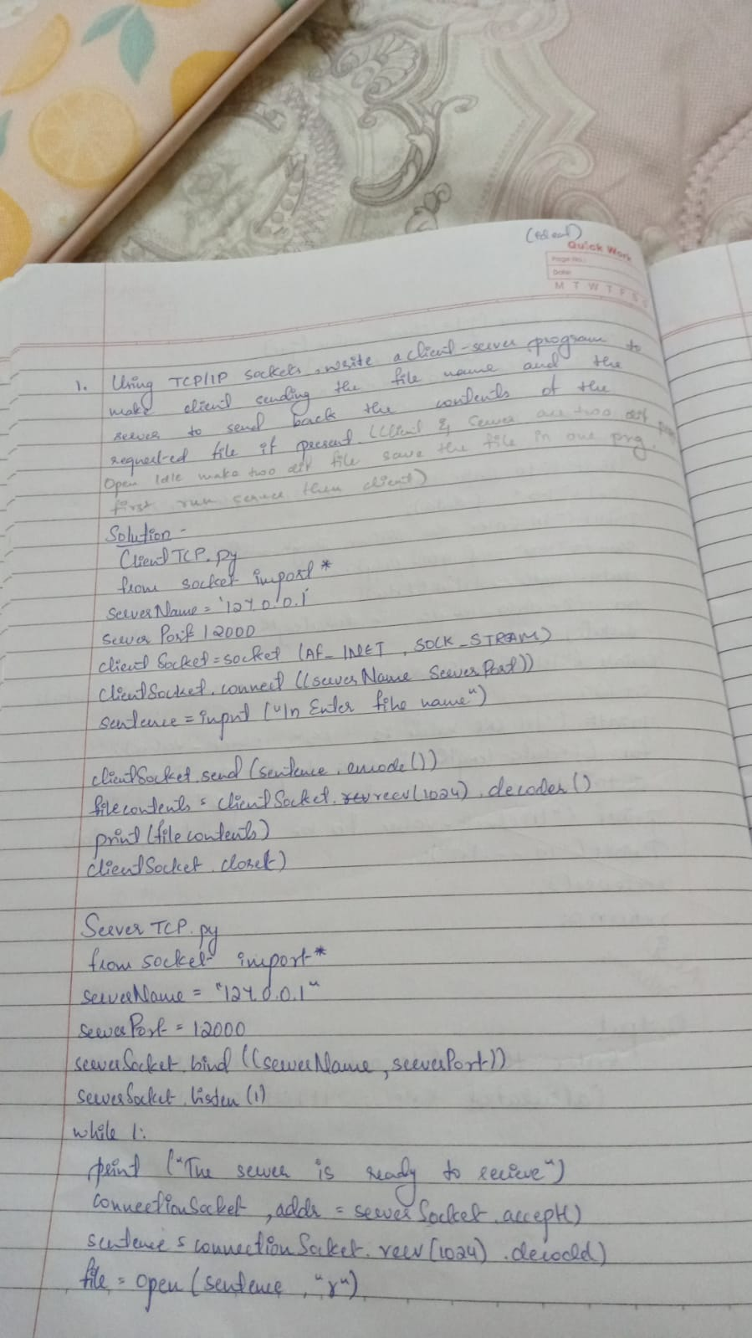

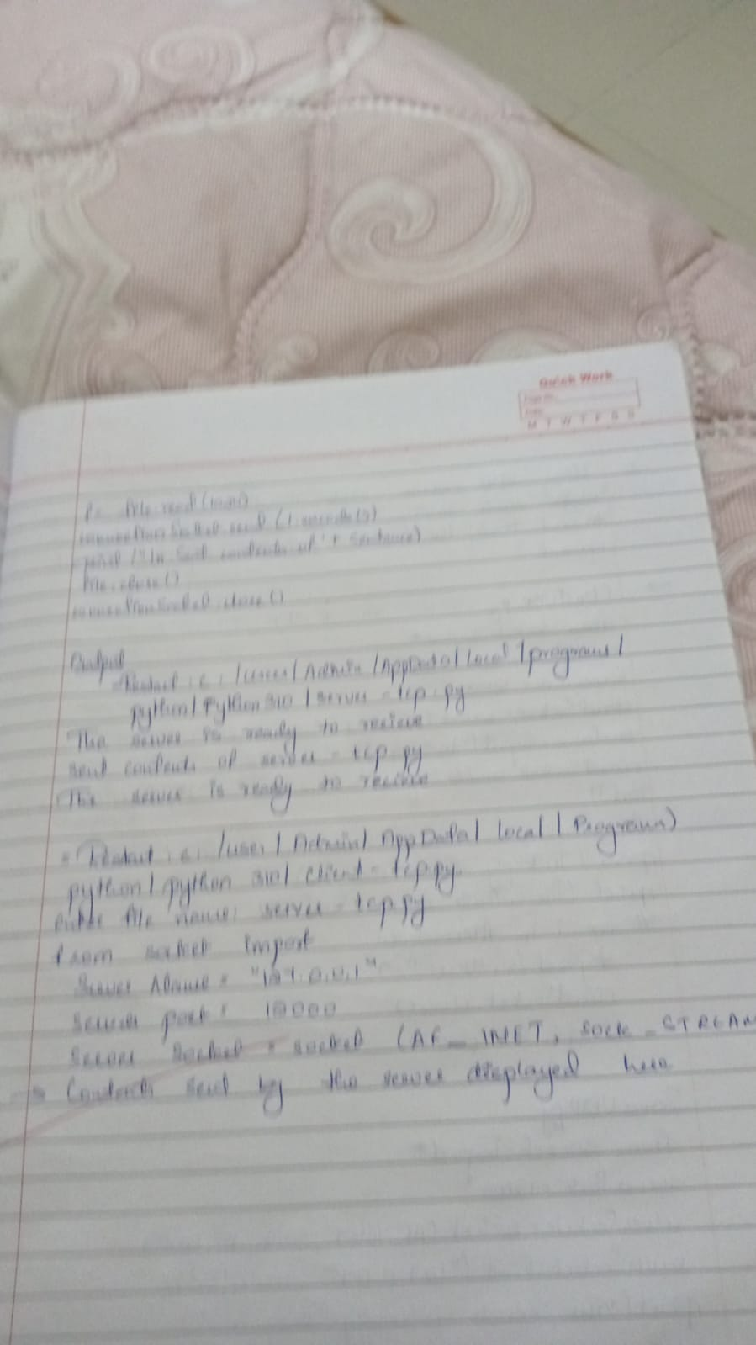

Output :

Server instance:

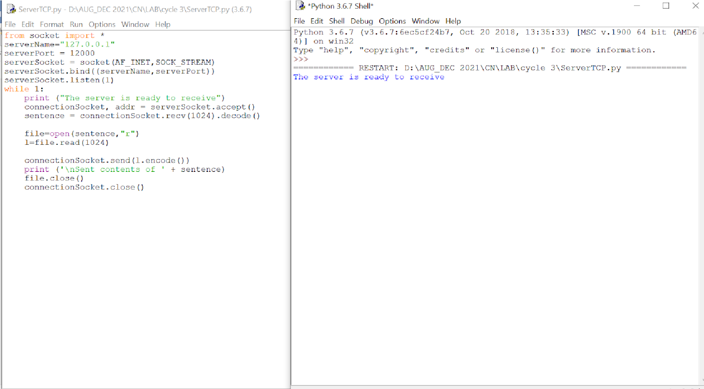

Client instance:

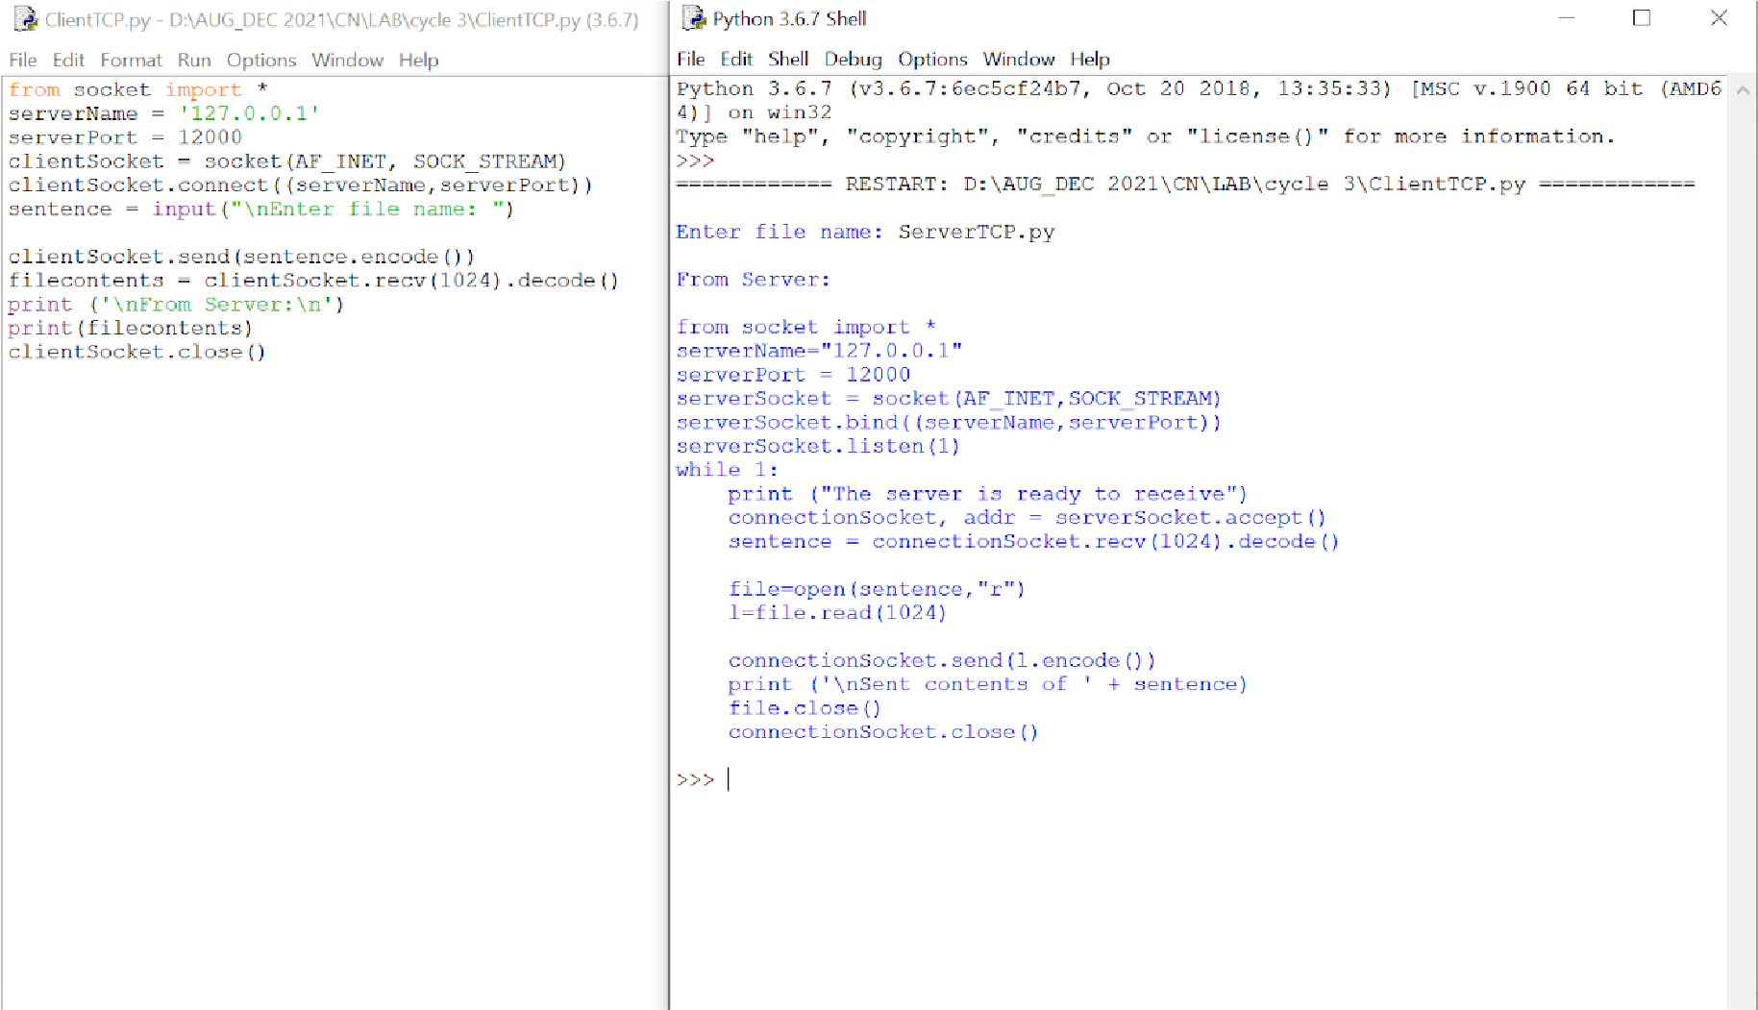

Server instance:

