**Cycle II LAB 16:**

**Aim : Using UDP sockets, write a client-server program to make client sending the file name and the server to send back the contents of the requested file if present.**

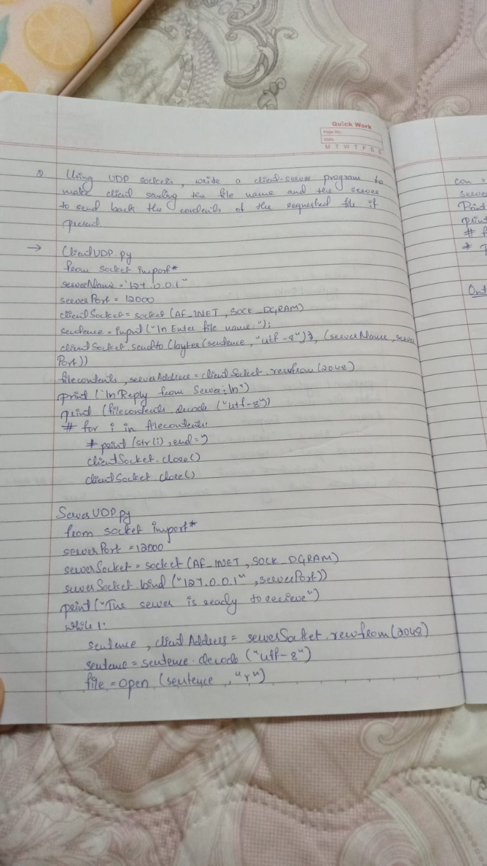

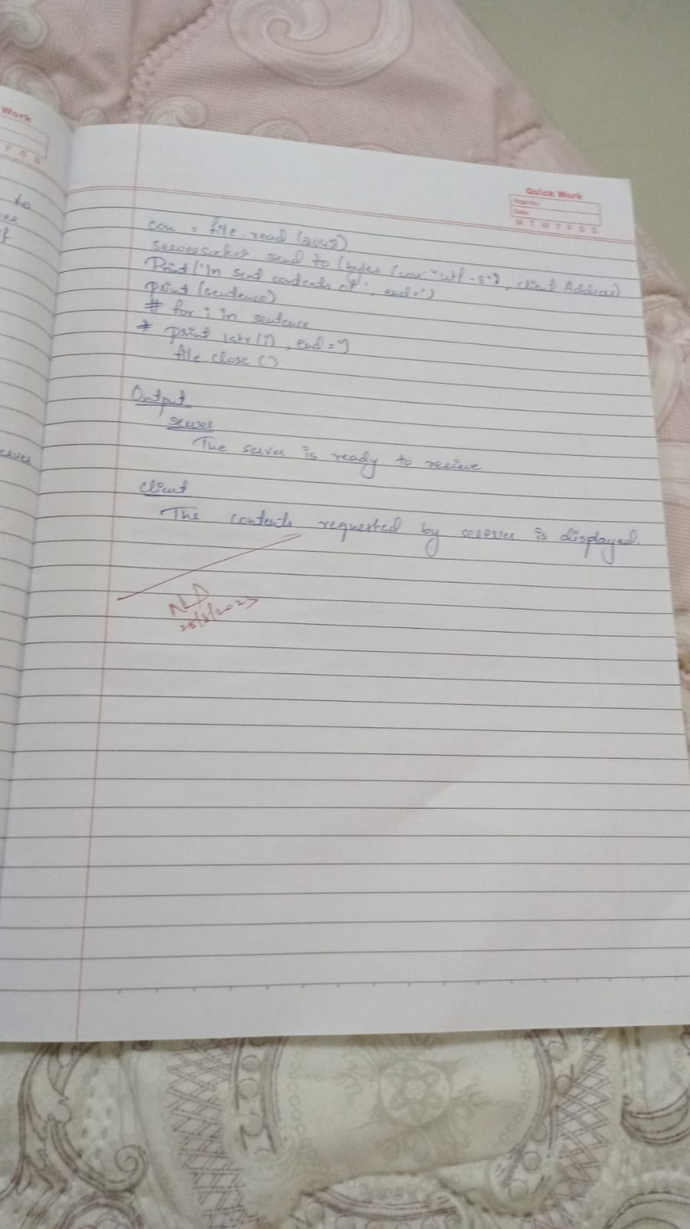

**Output :**

**Server instance :**

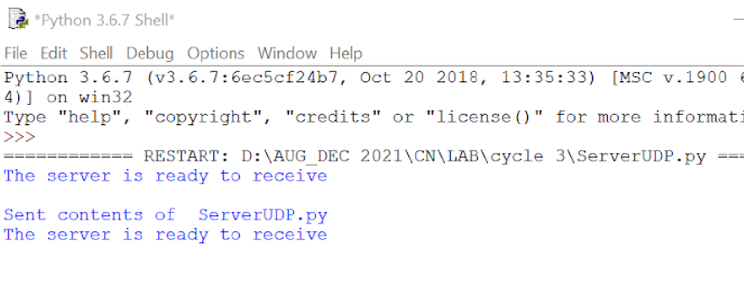

**Client instance :**

