NAME:-CHANCHALA KUMARI

REGISTRATION:-243510046483

ENROLLMENT:-24/10/JC/033

* FIRST PROGRAMME JAWA SWING:-

**package** test;

**import** javax.swing.*;

**import** java.awt.*;

**public** **class** Swingtest {

**public** **static** **void** **main**(String[] args) {

// Create the frame

JFrame **frame** = **new** JFrame("Swing UI Example");

frame.setSize(400, 300);

frame.setLayout(**new** FlowLayout());

// Label

JLabel **label** = **new** JLabel("Enter your name:");

frame.add(label);

// Text field

JTextField **textField** = **new** JTextField(20);

frame.add(textField);

// Radio buttons

JRadioButton **male** = **new** JRadioButton("Male");

JRadioButton **female** = **new** JRadioButton("Female");

ButtonGroup **genderGroup** = **new** ButtonGroup();

genderGroup.add(male);

genderGroup.add(female);

frame.add(female);

frame.add(male);

// Button

JButton **button** = **new** JButton("Submit");

frame.add(button);

// Toggle Button

JToggleButton **toggleButton** = **new** JToggleButton("Toggle Me");

frame.add(toggleButton);

// Checkbox

JCheckBox **checkBox** = **new** JCheckBox("Check me");

frame.add(checkBox);

// Radio Buttons

JRadioButton **r1** = **new** JRadioButton("Option 1");

JRadioButton **r2** = **new** JRadioButton("Option 2");

ButtonGroup **bg** = **new** ButtonGroup();

bg.add(r1);

bg.add(r2);

frame.add(r2);

frame.add(r1);

// ComboBox

String[] **items** = {"Apple", "Banana", "Orange"};

JComboBox<String> **comboBox** = **new** JComboBox<>(items);

// JList with ScrollPane

String[] **listItems** = {"Item 1", "Item 2", "Item 3", "Item 4"};

JList<String> **list** = **new** JList<>(listItems);

JScrollPane **listScrollPane** = **new** JScrollPane(list);

listScrollPane.setPreferredSize(**new** Dimension(100, 60));

// JSpinner

JSpinner **spinner** = **new** JSpinner(**new** SpinnerNumberModel(0, 0, 100, 1));

// Password Field

JPasswordField **passwordField** = **new** JPasswordField(15);

// JSlider

JSlider **slider** = **new** JSlider(JSlider.***HORIZONTAL***, 0, 100, 50);

slider.setMajorTickSpacing(25);

slider.setPaintTicks(**true**);

slider.setPaintLabels(**true**);

// JPanel

JPanel **panel1** = **new** JPanel();

panel1.add(**new** JLabel("This is inside Panel 1"));

JPanel **panel2** = **new** JPanel();

panel2.add(**new** JLabel("This is inside Panel 2"));

// JTabbedPane

JTabbedPane **tabbedPane** = **new** JTabbedPane();

tabbedPane.addTab("Tab 1", panel1);

tabbedPane.addTab("Tab 2", panel2);

// Add components to frame

frame.add(button);

frame.add(panel1);

frame.add(panel2);

frame.add(tabbedPane);

frame.add(slider);

frame.add(spinner);

frame.add(toggleButton);

frame.add(passwordField);

// Set frame visible

frame.setVisible(**true**);

}

}

*OUTPUT:-

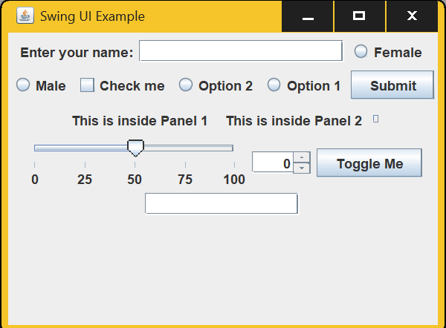

* SECOND PROGRAAME RELEATED TO HANDELING EVENT:-

package test;

import javax.swing.*;

import java.awt.*;

import java.awt.event.*;

public class Eventswing {

public static void main(String[] args) {

// TODO Auto-generated method stub

JFrame frame = new JFrame("Drag and Drop Fix");

frame.setSize(500, 300);

frame.setLayout(new GridLayout(1, 2));

JPanel panel1 = new JPanel();

panel1.setBorder(BorderFactory.createTitledBorder("Panel 1"));

panel1.setLayout(new FlowLayout());

JPanel panel2 = new JPanel();

panel2.setBorder(BorderFactory.createTitledBorder("Panel 2"));

panel2.setLayout(new FlowLayout());

JButton draggable = new JButton("Drag Me");

// Add button to first panel

panel1.add(draggable);

MouseAdapter dragAdapter = new MouseAdapter() {

Point startPoint;

public void mousePressed(MouseEvent e) {

startPoint = e.getPoint();

}

public void mouseReleased(MouseEvent e) {

Component comp = e.getComponent();

Point dropPoint = SwingUtilities.convertPoint(comp, e.getPoint(), frame);

if (panel2.getBounds().contains(dropPoint)) {

// Remove from old panel

Container parent = comp.getParent();

if (parent != null) {

parent.remove(comp);

parent.revalidate();

parent.repaint();

}

// Add to new parent

panel2.add(comp);

panel2.revalidate();

panel2.repaint();

} else if (panel1.getBounds().contains(dropPoint)) {

Container parent = comp.getParent();

if (parent != null) {

parent.remove(comp);

parent.revalidate();

parent.repaint();

}

panel1.add(comp);

panel1.revalidate();

panel1.repaint();

}

}

};

draggable.addMouseListener(dragAdapter);

frame.add(panel1);

frame.add(panel2);

frame.setVisible(true);

}

}

*OUTPUT:-

