Infrastructure Setup
Description:
Five virtual machines were created to simulate a production environment. Separate VMs were used for Jenkins, MySQL, Nginx Load Balancer, and two Tomcat application servers.

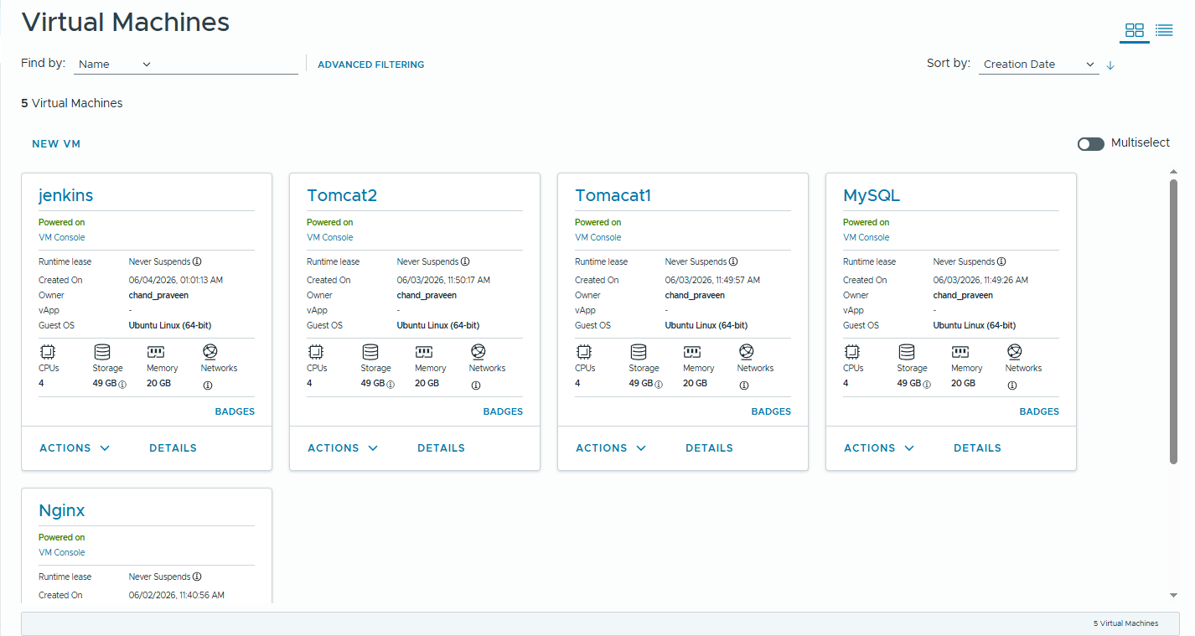

Initial Application Deployment

Before Change
The application was successfully deployed on Tomcat servers and accessed through the Nginx Load Balancer.
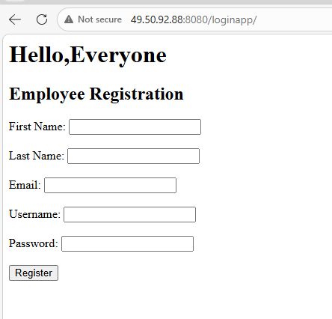

NAT Rules
Description:
NAT rules were configured to allow external access to internal virtual machines through public IP addresses.
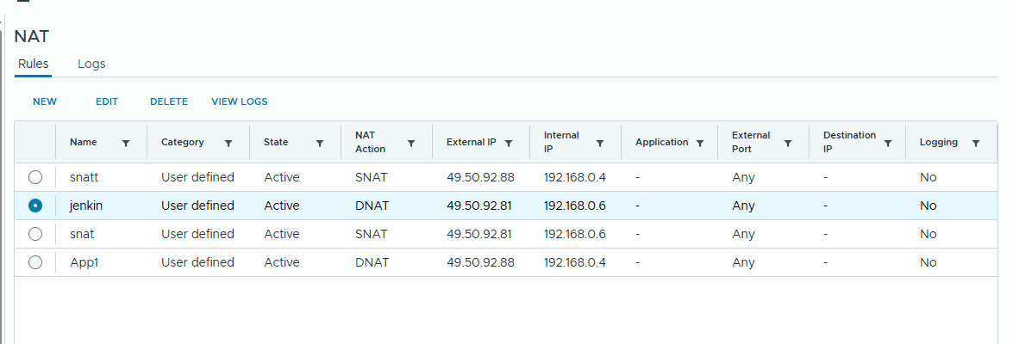

Firewall Rules

Description
Firewall rules were implemented to control network traffic between the virtual machines. Only required services such as HTTP, SSH, Jenkins, and database communication were allowed, improving overall security and isolation of the infrastructure.
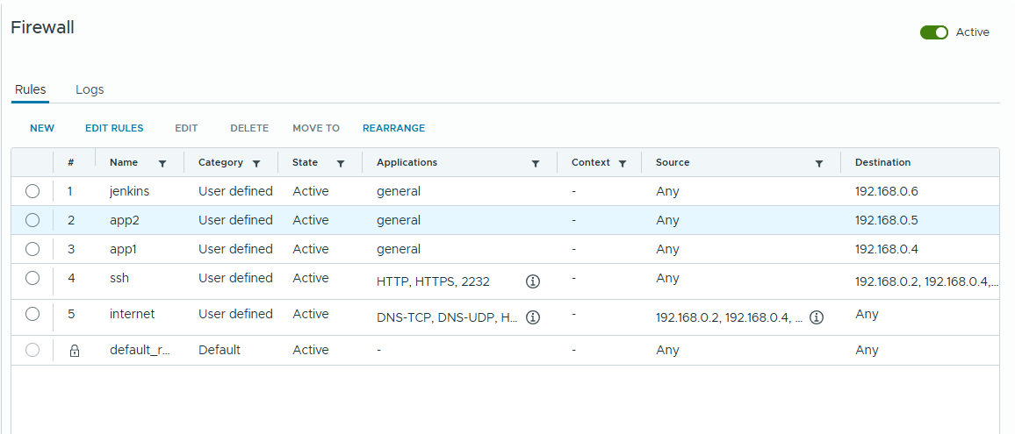

Jenkins CI/CD Pipeline
Description:
Jenkins was configured to automatically build and deploy the Java application whenever code changes were pushed to GitHub.

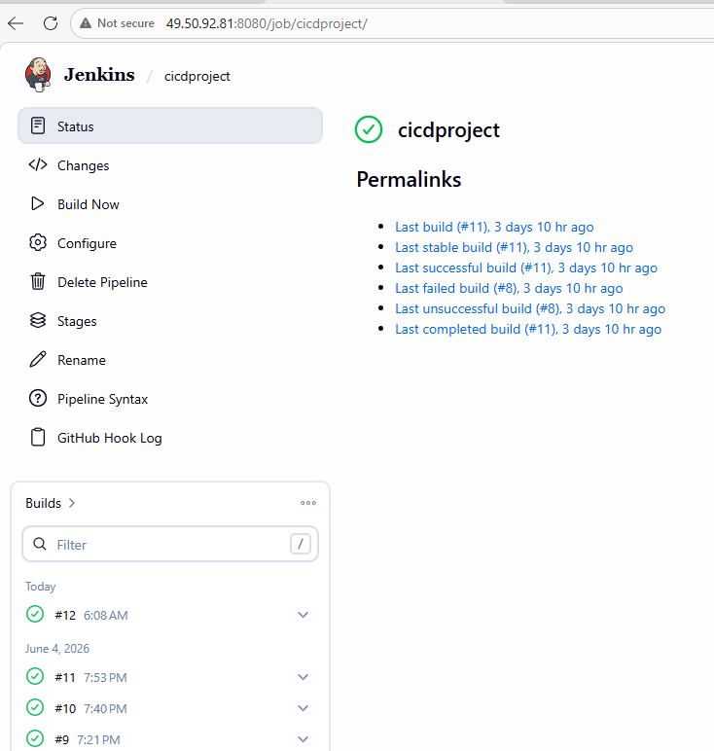

Code Modification
Description:
A change was made in the application source code to validate the automated deployment workflow.
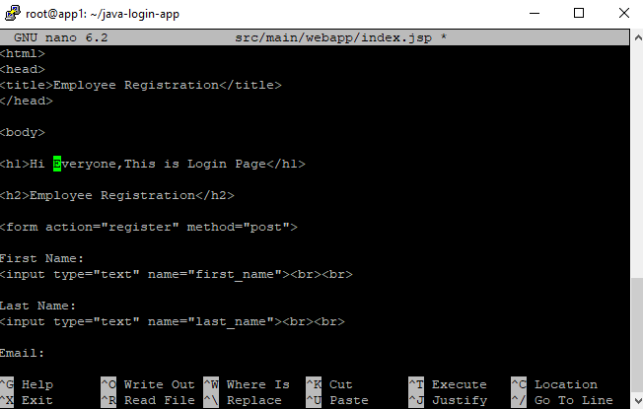

Git Push
Description:
Modified code was committed and pushed to the GitHub repository.
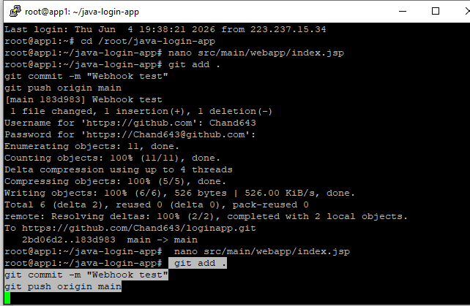

Automatic Jenkins Build
Description:
GitHub Webhook triggered Jenkins automatically. Jenkins fetched the latest code, built the WAR file using Maven, and deployed it to both Tomcat servers.

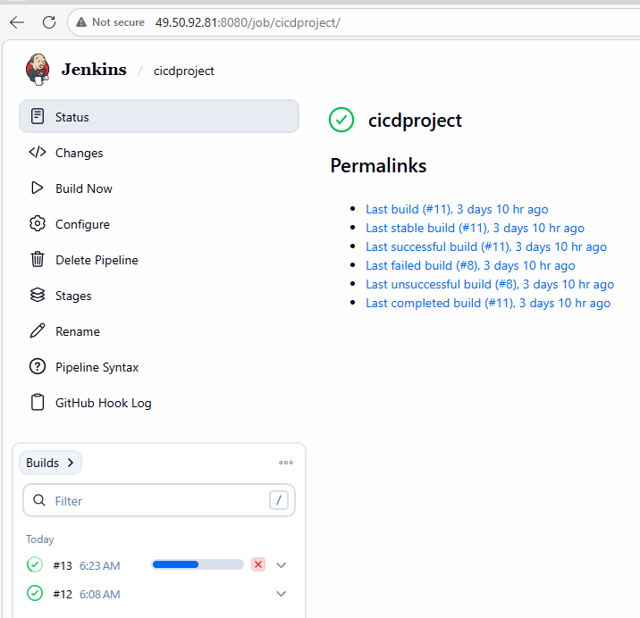

Final Result
Description:
The updated application was successfully deployed and the changes became visible on the live application without manual deployment.

