- Headline (clear + strong):
Barytes (Barite) Exporter from India – API Grade | High Purity | Bulk Supply
Sub-line:
✔ Direct sourcing from mines in Andhra Pradesh & Rajasthan
✔ Consistent API-grade supply for Oil & Gas drilling
✔ Bulk export capability (500–3000 MT/month)
CTA (must be visible):
- “Request Latest Price”
- “Send Requirement on WhatsApp”

- Headline: "India's Premium Barytes — API, Drilling & Industrial Grade, Shipped Worldwide"
- Sub-headline: SG range, purity %, countries shipped to
- Background: mine or loading dock imagery (not stock)
- Live WhatsApp / Enquiry button — high conversion on mobile

- Trust bar
Stats that matter to buyers instantly

4–5 numbers in a single row — scannable in 3 seconds
- Tonnes exported per year / countries served / years in business
- Min order quantity & lead time range

- Product grades catalogue
Detailed grade cards with specs table
Buyer intentTechnical
Each grade as a card with its own specs — buyer should know immediately which grade fits their use case. TDS for each grade and some basic lines
- API Drilling Grade (SG 4.2+) — BaSO₄ %, mesh size, moisture, Fe₂O₃ limit
- Paint & Coating Grade — brightness, oil absorption, particle size D50/D97
- Medical / X-Ray Grade — purity %, soluble barium limits
- Filler / Rubber Grade — whiteness index, bulk density
- Chemical Grade (BaSO₄ precipitated) — assay, heavy metals

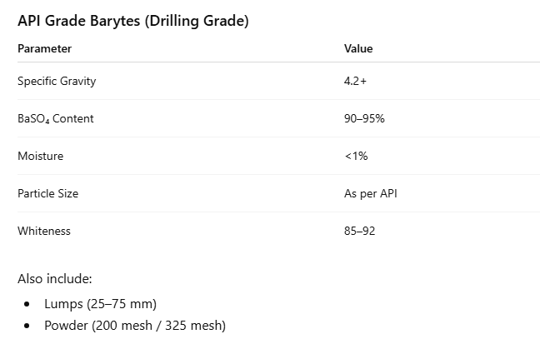

- Origin & sourcing map
Where the barytes comes from
TechnicalSeller intent
Visual map of Indian mining regions (Andhra Pradesh, Rajasthan, MP) — tells both buyers and potential mine partners you know the belt
- Brief geology note: why Indian barytes has high SG (Cuddapah basin)
- Mention of captive mine tie-ups vs spot sourcing
- CTA for mines: "Are you a mine owner? Partner with us"

- Why Buyers Choose us
Don’t say “high quality”. Say THIS:
✔ Direct access to multiple mines → no supply disruption
✔ Competitive pricing vs China & Morocco
✔ Bulk loading capability (vessel / container)
✔ SGS / Intertek inspection support
✔ Experience in Africa, Middle East, Southeast Asia
“We don’t depend on a single mine — ensuring consistent supply even in high-demand periods.”

Supplier / Mine Collaboration Section
.

“For Mine Owners & Suppliers”
✔ Looking to partner with barytes mines across India
✔ Assured bulk offtake for export markets
✔ Fast-moving export channels (Africa, Middle East)
✔ Flexible working model (direct supply / stock & sale)
Add:
“If you are a mine owner or processor, connect with us for long-term export collaboration.”

- FAQ
Answer objections before they're asked
Buyer intentTrust
- What is the minimum order quantity? 1 MT
- Can you supply API 13A certified barytes? yes
- What payment terms do you accept? TT, LC or can be discussed
- Do you provide samples before bulk order? Yes
- How is barytes different from barite? Both are same
- Can you customise mesh size / SG to our spec? yes , depends upon irder size

