1. Headline:
Cenospheres Supplier & Exporter from India – Lightweight Fillers for Industrial Applications
Sub-line:
Bulk supply for oilfield, construction, paints & plastics | Export-ready shipments

2. What are Cenospheres (Keep It Sharp)
Cenospheres are lightweight, hollow, inert microspheres derived from coal fly ash, widely used as a filler material to reduce weight, improve strength, and enhance insulation properties.

Formation and Origin
Cenospheres form during the high-temperature combustion of pulverised coal at temperatures between 1,200°C and 1,700°C. The sequence of formation involves:
- Coal particles melt and form molten droplets in the combustion zone.
- Trapped gases (CO, CO₂, SO₂, and steam) expand inside the molten droplets.
- Surface tension retains the gas bubble, forming a hollow sphere.
- Rapid cooling as the particles exit the furnace solidifies the shell, preserving the hollow structure.
Only a small fraction of fly ash — typically 0.1% to 2% by weight — consists of cenospheres, making selective extraction economically meaningful.

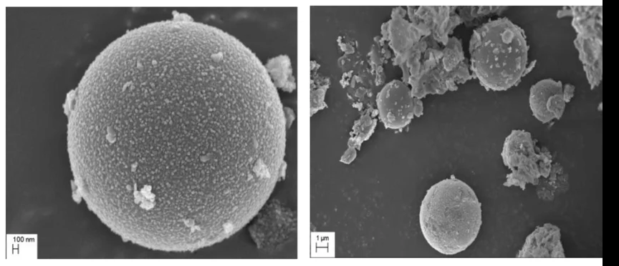
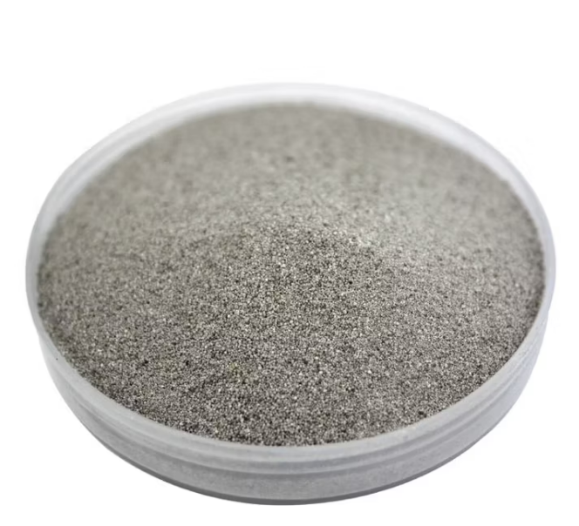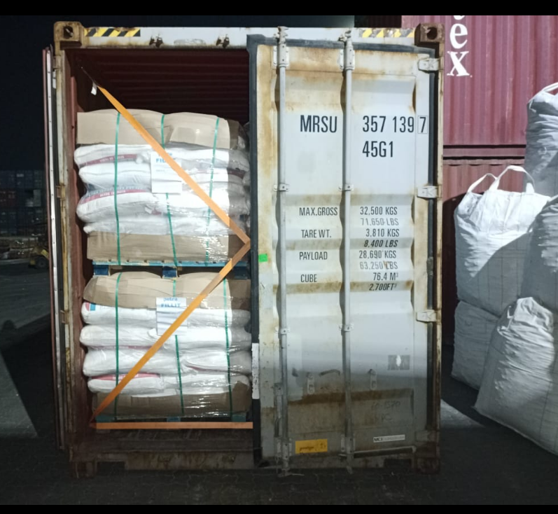

3. Physical and Chemical Properties

3.1 Physical Properties
Property | Typical Value / Range
Particle diameter | 10 – 500 μm (typically 50–200 μm)
Bulk density | 0.25 – 0.45 g/cm³
True particle density | 0.4 – 0.8 g/cm³
Shell wall thickness | 2 – 10 μm
Compressive strength | Up to 150 MPa (varies by shell thickness)
Melting point | ~1,200 – 1,500°C
Colour | Grey, white, or off-white

3.2 Chemical Composition
Cenospheres are predominantly aluminosilicate in composition. The main chemical components are:
- Silicon dioxide (SiO₂): 50–65%
- Aluminium oxide (Al₂O₃): 25–35%
- Iron oxide (Fe₂O₃): 1–8%
- Calcium oxide (CaO), magnesium oxide (MgO), and other trace oxides: remainder
The enclosed gas is typically a mixture of nitrogen and carbon dioxide. The glassy amorphous shell gives cenospheres their chemical stability and resistance to most acids and alkalis.

4. Applications

4.1 Construction and Building Materials
In the construction industry, cenospheres are incorporated into lightweight concrete, plaster, and grouting compounds. They reduce the overall density of the material, improve workability, and enhance thermal and acoustic insulation without significantly compromising structural performance.

4.2 Oil and Gas Industry
Cenospheres are used as a lightweight filler in oil well cement slurries. By reducing slurry density, they help control hydrostatic pressure during cementing operations in deep wells, reducing the risk of formation fracturing.

4.3 Aerospace and Automotive
Their low density and mechanical strength make cenospheres ideal fillers in syntactic foams used for buoyancy modules, automotive body panels, underbody coatings, and ablative thermal protection systems. They contribute to weight reduction without sacrificing structural integrity.

4.4 Paints and Coatings
When added to paints, primers, and coatings, cenospheres improve texture, reduce weight, lower material costs, and provide thermal insulating properties. They are widely used in exterior architectural coatings and marine applications.

4.5 Plastics and Composites
As a functional filler in polymer matrices, cenospheres enhance stiffness, reduce shrinkage, and improve surface finish. They are used in thermoplastic and thermoset composites for industrial, consumer, and sporting goods applications.

4.6 Refractory and High-Temperature Applications
Cenospheres are used in refractory castables, kiln furniture, and insulation boards owing to their high melting point and low thermal conductivity. They are suitable for furnace linings and high-temperature industrial equipment.

5. Why Source Cenospheres from India?
India is one of the world's largest cenosphere exporters, supplying nearly a quarter of global demand. An extensive network of coal-fired thermal power plants ensures abundant, consistent supply of high-quality material. Indian cenospheres are trusted by global buyers for their superior alumina-silica composition and consistent particle sizing — qualities that frequently outperform competing origins. Strategically located, India offers shorter transit times to the Middle East, Southeast Asia, and beyond, making it the most cost-effective and reliable sourcing destination in the world.

6. Why Ochnology Solution Pvt. Ltd.?
We source directly from thermal power plants across India's major coal belts — no intermediaries, no inflated costs, full traceability on every batch. Our direct TPP sourcing model ensures consistently priced, lab-tested cenospheres that meet your exact specifications. Backed by pre-established freight partnerships and streamlined export documentation, we move orders from plant to port faster than most. We supply buyers across the Middle East, USA, Europe, and Southeast Asia — and our clients keep coming back because we deliver on time, every time.

