- What is DBM
Dead burnt magnesite (also called dead burned magnesia or DBM) is a form of magnesium oxide (MgO) produced by calcining magnesite (MgCO₃) at very high temperatures — typically 1500°C to 2000°C.

Production
The process starts with natural magnesite ore:
MgCO₃ → MgO + CO₂
At these extreme temperatures, the MgO crystals grow large and dense (a process called sintering), resulting in a product that is:
- Highly crystalline (periclase crystal structure)
- Very low in reactivity with water and CO₂
- Extremely dense and hard
This distinguishes it from:
- Light burned / caustic calcined magnesia — made at ~700–1000°C, highly reactive
- Hard burned magnesia — intermediate temperature (~1000–1400°C)

Key Properties
Property | Value
MgO content | 90–98%
Bulk density | 3.0–3.5 g/cm³
Melting point | ~2852°C
Reactivity with water | Very low
Crystal size | Large periclase grains

3.

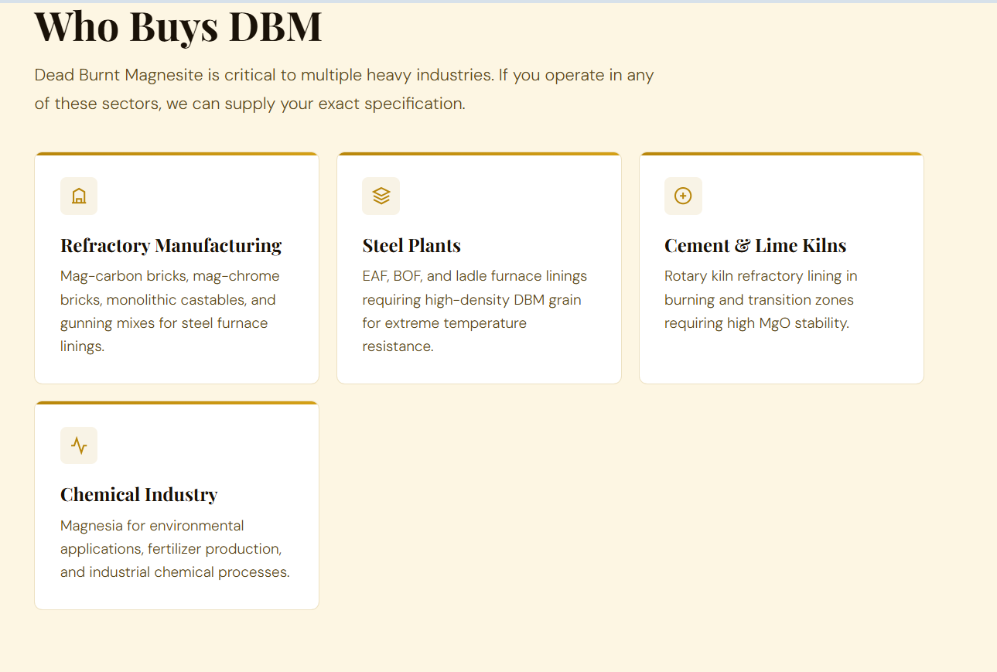

4.
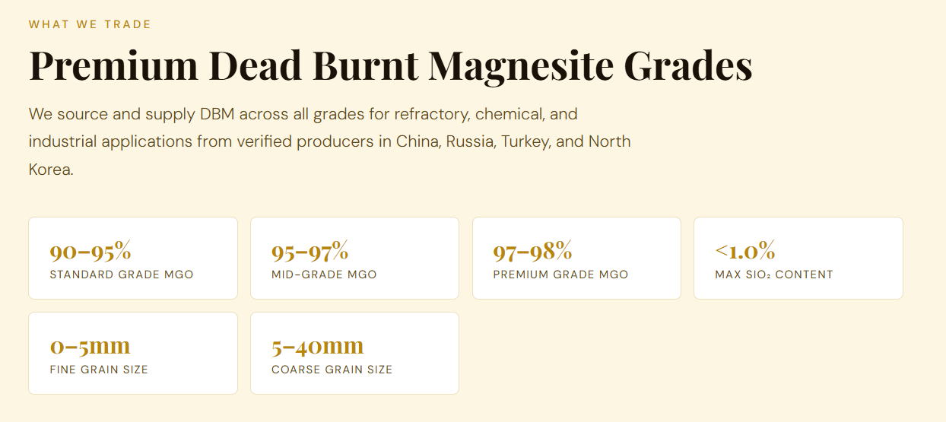

5. Add real photos of showing color , stock etc . Also show photo of dbm loaded in truck, in container

6. Buyer Benefits

What to Expect When You Reach Out
We understand that large DBM purchases are capital-intensive. Our approach is to understand your business first — then match you with suppliers who are genuinely interested in building a lasting trade relationship.
- Access to Chinese, Russian & Turkish DBM producers
- Grades from 90% to 98% MgO, any grain size
- Trial orders from 25 MT — scale at your pace
- Transaction terms discussed based on volume & relationship
- COA and inspection on every shipment
- Dedicated point of contact throughout the deal
- Competitive pricing
Every buyer relationship starts with a conversation — share your requirements and we will work around your procurement cycle.

7. For Suppliers & Exporters

Tap Into a Hungry, Growing Market

India's refractory and steel sector consumes thousands of MT of DBM every month — and serious buyers are actively looking for reliable, long-term supply partners. Are you one?

The Opportunity for Exporters
India is one of the fastest-growing importers of Dead Burnt Magnesite — driven by rapid steel capacity expansion and refractory manufacturing growth. Buyers here are not looking for a single shipment. They want a partner they can rely on month after month.
What our buyers bring to the table: consistent monthly volumes, established import infrastructure, and a genuine interest in multi-year sourcing arrangements — the kind of relationship that makes your export pipeline predictable.
- Repeat monthly orders — not one-off spot buys
- Buyers with proven import history and credibility
- Transparent deal structures, no hidden layers
- Your pricing and quality positioned to the right audience
- We handle the India-side logistics, customs, and documentation
- Suppliers who offer competitive payment terms get priority matching

The suppliers who grow fastest in new markets are those willing to invest in the relationship early — our best-matched deals have come from exporters who approached us with a partnership mindset.

