- Wollastonite exporter from India - High Purity & Consistent Supply

Headline: "India's Premium Wollastonite — High-Aspect-Ratio Acicular Grade for Ceramics, Plastics, Paints & Metallurgy — Shipped Worldwide"
Sub-headline: CaSiO₃ 95%+ · Aspect ratio up to 15:1 · Bright white · 200 to 10 mesh · Rajasthan & Gujarat origin
- Real imagery: wollastonite ore close-up showing needle structure, grinding plant, container loading

- Trust bar
MT exported per year / countries supplied
Years in wollastonite processing and export
Processing capacity: own rented grinding unit — MT/month
Lead time: samples in 48 hrs · bulk 15–20 days · ex-stock available

- Product grades catalogue
Grade | CaSiO₃ min | Aspect ratio | Mesh / D50 | Brightness | Fe₂O₃ max | Primary use
Standard powder (SP) | 92% | 3:1 – 5:1 | 200 mesh / D50 25µm | 82–86 | 0.5% | Ceramics body, glaze, paint filler
Fine powder (FP) | 93% | 4:1 – 6:1 | 325 mesh / D50 15µm | 84–88 | 0.4% | Premium ceramics, coatings, sealants
High aspect ratio (HAR) | 95% | 10:1 – 15:1 | D50 50–80µm | 88–92 | 0.3% | Plastics reinforcement, nylon/PP compounds
Surface treated (ST-HAR) | 95% | 10:1 – 15:1 | D50 50–80µm | 88–92 | 0.3% | Nylon 6/66, PP, TPE compounds — coupling agent coated
Lump / crushed grade | 90–92% | — | 3–50mm | 78–84 | 0.6% | Metallurgy flux, cement kiln, slag conditioner
Ultra-fine (UF) | 95%+ | 5:1 – 8:1 | D50 5–10µm | 90–94 | 0.2% | Premium paints, friction materials, speciality coatings
- Full chemistry: CaSiO₃, SiO₂, CaO, Fe₂O₃, Al₂O₃, MgO, TiO₂, LOI — provided per lot
- Downloadable typical TDS PDF for each grade · Custom mesh and surface treatment on request

- Origin, geology & sourcing map
Why Indian wollastonite leads

India holds ~40% of global wollastonite reserves — this section positions you as a knowledgeable insider who understands the mineral, not just a trading intermediary
- Rajasthan (Sirohi, Dungarpur, Pali): largest reserves; high-purity CaSiO₃, naturally bright white, low Fe₂O₃ — ideal for plastics and paints applications where colour is critical
- Gujarat (Chhota Udaipur, Bharuch): good quality deposits; closer to Mundra port — logistics advantage for export
- Geology note: wollastonite forms at the contact zone between limestone and silica-rich intrusions (skarn deposits) under high temperature and pressure — India's Precambrian terrain is ideal, producing naturally acicular (needle-shaped) crystals with high aspect ratios
- Processing chain: open-pit mining → jaw crushing → rod milling / impact milling (for HAR preservation) → air classification → surface treatment (if required) → packaging
- Key note: HAR grades require special milling — impact mills preserve needle length better than ball mills; mention if you use dedicated HAR processing line
- CTA for local partners: "Are you a wollastonite mine owner, crusher or grinding unit in Rajasthan or Gujarat? Partner with us for consistent, well-priced export offtake"

- Industry applications deep-dive

Wollastonite's acicular morphology gives it functional properties no other white filler can replicate

- Ceramics & tiles (largest market): flux in ceramic body — reduces firing temperature by 50–100°C (energy saving), controls shrinkage, improves green strength; ideal for fast-fire wall tiles; also used in sanitaryware, technical ceramics and glazes; mention thermal expansion coefficient compatibility
- Plastics & polymer compounds: HAR grade reinforces nylon (PA6/PA66), polypropylene, ABS — improves flexural modulus, reduces warpage, enhances dimensional stability; replaces or supplements glass fibre at lower cost and lower abrasion to processing equipment; surface-treated grade improves matrix adhesion
- Paints & coatings: functional extender replacing TiO₂ partially — improves scrub resistance, reduces gloss where needed, flattens sheen; in anti-corrosion coatings acts as barrier pigment due to plate-like/needle orientation; reduces cracking in exterior paints
- Friction materials & brake pads: replaces asbestos as reinforcing fibre — improves thermal stability, reduces brake fade, meets environmental regulations; major growth segment as global asbestos phase-out continues
- Metallurgy (steel / iron foundry): lump/crushed grade as flux — lowers slag melting point, improves slag fluidity, acts as slag conditioner in EAF / BOF; also used in welding flux formulations
- Sealants, adhesives & construction: improves thixotropy in sealants, reduces slump; in construction boards as filler for fibre cement panels
- Agriculture: slowly releases calcium and silicon — used as soil amendment in silicon-deficient soils; growing niche in India's own agricultural market

- Why buy from us — buyer advantages

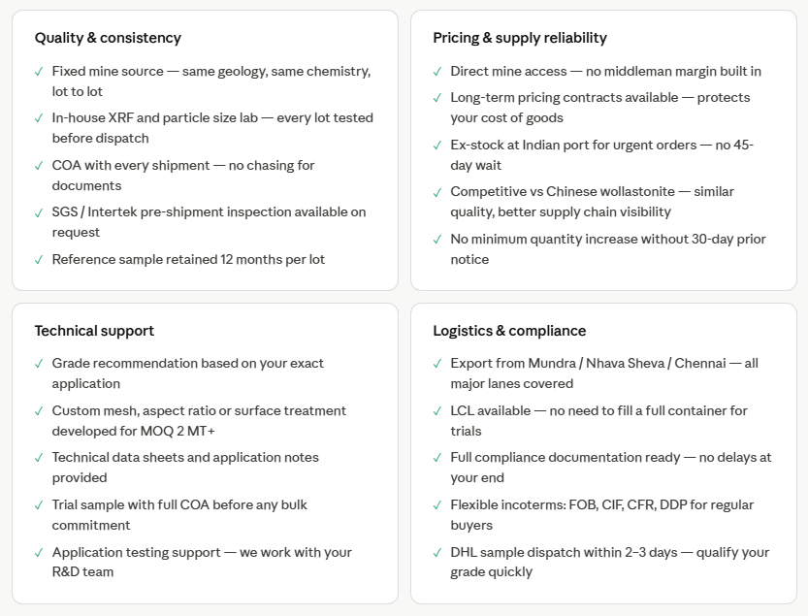

- Partner with us — seller / mine advantages
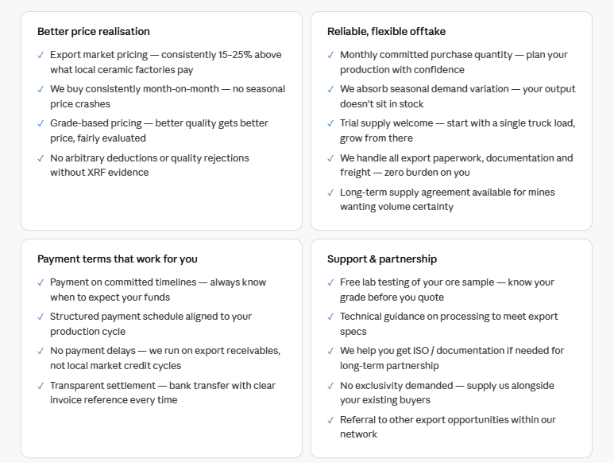

FAQ
1. What price can you offer for wollastonite?
Pricing depends on grade, mesh size, and quantity. Share your requirement and we will provide a competitive FOB/CIF quote quickly.

2. How fast can you dispatch material?
For standard grades, dispatch can be arranged within a short timeframe depending on availability and order size.

3. Can I start with a trial order before bulk purchase?
Yes, trial quantities or sample shipments can be arranged before committing to full container loads.

4. Do you supply consistent quality for repeat orders?
Yes, we work with selected processors and maintain consistency across shipments with proper quality checks.

5. Which countries do you export to?
We regularly supply to Africa, Middle East, and Southeast Asia markets.

6. What payment terms do you offer?
We accept TT and LC payment terms, with flexibility based on order volume and long-term partnership.

7. Can you match or improve pricing compared to other suppliers?
We always aim to offer competitive pricing with reliable quality and supply stability—share your target price and we will evaluate.

