JOHN MARTYN MEMORIAL SCHOOL (JMMS)
July 2026 School Report – Session 2026–2027

Greetings from JMMS,
We are happy to share with you the progress and highlights from July 2026 at John Martyn Memorial School.
At JMMS we nurture young minds with love, learning and laughter, shaping compassionate leaders of tomorrow. Guided by our mission to provide quality education to children from all backgrounds. We strive to create a school where every child feels seen, valued, and inspired to dream big. Rooted in empathy and excellence, JMMS is more than a school — it’s a family that grows together.

July 2026

Visit to the post office

On 13th of July
As part of experiential learning, Class IV students visited the Bhagwantpur Post Office to complement their Hindi lesson on “Dak Ghar”.
During the visit, children observed the working of the post office and engaged in an interactive session with the Postmisterss (Kiran Joshi) and Postman ( Tukaram ). They learned about the journey of a letter, the importance of stamps, and how mail reaches every corner of the country.
The visit made the lesson meaningful and memorable, helping students connect classroom concepts with real-world experiences.
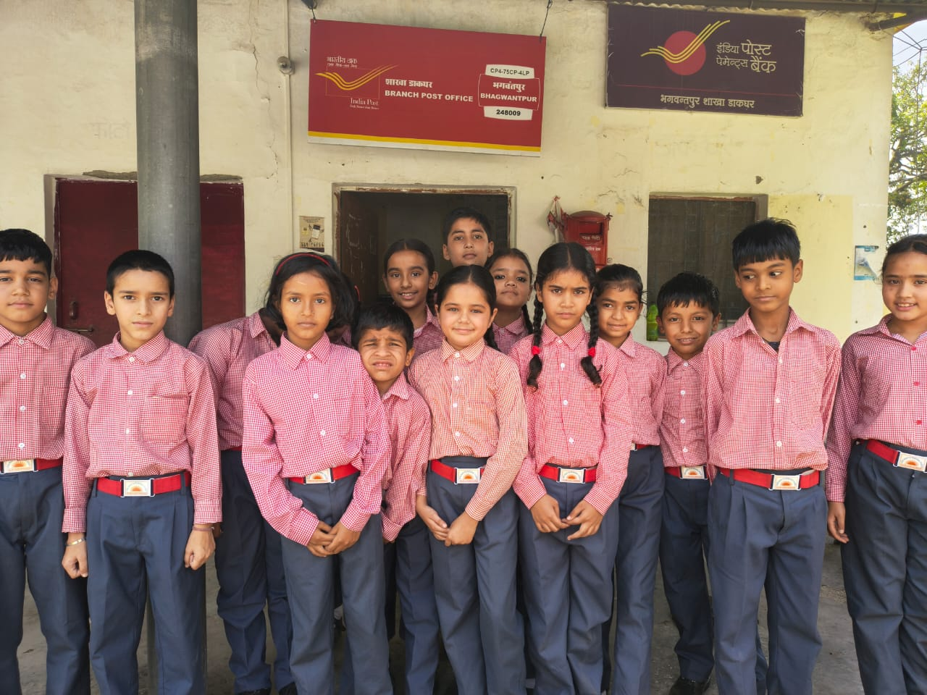

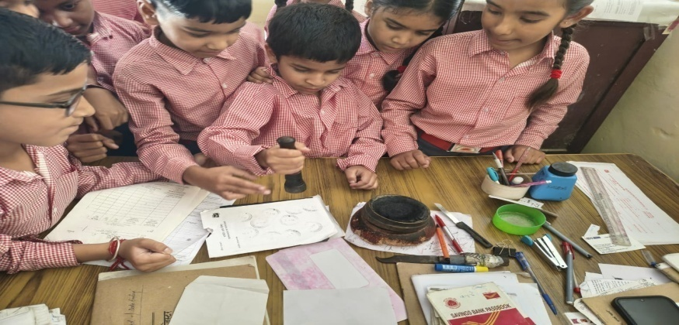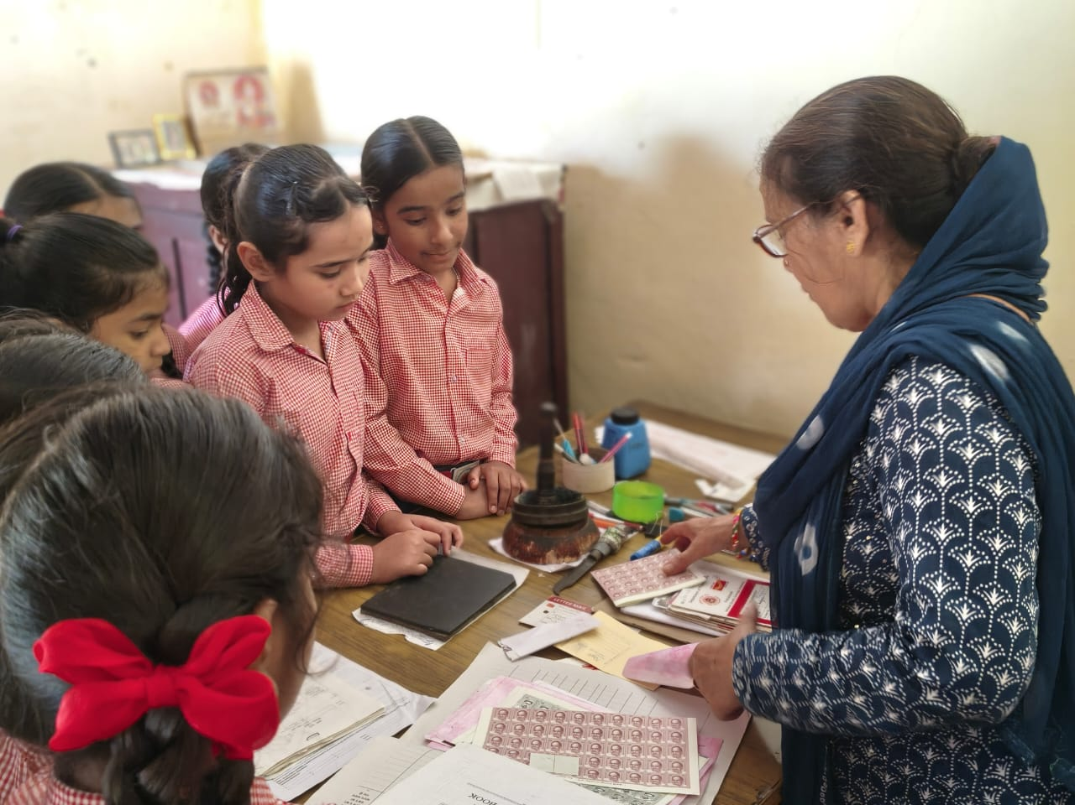

Celebration of Harela – 15th July

At JMMS, we deeply believe that true education extends beyond classrooms — it lies in nurturing a bond with nature and community.
In keeping with this spirit, every Thursday our students, along with the local group "Let's Do It", dedicate themselves to the noble cause of preserving our environment by cleaning our neighbourhood. This weekly pledge is our small step toward a cleaner, greener tomorrow.
On 15th July, we celebrated Harela — the festival of greenery, growth, and prosperity — with great enthusiasm and reverence. The day began with a cleanliness drive across the school premises, followed by a plantation drive where saplings were planted to strengthen our commitment to a sustainable future.
To make the message of Harela more meaningful, each child was encouraged to take this initiative home. With pride and joy, every student planted a tree or a plant in their home or in their neighbourhood , becoming young ambassadors of environmental conservation.
We were deeply honored to have with us Retired Major General Satish Agarwal, Ms. Saumya Prasad from Nature Science Initiative. Their gracious presence and words of encouragement inspired both students and staff, and made the celebration truly memorable.
The celebration of Harela at JMMS was not just an event — it was a reaffirmation of our responsibility toward Mother Earth and our pledge to nurture her for generations to come.

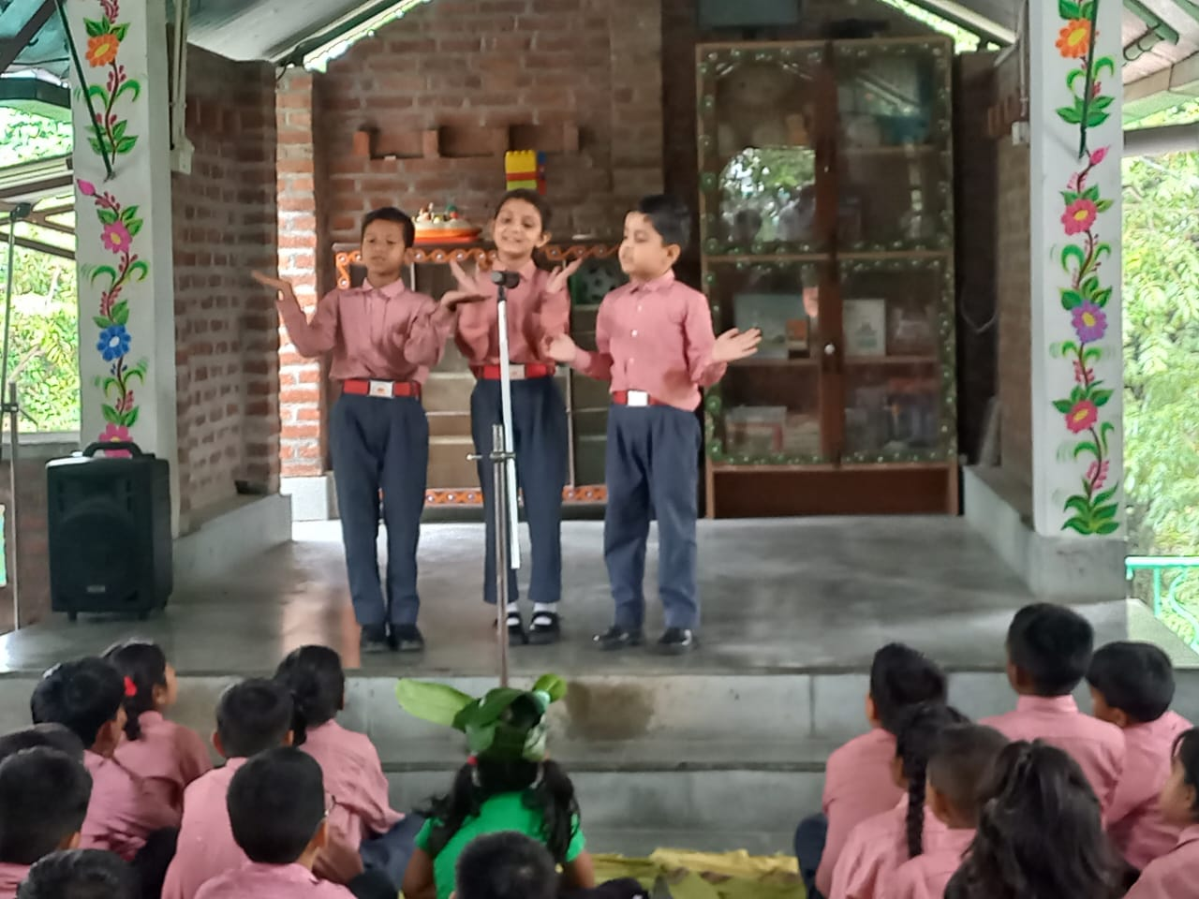
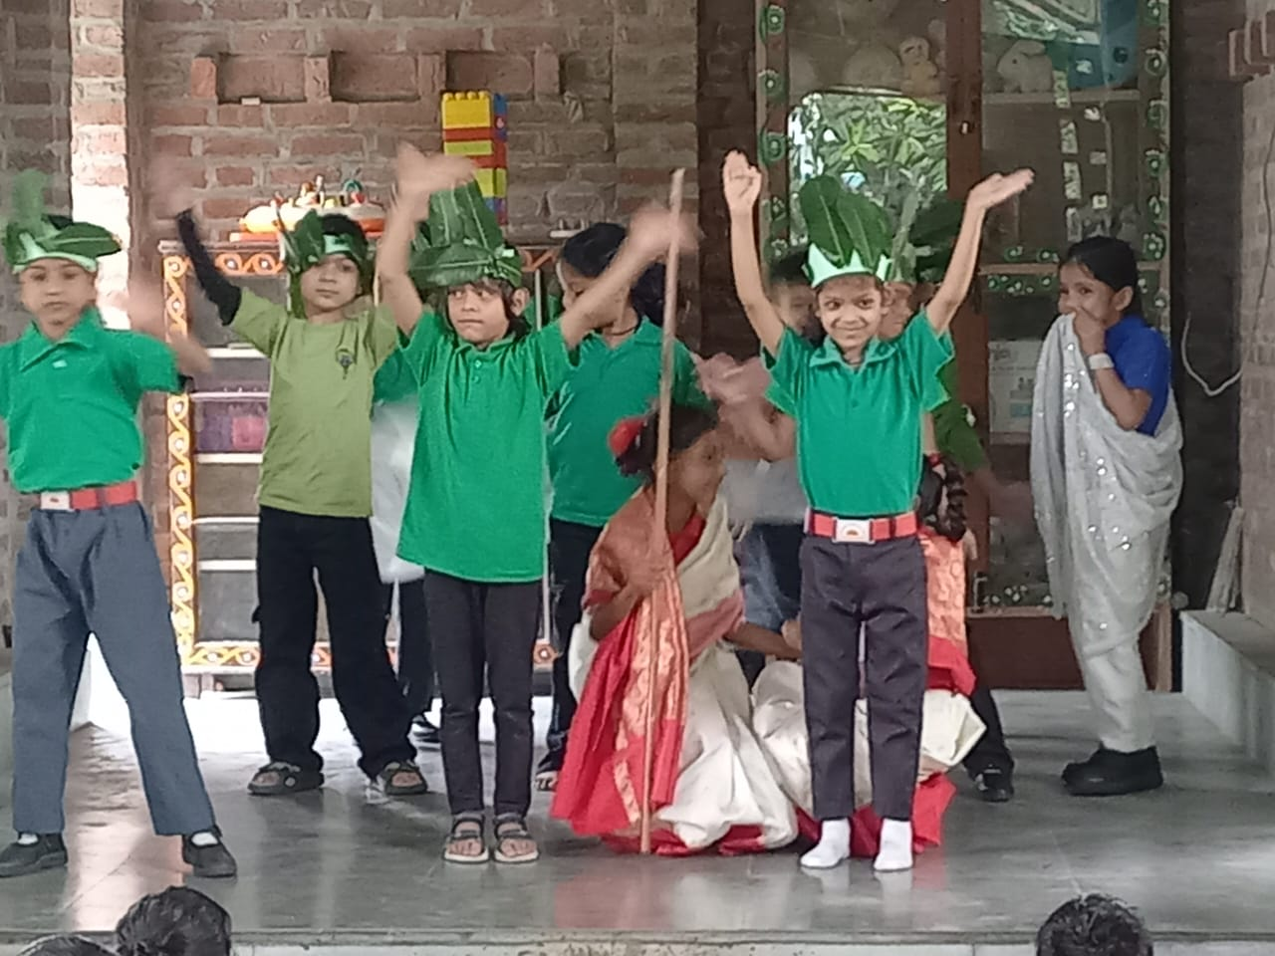

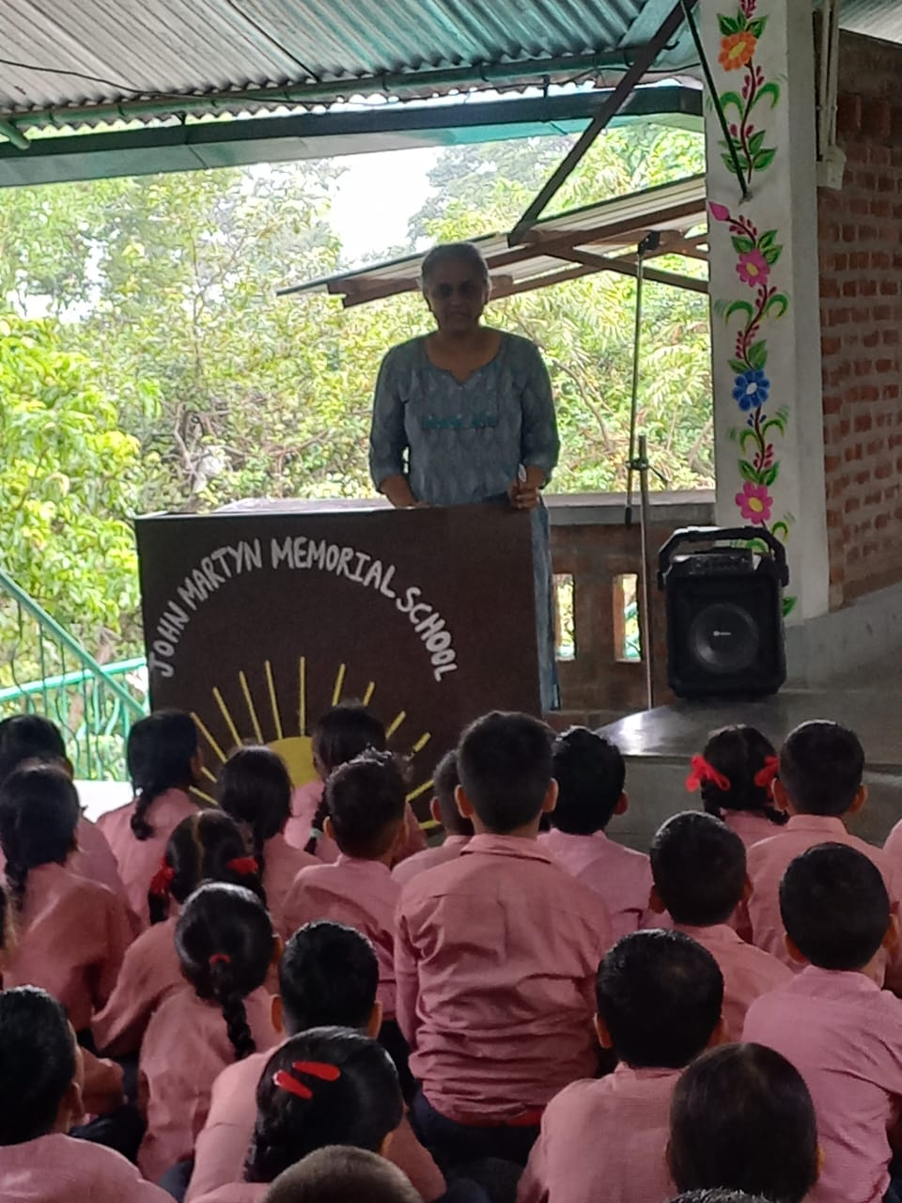

Visit to the Punjab national bank
As part of our focus on experiential learning, students of Class V visited Punjab National Bank on an educational trip.
During the visit, students interacted with the Bank Manager MR Vaibhav kishore singh branch manager and learned about basic banking operations such as opening accounts, depositing and withdrawing money, and the importance of saving. They also asked questions about financial habits and the value of money, which the Manager addressed in a simple and engaging way.
The visit gave students practical exposure to banking services and helped them understand financial responsibility from an early age. It was an informative and enriching learning experience.

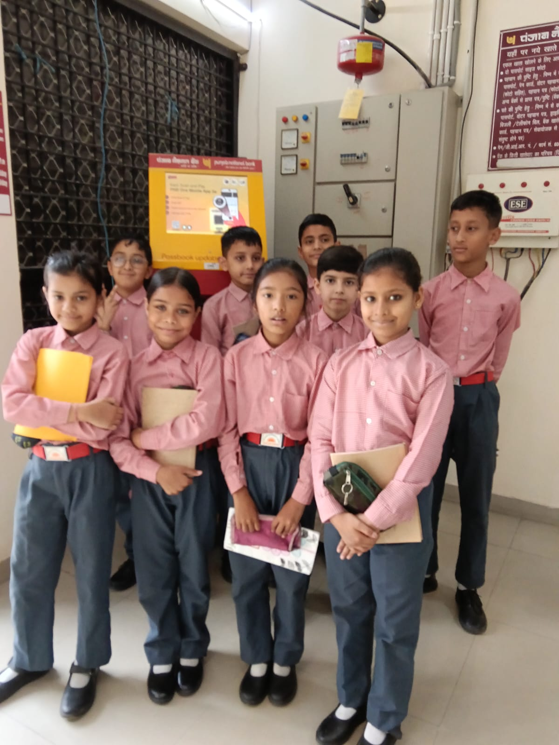

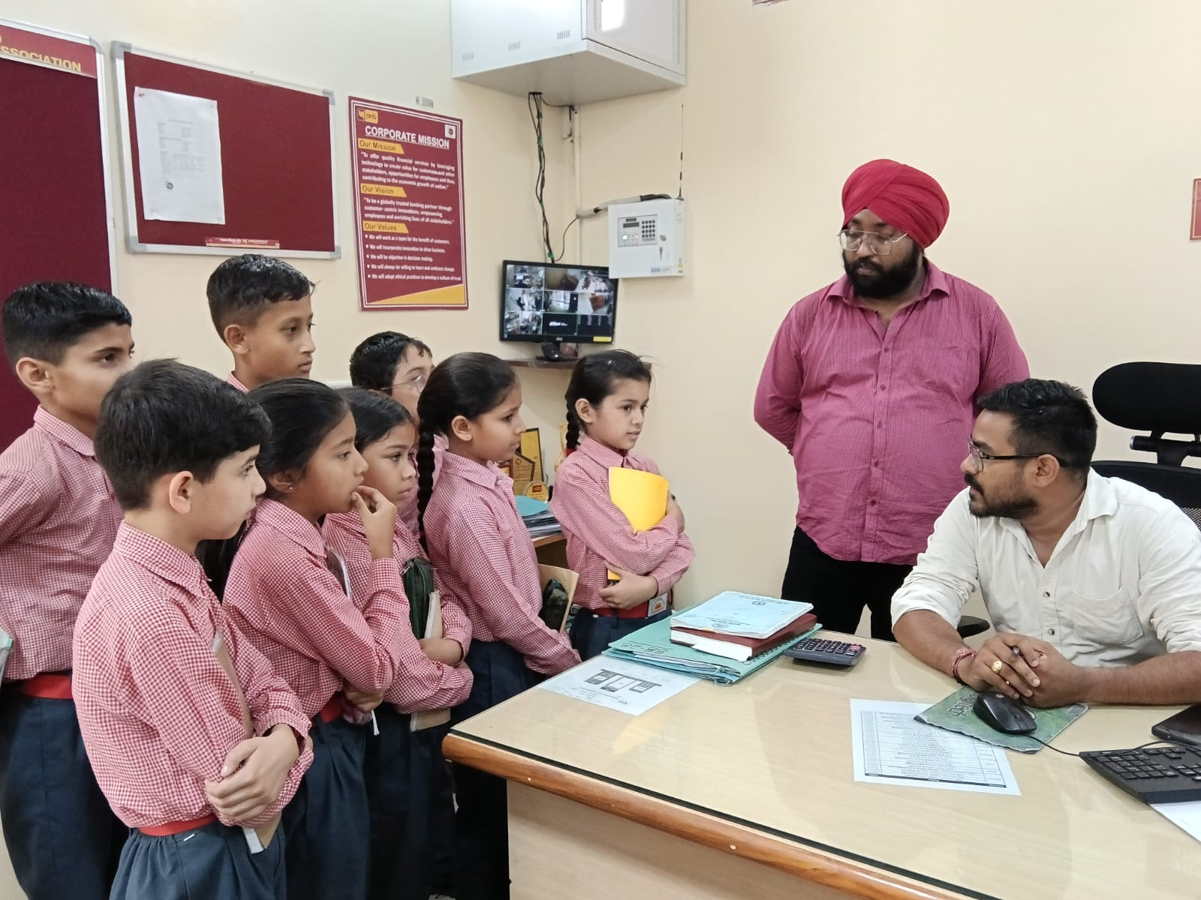

Continuity of Learning During School Closure

In accordance with the District Magistrate’s order, the school remained closed for 4 days. However, at JMM, we firmly believe that learning never stops.
During this period, our dedicated teachers and enthusiastic students came together for engaging online classes. The virtual classrooms were filled with active participation, meaningful discussions, and lots of interaction.
This initiative ensured that the learning journey continued without interruption and that our children remained connected, curious, and motivated even from home.
It was a wonderful reflection of the JMM spirit — adaptable, resilient, and committed to education under all circumstances.

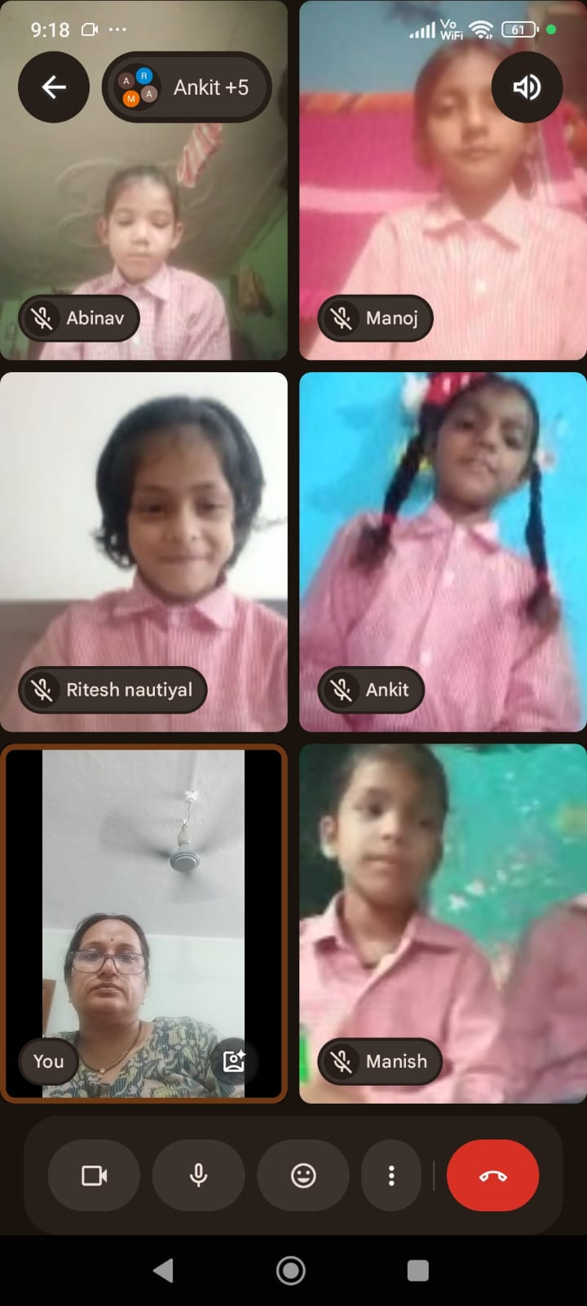

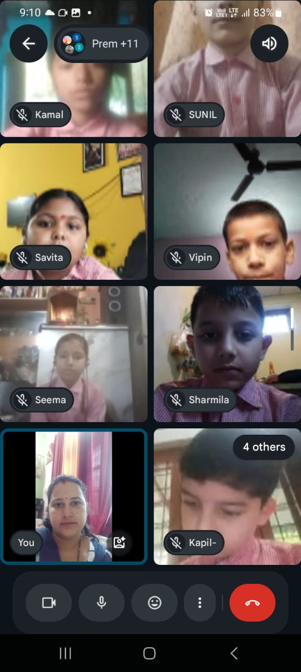

Storytelling from abroad
We are delighted to share that our Class IV students are now enjoying interactive online reading and storytelling sessions with Ashna, a student volunteer from GEMS Wellington International School, Dubai.
This wonderful collaboration is our step towards giving our children global exposure and helping them learn beyond boundaries.
The children are thoroughly enjoying these engaging sessions and are getting the opportunity to interact, listen, and learn from a peer across the world.
Learning truly knows no borders at JMMS!

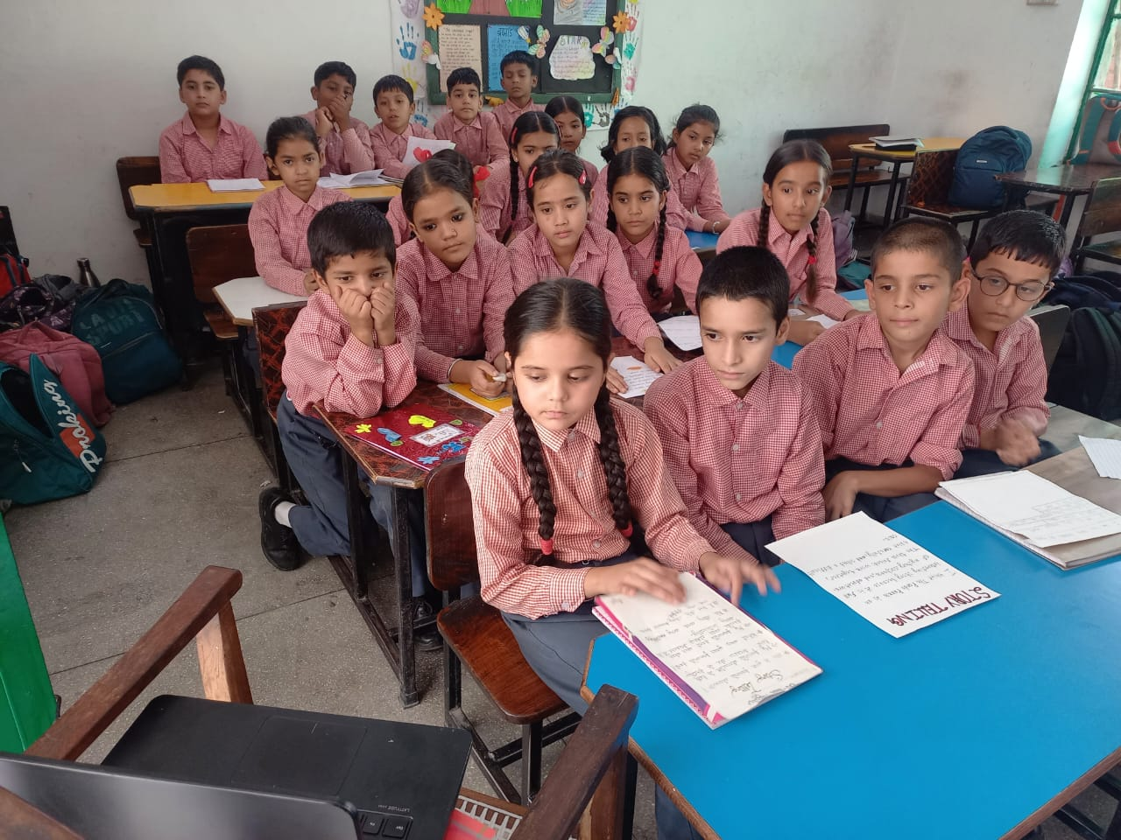

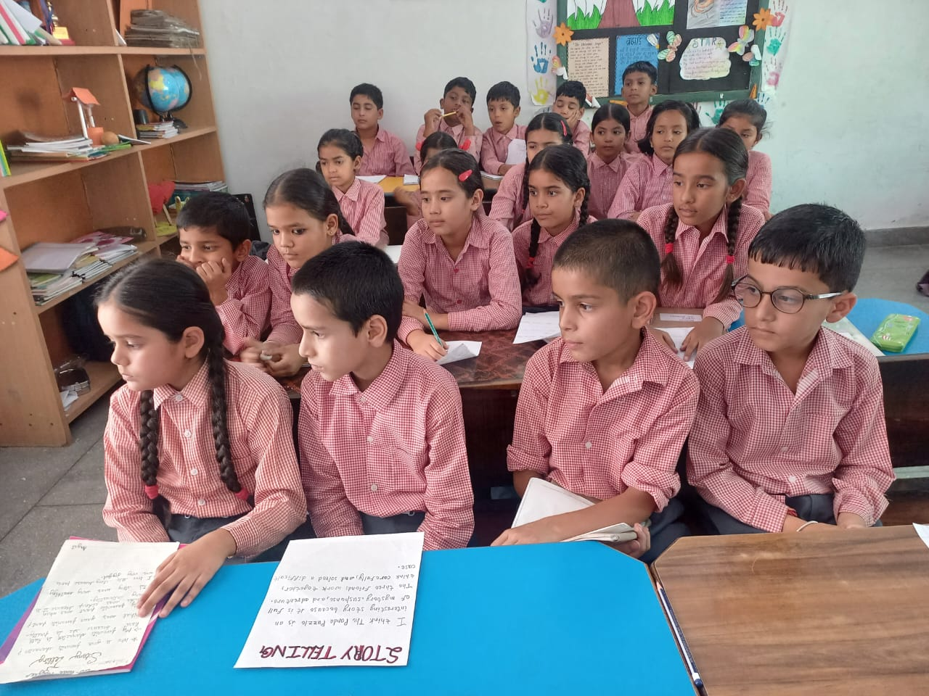

Skill Development Through Music Classes

As part of our continuous effort towards skill-based learning, we have introduced Tabla, Harmonium, and Vocal Music classes for our students.
These classes are being conducted by our talented teachers, Mr. Ashish Chetri and Ms. Pooja Padmavathi.
The sessions aim to nurture musical talent, enhance creativity, and provide students with a platform to explore and develop their artistic skills from an early age.
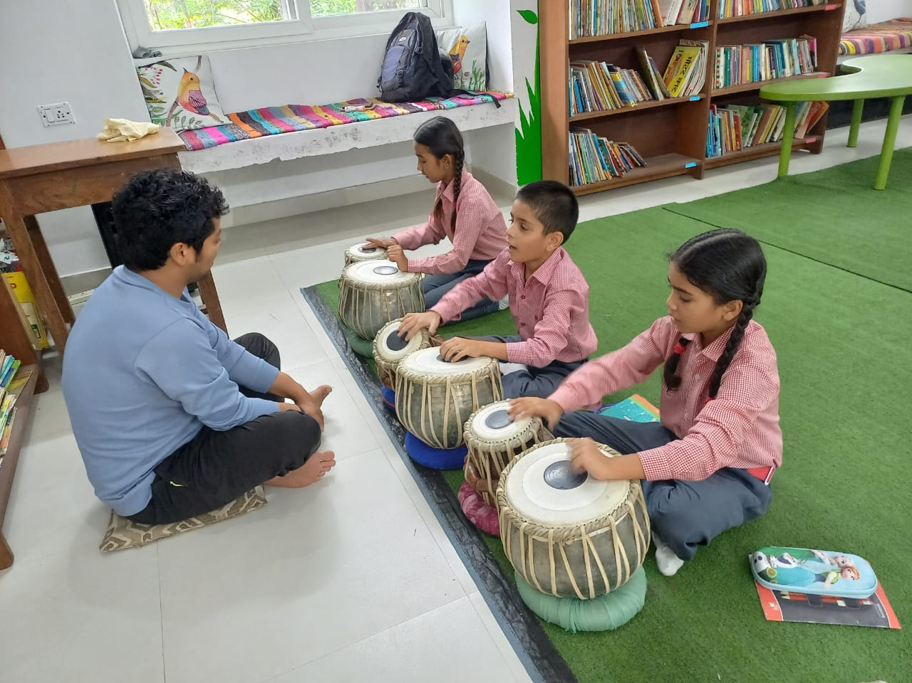

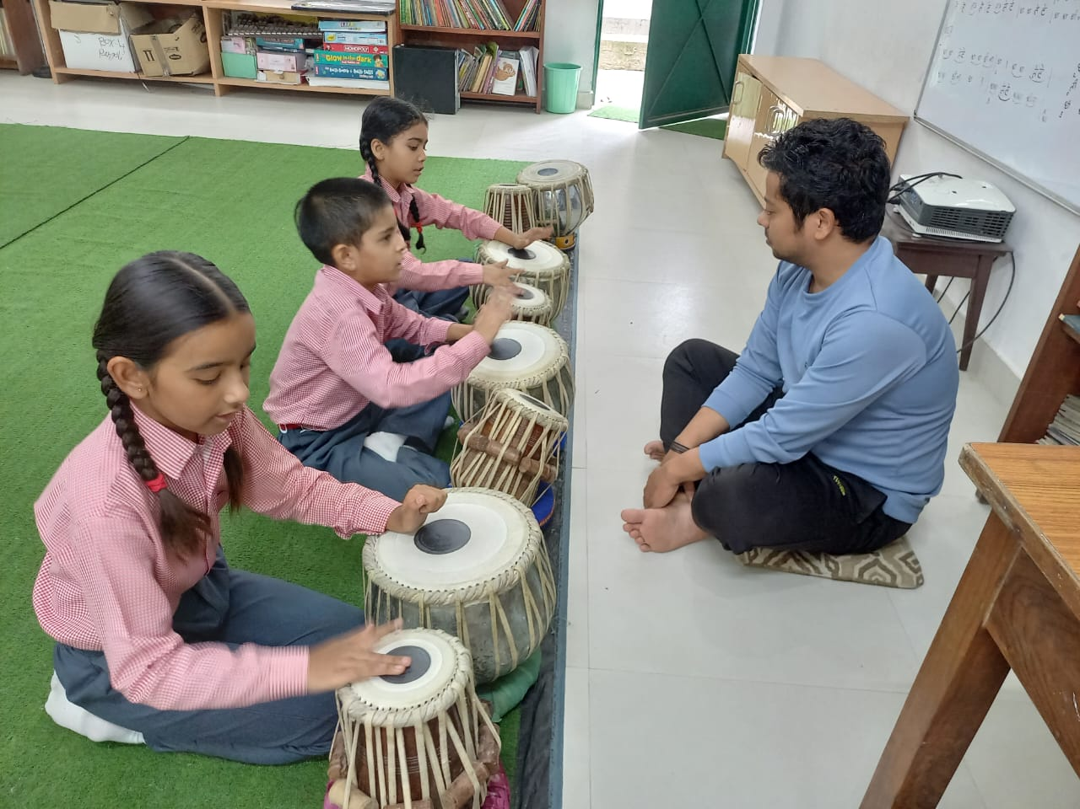

Butterfly Rearing Session
Date: 22nd July

As part of our experiential learning initiative, a Butterfly Rearing Session was conducted for our students on 22nd July.
The session was led by Mr. Raman Prasad and Ms. Samriddhi Sharma from NSI - Nature Science Initiative.
Children were introduced to the life cycle of butterflies and the importance of biodiversity. The hands-on session aimed to create awareness about nature conservation and foster curiosity about the natural world among our students.

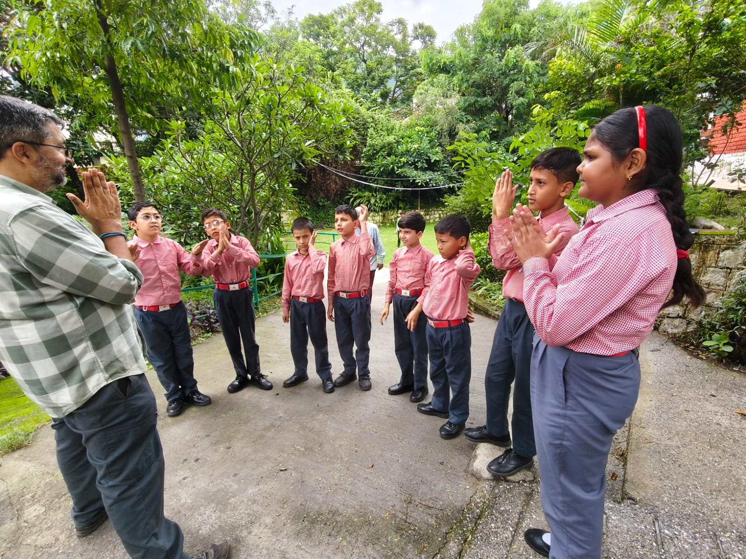

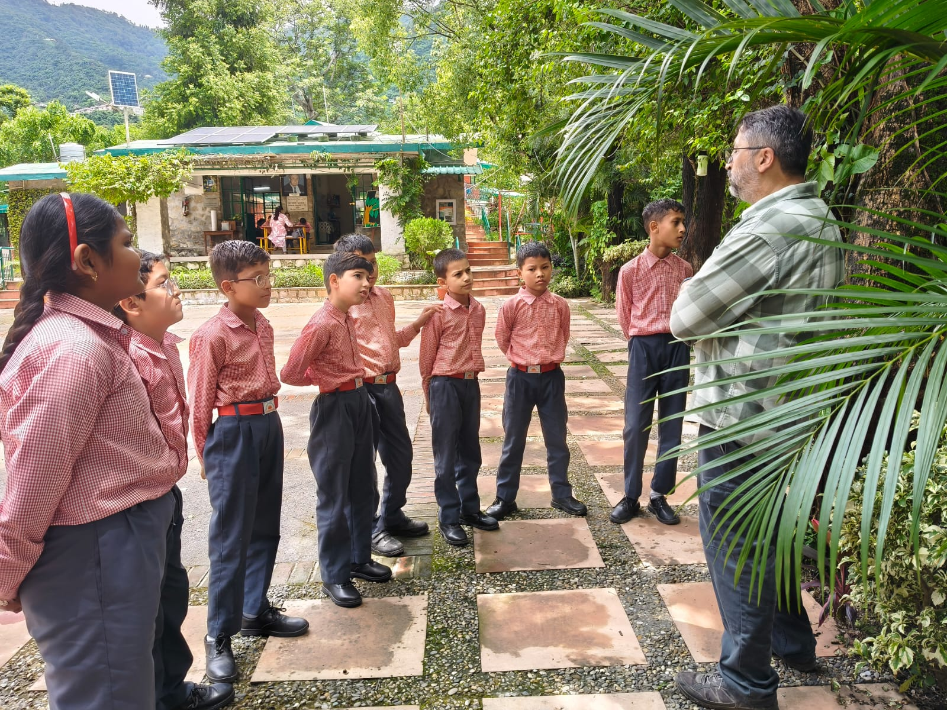

New addition

We are pleased to inform that a Force Jeep has been added to our school transport fleet.
This addition has enabled us to expand our conveyance facility and provide safe and reliable transport to more children.
We sincerely thank Mrs. Ramni Nirula and our Fundraising Team for their continued support and commitment to the welfare of our students.
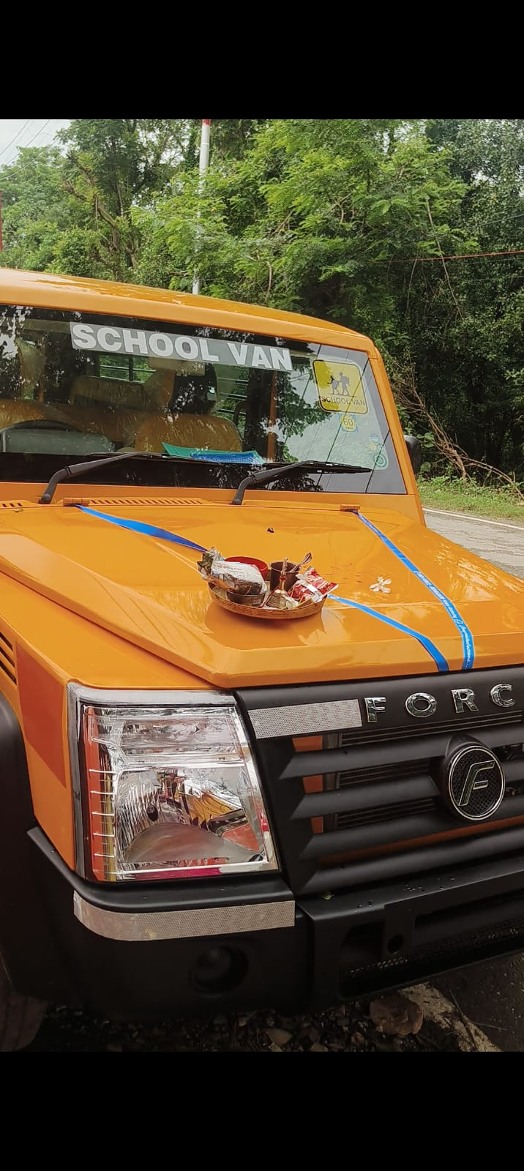

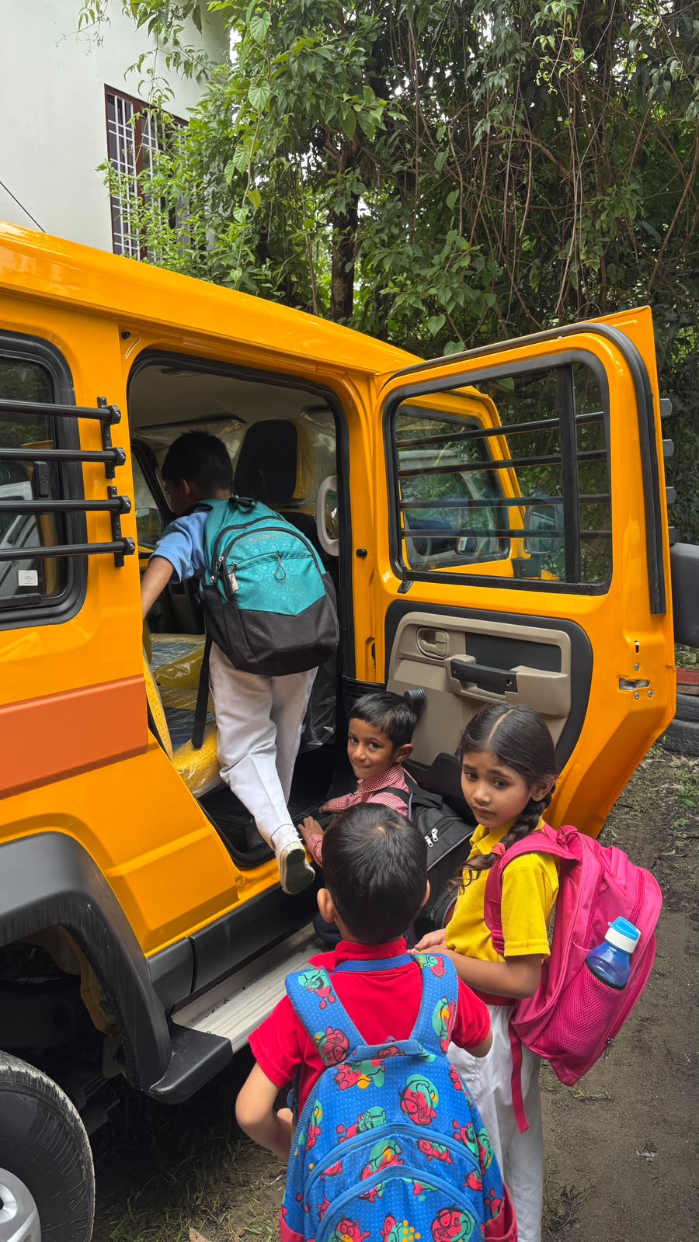

Visit to the DOON SCHOOL

It was a privilege to meet Mr. Jagpreet Singh, Headmaster, The Doon School. He was extremely welcoming and encouraging, and assured us of greater engagement from Doon students with JMMS through their Community Service program. We sincerely look forward to their visit.
I also had the honor of meeting Ms. Monika Arora Principal, Him Jyoti School. She graciously extended her full support and affirmed her commitment to collaborate with us.

Our Special guest to the campus
Zara seth
Music Session by Ms. Zara Seth
We were delighted to host Ms. Zara Seth, granddaughter of Mr. Aftab Seth, who conducted engaging music sessions for students of Classes 3, 4 and 5.
The children thoroughly enjoyed the energy and enthusiasm of the young instructor. They participated wholeheartedly in the fun activities and dance steps taught by her. The session was interactive, joyful, and provided a wonderful platform for creative expression.
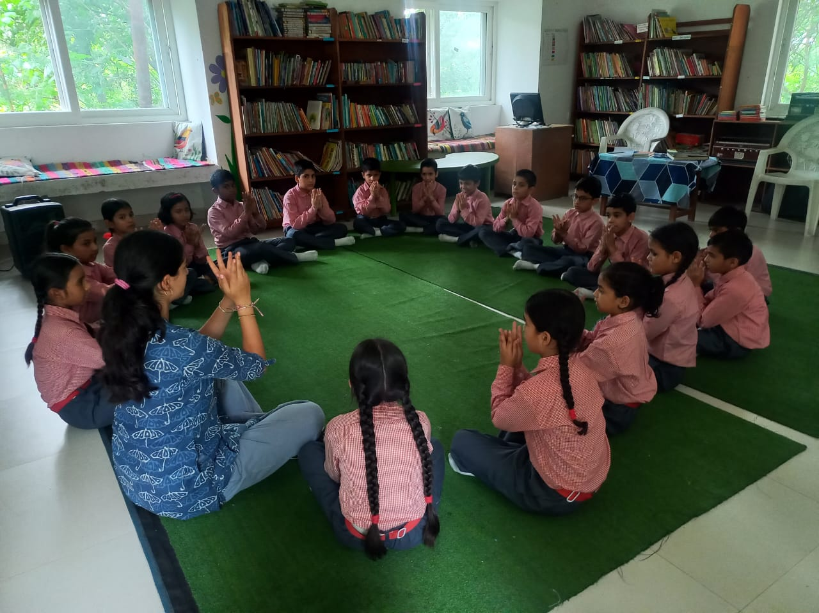

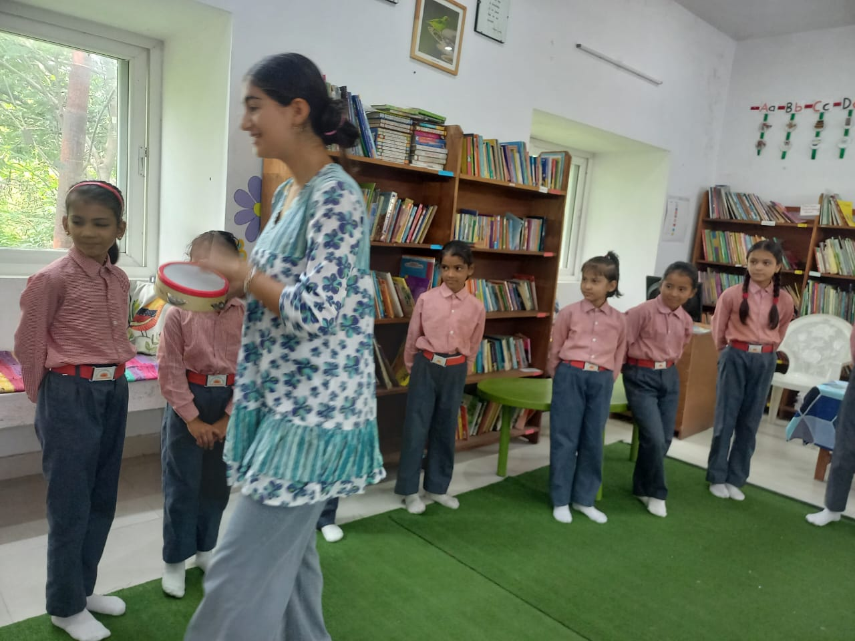

Our Testimonials and feedback
By Ms. Zara Seth
Being a 15-year-old from New York City, the experience of getting to work at the John Martyn School was extremely special. Although my stay was short, I learned and saw many meaningful things that I plan to take back with me to America. Getting to work with kids ranging from 6 to 11 years old was a bit intimidating at first, but the principal and teachers at JMMS made me feel extremely welcome and at home. I felt the students and teachers appreciation and excitement at all times.
One of the most meaningful parts of my experience was getting to interact with the students and see their enthusiasm for learning. I came to JMMS hoping to make a small contribution, but quickly realized that the students were teaching me just as much as I was teaching them. Their curiosity, energy, and warmth made my time there incredibly memorable.
I am so grateful for the opportunity to have been a part of the JMMS community, even for a short time. I hope to carry the lessons and memories I made there with me back to New York, and I hope this is only the beginning of my relationship with the John Martyn School.
By Ashna
Over the past few sessions, it has been a wonderful experience interacting with the students. We are currently reading The Panda Puzzle and have reached Chapter 4. The students have been enthusiastic, actively participating in discussions, asking thoughtful questions, and sharing their ideas throughout the sessions. I am really pleased to see that they are usually completing their homework and coming prepared into sessions which shows their interest and commitment! Overall, it has been a very positive experience, and I look forward to continuing our reading journey together!

By the bank manager of Punjab national bank viabhav kishore singh
The Bank Manager, Mr. Vaibhav Kishore Singh, shared very positive feedback.
He was impressed by the children’s curiosity and noted, “They are very intelligent and asked insightful questions about finance and shares.”
He was pleasantly surprised by their awareness and confidence.
Such visits help children understand real-world concepts beyond the classroom.

Overall Note

July has been an engaging and fruitful month for JMMS.
From enriching learning experiences and community partnerships to the expansion of our transport facility, the month reflects the collective support that continues to strengthen our commitment to the holistic growth and welfare of our students.

