Dear Trustees,
It gives me pleasure to share the key highlights and initiatives undertaken at JMMS during the month of May 2026. The month was marked by new beginnings, experiential learning, and strong community engagement.
1. Launch of DEAR Project – 4th May 2026
Drop Everything and Read (DEAR) program was launched on 4th May to inculcate reading habits among students. A dedicated time slot has been set aside daily for silent reading. Children have responded with great enthusiasm, sometimes bringing books from home also and using the school library more actively. This initiative is already building vocabulary, focus, and a genuine love for books.
2. Super Mom Contest – 7th May 2026
In collaboration with JK Papers, the school organized a Super Mom Contest on 7th May. Children participated with zeal in fun activities and showcased their talents. They wrote letters to their mom and draw pictures of their mom as super mom. All the material needed for this contest was provided by JK Papers.
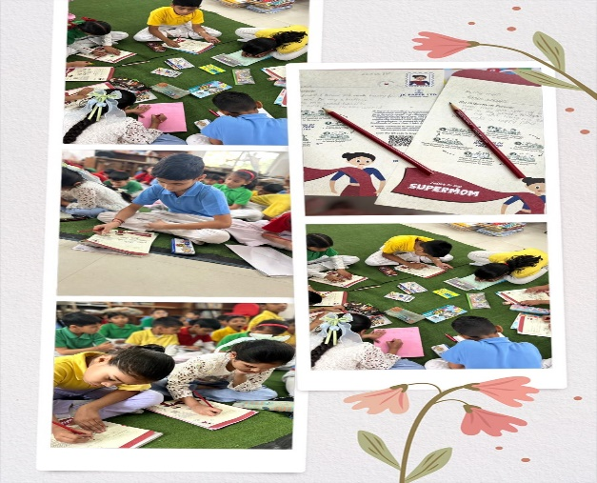 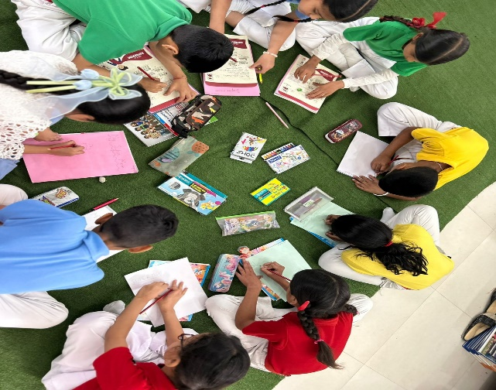
3. Mother’s Day Celebration – 9th May 2026
For the first time in JMMS history, Mother’s Day was celebrated in school on 9th May. Children prepared a small cultural program of songs, poems, and dances dedicated to their mothers. They also made handmade cards as tokens of love. Games and refreshments were arranged for all mothers. The gesture left many mothers teary-eyed and overwhelmed. Several mothers wrote heartfelt testimonials expressing gratitude for making them feel so special. The school campus witnessed an emotional and memorable afternoon.
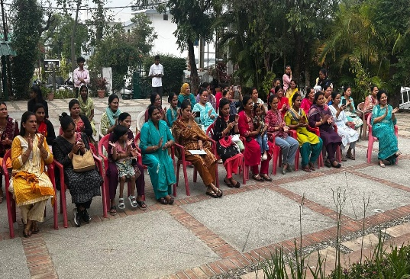 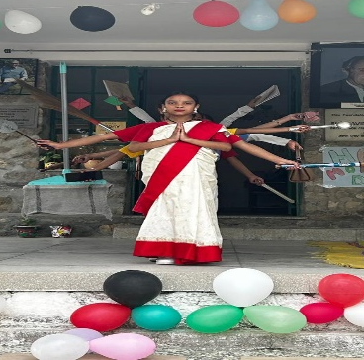 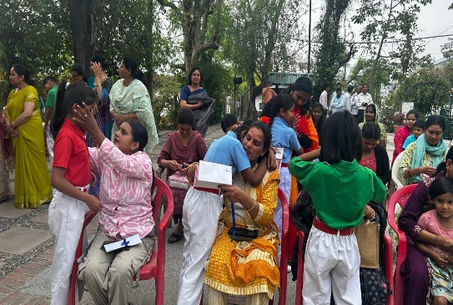

4. Educational Excursion to Rashtrapati Niketan – 9th & 11th May 2026
Classes 3 and 4 were taken to Rashtrapati Niketan on 11th and 13th May respectively for an educational excursion. The visit exposed children to heritage, nature, and architecture. It enhanced their observation skills, encouraged communication with peers and guides, and provided real-world learning beyond textbooks. Students returned with enriched knowledge and excitement to share their experiences.
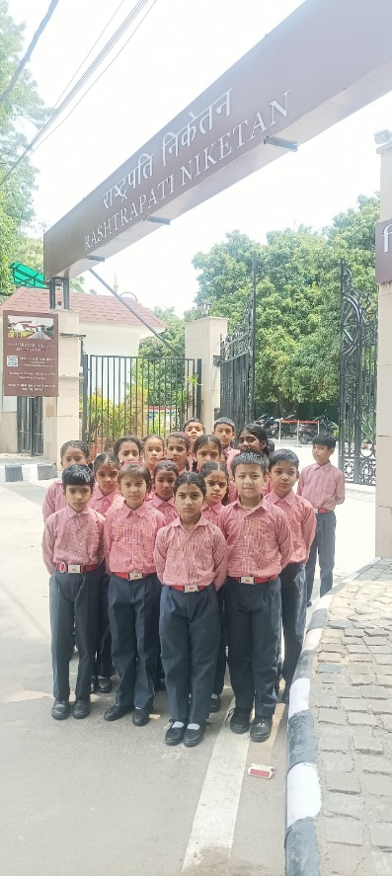
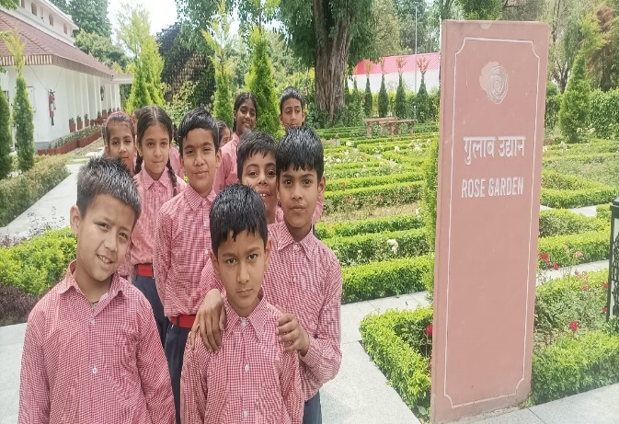

5. Kickstart of Crochet & Skill Training – 11th May 2026
A new skill training initiative was launched on 11th May under the guidance of Ms. Shashi Bagga. Both boys and girls began learning crochet work. Loom work was revived and sessions on macrame and simple stitching have also started. This is a step towards equipping students with vocational skills, creativity, and patience, aligning with NEP’s emphasis on hands-on learning.
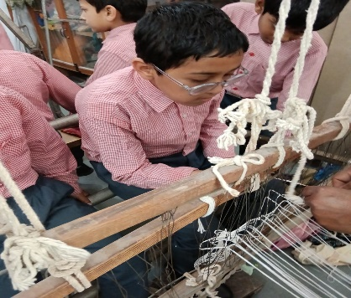 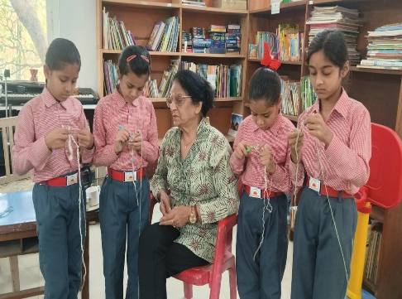 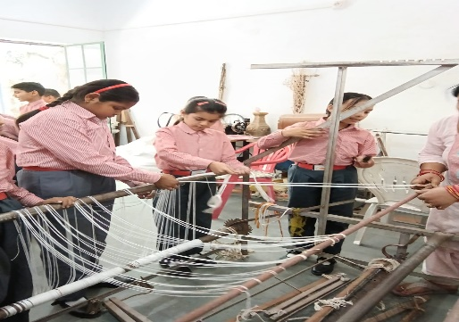

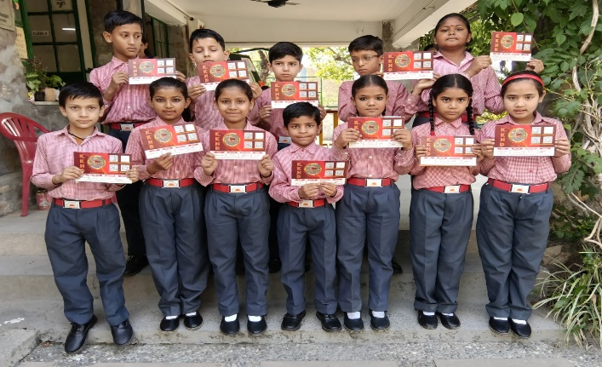
6. Participation in TV Talent Show ‘KKHD’ – 13th May 2026
Students from Classes 3, 4, and 5 participated in the TV talent show _Kisme Kitna Hai Dum_ (KKHD) on 13th May. Children competed in various categories like GK, dance, painting, spell bee, singing and handwriting. The platform gave them excellent exposure, built stage confidence, and helped them showcase their talents beyond school.

7. Online Reading Session with Good School Alliance – 17th May 2026
Our students participated in their first online reading session with the Good School Alliance on 17th May. They interacted with eminent educators like Ms. Brinda Ghosh, Mr. Jugjeev Singh, and Ms. Manisha Khanna. Children shared their reading experiences and narrated stories. The session, an outcome of our DEAR Project, helped them learn new words and boosted their confidence and curiosity.
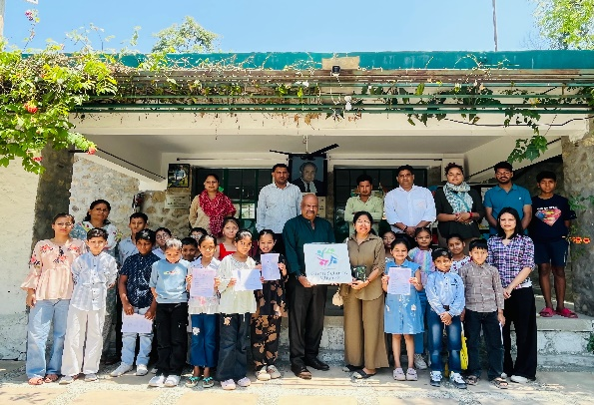 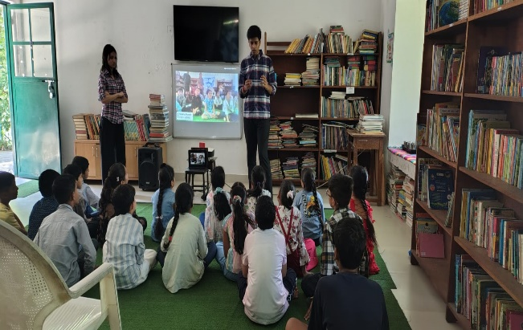

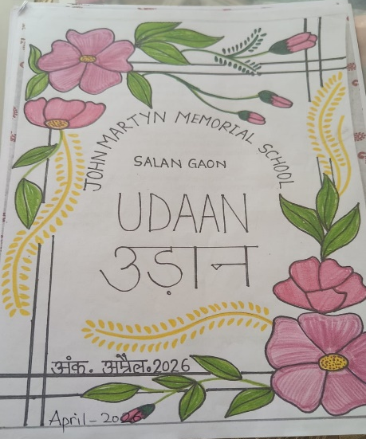
8. Launch of School Newsletter ‘Udaan’ – May 2026
We are proud to share that JMMS launched its first student-led newsletter Udaan this month. . The April issue was released in May, featuring original, unedited articles by children to reflect their authentic voice and progress. The May issue is currently in progress. This initiative aims to sharpen writing skills, nurture leadership, and encourage self-reflection. We plan to improve design and content with each issue and move towards professional printing soon.
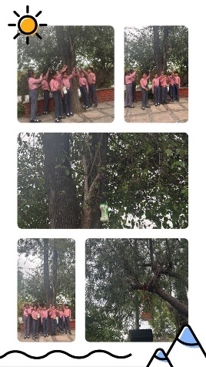
9.To nurture environmental consciousness and the value of reduce, reuse, recycle, our students crafted bird feeders using waste materials like plastic bottles, coconut shells, and cartons. These handmade feeders were then placed on trees across the school campus. The activity not only sensitized children towards birds and biodiversity but also gave them hands-on experience in upcycling. Students now take turns refilling them with grains and water, making it a daily act of care. This small step reflects our commitment to building green habits and empathy for all living beings among our students.

10. On 22nd April, three students from our school participated in the Himalayan Sustainability Program held at the Forest Research Institute (FRI). They created awareness about sustainable practices and displayed innovative products made from waste materials. We are proud to share that Agrim Verma of Class 4 was felicitated as the 1st Runner-up by the Hon’ble Forest Minister.
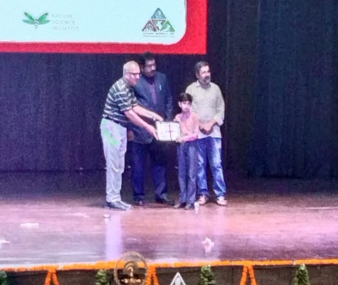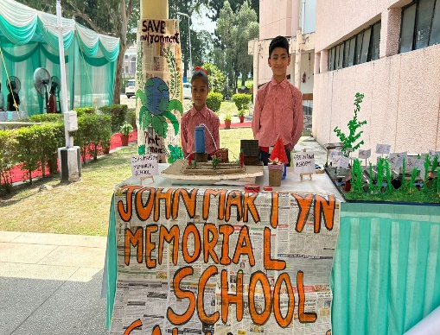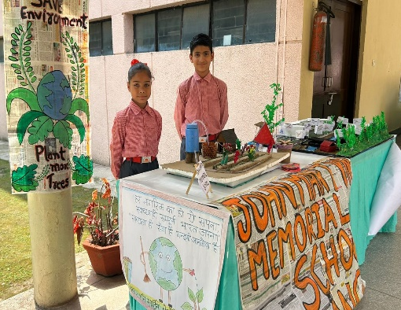

May was a month of many ‘firsts’ for JMMS. From launching reading and writing platforms to celebrating mothers, gaining media exposure, and introducing skill training, our focus remains on holistic development. We look forward to your continued guidance and support.
While the school remains closed for summer vacations, we have initiated a Summer Camp from 1st June to 30th June, conducted each morning for two hours.
The objective is to ensure continued engagement and skill development for interested students. Activities include Table Tennis, Computer Skills, Candle Making, and Loom Work, under the supervision of designated teachers. This provides a constructive alternative to excessive screen time and promotes hands-on learning.
Additionally, the school library will remain accessible to students throughout the vacation period, reinforcing our belief that learning should be continuous.

