JOHN MARTYN MEMORIAL SCHOOL
School Activities Report — September 2026

Staff Day
Date: 2 September 2026
Staff Day was celebrated to make the children aware of, and to acknowledge, the valuable services provided by the school's helping staff.
The staff members were honoured in the morning assembly and were given small tokens of appreciation as a gesture of gratitude. The children also made beautiful 'Thank You' cards for them.
This was the school's humble effort to sensitise the children towards the dignity of labour and the contribution of the helping staff, while also keeping the staff motivated and making them feel valued and respected.
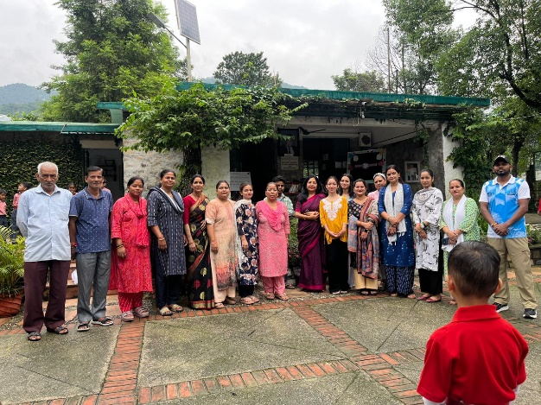
Photo: Staff Day

Janmashtami Celebration
Date: 4 September 2026
Janmashtami was celebrated with great joy and devotion in the school.
The children of the Playgroup presented a small and delightful cultural programme on the life of Lord Krishna. Dressed as Radha and Krishna, they brought the festive spirit alive with their innocent performances.
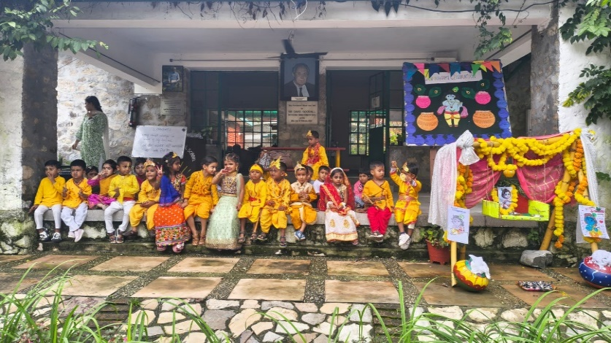
Photo: Janmashtami Celebration

Musical Performance by Students of The Doon School
Date: 5 September 2026
Ten boys from The Doon School visited the school and gave a wonderful musical performance for the children.
Students of Classes 3, 4 and 5 enjoyed the performance immensely. The Doon boys played the Casio, drums and guitar with great skill, and the children participated with great enthusiasm.
As the school's own children are learning Tabla and Harmonium, they were especially fascinated by the guitar performance. The interaction was highly motivating and inspiring for them.
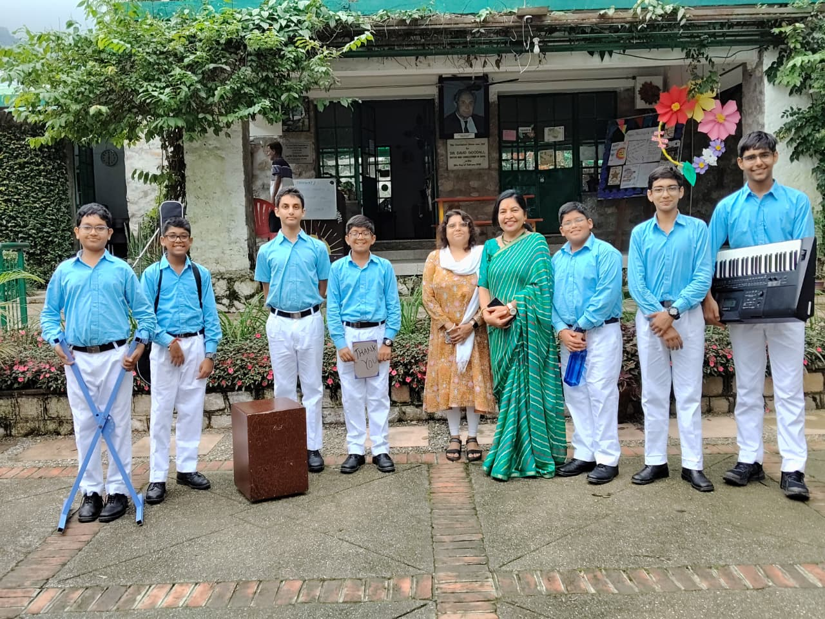
Photo: Musical Performance by Students of The Doon School

Teachers' Day
Date: 5 September 2026
Teachers' Day was celebrated in the school to honour the dedication, hard work and guidance of our teachers.
The day was observed with respect and gratitude towards the teachers for their valuable role in shaping the lives of the children.
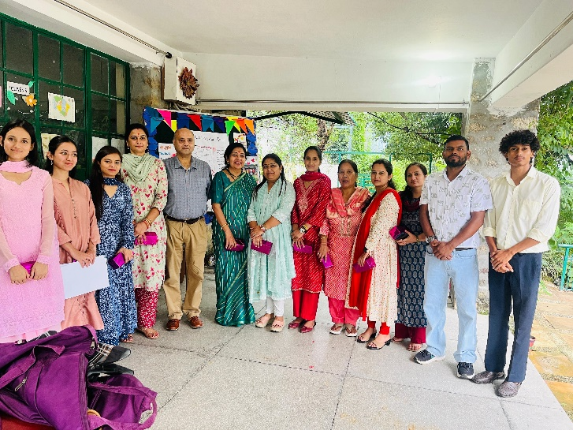
Photo: Teachers' Day

Professional Development Session: “How to Read a Book”
Date: 8 September 2026
A Professional Development (PD) session on “How to Read a Book” was conducted by Mohammad Istemdad Ali at The Doon School. Two teachers from John Martyn Memorial School, Ruchi Bhandari and Madhuri Kothal, attended the workshop.
The session focused on effective reading techniques, different types of reading, and ways to improve comprehension and knowledge through purposeful reading. It was informative and interactive, encouraging participants to develop better reading habits.
At the conclusion of the session, Dr. Jagpreet Singh, Headmaster of The Doon School, presented certificates to the participants in recognition of their participation. Overall, the session was enriching and motivating, encouraging everyone to make reading a meaningful part of their learning journey.
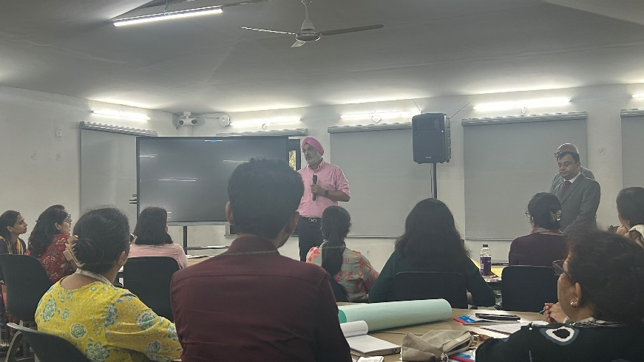
Photo: Professional Development Session: “How to Read a Book”

Visit by Delegation from Sunbeam School, Mau
Date: 10 September 2026
A delegation of four teachers, along with the Vice Principal from Sunbeam School, Mau, Uttar Pradesh, visited John Martyn Memorial School.
The team interacted with the students of Classes 4 and 5 and observed the overall functioning of the school. They were highly impressed with the school model, particularly the manner in which the campus is kept clean with the active participation of the children, and the high level of discipline maintained by the students.
The visiting team appreciated the school's approach and remarked that this sense of responsibility and discipline is something they miss in their own school environment. The visit was encouraging and a proud moment for the school.
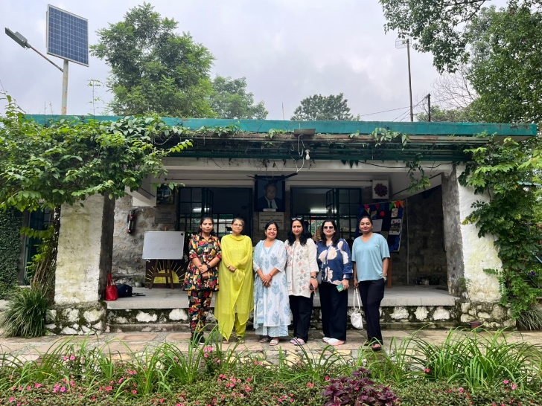
Photo: Visit by Delegation from Sunbeam School, Mau

Online HSC Conference on Waste Management
Date: 12 September 2026
Namrata and Arbaaz of Class V attended an online HSC Conference on Waste Management conducted by Ms. Soumya. Twenty schools participated in the conference.
The students completed all three rounds, which addressed plastic waste, paper waste management, and wet and e-waste disposal. They also shared the steps taken in the school to reduce, reuse and recycle waste.
The session helped them understand the importance of proper waste management and motivated them to spread awareness on environmental protection in the school.
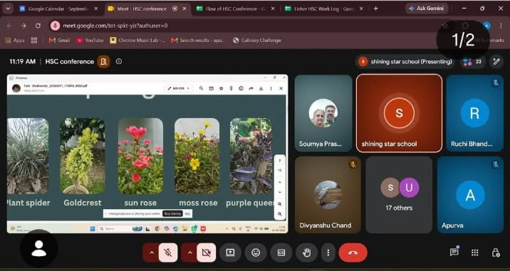
Photo: Online HSC Conference on Waste Management

Workshop on Women's Health & Hygiene
Date: September 2026 (exact date not specified)
The school believes that to educate its children about cleanliness, it is equally important to educate their mothers.
A session was conducted by Ms. Apoorva and Ms. Gatha from the Aadyan Nature Science Initiative (NSI) Group for the mothers of the students on the use of silicone menstrual cups — a safe, economical and eco-friendly alternative to sanitary napkins.
The session was well received and marks a small step towards better health, hygiene, and reduced sanitary waste in the village community.
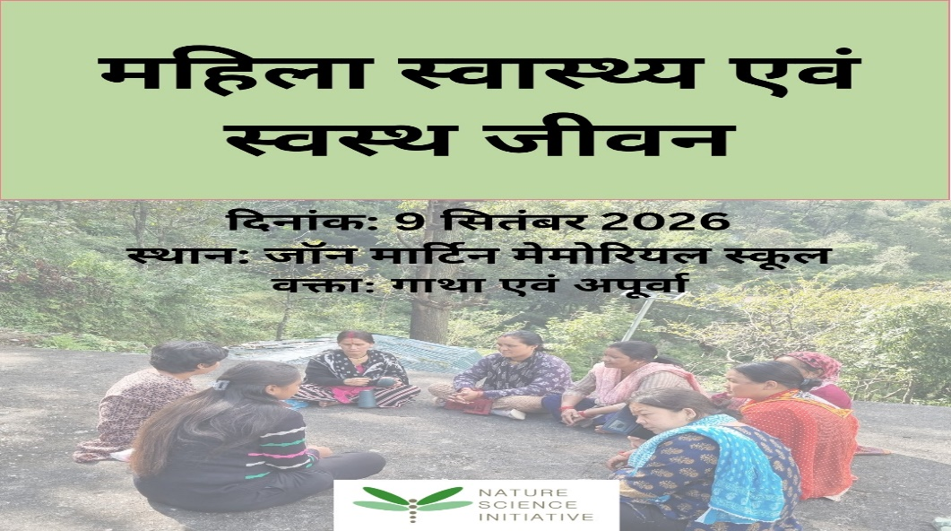
Photo: Workshop on Women's Health & Hygiene

Hope for Animals — Beyond Rescue
Date: September 2026 (exact date not specified)
Manish, Himanshu and their team visited the school to sensitise the children towards animals. They brought puppies, a kitten and a squirrel, and performed small skits to make children aware of cruelty to animals and the importance of kindness towards all living beings.
The children enjoyed interacting with the animals and learned a valuable lesson in compassion.
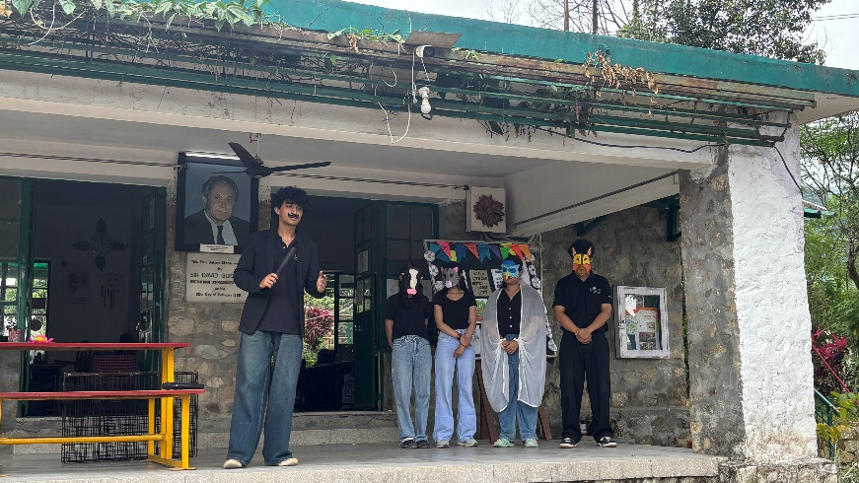
Photo: Hope for Animals — Beyond Rescue

Safety Awareness Programme by Indian Oil
Date: Date not specified
Indian Oil Gas Corporation conducted a safety awareness programme for the children and staff of the school.
The participants were briefed on safety precautions for using gas, preventive measures to be taken, and the actions to be taken in case of an emergency.
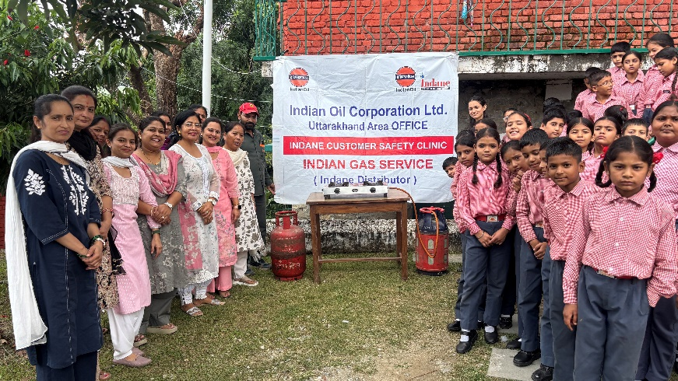
Photo: Safety Awareness Programme by Indian Oil

