**Prerequisite Installation**

1. Python (latest Version)
2. Selenium
3. Eclipse

**Project Setup and Eclipse Installation**

1. Download the “eclipse” file from <https://www.eclipse.org/downloads/>
2. Create the folder Eclipse inside the users or apps: “C:\Users\Eclipse”
3. Create the folder eclipse-workspace in the Eclipse root folder: “C:\Users\Eclipse\ eclipse-workspace”
4. Launch the “eclipse.exe”

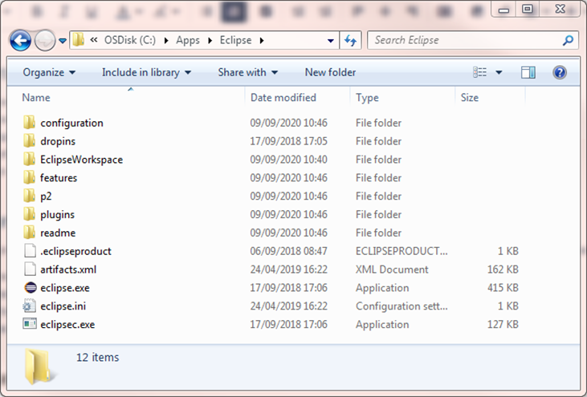

1. After Launch, In Workspace, check the “Use this as the default..” checkbox and click the Launch button.

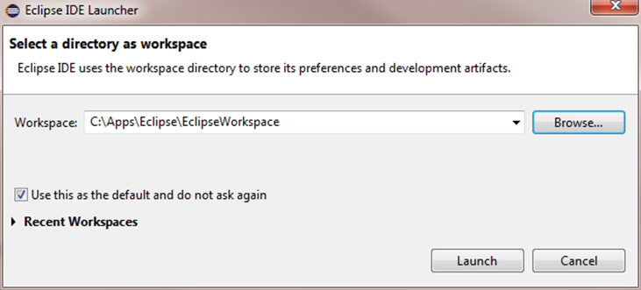

1. The eclipse home page will open.
2. Create a new project using a wizard File > New > Project
3. Select PyDev > PyDev Project, then press “Next”. (If we cannot see PyDev, so need to install the Eclipse plugin)

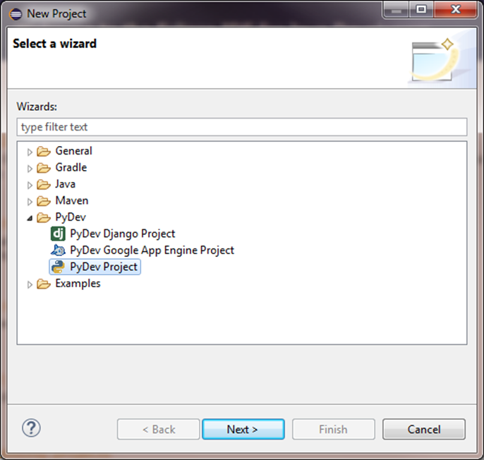

1. To confirm Add as project name “HelloWorld”. This will be stored in

“C:\Users\Eclipse\ eclipse-workspace\HelloWorld”

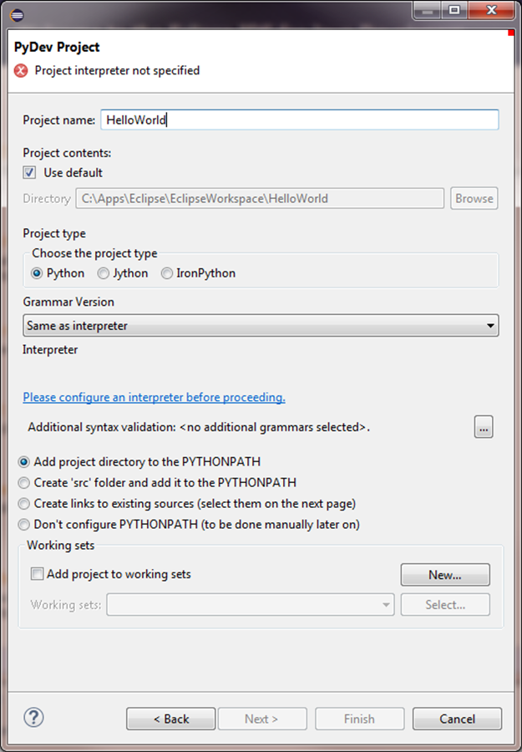

1. Click on the hyperlink “Please configure an interpreter…”
2. Select the option “Manual config”

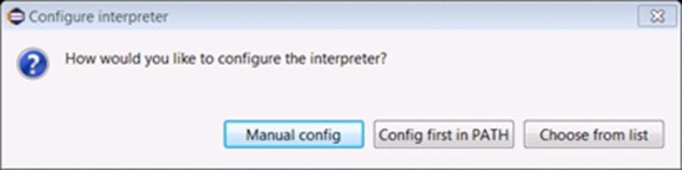

1. Select the option “browse for python/pypy.exe”

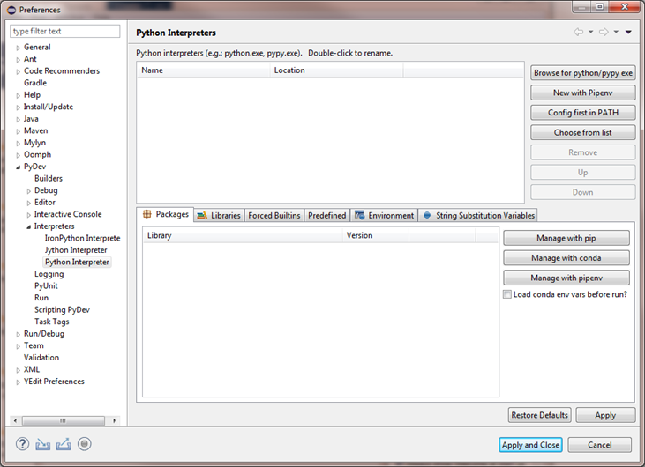

1. Navigate to the Python installation folder and select the “python.exe” file, then click “Open”.

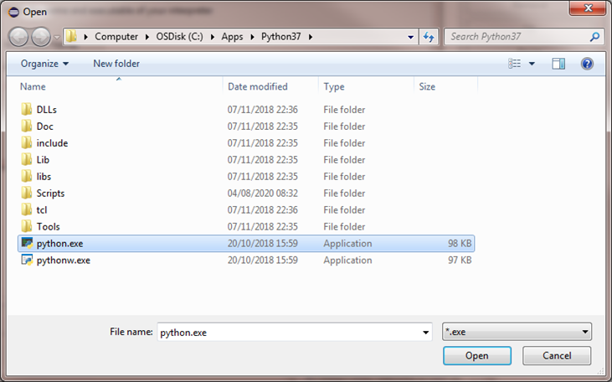

1. Interpreter Name and Executable are loaded. Click “OK”

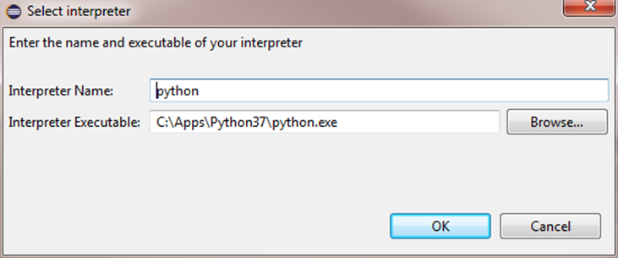

1. Ensure all folders in the list are selected, then click “OK”.

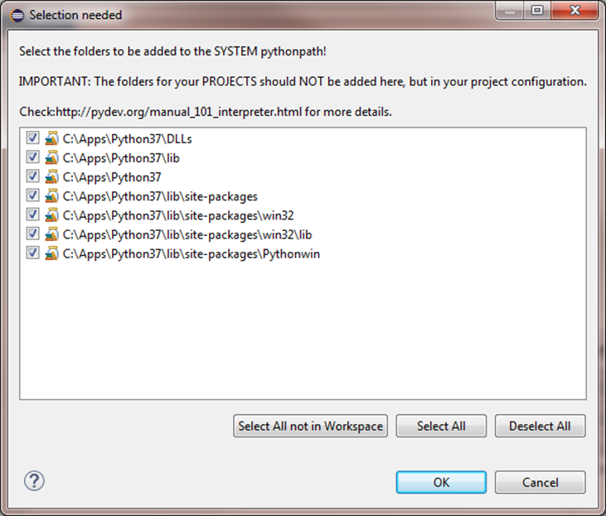

1. Click on “Apply and Close”.

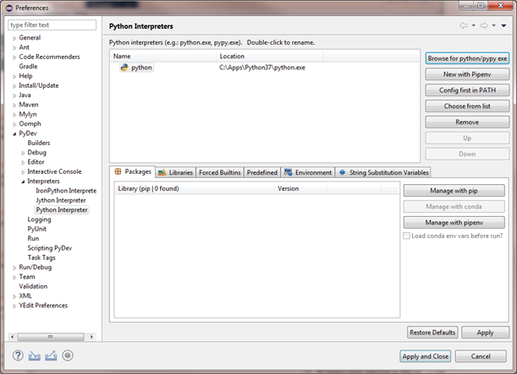

1. After the python interpreter has been configured, select “Finish”

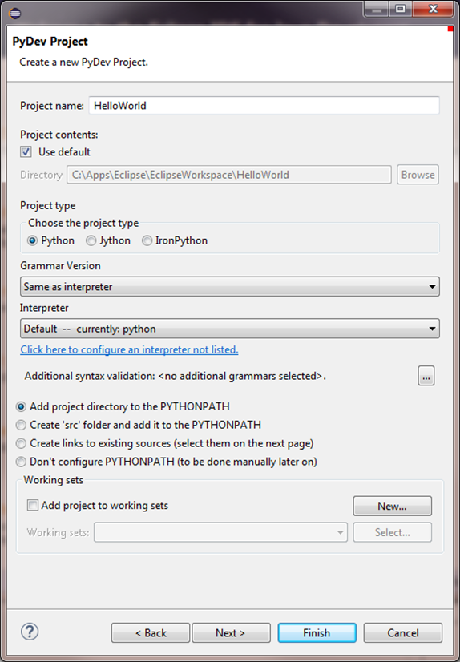

1. Select “Open Perspective” in the next dialogue box.

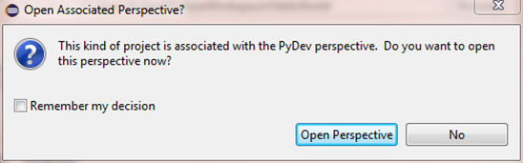

1. Deselect “Always show Welcome at start up” option int the bottom right corner (1), then close the Welcome Window (2)
2. Configure the following viewing preferences

Window > Appearance > Show Toolbar

Window > Show View > Console

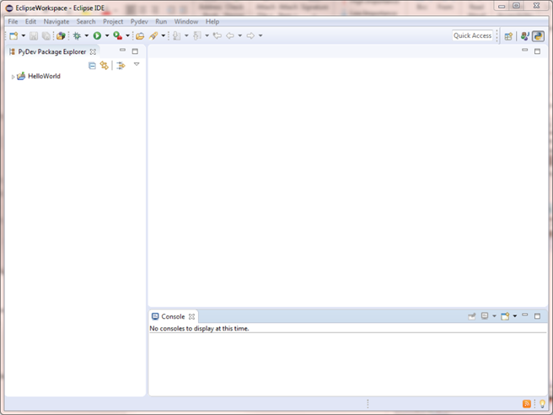

1. In the PyDev Package Explorer area, right click on the “HelloWorld” project and select “New>File”, name it “MyFirstScript.py”

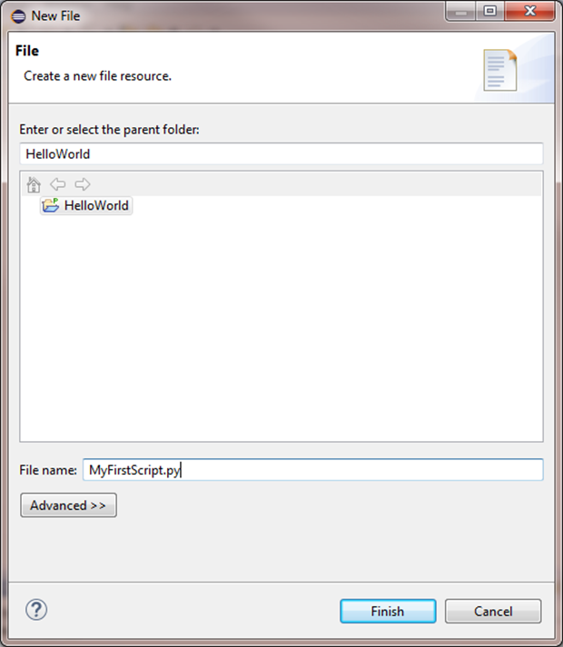

1. Select the “Finish” Button.
2. Accept the Default Eclipse preferences

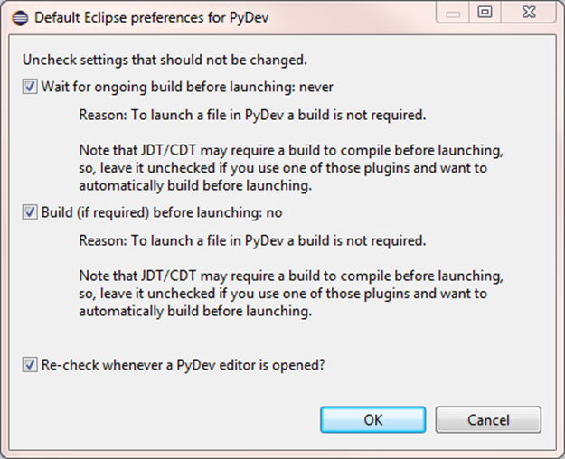

1. Type the following command in the area seen below: print(“Hello World”)

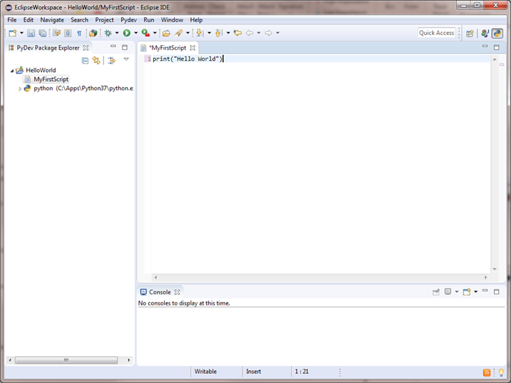

1. Select Run in the top Toolbar, then select “Run As” then select “Python Run”

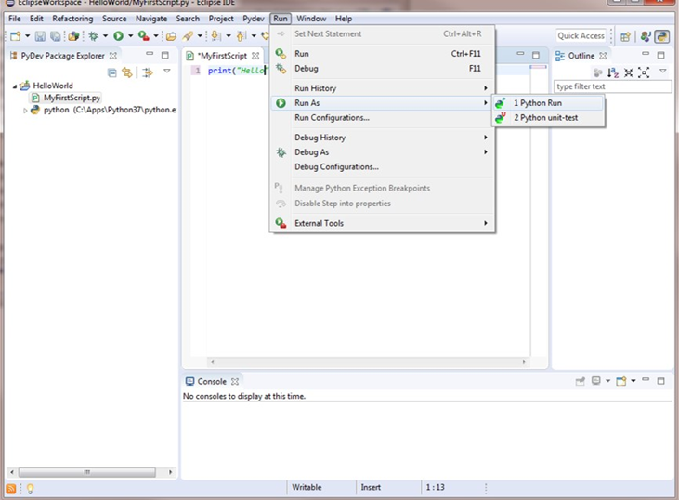

1. Check the bottom box “Always save…” then press “OK”

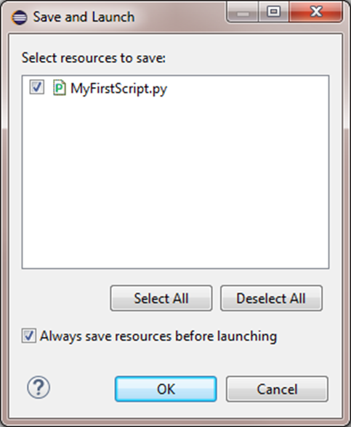

1. In the console area now “Hello World” is printed

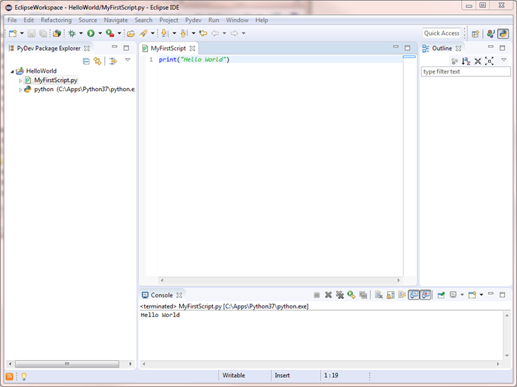

1. Done setting up Eclipse and Python !