AFLL ASSIGNMENT

TEAM :
HARSHIT CHANDAK (PES2UG24CS185)
NIKITHA V (PES2UG25CS816)

LANGUAGE : RUST

CONSTRUCTS:
1) ARITHMETIC EXPRESSION

2) SIMPLE ASSIGNMENT STATEMENTS

3) IF-ELSE CONDITIONAL STATEMENTS

4) FUNCTION CALL

5) MATCH EXPRESSION

- ARITHMETIC EXPRESSION
1)lexer.py

import ply.lex as lex

tokens = (
'NUMBER',
'ID',
'PLUS', 'MINUS', 'TIMES', 'DIVIDE',
'ASSIGN',
'SEMICOLON',
'LPAREN', 'RPAREN',
'LET',
)

t_PLUS = r'\+'
t_MINUS = r'-'
t_TIMES = r'\*'
t_DIVIDE = r'/'
t_ASSIGN = r'='

t_SEMICOLON = r';'
t_LPAREN = r'\('
t_RPAREN = r'\)'

reserved = {
'let': 'LET',
}

def t_ID(t):
r'[a-zA-Z_][a-zA-Z0-9_]*'
t.type = reserved.get(t.value, 'ID')
return t

def t_NUMBER(t):
r'\d+'
t.value = int(t.value)
return t

t_ignore = ' \t'

def t_newline(t):
r'\n+'
t.lexer.lineno += len(t.value)

def t_error(t):
print(f"Illegal character '{t.value[0]}'")
t.lexer.skip(1)

lexer = lex.lex()

2)parser.py
import ply.yacc as yacc
from lexer import tokens

variables = {}
start = 'statement'

def p_statements_multiple(p):
'statements : statements statement'
p[0] = None

def p_statements_single(p):
'statements : statement'
p[0] = None

def p_statement_assign(p):
'statement : ID ASSIGN expression SEMICOLON'
variables[p[1]] = p[3]
p[0] = p[3]

def p_statement_let_assign(p):
'statement : LET ID ASSIGN expression SEMICOLON'
variables[p[2]] = p[4]
p[0] = p[4]

def p_expression_binop(p):
'''
expression : expression PLUS term
| expression MINUS term
'''
if p[2] == '+':
p[0] = p[1] + p[3]
else:
p[0] = p[1] - p[3]

def p_expression_term(p):
'expression : term'
p[0] = p[1]

def p_term_binop(p):
'''
term : term TIMES factor
| term DIVIDE factor
'''
if p[2] == '*':
p[0] = p[1] * p[3]
else:
if p[3] == 0:
print("Error: Division by zero!")
p[0] = 0
else:
p[0] = p[1] / p[3]

def p_term_factor(p):
'term : factor'
p[0] = p[1]

def p_factor_num(p):
'factor : NUMBER'
p[0] = p[1]

def p_factor_id(p):
'factor : ID'
try:
p[0] = variables[p[1]]
except KeyError:
print(f"Error: Variable '{p[1]}' not defined")
p[0] = 0

def p_factor_expr(p):
'factor : LPAREN expression RPAREN'
p[0] = p[2]

def p_error(p):
if p:
print(f"Syntax error at '{p.value}'")
else:
print("Syntax error at EOF")

parser = yacc.yacc()

3)main.py
from lexer import lexer
from parser import parser

if __name__ == "__main__":
print("Rust-style Arithmetic Evaluator")
print("Type 'exit;' to quit.\n")

while True:
data = input(">>> ")
if data.strip().lower() == "exit;":
print("Exiting...")
break
if not data.strip():
continue

lexer.input(data)
try:
result = parser.parse(data)
if result is not None:
print("Result:", result)
else:
print("Parsed successfully (No direct Result)")
except Exception as e:
print("Error:", e)

Working:
- Lexical Analysis (Lexer):
The lexer scans the input and breaks it into tokens such as identifiers (ID), numbers (NUMBER), operators (+, -, *, /), assignment (=), parentheses, and keywords like let.
It also handles whitespace, newlines, and invalid characters gracefully.
- Syntax Parsing (Parser):
The parser defines grammar rules to interpret valid Rust-like statements such as:
  - Variable declarations → let x = 10;
  - Assignments → x = 20;
  - Arithmetic expressions → (x + 5) * 2;
It constructs a parse tree and evaluates expressions according to operator precedence (i.e., * and / before + and -).
- Variable Handling:
Variables are stored in a dictionary (variables) to support usage and reassignment across statements.
- Error Handling:
The program includes clear error messages for undefined variables, syntax errors, and division by zero.
Features:
- Supports arithmetic operations: +, -, *, /
- Supports variable declaration with let
- Handles parentheses for grouping
- Provides real-time evaluation in an interactive shell
- Detects syntax and runtime errors

OUTPUT :
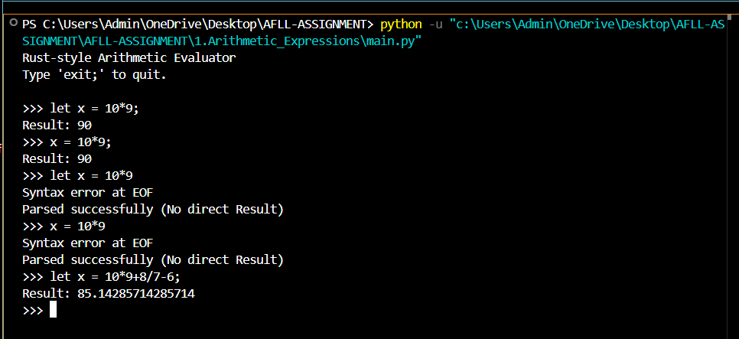

NEXT PAGE PLEASE
P.T.O

2)SIMPLE ASSIGNMENT STATEMENTS

1)lexer.py
import ply.lex as lex

tokens = (
'ID',
'NUMBER',
'ASSIGN',
'SEMICOLON',
'LET',
)

t_ASSIGN = r'='
t_SEMICOLON = r';'

reserved = {
'let': 'LET',
}

def t_ID(t):
r'[a-zA-Z_][a-zA-Z0-9_]*'
t.type = reserved.get(t.value, 'ID')
return t

def t_NUMBER(t):
r'\d+'
t.value = int(t.value)
return t

t_ignore = ' \t'

def t_newline(t):
r'\n+'
t.lexer.lineno += len(t.value)

def t_error(t):
print(f"Illegal character '{t.value[0]}'")
t.lexer.skip(1)

lexer = lex.lex()

- Parser.py
- import ply.yacc as yacc
- from lexer import tokens

- variables = {}
- start = 'statement'

- def p_statements_multiple(p):
- 'statements : statements statement'
- p[0] = None

- def p_statements_single(p):
- 'statements : statement'
- p[0] = None

- def p_statement_assign(p):
- 'statement : ID ASSIGN NUMBER SEMICOLON'
- variables[p[1]] = p[3]
- p[0] = p[3]

- def p_statement_let_assign(p):
- 'statement : LET ID ASSIGN NUMBER SEMICOLON'
- variables[p[2]] = p[4]
- p[0] = p[4]

- def p_error(p):
- if p:
- print(f"Syntax error at '{p.value}'")
- else:
- print("Syntax error at EOF")

- parser = yacc.yacc()

3)main.py
from lexer import lexer
from parser import parser

if __name__ == "__main__":
print("Rust-style Simple Assignment Evaluator")
print("Type 'exit;' to quit.\n")

while True:
data = input(">>> ")
if data.strip().lower() == "exit;":
print("Exiting...")
break
if not data.strip():
continue

lexer.input(data)
try:
result = parser.parse(data)
if result is not None:
print("Accepted:", result)
else:
print("Parsed successfully (No direct Result)")

except Exception as e:
print("Error:", e)

Working:
- Lexer (Lexical Analyzer):
The lexer scans the input and converts it into a stream of tokens such as:
  - Identifiers (ID)
  - Numbers (NUMBER)
  - Assignment operator (=)
  - Semicolon (;)
  - Keyword (let)
It also ignores whitespaces and handles invalid characters by displaying an error message.
- Parser (Syntax Analyzer):
The parser checks the syntax of input statements according to defined grammar rules.
It supports two types of statements:
  - Variable declaration: let x = 10;
  - Variable assignment: x = 20;
All declared variables are stored in a dictionary (variables), simulating a simple memory environment.
- Execution:
The program runs in an interactive shell where users can type Rust-like assignment statements.
It parses the input and displays confirmation messages upon successful parsing.
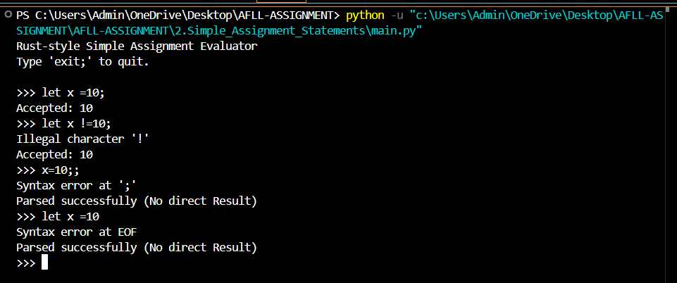
3) IF ELSE CONDITIONAL STATEMENTS
1)lexer.py

import ply.lex as lex

tokens = (
'IF', 'ELSE',
'LPAREN', 'RPAREN',
'LBRACE', 'RBRACE',
'ID', 'NUMBER',
'ASSIGN', 'SEMICOLON',
'GT', 'LT', 'GE', 'LE', 'EQ', 'NE'
)

# Keywords
reserved = {
'if': 'IF',
'else': 'ELSE',
}

# Operators
t_ASSIGN = r'='
t_GT = r'>'
t_LT = r'<'
t_GE = r'>='
t_LE = r'<='
t_EQ = r'=='
t_NE = r'!='

# Delimiters
t_LPAREN = r'\('
t_RPAREN = r'\)'
t_LBRACE = r'\{'
t_RBRACE = r'\}'
t_SEMICOLON = r';'

def t_ID(t):
r'[a-zA-Z_][a-zA-Z0-9_]*'
t.type = reserved.get(t.value, 'ID')
return t

def t_NUMBER(t):
r'\d+'
t.value = int(t.value)
return t

t_ignore = ' \t'

def t_newline(t):
r'\n+'
t.lexer.lineno += len(t.value)

def t_error(t):
print(f"Illegal character '{t.value[0]}'")
t.lexer.skip(1)

lexer = lex.lex()

2)parser.py
import ply.yacc as yacc
from lexer import tokens

# Symbol table (optional)
variables = {}

# -------------------------------
# Statements
# -------------------------------
def p_statements_multiple(p):
'statements : statements statement'
p[0] = None

def p_statements_single(p):
'statements : statement'
p[0] = None

# Assignment inside if/else blocks
def p_statement_assign(p):
'statement : ID ASSIGN NUMBER SEMICOLON'
variables[p[1]] = p[3]
p[0] = p[3]

# If-Else
def p_statement_if_else(p):
'statement : IF LPAREN condition RPAREN LBRACE statements RBRACE ELSE LBRACE statements RBRACE'
if p[3]:
p[0] = p[6]
else:
p[0] = p[10]

def p_statement_if(p):
'statement : IF LPAREN condition RPAREN LBRACE statements RBRACE'
if p[3]:
p[0] = p[6]

# -------------------------------
# Conditions (simple numeric comparisons)
# -------------------------------
def p_condition(p):
'''
condition : NUMBER GT NUMBER
| NUMBER LT NUMBER
| NUMBER GE NUMBER
| NUMBER LE NUMBER
| NUMBER EQ NUMBER
| NUMBER NE NUMBER
'''
if p[2] == '>':
p[0] = p[1] > p[3]
elif p[2] == '<':
p[0] = p[1] < p[3]
elif p[2] == '>=':
p[0] = p[1] >= p[3]
elif p[2] == '<=':
p[0] = p[1] <= p[3]
elif p[2] == '==':
p[0] = p[1] == p[3]
elif p[2] == '!=':
p[0] = p[1] != p[3]

def p_error(p):
if p:
print(f"Syntax error at '{p.value}'")
else:
print("Syntax error at EOF")

parser = yacc.yacc()

3)main.py
from lexer import lexer
from parser import parser

if __name__ == "__main__":
print("Rust-style If-Else Evaluator")
print("Type 'exit;' to quit.\n")

while True:
data = input(">>> ")
if data.strip().lower() == "exit;":
print("Exiting...")
break
if not data.strip():
continue

lexer.input(data)
try:
result = parser.parse(data)
print("Parsed successfully")
except Exception as e:
print("Error:", e)

Working:
- Lexer (Lexical Analyzer):
The lexer breaks the input into tokens such as:
  - Keywords: if, else
  - Operators: =, >, <, >=, <=, ==, !=
  - Delimiters: (), {}, ;
  - Identifiers and numbers
It ignores whitespace and identifies illegal characters gracefully.
- Parser (Syntax Analyzer):
The parser defines grammar rules to process conditional statements and assignments in a Rust-like syntax.
Supported constructs include:
  - Simple if statement:
if (5 > 3) { a = 10; }
If-else statement:
if (2 < 1) { a = 5; } else { a = 10; }
The parser evaluates the condition, executes the correct block, and updates variables accordingly.
Condition Evaluation:
Conditions involving comparison operators (>, <, >=, <=, ==, !=) are evaluated as boolean expressions, determining which block of code to execute.
Execution Environment:
The program runs interactively, allowing users to input and test multiple if-else statements. Variables are stored in a Python dictionary (variables) to simulate a symbol table.
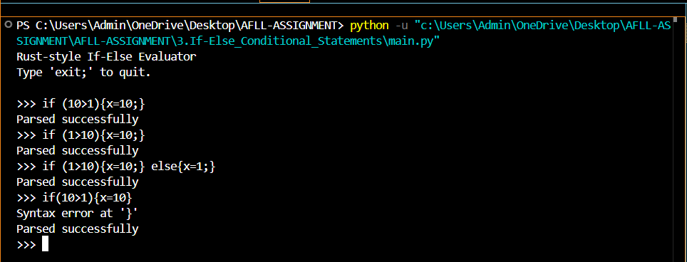

NEXT PAGE PLEASE
P.T.O

4) FUNCTION CALL
1)lexer.py
import ply.lex as lex

tokens = (
'IDENTIFIER',
'NUMBER',
'COMMA',
'LPAREN',
'RPAREN',
)

t_COMMA = r','
t_LPAREN = r'\('
t_RPAREN = r'\)'

def t_IDENTIFIER(t):
r'[a-zA-Z_][a-zA-Z0-9_]*'
return t

def t_NUMBER(t):
r'\d+'
return t

t_ignore = ' \t\n'

def t_error(t):
print(f"Illegal character '{t.value[0]}'")
t.lexer.skip(1)

lexer = lex.lex()

2)parser.py

import ply.yacc as yacc
from lexer import tokens

def p_program(p):
'''program : function_call'''
p[0]=p[1]
print("Valid function call:", p[1])

def p_function_call(p):
'''function_call : IDENTIFIER LPAREN RPAREN
| IDENTIFIER LPAREN arguments RPAREN'''
if len(p) == 4:
p[0] = ('call', p[1], [])
else:
p[0] = ('call', p[1], p[3])

def p_arguments(p):
'''arguments : arguments COMMA expression
| expression'''
if len(p) == 4:
p[0] = p[1] + [p[3]]
else:
p[0] = [p[1]]

def p_expression(p):
'''expression : IDENTIFIER
| NUMBER
| function_call'''
p[0] = p[1]

def p_error(p):
print(" Syntax error!")

parser = yacc.yacc()

3) main.py
# main.py
from parser import parser

if __name__ == "__main__":
print("Welcome to the Simple Function Call Parser.")
print("Enter a function call (e.g., 'foo(a, 10)') or type 'quit' to exit.\n")

while True:
data = input(">>> ")

if data.strip().lower() == "quit":
print("Exiting...")
break

if not data.strip():
continue

try:
result = parser.parse(data)

if result is not None:
print("AST:", result)

except Exception as e:
print(f"Internal Error: {e}")

Working:
- Lexer (Lexical Analyzer):
The lexer scans the input code and divides it into tokens such as:
  - IDENTIFIER – function names or variable names (e.g., foo, sum, a)
  - NUMBER – numeric literals (e.g., 10, 42)
  - COMMA (,) – used to separate arguments
  - Parentheses ( and ) – used to define function call boundaries
It ignores spaces, tabs, and newlines, and detects any illegal characters.
- Parser (Syntax Analyzer):
The parser defines grammar rules to recognize valid function call structures, including:
  - Function calls without arguments:
foo()
Function calls with arguments:
foo(a, 10, bar)
Each valid function call generates an Abstract Syntax Tree (AST), representing the hierarchical structure of the call.
3) Execution:
The program runs interactively, asking the user for function calls and checking their validity.
If the syntax is correct, it prints the AST (Abstract Syntax Tree) representation.

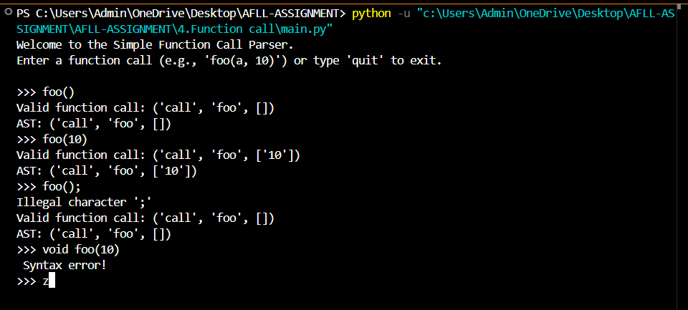

5) MATCH EXPRESSION
1)lexer.py
import ply.lex as lex

tokens = (
'MATCH',
'IDENTIFIER',
'NUMBER',
'UNDERSCORE',
'ARROW',
'LBRACE',
'RBRACE',
'LPAREN',
'RPAREN',
'COMMA'
)

t_ARROW = r'=>'
t_LBRACE = r'{'
t_RBRACE = r'}'
t_LPAREN = r'\('
t_RPAREN = r'\)'
t_COMMA = r','
t_UNDERSCORE = r'_'

keywords = {
'match': 'MATCH',
}

def t_IDENTIFIER(t):
r'[a-zA-Z_][a-zA-Z0-9_]*'
t.type = keywords.get(t.value, 'IDENTIFIER')
return t

def t_NUMBER(t):
r'\d+'
try:
t.value = int(t.value)
except ValueError:
t.value = 0
return t

t_ignore = ' \t'
def t_newline(t):
r'\n+'
t.lexer.lineno += len(t.value)

def t_error(t):
print(f"Illegal character '{t.value[0]}' at line {t.lexer.lineno}")
t.lexer.skip(1)

lexer = lex.lex()

2)parser.py
import ply.yacc as yacc
from lexer import tokens

start = 'program'

def p_program(p):
'''program : match_expression'''
p[0] = p[1]
print("\n Valid Match Expression (AST Output):")

def p_match_expression(p):
'''match_expression : MATCH expression LBRACE match_arms RBRACE'''
p[0] = ('match', p[2], p[4])

def p_match_arms(p):
'''match_arms : match_arms match_arm
| match_arm'''
if len(p) == 3:
p[0] = p[1] + [p[2]]
else:
p[0] = [p[1]]

def p_match_arm(p):
'''match_arm : pattern ARROW expression
| pattern ARROW expression COMMA'''
p[0] = (p[1], p[3])

def p_pattern(p):
'''pattern : IDENTIFIER
| UNDERSCORE
| NUMBER'''
p[0] = p[1]

def p_expression(p):
'''expression : IDENTIFIER
| NUMBER
| function_call
| match_expression'''
p[0] = p[1]

def p_function_call(p):
'''function_call : IDENTIFIER LPAREN arguments RPAREN
| IDENTIFIER LPAREN RPAREN'''
if len(p) == 5:
p[0] = ('call', p[1], p[3])
else:
p[0] = ('call', p[1], [])

def p_arguments(p):
'''arguments : arguments COMMA expression
| expression'''
if len(p) == 4:
p[0] = p[1] + [p[3]]
else:
p[0] = [p[1]]

def p_error(p):
if p:
print(f"Syntax error at token '{p.value}' (type: {p.type}, line: {p.lineno})")
else:
print("Syntax error at EOF")

parser = yacc.yacc()

3) main.py
# main.py
from parser import parser

if __name__ == "__main__":
print("Welcome to the Match Expression Parser.")
print("Type 'quit' or 'exit;' to quit.\n")

while True:
data = input(">>> ")

if data.strip().lower() in ["quit", "exit;"]:
print("Exiting...")
break

if not data.strip():
continue

try:
result = parser.parse(data)

if result is not None:
print("AST:", result)

except Exception as e:
print(f"Internal Error:{e}")

Working:
- Lexer (Lexical Analyzer):
The lexer breaks the input code into tokens such as:
  - Keywords: match
  - Symbols: {, }, (, ), ,, =>, _
  - Identifiers & Numbers: variable names and numeric literals
It skips whitespaces and reports illegal characters with line numbers.
- Parser (Syntax Analyzer):
The parser defines grammar rules that simulate Rust’s match statement behavior.
Supported syntax:
match x {
1 => foo(),
2 => bar(),
_ => baz(),
}
The main match expression evaluates a value or variable.
Each match arm has a pattern (number, identifier, or _) followed by => and an expression.
Arms are separated by commas.
3) AST Generation:
Each valid match expression is transformed into a structured AST, representing:
('match', expression, [(pattern, result_expression), ...])
4) ('match', expression, [(pattern, result_expression), ...])

