Microprocessor and Computer Architecture
UE24CS251B
4th Semester, Academic Year 2025-26
Date:
Name: Harshit Chandak | SRN:  PES2UG24CS185 | Section  C
LAB #____5_______ Program Number: ____1___
Title of the Program
Write an ARM assembly language program to compute the sum of all elements in a 3×3 matrix stored in memory.
The matrix elements are stored in row-major order as a one-dimensional array. The program should:
- Use nested loops to iterate over rows and columns.
- Compute the effective memory address of each matrix element using a separate subroutine.
- Load each matrix element from memory and accumulate the total sum in a register.
- Store or maintain the final sum in a designated register before program termination.
The program must use:
- A subroutine to calculate the address of a[i][j]
- Stack operations (STMFD, LDMFD) to preserve register values
- Multiply-Accumulate (MLA) for address computation

- Typed ARM Assembly Code
- Output Screen Shot
( Screenshot including Register Window,Output Window and Code Window)

.DATA
A: .WORD 1,2,3,4,5,6,7,8,9
SUM: .WORD 0

.TEXT

LDR R8,=A
MOV R0,#0
MOV R7,#0
MOV R3,#3
LDR R9,=SUM

ROW:
CMP R0,#3
BEQ EXIT
MOV R1,#0

COLUMN:
CMP R1,#3
BEQ NEXT_ROW
BL ADDRESS
LDR R6,[R5]
ADD R7,R7,R6
ADD R1,R1,#1
B COLUMN

NEXT_ROW:
ADD R0,R0,#1
B ROW

ADDRESS:
STMFD R13!,{R3,R4,LR}
MLA R4,R0,R3,R1
MOV R4, R4, LSL #2
ADD R5,R4,R8
LDMFD R13!,{R3,R4,LR}
MOV PC,LR

EXIT:
STR R7,[R9]
SWI 0x11
.END
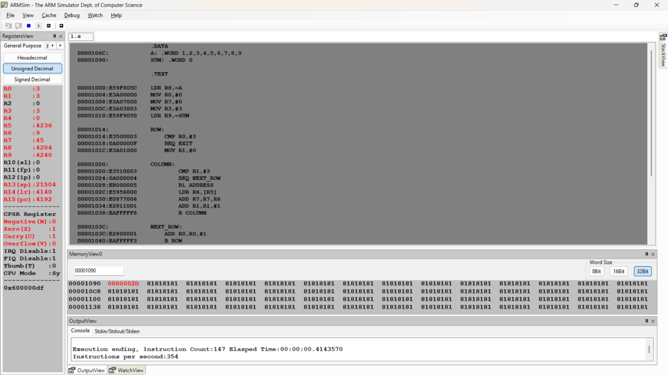

Microprocessor and Computer Architecture
UE24CS251B
4th Semester, Academic Year 2025-26
Date:
Name: Harshit Chandak | SRN:  PES2UG24CS185 | Section  C

LAB #____5_______ Program Number: ____2___
Title of the Program
Write an ARM assembly program to transfer a 3×3 matrix stored in memory location A to memory location C. Use a subroutine to compute element addresses and stack operations to save and restore registers.
The source matrix is stored as a one-dimensional array in row-major order. The program should:
Use nested loops to traverse rows and columns of the matrix.
Compute the effective address of each matrix element using a separate subroutine.
Load each element from the source matrix and store it into the destination matrix.
Use stack operations to preserve register values during subroutine calls.
Ensure that all matrix elements are copied correctly before program termination.

- Typed ARM Assembly Code
- Output Screen Shot
(One Screenshot including Register Window,Output Window and Code Window,Memory Window)
.DATA
A: .WORD 1,2,3,4,5,6,7,8,9
B: .WORD 0,0,0,0,0,0,0,0,0

.TEXT

MOV R0,#0
MOV R2,#3
LDR R3,=A
LDR R4,=B

ROW:
CMP R0,#3
BEQ EXIT
MOV R1,#0
COLUMN:
CMP R1,#3
BEQ NEXT_ROW
BL ADDRESS
LDR R7,[R6]
STR R7,[R4]
ADD R4,R4,#4
ADD R1,R1,#1
B COLUMN

NEXT_ROW:
ADD R0,R0,#1
B ROW

ADDRESS:
STMFD R13!,{R2,R1,LR}
MLA R5,R0,R2,R1
MOV R5, R5, LSL #2
ADD R6,R3,R5
LDMFD R13!,{R2,R1,LR}
MOV PC,LR

EXIT:
SWI 0x11

.END

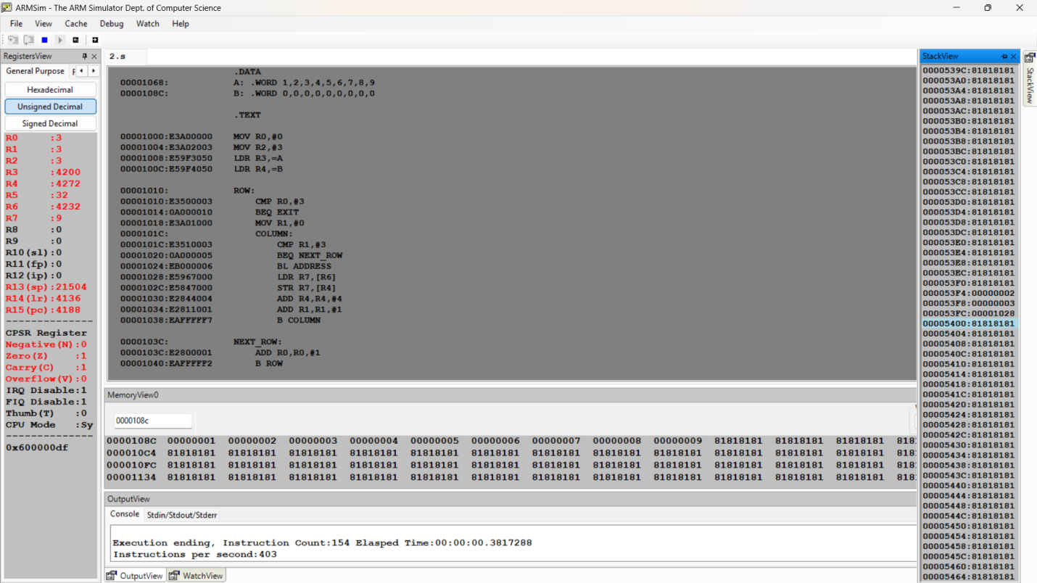

Microprocessor and Computer Architecture
UE24CS251B
4th Semester, Academic Year 2025-26
Date:
Name: Harshit Chandak | SRN:  PES2UG24CS185 | Section  C

LAB #____5_______ Program Number: ____3___
Title of the Program
Generate the first N Fibonacci numbers and store them in memory while using stack operations for register preservation.

- ARM Assembly Code
- Output Screen Shot
(One Screenshot including Register Window,Memory Window and Code Window)
.DATA
FIB: .WORD 0,0,0,0,0

.TEXT
LDR R4, =FIB
MOV R2, #10
MOV R0, #0
MOV R1, #1

STMFD SP!, {R0,R1}
STR R0, [R4], #4
STR R1, [R4], #4

SUB R2, R2, #2

LOOP:
ADD R3, R0, R1
MOV R0, R1
MOV R1, R3

STMFD SP!, {R3}
STR R3, [R4], #4

SUBS R2, R2, #1
BNE LOOP

SWI 0x11
.END

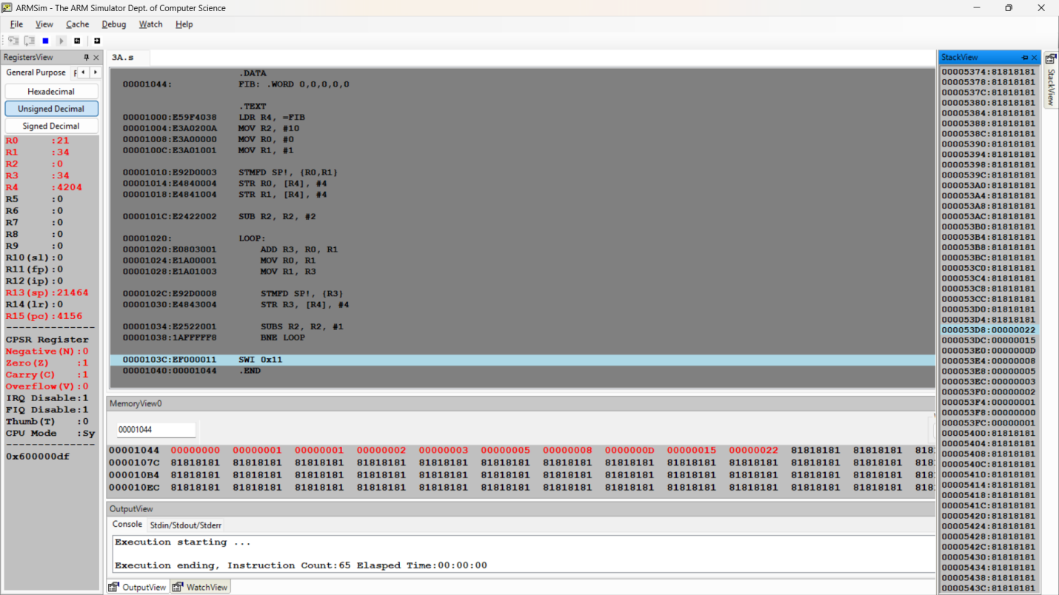

Microprocessor and Computer Architecture
UE22CS251B
4th Semester, Academic Year 2023-24
Date:
Name:Harshit Chandak | SRN: PES2UG24CS185 | Section  C

LAB #____5_______ Program Number: ____4___
Title of the Program
Write an ARM ALP to count the number of words in a string.

- ARM Assembly Code
- Output Screen Shot
(One Screenshot including Register Window,Memory Window ,Output Window, Code Window)
.DATA
MSG: .ASCIZ "ARM MPCA PES"
COUNT: .WORD 0
.TEXT

LDR R0,=MSG
MOV R1,#0
MOV R2,#1

LOOP:
LDRB R3,[R0],#1
CMP R3,#0
BEQ EXIT
CMP R3,#' '
BEQ SPACE
CMP R2,#1
ADDEQ R1,R1,#1
MOVEQ R2,#0
B LOOP

SPACE:
MOV R2,#1
B LOOP

EXIT:
LDR R3,=COUNT
STR R1,[R3]
SWI 0x11

.END
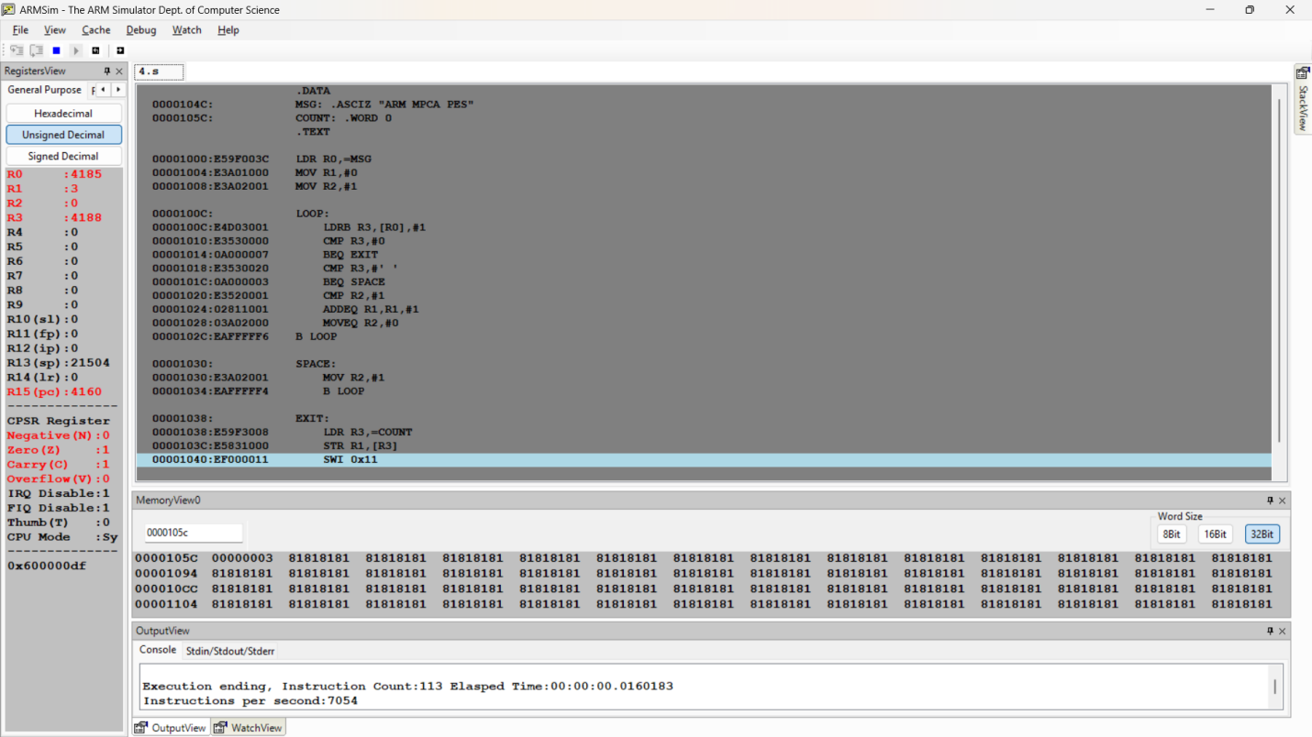

Microprocessor and Computer Architecture
UE22CS251B
4th Semester, Academic Year 2023-24
Date:
Name: Harshit Chandak | SRN:  PES2UG24CS185 | Section  C

LAB #____5_______ Assignment Question 1
Title of the Program
Write an ALP using conditional ARM instructions to sort an array of numbers using Bubble Sort Algorithm. Use STMFD to save registers before swap and LDMFD to restore the registers

- ARM Assembly Code
- Output Screen Shot
(Screenshot including Register Window,Memory Window and Code Window)

.DATA
A: .WORD 3,4,1,6,5

.TEXT

LDR R1,=A
MOV R5,#5

MOV R0,#0

LOOP:
CMP R0,#4
BEQ EXIT

MOV R2,#0

INNERLOOP:
MOV R4, R5
SUB R4, R4, R0
SUB R4, R4, #1
CMP R2, R4
BEQ NEXT_OUTER

BL ADDRESS

LDR R6,[R3]
LDR R7,[R3,#4]
CMP R6,R7

STRGT R7,[R3]
STRGT R6,[R3,#4]

ADD R2,R2,#1
B INNERLOOP

NEXT_OUTER:
ADD R0,R0,#1
B LOOP

ADDRESS:
STMFD R13!,{R0,R2,LR}
ADD R3,R1,R2,LSL #2
LDMFD R13!,{R0,R2,LR}
MOV PC,LR

EXIT:
SWI 0x11
.END
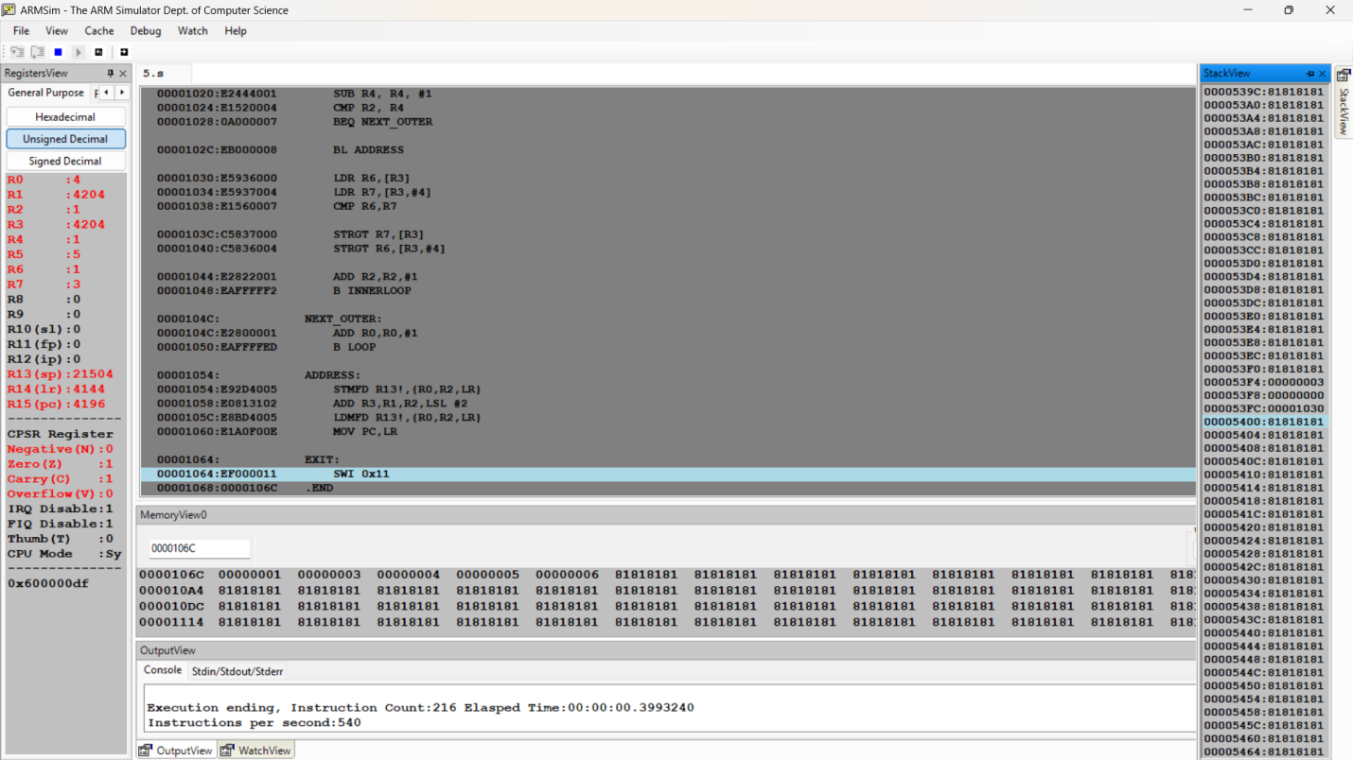

Microprocessor and Computer Architecture
UE22CS251B
4th Semester, Academic Year 2023-24
Date:
Name: Harshit Chandak | SRN:  PES2UG24CS185 | Section  2

LAB #____3_______
Assignment Question 2
Title of the Program
Write an ALP using ARM7TDMI to find the length of string

- ARM Assembly Code
- Output Screen Shots
(One Screenshot including Register Window,Memory Window and Code Window)
.DATA
A: .ASCIZ "HARSHITCHANDAK"
COUNT: .WORD 0

.TEXT
LDR R0,=A
MOV R3,#0

LOOP:
LDRB R1,[R0],#1
CMP R1,#0
BEQ EXIT
ADD R3,R3,#1
BNE LOOP

EXIT:
LDR R2,=COUNT
STR R3,[R2]
SWI 0x11
.END
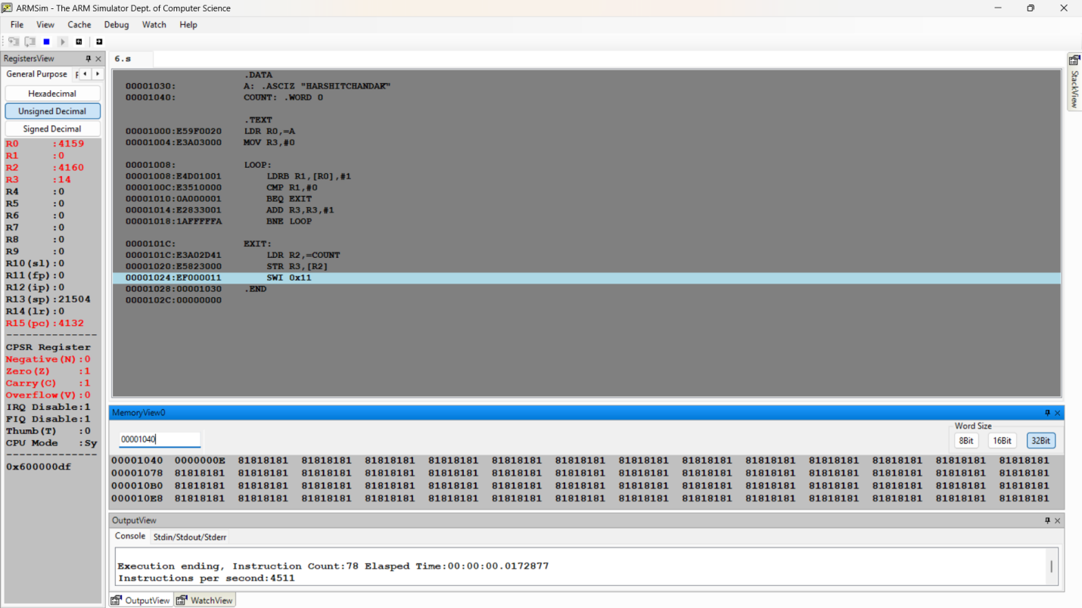

Disclaimer:
- The programs and output submitted is duly written, verified and executed by me.
- I have not copied from any of my peers nor from the external resource such as internet.
- If found plagiarized, I will abide with the disciplinary action of the University.

Signature:
Name:
SRN:
Section:
Date:

