Phase 1
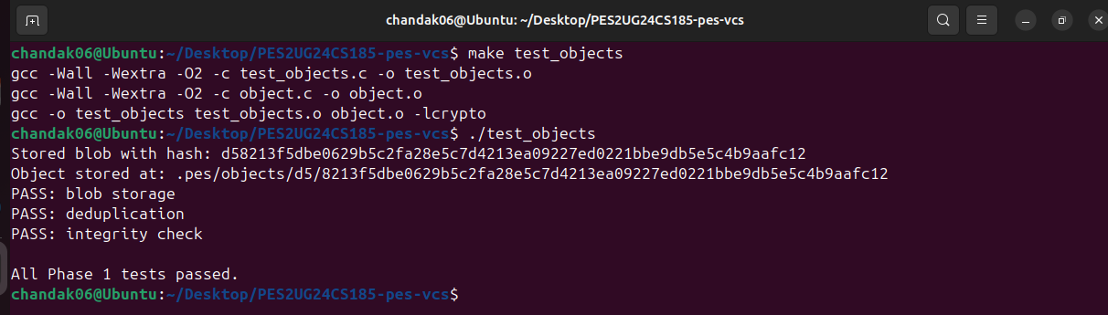
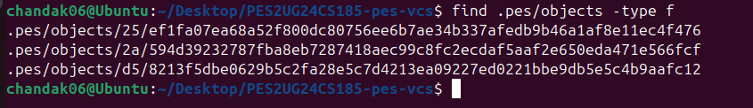
Phase 2
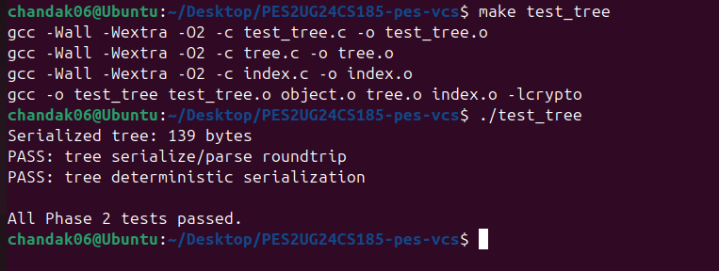
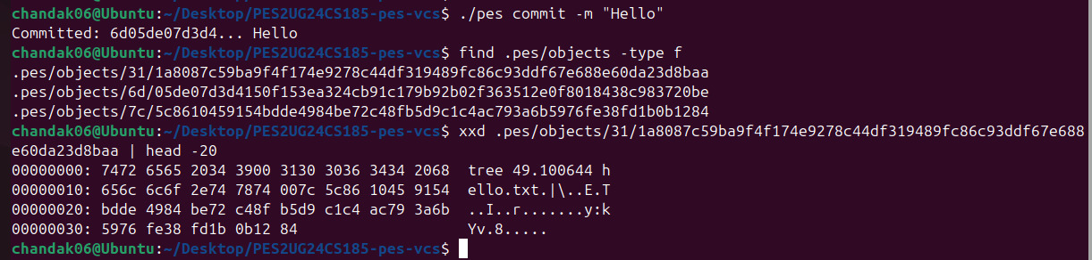

Phase 3
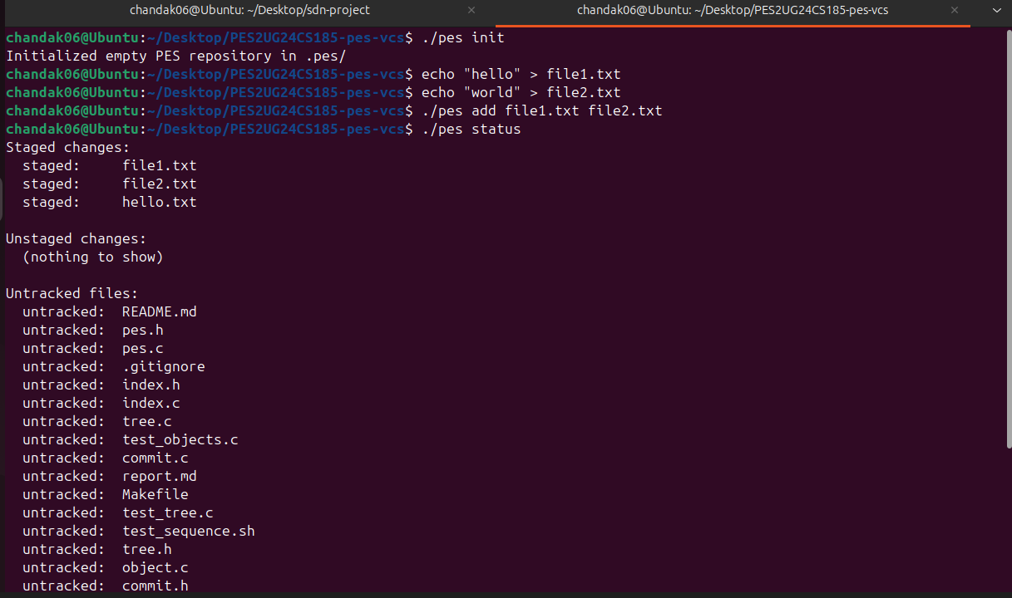
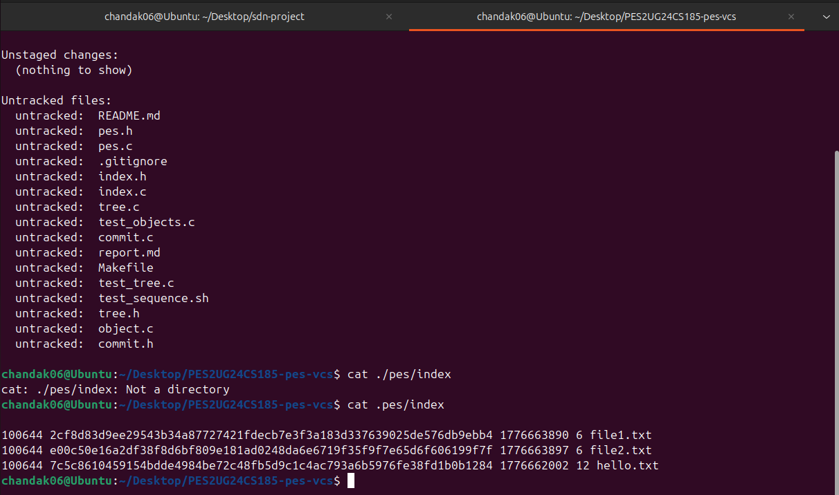
Phase 4
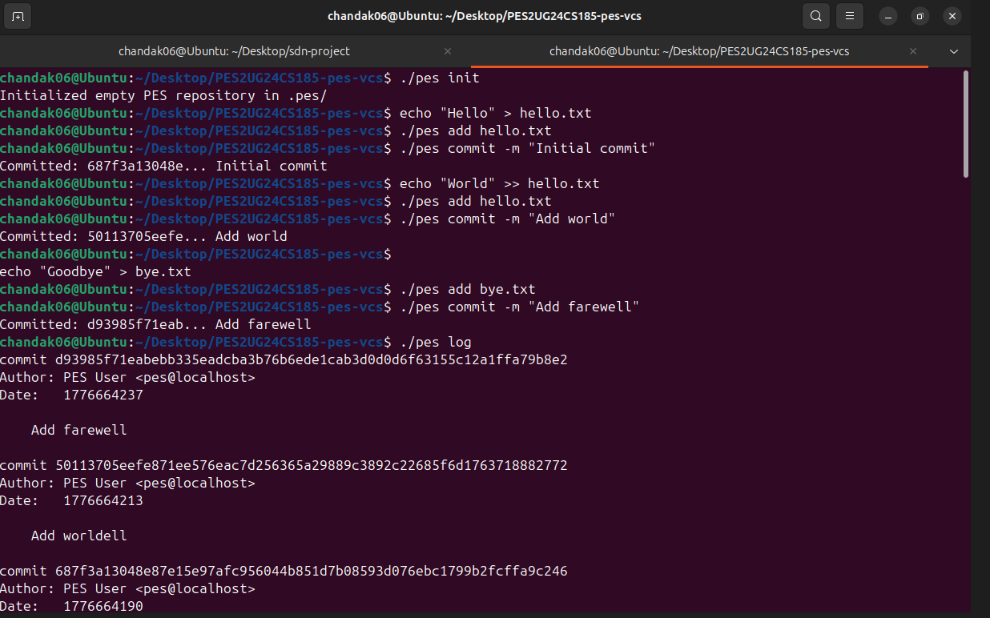
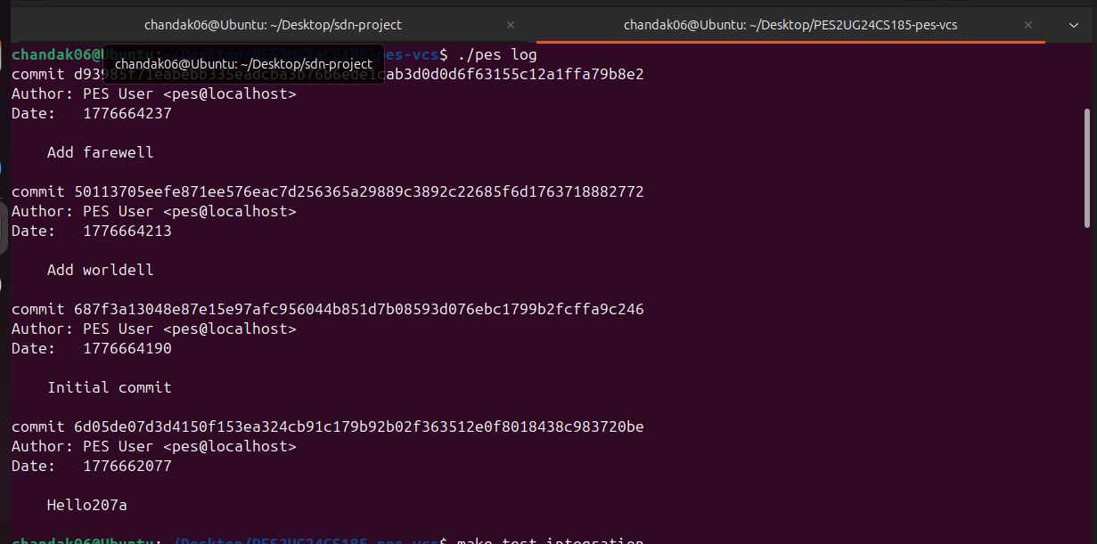

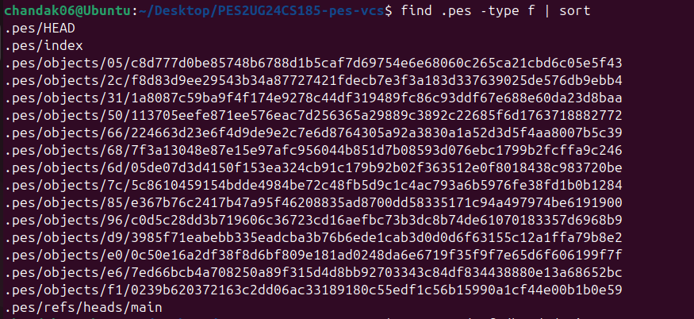

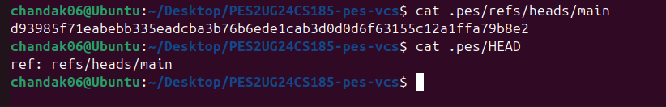

MAKE TEST INTEGRATION
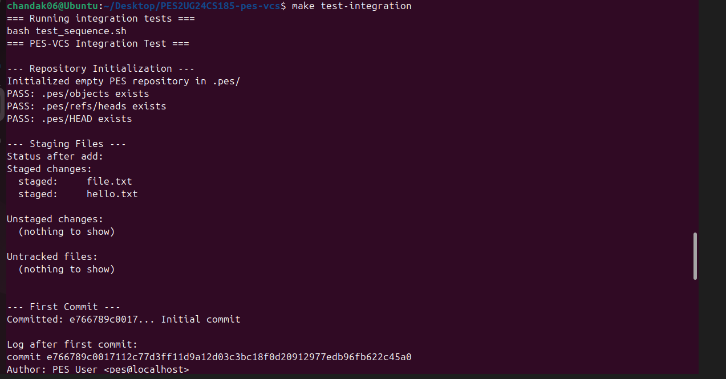
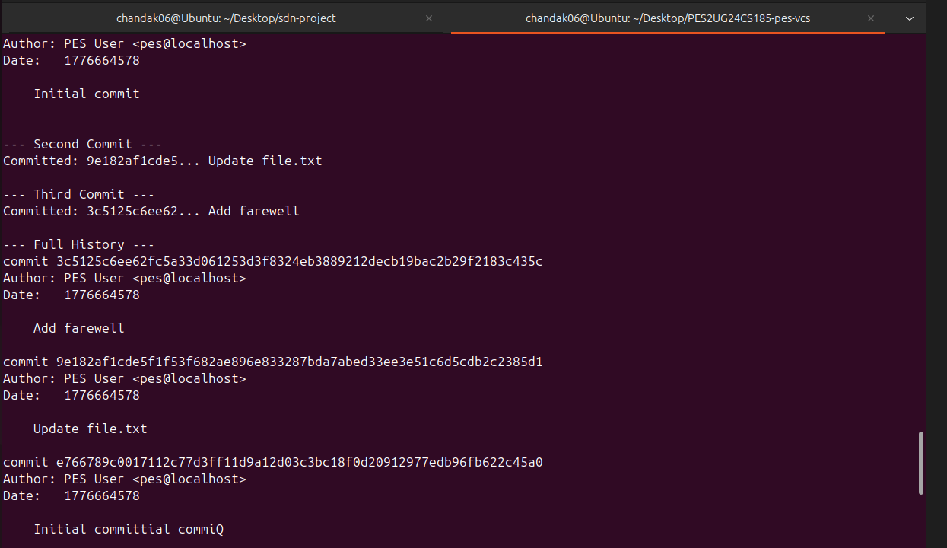
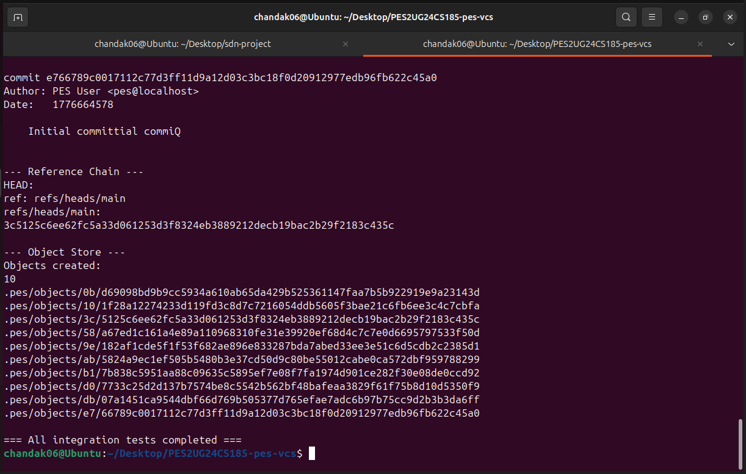

Q5.1: In PES-VCS, pes checkout <branch> would first read the commit hash stored in .pes/refs/heads/<branch> and update .pes/HEAD to point to that branch. Then it must load the target commit’s tree, update the working directory files to match that snapshot, remove files no longer present, and recreate the index accordingly. This operation is complex because it changes HEAD, index, and actual files together. It must also avoid overwriting user changes or deleting important data accidentally.
Q5.2: To detect a dirty working directory, compare each tracked file in the index with the current working file. If size or modification time differs, recompute the file’s hash and compare it with the hash stored in .pes/index. If they differ, the file has uncommitted changes. Then compare that file with the target branch’s version from the object store. If checkout would overwrite those edits, the command must refuse and warn the user.
Q5.3: In detached HEAD state, .pes/HEAD stores a commit hash directly instead of a branch reference. New commits can still be created, but no branch name moves forward to track them. If the user switches branches later, those commits may become unreachable. Recovery is possible by creating a new branch pointing to those commits or using commit hashes from logs/reflog-like history. Detached HEAD is useful for temporary experiments.
Q6.1: Garbage collection would start from all branch heads in .pes/refs/heads/ and mark every reachable commit, tree, and blob by recursively following parent links and tree references. After marking, any object file not visited is unreachable and can be deleted. A hash set is ideal for storing visited hashes efficiently. For 100,000 commits and 50 branches, roughly all reachable commits plus their trees and blobs must be scanned, so several hundred thousand objects may be visited.
Q6.2: Running garbage collection during a commit is dangerous because GC may delete objects created by the commit before the branch reference is updated. For example, a tree object may be written, but before the new commit points to it, GC sees no reference and removes it. Then the commit finishes with missing objects, corrupting history. Real Git avoids this using locks, temporary files, and only deleting objects older than a safety grace period.

