Entity Framework Core - HOL1 Output

dotnet build

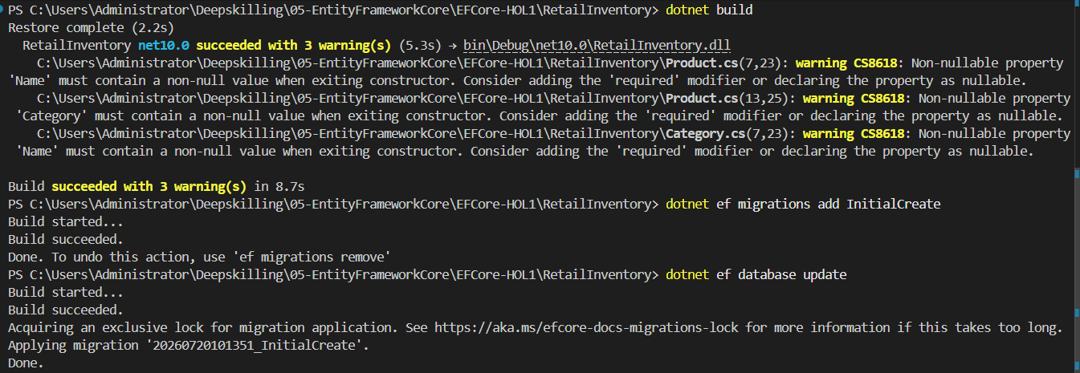

dotnet ef migrations add InitialCreate & dotnet ef database update

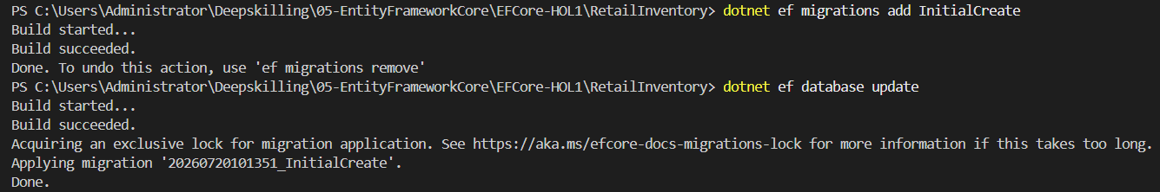

dotnet run
