WebAPI HOL2 Screenshot Outputs
This document contains the exported PNG screenshots from the WebAPI HOL2 Outputs/Documents folder.

Delete_Postman.png
C:\Users\Administrator\Deepskilling\06-WebAPI\WebAPI-HOL2\Outputs\Documents\Delete_Postman.png
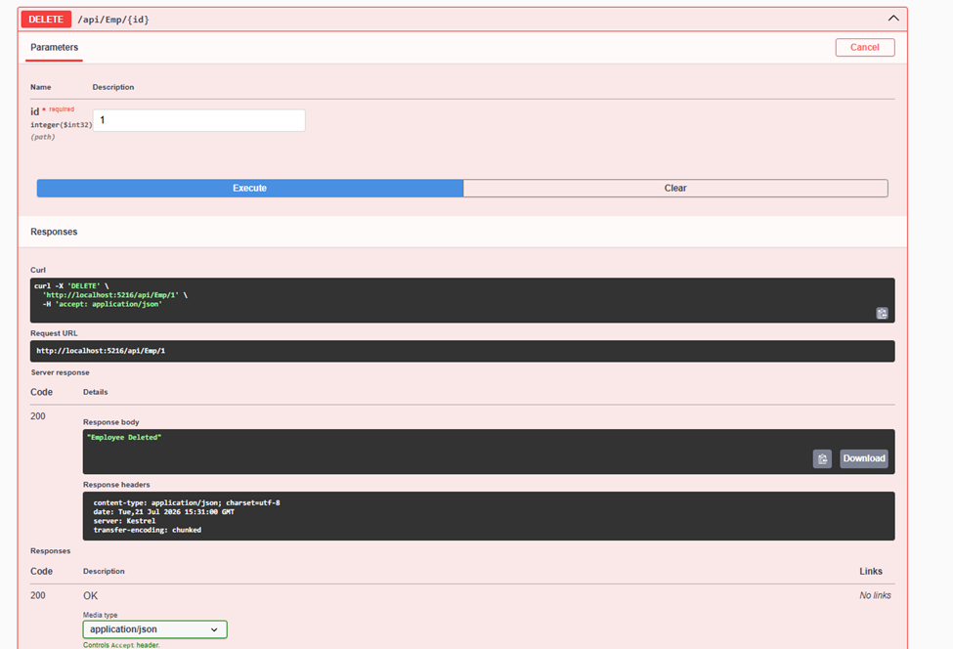

Get_Output_1.png
C:\Users\Administrator\Deepskilling\06-WebAPI\WebAPI-HOL2\Outputs\Documents\Get_Output_1.png
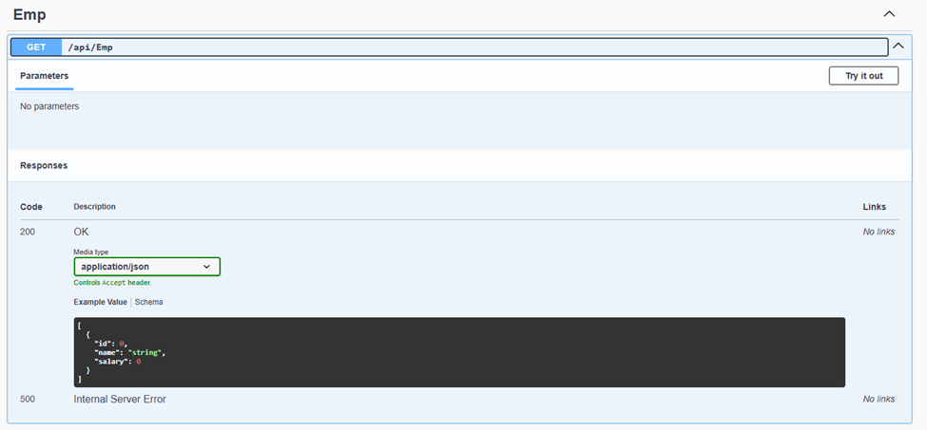

Post_Swagger_1.png
C:\Users\Administrator\Deepskilling\06-WebAPI\WebAPI-HOL2\Outputs\Documents\Post_Swagger_1.png
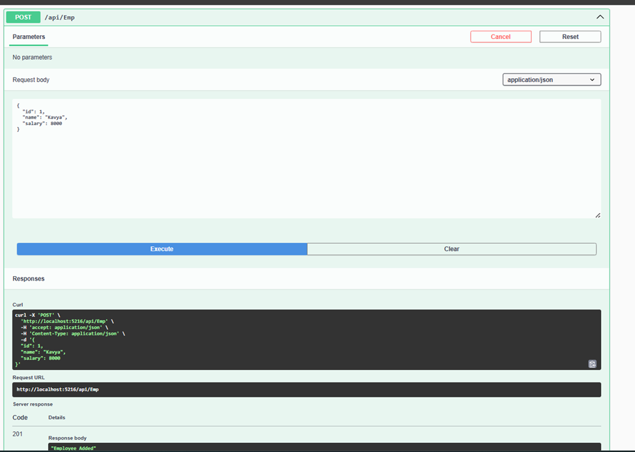

Postmaan_Output.png
C:\Users\Administrator\Deepskilling\06-WebAPI\WebAPI-HOL2\Outputs\Documents\Postmaan_Output.png
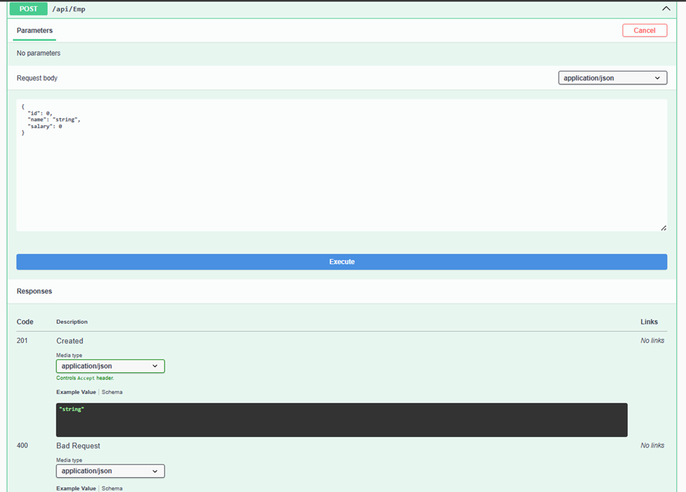

Postman.png
C:\Users\Administrator\Deepskilling\06-WebAPI\WebAPI-HOL2\Outputs\Documents\Postman.png
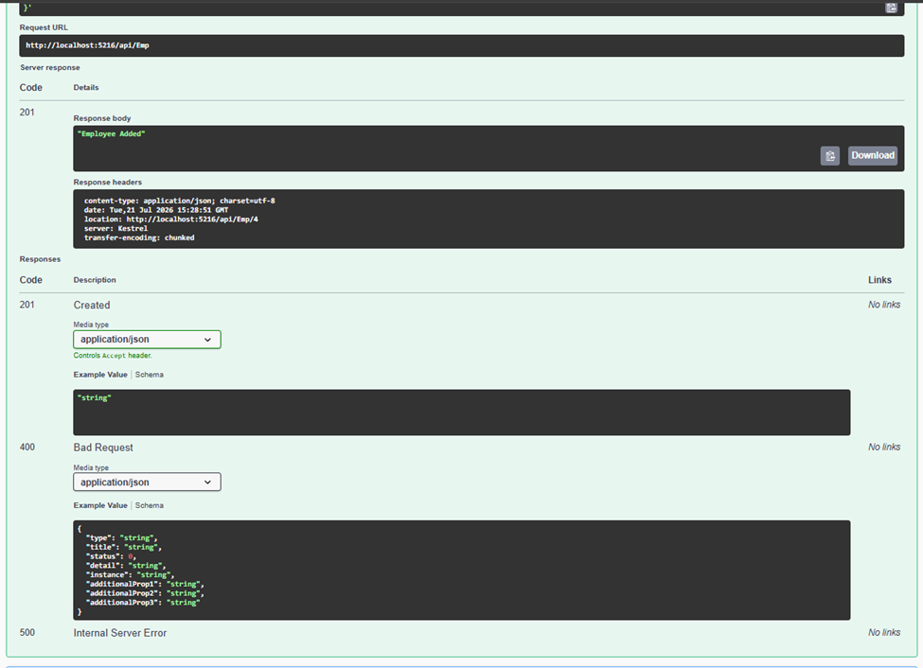

Swagger_Get_Output_2.png
C:\Users\Administrator\Deepskilling\06-WebAPI\WebAPI-HOL2\Outputs\Documents\Swagger_Get_Output_2.png
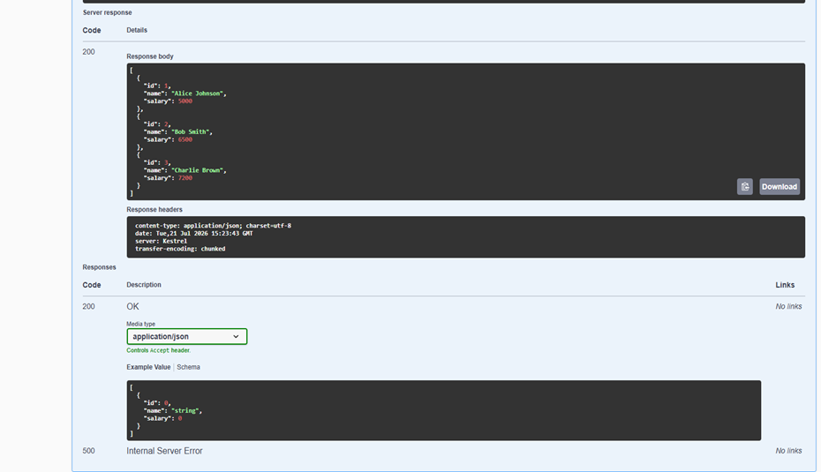

Swagger_Output.png
C:\Users\Administrator\Deepskilling\06-WebAPI\WebAPI-HOL2\Outputs\Documents\Swagger_Output.png
