Cognizant DeepSkilling
Module 1 – Design Patterns
Name: Chandaluri Kavya
Super Set Id: 8000661
Registration No: 231FA18150
GitHub: https://github.com/Chandaluri-Kavya/Deepskilling
1. Singleton Pattern
2. Factory Method Pattern
3. Builder Pattern
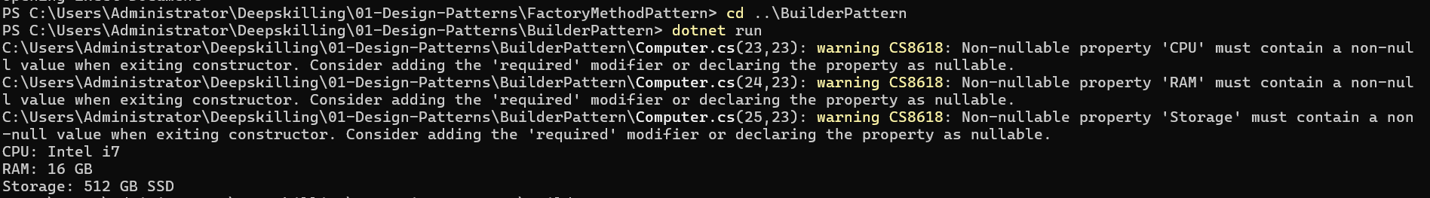
4. Adapter Pattern
5. Decorator Pattern
6. Proxy Pattern
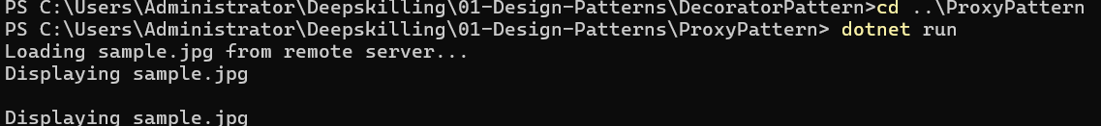
7. Observer Pattern
8. Strategy Pattern
9. Command Pattern
10. MVC Pattern
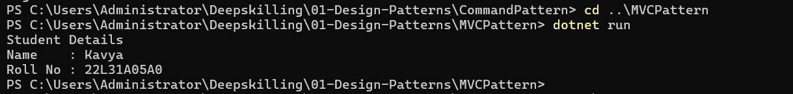
11. Dependency Injection

