Cognizant DeepSkilling
Module 2 – Data Structures and Algorithms
Name: Chandaluri Kavya
Super Set Id: 8000661
Registration No: 231FA18150
GitHub Repository: https://github.com/Chandaluri-Kavya/Deepskilling

Ecommerce Search Function

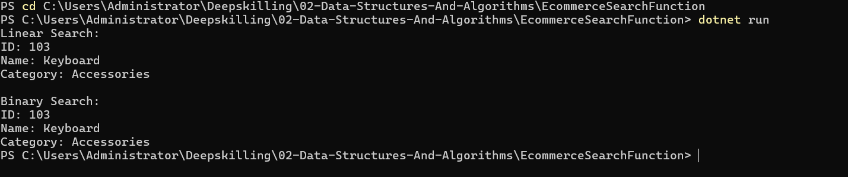

Financial Forecasting

