WEEK 1 Report
Data Collection And Data Cleaning
Tasks Done
- Dataset collection
I have collected datasets of previous matches of fifa from the year 1930-2022 and the rating and ranking of international teams updated on 2024.
links for the dataset:
- https://www.kaggle.com/datasets/piterfm/fifa-football-world-cup?select=fifa_ranking_2022-10-06.csv
- https://inside.fifa.com/fifa-world-ranking/men
- https://www.eloratings.net/

- Data Cleaning and Featuring
I have taken the raw dataset and made Data Cleaning using Pandas and deleted some features and made a clean data set for the model to train and to select appropriate features.
Raw Data
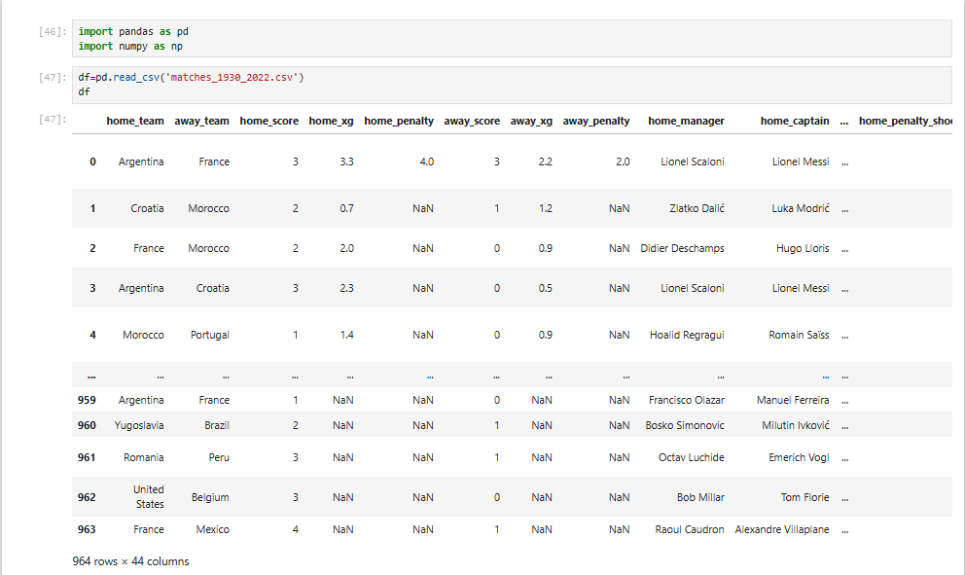

After Cleaning
