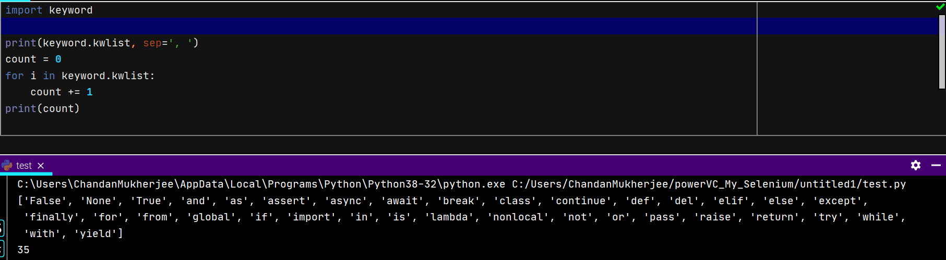

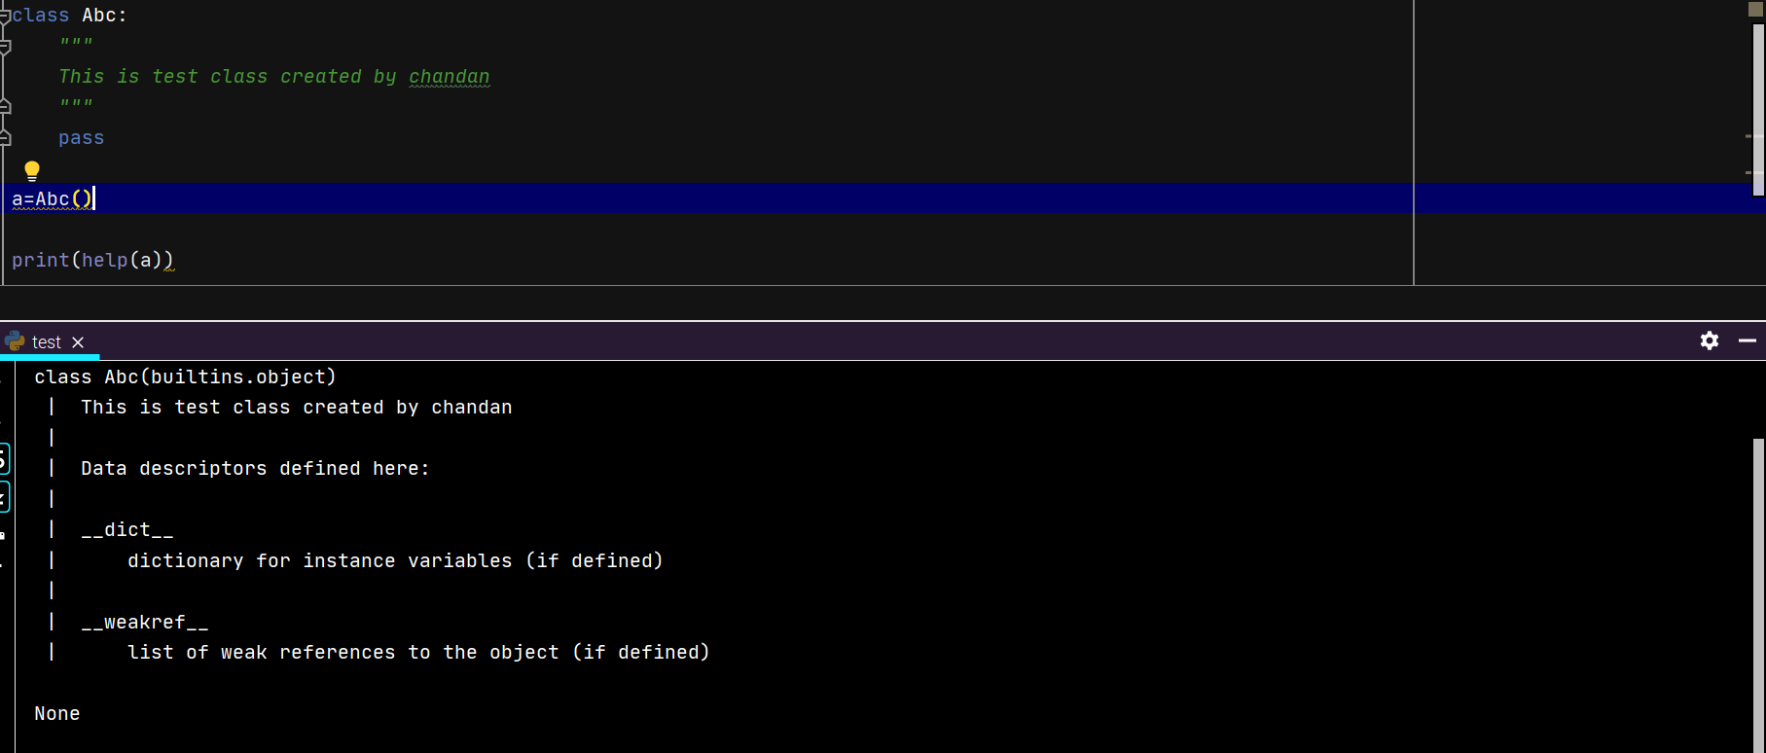

Remember floor division is not float division, so it may give you float too if you divide a float.

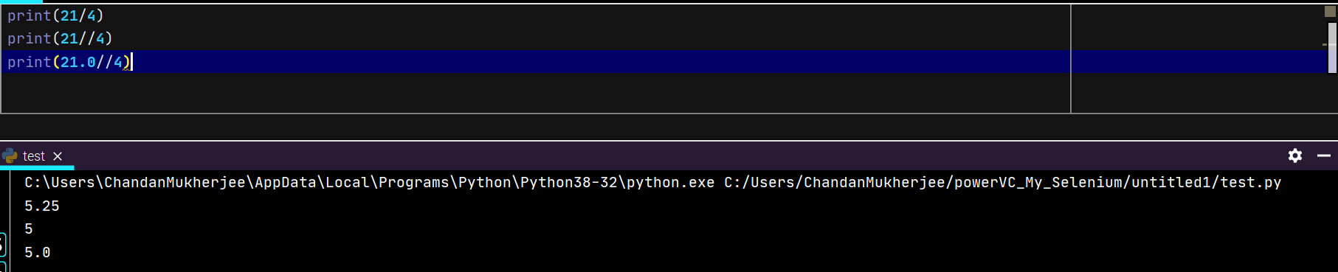

* Chapter 15 🡪 Binary number Manipulation

Indexing is not about position in .format method.

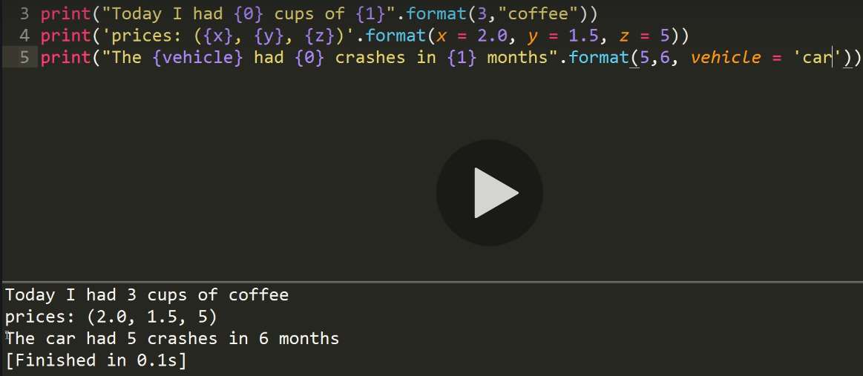

* Chapter 17 🡪 formatting of strings (extreme)

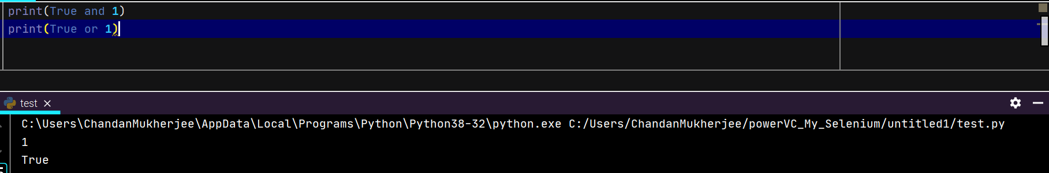

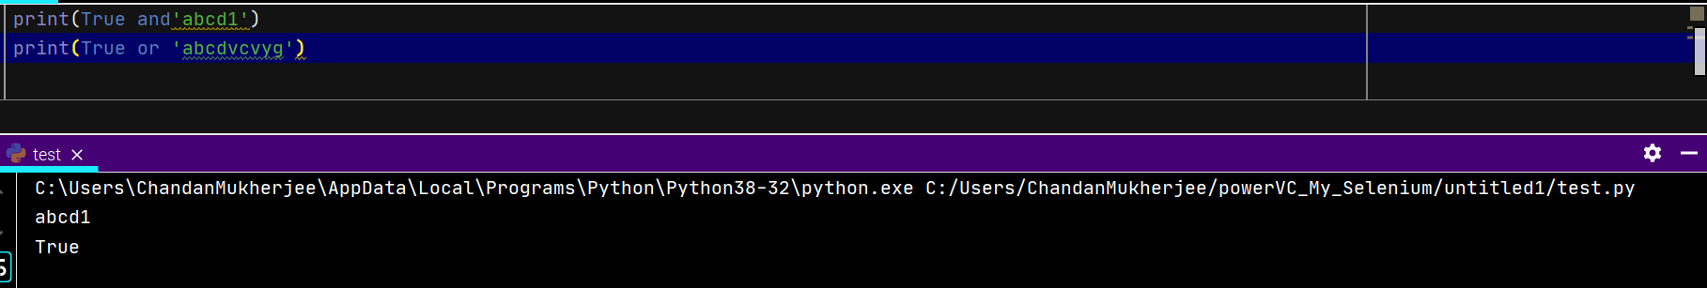

* Chapter 23 is important 🡪 ternary operator

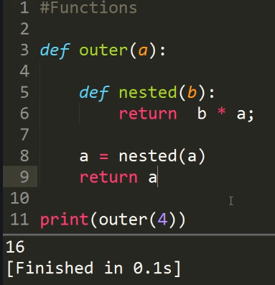 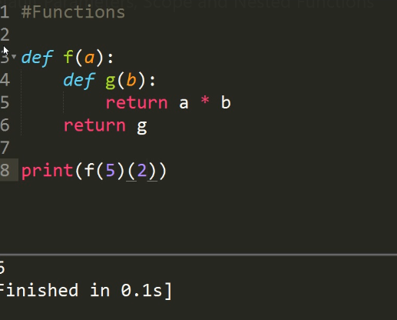

* Chapter 30 is important 🡪 passing arguments to function
* Chapter 31 is important 🡪 recursion using tail_sum
* Chapter 33 is important 🡪 Lambda Function in nested form

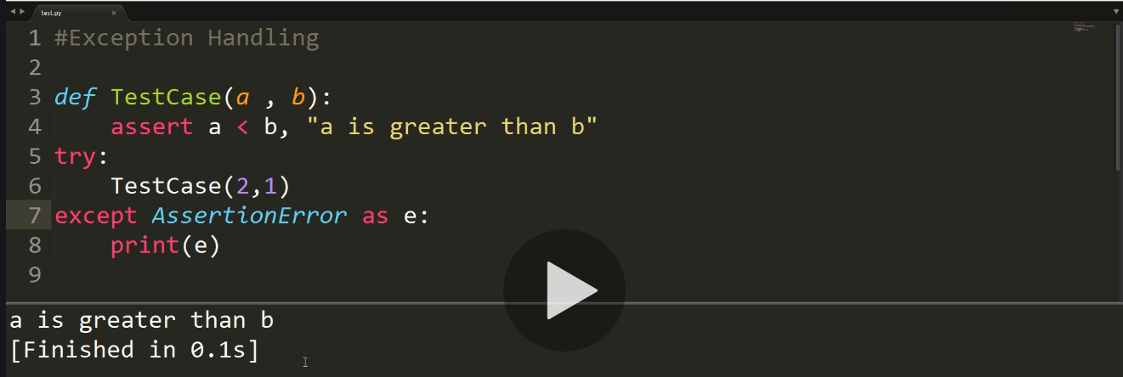

Imp, use of assert, DIY

Tell and seek function in file reading.

‘wb’ 🡪 writing file in binary format.



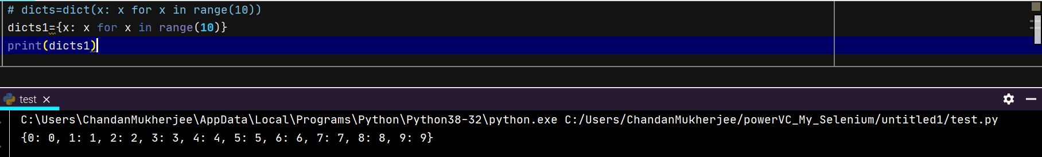

Clear method in dictionary is like truncate in SQL.

Shallow copy is applicable to list and dictionary data structures.

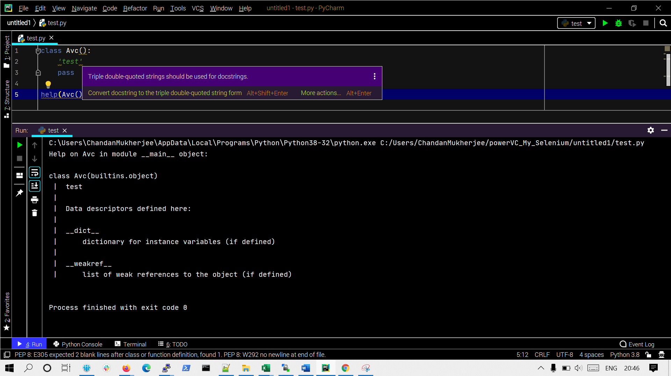

We can use single quote as docstring too, but it is not recommended.

In python3 , it internally calls truediv function for any division calls.



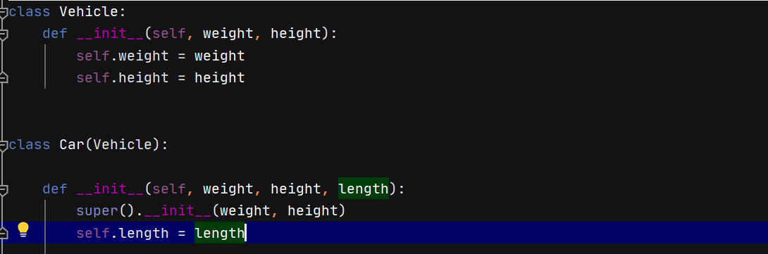

* Chapter 57 is important 🡪 destructors

General chapters I need to work on:

