** **

**Project report**

**on**

**BABY MONITORING SYSTEM USING IOT**

**Project report submitted for Partial fulfillment of the requirement for the**

**award of B.Tech Degree in**

**Electronics And Telecommunication Engineering under BPUT**

**SUBMITTED BY**

Suryakanta Behera(1601289236)

Swetaparna Mishra (1601289403)

Chandan Kumar Sahoo(1601289446)

Chandan Hota(1601289504)

**UNDER THE GUIDANCE OF**

**Mr. Shuvendra Kumar Tripathy**

**(Asst. Prof., Dept of ETC)**

**DEPARTMENT OF ELECTRONICS AND TELECOMMUNICATION ENGINEERING**

**TRIDENT ACADEMY OF TECHNOLOGY**

**BHUBANESWAR**

**TRIDENT ACADEMY OF TECHNOLOGY**

**BHUBANESWAR**



**CERTIFICATE**

This is to certify that the dissertation work entitled **‘BABY MONITORING SYSTEM USING IOT’** is the work done by Suryakanta Behera(1601289236), Swetaparna Mishra (1601289403), Chandan Kumar Sahoo(1601289446), Chandan Hota(1601289504) and is submitted in partial fulfillment for the award **“BACHELOR OF TECHNOLOGY(B.Tech)”** in Electronics And Telecommunication Engineering from Trident Academy of Technology affiliated to BPUT, Odisha

**PROJECT GUIDE(S) H.O.D. (ETC)**

**ACKNOWLEDGEMENT**

The satisfaction and euphoria that accompany the successful completion of any task would be incomplete without mentioning the people whose constant guidance and encouragement made it possible. I take pleasure in presenting before you, my project, which is a result the result of a blend of our studies, research and knowledge.

I express my earnest gratitude to Dr. Sakuntala Mahapatra (H.O.D, Dept. of ETC), my honorable guide, Mr.Shuvendra Tripathy (Asst. Prof. of Dept of ETC), for their constant support, encouragement and guidance. I am grateful for their cooperation and valuable suggestions. I am very much thankful to all my group members for assisting me to complete the project.

Finally I express my gratitude to all other members who are involved directly or indirectly for the completion of this project.

**SUBMITTED BY**

Suryakanta Behera(1601289236)

Swetaparna Mishra (1601289403)

Chandan Kumar Sahoo(1601289446)

Chandan Hota(1601289504)

**ABSTRACT**

In this project we are going to monitor the baby while his/her parents are out from home for work or anything else. This system considers all the minute details required for the care & protection of the Baby in the cradle.

The design of smartness & innovation comes with the use of technologies/methodologies which include Internet of Things (IOT) (Modules like Raspberry Pi, Humidity & Temperature sensing), Cry Detecting Mechanism, Live Video Surveillance, Cloud Computing (Data Storage) & User Friendly Web application (for User Controls). In order to detect each & every activity of Baby, different Sensors/Modules are attached to the Cradle: Humidity & Temperature Sensing Module for detection of Wetness of the bed, A Camera on top of the Cradle for live video footage & Cry Detection Circuit to analyze Cry Patterns.

All the data which is been taken from the sensors/modules will be stored in Cloud & analyzed at regular intervals. A Health Algorithm is applied to these datasets to get information about the body conditions which is helpful as any regular symptoms of a disease can be identified easily

**CONTENTS**

**TOPIC PAGE NO.**

1. **ACKNOWLEDGEMENT 1**
2. **ABSTRACT 2**
3. **LITERATURE SURVEY** **6-11**
   1. Paper 1 6
   2. Paper 2 7
   3. Paper 3 8
   4. Paper 4 9
   5. Paper 5 10
   6. Project overview 11
4. **INTRODUCTION TO IOT 13-17**
   1. What is IOT 13
   2. History of IOT 14
   3. Practical Application 14
   4. Working 15
   5. Importance 16
   6. Advantages 17
5. **BABY MONITORING SYSTEM 18-22**
   1. Introduction 18-19
   2. Baby Monitoring System 20
   3. Motivations and Problem Statement 21
   4. Related Works 22
6. **PROJECT DESCRIPTION 23-28**
   1. Block Diagram 23
   2. Hardware 24-27
   3. Software 28-41
7. **CONCLUSION 42**
8. **REFERENCES 43**

**LITERATURE**

**SURVEY**

**PAPER 1**

# Internet of Things-Based Baby Monitoring System for Smart Cradle

**This paper appears in:** International Journal of Advanced Research in Electrical, Electronics And Instrumentation Engineering

**Date of Publication:** September 2012

# Author(s): Miss.S.R. Jadhav

**Abstract:-** The current number of working mothers has greatly increased. Subsequently, baby care has become a daily challenge for many families. Thus, most parents send their babies to their grandparents’ house or to baby care houses. However, the parents cannot continuously monitor their babies’ conditions either in normal or abnormal situations. Therefore, an Internet of Things-based Baby Monitoring System (IoT-BBMS) is proposed as an efficient and low-cost IoT-based system for monitoring in real time. We also proposed a new algorithm for our system that plays a key role in providing better baby care while parents are away. In the designed system, Node Micro-Controller Unit (NodeMCU) Controller Board is exploited to gather the data read by the sensors and uploaded via Wi-Fi to the AdaFruit MQTT server. The proposed system exploits sensors to monitor the baby’s vital parameters, such as ambient temperature, moisture, and crying. A prototype of the proposed baby cradle has been designed using Nx Siemens software, and a red meranti wood is used as the material for the cradle. The system architecture consists of a baby cradle that will automatically swing using a motor when the baby cries. Parents can also monitor their babies’ condition through an external web camera and switch on the lullaby toy located on the baby cradle remotely via the MQTT server to entertain the baby. The proposed system prototype is fabricated and tested to prove its effectiveness in terms of cost and simplicity and to ensure safe operation to enable the baby-parenting anywhere and anytime through the network. Finally, the baby monitoring system is proven to work effectively in monitoring the baby’s situation and surrounding conditions according to the prototype.

**PAPER 2**

# Intelligent Baby Monitoring System

**This paper appears in:** International Journal of Advanced Research in Electrical, Electronics And Instrumentation Engineering

**Date of Publication:** September 2012

**Author(s):** Dr. J. Abdul Jaleel, SibiSalim, Aswin.R.B

**Abstract:-** This paper presents a design of a Baby Monitoring System based on the GSM network. A prototype is developed which gives a reliable and efficient baby monitoring system that can play a vital role in providing better infant care. This system monitor vital parameters such as body temperature, pulse rate, moisture condition, movement of an infant and using GSM network this information is transferred to their parents. Measurements of this vital parameters can be done and under risk situation conveyed to the parents with alarm triggering system to initiate the proper control actions. The system architecture consist of sensors for monitoring vital parameters, LCD screen, GSM interface and a sound buzzer all controlled by a single microcontroller core. KeywordsBaby monitoring, vital parameters, microcontroller, GSM network. This paper presents a style of a Baby observance System supported the GSM network. A model is developed which supplies a reliable and economical baby observance system that may play an important role in providing higher kid care. this technique monitor important parameters like voice, movement of AN kid and exploitation GSM network this info is transferred to their oldsters. Measurements of this important parameters are often done and below risk state of affairs sent to the fogeys with SMS and vocation system to initiate the right management actions. The system design incorporates voice sensors for observance important parameters, GSM interface controlled by one microcontroller core

**PAPER 3**

# Intelligent Baby Monitoring System

**This paper appears in:** International Journal of Advanced Research in Electrical, Electronics And Instrumentation Engineering

**Date of Publication:** September 2012

**Author(s):** Dr. J. Abdul Jaleel, SibiSalim, Aswin.R.B

**Abstract:-**. This project presents a baby monitoring system for busy parents so that they can ensure the proper care and safety of their babies. This system can detect the baby's motion and sound; especially crying and video output of baby's present position can be displayed on a display monitor so that the mother or another responsible person can watch the baby while away from him or her. This baby monitoring system is capable of detecting motion and crying condition of the baby automatically. The Raspberry Pi B+ module is used to make the total control system of the hardware, condenser MIC is used to detect baby's crying, PIR motion sensor is incorporated to detect baby's movement and Pi camera is used to capture the baby's motion. A display is used to have video output of sleeping baby. Finally, the developed hardware is tested to analysis the capability of detecting the motion and crying sound of baby as well as the video output. Key ResultThis proposed system can provide an easier and convenient way for busy parents in terms of taking care of their babies. This paper represents a design of smart infant cradle which gives reliable and cost-efficient baby monitoring system. It plays a important role by giving better baby care. Smart infant cradle system swings automatically when baby continuously cry for stipulated time. The cradle system contain set of sensors, the sound sensor is mainly used for detect baby cry voice, the moisture sensor is used for detect the wetness of the diaper and methane sensor is used for detecting methane content. Servo motor is used for swing the cradle.

**PAPER 4**

# Automated Alarm System for Diaper Wet Using GSM

**This paper appears in:** International Journal of Advanced Research in Electrical, Electronics And Instrumentation Engineering

**Date of Publication:** September 2012

**Author(s):** Dr. J. Abdul Jaleel, SibiSalim, Aswin.R.B

**Abstract:-**. Wearing a wet diaper for prolonged periods, cause diaper rash. This paper presents an automated alarm system for Diaper wet. The design system using an advanced RF transceiver and GSM system to sound an alarm on the detection of moisture in the diaper to alert the intended person to change the diaper. A wet diaper detector comprises an elongated pair of spaced fine conductors which form the wet sensor. The sensor is positioned between the layers of a diaper in a region subject to wetness. The detector and RF transmitter are adapted to be easily coupled to the protruding end of the elongated sensor. When the diaper is wet the resistance between the spaced conductors falls below a pre-established value. Consequently, the detector and RF transmitter sends a signal to the RF receiver and the GSM to produce the require alarm. When the diaper is changed, the detector unit is decoupled from the pressing studs for reuse and the conductor is discarded along with the soiled diaper. Key ResultOur experimental tests show that the designed system perfectly produces the intended alarm and can be adjusted for different level of wet if needed.

**PAPER 5**

# Automatic E-Baby Cradle Swing based on Baby Cry

**This paper appears in:** International Journal of Advanced Research in Electrical, Electronics And Instrumentation Engineering

**Date of Publication:** September 2012

**Author(s):** Dr. J. Abdul Jaleel, SibiSalim, Aswin.R.B

**Abstract:-**. There is a need to develop a new low cost indigenous electronic cradle because the existing cradles are imported and costly. This paper presents the design and implementation of a new indigenous low cost E-Baby Cradle that swings automatically when baby cries, for this it has a cry analyzing system which detects the baby cry voice and accordingly the cradle swings till the baby stops crying. The speed of the cradle can be controlled as per the user need. The system has inbuilt alarm that indicates two conditions – first when the mattress is wet, which is an important parameter to keep the baby in hygienic condition, second when baby does not stop crying with in a stipulated time, which intimated that baby needs attention. This system helps parents and nurses to take care of babies without physical attention. General Terms E-Baby cradle, low cost, indigenous. Using electronic devices is not limited to adults or to specific time or place. Children use different types of mobile devices with no constrains. Guardians concern

about the effect of the technical explosion on their children development. Controlling,

monitoring, and managing approaches are in need to help in overcoming some of these

worries. This project gives insight in approaches to monitor and control children

electronic devices. The project includes an overview of the related research efforts

that allow guardians to manage and monitor data, applications, or services available in

kids’ mobile devices. The main challenge is to balance privacy and flexibility with the

ease of use. The project also includes the implementation of an Android app called

Time’s Up.

**PROJECT OVERVIEW**

**Introduction:** At present, female participation in the work force in the industrialized nations has greatly increased, thereby affecting infant care in many families. Both parents are required to work due to the high cost of living. However, they still need to look after their babies, thereby increasing workload and stress, especially of the mother. Working parents cannot always care for their babies. They either send their babies to their parents or hire a baby caregiver while they are working. Some parents worry about the safety of their babies in the care of others. Thus, they go home to check on their babies during their free time, such as lunch or tea break. A baby monitoring system that can monitor the babies’ condition real time is proposed to solve these problems. A baby monitor ring system consisting of a video camera and microphone without limitations of coverage. It can send data and immediately notify the parents about urgent situations, thereby shortening the time needed to handle such scenarios. Generally, babies cry because they are hungry, tired, unwell, or need their diaper changed.

**Problem:** Under fast-paced life conditions, everyone is busy in their professional life including parents. They leave the house early in the morning and come back before dinner time. Even the mothers are working. Thus, they do not have sufficient time to take care of their babies. Not all parents could afford a nanny to help them with their children. Then, after working for long hours, the mothers still have to manage the house and take care of their babies simultaneously.

**Solution:** Parents might not have the time to soothe their baby to sleep or rock their baby back to sleep in the middle of the night. Studies about the effect of rocking a baby have been carried out and found that babies sleep better while being rocked or swung lightly because the rhythmic movement mimics the gentle rocking they felt while in their mothers’ womb. Most available automated cradles are designed to rock non-stop. However, the rocking movement can make the baby nauseous and uncomfortable. Thus, allowing the automated cradle to rock the baby to sleep in the middle of the night is also a problem.

**The approach:** To address these challenges, we designed and fabricated a baby monitoring system for a smart cradle using NodeMCU as the microcontroller while the system was developed using Arduino IDE. This system consists of a cradle that can swing whenever the sound sensor detects crying. A mini fan is attached on top of the cradle to provide ventilation. The mini fan and the swinging of the cradle can be switched on either by the sensors or through remote control from the MQTT server. An external Wi-Fi camera has been installed on the cradle to enable real-time vision monitoring. The parents can see the baby’s condition and talk to the baby using the ready-made mobile application of the Wi-Fi camera. An Internet of Things-based baby monitoring system for smart cradle is proposed in this paper.

**Conclusion:** A smart cradle with a baby monitoring system over IoT has been designed and fabricated to monitor a baby’s vital parameters, such as crying condition, humidity, and ambient temperature.

**INTRODUCTION**

**TO**

**IOT**

**WHAT IS IOT**

Today, Internet application development demand is very high. So IoT is a major technology by which we can produce various useful internet applications.

Basically, IoT is a network in which all physical objects are connected to the internet through network devices or routers and exchange data. IoT allows objects to be controlled remotely across existing network infrastructure. IoT is a very good and intelligent technique which reduces human effort as well as easy access to physical devices. This technique also has autonomous control feature by which any device can control without any human interaction.

The above figure shows the connectivity of various devices of different fields with Internet and exchange data between them. So above figure represent the connectivity of world through various existing technologies.

“Things” in the IoT sense, is the mixture of hardware, software, data, and services. “Things” can refer to a wide variety of devices such as DNA analysis devices for environmental monitoring, electric clamps in coastal waters, Arduino chips in home automation and many other. These devices gather useful data with the help of various existing technologies and share that data between other devices. Examples include Home Automation System which uses Wi-Fi or Bluetooth for exchange data between various devices of home.

**HISTORICAL BACKGROUND**

In early 1982 the concept of the network of smart devices was discussed, with a modified Coke machine. This coke machine is modified at “Carnegie Mellon University” and becoming the first Internet-connected appliance. This machine was able to report its inventory and whether newly loaded drinks were cold.

In 1994 Reza Raji explained the idea of IoT as “small packets of data to a large set of nodes, so as to integrate and automate everything from home appliances to entire factories”. After that many companies proposed various solutions like Microsoft’s at Work or Novell’s Nest. Bill Joy proposed Device to Device (D2D) communication as a part of his “Six Webs” frameworks at the World Economic Forum at Davos in 1999.

The thought of Internet of Things first became popular in 1999. British entrepreneur Kevin Ashton first used the term Internet of Things in 1999 while working at Auto-ID labs. Besides that near field communication, barcode scanners, QR code scanners and digital watermarking are the various devices which are working on IoT in the present scenario.

**PRACTICAL APPLICATIONS**

The versatility of IoT has become very popular in recent years. There are many advantages to having a device based on IoT. **Mckinsey Global Institute reports that IoT business will reach 6.2 trillion in revenue by 2025**. There are lots of applications are available in the market in different areas.

**1) Personal Home Automation System:** Home Automation system is the major example in this area. **Wemo Switch Smart Plug:** It is the most useful devices which connected home devices in the Switch, a smart plug. **It plugs into a regular outlet, accepts the power cable from any device, and can be used to turn it on and off on hit a button on your smartphone.**

**2) Enterprise:** In the enterprise area many applications are there Like environmental monitoring system, smart environment etc.

**Nest Smart Thermostat:** It is connected to the internet. **The Nest learns automatically your family’s routines and will automatically adjust the temperature based on your activities, to make your house more efficient.** There is also a mobile app which allows the user to edit temperature and schedules.

**3) Utilities:** **smart metering, smart grid, and water monitoring system** are the most useful applications in the various utility area.

**4) Energy Management:** **Advanced Metering Infrastructure** is the major example in this area.

**5) Medical and Health Care:** **Remote health monitoring and emergency notification system** are examples of IOT in the medical field.

**Health patch Health Monitor:** It can be used for the patient who can’t go to doctors, letting them get ECG, heart rate, respiratory rate, skin temperature, body posture, fall detection, and activity readings remotely.

**6) Transportation:** **Electronic toll collection system** is the most useful example in this area.

**7) Large scale deployment:** There are various large projects ongoing in the world. **Songdo (South Korea), the first of its kind fully wired Smart City, is near completion**. Everything in this city is planned to be wired, connected and turned into a data stream that would be monitored by an array of computers without any human interaction.

**WORKING**

An IoT ecosystem consists of web-enabled smart devices that use embedded processors, sensors and communication hardware to collect, send and act on data they acquire from their environments. [IoT devices](https://internetofthingsagenda.techtarget.com/definition/IoT-device) share the sensor data they collect by connecting to an IoT gateway or other edge device where data is either sent to the cloud to be analyzed or analyzed locally.

Sometimes, these devices communicate with other related devices and act on the information they get from one another. The devices do most of the work without human intervention, although people can interact with the devices -- for instance, to set them up, give them instructions or access the data.

The connectivity, networking and communication protocols used with these web-enabled devices largely depend on the specific IoT applications deployed.

**IMPORTANCE**

The internet of things helps people live and work smarter as well as gain complete control over their lives. In addition to offering smart devices to automate homes, IoT is essential to business. IoT provides businesses with a real-time look into how their companies’ systems really work, delivering insights into everything from the performance of machines to supply chain and logistics operations.

IoT enables companies to automate processes and reduce labor costs. It also cuts down on waste and improves service delivery, making it less expensive to manufacture and deliver goods as well as offering transparency into customer transactions.

IoT touches every industry, including healthcare, finance, retail and manufacturing. [Smart cities](https://internetofthingsagenda.techtarget.com/definition/smart-city) help citizens reduce waste and energy consumption and connected sensors are even used in farming to help monitor crop and cattle yields and predict growth patterns.

As such, IoT is one of the most important technologies of everyday life and it will continue to pick up steam as more businesses realize the potential of connected devices to keep them competitive.

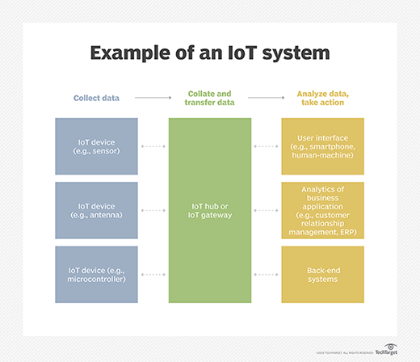

**ADVANTAGES**

The internet of things offers a number of benefits to organizations, enabling them to:

* Monitor their overall business processes;
* Improve the customer experience;
* Save time and money.
* Enhance employee productivity.
* Integrate and adapt business models.
* Make better business decisions and
* Generate more revenue.

IoT encourages companies to rethink the ways they approach their businesses, industries and markets and gives them the tools to improve their business strategies.

**BABY**

**MONITORING**

**SYSTEM**

**INTRODUCTION**

As we are very well familiar with the hurdles faced by Parents to nurture their infant and especially in case if both the Parents are working. To give 24 hours of time in such cases is next to impossible. Thus, we need to develop something unique that can help Parents to have a continuous surveillance/watch on the Baby/Infant and can notify about the same.  
Thus, we have come up with an idea to design a Smart Cradle System using IOT which will help the Parents to monitor their child even if they are away from home & detect every activity of the Baby from any distant corner of the world.

**BABY MONITORING SYSTEM**

* It is an innovative, smart & protective Cradle System to nurture an infant in an efficient way. This system considers all the minute details required for the care & protection of the Baby in the cradle. The design of smartness & innovation comes with the use of technologies/methodologies which include Internet Of Things (IOT) (Modules like Raspberry Pi, Arduino, Humidity & Temperature sensing), Swing Automation, Cry Detecting Mechanism, Live Video Surveillance, Cloud Computing (Data Storage) & User Friendly Android Mobile Application (for User Controls).
* In order to detect each & every activity of Baby, different Sensors/Modules are attached to the Cradle: Humidity & Temperature Sensing Module for detection of Wetness of the bed, A Camera on top of the Cradle for live video footage & Cry Detection Circuit to analyse Cry Patterns which eventually triggers the swinging mechanism (if required based on the range of frequency).
* All the data which is been taken from the sensors/modules will be stored in Cloud (Google Firebase) & analyzed at regular intervals. A Health Algorithm is applied to these datasets to get information about the body conditions which is helpful as any regular symptoms of a disease can be identified easily.
* An instant mobile notification will be generated if any abnormal activity is detected (something unusual OR crying of baby OR wetness due to Baby Urine) in the Android Mobile Application which has been developed. It has UI controls which include the feature of controlling the swinging mechanism of the cradle (can be turned on, turned off & can maintain the speed of swing), control for switching on the camera live footage & controls for playing the toy/projector whenever the baby cries.

**MOTIVATIONS AND PROBLEM STATEMENT**

* Under fast-paced life conditions, everyone is busy in their professional life including parents. They leave the house early in the morning and come back before dinner time. Even the mothers are working. Thus, they do not have sufficient time to take care of their babies. Not all parents could afford a nanny to help them with their children. Then, after working for long hours, the mothers still have to manage the house and take care of their babies simultaneously.
* Parents might not have the time to soothe their baby to sleep or rock their baby back to sleep in the middle of the night. Studies about the effect of rocking a baby have been carried out and found that babies sleep better while being rocked or swung lightly because the rhythmic movement mimics the gentle rocking they felt while in their mothers’ womb. Most available automated cradles are designed to rock non-stop. However, the rocking movement can make the baby nauseous and uncomfortable. Thus, allowing the automated cradle to rock the baby to sleep in the middle of the night is also a problem.
* Furthermore, some parents place their baby in a separate room. Therefore, parents could not hear the baby crying and could not be there to ease their baby back to sleep in the middle of the night. Other parents may be occupied with house chores. Thus, because they cannot hear their baby crying, they cannot attend to them immediately. Sometimes, the baby only needs a little distraction to return to deep sleep. Several types of baby cradles are available in stores, but they are expensive, and not everyone can afford them. In addition, the existing automatic cradles in the literature have many limitations in terms of functionality, cost, and communication technology support . To the best of our knowledge, no previous studies have developed a smart cradle with IoT support from scratch, similar to that in the present study. To overcome this problem, a new automatic IoT-based baby monitoring system (IoT-BBMS) is designed, allowing the parents to access an account to monitor the baby’s condition anywhere and anytime.

**RELATED WORKS**

Few studies have investigated the possibilities of automated baby cradle using different perspectives. A baby monitoring system has been proposed in [16], in which an enhanced noise cancelling system that monitors the baby and reduces sound pollution has been suggested. The main function of the system is to reduce the noise that might disturb the baby by playing relaxing songs. This system can also adjust the room’s light intensity with the aid of a light sensor. However, our system has more advanced features, such as supporting real-time monitoring over the IoT network and vision monitoring using web camera.

* Goyal and Kumar introduced an E-baby cradle that can swing automatically when it detects crying and stops swinging when the crying stops. The speed for the swinging cradle can be controlled based on the user’s need. It has an alarm embedded in the system, which notifies the user when two conditions occurred. First, the alarm goes off when the mattress is wet, indicating that the mattress should be changed. Second, when the baby does not stop crying for a certain time, the alarm alerts the parents to attend to their baby. However, it is only applicable when parents are near the cradle, because it only uses a buzzer alarm, the sound of which might frighten the baby. Parents cannot monitor their baby when they are away from home, for example when at work or when traveling to other places.
* A similar automatic baby monitoring system was proposed. The authors developed a low-budget system that swings the cradle when the crying sound is detected, and the cradle stops when the baby stops crying. The built-in alarm goes off under either one of the following conditions: the mattress is wet or the baby does not stop crying after a certain period. A video camera is placed above the cradle to monitor the baby. However, the parents can only receive the notification via SMS and cannot control the system. Therefore, the proposed system in the current study is more advanced, because it utilizes an IoT application to monitor and control the developed smart cradle in real time anywhere and anytime.
* An Arduino-based resonant cradle designed with infant cry recognition A ball bearing design is adopted to reduce system damping and allows the cradle to swing freely even without electricity. Subsequently, an appropriate sensor is designed to detect the swinging status or angle. The authors claimed that their system is energy saving and allows parents to record infant cries due to hunger or pain on an SD card stored in an SD module. However, such local control solution is inappropriate when parents are located slightly far from their babies, because it does not allow updating of the data in the IoT server or controlling the cradle remotely.
* Kaur and Jasuja proposed a system that can monitor the pulse rate and body temperature of the person. Dedicated sensors are placed along with Raspberry Pi and IoT to monitor the health condition and store the obtained data to Bluemix cloud. The data stored are sent to a doctor for health analysis and to detect abnormalities. The KG011 sensor is used to measure the heart rate, and the DS18B20 sensor is used to measure the temperature. Then, the readings are shown in the IBM Watson IoT Platform in graph form. The article proposed a good point, which is about using the sensors to send data to the IoT platform. However, this system is unsuitable for infants, because their bodies’ immune system is weaker than that of adults. This wearable system might emit some radiation that could harm the infants and cause some side effects.
* A baby condition monitoring system based on GSM network was proposed. The authors built a prototype that can measure infants’ pulse rate, body temperature, movement, and moisture condition and send information through GSM network. It consists of sensors, LCD screen, GSM interface, and buzzer, which are controlled by a PIC 18f4520 8-bit microcontroller. The LCD module displays the sensor readings, and the GSM interface sends an SMS alert to the parent’s mobile number. Although the system was proposed to monitor the baby’s condition, appropriate control actions are required to make accurate readings, given that the baby could have crawled around and the sensors might have been detached. The baby might also get injured or electrocuted when the unattended baby touches the system circuit. The system should be improved in terms of safety, cost effectiveness, and user-friendliness.
* Saadatian proposed a mobile-based system that updates parents about the infants’ status. The system measures the temperature, motion, and heart rate, and then sends the data to a server to be analyzed. The analyzed data will then be sent to the parents and generate alert if any abnormality is found. The parents will receive an advisory first-aid information for immediate action, and a nearby clinic will be notified by the system. The system was tested on adults during the prototype stage by collecting data for analysis. The developed system uses Bluetooth as a communication technology, which is limited in range and data rate. Such a system is only applicable for short-distance baby devices. The system does not support the IoT solution, remote control, and vision monitoring as in our proposed system.

**PROJECT**

**DESCRIPTION**

**Block Diagram:-**

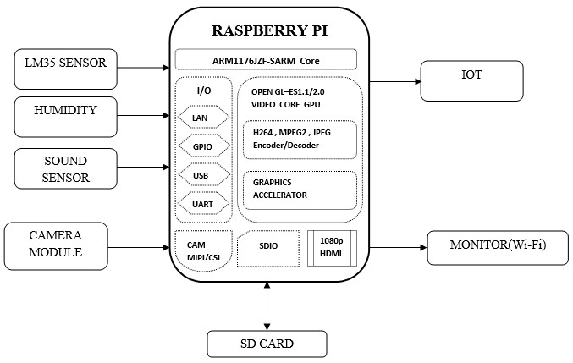

**HARDWARE DESCRIPTION**

1. Raspberry Pi
2. Temperature (LM 35)
3. Humidity Sensor
4. Sound Sensor
5. MCP3008(ADC IC)
6. USB Camera
7. SD card
8. Monitor

**1. RASPBERRY PI**

The Raspberry Pi is a low cost, credit-card sized computer that plugs into a computer monitor or TV, and uses a standard keyboard and mouse. It is a capable little device that enables people of all ages to explore computing, and to learn how to program in languages like Scratch and Python. It’s capable of doing everything you’d expect a desktop computer to do, from browsing the internet and playing high-definition video, to making spreadsheets, word-processing, and playing games.

What’s more, the Raspberry Pi has the ability to interact with the outside world, and has been used in a wide array of digital maker projects, from music machines and parent detectors to weather stations and tweeting birdhouses with infra-red cameras. We want to see the Raspberry Pi being used by kids all over the world to learn to program and understand how computers work.

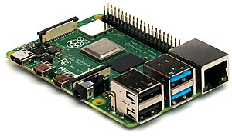

**Raspberry pi Model**

**2. TEMPERATURE (LM 35)**

LM35 is a temperature measuring device having an analog output voltage proportional to the temperature. It provides output voltage in Centigrade (Celsius). It does not require any external calibration circuitry. The sensitivity of LM35 is 10 mV/degree Celsius. As temperature increases, output voltage also increases. E.g. 250 mV means 25°C. It is a 3-terminal sensor used to measure surrounding temperature ranging from -55 °C to 150 °C. LM35 gives temperature output which is more precise than thermistor output.

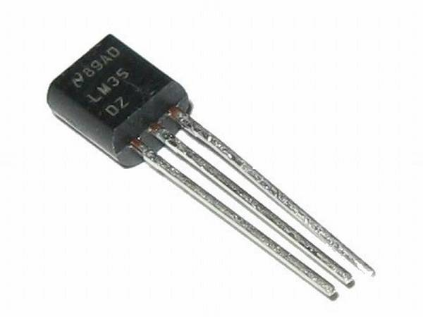

**LM35 Temperature Sensor**

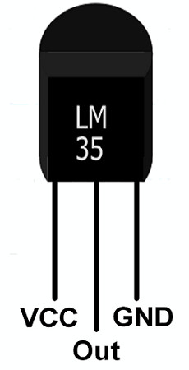

**Pin Description**

**3. HUMIDITY SENSOR**

Humidity is defined as the amount of water present in the surrounding air. This water content in the air is a key factor in the wellness of mankind. For example, we will feel comfortable even if the temperature is 00C with less humidity i.e. the air is dry.But if the temperature is 100C and the humidity is high i.e. the water content of air is high, then we will feel quite uncomfortable. Humidity is also a major factor for operating sensitive equipment like electronics, industrial equipment, electrostatic sensitive devices and high voltage devices etc. Such sensitive equipment must be operated in a humidity environment that is suitable for the device.Absolute Humidity (AH) sensors or Relative Humidity (RH) sensors. Humidity Sensors can also be classified based on the parameter used for measuring Humidity i.e. Capacitive Humidity Sensors, Electrical Conductivity (or Resistive) Humidity Sensors and Thermal Conductivity Humidity Sensors.There are other types of Humidity Sensors or Hygrometers like Optical Hygrometer, Oscillating Hygrometer and Gravimetric Hygrometer.

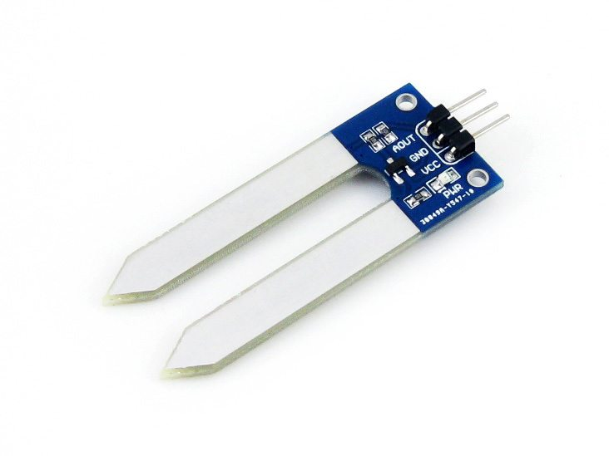

HUMIDITY SENSOR

**4. Sound Sensor**

The sound [sensor is one type of module](https://www.elprocus.com/map-sensor-working-and-its-applications/) used to notice the sound. Generally, this module is used to detect the intensity of sound. The applications of this module mainly include switch, security, as well as [monitoring](https://www.elprocus.com/wireless-monitoring-hardware-for-insightcm-by-national-instruments/). The accuracy of this sensor can be changed for the ease of usage.

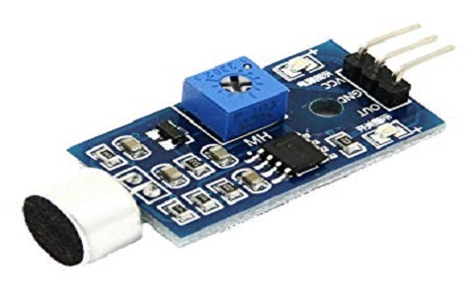

SOUND SENSOR

**5. MCP3008(ADC IC)**

The MCP3008 is a low cost 8-channel 10-bit analog to digital converter.  The precision of this ADC is similar to that of an Arduino Uno, and with 8 channels you can read quite a few analog signals from the Pi.  This chip is a great option if you just need to read simple analog signals, like from a temperature or light sensor.  If you need more precision or features, check out the ADS1x115 series on the next page.

Before you use the MCP3008 it will help to skim this older Raspberry Pi MCP3008 guide for more information about using it with the Raspberry Pi.  However **don't** use the code from the older guide as it's deprecated.  This guide will show you an easier way to install and use new Python code to talk to the MCP3008 ADC.

The MCP3008 datasheet is also an important resource to skim and have handy

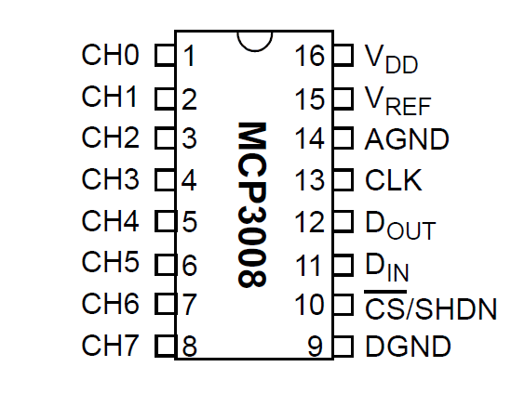

**Pin Diagram**

**SOFTWARE DESCRIPTION:**

**1. NOOBS- OS:**

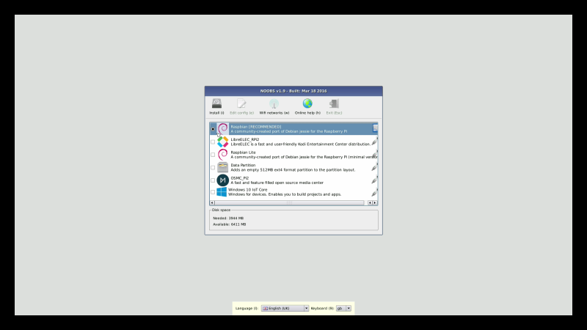

One of the things we love about the Raspberry Pi is just how easy it is to get started. A lot of this is down to a custom simple-to-use installer called NOOBS.

NOOBS (or "New Out Of the Box Software" to give it its full name) is a unique installation image. With NOOBS loaded on an SD Card you can install a wonderful range of operating systems for your Raspberry Pi.

<https://www.raspberrypi.org/magpi/install-noobs-raspberry-pi/>

More importantly, you can speedily set up a new Raspberry Pi with Raspbian, the official operating system. NOOBS is an essential tool for newcomers.

When you start up a Raspberry Pi with NOOBS for the first time, you the option to install the Raspbian Operating system. Connect the Raspberry Pi to a network and you'll also get a bunch of other operating systems to choose from.

From there it's just a matter of picking the OS you want, and letting NOOBS do its thing. The NOOBS installer wipes the Micro SD card and sets up the operating system.

When the Raspberry Pi restarts you'll no longer see NOOBS but your operating system.

In this tutorial we're going to help absolute newcomers install Raspbian Jessie with PIXEL (the official operating system). But don't forget you can use NOOBS to experiment with other operating systems. NOOBS isn't just great for beginners, it's also ideal for exploring what other operating systems have to offer.

**Step 1: Download NOOBs**

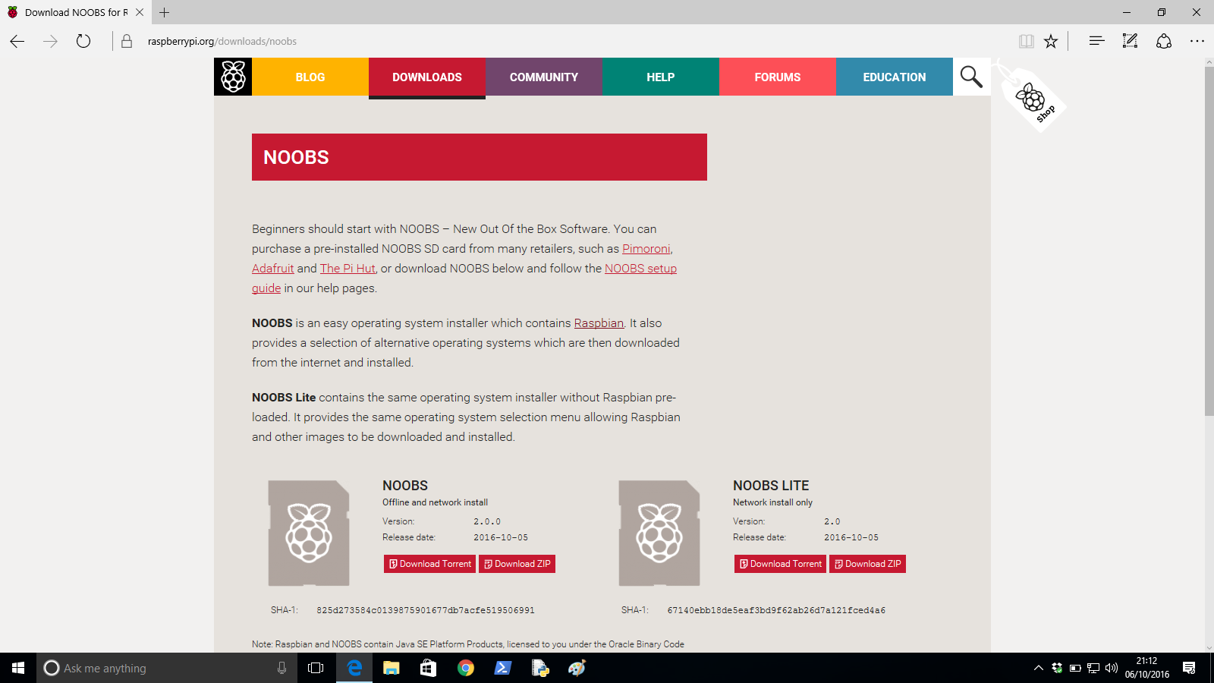Beginner's Guide to NOOBS

Open your web browser and visit [raspberrypi.org/downloads/noobs/](https://www.raspberrypi.org/downloads/noobs/). Click on Download ZIP under NOOBS Offline and network install. Save the zip file to your Downloads folder and extract its contents

**Step 2: SD Card**

Beginner's Guide to NOOBS

Download SD Card Formatter from sdcard.org and open the program (click Yes in User Account Control alert on Windows). Attach your Micro SD card and the card will appear in Drive. Enter "SD CARD" in the Volume Label so you can identify it in the next step. Click Format (enter your password on a Mac). Answer OK to the alerts.

**Step 3: Copy the files**

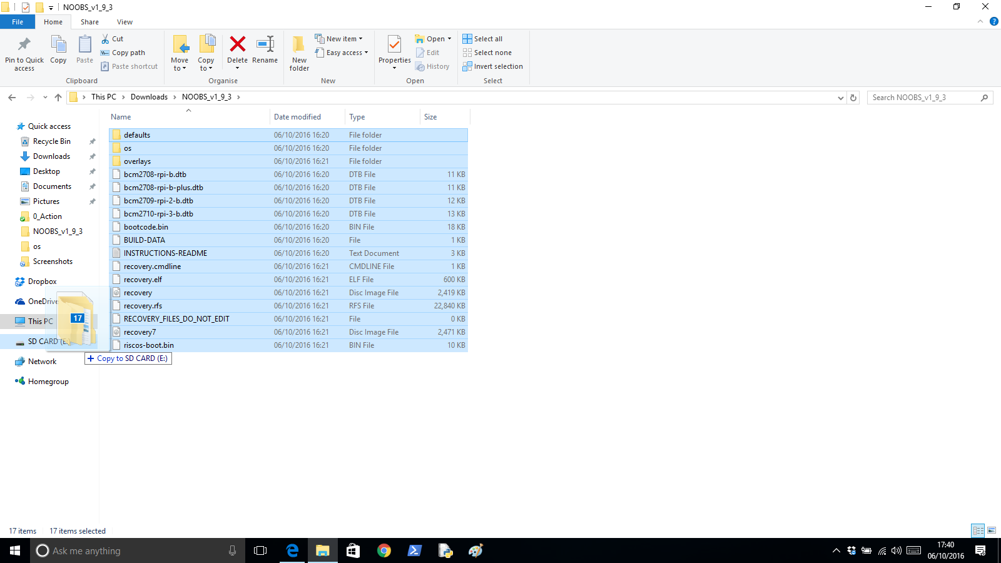Beginner's Guide to NOOBS

Return to your downloads and open the folder containing the NOOBS files. Make sure you are looking at the files inside the folder, and not the folder itself. Select all the files in the NOOBS folder and drag them to the SD Card folder (in the sidebar).

**Step 4: Power up**

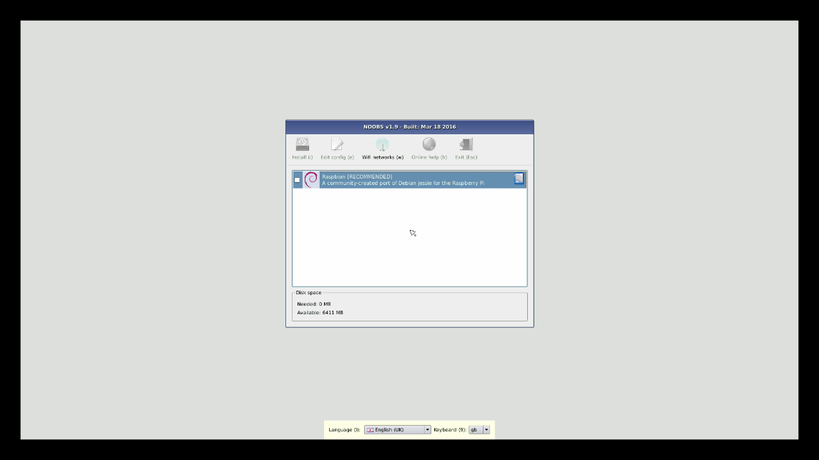Beginner's Guide to NOOBS

Eject the Micro SD card from your computer. Place it into your Raspberry Pi and power it up. You'll be greeted by the NOOBS v1.9 screen. If you have not connected to the Internet you'll see just a single option: Raspbian [RECOMMENDED]

**Step 5: Connect to network**

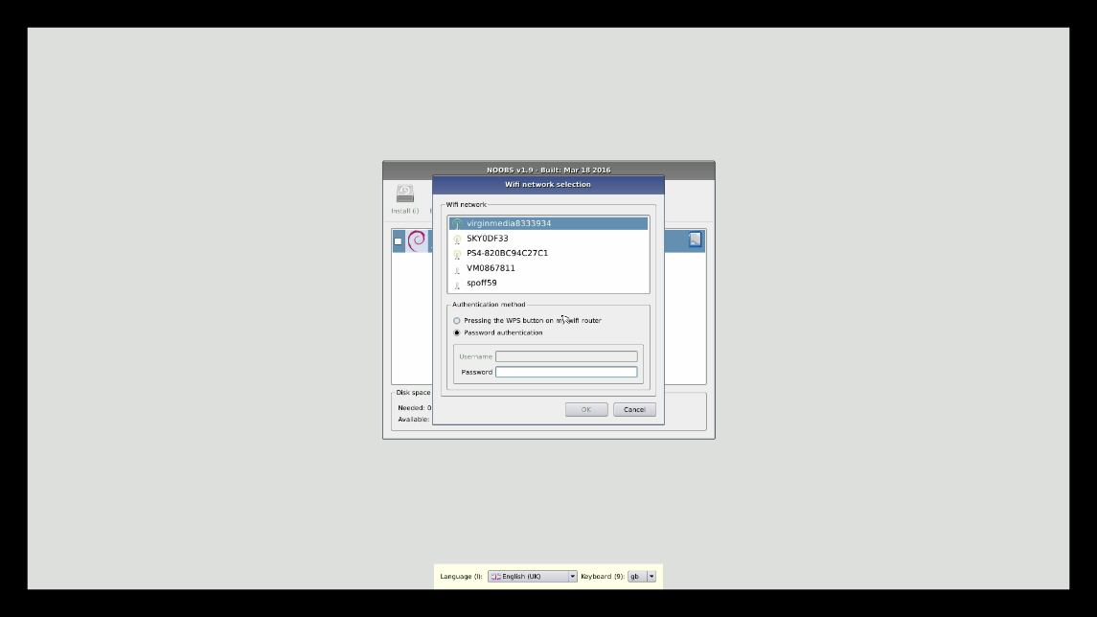Beginner's Guide to NOOBS

To access more operating system options, connect the Raspberry Pi to a network. Attach an Ethernet cable or click Wifi networks. Choose your wireless network and enter the Password. Click OK. You'll now see a wider range of options (as shown in the main image opposite).

**Step 6: Install Raspbian**

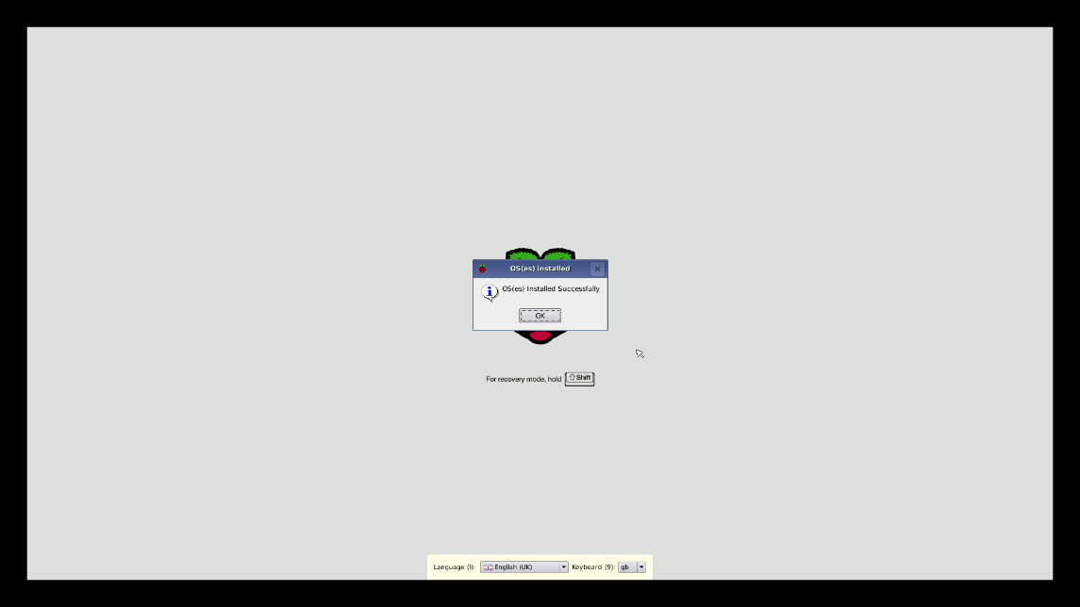Beginner's Guide to NOOBS

We're going to go with Raspbian, so place a tick next to Raspbian [RECOMMENDED] and click Install. Click Yes in the alert window. The NOOBs software is copied to the Micro SD Card. NOOBS displays "OS(es) Installed Successfully" when the software is installed. Click OK and the Raspberry Pi will restart and boot into the operating system.

**2. PYTHON**

Python is an interpreted, object-oriented, high-level programming language with dynamic semantics. Its high-level built in data structures, combined with dynamic typing and dynamic binding, make it very attractive for Rapid Application Development, as well as for use as a scripting or glue language to connect existing components together. Python's simple, easy to learn syntax emphasizes readability and therefore reduces the cost of program maintenance. Python supports modules and packages, which encourages program modularity and code reuse. The Python interpreter and the extensive standard library are available in source or binary form without charge for all major platforms, and can be freely distributed.

Often, programmers fall in love with Python because of the increased productivity it provides. Since there is no compilation step, the edit-test-debug cycle is incredibly fast. Debugging Python programs is easy: a bug or bad input will never cause a segmentation fault. Instead, when the interpreter discovers an error, it raises an exception. When the program doesn't catch the exception, the interpreter prints a stack trace. A source level debugger allows inspection of local and global variables, evaluation of arbitrary expressions, setting breakpoints, stepping through the code a line at a time, and so on. The debugger is written in Python itself, testifying to Python's introspective power. On the other hand, often the quickest way to debug a program is to add a few print statements to the source: the fast edit-test-debug cycle makes this simple approach very effective.

### Applications of Python

* GUI based desktop applications
  + Image processing and graphic design applications
  + Scientific and computational applications
  + Games
* Web frameworks and web applications
* Enterprise and business applications
* Operating systems
* Language development
* Prototyping

### Advantages/Benefits of Python

The diverse application of the Python language is a result of the combination of features which give this language an edge over others. Some of the benefits of programming in Python include:

#### 1. Presence of Third Party Modules:

The Python Package Index (PyPI) contains numerous third-party modules that make Python capable of interacting with most of the other languages and platforms.

#### 2. Extensive Support Libraries:

Python provides alarge standard library which includes areas like internet protocols, string operations, web services tools and operating system interfaces. Many high use programming tasks have already been scripted into the standard library which reduces length of code to be written significantly.

#### 3. Open Source and Community Development:

Python language is developed under an OSI-approved open source license, which makes it free to use and distribute, including for commercial purposes.

Further, its development is driven by the community which collaborates for its code through hosting conferences and mailing lists, and provides for its numerous modules.

#### 4. Learning Ease and Support Available:

Python offers excellent readability and uncluttered simple-to-learn syntax which helps beginners to utilize this programming language. The code style guidelines, PEP 8, provide a set of rules to facilitate the formatting of code. Additionally, the wide base of users and active developers has resulted in a rich internet resource bank to encourage development and the continued adoption of the language.

#### 5. User-friendly Data Structures:

Python has built-in list and dictionary data structures which can be used to construct fast runtime data structures. Further, Python also provides the option of dynamic high-level data typing which reduces the length of support code that is needed.

#### 6. Productivity and Speed:

Python has clean object-oriented design, provides enhanced process control capabilities, and possesses strong integration and text processing capabilities and its own unit testing framework, all of which contribute to the increase in its speed and productivity. Python is considered a viable option for building complex multi-protocol network applications.

**Code of Python Programming:**

"""Function to fetch words."""

import random

WORDLIST = 'wordlist.txt'

def get_random_word(min_word_length):

"""Get a random word from the wordlist using no extra memory."""

num_words_processed = 0

curr_word = None

with open(WORDLIST, 'r') as f:

for word in f:

if '(' in word or ')' in word:

continue

word = word.strip().lower()

if len(word) < min_word_length:

continue

num_words_processed += 1

if random.randint(1, num_words_processed) == 1:

curr_word = word

return curr_word

The output is as follows:

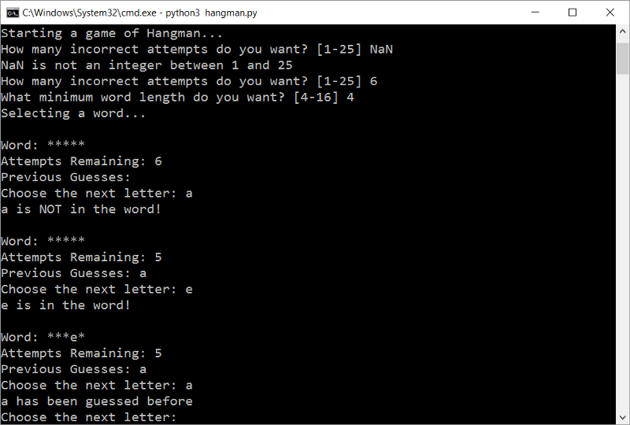

**3. WEB APPLICATION**

Web Application Monitoring (sometimes referred to as “Transaction Monitoring”) is a form of Synthetic Monitoring that routinely tests and verifies the proper function of a website when responding to user input such as logging in or making a purchase. A software application loads the web application into a web browser, and using an automation script, the software application performs the user interactions and reports on the web application's performance and sends alerts in the event of an error.

**How does Web Application monitoring work:-**

Web Application Monitoring appears simple on the surface, but it can quickly become quite complicated. To help keep web application monitoring simple, services first identify their “happy paths.” A happy path is the steps an end user takes to complete a single transaction on the website or web service. The monitoring service builds a script based on the happy path. The monitoring service uses the script to conduct regularly scheduled tests to ensure that the functionality and performance meet expectations. For example, to verify that the login process works properly the remote computer checkpoint will:

**Server availability:** – As long as a server or device recognizes TCP/IP protocol, a monitoring service can verify availability for the device and selected ports. A monitoring service can check the availability as frequently as once per minute preventing costly downtime and lost productivity over the web or behind the firewall.

**Process for operating that web page:-**

1.     Navigate to the login page using a browser

2.     Input a user ID

3.     Input a password

4.     Click submit

5.     Wait for the response

6.     Report findings to the web application monitoring company.

**4. PHP FRONT END**

The PHP parser (front end) enables the construction of PHP custom analysis tools, or source transformation tools. It is a member of [SD's family of language front ends](http://www.semdesigns.com/Products/FrontEnds/index.html?Home=PHPFrontEnd), based on [first-class infrastructure (DMS) for implementing such custom tools](http://www.semdesigns.com/Products/DMS/DMSToolkit.html?Home=PHPFrontEnd). The PHP front end includes:

* Lexical analysis including parsing sources in ASCII and ISO8859-1, and UNICODE
  + Conversion of literal values (numbers, escaped strings) into native values to enable easy computation over literal values
  + String literals represented internally in UNICODE to support 16-bit characters
* Explicit grammar directly implements PHP4, PHP5 and PHP7
  + Full PHP parser
  + All dialects for PHP4, PHP5 and PHP7 are available
* Automatic construction of complete abstract syntax tree
  + Capture of comments and formats (shape) of literal values
  + Ability to parse large systems files into same workspace, enabling interprocedural and cross-file analysis/transformation
  + Ability to parse different languages into same workspace, enabling cross-language analysis/transformation
* Facilities to process syntax trees
  + Complete procedural API to visit/query/update/construct/print syntax trees
  + Source regeneration by prettyprinting and/or fidelity printing of syntax trees with comments and lexical formats
  + Automatically generated source-to-source transformation system
  + Ability to define custom attribute-grammar-based analyzers
* Available as source code to enable complete customization
  + Means to manage multiple language dialects with highly shared common core
* Robustness due to careful testing and application across many customers

Many of these facilities come as a consistent consequence of the front end being built to top of [DMS](http://www.semdesigns.com/Products/DMS/DMSToolkit.html?Home=PHPFrontEnd).

Here are some sample tools (many offered by SD as products) built using the PHP front end:

* [Source Formatter](http://www.semdesigns.com/Products/Formatters/PHPFormatter.html?Home=PHPFrontEnd)
* [Source Obfuscator](http://www.semdesigns.com/Products/Obfuscators/PHPObfuscator.jsp?Home=PHPFrontEnd)
* [Test Coverage Analysis](http://www.semdesigns.com/Products/TestCoverage/PHPTestCoverage.jsp?Home=PHPFrontEnd)
* [Performance Profiler](http://www.semdesigns.com/Products/Profilers/PHPProfiler.html?Home=PHPFrontEnd)

Your organization may use DMS with the PHP front end to implement and deploy your own custom tools. The sample tools can be obtained in source form as part of the PHP front end for customization. Semantic Designs is also willing to build custom tools under contract.

### Examples of Front Endweb development developer

### 1) Novi Builder

[Novi Builder](https://bit.ly/2LSCXXo) is a drag-and-drop builder that can be called a great choice for an experienced web-developer. It provides them with access to the source code and allows making multiple changes in design. You will get full control of your online-project and get a chance to make the most out of its functionality. Despite the fact that it can be a little bit hard to use for beginners, there are different benefits that outweigh this weakness.

**Features:**

* advanced code editor;
* additional apps integration;
* a wide selection of pre-made themes;
* drag-and-drop interface;
* eCommerce support;
* preview tool.

### 2) [ONE Subscription](https://bit.ly/2YYyRB0)

[ONE Subscription](https://bit.ly/2YYyRB0) is an effective web-development kit that allows getting access to a great number of top-quality digital products. It boasts tons of high-quality items that make it possible to launch fully-fledged blogs, online-stores, landing pages, and other websites. In general, you will be provided with thousands of themes and templates, different plugins and graphic elements, additional services, and other advantages.

**Features:**

* professional support for all items;
* regular updates;
* security (you can easily cancel your subscription within 14 days after its starts if you have not downloaded anything from the database);
* unlimited yearly license;
* useful services (as an example, template customization or installation).

### 3) [Creative Tim](https://bit.ly/2JMju8g)

[Creative Tim](https://bit.ly/2JMju8g) provides Bootstrap based design elements, which help you faster your development work. You can create web and mobile apps using this tool.

**Features:**

* Provide the easiest way to get started is to use one of our pre-built example pages.
* Using this tool helps you to save your time and as it allows you to focus on your business model.
* Offers an easy to use Admin Templates
* Admin Dashboards helps you to save a large amount of time
* Offers pre-Made Sections & Elements

**Features:**

* Provide the easiest way to get started is to use one of our pre-built example pages.
* Using this tool helps you to save your time and as it allows you to focus on your business model.
* Offers an easy to use Admin Templates
* Admin Dashboards helps you to save a large amount of time
* Offers pre-Made Sections & Element

### 4) Npm:

[Npm](https://www.npmjs.com/) is the Node package manager for JavaScript. It helps to discover packages of reusable code and assemble them in powerful new ways. This web development tool is a command-line utility for interacting with a said repository that aids in the package.

**Features:**

* Discover and reuse over 470,000 free code packages in the Registry
* Encourage code discovery and reuse within teams
* Publish and control access to namespace
* Manage public and private code using the same workflow

### 5) AngularJS:

### [AngularJS](https://www.guru99.com/angularjs-tutorial.html) is another must-have tool for front-end developers. It is an open-source web application framework. It helps to extend the HTML syntax for web applications. It simplifies front-end development process by developing accessible, readable and expressive environment.

### ****Features:****

* It is an is open source, completely free, and used by thousands of developers around the world
* It offers to create RICH Internet Application
* It provides option to write client side application using JavaScript using MVC
* It automatically handles JavaScript code suitable for each browser

Example of PHP Front End coding for Angular JS

<!doctype html>

<htmlng-app>

<head>

<scriptsrc="https://ajax.googleapis.com/ajax/libs/angularjs/1.7.8/angular.min.js"></script>

</head>

<body>

<div>

<label>Name:</label>

<inputtype="text"ng-model="yourName"placeholder="Enter a name here">

<hr>

<h1>Hello {{yourName}}!</h1>

</div>

</body>

**5. My SQL DB:**

# SQL server monitoring:-

SQL server monitoring is the process of collecting, aggregating, and monitoring various metrics of SQL servers. Microsoft SQL servers are widely-used enterprise database systems; more often than not, whenever there are latency problems, SQL database servers have been identified as the culprit. Therefore, an SQL Server Monitor must be employed to maintain the health and availability of SQL databases, as unavailability of these servers greatly affects businesses.

Basic SQL monitoring tools only provide information about the SQL servers employed in your IT infrastructure and their relevant parameters. With the right SQL server monitoring tools, you can do much more—optimize the performance of SQL servers and maintain them at peak health, identify fault zones, set thresholds, prevent the occurence of errors, and troubleshoot the inevitable ones quickly.

# Windows Server Monitoring

Windows Server Operating system is designed to run on servers which operate within a client-server architecture. These servers are usually designed to handle heavy workloads and serve as the backbone of most software operations involved in businesses. Therefore, Windows server monitoring is crucial to businesses in order to prevent any loss of service due to performance issues and to maintain the seamless flow of operations. Using Windows server monitoring tools, you can increase the performance and availability of Windows by fast detection and troubleshooting of errors and error patterns preceding system failure.

Manage Engine Applications Manager's Windows server monitor provides an agentless approach to Windows service monitoring with its out of the box monitoring capabilities. Ensure that key performance attributes such as CPU, memory, disk utilizations are within permissible usage and ensure that applications hosted on these servers always run at peak performance.

# Big Data Monitoring

The enormous growth in the volume of data shared and exchanged each day on the web has become unimaginable. Organizations are slowly pushing towards a low cost and low complexity big data environment planning ahead for the future.

Quite often, analysing this chaotic data could reveal something of business value and help admins in better understanding and implementing new business strategies. The complexities associated with handling big data has brought programming frameworks like Hadoop and Apache Spark to the fore because of their strong ability to effectively handle big data.

**CONCLUSION:**

Looking after babies care is hard problem worldwide. Babies are society future.    
   
This system will emphasize the importance of baby care. This “Baby Monitoring System” will be an economical and user friendly and very useful for the working parent and also for nurses/nanny.  They will be able to manage their work efficiently. Proposed Baby Monitoring System is an inexpensive and simple to use, which can improve the quality of infantparent communication.  As GSM technology is used which makes the users to communicate for longer distances.

This is a convenient system to monitor the baby's health condition from any distance.  Proposed  Infant  Monitoring System is an inexpensive and simple to use, which can improve the quality of infant-parent communication. This system expressively provides the parents with the feeling of assurance. The constant capturing of multiple biological parameters of the baby and analysis of the overall health helps mother to understand the internal status of the baby. As GSM technology is used  which makes the users to communicate for longer distances. This is a convenient system to monitor  the baby's health condition from any distance.

The tools and techniques mentioned lead to the development of a low-cost neonatal monitoring system. Consequently, the proposed low-cost system can enhance the quality of life of patients, especially those from lowincome households. The developed working model utilizes Bluetooth Mate Silver and Arduino pro mini integrated together with programming to exhibit accurate information transmission and display. Test results demonstrate that the model framework effectively transmits and gets information from various sensors inside the scope of 20 meters.

Unlike the current systems being employed at hospitals, the prototype developed is non-invasive, non-obtrusive, and incorporates wearable and wireless technology. The neonatal jacket provides comfort whilst measuring the vital signs as it lessens the obstruction caused to the infant as well as the medical personnel handling the system. Despite the lower efficiency output of the fabric electrodes when compared to the traditionally used Ag/AgCl electrodes, the ECG obtained had shown minimalistic noise. The prototype additionally has the advantage of being portable and battery powered, and hence can be used not only as a monitoring system at the NICU, but also as a home health monitoring system

**REFERENCE**

[1] .S.Sundar, Rohan Ghosh, Harris Shahil, A PROTOTYPE OF AUTOMATED CHILD MONITORING SYSTEM, International Journal of Computational Intelligence Research ISSN 0973-1873 Volume 13, Number 7 (2017), pp. 1593-1603  
[2] . Shatha K. Jawad, Al-Gawagzeh Mohammed Yousef, Balkiest Essa Al-Shagoor, A MULTIPURPOSE CHILD MONITORING SYSTEM DESIGN AND IMPLEMENTATION, International Journal of Soft Computing applications ISSN 1453-2277 Issue 4 (2009), pp.57-68.  
[3] . Stephen H. Scott, OPTIMAL FEEDBACK CONTROL AND THE NEURAL BASIS OF VOLITIONAL MOTOR CONTROL, Nature Publishing Group (2004), Volume 5, pp. 532546. doi: 10.1038/nrn1427  
[4] . Vibhor Gupta, WORKING AND ANALYSIS OF THE HBRIDGE MOTOR DRIVER CIRCUIT DESIGNED FOR WHEELED MOBILE ROOTS,International Conference on Advanced Computer Control (2010) Volume 3, pp. 441-444. doi: 10.1109/ICACC.2010. 5486818  
[5] . Chirag Yadav, Ankit Pandey, Mayank Saraogi, Shubham Tribhuwan, ACTIVE RFID AND ESP8266 BASED CHILD MONITORING SYSTEM, International Journal of Computer Applications ISSN 0975-8887 Volume139, Number 12 (2016) pp. 22-25  
[6] . J. Saranya,J.Selvakumar, IMPLEMENTATION OF CHILDREN TRACKING SYSTEM ON ANDROID MOBILE TERMINALS, International Conference on Communication and Signal Processing(2013), pp. 961-965, doi: 10.1109/iccsp.2013.6577199

[7].   N. M. Z. Hashim, "Development of Optimal Photosensors Based Heart Pulse  Detector",International Journal of Engineering and Technology (IJET) Aug-Sep2013.s

[8].   Nur Ilyani Ramli, Mansour Youseffi, and Peter Widdop, "Design and Fabrication of a low cost heart monitor using reflectance Photoplethysmogram",World Academy of science, Engineering and Technology 08 2011,pages 417 to 418.

[9]. Carsten Linti, Hansjurgen Horter, Peter Osterreicher,and  Heinrich Planck, "Sensory baby vest for the monitoring of infant", International workshop on Wearable and Implantable Body Sensor Networks, BSN 2006,3-5 April 2006.

[10]. Sharief F. Babiker, Liena Elrayah Abdel-Khair, and Samah M. Elbasheer, "Microcontroller Based Heart Rate Monitor using Fingertip Sensors", UofKEJ Vol. 1 Issue 2 pp. 47-51 (October 2011.

[11].  Prof.K.Padmanabhan, "Microcontroller-Based Heart-Rate Meter", electronics for you ,[www.efymag.com](http://www.efymag.com/). [12]. S.Deepika, V.Saravanan, "An Implementation of Embedded Multi Parameter Monitoring System for Biomedical Engineering", International

https://ssl.gstatic.com/ui/v1/icons/mail/images/cleardot.gif