**LITERATURE**

**SURVEY**

**PAPER 1**

**Artificial Neural Network Based Detection of Skin**

**Cancer**

**This paper appears in:** International Journal of Advanced Research in Electrical, Electronics And Instrumentation Engineering

**Date of Publication:** September 2012

**Author(s):**Dr. J. Abdul Jaleel, SibiSalim, Aswin.R.B

**Abstract:** Skin cancers are the most common form of cancers in humans. It is a deadly type of cancer. Most of the skin cancers are cureable at initial stages. So an early detection of skin cancer can save the patients. With the advancement of technology, early detection of skin cancer is possible. One such technology is the early detection of skin cancer using Artificial NeuralNetwork. The diagnosing methodology uses Image processing techniques and Artificial Intelligence. The dermoscopy image of skin cancer is taken and it is subjected to various pre-processing for noise removal and image enhancement. Then the image is

undergone image segmentation using Thresholding. There are certain features unique for skin cancer regions. Such features are extracted using feature extraction technique - 2D Wavelet Transform method. These features are given as the input nodes to the neural network. Back-Propagation Neural (BPN) Network is used for classification purpose. It classifies the given data set into cancerous or non-cancerous.

**PAPER 2**

**A Preliminary Approach for Automated Recognisation of Malignant Melanoma**

**This paper appears in:**Image and Stereol ‘Original Research Paper’

**Date of publication:**March 2004

**Author(s):**EzzeddineZagrouba and WalidBarhoumi (Campus University, Tunisia)

**Abstract:**This work is motivated by the desire to classify skin lesions as malignant or benign from color photographic slides of the lesions. Thus, we use color images of skin lesions, image processing techniques and artificial neural network classifier to distinguish melanoma from benign pigmented lesions. As the first step of the data set analysis, a preprocessing sequence is implemented to remove noise and undesired structures from the color image. Second, an automated segmentation approach localizes suspicious lesion regions by region growing after a preliminary step based on fuzzy sets. Then, we rely on quantitative image analysis to measure a series of candidate attributes hoped to contain enough information to differentiate melanomas from benign lesions. At last, the selected features are supplied to an artificial neural network for classification of tumor lesion as malignant or benign. For a preliminary balanced training/testing set, our approach is able to obtain 79.1% of correct classification of malignant and benign lesions on real skin lesion images.

**CONCLUSION:**

In this study, attempt to diagnose melanoma from color skin images using image processing techniques and an artificial neural network classifier is made. Towards the end, the paper relied on a preprocessing step essentially based on a median filter for its ability to remove noise and undesired components. Then, a PCA like analysis is performed to enhance edges. An automated segmentation approach permitted to localize suspicious lesion region by region growing after a preprocessing step based on fuzzy sets.. Finally, a mono-layer perceptron was trained with these attributes in order to classify the lesion as melanoma or nonmelanoma.

**PAPER 3**

**Automated Melanoma Recognition**

**This paper appears in:**IEEE Transactions On Medical Imaging, VOL. 20, NO. 3

**Date of Publication:**March 2001

**Author(s):**HaraldGanster, Axel Pinz, ReinhardRöhrer, Ernst Wildling,

Michael Binder and Harald Kittler

**Abstract:** A system for the computerized analysis of images obtained from ELM has been developed to enhance the early recognition of malignant melanoma. As an initial step, the binary mask of the skin lesion is determined by several basic segmentation algorithms together with a fusion strategy. A set of features containing shape and radiometric features as well as local and global parameters is calculated to describe the malignancy of a lesion. Significant features are then selected from this set by application of statistical feature subset selection methods. The final KNN classification delivers a sensitivity of 87% with a specificity of 92%.

**PAPER 4**

**Image Processing for Skin Cancer Features Extraction**

**This paper appears in:** International Journal of Scientific & Engineering Research Volume 4, Issue 2

**Date of Publication:** February 2013

**Author(s):** Md. AmranHossen Bhuiyan, Ibrahim Azad, Md. Kamal Uddin

**Abstract:** The application of image processing for diagnostics purpose is a non-invasive technique. There is currently a great interest in the prospects of automatic image analysis method for image processing, both to provide quantitative information about a lesion, which can be relevant for the clinical, and as a standalone early warning tool. In order to achieve an effective way to identify skin cancer at an early stage without performing any unnecessary skin biopsies, digital images of melanoma skin lesions have been investigated. To achieve this goal, feature extraction is considered as an essential-weapon to analyze an image appropriately. In this paper, different digital images have been analyzed based on unsupervised segmentation techniques. Feature extraction techniques are then applied on these segmented images. After this, a comprehensive discussion has been explored based on the obtained results.

**PAPER 5**

**Automated Malignant Melanoma Detection Using MATLAB**

**This paper appears in:**Proceedings of the 5th WSEAS Int. Conf. on DATA NETWORKS, COMMUNICATIONS & COMPUTERS, Bucharest, Romania

**Date of Publication:** October 2006

**Author(s):**G. Grammatikopoulos, A. Hatzigaidas, A. Papastergiou, P. Lazaridis, Z. Zaharis, D. Kampitaki, G. Tryfon

**Abstract:** Malignant melanoma, the most deadly form of skin cancer, has a good prognosis if treated in the curable early stages. Early diagnosis and surgical excision is the most effective treatment of melanoma. Well-trained dermatologists reach a high level of diagnostic accuracy but their performance is increased by using computer aided numerical imaging tools. This study is limited in the use of simple image processing algorithms, for the sake of clarity, in order to illustrate the use of MATLAB in the calculation of the ABCD Total Dermatoscopy Score (TDS) for potentially malignant melanomas. A high ABCD score means that alesion is more likely to be a malignant melanoma. It has been demonstrated in this study that Matlab is a powerful tool for the early prediction and diagnosis of malignant melanoma by using numerical image.

**PAPER 6**

**Automatic Detection of Melanoma Skin Cancer Using Texture Analysis**

**This paper appears in:** International Journal of Computer Applications

**Date of Publication:** October 2009

**Author(s):** Mariam A.Sheha Mai S.Mobrouk AmrSharawy

(Cairo University) (MUST University) (Cairo University)

**Abstract:** Melanoma is considered the most dangerous type of skin cancer. Early and accurate diagnosis depends mainly on important issues, accuracy of feature extracted and efficiency of classifier method. This paper presents an automated method for melanoma diagnosis applied on a set of dermoscopy images. Features extracted are based on gray level Co-occurrence matrix (GLCM) and Using Multilayer perceptron classifier (MLP) to classify between Melanocytic Nevi and Malignant melanoma. MLP classifier was proposed with two different techniques in training and testing process: Automatic MLP and Traditional MLP. Results indicated that texture analysis is a useful method for discrimination of melanocytic skin tumors with high accuracy. The first technique, Automatic iteration counter is faster but the second one, Default iteration counter gives a better accuracy, which is 100 % for the training set and 92 % for the test set.

**PROJECT OVERVIEW**

**Introduction:** The incidence of cutaneous melanoma, the most lethal of the skin cancers, has risen every year since 1979.Every year around 2.5–3 million skin lesions are biopsied in the US, and a fraction of these – between 50,000 and 100,000 – are diagnosed as melanoma. Diagnostic instruments that allow early detection of melanoma are the key to improving survival rates and reducing the number of unnecessary biopsies, the associated morbidity, and the costs of care.

**Problem:** If melanoma is detected at an early stage, before the tumor has penetrated the epidermis, the 5-year survival rate is about 99%. However, the 5-year survival rate drops dramatically – to 15% – for patients with advanced disease. At present, there are no systemic treatments available that significantly extend the life span of patients with advanced melanoma therefore; the key to extended survival is early detection and treatment. In order to enable early detection and diagnosis, avoid unnecessary biopsies, and ultimately reduce the cost of care, it is essential to develop accurate, sensitive, and objective quantitative diagnostic instruments that have the potential to have a deep impact on the disease.

**Solution:** Dramatic advances in solid-state electronics and instrumentation, imaging hardware, computers, and software tools, including image-analysis techniques, have opened new avenues for quantitative imaging for the detection of melanoma. This review highlights and compares some of the emerging technologies that hold the promise of melanoma diagnosis. The emphasis of the review is placed on the technology aspect of the instrumentation, recent advances, challenges, and research needs.

The need to improve the efficiency, effectiveness and accuracy of melanoma diagnosis is clear. The personal and financial costs of failing to diagnose melanoma early are considerable.

**The approach:** Develop a semi-automated system that will capture 3D images of patient’s skin at reasonable cost and minimal expertise – thus facilitating broader use of this tool .The goal of the project is to develop and disseminate digital imaging standards and resources that will help to support efforts to reduce melanoma-related deaths and unnecessary biopsies by improving the early detection of this skin cancer.

**Conclusion:** Specifically, the project is designed to address the significant needs for improving the application of skin imaging technologies to the melanoma problem.

**INTRODUCTION**

**TO**

**SKIN MELANOMA**

**WHAT IS SKIN MELANOMA?**

Skin Melanoma is a [malignant](http://en.wikipedia.org/wiki/Malignant) [tumor](http://en.wikipedia.org/wiki/Tumor) of the [melanocytes](http://en.wikipedia.org/wiki/Melanocyte).  The Melanocytes produce the dark pigment, [melanin](http://en.wikipedia.org/wiki/Melanin), which is responsible for the color of skin. These cells predominantly occur in skin, but are also found in other parts of the body, including the [bowel](http://en.wikipedia.org/wiki/Bowel) and the [eye](http://en.wikipedia.org/wiki/Human_eye) . Melanoma can originate in any part of the body that contains melanocytes.

Melanoma is less common than other [skin cancers](http://en.wikipedia.org/wiki/Skin_cancer). However, it is much more dangerous if it is not found early. It causes the majority (75%) of deaths related to skin cancer. Worldwide, doctors diagnose about 160,000 new cases of melanoma yearly. In women, the most common site is the legs and melanomas in men are most common on the back. It is particularly common among [Caucasians](http://en.wikipedia.org/wiki/Caucasian_race), especially northwestern Europeans living in sunny climates. There are high rates of incidence in Oceania, Northern America, Europe, Southern Africa, and Latin America, with a paradoxical decrease in southern Italy and Sicily. This geographic pattern reflects the primary cause, [ultraviolet light](http://en.wikipedia.org/wiki/Ultraviolet_light) (UV) exposure crossed with the amount of skin pigment.[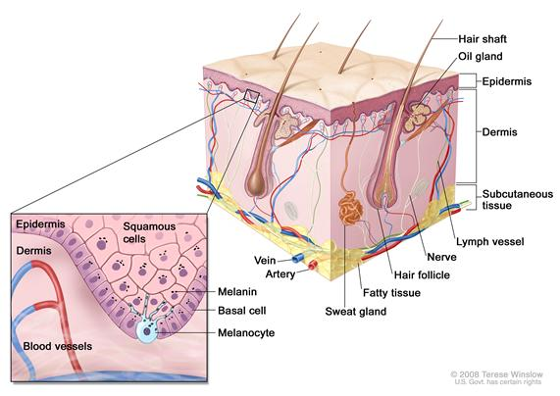](http://www.cancer.gov/PublishedContent/MediaLinks/627045.html)

**Fig. - Layers of skin**

According to a [WHO](http://en.wikipedia.org/wiki/WHO) report, about 48,000 melanoma related deaths occur worldwide per year.

The treatment includes surgical removal of the tumor. If melanoma is found early, while it is still small and thin, and if it is completely removed, then the chance of cure is high. The likelihood of the melanoma coming back or spreading depends on how deeply it has gone into the layers of the skin. For melanomas that come back or spread, treatments include [chemo-](http://en.wikipedia.org/wiki/Chemotherapy) and [immunotherapy](http://en.wikipedia.org/wiki/Cancer_immunotherapy), or [radiation therapy](http://en.wikipedia.org/wiki/Radiation_therapy).

## DIFFERENT TYPES OF MELANOMA:

Superficial spreading melanoma, nodular melanoma, and lentigno maligna melanomas make up 90% of all diagnosed malignant melanomas. Acral lentiginous melanoma and a few very rare types together make up the other 10%.

## 1. Superficial spreading melanoma

This is the most common type of melanoma. About 7 out of 10 of all melanomas in the UK (70%) are this type. They are most common in middle aged people. To start with, they tend to grow outwards rather than downwards into the skin. Doctors call this the radial growth phase. The melanoma is not usually at risk of spreading to other parts of the body until it begins to grow downwards into the deeper layers of skin and beyond. So if you have a mole that is getting bigger, particularly if it has an irregular edge, it is important to go and get it checked.

## 2. Nodular melanoma

This type of melanoma tends to develop quite quickly. It is found most often in middle aged people and in parts of the body only exposed to the sun occasionally. So it is most often found on the chest or back. It begins to grow downwards, deeper into the skin, quite quickly if it is not removed. There is often a raised area on the skin surface with this type of melanoma. Nodular melanomas are often very dark brownish black, or black, in colour. They can come up in areas of skin that have not received a great deal of sun. And they may not necessarily develop from a mole which was already there.

**3. Lentigo maligna melanoma**

About 1 in 10 melanomas (10%) are this type. They develop from very slow growing pigmented areas of skin called lentigo maligna or Hutchinson's melanotic freckle. Lentigo maligna and lentigo maligna melanoma are most common in elderly people. They appear in areas of skin that get a lot of sun exposure, so are most common on the face. They are  also more common in people who have spent a lot of time outdoors. The lentigo maligna is flat and grows outwards in the surface layers of the skin. So it may gradually get bigger over several years and may change shape. If it becomes a lentigo maligna melanoma, it starts to grow down into the deeper layers of the skin and may form lumps (nodules).

4.  **Acral lentiginous melanoma**

This type is rare and is most commonly found on the palms of the hands and soles of the feet or around the big toenail. It can also grow under the nails. It is much more common on the feet than on the hands and is the most common type of melanoma in dark skinned people.

 5. **Amelanotic melanoma**

Amelanotic means without melanin. Melanomas tend to be dark in colour, amelanotic melanomas usually have no, or very little colour. Occasionally they are pink or red, or have light brown or gray around the edges. Less than 5 out of 100 melanomas (5%) are amelanotic. Other types of melanoma such as acral lentiginous can lack colour and are amelanotic melanomas. They are often difficult to diagnose because of their lack of colour and may be mistaken for other conditions of the skin. Treatment is the same as for other types of melanoma.

**Other types of melanoma**

Melanoma can occur anywhere in the body, including in the internal organs. Melanoma of the skin is also called cutaneous malignant melanoma. Cutaneous is another word for the skin.

One area where melanoma can occur, although it is rare, is inside the eye. There are [melanocytes](http://www.cancerresearchuk.org/cancer-help/type/melanoma/about/the-skin-and-melanoma#melanocyte) in the iris (the coloured bit around the pupil) and also in a lining inside the eye called the choroid layer. If these melanocytes (the pigment producing cells) become cancerous, then this is a melanoma. If melanoma starts in the iris, a dark spot may show. But if it is anywhere else in the eye, it will only be seen if a specialist examines the eye. There is more information about [melanoma of the eye](http://www.cancerresearchuk.org/cancer-help/type/eye-cancer/about/types-of-eye-cancer#mel) in the eye cancer section.

**STAGING OF MELANOMA:**

Melanoma stages: 5 year survival rates:

**Stage 0**: Melanoma *in situ* (Clark Level I), 99.9% survival

**Stage I / II**: Invasive melanoma, 89–95% survival

* T1a: Less than 1.0 mm primary tumor thickness, without ulceration, and mitosis < 1/mm2
* T1b: Less than 1.0 mm primary tumor thickness, with ulceration or mitoses ≥ 1/mm2
* T2a: 1.01–2.0 mm primary tumor thickness, without ulceration

**Stage II**: High risk melanoma, 45–79% survival

* T2b: 1.01–2.0 mm primary tumor thickness, with ulceration
* T3a: 2.01–4.0 mm primary tumor thickness, without ulceration
* T3b: 2.01–4.0 mm primary tumor thickness, with ulceration
* T4a: Greater than 4.0 mm primary tumor thickness, without ulceration
* T4b: Greater than 4.0 mm primary tumor thickness, with ulceration

**Stage III**: Regional metastasis, 24–70% survival

* N1: Single positive lymph node
* N2: Two to three positive lymph nodes *or* regional skin/in-transit metastasis
* N3: Four positive lymph nodes *or* one lymph node and regional skin/in-transit metastases

**Stage IV**: Distant metastasis, 7–19% survival

* M1a: Distant skin metastasis, normal [LDH](http://en.wikipedia.org/wiki/Lactate_dehydrogenase)
* M1b: Lung metastasis, normal LDH
* M1c: Other distant metastasis *or* any distant metastasis with elevated LDH

**CAUSE**

All cancers are caused by damage to the [DNA](http://en.wikipedia.org/wiki/DNA) inside cells. This damage can be inherited in the form of [genetic mutations](http://en.wikipedia.org/wiki/Genetic_mutations), but in most cases, it builds up over a person's lifetime and is caused by factors in their environment. DNA damage causes the cell to grow out of control, leading to a [tumor](http://en.wikipedia.org/wiki/Tumor). Melanoma is usually caused by damage from UV light from the sun, but UV light from [sun beds](http://en.wikipedia.org/wiki/Tanning_bed) can also contribute to the disease.

**HISTORY**

Although melanoma is not a new disease, evidence for its occurrence in antiquity is rather scarce. However, one example lies in a 1960s examination of nine [Peruvian](http://en.wikipedia.org/wiki/Peru) mummies, [radiocarbon](http://en.wikipedia.org/wiki/Radiocarbon) dated to be approximately 2400 years old, which showed apparent signs of melanoma: melanotic masses in the skin and diffuse metastases to the bones.

[John Hunter](http://en.wikipedia.org/wiki/John_Hunter_(surgeon)) is reported to be the first to operate on metastatic melanoma in 1787. It was not until 1968 that microscopic examination of the specimen revealed it to be an example of metastatic melanoma.

The French physician [René Laennec](http://en.wikipedia.org/wiki/Ren%C3%A9_Laennec) was the first to describe melanoma as a disease entity. The first English language report of melanoma was presented by an English general practitioner from Stourbridge, William Norris in 1820.In his later work in 1857 he remarked that there is a familial predisposition for development of melanoma (The first formal acknowledgment of advanced melanoma as untreatable came from [Samuel Cooper](http://en.wikipedia.org/wiki/Samuel_Cooper_(surgeon)) in 1840. He stated that the only chance for a cure depends upon the early removal of the disease (i.e., early excision of the malignant mole). More than one and a half centuries later this situation remains largely unchanged.

**THE PROBLEM**

Melanoma is almost 100% curable if diagnosed early. The issue with melanoma lies not in the actual cancer cell but that it is often not diagnosed early enough. Because of the higher incidence of malignant melanoma, researchers are concerned more and more with the automated diagnosis of skin lesions. Many publications report on isolated efforts into the direction of automated melanoma recognition by image processing. Complete integrated dermatological image analysis systems are hardly found in clinical use, or are not tested on a significant number of real life samples.Our project aims to make melanoma cancer diagnosis easier so that patients are more inclined to check themselves earlier.

**PROBLEM ERADICATION**

As with many cancer diagnoses, if melanoma is diagnosed early the survival rates are good; most stage 1 and stage 2 melanomas can be cured. The performance of dermoscopy has been widely investigated, and two meta-analyses have confirmed its use increases diagnostic accuracy .But,

* Accuracy is limited between 5% and 30% compared with clinical visual inspection.
* Atypical nevi acquire several properties similar to melanoma; their recognition posed high difficulties even to experts.
* The classical ABCD(Asymmetry, Border irregularity, colour, diameter)guidance is not reliable therefore cannot be used as sole indicator for detection of melanoma

That’s why Construction of an automated, image-based system for classification of Malignant Melanoma and Dysplastic Nevi using solely the visual texture information of the lesion has been used as sole indicator for detection of melanoma for both clinical and public examination.

However the small percentage of melanoma misclassification as well as the relatively low success rate for nevus and dysplastic nevi suggests that we may not have the complete data set for the experiments.

**MELANOMA INCIDENCE**

**Graph1: Caucasian has the highest incidence of MM.**

Having fair complexion is one of the risk factors. Researches attribute this to low level of melanin that absorbs harmful UV radiation in fair skin, thus UV penetrates much deeper layer affects the surrounding cells.

**Graph2: men shows higher incidence than women.**

This graph shows that melanoma has higher incidence rate among men than women.

****

**Graph3: Incidence increases with age. Link to cumulative sun exposure**

Some studies suggested that people who had significant exposure to UV at younger age have higher risk in later age when UV exposure decreases.

**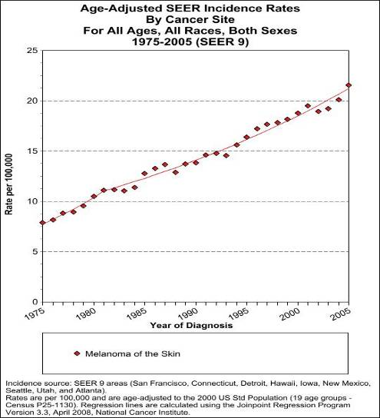**

**Graph4: It is estimated that 62,480 men and women (34,950 men and 27,530 women) will be diagnosed with and 8,420 men and women will die of melanoma of the skin in 2008**

**EXISTING TECHNOLOGIES OR ALGORITHMS**

**1. ABCDs and E of melanoma:**

One of the key educational tools used to train physicians, medical personnel and the general public on how to recognize early melanomas is the ABCDEs of Melanoma Detection. These characteristics of moles for which individuals should check their skin include Asymmetry (one half unlike the other half), Border (irregular, scalloped or poorly defined), Color (varies from one area to another; shades of tan and brown, black; sometimes white, red or blue), and Diameter.

Recently the Academy has added an “E” to these criteria, which stands for Evolving (or changing in size, shape or color)

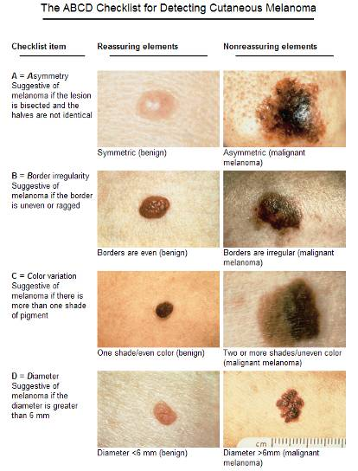

**Fig- The ABCDE Detection Technique**

**2. Dermoscopy:**

Current in vivo imaging tools commonly used by dermatologists are digital photography (total cutaneous imaging or the imaging of individual lesions) and dermoscopy. In digital photography, serial images recorded over time (photographic follow-up) are compared in order to find changes in size, shape, and color of pigmented lesions that might suggest malignancy. Since there are few surface features to distinguish melanomas from benign pigmented lesions, more dermatologists are using hand-held microscopes to identify features not visible to the naked eye.

**3. Full-body photography and mole mapping:**

Total-body photography is an important tool used by some dermatologists in the surveillance of high-risk individuals who may develop melanoma.

Some of the indications for using total-body photography include personal history of melanoma, family history of melanoma, atypical mole syndrome, or multiple moles of different size, shape and colour. Another less commonly used method of following change with pigmented lesions is mole mapping. With this technology, suspicious moles can be digitized with demoscopy cameras and reimaged at three- to six-month intervals to determine if any changes in characteristics have occurred during this time.

**TREATMENT**

Confirmation of the clinical diagnosis is done with a [skin biopsy](http://en.wikipedia.org/wiki/Skin_biopsy). This is usually followed up with a wider excision of the scar or tumor. Depending on the stage, a node biopsy is done, as well, although controversy exists around trial evidence for this procedure. Treatment of advanced malignant melanoma is performed from a multidisciplinary approach.

**Surgery:**

Excisional biopsies may remove the tumor, but further surgery is often necessary to reduce the risk of recurrence. Complete surgical excision with adequate [surgical margins](http://en.wikipedia.org/wiki/Surgical_margin) and assessment for the presence of detectable metastatic disease along with short- and long-term followup is standard. Often this is done by a [wide local excision](http://en.wikipedia.org/wiki/Wide_local_excision) (WLE) with 1 to 2 cm margins. Melanoma-in-situ and lentigo malignas are treated with narrower surgical margins, usually 0.2 to 0.5 cm. Many surgeons consider 0.5 cm the standard of care for standard excision of melanoma-in-situ. But 0.2 cm margin might be acceptable for margin controlled surgery or the double-bladed technique with margin control). The wide excision aims to reduce the rate of tumor recurrence at the site of the original lesion. This is a common pattern of treatment failure in melanoma. Considerable research has aimed to elucidate appropriate margins for excision with a general trend toward less aggressive treatment during the last decades.

Mohs surgery has been reported with cure rate as low as 77% and as high as 98.0% for melanoma-in-situ.. [CCPDMA](http://en.wikipedia.org/wiki/CCPDMA) and the "double scalpel" peripheral margin controlled surgery is equivalent to Mohs surgery in effectiveness on this "intra-epithelial" type of melanoma.

Melanomas that spread usually do so to the [lymph nodes](http://en.wikipedia.org/wiki/Lymph_nodes) in the area of the tumor before spreading elsewhere. Attempts to improve survival by removing lymph nodes surgically ([lymphadenectomy](http://en.wikipedia.org/wiki/Lymphadenectomy)) were associated with many complications, but no overall survival benefit. Recently, the technique of [sentinel lymph node](http://en.wikipedia.org/wiki/Sentinel_lymph_node) biopsy has been developed to reduce the complications of lymph node surgery while allowing assessment of the involvement of nodes with tumor.Biopsy of sentinel lymph nodes is a widely used procedure when treating cutaneous melanoma. Neither sentinel lymph node biopsy nor other diagnostic tests should be performed to evaluate early, thin melanoma, including melanoma in situ, T1a melanoma or T1b melanoma ≤ 0.5mm. People with these conditions are unlikely to have the cancer spread to their lymph nodes or anywhere else and already have a 97% 5-year survival rate. Because of these things, sentinel lymph node biopsy is [unnecessary health care](http://en.wikipedia.org/wiki/Unnecessary_health_care) for them. Furthermore, baseline blood tests and radiographic studies should not be performed only based on identifying this kind of melanoma, as there are more accurate tests for detecting cancer and these tests have high false-positive rates.

Sentinel lymph node biopsy is often performed, especially for T1b/T2+ tumors, mucosal tumors, ocular melanoma and tumors of the limbs. A process called [lymphoscintigraphy](http://en.wikipedia.org/wiki/Lymphoscintigraphy) is performed in which a radioactive tracer is injected at the tumor site to localize the sentinel node(s). Further precision is provided using a blue tracer [dye](http://en.wikipedia.org/wiki/Dye), and surgery is performed to biopsy the node(s). Routine [hematoxylin and eosin](http://en.wikipedia.org/wiki/H%26E_stain) (H&E) and [immunoperoxidase](http://en.wikipedia.org/wiki/Immunoperoxidase) staining will be adequate to rule out node involvement. [Polymerase chain reaction](http://en.wikipedia.org/wiki/Polymerase_chain_reaction) (PCR) tests on nodes, usually performed to test for entry into clinical trials, now demonstrate that many patients with a negative sentinel lymph node actually had a small number of positive cells in their nodes. Alternatively, a [fine-needle aspiration](http://en.wikipedia.org/wiki/Fine-needle_aspiration) biopsy may be performed and is often used to test masses.

If a lymph node is positive, depending on the extent of lymph node spread, a radical lymph node dissection will often be performed. If the disease is completely resected, the patient will be considered for adjuvant therapy. Excisional [skin biopsy](http://en.wikipedia.org/wiki/Skin_biopsy) is the management of choice. Here, the suspect lesion is totally removed with an adequate (but minimal, usually 1 or 2 mm) ellipse of surrounding skin and tissue. To avoid disruption of the local lymphatic drainage, the preferred surgical margin for the initial biopsy should be narrow (1 mm). The biopsy should include the epidermal, dermal, and subcutaneous layers of the skin. This enables the [histopathologist](http://en.wikipedia.org/wiki/Pathology) to determine the thickness of the melanoma by microscopic examination. This is described by [Breslow's thickness](http://en.wikipedia.org/wiki/Breslow%27s_thickness) (measured in millimeters). However, for large lesions, such as suspected lentigo maligna, or for lesions in surgically difficult areas (face, toes, fingers, eyelids), a small punch biopsy in representative areas will give adequate information and will not disrupt the final staging or depth determination. In no circumstances should the initial biopsy include the final surgical margin (0.5 cm, 1.0 cm, or 2 cm), as a misdiagnosis can result in excessive scarring and [morbidity](http://en.wikipedia.org/wiki/Morbidity) from the procedure. A large initial excision will disrupt the local lymphatic drainage and can affect further lymphangiogram-directed lymphnode dissection. A small punch biopsy can be used at any time where for logistical and personal reasons a patient refuses more invasive excisional biopsy. Small punch biopsies are minimally invasive and heal quickly, usually without noticeable scarring.

**Adjuvant treatment:**

High-risk melanomas may require [adjuvant](http://en.wikipedia.org/wiki/Adjuvant_therapy) treatment, although attitudes to this vary in different countries. In the United States, most patients in otherwise good health will begin up to a year of high-dose [interferon](http://en.wikipedia.org/wiki/Interferon) treatment, which has severe side effects, but may improve the patient's prognosis slightly. However British Association of Dermatologist guidelines on melanoma state that interferon is not recommended as a standard adjuvant treatment for melanoma. A 2011 meta-analysis showed that interferon could lengthen the time before a melanoma comes back but increased survival by only 3% at 5 years. The unpleasant side effects also greatly decrease quality of life. In Europe, interferon is usually not used outside the scope of clinical trials.

Metastatic melanomas can be detected by X-rays, CT scans, MRIs, PET and PET/CTs, ultrasound, LDH testing and photoacoustic detection.

**Chemotherapy and immunotherapy:**

Various [chemotherapy](http://en.wikipedia.org/wiki/Chemotherapy) agents are used, including [dacarbazine](http://en.wikipedia.org/wiki/Dacarbazine) (also termed DTIC), [immunotherapy](http://en.wikipedia.org/wiki/Cancer_immunotherapy) (with [interleukin-2](http://en.wikipedia.org/wiki/Interleukin-2) (IL-2) or [interferon](http://en.wikipedia.org/wiki/Interferon)(IFN)), as well as local perfusion, are used by different centers. The overall success in metastatic melanoma is quite limited. IL-2 ([Proleukin](http://en.wikipedia.org/wiki/Proleukin)) is the first new therapy approved for the treatment of metastatic melanoma in 20 years. Studies have demonstrated that IL-2 offers the possibility of a complete and long-lasting remission in this disease, although only in a small percentage of patients. A number of new agents and novel approaches are under evaluation and show promise. Clinical trial participation should be considered the standard of care for metastatic melanoma.

Other options include [ipilimumab](http://en.wikipedia.org/wiki/Ipilimumab) (a biological immmunotherapy agent), and chemotherapy drugs such as [vemurafenib](http://en.wikipedia.org/wiki/Vemurafenib) and[temozolomide](http://en.wikipedia.org/wiki/Temozolomide).

**Lentigo maligna treatment:**

Standard excision is still being done by most surgeons. Unfortunately, the recurrence rate is exceedingly high (up to 50%). This is due to the ill-defined visible surgical margin, and the facial location of the lesions (often forcing the surgeon to use a narrow surgical margin). The narrow surgical margin used, combined with the limitation of the standard "bread-loafing" technique of fixed tissue histology — result in a high "false negative" error rate, and frequent recurrences. Margin control (peripheral margins) is necessary to eliminate the false negative errors. If [bread loafing](http://en.wikipedia.org/wiki/Bread_loafing) is used, distances from sections should approach 0.1 mm to assure that the method approaches complete margin control.

[Mohs surgery](http://en.wikipedia.org/wiki/Mohs_surgery) has been done with cure rate reported to be as low as 77%, and as high as 95% by another author. The "double scalpel" peripheral margin controlled excision method approximates the Mohs method in margin control, but requires a pathologist intimately familiar with the complexity of managing the vertical margin on the thin peripheral sections and staining methods.

Some melanocytic nevi, and melanoma-in-situ ([lentigo maligna](http://en.wikipedia.org/wiki/Lentigo_maligna)) have resolved with an experimental treatment, [imiquimod](http://en.wikipedia.org/wiki/Imiquimod) (Aldara) topical cream, an immune enhancing agent. Some dermasurgeons are combining the 2 methods: surgically excising the cancer and then treating the area with Aldara cream postoperatively for three months.

**Radiation therapy:**

[Radiation therapy](http://en.wikipedia.org/wiki/Radiation_therapy) is often used after surgical resection for patients with locally or regionally advanced melanoma or for patients with unresectable distant metastases. It may reduce the rate of local recurrence but does not prolong survival. [Radioimmunotherapy](http://en.wikipedia.org/wiki/Radioimmunotherapy) of metastatic melanoma is currently under investigation. Radiotherapy has a role in the palliation of metastatic melanoma.

**RESEARCH DONE IN MELANOMA**

* **Training people to recognize melanoma skin cancer**

There is a UK [study looking at the skills people need to help them recognize melanoma](http://www.cancerresearchuk.org/cancer-help/type/melanoma/treatment/ssLINK/a-study-looking-skills-people-need-recognise-melanoma-skin-cancer) skin cancer and to see if these skills could be improved. The trial aims to see if people can match up their skin change with a computer picture to help them decide if it could be melanoma. The researchers hope that this will help people to go to their doctor sooner.

* **Using scanners to detect melanoma**

The [Mole Mate trial](http://www.cancerresearchuk.org/cancer-help/type/melanoma/treatment/ssLINK/a-trial-looking-at-a-new-way-for-family-doctors-to-check-moles-to-see-if-they-need-to-be-seen-by-a-specialist) looked at whether a new type of hand held scanner helped GPs to tell the difference between normal moles and melanomas. The scanner was linked to a computer which analyzed the moles and gave a report on whether the mole could be a melanoma. The researchers hoped using the scanner would reduce the number of people who are unnecessarily referred to a specialist. Both patients and doctors thought very positively about the Mole Mate system. But from the results of this trial, the researchers concluded there was no evidence that using the system improved the appropriateness of referrals for suspected melanoma. Another study is looking at a new system called a [Skin Analyzers](http://www.cancerresearchuk.org/cancer-help/type/melanoma/treatment/ssLINK/a-study-looking-possible-test-help-diagnose-melanoma-skin-cancer) that takes detailed pictures and shows the texture of abnormal areas of skin. Researchers are using the Skin analyzers to look at areas of abnormal skin, such as moles or skin blemishes, in people with and without suspected skin cancer. They will look at this information along with results from SIAscopy (hand held scanner test) and physical examination. They hope to use this information to develop a system that can spot suspected skin cancer as accurately as possible.

* **Preventing melanoma coming back after treatment**

There is a [study looking into lifestyle factors](http://www.cancerresearchuk.org/cancer-help/type/melanoma/treatment/ssLINK/a-study-to-find-out-if-diet-and-lifestyle-can-affect-the-chances-of-melanoma-coming-back-after-treatment), such as how people live, what they eat, and how much time they spend in the sun after they have been treated. Researchers want to see if any of these factors might increase the risk of the melanoma coming back. This study is also looking at the genes of people with melanoma, to find out if any of these affect the risk of recurrence.

## Research into surgery for melanoma

When removing melanoma with surgery doctors sometimes remove the nearest lymph node (sentinel node) to see if the melanoma has spread there. This surgery is called sentinel node biopsy. At the moment if tests show melanoma cells in the sentinel node the standard treatment is an operation to remove all the other lymph nodes in the area. This is because they may contain cancer cells too. But lymph node dissection has side effects and doctors are not sure whether it is necessary to remove all the lymph nodes straight away. So in this trial some people will have their lymph nodes removed and some will have monitoring with regular ultrasound scans. The trial aims to find out whether people need to have all their lymph nodes removed straight away.

* **Radiotherapy research for melanoma**

If melanoma spreads to the brain it can't be cured. But radiotherapy can sometimes help to shrink a melanoma tumour in the brain that is causing symptoms. Some people have surgery to remove the melanoma tumour. Or they may have stereotactic radiotherapy, which targets radiotherapy very precisely at the tumour.

### Gene therapy

This is one of the newer approaches to cancer treatment and is in the very early stages of clinical trials in the USA and UK. It really is early days. We are a long way from having gene therapy treatment for melanoma. We don't yet know if it will work at all.

By studying how changes in genes make normal cells in the skin become cancerous, scientists aim to eventually develop gene therapy so that damaged genes in the cancer cells can be replaced with normal ones.

One example of gene therapy is with a drug called Augmerosen. It is also called oblimersen or Genasense. This drug can stop cells from making a protein found in many melanoma cells. The protein stops the melanoma cells dying off, as normal cells eventually would. An international phase 3 study has been looking at Augmerosen with a chemotherapy drug called [dacarbazine](http://www.cancerresearchuk.org/cancer-help/type/melanoma/treatment/ssLINK/dacarbazine) (DTIC) for people with [advanced melanoma](http://www.cancerresearchuk.org/cancer-help/type/melanoma/treatment/ssLINK/advanced-melanoma). It will be a couple of years before the results are known.

* **Radiotherapy research for melanoma**

If melanoma spreads to the brain it can't be cured. But radiotherapy can sometimes help to shrink a melanoma tumour in the brain that is causing symptoms. Some people have surgery to remove the melanoma tumour. Or they may have stereotactic radiotherapy, which targets radiotherapy very precisely at the tumour.

[A trial is looking at radiotherapy for melanoma that has spread to the brain.](http://www.cancerresearchuk.org/cancer-help/type/melanoma/treatment/ssLINK/a-trial-looking-radiotherapy-melanoma-that-has-spread-brain) It is looking at giving radiotherapy to the whole brain (whole brain radiotherapy) after surgery or stereotactic radiotherapy. It wants to find out if having whole brain radiotherapy after surgery or stereotactic radiotherapy (or both) helps to delay the melanoma from coming back. It also wants to find out about the side effects of whole brain radiotherapy. Doctors don't know at the moment if this treatment is helpful or not.

## Chemotherapy research for melanoma

Researchers are trying to find better ways of using chemotherapy for melanoma. Your doctors may suggest [chemotherapy for melanoma](http://www.cancerresearchuk.org/cancer-help/type/melanoma/treatment/ssLINK/chemotherapy-for-melanoma)

* If your melanoma has spread to other parts of the body
* If your melanoma is too [advanced](http://www.cancerresearchuk.org/cancer-help/type/melanoma/treatment/ssLINK/advanced-melanoma) for surgery when it is diagnosed

Doctors have also used chemotherapy after surgery to try to lower the risk of the cancer coming back (adjuvant treatment). So far, there is no real evidence from research that adjuvant chemotherapy is helpful in stopping melanoma from coming back.

[Dacarbazine (DTIC)](http://www.cancerresearchuk.org/cancer-help/type/melanoma/treatment/ssLINK/dacarbazine) has been tested more than any other chemotherapy drug for melanoma that has spread. It has had some success in controlling the melanoma for a time in some people. Dacarbazine (DTIC) used to be the first choice of doctors using chemotherapy to treat melanoma. But now, doctors tend to only use it if the melanoma tumour does not have the faulty [BRAF protein](http://www.cancerresearchuk.org/cancer-help/type/melanoma/treatment/ssLINK/whats-new-in-melanoma-research#braf). If the tumour does have a faulty BRAF protein, doctors usually offer [vemurafenib](http://www.cancerresearchuk.org/cancer-help/type/melanoma/treatment/ssLINK/vemurafenib) as the first choice of treatment.

A newer chemotherapy drug called [temozolomide](http://www.cancerresearchuk.org/cancer-help/type/melanoma/treatment/ssLINK/temozolomide) (Temodal) has had some success in treating [brain tumours](http://www.cancerresearchuk.org/cancer-help/type/melanoma/treatment/ssNODELINK/BrainTumours). A trial called EORTC 18032 compared temozolomide with dacarbazine for advanced melanoma. But the trial found that having a higher dose of temozolomide more frequently than the standard dose was no better than dacarbazine.

### Electrochemotherapy

In some countries doctors are looking at using [bleomycin](http://www.cancerresearchuk.org/cancer-help/type/melanoma/treatment/ssLINK/bleomycin) chemotherapy combined with an electrical current. This is called electrochemotherapy. The chemotherapy may be given into a vein or injected into the area of the melanoma. This treatment is very experimental at the moment and we don't know whether it will be helpful for melanoma. We don't know of any trials using this treatment in the UK.

**DIGITAL**

**IMAGE**

**PROCESSING**

**DIGITAL IMAGE PROCESSING**

Digital image processing is the use of compute algorithms to perform [image processing](http://en.wikipedia.org/wiki/Image_processing) on [digital images](http://en.wikipedia.org/wiki/Digital_image). As a subcategory or field of [digital signal processing](http://en.wikipedia.org/wiki/Digital_signal_processing), digital image processing has many advantages over [analog image processing](http://en.wikipedia.org/wiki/Analog_image_processing). It allows a much wider range of algorithms to be applied to the input data and can avoid problems such as the build-up of noise and signal distortion during processing. Since images are defined over two dimensions (perhaps more) digital image processing may be modeled in the form of [multidimensional systems](http://en.wikipedia.org/wiki/Multidimensional_systems).

## DIFFERENT STEPS IN DIGITAL IMAGE PROCESSING

To perform an image-processing task, the different steps are -

* Image acquisition.
* Preprocessing.
  1. Image Enhancement.
  2. Color Image Processing.
  3. Image Restoration.
  4. Image Compression.
* Segmentation.
* Representation and description.
* Recognition and interpretation.

**IMAGE ENHANCEMENT AND COLOR IMAGE**

Image enhancement seeks to improve the appearance of images for human perception by making some features of the image like edges, boundaries or contrast more prominent.After a digital image has been obtained, the next step deals with preprocessing that image i.e. image enhancement. The key function of preprocessing is to improve the image in ways that increase the chances for success of the other process.The principal objective of sharpening is to highlight fine detail in an image or to enhance detail that has been blurred or image as a natural effect of a particular method of image acquisition.

**IMAGE REGISTRATION**

Image registration is the process of transforming different sets of data into one coordinate system. Data may be multiple photographs, data from different sensors, times, depths, or viewpoints. It is used in [computer vision](http://en.wikipedia.org/wiki/Computer_vision), [medical imaging](http://en.wikipedia.org/wiki/Medical_imaging), military [automatic target recognition](http://en.wikipedia.org/wiki/Automatic_target_recognition), and compiling and analyzing images and data from satellites. Registration is necessary in order to be able to compare or integrate the data obtained from these different measurements.

**ALGORITHM CLASSIFICATION**

Image registration or image alignment algorithms can be classified into intensity-based and feature-based. One of the images is referred to as the reference or source and the others are referred to as the target or sensed images. Image registration involves spatially registering the target image(s) to align with the reference image. Intensity-based methods compare intensity patterns in images via correlation metrics, while feature-based methods find correspondence between image features such as points, lines, and contours. Intensity-based methods register entire images or sub images. If sub images are registered, centers of corresponding sub images are treated as corresponding feature points. Feature-based methods establish a correspondence between a numbers of especially distinct points in images. Knowing the correspondence between a numbers of points in images, a transformation is then determined to map the target image to the reference images, thereby establishing point-by-point correspondence between the reference and target images.

Image registration algorithms can also be classified according to the transformation models they use to relate the target image space to the reference image space. The first broad category of transformation models includes [linear transformations](http://en.wikipedia.org/wiki/Linear_transformation), which include rotation, scaling, translation, and other affine transforms. [Linear transformations](http://en.wikipedia.org/wiki/Linear_transformation) are global in nature, thus, they cannot model local geometric differences between images. The second category of transformations allows 'elastic' or 'nonrigid' transformations. These transformations are capable of locally warping the target image to align with the reference image. Nonrigid transformations include radial basis functions (thin-plate or surface splines, multiquadrics, and compactly-supported transformations, physical continuum models (viscous fluids), and large deformation models ([diffeomorphisms](http://en.wikipedia.org/wiki/Diffeomorphism)).

### Spatial vs. frequency domain methods:

Spatial methods operate in the image domain, matching intensity patterns or features in images. Some of the feature matching algorithms are outgrowths of traditional techniques for performing manual image registration, in which an operator chooses corresponding [control points](http://en.wikipedia.org/wiki/Feature_(computer_vision)) (CPs) in images. When the number of control points exceeds the minimum required to define the appropriate transformation model, iterative algorithms like [RANSAC](http://en.wikipedia.org/wiki/RANSAC) can be used to robustly estimate the parameters of a particular transformation type (e.g. affine) for registration of the images.

Frequency-domain methods find the transformation parameters for registration of the images while working in the transform domain. Such methods work for simple transformations, such as translation, rotation, and scaling. Applying the [Phase correlation](http://en.wikipedia.org/wiki/Phase_correlation) method to a pair of images produces a third image which contains a single peak. The location of this peak corresponds to the relative translation between the images. Unlike many spatial-domain algorithms, the phase correlation method is resilient to noise, occlusions, and other defects typical of medical or satellite images. Additionally, the phase correlation uses the [fast Fourier transform](http://en.wikipedia.org/wiki/Fast_Fourier_transform) to compute the cross-correlation between the two images, generally resulting in large performance gains. The method can be extended to determine rotation and scaling differences between two images by first converting the images to [log-polar](http://en.wikipedia.org/wiki/Log-polar_coordinates) coordinates.[[4]](http://en.wikipedia.org/wiki/Image_registration#cite_note-4) Due to properties of the [Fourier transform](http://en.wikipedia.org/wiki/Fourier_transform), the rotation and scaling parameters can be determined in a manner invariant to translation.

### Single- vs. multi-modality methods:

Another classification can be made between single-modality and multi-modality methods. Single-modality methods tend to register images in the same modality acquired by the same scanner/sensor type, while multi-modality registration methods tended to register images acquired by different scanner/sensor types.

Multi-modality registration methods are often used in [medical imaging](http://en.wikipedia.org/wiki/Medical_imaging) as images of a subject are frequently obtained from different scanners. Examples include registration of brain [CT](http://en.wikipedia.org/wiki/Computed_tomography)/[MRI](http://en.wikipedia.org/wiki/MRI) images or whole body [PET](http://en.wikipedia.org/wiki/Positron_emission_tomography)/[CT](http://en.wikipedia.org/wiki/Computed_tomography) images for tumor localization, registration of contrast-enhanced [CT](http://en.wikipedia.org/wiki/Computed_tomography) images against non-contrast-enhanced [CT](http://en.wikipedia.org/wiki/Computed_tomography) images for segmentation of specific parts of the anatomy, and registration of [ultrasound](http://en.wikipedia.org/wiki/Ultrasound) and [CT](http://en.wikipedia.org/wiki/Computed_tomography) images for [prostate](http://en.wikipedia.org/wiki/Prostate) localization in [radiotherapy](http://en.wikipedia.org/wiki/Radiotherapy).

### Automatic vs. interactive methods

Registration methods may be classified based on the level of automation they provide. Manual, interactive, semi-automatic, and automatic methods have been developed. Manual methods provide tools to align the images manually. Interactive methods reduce user bias by performing certain key operations automatically while still relying on the user to guide the registration. Semi-automatic methods perform more of the registration steps automatically but depend on the user to verify the correctness of a registration. Automatic methods do not allow any user interaction and perform all registration steps automatically.

### SIMILARITY MEASURES FOR IMAGE REGISTRATION

Image similarities are broadly used in [medical imaging](http://en.wikipedia.org/wiki/Medical_imaging). An image similarity measure quantifies the degree of similarity between intensity patterns in two images.[[2]](http://en.wikipedia.org/wiki/Image_registration#cite_note-AG-2) The choice of an image similarity measure depends on the modality of the images to be registered. Common examples of image similarity measures include [cross-correlation](http://en.wikipedia.org/wiki/Cross-correlation), [mutual information](http://en.wikipedia.org/wiki/Mutual_information), sum of squared intensity differences, and ratio image uniformity. Mutual information and normalized mutual information are the most popular image similarity measures for registration of multimodality images. Cross-correlation, sum of squared intensity differences and ratio image uniformity are commonly used for registration of images in the same modality.

**IMAGE RESTORATION**

A variety of intermixing factors such as noise in sensors, defocused imaging camera, relative motion between object and camera, insufficient or non-uniform illumination may degrade the quality of acquired images. Restoration attempts to reconstruct or recover an original scene from degraded observations by correcting such imaging defects.

**IMAGE ACQUISITION PROCESS AND IMAGE PROCESSING**

**IMAGE ACQUISITION**

Dermoscopic images are basically digital photographs/images of magnified skin lesion, taken with conventional camera equipped with special lens extension. The lens attached to the dermatoscope acts like a microscope magnifier with its own light source that illuminates the skin surface evenly. There are various types of dermoscopy equipment, but all of them use the same principle and allow registering skin images with x10 magnification and above. Due to light source integrated into dermatoscope lens, there happens to be problem with skin reflections. To counteract this problem, a liquid is used as a medium layer between the lens and the skin. In modern dermatoscope the liquid is not necessary, because of the polarized light source that removes the reflection problem. Digital images acquired using photo dermatoscope are sufficiently high resolution to allow for precise analysis in terms of differential structures appearance. Dermatologist can create accurate documentation of gathered images, opening a path for computer analysis, where images are processed in order to extract information that can later be used to classify those images.

**IMAGE PREPROCESSING**

Before analysis of any image set can take place, preprocessing should be performed on all the images. This process is applied in order to make sure that all the images are consistent in desired characteristic. When working with dermatoscopic images, preprocessing can cover number of features like: image illumination equalization, color range normalization, imagescale fitting, or image resolution normalization. This can be dependent on defined prerequisites and methods applied in post processing.

An example of elementary operation such as image normalization is the resolution matching. Assuming that the image size in pixels is given, and all images are in the same proportion (e.g. aspect ratio of 4:3), it is easy to find the images of smallest resolution and then scale the larger images to match the size of the smallest one. This operation allows calculating the features like lesion dimensions, lesion border length and lesions area coverage. It is possible to normalize the other parameters like color palette normalization, color saturation normalization, normalization of color components, and so on. Very common operation in preprocessing is color components normalization, known as the

histogram equalization.

Image histogram is the distribution of colors values in between extreme colors used in the palette. Assuming the situation where the brightest points of the grayscale image are not white and the darkest points are not black, performing histogram equalization will redistribute all the colors of the image in a way that brightest spot of the processed image will be color and the darkest regions of the image will become black. Figure 2 illustrates the results of histogram equalization performed on a dermoscopic image.

****

**Fig. 2. a) original image and its corresponding histogram, b) image after histogram**

**equalization and its corresponding histogram.**

Normalized image is characterized by better brightness, sharpness and color depth, thereby allowing easier separation the lesion area from the background (skin color). Applying histogram equalization operation allows for better differentiation of image detail, and thus improves the efficiency of features extraction. Histogram equalization can be performed for each of the color components separately, or on all of the components at once.

**FILTERS**

Filtering an image consists of application of a certain transformation or an algorithm to image data in order to modify certain part of it. The most common task of a filter is to separate redundant information from the relevant data. By using simple filters it is possible to sharpen image, blur image, change color, etc. Applying more complex filters is possible to enhance more important sections of the image. An example for this can be strengthening particles or detection edges.

In image processing one certain transformation is most notable, namely the binarization. It is a point transformation that is one of the basic operations used when processing any image. This operation based on grayscale image and given threshold value will outputs binary image, which uses only two colors (black and white) to represent data. To achieve the binary image a threshold needs to be defined. This threshold is used to determine which points of the original image will be converted to black and which to white. The binarization process is illustrated by figure 3. Having a binary image allows performing variousoperations like measuring the length, performing segmentation, determining the number ofelements, etc. Binary image is easy to work with, as most operations are fast to perform anddo not require long computing time. It is quite easy to analyze the shape of objects, calculatesymmetry, or find the center of weight of an object.

****

**Fig. 3. a) original image, b) binarized image using threshold value of 60, c) binarized image**

**using threshold value of 100, d) binarized image using threshold value of 200**

A simple example illustrating the idea of using filters in dermoscopic images can be theremoval of artifacts such as hair (figure 4). To do this, a maximum filter can be applied on abinary image. Maximum filter process each point of an image and calculate its surrounding(neighborhood) in determined distance, then the maximum value is entered in the outputimage. As a result, the small details of the image are removed depending on theneighborhood size. The use of this filter on the single object will reduce it in size.

****

**Fig. 4.Hair removal. a) original image, b) binarized image, c) image with removed artifacts.**

Performing binarization on dermoscopic image can sometimes create errors in output, mayit be due to poor illumination of the corners, or hairs on the image. Dealing with unevenlyilluminated image is another practical example of filtering unwanted data from dermoscopic image. For this purpose a specific algorithm is used and results of its application can be viewed in figure 5. This algorithm’s task is to check whether there is an object in the middle of the image, and then whether each of the corners of the image contains different object in contact with the edges of the image. If it happens that all image corners contain objects then they are removed. Condition for the proper removal o fredundant objects is that on the image, there must be at least two different objects, and each of the points in the corners must be a part of one of the objects. If all conditions are met, the filter removes all points belonging to object in contact with the corners of the image. This filter can only work with images that cover entire lesion. If image contains only a fragment of the lesion, this filter will not modify the input image.

****

**Fig. 5.Filtering of vignetingartefacts. a) original image, b) binarized image, c) image with**

**filtered corners.**

**METHODOLOGY**

**PROPOSED METHODOLOGY**

**READ AND DISPLAY**

**REAL TIME SKIN MELANOMA IMAGES**

**FEATURE EXTRACTION**

**OF**

**THE IMAGES**

**COLOUR**

**FEATURE**

**ALGORITHMS**

**TEXTURE**

**FEATURE**

**ALGORITHMS**

**SEGMENTATION**

**OF**

**THE IMAGES**

**DETECTION**

**AND**

**ANALYSIS**

**TEXTURE ANALYSIS**

An **image texture** is a set of metrics calculated in image processing designed to quantify the perceived texture of an image. Image Texture gives us information about the spatial arrangement of color or intensities in an image or selected region of an image.Image textures can be artificially created or found in natural scenes captured in an image. Image textures are one way that can be used to help in [Segmentation (image processing)](http://en.wikipedia.org/wiki/Segmentation_(image_processing)) or classification of images. To analyze an image texture in computer graphics, there are two ways to approach the issue: Structured Approach and Statistical Approach.

**1. Structured Approach**

A structured approach sees an image texture as a set of primitive [texels](http://en.wikipedia.org/wiki/Texel_(graphics)) in some regular or repeated pattern. This works well when analyzing artificial textures.To obtain a structured description a characterization of the spatial relationship of the texels is gathered by using [Voronoi tessellation](http://en.wikipedia.org/wiki/Voronoi_tessellation) of the texels.

To describe the texture, one must define the primitives and the placement rules. The choice of a primitive (from a set of primitives) and the probability of the chosen primitive to be placed at a particular location can be a function of location or the primitives near the location. The advantage of the structural approach is that it provides a good symbolic description of the image; however, this feature is more useful for synthesis than analysis tasks. The abstract descriptions can be ill defined for natural textures because of the variability of both micro- and macrostructure and no clear distinction between them. A powerful tool for structural texture analysis is provided by mathematical morphology. It may prove to be useful for bone image analysis, e.g. for the detection of changes in bone microstructure.

**2. Statistical Approach**

A statistical approach sees an image texture as a quantitative measure of the arrangement of intensities in a region. In general this approach is easier to compute and is more widely used, since natural textures are made of patterns of irregular subelements.In contrast to structural methods, statistical approaches do not attempt to understandexplicitly the hierarchical structure of the texture. Instead, they represent the textureindirectly by the non-deterministic properties that govern the distributions andrelationships between the grey levels of an image. Methods based on second-orderstatistics (i.e. statistics given by pairs of pixels) have been shown to achieve higherdiscrimination rates than the power spectrum (transform-based) and structural methods.

**USE OF TEXTURE ANALYSIS:**

**•** Segment an image into regions with the sametexture, i.e. as a complement to gray level

• Recognize or classify objects based on theirtexture

• Find edge of an image, i.e. where the texturechanges

• object detection, compression,synthesis

**EDGE DETECTION:**

[Edge detection](http://en.wikipedia.org/wiki/Edge_detection) is a well-developed field on its own within image processing. Region boundaries and edges are closely related, since there is often a sharp adjustment in intensity at the region boundaries. Edge detection techniques have therefore been used as the base of another segmentation technique.

The edges identified by edge detection are often disconnected. To segment an object from an image however, one needs closed region boundaries. The desired edges are the boundaries between such objects.

Segmentation methods can also be applied to edges obtained from edge detectors. Lindeberg and Li developed an integrated method that segments edges into straight and curved edge segments for parts-based object recognition, based on a minimum description length (MDL) criterion that was optimized by a split-and-merge-like method with candidate breakpoints obtained from complementary junction cues to obtain more likely points at which to consider partitions into different segments.

**FEATURE EXTRACTION**

In [pattern recognition](http://en.wikipedia.org/wiki/Pattern_recognition) and in [image processing](http://en.wikipedia.org/wiki/Image_processing), **feature extraction** is a special form of [dimensionality reduction](http://en.wikipedia.org/wiki/Dimensionality_reduction).

When the input data to an [algorithm](http://en.wikipedia.org/wiki/Algorithm) is too large to be processed and it is suspected to be notoriously redundant (e.g. the same measurement in both feet and meters) then the input data will be transformed into a reduced representation set of features (also named features vector). Transforming the input data into the set of features is called **feature extraction**.

Feature extraction involves simplifying the amount of resources required to describe a large set of data accurately. When performing analysis of complex data one of the major problems stems from the number of variables involved. Analysis with a large number of variables generally requires a large amount of memory and computation power or a [classification](http://en.wikipedia.org/wiki/Statistical_classification) algorithm which [overfits](http://en.wikipedia.org/wiki/Overfitting) the training sample and generalizes poorly to new samples. Feature extraction is a general term for methods of constructing combinations of the variables to get around these problems while still describing the data with sufficient accuracy.

The **feature** is deﬁned as a function of one or more measurements, each of which speciﬁes some quantiﬁable property of an object, and is computed such that it quantiﬁes some signiﬁcant characteristics of the object.

We classify the various features currently employed asfollows:

* **General features**: Application independent features such as color, texture, and shape. According to the abstraction level, they can be further divided into:
* **Pixel-level features**: Features calculated at each pixel, e.g. color, location.
* **Local features**: Features calculated over the results of subdivision of the image band on image segmentation or edge detection.
* **Global features**: Features calculated over the entire image or just regular sub-area of an image.
* **Domain-speciﬁc features**: Application dependent features such as human faces, ﬁngerprints, and conceptual features. These features are often a synthesis of low-level features for a speciﬁc domain.

**TEXTURE FEATURE ALGORITHM**

Region-based image retrieval has been an active research area. Texture is one of the important features to describe regions. An efficient texture feature extraction algorithm for arbitrary-shaped regions is represented. With a proper initial padding used, the algorithm first extends an arbitrary-shaped region into a rectangular area onto which block transformation can be applied. Then a set of coefficients are selected, from which texture feature of the region can be extracted. Experimental results demonstrate the effectiveness of the proposed algorithm in texture feature extraction from arbitrary-shaped regions for image retrieval purposes. And it is shown that a proper initial padding is the key to the performance of the algorithm.

**COLOUR FEATURE ALGORITHM:**

The growing size of the database will result in long search time which may be unacceptable in many practical situations. For solving this problem and to improve the performance of the image database management system, based on color features, color feature algorithms are widely used structures.

Color is the first and most straightforward visual feature for indexing and retrieval of images. It is also the most commonly used feature in the field. There are two types of image descriptors.

* global color features of the images
* color descriptor, called Color Descriptor Matrix

However efficiency of color feature algorithm approach for image database organization and retrieval depends on the selected algorithms and methods for fast file sorting and searching. These algorithms are well known and widely used in the field of theory and practice of the algorithms and data structures. It is useful to say that the proposed approach is very efficient in respect of similarity calculating, because the similarity coefficients are calculated automatically through the process of list scanning.

**IMAGE SEGMENTATION**

In [computer vision](http://en.wikipedia.org/wiki/Computer_vision), image segmentation is the process of partitioning a [digital image](http://en.wikipedia.org/wiki/Digital_image) into multiple segments ([sets](http://en.wikipedia.org/wiki/Set_(mathematics)) of [pixels](http://en.wikipedia.org/wiki/Pixel), also known as superpixels). The goal of segmentation is to simplify and/or change the representation of an image into something that is more meaningful and easier to analyze. Image segmentation is typically used to locate objects and boundaries (lines, curves, etc.) in images. More precisely, image segmentation is the process of assigning a label to every pixel in an image such that pixels with the same label share certain visual characteristics.

The result of image segmentation is a set of segments that collectively cover the entire image, or a set of [contours](http://en.wikipedia.org/wiki/Contour_line) extracted from the image (see [edge detection](http://en.wikipedia.org/wiki/Edge_detection)). Each of the pixels in a region are similar with respect to some characteristic or computed property, such as color, [intensity](http://en.wikipedia.org/wiki/Luminous_intensity), or [texture](http://en.wikipedia.org/wiki/Image_texture). Adjacent regions are significantly different with respect to the same characteristic(s). When applied to a stack of images, typical in [medical imaging](http://en.wikipedia.org/wiki/Medical_imaging), the resulting contours after image segmentation can be used to create 3D reconstructions with the help of interpolation algorithms like [Marching cubes](http://en.wikipedia.org/wiki/Marching_cubes).

Several general-purpose [algorithms](http://en.wikipedia.org/wiki/Algorithm) and techniques have been developed for image segmentation. To be useful, these techniques must typically be combined with a domain's specific knowledge in order to effectively solve the domain's segmentation problems.

**1. THRESHOLDING:-**

The simplest method of image segmentation is called the [thresholding](http://en.wikipedia.org/wiki/Thresholding_(image_processing)) method. This method is based on a clip-level (or a threshold value) to turn a gray-scale image into a binary image.The key of this method is to select the threshold value (or values when multiple-levels are selected). Several popular methods are used in industry including the maximum entropy method, [Otsu's method](http://en.wikipedia.org/wiki/Otsu%27s_method) (maximum variance), and [k-means](http://en.wikipedia.org/wiki/K-means) clustering.

Recently, methods have been developed for thresholding computed tomography (CT) images. The key idea is that, unlike [Otsu's method](http://en.wikipedia.org/wiki/Otsu%27s_method), the thresholds are derived from the radiographs instead of the (reconstructed) image

**2. CLUSTERING METHODS:-**

The [K-means algorithm](http://en.wikipedia.org/wiki/K-means_algorithm) is an [iterative](http://en.wikipedia.org/wiki/Iterative) technique that is used to image into K clusters. The basic [algorithm](http://en.wikipedia.org/wiki/Algorithm) is:

1. Pick K cluster centers, either [randomly](http://en.wikipedia.org/wiki/Random) or based on some [heuristic](http://en.wikipedia.org/wiki/Heuristic)
2. Assign each pixel in the image to the cluster that minimizes the distance between the pixel and the cluster center
3. Re-compute the cluster centers by averaging all of the pixels in the cluster
4. Repeat steps 2 and 3 until convergence is attained (i.e. no pixels change clusters)

In this case, [distance](http://en.wikipedia.org/wiki/Distance) is the squared or absolute difference between a pixel and a cluster center. The difference is typically based on pixel [color](http://en.wikipedia.org/wiki/Hue), [intensity](http://en.wikipedia.org/wiki/Brightness), [texture](http://en.wikipedia.org/wiki/Texture_(computer_graphics)), and location, or a weighted combination of these factors. K can be selected manually, [randomly](http://en.wikipedia.org/wiki/Random), or by a [heuristic](http://en.wikipedia.org/wiki/Heuristic). This algorithm is guaranteed to converge, but it may not return the [optimal](http://en.wikipedia.org/wiki/Global_optimum) solution. The quality of the solution depends on the initial set of clusters and the value of K.

**3. COMPRESSION BASED METHODS:-**

Compression based methods postulate that the optimal segmentation is the one that minimizes, over all possible segmentations, the coding length of the data. The connection between these two concepts is that segmentation tries to find patterns in an image and any regularity in the image can be used to compress it. The method describes each segment by its texture and boundary shape. Each of these components is modeled by a probability distribution function and its coding length is computed

**4. HISTOGRAM BASED METHODS:**

[Histogram](http://en.wikipedia.org/wiki/Histogram)-based methods are very efficient when compared to other image segmentation methods because they typically require only one pass through the [pixels](http://en.wikipedia.org/wiki/Pixel). In this technique, a histogram is computed from all of the pixels in the image, and the peaks and valleys in the histogram are used to locate the [clusters](http://en.wikipedia.org/wiki/Cluster_analysis) in the image. [Color](http://en.wikipedia.org/wiki/Hue) or [intensity](http://en.wikipedia.org/wiki/Brightness) can be used as the measure.

A refinement of this technique is to [recursively](http://en.wikipedia.org/wiki/Recursion_(computer_science)) apply the histogram-seeking method to clusters in the image in order to divide them into smaller clusters. This is repeated with smaller and smaller clusters until no more clusters are formed..

One disadvantage of the histogram-seeking method is that it may be difficult to identify significant peaks and valleys in the image.

Histogram-based approaches can also be quickly adapted to occur over multiple frames, while maintaining their single pass efficiency.

**5. REGION GROWING METHOD:**

The first [region-growing](http://en.wikipedia.org/wiki/Region-growing) method was the seeded region growing method. This method takes a set of seeds as input along with the image. The seeds mark each of the objects to be segmented. The regions are iteratively grown by comparing all unallocated neighboring pixels to the regions. The difference between a pixel's intensity value and the region's mean, \delta, is used as a measure of similarity. The pixel with the smallest difference measured this way is allocated to the respective region. This process continues until all pixels are allocated to a region

**DETECTION AND ANALYSIS**

After implementing the available algorithms of digital image processing on real time skin melanoma images ,it will be a lot easier to detect the disease and a medical analysis can be done which will help in the early detection of the melanoma.

**Project**

**DESCRIPTION**

**BLOCK DIAGRAM**

ORIGINAL IMAGE TO NEGATIVE IMAGE

RGB TO GRAY

CONVERSION

INPUT

IMAGE

CONTRAST STRETCHING AND NORMALISATION

SMOOTHING OF

IMAGE

MORPHOLOGICALIMAGE PROCESSING

HISTOGRAM AND HISTOGRAM EQUALISATION

EDGE DETECTION OF THE AFFECTED AREA

**NEGATIVE OF IMAGE**

A positive image is a normal image. A negative image is a total inversion, in which light areas appear dark and vice versa. The Negative of an image was found out by replacing any intensity “i” in the original image by “i-1” in the negative.

We take negative of image by taking the input value and the maximum pixel value. Then by subtracting the input value from maximum value we get the Negative of image.

**CONTRAST STRETCHING AND NORMALISATION:**

Contrast stretching is a simple image enhancement technique that attempts to improve the contrast in an image by `stretching' the range of intensity values it contains to span a desired range of values.

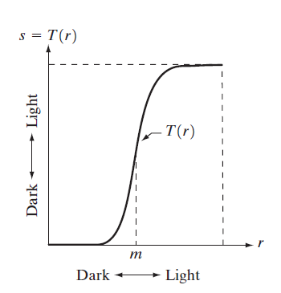

**Fig- Contrast Stretching**

For example, if T(r) has the form shown in Fig. of the previous slide the effect of this transformation would be to produce an image of higher contrast than the original by darkening the levels below m and brightening the levels above m in the original image. In this technique, known as contrast stretching, the values of r below m are compressed by the transformation function into a narrow range of s, toward black. The opposite effect takes place for values of r above m.

In [image processing](http://en.wikipedia.org/wiki/Image_processing), normalization is a process that changes the range of [pixel](http://en.wikipedia.org/wiki/Pixel) intensity values. Applications include photographs with poor [contrast](http://en.wikipedia.org/wiki/Contrast_%28vision%29) due to glare, for example. Normalization is sometimes called contrast stretching or histogram stretching. In more general fields of data processing, such as [digital signal processing](http://en.wikipedia.org/wiki/Digital_signal_processing), it is referred to as [dynamic range](http://en.wikipedia.org/wiki/Dynamic_range) expansion.

The purpose of dynamic range expansion in the various applications is usually to bring the image, or other type of signal, into a range that is more familiar or normal to the senses, hence the term normalization. Often, the motivation is to achieve consistency in dynamic range for a set of data, signals, or images to avoid mental distraction or fatigue. For example, a newspaper will strive to make all of the images in an issue share a similar range of [grayscale](http://en.wikipedia.org/wiki/Grayscale).

The [linear](http://en.wikipedia.org/wiki/Linear) normalization of a [grayscale](http://en.wikipedia.org/wiki/Grayscale) [digital image](http://en.wikipedia.org/wiki/Digital_image) is performed according to the formula

I_N=(I-\text{Min})\frac{\text{newMax}-\text{newMin}}{\text{Max}-\text{Min}}+\text{newMin}

For example, if the intensity range of the image is 50 to 180 and the desired range is 0 to 255 the process entails subtracting 50 from each of pixel intensity, making the range 0 to 130. Then each pixel intensity is multiplied by 255/130, making the range 0 to 255.

**Advantages of Normalization:**

* Normalization process changes the range of pixel intensity values.
* Normalization, sometimes called contrast stretching or histogram stretching. In more general fields of data processing, it is referred to as dynamic range expansion.
* The purpose of dynamic range expansion is usually to bring the image, or other type of signal, into a range that is more familiar to the senses, hence the term normalization.
* Objective: to achieve consistency in dynamic range for a set of data, signals, or images to avoid mental distraction or fatigue.

**FILTERING**

**LOW PASS FILTERS**

Low pass filtering, otherwise known as "smoothing", is employed to remove high [spatial frequency](http://www.cs.washington.edu/research/metip/tutor/tutor.glossary.html#Spatial Frequency) noise from a digital image. Noise is often introduced during the analog-to-digital conversion process as a side-effect of the physical conversion of patterns of light energy into electrical patterns .

There are several common approaches to removing this noise:

* If several copies of an image have been obtained from the source, some static image, then it may be possible to sum the values for each pixel from each image and compute an average. This is not possible, however, if the image is from a moving source or there are other time or size restrictions.
* If such averaging is not possible, or if it is insufficient, some form of **low pass spatial filtering** may be required. There are two main types:
  + **Reconstruction filtering**, where an image is restored based on some knowledge of the type of degradation it has undergone. Filters that do this are often called "optimal filters".
  + **Enhancement filtering**, which attempts to improve the (subjectively measured) quality of an image for human or machine interpretability. Enhancement filters are generally heuristic and problem oriented; they are the type that are discussed in this tutorial.

**MOVING WINDOW OPERATIONS:**

The form that low-pass filters usually take is as some sort of moving window operator. The operator usually affects one pixel of the image at a time, changing its value by some function of a "local" region of pixels ("covered" by the window). The operator "moves" over the image to affect all the pixels in the image. Some common types are:

**Neighborhood-averaging filters**

These replace the value of each pixel, *a[i,j]* say, by a weighted-average of the pixels in some neighborhood around it, i.e. a weighted sum of *a[i+p,j+q]*, with *p = -k to k, q = -k to k* for some positive *k*; the weights are non-negative with the highest weight on the *p = q = 0* term. If all the weights are equal then this is a *mean* filter. "linear"

**MEAN FILTER:**

Mean filtering is a simple, intuitive and easy to implement method of http://homepages.inf.ed.ac.uk/rbf/HIPR2/mote.gifsmoothing images, i.e. reducing the amount of intensity variation between one pixel and the next. It is often used to http://homepages.inf.ed.ac.uk/rbf/HIPR2/mote.gifreduce noise in images.

**How It Works:**

The idea of mean filtering is simply to replace each pixel value in an image with the mean (`average') value of its neighbors, including itself. This has the effect of eliminating pixel values which are unrepresentative of their surroundings. Mean filtering is usually thought of as a http://homepages.inf.ed.ac.uk/rbf/HIPR2/mote.gif[convolution filter](http://homepages.inf.ed.ac.uk/rbf/HIPR2/convolve.htm). Like other convolutions it is based around a [kernel](http://homepages.inf.ed.ac.uk/rbf/HIPR2/kernel.htm), which represents the shape and size of the neighborhood to be sampled when calculating the mean. Often a 3×3 square kernel is used, as shown in Figure 1, although larger kernels (e.g. 5×5 squares) can be used for more severe smoothing. (Note that a small kernel can be applied more than once in order to produce a similar but not identical effect as a single pass with a large kernel.)

**MEDIAN FILTERS:**

This replaces each pixel value by the median of its neighbors, i.e. the value such that 50% of the values in the neighborhood are above, and 50% are below. This can be difficult and costly to implement due to the need for sorting of the values. However, this method is generally very good at preserving edges.

The median filter is normally used to http://homepages.inf.ed.ac.uk/rbf/HIPR2/mote.gifreduce noise in an image, somewhat like the [mean filter](http://homepages.inf.ed.ac.uk/rbf/HIPR2/mean.htm). However, it often does a better job than the mean filter of preserving useful detail in the image.

## How It Works

# Like the [mean filter](http://homepages.inf.ed.ac.uk/rbf/HIPR2/mean.htm), the median filter considers each pixel in the image in turn and looks at its nearby neighbors to decide whether or not it is representative of its surroundings. Instead of simply replacing the pixel value with the mean of neighboring pixel values, it replaces it with the median of those values. The median is calculated by first sorting all the pixel values from the surrounding neighborhood into numerical order and then replacing the pixel being considered with the middle pixel value. (If the neighborhood under consideration contains an even number of pixels, the average of the two middle pixel values is used.) Figure 1 illustrates an example calculation.

**THE MATHEMATICS BEHIND LINEAR FILTERS**

Consider a [linear operator](http://www.cs.washington.edu/research/metip/tutor/tutor.glossary.html#linear operator) *S*, a function *f(x)* and a function *g(x) = S(f(x))* (this is sometimes called a system). In the case of image processing, *f(x)* could represent the original image (a one-dimensional image in this case), *S*a filtering operation and *g(x)* the filtered output image.

If *S* is also shift invariant, then we can write

http://www.cs.washington.edu/research/metip/tutor/gif/tutor.conv1d.gif

a **convolution integral**, also written *g = f\*h*. *h(t)* is called the point spread function or impulse response and completely characterizes the filter. Discretizing this equation, we can write

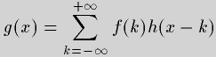

which is appropriate for dealing with [digital images](http://www.cs.washington.edu/research/metip/digital.html). *h(t)* is usually non-zero only in some range including *x*, say *[-w,+w]*, so we may rewrite this equation

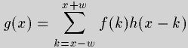

Thus the output image at a pixel *x* has a value given by a weighted sum of the values of the pixels in *[-w,+w]* in the original image, with the weights given by *h(k)*. For the output at *x+1*, *h(k)* is shifted by one and the weighted sum is recomputed. This series of shift-multiply-sum operations is performed over the whole image; this is called a **digital convolution**. For a two-dimensional image, we have

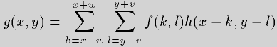

which is similarly computed by a series of shift-multiply-sum operations. h(x,y)'s values are often referred red to as the filter weights, filter kernel or filter mask.

**Image Sharpening:**

Human perception is highly sensitive to edges and fine details of an image, and since they are composed primarily by high frequency components, the visual quality of an image can be enormously degraded if the high frequencies are attenuated or completed removed. In contrast, enhancing the high-frequency components of an image leads to an improvement in the visual quality. Image sharpening refers to any enhancement technique that highlights edges and fine details in an image. Image sharpening is widely used in printing and photographic industries for increasing the local contrast and sharpening the images.In principle, image sharpening consists of adding to the original image a signal that is proportional to a high-pass filtered version of the original image. Figure (5.33) illustrates this procedure, often referred to an unsharp masking on a one-dimensional signal. As shown in Fig (5.33), the original image is first filtered by a high-pass filter that extracts the high-frequency components, and then a scaled version of the high-pass filter output is added to the original image, thus producing a sharpened image of the original. Note that the homogeneous regions of the signal, i.e., where the signal is constant, remain unchanged.

**HISTOGRAM PROCESSING**

In [statistics](http://en.wikipedia.org/wiki/Statistics), a **histogram** is a graphical representation of the distribution of data. It is an estimate of the [probability distribution](http://en.wikipedia.org/wiki/Probability_distribution) of a [continuous variable](http://en.wikipedia.org/wiki/Continuous_variable) and was first introduced by [Karl Pearson](http://en.wikipedia.org/wiki/Karl_Pearson)

The histogram of an image represents the relative frequency of occurrence of the various gray levels in the image. Histogram modeling techniques modify an image so that its histogram has a desired shape.The histogram of a digital image with intensity level in the range [0, L-1] is a discrete function h (rk) = nk where rk is the kth intensity value and nk the number of pixels in the image with intensity rk. The histogram is normalized by dividing each of its components by total number of pixels in the image. So a normalized histogram is given by

P (rk) = nk/MN for k=0, 1, 2…..L-1.

This is useful in stretching the low contrast levels of image with narrow histograms. Histogram technique has been found to be a powerful technique for image enhancement.

**HISTOGRAM EQUALISATION**

In histogram equalization the goal is to obtain a uniform histogram for the output image. Consider an image pixel value u > 0 to be a random variable with a continuous probability density function Pu (u) and cumulative probability distribution Fu(u)ΔP[u < u]

Then the random variable

Δ Fu(u) Δ

will be uniformly distributed over (0,1).

Uniform

Quantization

u

**Fig- Histogram equalization Transformation**

To implement this transformation on digital images suppose the input u has L gray levels xi , i = 0, 1… L-1 with probabilities Pu(x). These probabilities can be determined from the histogram of an image that gives h(xi), the number of pixels with gray level value xi.

Then

Pu(xi) =

The output v , also assumed to have L levels, is given as follows:

uΔ

Δ Int[ (L-1) + 0.5 ]

Where is the smallest positive value of.

**Advantage of Histogram Equalization:**

This method usually increases the global [contrast](http://en.wikipedia.org/wiki/Contrast_%28vision%29) of many images, especially when the usable [data](http://en.wikipedia.org/wiki/Data) of the image is represented by close contrast values. Through this adjustment, the [intensities](http://en.wikipedia.org/wiki/Luminous_intensity) can be better distributed on the histogram. This allows for areas of lower local contrast to gain a higher contrast.

Histogram equalization accomplishes this by effectively spreading out the most frequent intensity values. The method is useful in images with backgrounds and foregrounds that are both bright or both dark. In particular, the method can lead to better views of [bone](http://en.wikipedia.org/wiki/Bone) structure in [x-ray](http://en.wikipedia.org/wiki/X-ray) images, and to better detail in [photographs](http://en.wikipedia.org/wiki/Photographs) that are over or under-exposed. A key advantage of the method is that it is a fairly straightforward technique and an [invertible](http://en.wikipedia.org/wiki/Invertible) [operator](http://en.wikipedia.org/wiki/Operator_%28mathematics%29). So in theory, if the histogram equalization [function](http://en.wikipedia.org/wiki/Function_%28mathematics%29) is known, then the original histogram can be recovered. The calculation is not [computationally](http://en.wikipedia.org/wiki/Computation) intensive.

**MORPHOLOGICAL IMAGE PROCESSING**

Morphological image processing is a collection of non-linear operations related to the shape or morphology of features in an image. Morphological operations rely only on the relative ordering of pixel values, not on their numerical values, and therefore are especially suited to the processing of binary images. Morphological operations can also be applied to grayscale images such that their light transfer functions are unknown and therefore their absolute pixel values are of no or minor interest. Morphological techniques probe an image with a small shape or template called a structuring element. The structuring element is positioned at all possible locations in the image and it is compared with the corresponding neighbourhood of pixels. Some operations test whether the element "fits" within the neighbourhood, while others test whether it "hits" or intersects the neighbourhood. Mathematical morphology is a tool for extracting image components that are useful in the representation and description of region shape such as boundaries, skeletons and convex hull.

Two fundamental operations of morphological image processing are erosion and dilation.

**EROSION:**

Erosion “shrinks” or “thins” objects in a binary image. The manner and extent of shrinking is controlled by structuring element.

With A and B as sets inZ2, the erosion of A and b denoted as AӨB

AӨB= {Z│ (B) z **∩** Ac ≠ Ø}

In other words, erosion of A by B is the set of all structuring element origin locations where the translated B has no overlap with the background of A.



Fig: Erosion

**Example application:** Assume we have received a fax of a dark photocopy. Everything looks like it was written with a pen that is bleeding. Erosion process will allow thicker lines to get skinny and detect the hole inside the letter "o".

**DILATION:**

Dilation is an operation that “grows” or “thickens” object in binary image. The specific manner and extent of this thickening is controlled by a shape referred to as structuring element.

The dilation of A and B, denoted as A B is defined as

A B= {Z│ (B) z **∩**A ≠ Ø}

Where Ø is empty set and B is structuring element.



Fig: Dilation

**Example application**: Dilation is the dual operation of the erosion. Figures that are very lightly drawn get thick when "dilated". Easiest way to describe it is to imagine the same fax/text is written with a thicker pen.

**Advantage of Morphological Image Processing:**

Binary images may contain numerous imperfections. In particular, the binary regions produced by simple thresholding are distorted by noise and texture. Morphological image processing pursues the goals of removing these imperfections by accounting for the form and structure of the image. These techniques can be extended to grayscale images.

**EDGE DETECTION**

Edge detection is the name for a set of mathematical methods which aim at identifying points in a [digital image](http://en.wikipedia.org/wiki/Digital_image) at which the [image brightness](http://en.wikipedia.org/wiki/Luminous_intensity) changes sharply or, more formally, has discontinuities. The points at which image brightness changes sharply are typically organized into a set of curved line segments termed edges. The same problem of finding discontinuities in 1D signal is known as [step detection](http://en.wikipedia.org/wiki/Step_detection) and the problem of finding signal discontinuities over time is known as [change detection](http://en.wikipedia.org/wiki/Change_detection). Edge detection is a fundamental tool in [image processing](http://en.wikipedia.org/wiki/Image_processing), [machine vision](http://en.wikipedia.org/wiki/Machine_vision) and [computer vision](http://en.wikipedia.org/wiki/Computer_vision), particularly in the areas of [feature detection](http://en.wikipedia.org/wiki/Feature_detection_%28computer_vision%29) examples of operators such as Canny, Sobel, Kayyali,..etc. and [feature extraction](http://en.wikipedia.org/wiki/Feature_extraction).

## Approaches of Edge Detection:

There are many methods for edge detection, but most of them can be grouped into two categories:

1. search-based

2. [zero-crossing](http://en.wikipedia.org/wiki/Zero_crossing) based.

The search-based methods detect edges by first computing a measure of edge strength, usually a first-order derivative expression such as the gradient magnitude, and then searching for local directional maxima of the gradient magnitude using a computed estimate of the local orientation of the edge, usually the gradient direction.

The zero-crossing based methods search for zero crossings in a second-order derivative expression computed from the image in order to find edges, usually the zero-crossings of the [Laplacian](http://en.wikipedia.org/wiki/Laplacian) or the zero-crossings of a non-linear differential expression.

As a pre-processing step to edge detection, a smoothing stage, typically Gaussian smoothing, is almost always applied (see also [noise reduction](http://en.wikipedia.org/wiki/Noise_reduction)).The edge detection methods that have been published mainly differ in the types of smoothing filters that are applied and the way the measures of edge strength are computed. As many edge detection methods rely on the computation of image gradients, they also differ in the types of filters used for computing gradient estimates in the x- and y-directions.

**Advantages of edge detection:**

1. Sharp and thin edges lead to greater efficiency in object recognition.
2. If the edge happens to be the boundary of a region, then thinning could easily give the image parameters like perimeter without much algebra.
3. Significantly reduce the amount of data in an image, while preserving the structural properties to be used for further image processing.

**CANNY EDGE DETECTION ALGORITHM:**

The Canny edge detector is an [edge detection](http://en.wikipedia.org/wiki/Edge_detection) operator that uses a multi-stage [algorithm](http://en.wikipedia.org/wiki/Algorithm)to detect a wide range of edges in images. It was developed by [John F. Canny](http://en.wikipedia.org/wiki/John_F._Canny) in 1986. Canny also produced a computational theory of edge detection explaining why the technique works. This Algorithm was developed by John F. Canny (JFC) in 1986 .Even though it is quite old, it has become one of the standard edge detection methods and it is still used in research. The aim of JFC was to develop an algorithm that is optimal with regards to the following criteria:

**1. Detection:**

The probability of detecting real edge points should be maximized while the probability of falsely detecting non-edge points should be minimized. This corresponds to maximizing the signal-to-noise ratio.

**2. Localization:**

The detected edges should be as close as possible to the real edges.

**3. Number of responses:**

One real edge should not result in more than one detected edge .With JFC’s mathematical formulation of these criteria, Canny’s Edge Detector is optimal for a certain class of edges (known as step edges).

**STAGES OF CANNY ALGORITHM:**

**1. Noise reduction:**

Because the Canny edge detector is susceptible to noise present in raw unprocessed image data, it uses a filter based on a Gaussian (bell) curve, where the raw image is [convolved](http://en.wikipedia.org/wiki/Convolution) with a [Gaussian filter](http://en.wikipedia.org/wiki/Gaussian_filter). The result is a slightly[blurred](http://en.wikipedia.org/wiki/Gaussian_blur) version of the original which is not affected by a single noisy pixel to any significant degree.

### 2. Finding the intensity gradient of the image:

An edge in an image may point in a variety of directions, so the Canny algorithm uses four filters to detect horizontal, vertical and diagonal edges in the blurred image. The [edge detection operator](http://en.wikipedia.org/wiki/Edge_detection) ([Roberts](http://en.wikipedia.org/wiki/Roberts_Cross), [Prewitt](http://en.wikipedia.org/wiki/Prewitt), [Sobel](http://en.wikipedia.org/wiki/Sobel_operator) for example) returns a value for the first derivative in the horizontal direction (Gx) and the vertical direction (Gy). From this the edge gradient and direction can be determined:

\mathbf{G} = \sqrt{ {\mathbf{G}_x}^2 + {\mathbf{G}_y}^2 }

\mathbf{\Theta} = \operatorname{atan2}\left(\mathbf{G}_y, \mathbf{G}_x\right),

where G can be computed using the [hypot](http://en.wikipedia.org/wiki/Hypot) function and [atan2](http://en.wikipedia.org/wiki/Atan2) is the arctangent function with two arguments. The edge direction angle is rounded to one of four angles representing vertical, horizontal and the two diagonals (0, 45, 90 and 135 degrees for example).

### 3. Non-maximum suppression:

Non-maximum suppression is an [edge thinning](http://en.wikipedia.org/wiki/Edge_detection#Edge_thinning) technique.

Given estimates of the image gradients, a search is carried out to determine if the gradient magnitude assumes a local maximum in the gradient direction. In some implementations, the algorithm categorizes the continuous gradient directions into a small set of discrete directions, and then moves a 3x3 filter over the output of the previous step (that is, the edge strength and gradient directions). At every pixel, it suppresses the edge strength of the center pixel (by setting its value to 0) if its magnitude is not greater than the magnitude of the two neighbors in the gradient direction. For example,

* if the rounded gradient angle is zero degrees (i.e. the edge is in the north-south direction) the point will be considered to be on the edge if its gradient magnitude is greater than the magnitudes at pixels in the north and south directions,
* if the rounded gradient angle is 90 degrees (i.e. the edge is in the east-west direction) the point will be considered to be on the edge if its gradient magnitude is greater than the magnitudes at pixels in the east and west directions,
* if the rounded gradient angle is 135 degrees (i.e. the edge is in the north east-south west direction) the point will be considered to be on the edge if its gradient magnitude is greater than the magnitudes at pixels in the north east and south west directions,
* if the rounded gradient angle is 45 degrees (i.e. the edge is in the north west-south east direction) the point will be considered to be on the edge if its gradient magnitude is greater than the magnitudes at pixels in the north west and south east directions.

In more accurate implementations, linear interpolation is used between the two neighbouring pixels that straddle the gradient direction. For example, if the gradient angle is between 45 degrees and 90 degrees interpolation between gradients at the north east and eastpixels will give one interpolated value, and interpolation between the south west and west pixels will give the other (using the conventions of last paragraph). The gradient magnitude at the central pixel must be greater than both of these for it to marked as an edge.

The Canny algorithm is adaptable to various environments. Its parameters allow it to be tailored to recognition of edges of differing characteristics depending on the particular requirements of a given implementation. In Canny's original paper, the derivation of the optimal filter led to a [Finite Impulse Response](http://en.wikipedia.org/wiki/Finite_Impulse_Response) filter, which can be slow to compute in the spatial domain if the amount of smoothing required is important (the filter will have a large spatial support in that case). For this reason, it is often suggested to use Rachid Deriche's [infinite impulse response](http://en.wikipedia.org/wiki/Infinite_impulse_response) form of Canny's filter (the [Canny–Deriche detector](http://en.wikipedia.org/wiki/Deriche_edge_detector)), which is recursive, and which can be computed in a short, fixed amount of time for any desired amount of smoothing. The second form is suitable for real time implementations in [FPGAs](http://en.wikipedia.org/wiki/FPGA) or [DSPs](http://en.wikipedia.org/wiki/Digital_signal_processor), or very fast embedded PCs. In this context, however, the regular recursive implementation of the Canny operator does not give a good approximation of rotational symmetry and therefore gives a bias towards horizontal and vertical edges.

**SOBEL’S EDGE DETECTION ALGORITHM:**

Sobel is a popular edge detection where exists a function, edge.m which is in the image toolbox. In the edge function, the Sobel method uses the derivative approximation to find edges. Therefore, it returns edges at those points where the gradient of the considered image is maximum. The Sobel operator performs a 2-D spatial gradient measurement on images. It uses a pair of horizontal and vertical gradient matrices whose dimensions are 3×3 for edge detection operations. It will also demonstrate how to build a Sobel detector function of 5 ×5 dimension in matlab to find edges.

**Sobel operator:**

The Sobel operator is used in [image processing](http://en.wikipedia.org/wiki/Image_processing), particularly within [edge detection](http://en.wikipedia.org/wiki/Edge_detection) algorithms. Technically, it is a [discrete differentiation operator](http://en.wikipedia.org/wiki/Difference_operator), computing an approximation of the [gradient](http://en.wikipedia.org/wiki/Image_gradient) of the image intensity function. At each point in the image, the result of the Sobel operator is either the corresponding gradient vector or the norm of this vector. The Sobel operator is based on convolving the image with a small, separable, and integer valued filter in horizontal and vertical direction and is therefore relatively inexpensive in terms of computations. A convolution mask is used is usually much smaller than the actual image. As a result, the mask is slid over an area of the input image, changes that pixel's value and then shifts one pixel to the right and continues to the right until it reaches the end of a row. It then starts at the beginning of the next row.

Each direction of Sobel masks is applied to an image, then two new images are created. One image shows the vertical response and the other shows the horizontal response. Two images combined into a single image. The purpose is to determine the existence and location of edges in a picture. This two image combination is explained that the square of created masks pixel estimate coincidence each other as coordinate are summed. Thus new image on which edge pixels are located obtained the value which is the squared of the above summation. The value of threshold in this above process is used to detect edge pixels. An algorithm is developed to find edges using the new matrices and then, a matlab function, which is called as Sobel5×5.m, is implemented in matlab. This matlab function requries a grayscale intensity image, two-dimensional array.

Standard Sobel operators, for a 3×3 neighborhood, each simple central gradient estimate is vector sum of a pair of orthogonal vectors . Each orthogonal vector is a directional derivative estimate multiplied by a unit vector specifying the derivative’s direction. The vector sum of these simple gradient estimates amounts to a vector sum of the 8 directional derivative vectors.

**Steps for Sobel edge detection method:**

Input: A Sample Image

Output: Detected Edges

Step 1: Accept the input image

Step 2: Apply mask Gx,Gy to the input image

Step 3: Apply Sobel edge detection algorithm and the gradient

Step 4: Masks manipulation of Gx,Gy separately on the input image

Step 5: Results combined to find the absolute magnitude of the gradient

│G│═√Gx2 + Gy2

Step 6: The absolute magnitude is the output.

Typically, it is used to find the approximate absolute gradient magnitude at each point I of an input grayscale image. The Sobel edge detector uses a pair of 3 x 3 convolution masks, one estimating gradient in the x-direction and the other estimating gradient in y- direction. This is because when placing the center of the mask over a pixel in the first row for example, the mask will be outside the image boundaries. The Gx mask highlights the edges in the horizontal direction while the Gy mask highlights the edges in vertical direction. After taking the magnitude

of both, the resulting output detects edges in both directions.

**Advantages:**

The following advantages of Sobel edge detector justify its superiority over other edge detection techniques:

1. **Edge Orientation**: The geometry of the operator determines a characteristic direction in which it is most sensitive to edges. Operators can be optimized to look for horizontal, vertical, or diagonal edges.
2. **Noise Environment**: Edge detection is difficult in noisy images, since both the noise and the edges contain high-frequency content. Attempts to reduce the noise result in blurred and distorted edges. Operators used on noisy images are typically larger in scope, so they can average enough data to discount localized noisy pixels. This results in less accurate localization of the detected edges.
3. **Edge Structure**: Not all edges involve a step change in intensity. The operator is chosen to be responsive to such a gradual change in those cases.

**THE EXECUTABLE SPECIFICATION OF SOBEL EDGE DETECTION ALGORITHM****:**

As designs become larger and more complicated, it has become necessary to describe a design at a high level. This high level description not only enables the designer to run simulations faster, it can also be used throughout the development process for verification. This resulting process allows developers to identify bugs early on and avoid costly bug discovery towards the end of development. This high-level design is usually done by system engineers.

To implement a DSP algorithm on hardware such as ASIC or an FPGA, a system-level engineer first designs the algorithm and verifies that the algorithm satisfies the project requirements. This design later becomes the golden reference for the engineers responsible for taking the algorithm to the hardware.

In this example, the Sobel Edge Detection algorithm has been implemented in Simulink. Open the [executable model](http://www.mathworks.in/help/hdlverifier/examples/rmvd_matlablink__6f613d26ad3882638998f7c27fadc905.html) and double click on the "Sobel Edge Detection" block to learn how the algorithm is implemented in Simulink. When you double-click on the Sobel Edge Detection block, you can see that the algorithm is comprised of two 2D filters, one to calculate the gradient in the column direction (top filter) and one to calculate the gradient in the row direction (bottom filter). Both filters use a 3x3 kernel.

This Simulink model serves as the specification for the rest of the development path. It is an **executable specification**, meaning you can readily execute this model in the Simulink environment.

**Result**

**Analysis**

**RGB TO GRAY CONVERSION OF THE IMAGE**

**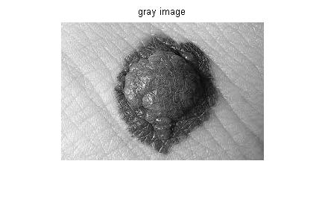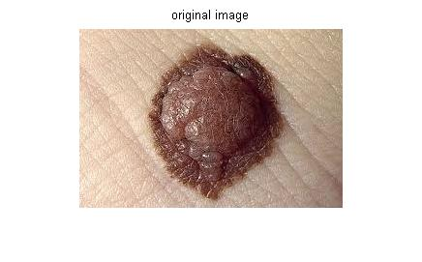**

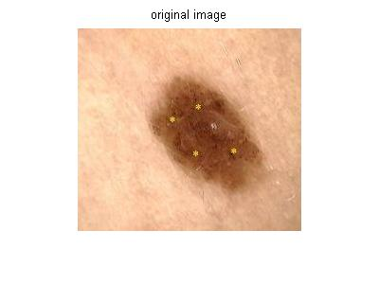

**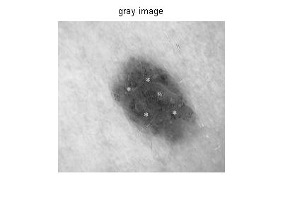**

**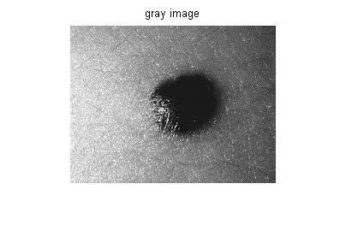**

**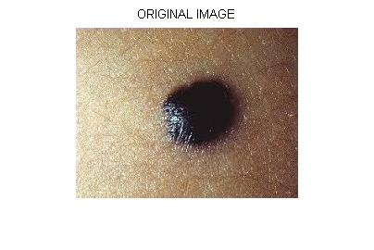**

**NEGATIVE OF IMAGE**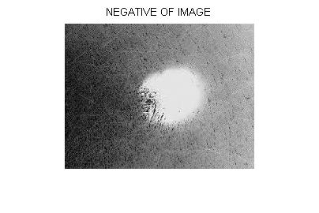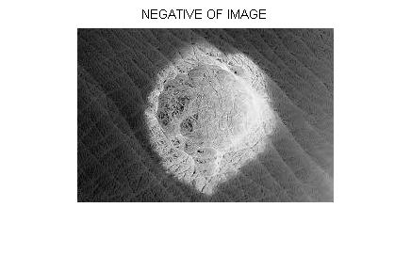

**CONTRAST STRETCHING**

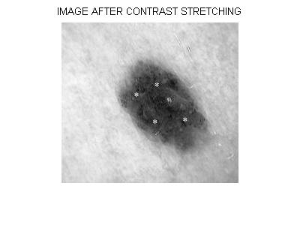

**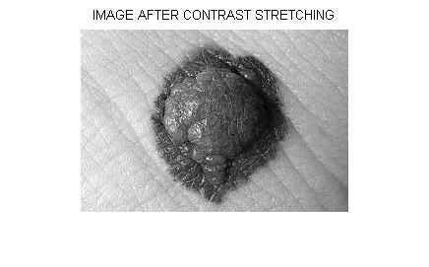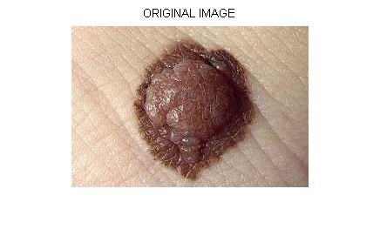**

**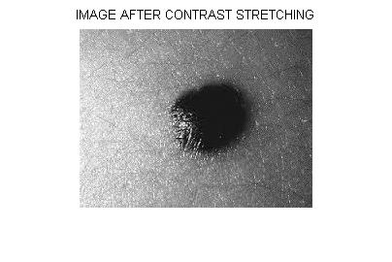**

**IMAGE SMOOTHING**

LOWPASS FILTERING MEDIAN FILTERING

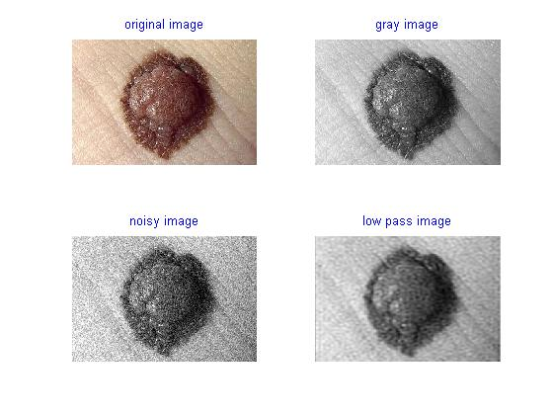

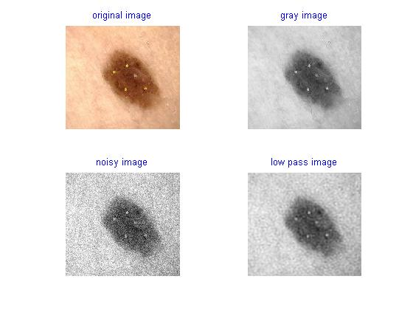

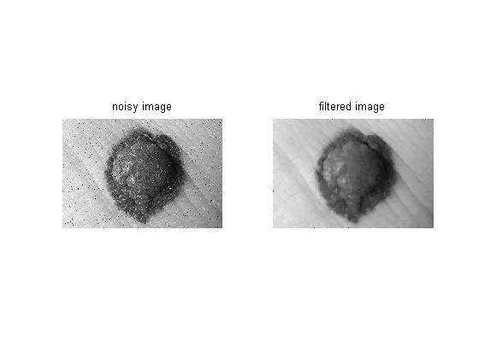

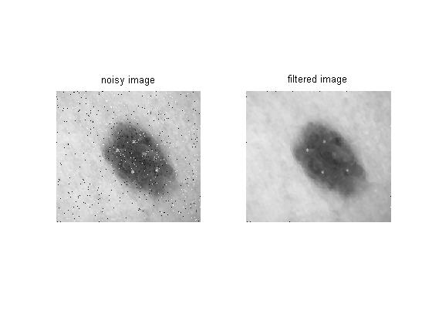

**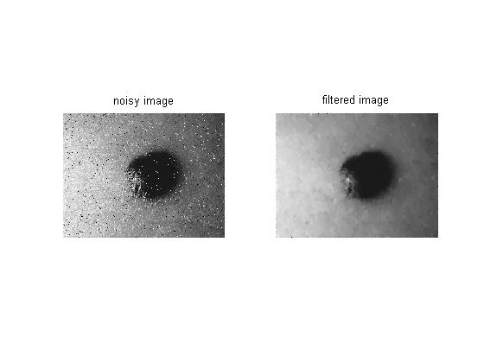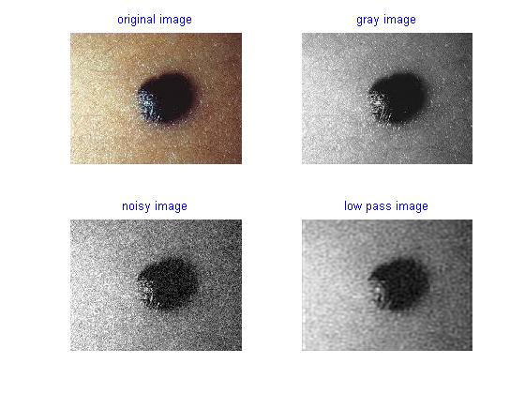**

**HISTOGRAM**

**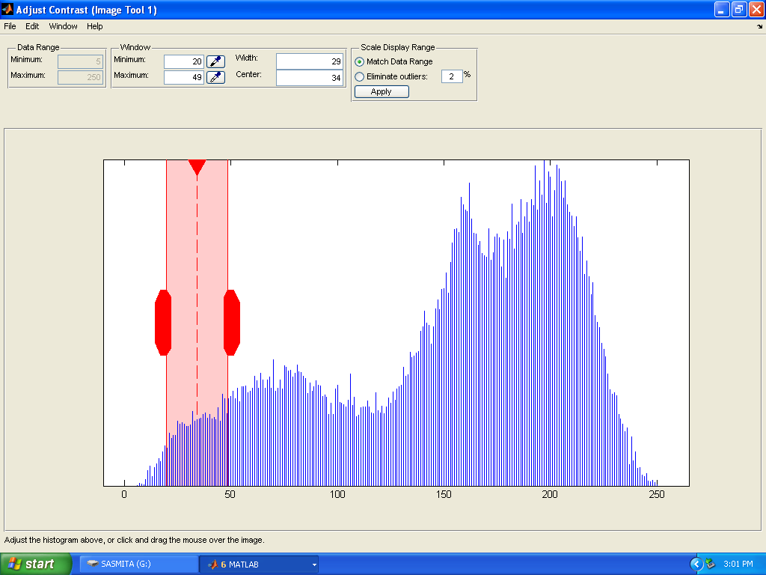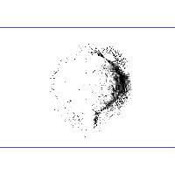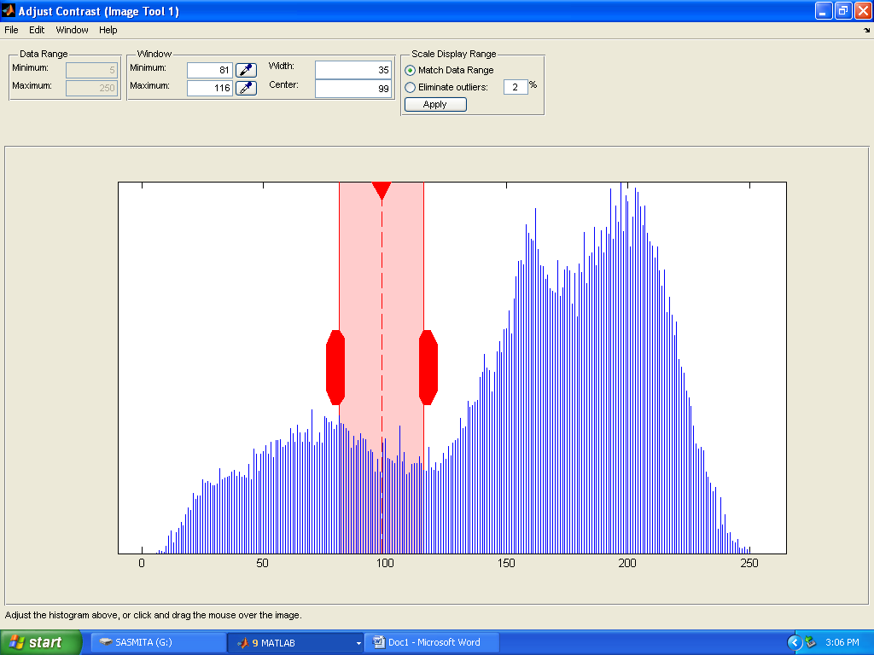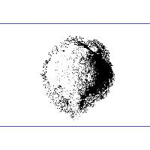**

**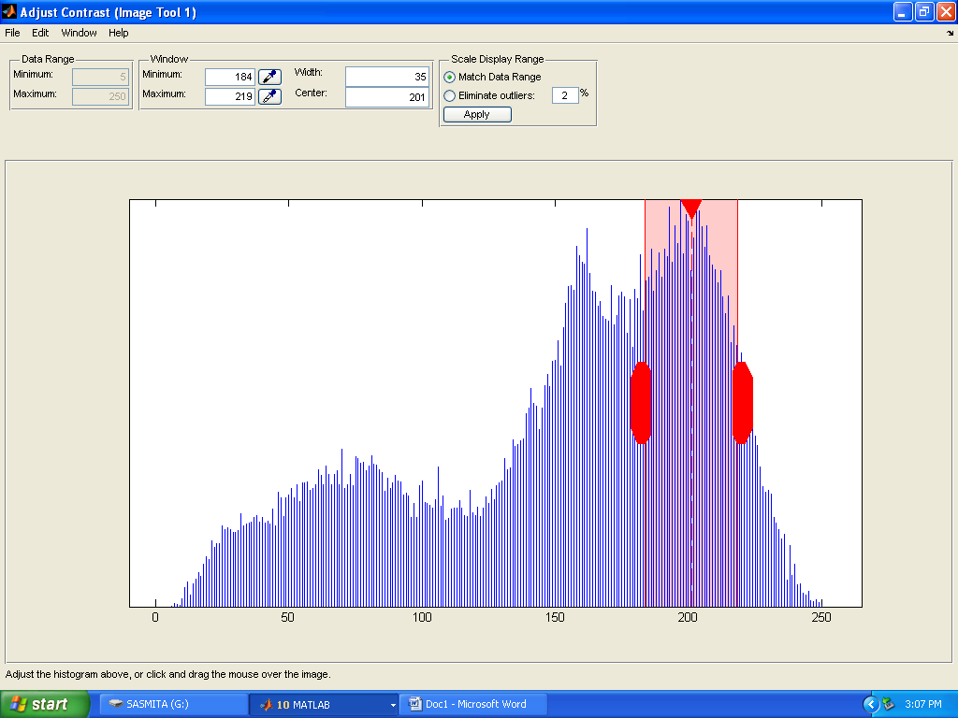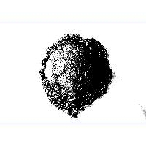**

**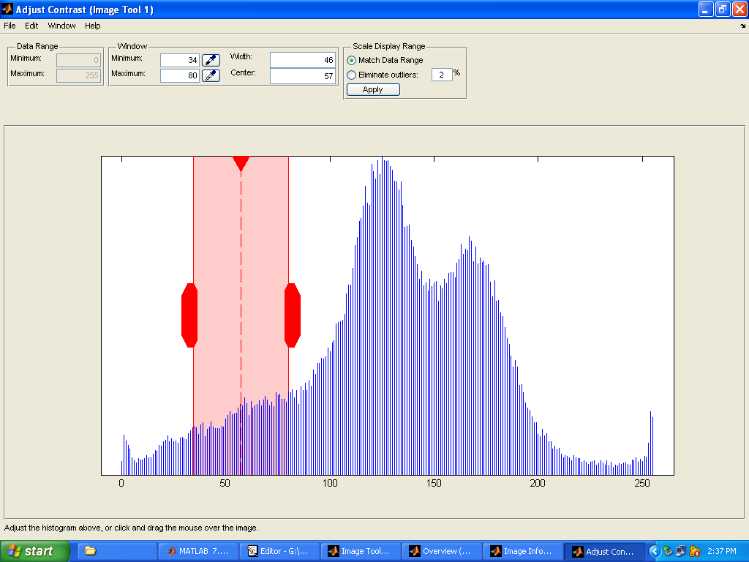**

**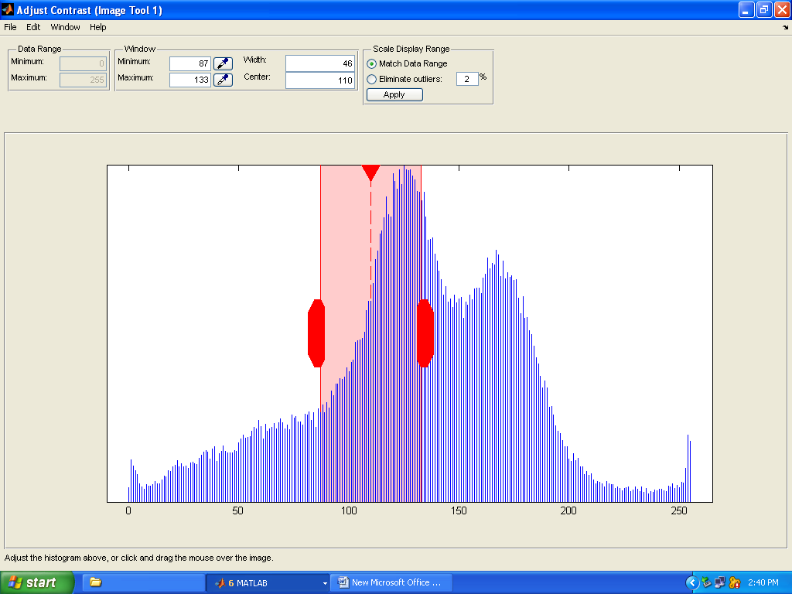**

**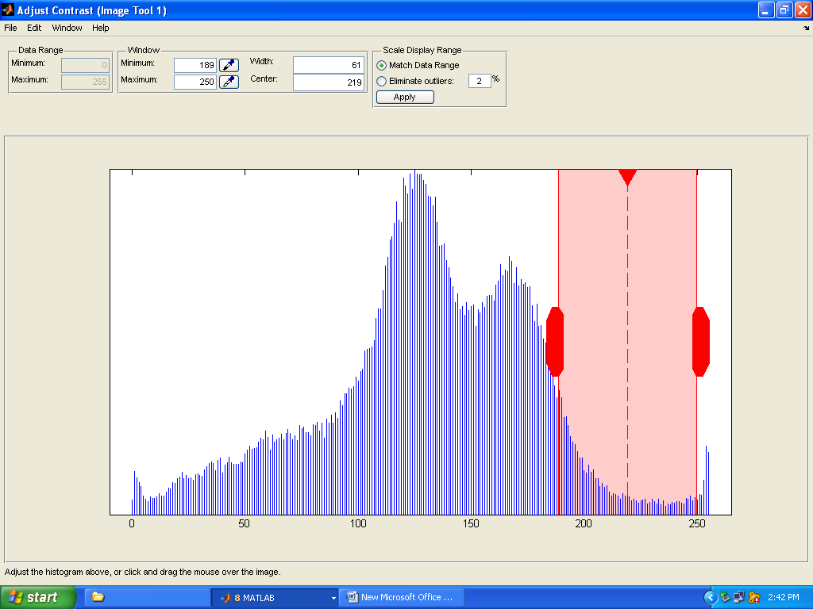**

**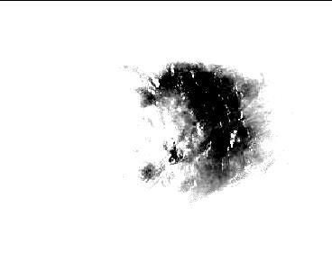**

**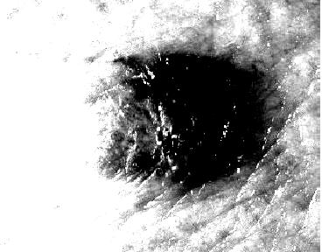**

**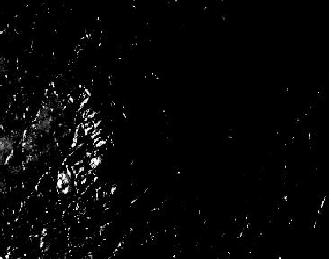**

**EDGE DETECTION USING MORPHOLOGICAL IMAGE PROCESSING**

**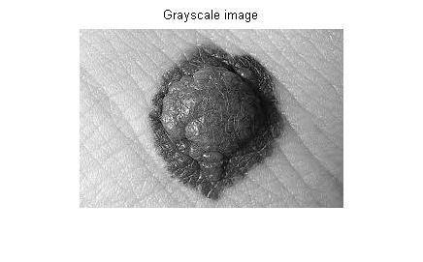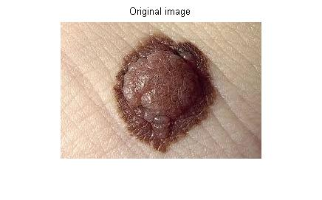**

**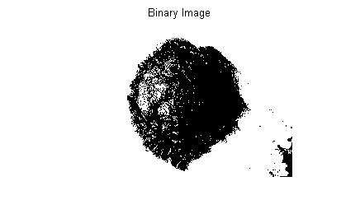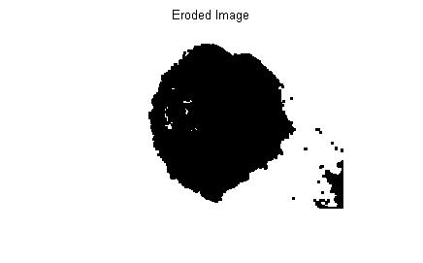**

**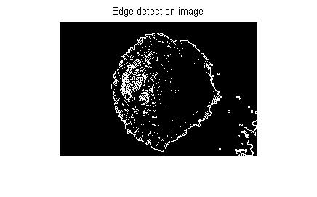**

**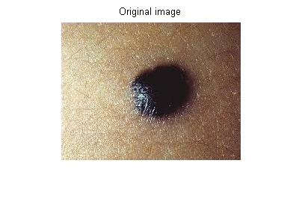**

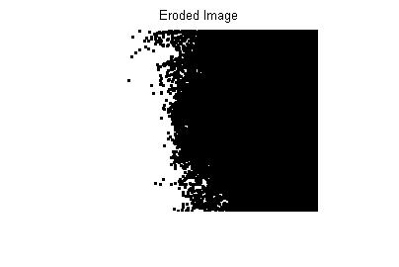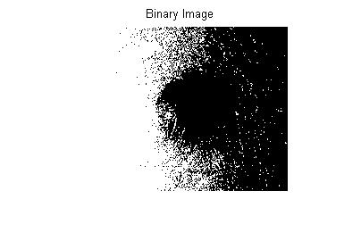

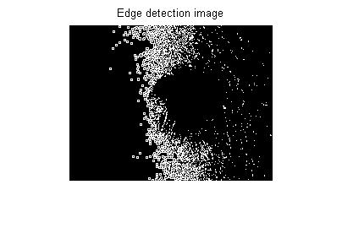

**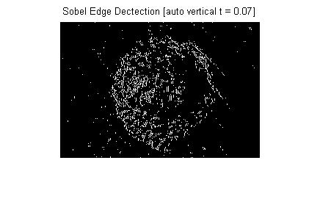EDGE DETECTION USING SOBEL’S ALGORITHM**

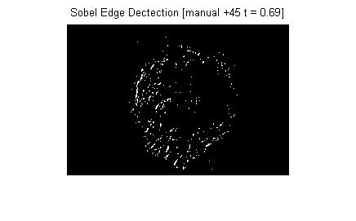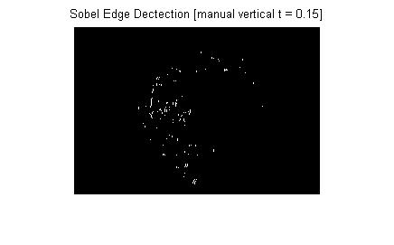

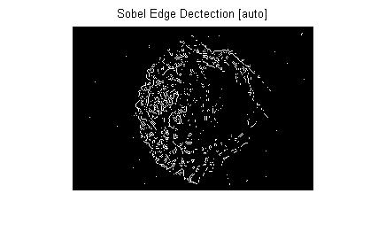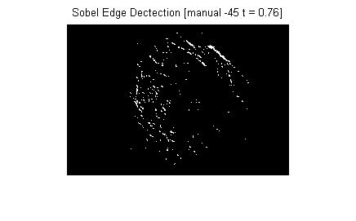

**EDGE DETECTION USING SOBEL’S ALGORITHM**

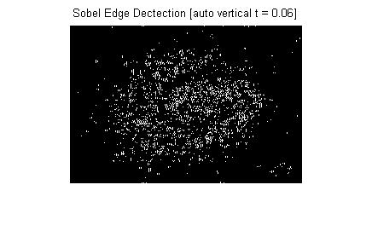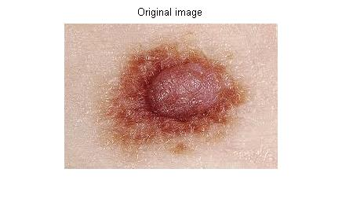

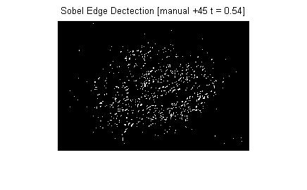

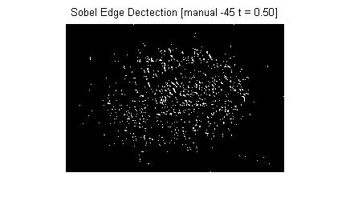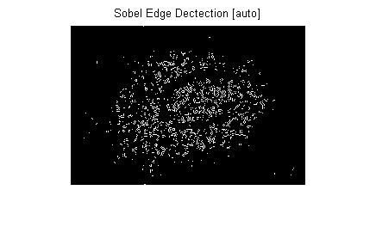

**FUTURE**

**WORK**

**FUTURE SCOPE AND WORK OF THE PROJECT**

In image feature extraction process 2D wavelet transform can be used.

Classifier is used for classifying malignant melanoma from other skin diseases. Based on the computational simplicity Artificial Neural Network (ANN) based classifier will be used in the final detection. In this system a feed forward multilayer network will be used. Back Propagation Algorithm (BPN) will be used for training. There must be input layer, atleast one hidden layer and output layer. The hidden and output layer nodes adjust the weights value depending on the error in the classification. In BPN the signal flow will be in feed forward direction, but the error is back propagated and weights are updated to reduce error. The output of the network will help us to distinguish between skin melanoma and other skin diseases.

FEATURES

OF THE OUTPUT

INPUT

IMAGE 0 OR 1

INPUT LAYER HIDDEN LAYER OUTPUT LAYER

The obtained features will be given as input to the network. The output of the network will be either ‘0’ or ‘1’. One will represent skin melanoma and zero will represent non melanoma condition.

**Scope for commercialization:**

This network can be implemented in the hardware which in return will make up an excellent medical instrument for skin melanoma detection and thus avoiding unnecessary biospsis.

**MARKET VIABILITY**

This past year represented a period of exciting growth in our cancer therapy business. We also made progress with the transformation of our cancer detection business model. We are executing on our strategy by delivering a new generation of highly targeted tools for detection, diagnosis, and treatment of cancers. We are using digital image processing for the detection of skin melanoma which is the most serious type of skin cancer if it is not detected early. Melanoma is the least common form of skin cancer, but it is the most serious. It is the one most likely to spread to other parts of the body. There are about 9,000 new cases of melanoma each year in the UK. The number of cases has about doubled over a period of 20 years or so. Melanoma is the second most common cancer in people aged 15-34.

Melanomas are traditionally sought and discovered by distinct morphological characteristics. A dramatic fall in mortality rates from melanoma may come from early detection of melanoma based on cutaneous color change patterns. Life saving melanoma skin cancer interventions may be summarized as primary prevention (reduction in case numbers), screening (public heath methods for the detection of disease), and treatment. Primary prevention has been ineffective; melanoma has been the fastest growing type of cancer for the last 70 years. The incidence increases from 3 percent to 7 percent yearly

So the best way to reduce the number of skin cancers and the pain and loss of life from this disease is the early detection of the disease. Our system does not require a radioactive isotope

or a costly shielded environment, which enables the system to be used in any size hospital or clinic. By digital image processing technique we can detect the affected part of our body that we are having doubt of melanoma. We can take the image of that area and simply process the image through our software for the detection. So we think that it is a very simple process. A common man can also afford it. As we know that after detection of the disease it is very difficult to cure it. It is also very painful. So better if we have a small doubt by looking some symptoms on our skin then we can just verify it. Early detection of this will also save our life.

**CONCLUSION**

Thus we concluded that skin melanoma is the most common type of cancer and represents 50% all new cancers detected each year. This brief review discusses some of the promising current technologies as well as the needs and challenges in developing sensitive and reliable diagnostic tools for the early detection of melanoma. Melanoma is the fastest-growing cancer in terms of incidence, and the need for accurate diagnostic tools is increasing. Every year, around 2.5–3 million skin lesions are evaluated in the US, and over 100,000 are diagnosed as melanoma. The objective is to develop automated diagnostic method for screening of individual lesions and full-body screening, as well as sophisticated instruments that can provide dermatologists with fine detail regarding the structure of a lesion and staging information in vivo. Screening instruments would alert patients to seek the care of a dermatologist, and would be intended for use in primary care facilities or by the patients, similar to blood pressure cuffs or diabetes-testing equipment. With recent progress in electronics and instrumentation, several sophisticated and very promising imaging methods have emerged and are being investigated in small trials. One of the key challenges is that diagnostic instruments are expected to compete in price and ease of use with visual inspection, which is the current standard of care. Clearly, using a diagnostic instrument would increase the duration and the cost of the exam; therefore, insurance coverage would be a key driving factor for technology development. The funding for technology development beyond the initial feasibility studies and the funding of large scale studies to demonstrate the effectiveness of imaging systems along with the complex and lengthy governmental approval process are the main challenges on the path of these imaging systems finding their place in medical care.

**REFERENCES**

1. PankajAgrawal, S.K.Shriwastava and S.S.Limaye, MATLAB Implementation of Image Segmentation Algorithms, IEEE Pacic Rim Conference on Communication, Computer and Signal Processing, pp. 602-605., 2010.
2. AsadollahShahbahrami, Jun Tang A Colour Image Segmentation algorithm Based on Region Growing, IEEE Trans. on Consumer Electronics Euromicro, pp 362-368, 2010.
3. T. Tanaka, R. Yamada, M. Tanaka, K. Shimizu, M. Tanaka,A Study on the Image Diagnosis of Melanoma, IEEE Trans. on Image Processing, pp.1010-1024, June 2004.
4. Y. Andreopoulos, N. D. Zervas, G. Lafruit, P. Schelkens, A local wavelet transform implementation versus an optimal row-column algorithm for the 2D multilevel decomposition, IEEE International Conf. on Image Processing, volume 3, 2001.
5. Mariam, A.Sheha,Mai, S.Mabrouk, AmrSharawy, Automatic Detection of Melanoma Skin Cancer using Texture Analysis, International Journal of Computer Applications, Volume 42, 2012.
6. M. Vetterli, O. Riol, Wavelets and Signal processing, IEEE Signal Processing Magazine, pp.14-38, Oct 1991.
7. Shubhankar Ray and Andrew Chan, Automatic feature extraction from wavelet coefficients using Genetic Algorithms, IEEE Trans. on Image Processing, pp. 980-1025, June 2000.
8. Green A, Martin N, Pfitzner J, O’Rourke M, Knight N. Computer image analysis in the diagnosis of melanoma. J Am AcadDermatol 1994: 31: 958–964.
9. Dhawan AP. An expert system for the early detection of melanoma using knowledge-based image analysis. Anal Quant CytolHistol 1988: 10: 405–416.
10. Green A, Martin N, McKenzie G, et al. Computer image analysis of pigmented skin lesions. Melanoma Res 1991: 1:231–236.
11. Cascinelli N, Ferrario M, Bufalino R, et al. Results obtained by using a computerized image analysis system designed asan aid to diagnosis of cutaneous melanoma. Melanoma Res 1992: 2: 163–170
12. Patel JK, Konda S, Perez OA, Amini S, Elgart G, Berman B. Newer technologies/techniques and tools in the diagnosis of melanoma. Eur J Dermatol. 2008;18(6):617–631.

**INSTRUCTION FOR PROJECT REPORT**

* All the pages should have boundary lines
* The hard binding cover of project report
* Line spacing is 1.5
* Letter size 12
* Heading 14 or 16
* Font is Times New Roman
* All Paragraph must be justified
* Project Report should contain minimum 70-90 pages
* Use Glossy papers for the first 3 pages (i.e. front page ,certificate page and acknowledgement page)
* References must be given in IEEE format