BUG REPORT
CRM Dashboard Application — QA Testing
Date: 20 July 2026 Tester: Krishang Phase: Smoke + Functional Testing Total Bugs: 20

Bug Summary

Bug ID | Title | Role | Module | Severity
BUG-001 | Revenue Page Redirects to Dashboard Instead of Loading | Founder | Revenue | HIGH
BUG-002 | "View Analysis" Link Not Working | Founder | Dashboard | HIGH
BUG-003 | State Manager, Industry Manager and Sales Staff Links Not Clickable from Founder Dashboard | Founder | Founder Dashboard | HIGH
BUG-004 | Follow-Up Count Data Mismatch on Founder Dashboard | Founder | Founder Dashboard | CRITICAL
BUG-005 | Lost Leads Data Mismatch on Founder Dashboard | Founder | Founder Dashboard | CRITICAL
BUG-006 | Notification Bell Not Clickable in Lead Management | Founder | Lead Management | MEDIUM
BUG-007 | "Forgot Password" Link Not Showing on Invalid Login | All roles | Authentication | HIGH
BUG-008 | Password Text Box Has a Visual / Functional Issue While Changing Password | All roles | Authentication | MEDIUM
BUG-009 | Filter Button Not Working in District Executives Table (Dashboard) | Industry Manager | Overview Dashboard | MEDIUM
BUG-010 | Lead Management Total Data Not Matching Sum of Individual Sections | Industry Manager | Lead Management | CRITICAL
BUG-011 | GET Request Failing in "My Attendance" Section | Industry Manager | My Attendance | HIGH
BUG-012 | Warning Displayed in "My Performance" Section | Industry Manager | My Performance | MEDIUM
BUG-013 | Notification Bell Not Working in Staff Performance Section | Industry Manager | Staff Performance | MEDIUM
BUG-014 | Attendance Report Export Not Working | Industry Manager | Attendance | HIGH
BUG-015 | 404 Error When Requesting Leave | Industry Manager | Leave Management | HIGH
BUG-016 | Mobile Number Field Has No Character Limit When Creating a Lead | Industry Manager | Lead Management | MEDIUM
BUG-017 | Duplicate Lead Creation Is Allowed | Industry Manager | Lead Management | HIGH
BUG-018 | Overdue Tasks Not Appearing in the Overdue Section After Deadline | Industry Manager | Tasks | HIGH
BUG-019 | "View Tomorrow's Schedule" Button Not Working in Overview | Industry Manager | Overview | MEDIUM
BUG-020 | Task Visible to Industry Manager But Not Visible to Founder | Industry Manager / Founder | Tasks | HIGH

🔴 Critical: 3 | 🟠 High: 10 | 🟡 Medium: 7 | 🟢 Low: 0

Detailed Bug Reports

BUG-001 Revenue Page Redirects to Dashboard Instead of Loading
⚠ SEVERITY | HIGH
Role | Founder
Module / Area | Revenue / Navigation
Description | When the Founder navigates to the Revenue page, the application redirects back to the main dashboard instead of loading the Revenue page content.
Steps to Reproduce | 1. Log in as Founder 2. Click on "Revenue" in the navigation menu 3. Observe the page that loads
Expected Result | Revenue page loads and displays revenue data correctly
Actual Result | Application redirects back to the dashboard. Revenue page is inaccessible to the Founder.
Impact | Founder cannot view revenue information at all. Core reporting functionality broken for the highest-privilege role.
Screenshot | 📷 [ INSERT SCREENSHOT HERE ]  Click and paste / drag your screenshot into this box
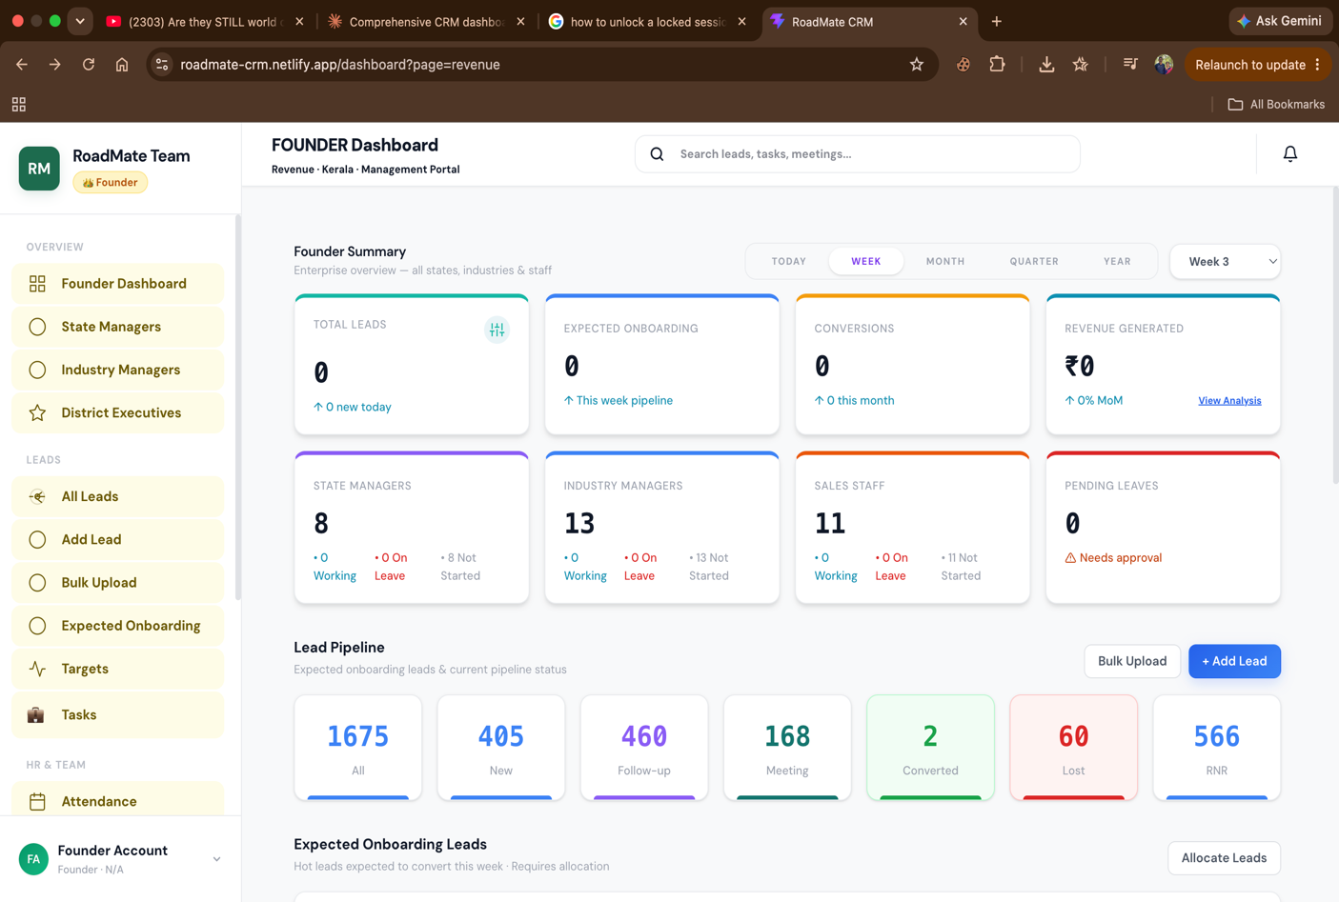

BUG-002 "View Analysis" Link Not Working
⚠ SEVERITY | HIGH
Role | Founder
Module / Area | Dashboard / Analytics
Description | The "View Analysis" link on the Founder dashboard does not respond when clicked — no navigation occurs and no error message is shown.
Steps to Reproduce | 1. Log in as Founder 2. Locate the "View Analysis" link on the dashboard 3. Click on it 4. Observe behaviour
Expected Result | Clicking "View Analysis" navigates to the analysis/analytics page or opens an analysis panel
Actual Result | Nothing happens when the link is clicked. The link appears functional in the UI but is completely non-responsive.
Impact | Founder cannot access analytical views from the dashboard. Analytics feature is effectively broken.
Screenshot | 📷 [ INSERT SCREENSHOT HERE ]  Click and paste / drag your screenshot into this box


BUG-003 State Manager, Industry Manager and Sales Staff Links Not Clickable from Founder Dashboard
⚠ SEVERITY | HIGH
Role | Founder
Module / Area | Founder Dashboard / User Management
Description | On the Founder dashboard, the navigation items or links pointing to State Manager, Industry Manager, and Sales Staff sections are not clickable — they do not respond to clicks.
Steps to Reproduce | 1. Log in as Founder 2. On the Founder dashboard, locate the State Manager / Industry Manager / Sales Staff navigation elements 3. Click on each one 4. Observe behaviour
Expected Result | Each link navigates to the respective role's management section where the Founder can view and manage those users
Actual Result | All three links/buttons are unresponsive. No navigation occurs, no error shown.
Impact | Founder cannot navigate to or manage State Managers, Industry Managers, or Sales Staff from the dashboard. Critical user management functionality is inaccessible.
Screenshot | 📷 [ INSERT SCREENSHOT HERE ]  Click and paste / drag your screenshot into this box


BUG-004 Follow-Up Count Data Mismatch on Founder Dashboard
⚠ SEVERITY | CRITICAL
Role | Founder
Module / Area | Founder Dashboard / Reporting
Description | The follow-up count shown on the Founder dashboard displays 459, but the actual count when verified against individual records is 294. The dashboard figure is incorrect by 165 records.
Steps to Reproduce | 1. Log in as Founder 2. Note the follow-up count displayed on the dashboard (shows 459) 3. Manually count or verify total follow-up records across all sections 4. Compare figures
Expected Result | Dashboard follow-up count accurately reflects the true total (294)
Actual Result | Dashboard shows 459 follow-ups. Actual count is 294. Data mismatch of 165 records.
Impact | Critical data integrity issue. Founder is making business decisions based on incorrect figures. All dashboard KPIs may be unreliable.
Screenshot | 📷 [ INSERT SCREENSHOT HERE ]  Click and paste / drag your screenshot into this box


BUG-005 Lost Leads Data Mismatch on Founder Dashboard
⚠ SEVERITY | CRITICAL
Role | Founder
Module / Area | Founder Dashboard / Reporting
Description | The Lost Leads figure shown on the Founder dashboard does not match the actual count of lost leads in the system. Dashboard figures are inconsistent with underlying data.
Steps to Reproduce | 1. Log in as Founder 2. Note the Lost Leads figure on the dashboard 3. Navigate to the leads section and filter by "Lost" status 4. Compare the two figures
Expected Result | Dashboard Lost Leads figure exactly matches the count of leads with "Lost" status in the leads list
Actual Result | Dashboard figure and actual record count do not match. Dashboard is displaying incorrect data.
Impact | Founder is seeing incorrect lost lead data, which affects business analysis, forecasting, and decision-making.
Screenshot | 📷 [ INSERT SCREENSHOT HERE ]  Click and paste / drag your screenshot into this box


BUG-006 Notification Bell Not Clickable in Lead Management
⚠ SEVERITY | MEDIUM
Role | Founder (likely affects all roles)
Module / Area | Lead Management / Notifications
Description | The notification bell icon within the Lead Management section is not clickable. Clicking it produces no response — no dropdown, no panel, no navigation.
Steps to Reproduce | All bell icons are not responding
Expected Result | Clicking the notification bell opens a notifications panel or dropdown showing relevant alerts
Actual Result | Notification bell does not respond to clicks. No panel opens.
Impact | Users cannot view notifications from within Lead Management. May cause missed follow-up alerts or assignment notifications.
Screenshot | 📷 [ INSERT SCREENSHOT HERE ]  Click and paste / drag your screenshot into this box

BUG-007 "Forgot Password" Link Not Showing on Invalid Login
⚠ SEVERITY | HIGH
Role | All roles (found via Founder session)
Module / Area | Authentication / Login
Description | When a user enters invalid credentials on the login page, the "Forgot Password" link does not appear or is not accessible. Users who are locked out have no recovery path visible.
Steps to Reproduce | 1. Navigate to the login page 2. Enter an incorrect username or password 3. Submit the login form 4. Check if a "Forgot Password" link is visible on the page
Expected Result | "Forgot Password" link is clearly visible on the login page at all times (or appears after a failed login), allowing users to initiate password recovery
Actual Result | "Forgot Password" option is not shown when invalid credentials are entered. Users have no visible way to recover account access.
Impact | Users who forget their password have no self-service recovery path. This increases support burden and could lock legitimate users out of the system permanently.
Screenshot | 📷 [ INSERT SCREENSHOT HERE ]  Click and paste / drag your screenshot into this box

BUG-008 Password Text Box Has a Visual / Functional Issue While Changing Password
⚠ SEVERITY | MEDIUM
Role | All roles (found via Founder session)
Module / Area | Authentication / Account Settings
Description | The password input text box behaves unexpectedly or has a visual issue when a user attempts to change their password. The exact nature of the issue (rendering glitch, input not accepting characters, toggle malfunction) needs further investigation.
Steps to Reproduce | 1. Log in as any role 2. Navigate to account settings or change password screen 3. Click on the password input field 4. Attempt to type a new password 5. Observe any visual or functional anomalies
Expected Result | Password text box accepts input normally, displays masked characters correctly, and behaves consistently across interactions
Actual Result | Text box exhibits an issue while changing password — possible rendering glitch, input inconsistency, or show/hide toggle problem.
Impact | Users may be unable to successfully change their password, creating a security and usability risk.
Screenshot | 📷 [ INSERT SCREENSHOT HERE ]  Click and paste / drag your screenshot into this box

BUG-009 Filter Button Not Working in District Executives Table (Dashboard)
⚠ SEVERITY | MEDIUM
Role | Industry Manager (likely affects other roles)
Module / Area | Overview Dashboard / District Executives Table
Description | The filter button in the District Executives section of the dashboard overview does not function. Clicking it produces no result — the table is not filtered.
Steps to Reproduce | 1. Log in as Industry Manager 2. Navigate to the Overview / Dashboard 3. Locate the District Executives table 4. Click the filter button 5. Observe behaviour
Expected Result | Filter panel or dropdown opens, allowing the user to filter the District Executives table by available criteria
Actual Result | Filter button is unresponsive. Table remains unfiltered. No panel or dropdown appears.
Impact | Industry Manager cannot filter district executive data. Usability severely impacted when managing large numbers of district executives.
Screenshot | 📷 [ INSERT SCREENSHOT HERE ]  Click and paste / drag your screenshot into this box
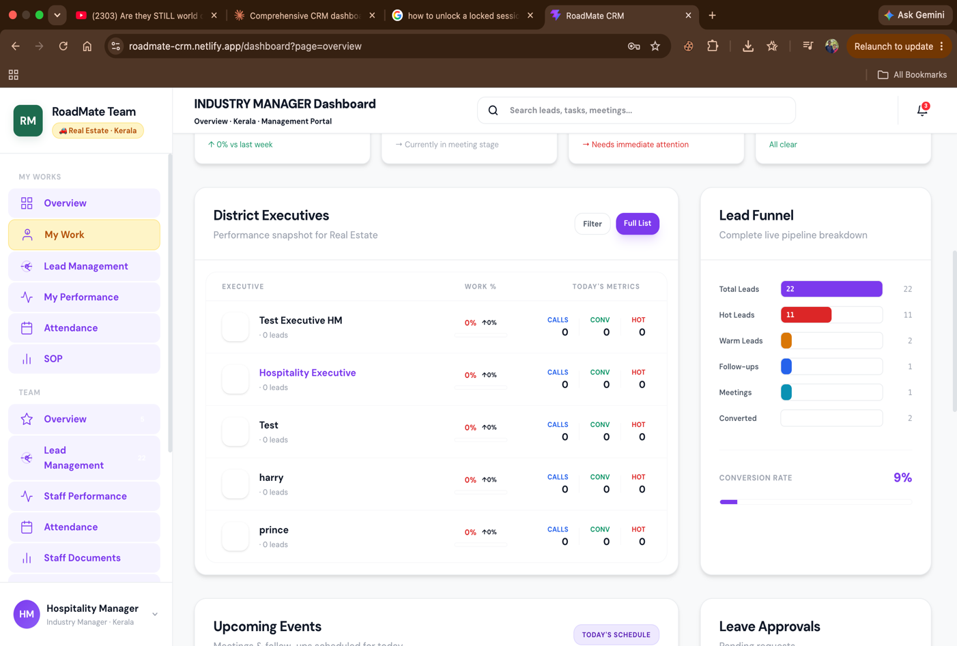

BUG-010 Lead Management Total Data Not Matching Sum of Individual Sections
⚠ SEVERITY | CRITICAL
Role | Industry Manager
Module / Area | Lead Management / Data Integrity
Description | In the Lead Management section, the total lead count displayed at the top does not match the sum of leads when individual sections/categories are added up manually. Data aggregation is incorrect.
Steps to Reproduce | 1. Log in as Industry Manager 2. Navigate to My Leads / Lead Management 3. Note the total lead count displayed 4. Add up the lead counts from each individual section or category 5. Compare the sum against the displayed total
Expected Result | Total lead count equals the exact sum of all individual section counts
Actual Result | Total count does not match the sum of individual sections. Data mismatch indicates incorrect aggregation logic.
Impact | Critical data integrity issue. Industry Manager cannot trust lead data. Reporting and decision-making based on these figures will be inaccurate.
Screenshot | 📷 [ INSERT SCREENSHOT HERE ]  Click and paste / drag your screenshot into this box
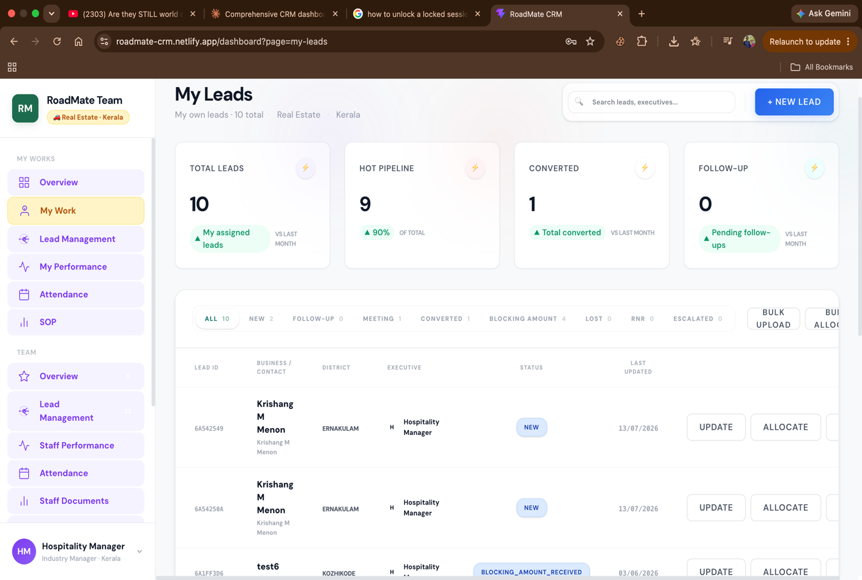

BUG-011 GET Request Failing in "My Attendance" Section
⚠ SEVERITY | HIGH
Role | Industry Manager
Module / Area | My Attendance
Description | The My Attendance section fails to load data. A GET request to the attendance API endpoint is returning an error response, preventing the section from displaying attendance records.
Steps to Reproduce | 1. Log in as Industry Manager 2. Navigate to My Attendance section 3. Open browser DevTools → Network tab 4. Observe the API GET request made for attendance data 5. Check the response status code and error
Expected Result | GET request returns 200 OK with attendance data. Section loads and displays records correctly.
Actual Result | GET request fails (non-200 status). Attendance section shows no data or an error state.
Impact | Industry Manager cannot view their own attendance records. HR/tracking functionality completely broken for this role.
Screenshot | 📷 [ INSERT SCREENSHOT HERE ]  Click and paste / drag your screenshot into this box

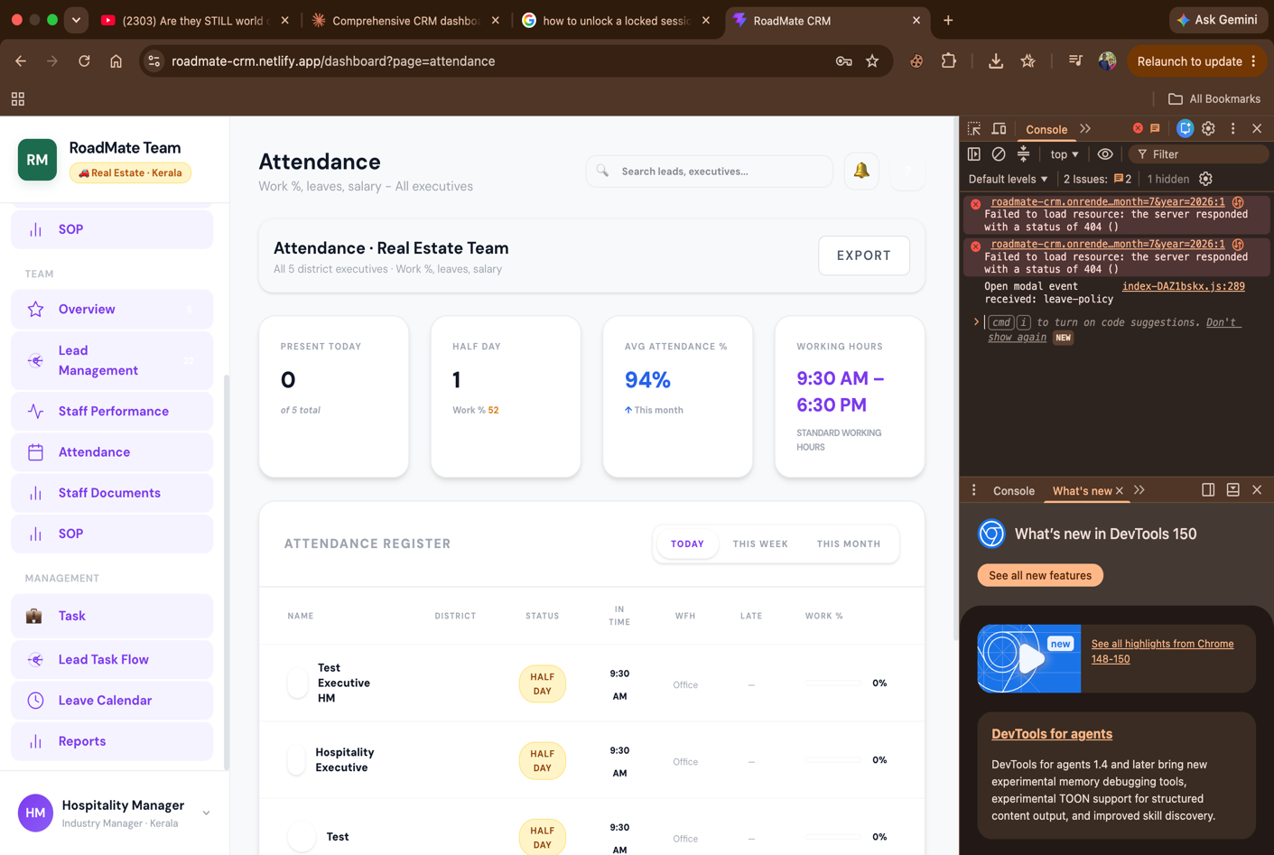
BUG-012 Warning Displayed in "My Performance" Section
⚠ SEVERITY | MEDIUM
Role | Industry Manager
Module / Area | My Performance
Description | An unexpected warning message is displayed in the My Performance section when the Industry Manager views it. The warning may indicate a data loading issue, missing configuration, or a backend error surfacing in the UI.
Steps to Reproduce | 1. Log in as Industry Manager 2. Navigate to My Performance section 3. Observe any warning messages displayed
Expected Result | My Performance section loads cleanly with performance data, no warning messages
Actual Result | A warning is displayed in the My Performance section. Root cause unclear — may be missing data, API error, or misconfiguration.
Impact | Degrades user confidence in performance data accuracy. May indicate underlying data or API issue.
Screenshot | 📷 [ INSERT SCREENSHOT HERE ]  Click and paste / drag your screenshot into this box
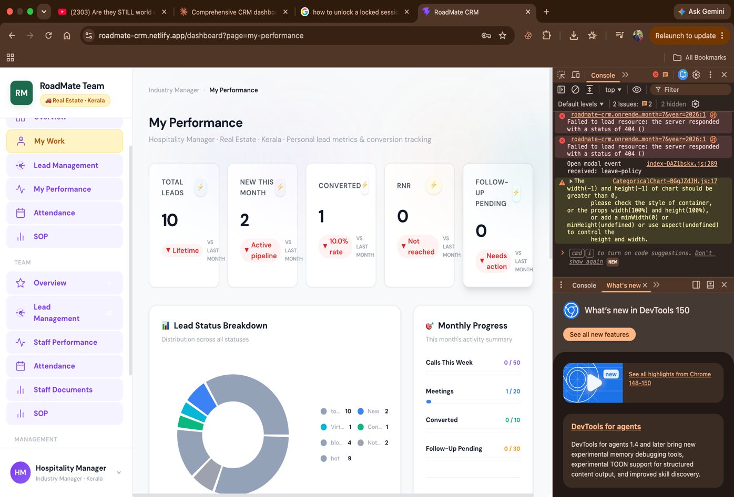

BUG-013 Notification Bell Not Working in Staff Performance Section
⚠ SEVERITY | MEDIUM
Role | Industry Manager (likely affects other roles)
Module / Area | Staff Performance / Notifications
Description | The notification bell within the Staff Performance section is non-functional. Clicking it does not open any notification panel or produce any response.
Steps to Reproduce | 1. Log in as Industry Manager 2. Navigate to Staff Performance section 3. Locate the notification bell 4. Click on it 5. Observe behaviour
Expected Result | Notification panel or dropdown opens with relevant alerts
Actual Result | Notification bell is unresponsive. No panel opens.
Impact | Industry Manager cannot access notifications from within Staff Performance. Notification system appears inconsistently broken across multiple sections.
Screenshot | 📷 [ INSERT SCREENSHOT HERE ]  Click and paste / drag your screenshot into this box

BUG-014 Attendance Report Export Not Working
⚠ SEVERITY | HIGH
Role | Industry Manager
Module / Area | Attendance / Export
Description | When the Industry Manager attempts to export the attendance report, the export fails — no file is downloaded and no success confirmation is shown.
Steps to Reproduce | 1. Log in as Industry Manager 2. Navigate to Attendance section 3. Click the Export button for the attendance report 4. Observe whether a file downloads
Expected Result | Clicking Export downloads the attendance report as an Excel/CSV/PDF file
Actual Result | No file is downloaded. Export action fails silently or shows an error.
Impact | Industry Manager cannot export attendance data for HR processing or record-keeping. Reporting functionality broken.
Screenshot | 📷 [ INSERT SCREENSHOT HERE ]  Click and paste / drag your screenshot into this box

BUG-015 404 Error When Requesting Leave
⚠ SEVERITY | HIGH
Role | Industry Manager (likely affects all roles)
Module / Area | Leave Management
Description | When the Industry Manager submits a leave request, the system returns a 404 Not Found error. The API endpoint for leave requests is either missing, misconfigured, or at an incorrect URL.
Steps to Reproduce | 1. Log in as Industry Manager 2. Navigate to Leave / Leave Management section 3. Fill in leave request details 4. Submit the request 5. Observe the response (check Network tab for 404)
Expected Result | 201 Created or 200 OK response confirming leave request was submitted successfully
Actual Result | 404 Not Found error returned. Leave request is not submitted.
Impact | Staff cannot apply for leave through the system. Leave management functionality is completely broken for this role.
Screenshot | 📷 [ INSERT SCREENSHOT HERE ]  Click and paste / drag your screenshot into this box
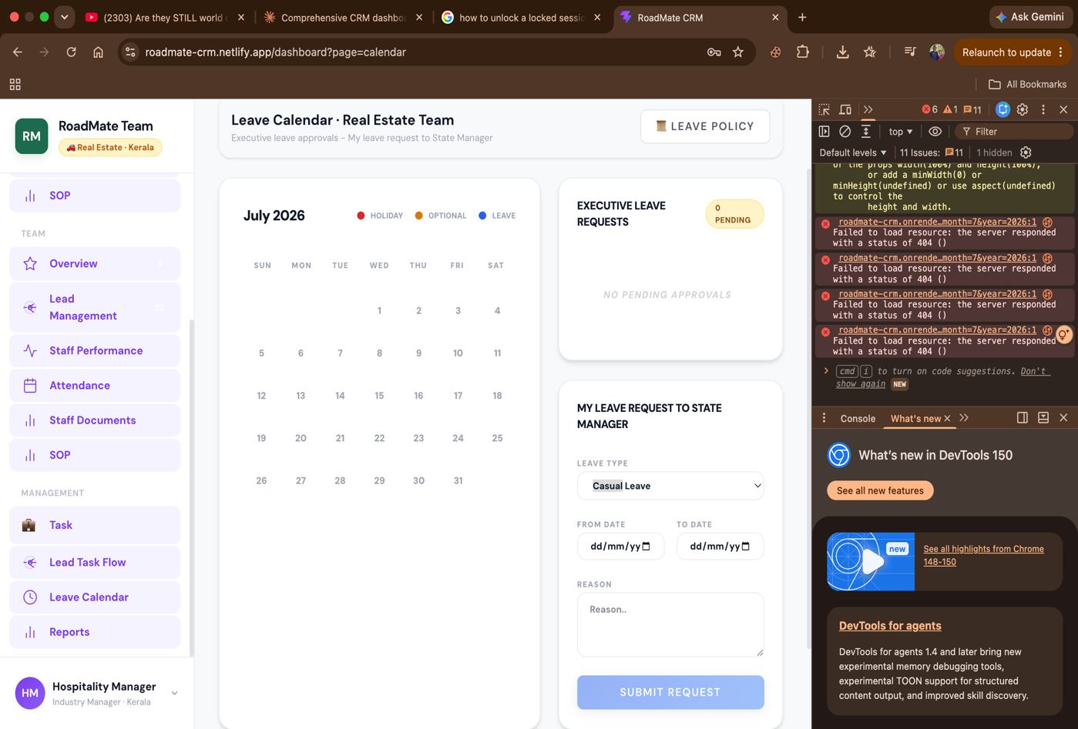

BUG-016 Mobile Number Field Has No Character Limit When Creating a Lead
⚠ SEVERITY | MEDIUM
Role | Industry Manager (likely affects all roles with lead creation)
Module / Area | Lead Management / Create Lead
Description | The mobile number input field in the Create Lead form does not enforce any character limit. Users can enter unlimited digits or non-numeric characters without any validation error.
Steps to Reproduce | 1. Log in as Industry Manager 2. Navigate to Lead Management → Create New Lead 3. Locate the Mobile Number field 4. Type more than 10 digits (e.g. 20+ digits) 5. Attempt to save the lead
Expected Result | Mobile number field accepts maximum 10 digits (Indian standard) and rejects non-numeric input. Validation error shown if limit exceeded.
Actual Result | Field accepts unlimited characters with no validation. Leads can be saved with invalid mobile numbers.
Impact | Data quality issue — invalid phone numbers enter the system. Downstream impact on calling/messaging workflows that depend on valid contact numbers.
Screenshot | 📷 [ INSERT SCREENSHOT HERE ]  Click and paste / drag your screenshot into this box

BUG-017 Duplicate Lead Creation Is Allowed
⚠ SEVERITY | HIGH
Role | Industry Manager (likely affects all roles)
Module / Area | Lead Management / Create Lead
Description | The system allows creating multiple lead records with identical details (same name, phone number, or email). No duplicate detection or warning is triggered.
Steps to Reproduce | 1. Log in as Industry Manager 2. Create a new lead with specific details (name, phone, email) 3. Save successfully 4. Create another lead with the exact same details 5. Attempt to save again
Expected Result | System detects the duplicate and either blocks creation with a warning message, or prompts the user to confirm they want to create a duplicate
Actual Result | Second lead is saved without any warning. Duplicate lead records now exist in the system.
Impact | Data integrity issue. Duplicate leads cause confusion, double follow-ups, and inflate lead count metrics. Sales teams may contact the same person twice.
Screenshot | 📷 [ INSERT SCREENSHOT HERE ]  Click and paste / drag your screenshot into this box

BUG-018 Overdue Tasks Not Appearing in the Overdue Section After Deadline
⚠ SEVERITY | HIGH
Role | Industry Manager (likely affects all roles)
Module / Area | Tasks / Overdue
Description | When a task's deadline passes, it does not automatically move to or appear in the Overdue section. Tasks past their deadline continue to appear only in their original section.
Steps to Reproduce | 1. Log in as Industry Manager 2. Create a task with a deadline set to today or yesterday 3. Navigate to the Overdue section 4. Verify whether the past-deadline task appears there
Expected Result | Tasks whose deadline has passed are automatically shown in the Overdue section
Actual Result | Past-deadline tasks do not appear in the Overdue section. Overdue tracking is not functioning.
Impact | Industry Manager has no reliable way to identify and prioritise overdue tasks. Critical tasks may be missed entirely.
Screenshot | 📷 [ INSERT SCREENSHOT HERE ]  Click and paste / drag your screenshot into this box

BUG-019 "View Tomorrow's Schedule" Button Not Working in Overview
⚠ SEVERITY | MEDIUM
Role | Industry Manager (likely affects all roles)
Module / Area | Overview / Schedule
Description | The "View Tomorrow's Schedule" button in the Overview section does not respond when clicked. No navigation or panel appears.
Steps to Reproduce | 1. Log in as Industry Manager 2. Navigate to Overview 3. Locate the "View Tomorrow's Schedule" button 4. Click it 5. Observe behaviour
Expected Result | Clicking the button navigates to or displays tomorrow's scheduled tasks/meetings/follow-ups
Actual Result | Button is unresponsive. No action occurs.
Impact | Users cannot quickly check their upcoming schedule from the overview. Planning workflow disrupted.
Screenshot | 📷 [ INSERT SCREENSHOT HERE ]  Click and paste / drag your screenshot into this box

BUG-020 Task Visible to Industry Manager But Not Visible to Founder
⚠ SEVERITY | HIGH
Role | Industry Manager / Founder (cross-role visibility issue)
Module / Area | Tasks / Cross-Role Visibility
Description | A task created and visible within the Industry Manager role does not appear when the Founder views tasks. The Founder should have full visibility of all tasks across all roles, but this task is missing from the Founder's view.
Steps to Reproduce | 1. Log in as Industry Manager 2. Note a specific task visible in the task list 3. Log out and log in as Founder 4. Navigate to the Tasks section 5. Search for the same task 6. Observe whether it appears
Expected Result | Founder can see all tasks created by or assigned to any role, including Industry Manager tasks
Actual Result | The task visible to Industry Manager is not visible to Founder. Data roll-up to Founder level is incomplete.
Impact | Founder has an incomplete view of all tasks in the system. This is an RBAC/visibility hierarchy bug — Founder should always see everything below them.
Screenshot | 📷 [ INSERT SCREENSHOT HERE ]  Click and paste / drag your screenshot into this box

