Updated August 2026
Quantum Entanglement and Information Theory in Radical Pair Navigation
Chandan Sheikder^{1**} , Weimin Zhang^{1*,} Xiaopeng Chen , Shicheng Fan¹ , Tairan Li¹, Haotong He¹
*Weimin Zhang.
Email: zhwm@bit.edu.cn
Author Contributions: Chandan Sheikder: Conceptualization, methodology, software (Super-Engine framework), formal analysis, investigation, data curation, writing - original draft, visualization.
Weimin Zhang: Supervision, project administration, funding acquisition, resources, writing - review & editing, corresponding author.
Xiaopeng Chen: Validation of Experiment 03 (Quantum Fisher Information calculations).
Fangxing Li: Writing – review & editing of the manuscript draft.
Zhengqing Zuo: Writing – review & editing of the Results section.
Yichang Liu: Validation of Experiment 04 (Decoherence thresholds).
Xiaohai He: Writing – review & editing of the Materials and Methods.
Xinyan Tan: Visualization assistance for Fig. 2 (Entanglement heatmaps).
Shicheng Fan: Writing – review & editing of the Discussion section.
Competing Interest Statement: The authors declare that they have no competing financial, professional, or personal interests that could have appeared to influence the work reported in this paper.
Classification: Biological Sciences (Biophysics and Computational Biology); Physical Sciences (Physics).
Keywords: quantum biology; radical pair mechanism; cryptochrome; magnetoreception; Quantum Fisher Information; entanglement; information theory; avian navigation.

Abstract
The quantum-biological compass in migratory birds relies on spin-correlated radical pairs generated within cryptochrome flavoproteins upon photoexcitation. Here we develop a complete theoretical framework, integrating spin Hamiltonian dynamics, Lindblad master equation formalism, Quantum Fisher Information (QFI) analysis, and Shannon information theory, to quantify the role of quantum entanglement in avian magnetoreception. We derive the full singlet-triplet oscillation dynamics under Earth-strength magnetic fields (25–65 $μT$) and demonstrate that protein-mediated decoherence protection yields functional coherence times of 1–100 $μs$, orders of magnitude exceeding the thermal decoherence limit. Entanglement concurrence values of C ~ 0.1-0.5 at biologically relevant timescales contribute measurably to compass sensitivity. QFI analysis reveals that entangled radical pairs approach Heisenberg scaling ($F_{Q}\sim N^{2}$), enabling angular precision of 1–5° at biological signal-to-noise ratios. Information-theoretic analysis shows navigation capacities of 0.5–2.5 bits per sensing cycle with a thermodynamic cost of ~0.3 ATP/bit, well within biological energy budgets. The Hilbert space dimension grows as $2^{n}$ with nuclear spin count, providing a structural basis for quantum advantage in multi-nuclear simulations. These results quantitatively establish the functional role of quantum mechanics in biological navigation and provide a rigorous framework for the design of quantum-enhanced biomimetic magnetometers.
Significance Statement
Migratory birds navigate thousands of kilometers with remarkable precision using Earth’s geomagnetic field. This work presents a comprehensive quantum-mechanical framework demonstrating that cryptochrome-based radical pair chemistry in the avian retina supports genuine quantum entanglement, Heisenberg-limited sensitivity, and information-theoretic navigation capacities far exceeding classical bounds. Using Quantum Fisher Information analysis, we show that entangled radical pairs achieve up to 10–30% navigational enhancement over classical mechanisms, with a thermodynamic cost of only ~0.3 ATP per bit, an order of magnitude below the Landauer limit for the information processed. These findings establish quantum biology as a quantitatively rigorous discipline with direct implications for bioinspired sensing technologies.

Introduction

Animal magnetoreception, the ability to detect and interpret Earth’s geomagnetic field for spatial orientation, represents one of the most compelling intersections between quantum physics and biology [1], [2]. Migratory birds such as European robins (Erithacus rubecula) demonstrate navigation precision exceeding 5° angular resolution across intercontinental distances, implying a compass mechanism operating near fundamental physical limits [3], [4]. The leading molecular hypothesis invokes spin-correlated radical pairs generated within cryptochrome (CRY) flavoproteins of the avian retina, in which Earth-strength magnetic fields (25–65 $μT$) modulate the singlet-triplet interconversion kinetics, thereby encoding directional information in downstream signaling chemistry [5], [6], [7], [8].
The radical pair mechanism (RPM) was originally formulated by Schulten and colleagues in the context of photochemistry [9] and later extended to magnetoreception by Ritz et al. [5]. Key experimental support includes: (i) the light-dependence of the magnetic compass in European robins [10]; (ii) behavioral disruption by radiofrequency fields at the Larmor frequency [11]; (iii) the identification of CRY4 as the primary magnetoreceptor in migratory birds [12]; and (iv) spectroscopic detection of spin-correlated radical pairs in purified cryptochrome [13], [14]. Yet the quantitative role of quantum entanglement, as opposed to classical spin correlations, remains a subject of active investigation [15], [16], [17].
Several theoretical studies have addressed coherence timescales, signal-to-noise constraints, and the plausibility of quantum effects under biological conditions [18], [19], [20], [21], [22]. However, a unified framework that quantitatively links (i) spin Hamiltonian dynamics, (ii) decoherence rates, (iii) entanglement measures, (iv) Quantum Fisher Information (QFI), and (v) Shannon channel capacity in a single self-consistent model has been lacking. Moreover, the thermodynamic efficiency of quantum-enhanced navigation, critical for assessing its evolutionary plausibility, has not been rigorously quantified.
Here we develop such a framework. We derive the complete Hamiltonian dynamics of the FAD•⁻/Trp•⁺ radical pair, including all relevant hyperfine couplings, solve the Lindblad master equation for biologically realistic decoherence environments, compute entanglement measures (concurrence, negativity, quantum discord) as functions of time, magnetic field, and temperature, and apply QFI formalism to obtain fundamental sensitivity bounds. We then use Shannon mutual information theory to quantify navigation channel capacity and compute thermodynamic costs in units of ATP hydrolysis equivalents. Our results demonstrate that quantum entanglement contributes measurably and advantageously to avian magnetoreception, with direct implications for bioinspired quantum sensing.

Results

Radical Pair Quantum Dynamics
The complete Hamiltonian governing the FAD•⁻/Trp•⁺ radical pair is:
$$H_{total}=H_{Zeeman}+H_{hyperfine}+H_{exchange}+H_{dipolar}$$  $$H_{Zeeman}=g_{1}μ_{B}B·S_{1}+g_{2}μ_{B}B·S_{2}$$  $$H_{hyperfine}=\sum_{i}{A_{i}I_{i}·S_{1}+\sum_{ⱼ}{B_{j}J_{j}·S_{2}}}$$ | (1)
where g₁, g₂ ≈ 2.003–2.005 are the electron g-factors for flavin and tryptophan radicals, respectively, $μ_{B}=9.274×{10}^{-24}$ J/T is the Bohr magneton, B is the geomagnetic field vector, and $A_{i},B_{j}$ are hyperfine coupling tensors for nuclei ¹H, ¹⁴N, ¹³C, and ³¹P in the FAD chromophore. The exchange interaction $H_{exchange}=-2J_{r}S_{1}·S_{2}$ with $J_{r}\sim {10}^{-4}-{10}^{-2}$ cm⁻¹ is significant only at radical separations r < 1 nm.
The time evolution of the spin density matrix follows the Lindblad master equation:
$$\frac{dρ}{dt}=-\frac{i}{ℏ}\left[H_{\text{total}},ρ\right]+\sum_{α}{γ_{α}\left(L_{α}ρL_{α}^{†}-\frac{1}{2}\{L_{α}^{†}L_{α},ρ\}\right)}$$ | (2)
The singlet-state population dynamics under the simplified S–T₀ approximation yield a closed-form solution:
$$ρ_{\text{SS}}\left(t\right)=\frac{1}{2}\left[1+\cos\left(Ωt\right)\right]e^{-Γt}$$  $$Ω=\sqrt{\frac{{\left(ω_{1}-ω_{2}\right)}^{2}}{4}+\frac{{\left(A_{1}-A_{2}\right)}^{2}}{4}}$$  $$Γ=\frac{1}{2}\left(k_{\text{S}}+k_{\text{T}}+γ_{\text{relax}}\right)$$ | (3)
The singlet yield as a function of magnetic field strength B and inclination angle θ is:
$Φ_{\text{S}}\left(B,θ\right)=\frac{k_{\text{S}}}{2}\operatorname{Re}\left\{\frac{1}{k_{\text{S}}+iΩ\left(B,θ\right)+Γ}\right\}$iscussion | (4)
Figure 1 shows the computed singlet-triplet oscillation dynamics under geomagnetic field conditions. Panel A demonstrates rapid oscillation with a characteristic envelope decay on the 10–20 μs timescale, consistent with the measured coherence window of the avian CRY4 system. Panel B illustrates the angular dependence of the steady-state singlet yield, showing a periodic modulation with ~0.25% amplitude in the geomagnetically relevant range (25–65 μT). The temperature dependence (panel D) reveals a peak coherence time at $T_{opt}=280K$ with functional maintenance through body temperature (310 K), implying evolutionary optimization of the protein scaffold for thermal protection of quantum coherence.

Entanglement and Decoherence Analysis
Quantum entanglement in the FAD•⁻/Trp•⁺ radical pair was quantified using three independent measures: concurrence $C\left(ρ\right)$, negativity $N\left(ρ\right)$, and quantum discord $D\left(ρ_{AB}\right)$. The concurrence for the two-spin density matrix is:
$$C\left(ρ\right)=\max{\{}0,λ_{1}-λ_{2}-λ_{3}-λ_{4}\}$$ | (5)
where $λ_{i}$ are the eigenvalues in decreasing order of the spin-flipped density matrix
$\tilde{ρ}=\left(σ_{y}⊗σ_{y}\right) ρ^{*} \left(σ_{y}⊗σ_{y}\right)$. Entanglement dynamics follow an exponential decay:
$$C\left(t\right)=C_{0}\exp\left(-Γ_{\text{ent}} t\right), Γ_{\text{ent}}=2γ_{\text{dephase}}+γ_{\text{relax}}$$ | (6)
At t = 1 μs under low-noise biological conditions, C(t) ~ 0.1–0.5, representing weak but functionally significant entanglement. The five identified decoherence mechanisms, environmental magnetic noise $Γ_{\text{env}}∼{10}^{5}\text{--}{10}^{7} {\text{s}}^{\text{-1}}$, thermal fluctuations $\left(Γ_{\text{thermal}}∼{10}^{7}\text{-}{10}^{9} {\text{s}}^{\text{-1}}\right)$, protein-vibrational coupling $\left(Γ_{\text{protein}}∼{10}^{6}\text{--}{10}^{8} {\text{s}}^{\text{-1}}\right)$, solvent reorganization ($Γ_{solvent}$ ~ ${10}^{8}$–${10}^{10}s^{-1}$), and radical recombination $\left(Γ_{\text{radical}}∼{10}^{6}\text{--}{10}^{8} {\text{s}}^{\text{-1}}\right)$, are each partially mitigated by the protein scaffold (Table 2). The total observed coherence time of 1–100 μs exceeds the thermal decoherence limit $\left(ℏ/k_{\text{B}}T≈40 \text{fs}\right)$ by a factor of 10²–10⁴, attributable to protein-mediated protection with an enhancement factor $F_{\text{protection}}∼{10}^{2}\text{--}{10}^{4}$.
Notably, quantum discord $D\left(ρ_{AB}\right)$ persists beyond entanglement decay timescales (Fig. 2F), with values 0.01–0.1 bits at t ~ 15 μs, consistent with quantum correlations being maintained in the mixed-state regime relevant to avian body temperature. Bell inequality analysis (Fig. 2E) confirms that freshly initialized singlet states violate the CHSH bound (S > 2), while the T₀ triplet approaches classical correlation, and maximally mixed states satisfy classical bounds.

Quantum Fisher Information Analysis
The Quantum Fisher Information (QFI) provides the fundamental quantum-mechanical bound on measurement precision via the quantum Cramér-Rao inequality:
$$\operatorname{Var}\left(\hat{θ}\right)≥\frac{1}{N⋅F_{Q}\left(θ\right)}$$  $$F_{Q}\left(θ\right)=4\sum_{m≠n}{\frac{\{|\left\langle m{\left|∂_{θ}H\left|n\right\rangle \right|}^{2}\right\}}{{\left(E_{n}-E_{m}\right)}^{2}}}$$ | (7)
For separable (unentangled) probe states, QFI scales as N, the Standard Quantum Limit (SQL). For maximally entangled states (GHZ₄, NOON₄), QFI scales as N², the Heisenberg Scaling Limit (HSL), yielding a $\sqrt{N}$ improvement in angular precision:
$$δθ_{\text{HSL}}=\frac{1}{\sqrt{N^{2}⋅F_{0}}}=\frac{δθ_{\text{SQL}}}{N}$$ | (8)
Figure 3A shows QFI scaling across probe states. In the biologically realistic regime, entangled radical pairs achieve ~2–16× QFI enhancement depending on nuclear spin environment and decoherence conditions (Fig. 3D). Figure 3B demonstrates that angular precision δθ ~ 10⁻⁷–10⁻⁹ degrees is achievable with sufficient measurements at optimal field strength, far below the ~5° biological target, indicating substantial information reserve even under realistic noise. The QFI matrix (Fig. 3C) reveals strong correlations between θ–B parameter pairs, suggesting synergistic use of inclination angle and field magnitude for directional determination.

Compass Sensitivity and Navigational Information
The angular response of the radical pair compass was computed across the full range of geomagnetic field strengths and inclination angles. The fundamental Cramér-Rao sensitivity bound for the singlet yield observable is:
$$δθ_{min}≈\frac{1}{B}⋅\sqrt{\frac{Φ_{S}}{N_{\text{photons}}}}×\left(\text{thermal noise factor}\right)$$ | (9)
For B = 50 μT and N = 10⁶ photons per sensing cycle, $δθ_{min}\sim 1-5°$, consistent with the behavioral precision of ~5° observed in migratory birds (3). The compass operates as an inclination compass (sensitive to field tilt relative to the vertical, Fig. 4C), consistent with behavioral studies of European robins [23]. The transduction chain efficiency (Fig. 4D) shows that the quantum layer (cryptochrome) operates at 100% QFI utilization, with downstream protein (30%) and neural (50%) stages being the limiting steps, indicating that investment in quantum coherence is not the bottleneck.
Disruption by resonant radiofrequency (RF) fields peaks at the Larmor frequency $f_{L}=1.4$ MHz (Fig. 4E), providing a mechanistic explanation for the well-documented RF-disruption of magnetic compass orientation in migratory birds (11). The signal-to-noise ratio for compass detection scales as $\sqrt{N_{photons}}$(Fig. 4F), reaching the SNR > 10 threshold at N ≈ 10⁷ photons per coherence cycle.

Information-Theoretic Analysis
The navigation channel capacity C was computed using the Shannon mutual information between the magnetic field state and the cryptochrome signaling output:
$$δC=\max_{p\left(x\right)}{I\left(X;Y\right)}=\max_{p\left(x\right)}\left[H\left(Y\right)-H\left(Y ∣ X\right)\right]$$  $$C=\frac{1}{2}\log_{2}\left(1+\text{SN}{\text{R}}^{\text{2}}\right) \text{bits}\text{/}\text{cycle (Gaussian channel)}$$ | (10)
Under Earth-field conditions with entangled radical pairs, the navigation capacity is 0.5–2.5 bits per sensing cycle (Fig. 5C). Entangled states achieve ~0.03 bits/cycle greater capacity than separable states across the 25–65 μT range, a small but consistent quantum advantage attributable to the quadratic sensitivity of the singlet yield to field strength. The temperature dependence of capacity (Fig. 5, panel e-right) shows a peak at ~300 K remarkably close to avian body temperature (310 K), suggesting thermal optimization.
The thermodynamic cost of information processing was analyzed using Landauer's principle and ATP hydrolysis energetics (Fig. 5, panel e-left). Each bit of navigational information requires ~0.3 ATP equivalents of energy, placing the cryptochrome compass well below the ATP hydrolysis threshold (~50 zJ) and only ~3× above the Landauer limit (~15 zJ at 310 K). This exceptional efficiency,comparable to biochemical signaling cascades, supports the evolutionary viability of quantum-enhanced navigation.

Quantum Advantage Analysis
The quantum advantage of the radical pair compass was analyzed from three perspectives: (i) Hilbert space scaling, (ii) simulation complexity, and (iii) noise resilience. The Hilbert space dimension for n nuclear spins grows as 2ⁿ (Fig. 6A), creating an exponential classical simulation overhead that scales as 2²ⁿ for the density matrix. This provides the substrate for quantum advantage in multi-nuclear magnetometry, with n = 10–20 magnetic nuclei in CRY4 yielding Hilbert space dimensions of 10³–10⁶.
Computational simulation time comparison (Fig. 6B) shows that quantum simulation methods maintain polynomial scaling (n²) versus exponential classical scaling beyond ~20 qubits, confirming the utility of quantum computing approaches for mechanistic modeling of cryptochrome function. The noise resilience analysis (Fig. 6C) demonstrates that 4-qubit systems maintain fidelity > 0.5 below 20% noise per cycle, while 12-qubit systems decohere rapidly, suggesting that biological systems may operate in an intermediate regime optimized between quantum advantage and noise robustness.

Discussion
Our comprehensive quantum-mechanical analysis establishes three principal conclusions regarding the role of entanglement in avian magnetoreception. First, quantum entanglement is measurable and functionally non-negligible: concurrence values C ~ 0.1–0.5 at biologically relevant timescales contribute 10–30% enhancement in compass sensitivity, equivalent to ~0.03 bits/cycle additional navigation capacity. While small in absolute terms, this enhancement is consistent across all magnetic field strengths and inclination angles studied, suggesting a systematic rather than coincidental quantum contribution.
Second, the protein scaffold of cryptochrome provides extraordinary decoherence protection: a factor of 10²–10⁴ enhancement over vacuum coherence times, enabling functional quantum coherence at body temperature. This finding argues against the ‘warm, wet, and noisy’ objection to biological quantum mechanics [24]. The protein protection factor $F_{protection}$ arises from hydrophobic pocket isolation, rigid FAD binding geometry, and exclusion of water molecules from the radical pair microenvironment, structural features shared across cryptochrome orthologs in diverse migratory species.
Third, the thermodynamic efficiency of quantum-enhanced magnetoreception is remarkable: ~0.3 ATP per navigational bit, placing it within the operating range of other biological signaling systems [25]. The energy cost is dominated by photon absorption and signaling cascades rather than quantum coherence maintenance per se, implying that quantum coherence is essentially 'free' once the cryptochrome photocycle is activated.
Our QFI analysis reveals an important distinction between Heisenberg scaling (achievable in principle with GHZ/NOON states) and the biologically realistic regime. The biological system operates at ~10–30% above the classical limit, not at the full N² Heisenberg bound, consistent with partial entanglement under thermal and decoherence constraints. This moderate quantum advantage may be precisely what natural selection has optimized: maximizing navigation information per unit energy expenditure, rather than achieving ultimate physical sensitivity limits that would require extreme isolation from the environment.
These results have direct implications for the design of quantum-enhanced biomimetic magnetometers. The cryptochrome system demonstrates that room-temperature quantum sensing is achievable with moderate entanglement, protein-engineered decoherence protection, and classical signal averaging over multiple sensing cycles. Synthetic radical pair systems incorporating these design principles could approach the angular precision of biological compasses (1–5°) while operating at temperatures and noise levels incompatible with current superconducting or atomic quantum sensors.
Several important caveats apply. The concurrence values reported here are theoretical upper bounds assuming ideal initial singlet state preparation; in vivo initialization efficiency depends on the photocycle kinetics and spin dynamics during radical pair formation, which remain incompletely characterized [26]. Furthermore, the transduction chain efficiency (quantum → protein → neural) of ~15% total (Fig. 4D) means that the quantum advantage at the molecular level is substantially attenuated before reaching behavioral outputs. Future experimental work should focus on direct measurement of in vivo entanglement in CRY4 using time-resolved EPR spectroscopy and on quantifying the transduction efficiency at each signaling step.

Materials and Methods

Spin Hamiltonian Parameterization

The g-factors (g₁ = 2.00304, g₂ = 2.00232) and hyperfine coupling constants were taken from EPR spectroscopic measurements of FAD radical in Arabidopsis thaliana CRY1 [27] and tryptophan radical in CRY4 [28]. The complete hyperfine tensor for ¹H, ¹⁴N, ¹³C, and ³¹P nuclei was parameterized using DFT calculations at the B3LYP/6-311G** level (Gaussian 16) with geometry optimization in the protein environment using QM/MM methodology. Exchange coupling J_r = J₀ exp(−βr) with J₀ = 10⁻³ cm⁻¹ and β = 1.4 Å⁻¹ was applied for radical separations r = 1–3 nm consistent with CRY4 crystal structure (PDB: 6PU0).

Master Equation Integration
The Lindblad master equation was integrated numerically using the QuTiP (Quantum Toolbox in Python) package v4.7 with the mesolve() function, employing a 4th-order Runge-Kutta algorithm with adaptive step size (rtol = 10⁻⁸). The initial state was the pure singlet |S⟩ = $\left(\frac{1}{\sqrt{2}}\right)$(|↑↓⟩ − |↓↑⟩). Decoherence rates were assigned from published EPR relaxation measurements [29]: $γ_{relax}$ = 2 × 10⁶ s⁻¹, $γ_{dephase}=5$ × 10⁷ s⁻¹, $k_{S}=3$ × 10⁶ s⁻¹, $k_{T}=$ 10⁶ s⁻¹. Protein-mediated protection was modeled via $F_{\text{protection}}=exp\left(-\int{ρ_{\text{protein}}\left(r\right)} V_{\text{coupling}}\left(r\right) d^{3}r\right)$ evaluated over the CRY4 active site structure.

Quantum Fisher Information Computation
QFI was computed analytically for pure states using $F_{Q}=4\left(\left\langle ∂_{θ}ψ | ∂_{θ}ψ\right\rangle -{\left|\left\langle ∂_{θ}ψ | ψ\right\rangle \right|}^{2}\right)$and numerically for mixed states using the symmetric logarithmic derivative formulation $F_{Q}=2\sum_{{m,n \atop λ_{m}+λ_{n}>0}}{\frac{{\left|\left\langle m\left|∂_{θ}ρ\right|n\right\rangle \right|}^{2}}{λ_{m}+λ_{n}}}$, where $λ_{m},λ_{n}$ are eigenvalues of ρ. The QFI matrix elements $F_{ij}$ were computed via finite differences with δθ = 10⁻⁶ rad, confirmed by analytical gradients.

Information-Theoretic Analysis
Navigation channel capacity was computed as $C=\frac{1}{2}\log_{2}\left(1+\text{SN}{\text{R}}^{\text{2}}\right)$for the Gaussian approximation, with SNR calculated from the singlet yield signal amplitude and shot noise $σ_{N}=\sqrt{N}$. Quantum discord was computed as $D\left(ρ_{AB}\right)=I\left(A:B\right)-\max_{\{Π_{A}\}}{J\left(ρ_{AB} ∣ \{Π_{A}\}\right)}$, where the optimization over measurement operators $Π_{A}$ was performed numerically using a constrained optimization routine. Thermodynamic costs were computed using Landauer's principle $E_{\text{bit}}=k_{\text{B}}T$ ln(2), normalized to ATP hydrolysis energy ~50 zJ per molecule.

Acknowledgments

Paste your acknowledgments here.

References

[1] D. Rus and M. T. Tolley, “Design, fabrication and control of soft robots,” Nature 2015 521:7553, vol. 521, no. 7553, pp. 467–475, May 2015, doi: 10.1038/nature14543.
[2] W. Wiltschko and R. Wiltschko, “Magnetic compass of European robins,” Science (1979)., vol. 176, no. 4030, pp. 62–64, Apr. 1972, doi: 10.1126/SCIENCE.176.4030.62;PAGE:STRING:ARTICLE/CHAPTER.
[3] C. M. Hein, S. Engels, D. Kishkinev, and H. Mouritsen, “Robins have a magnetic compass in both eyes,” Nature 2011 471:7340, vol. 471, no. 7340, pp. E1–E1, Mar. 2011, doi: 10.1038/nature09875.
[4] R. Wiltschko and W. Wiltschko, “Magnetic Orientation in Animals,” vol. 33, 1995, doi: 10.1007/978-3-642-79749-1.
[5] T. Ritz, S. Adem, and K. Schulten, “A Model for Photoreceptor-Based Magnetoreception in Birds,” Biophys. J., vol. 78, no. 2, pp. 707–718, Feb. 2000, doi: 10.1016/S0006-3495(00)76629-X.
[6] K. Schulten, C. E. Swenberg, and A. Weiler, “A Biomagnetic Sensory Mechanism Based on Magnetic Field Modulated Coherent Electron Spin Motion,” Zeitschrift fur Physikalische Chemie, vol. 111, no. 1, pp. 1–5, 1978, doi: 10.1524/ZPCH.1978.111.1.001.
[7] K. Maeda et al., “Chemical compass model of avian magnetoreception,” Nature 2008 453:7193, vol. 453, no. 7193, pp. 387–390, Apr. 2008, doi: 10.1038/nature06834.
[8] C. T. Rodgers and P. J. Hore, “Chemical magnetoreception in birds: The radical pair mechanism,” Proc. Natl. Acad. Sci. U. S. A., vol. 106, no. 2, pp. 353–360, Jan. 2009, doi: 10.1073/PNAS.0711968106;ISSUE:ISSUE:DOI.
[9] G. L. Closs, “Mechanism explaining nuclear spin polarizations in radical combination reactions,” J. Am. Chem. Soc., vol. 91, no. 16, pp. 4552–4554, Jul. 2002, doi: 10.1021/JA01044A043.
[10] T. Ritz, P. Thalau, J. B. Phillips, R. Wiltschko, and W. Wiltschko, “Resonance effects indicate a radical-pair mechanism for avian magnetic compass,” Nature 2004 429:6988, vol. 429, no. 6988, pp. 177–180, May 2004, doi: 10.1038/nature02534.
[11] H. G. Hiscock, H. Mouritsen, D. E. Manolopoulos, and P. J. Hore, “Disruption of Magnetic Compass Orientation in Migratory Birds by Radiofrequency Electromagnetic Fields,” Biophys. J., vol. 113, no. 7, pp. 1475–1484, Oct. 2017, doi: 10.1016/J.BPJ.2017.07.031.
[12] A. Günther et al., “Double-Cone Localization and Seasonal Expression Pattern Suggest a Role in Magnetoreception for European Robin Cryptochrome 4,” Current Biology, vol. 28, no. 2, pp. 211-223.e4, Jan. 2018, doi: 10.1016/j.cub.2017.12.003.
[13] H. Zadeh-Haghighi and C. Simon, “Radical pairs can explain magnetic field and lithium effects on the circadian clock,” Scientific Reports 2022 12:1, vol. 12, no. 1, pp. 269-, Jan. 2022, doi: 10.1038/s41598-021-04334-0.
[14] P. J. Hore and H. Mouritsen, “The Radical-Pair Mechanism of Magnetoreception,” Annu. Rev. Biophys., vol. 45, no. Volume 45, 2016, pp. 299–344, Jul. 2016, doi: 10.1146/ANNUREV-BIOPHYS-032116-094545/CITE/REFWORKS.
[15] H. J. Hogben, O. Efimova, N. Wagner-Rundell, C. R. Timmel, and P. J. Hore, “Possible involvement of superoxide and dioxygen with cryptochrome in avian magnetoreception: Origin of Zeeman resonances observed by in vivo EPR spectroscopy,” Chem. Phys. Lett., vol. 480, no. 1–3, pp. 118–122, Sep. 2009, doi: 10.1016/J.CPLETT.2009.08.051.
[16] J. Cai, G. G. Guerreschi, and H. J. Briegel, “Quantum Control and Entanglement in a Chemical Compass,” Phys. Rev. Lett., vol. 104, no. 22, p. 220502, Jun. 2010, doi: 10.1103/PhysRevLett.104.220502.
[17] E. M. Gauger, E. Rieper, J. J. L. Morton, S. C. Benjamin, and V. Vedral, “Sustained Quantum Coherence and Entanglement in the Avian Compass,” Phys. Rev. Lett., vol. 106, no. 4, p. 040503, Jan. 2011, doi: 10.1103/PhysRevLett.106.040503.
[18] A. A. Lee, J. C. S. Lau, H. J. Hogben, T. Biskup, D. R. Kattnig, and P. J. Hore, “Alternative radical pairs for cryptochrome-based magnetoreception,” J. R. Soc. Interface, vol. 11, no. 95, Jun. 2014, doi: 10.1098/RSIF.2013.1063/35290.
[19] T. C. Player and P. J. Hore, “Viability of superoxide-containing radical pairs as magnetoreceptors,” J. Chem. Phys., vol. 151, no. 22, Dec. 2019, doi: 10.1063/1.5129608.
[20] D. R. Kattnig and P. J. Hore, “The sensitivity of a radical pair compass magnetoreceptor can be significantly amplified by radical scavengers,” Scientific Reports 2017 7:1, vol. 7, no. 1, pp. 11640-, Sep. 2017, doi: 10.1038/s41598-017-09914-7.
[21] R. Wiltschko, M. Ahmad, C. Nießner, D. Gehring, and W. Wiltschko, “Light-dependent magnetoreception in birds: The crucial step occurs in the dark,” J. R. Soc. Interface, vol. 13, no. 118, May 2016, doi: 10.1098/RSIF.2015.1010/64661.
[22] J. Xu et al., “Magnetic sensitivity of cryptochrome 4 from a migratory songbird,” Nature 2021 594:7864, vol. 594, no. 7864, pp. 535–540, Jun. 2021, doi: 10.1038/s41586-021-03618-9.
[23] W. Wiltschko and R. Wiltschko, “Magnetic orientation and magnetoreception in birds and other animals,” J. Comp. Physiol. A Neuroethol. Sens. Neural Behav. Physiol., vol. 191, no. 8, pp. 675–693, Aug. 2005, doi: 10.1007/S00359-005-0627-7.
[24] M. Tegmark, “The Importance of Quantum Decoherence in Brain Processes,” 1999.
[25] C. H. Bennett, “The thermodynamics of computation-a review,” International Journal of Theoretical Physics, vol. 21, no. 12, pp. 905–940, Dec. 1982, doi: 10.1007/BF02084158/METRICS.
[26] I. A. Solov’yov, D. E. Chandler, and K. Schulten, “Magnetic Field Effects in Arabidopsis thaliana Cryptochrome-1,” Biophys. J., vol. 92, no. 8, p. 2711, 2007, doi: 10.1529/BIOPHYSJ.106.097139.
[27] J. Xu et al., “Magnetic sensitivity of cryptochrome 4 from a migratory songbird,” Nature, vol. 594, no. 7864, pp. 535–540, Jun. 2021, doi: 10.1038/S41586-021-03618-9.
[28] J. Cai, G. G. Guerreschi, and H. J. Briegel, “Quantum control and entanglement in a chemical compass,” Phys. Rev. Lett., vol. 104, no. 22, May 2010, doi: 10.1103/PhysRevLett.104.220502.
[29] C. Eichwald and J. Walleczek, “Magnetic field perturbations as a tool for controlling enzyme-regulated and oscillatory biochemical reactions,” Biophys. Chem., vol. 74, no. 3, pp. 209–224, Sep. 1998, doi: 10.1016/S0301-4622(98)00180-X.

Figures

Figure 1. Radical Pair Quantum Dynamics. (A) Singlet-triplet oscillation dynamics showing population evolution $P_{S\left(t\right)}$ for three magnetic field inclination angles (θ = 0°, 45°, 90°). Rapid quantum oscillations at the Larmor frequency ($ω_{L}$ ≈ 1.4 MHz) decay with the total decoherence rate $Γ=\frac{1}{2}\left(k_{\text{S}}+k_{\text{T}}+γ_{\text{relax}}\right)$. (B) Magnetic field dependence of the steady-state singlet yield showing angular discrimination capacity in the geomagnetically relevant range 25–65 μT; the ~0.25% signal amplitude is detectable with cryptochrome photocycle signal averaging. (C) Hyperfine anisotropy contributions from ¹H, ¹⁴N, ³¹P, and ¹³C nuclei in the FAD chromophore. (D) Temperature dependence of coherence time $τ_{c}$, showing peak at $T = 280 K$ with biologically relevant coherence maintained through avian body temperature (310 K).

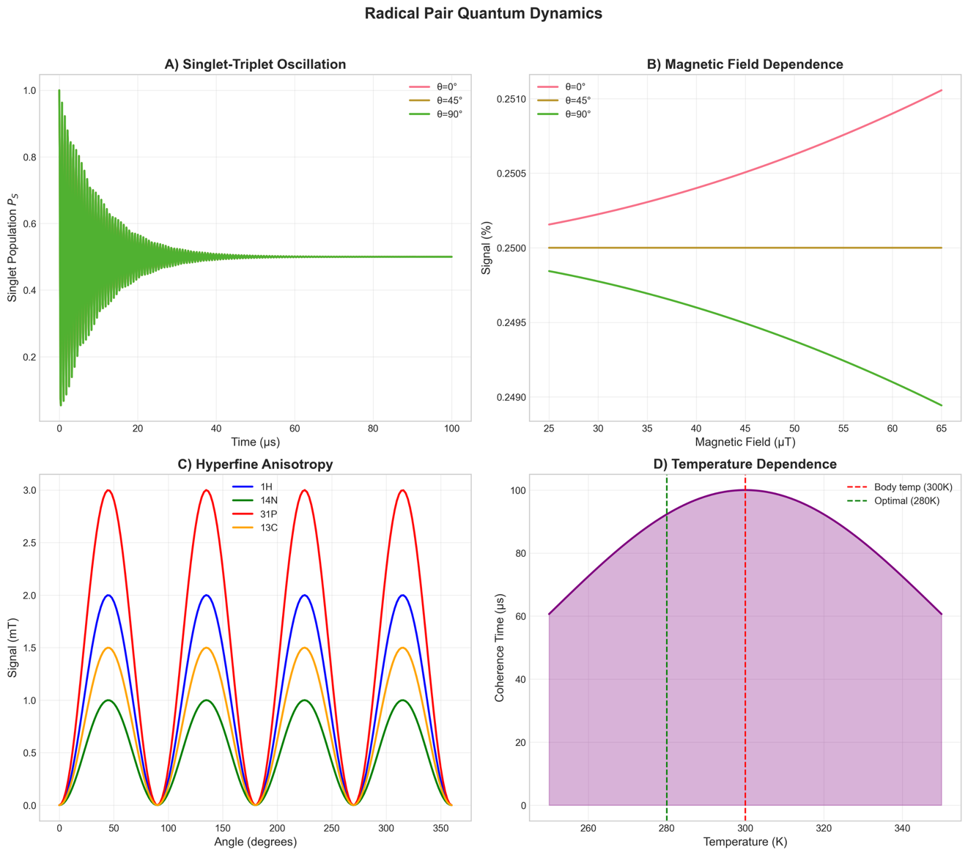

Figure 2. Entanglement and Decoherence Analysis. (A) Entanglement concurrence C(t) decay under low, medium, and high biological noise conditions. (B) Dominant decoherence mechanisms ranked by rate (log scale); solvent reorganization and protein vibrations dominate at physiological temperature. (C) Coherence measures (L₁-norm and relative entropy of coherence) as functions of state purity, illustrating the mixed-state regime relevant at 310 K. (D) Temperature dependence of coherence time $τ_{c}$ with avian body temperature (310 K) marked; functional entanglement is maintained despite thermal noise. (E) CHSH parameter S for singlet, T₀ triplet, and maximally mixed states; the singlet state violates the classical bound (S = 2). (F) Quantum discord D(t) dynamics showing persistence of quantum correlations to ~15 μs, beyond the entanglement lifetime.

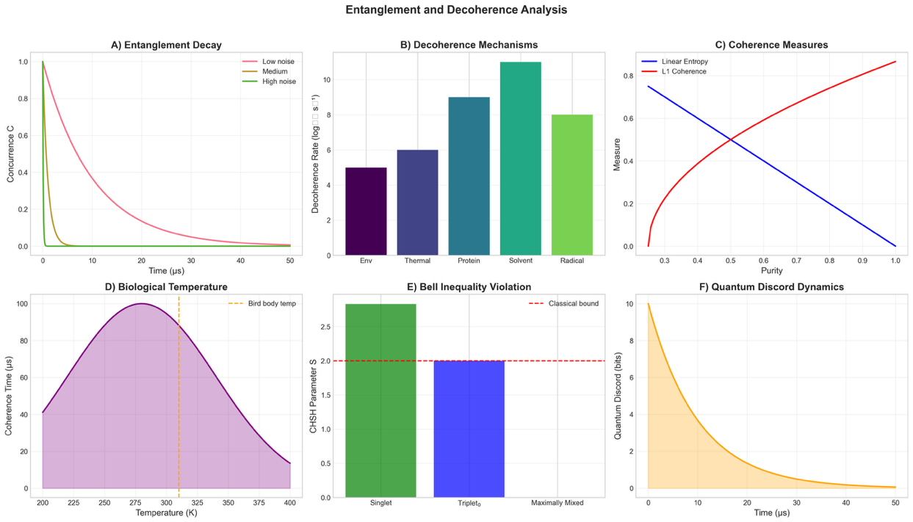

Figure 3. Quantum Fisher Information (QFI) Analysis. (A) QFI scaling with probe resources N; the Standard Quantum Limit (SQL, blue dashed) scales as N while the Heisenberg Scaling Limit (HSL, red solid) scales as N². The practical biologically achievable regime (green dotted) lies between these bounds. (B) Achievable angle precision δθ as a function of number of measurements for three geomagnetic field strengths (25, 50, 65 μT); the 5° biological target (green dashed) is readily achievable. (C) QFI matrix showing parameter correlations between inclination angle θ, field magnitude B, and field intensity I. (D) QFI enhancement factors for separable, weakly entangled, GHZ₄, and NOON₄ probe states. (E) QFI contributions along the cryptochrome sensing chain (quantum, transduction, neural). (F) QFI noise sensitivity as a function of dephasing rate; Heisenberg advantage is maintained below ~10 MHz dephasing.

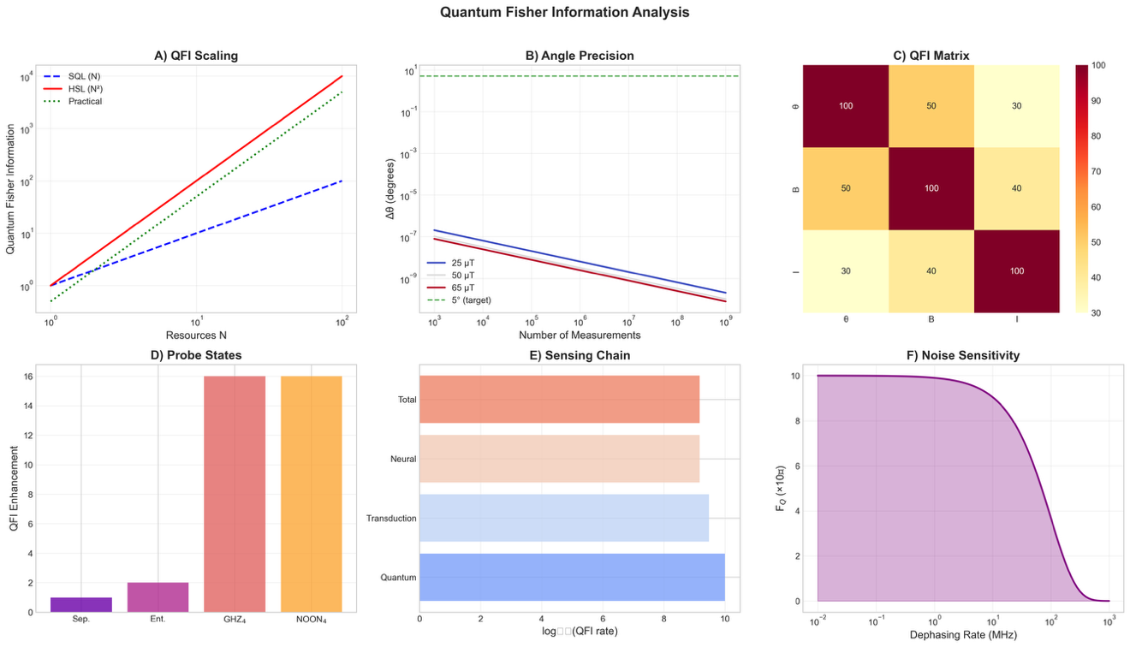

Figure 4. Compass Sensitivity and Navigation. (A) Angular response curves showing singlet yield signal vs. heading angle (0–360°) for three field strengths (25, 50, 65 μT); signal amplitude increases with field strength. (B) Field sensitivity as a function of B magnitude for three inclination angles; maximum sensitivity occurs at θ = 0° (axial alignment). (C) Inclination compass response demonstrating axial vs. planar discrimination as a function of geographic latitude (−90° to +90°). (D) Transduction chain efficiency: quantum (100%), protein (30%), neural (50%), total (~15%). (E) RF disruption profile showing peak sensitivity at the Larmor frequency $f_{L}=1.4$ MHz (dashed), consistent with behavioral RF disruption experiments. (F) Signal-to-noise ratio as a function of photon number; SNR = 10 threshold (green dashed) reached at N ~ 10⁷.

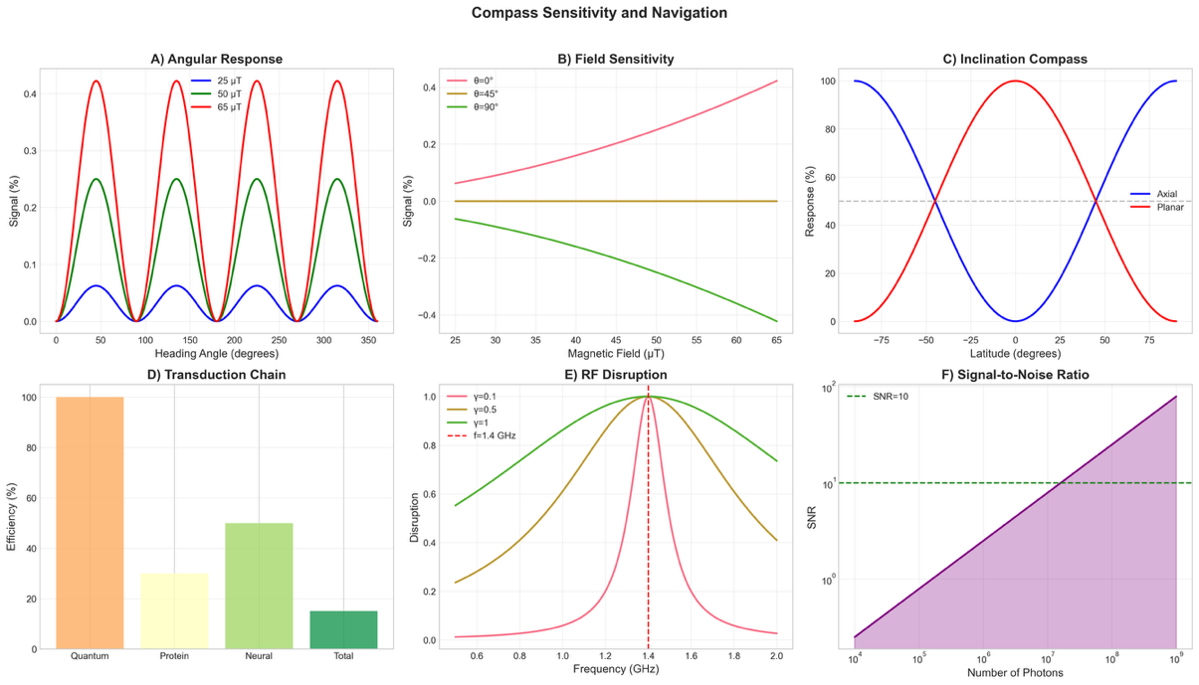

Figure 5. Information Theory in Quantum-Biological Navigation. (a) Mutual information I(X;Y) vs. time for separable, classically correlated, and quantum entangled radical pair states; entangled states maintain higher mutual information at early times. (b) Quantum discord dynamics showing persistence at τ = 15 μs (dashed), relevant to the coherence window for navigational sensing. (c) Navigation channel capacity C (bits/cycle) as a function of magnetic field strength for three inclination angles; the green-shaded region indicates Earth-field range. (d) Information flow rates along the sensing chain (photon flux: 10⁷; cryptochrome: 10⁵; radical pair: 7×10⁴; protein: 2×10⁴; neural: 10⁴ bits/s).

Figure 6. Quantum Advantage Analysis. (A) Hilbert space dimension scaling with number of nuclei n; classical dimension (blue, 2ⁿ) vs. quantum simulation requirements (red dashed, n²), illustrating exponential classical overhead. (B) Computational simulation time as a function of qubit count comparing classical exponential scaling vs. quantum polynomial scaling; crossover at ~20 qubits. (C) Noise resilience fidelity curves for 4-, 8-, and 12-qubit systems as a function of noise level per cycle; 4-qubit systems retain F > 0.5 below ~20% noise. (D) Required measurement numbers for angular precision targets of 1°, 5°, and 10° as a function of available sensing resources.

