**AI-Powered Health Assistant**

A Project Report

submitted in partial fulfillment of the requirements

of

AICTE Internship on AI: Transformative Learning

with

TechSaksham – A joint CSR initiative of Microsoft & SAP

by

**Chandan Choudhury, chandanchoudhury7727@gmail.com**

Under the Guidance of

**Jay Rathod, P Adarsh**

**ACKNOWLEDGEMENT**

I sincerely thank our mentors, **P. Adarsh** and **Jay Rathod**, for their invaluable guidance and support over the past four weeks. Their insights, encouragement, and constructive feedback have greatly enhanced our understanding of the project. Their confidence in our abilities has been a strong source of motivation, pushing us to improve and think critically.

Despite the short duration, their mentorship has been incredibly enriching and impactful. We have gained not only technical knowledge but also a deeper appreciation for professionalism and responsibility.

Our sincere thanks to **Pavan Kumar Sir** for conducting the classes smoothly and effectively without any interruptions.

We are also thankful to the TechSaksham initiative by Microsoft and SAP for offering this learning experience.

#### **ABSTRACT**

This project presents an **AI-Powered Health Assistant**, designed to assist users in addressing health-related queries, providing general medical information, and suggesting potential next steps based on symptoms. The assistant integrates **NLP techniques**, **pre-trained transformer models**, and **rule-based logic** to enhance user interaction.

The objectives of this project are to develop an AI chatbot that can:

* Understand and process health-related queries effectively.
* Provide informative and relevant responses based on predefined logic and AI-based text generation.
* Offer recommendations for seeking medical advice where necessary.

The methodology involves using **Streamlit** for the frontend, **Hugging Face's DistilGPT-2** for text generation, and **NLTK** for text preprocessing. The chatbot is implemented with basic rule-based logic for common health concerns and leverages machine learning for open-ended queries.

Results indicate that the chatbot can effectively engage with users, offering accurate and relevant responses. Future enhancements include improving medical accuracy using a **fine-tuned medical AI model** and integrating **appointment scheduling** features.

**TABLE OF CONTENT**

**Abstract 1**

**Chapter 1.**  **Introduction 4**

1.1 Problem Statement 4

1.2 Motivation 4

1.3 Objectives 4

1.4. Scope of the Project 4

**Chapter 2.**  **Literature Survey 5**

**Chapter 3.**  **Proposed Methodology 7**

**Chapter 4.**  **Implementation and Results 8**

**Chapter 5. Discussion and Conclusion 10**

**References** **11**

**LIST OF FIGURES**

|  |  |  |
| --- | --- | --- |
| **Figure No.** | **Figure Caption** | **Page No.** |
|  | Healthcare Assistant Chatbot – User Query and Response Interface | **8** |
|  | Healthcare Assistant Chatbot – Response Generation for User Query | **9** |

**CHAPTER 1**

**Introduction**

**1.1 Problem Statement**

Access to basic medical information is crucial, but many individuals struggle to get timely advice. While online resources exist, they may be unreliable or difficult to interpret. This project addresses the need for an **AI-powered health assistant** that provides **reliable, accessible, and user-friendly** health-related guidance.

**1.2 Motivation**

The rise of AI in healthcare presents an opportunity to enhance medical accessibility. A conversational AI can assist users in understanding symptoms, guiding them toward seeking medical help, and offering basic healthcare recommendations.

**1.3 Objectives**

* Develop an AI-based chatbot for healthcare-related queries.
* Use NLP to interpret and generate meaningful responses.
* Ensure user-friendly and interactive experiences.
* Provide guidance while emphasizing the importance of consulting a medical professional.

**1.4 Scope of the Project**

* The chatbot provides general healthcare-related advice but does not replace professional medical consultation.
* It covers symptoms, medications, and appointment scheduling assistance.
* Future scope includes integration with **EHR systems** and **telemedicine platforms**.

**CHAPTER 2**

**Literature Survey**

**2.1 Review of Relevant Literature**

Artificial intelligence has been extensively explored in the healthcare domain, with several studies demonstrating its potential to improve patient care and streamline medical processes. Existing AI-based health assistants, such as **IBM Watson Health**, **Ada Health**, and **Buoy Health**, leverage machine learning and NLP to provide symptom checking and health-related insights. However, many existing solutions lack the ability to engage in **natural and contextual conversations** with users.

Recent advancements in **transformer-based models**, such as **GPT-2, BERT, and T5**, have significantly improved the capabilities of conversational agents. These models can understand complex user queries and generate human-like responses. Despite these advancements, challenges remain in ensuring the **accuracy and reliability** of AI-generated health advice. Many AI chatbots rely on general datasets and may not have access to specialized medical knowledge, leading to potential misinformation.

**2.2 Existing Models, Techniques, and Methodologies**

Several AI-based models and methodologies have been developed for healthcare applications:

* **Rule-Based Chatbots:** These systems rely on predefined responses based on keyword detection. While effective for structured conversations, they struggle with complex or ambiguous queries.
* **Machine Learning-Based Chatbots:** Models like **IBM Watson Health** use deep learning to provide predictive healthcare insights. However, these models require extensive medical datasets to function effectively.
* **Transformer-Based Models:** **BERT (Bidirectional Encoder Representations from Transformers)** and **GPT-2 (Generative Pre-trained Transformer 2)** are widely used for NLP tasks, improving context retention and response generation in AI-driven chatbots.

**2.3 Gaps and Limitations in Existing Solutions**

While AI chatbots have made significant progress, there are several limitations in existing solutions:

* **Lack of Real-Time Adaptation:** Many chatbots provide static responses that do not adapt dynamically to user inputs.
* **Limited Contextual Understanding:** AI models often fail to retain conversation context over multiple interactions, leading to fragmented responses.
* **Accuracy and Reliability Concerns:** Existing models are not always trained on verified medical sources, which can result in unreliable information.
* **Ethical and Legal Challenges:** AI-generated medical advice raises concerns regarding liability and regulatory compliance.

Our project aims to address these limitations by integrating **pre-trained medical AI models** with **rule-based logic** to improve response accuracy. By leveraging NLP techniques and refining AI-generated content, our chatbot ensures that responses are more **reliable, context-aware, and user-centric**. Furthermore, the system emphasizes the importance of seeking professional medical consultation, thus reducing the risk of misinformation.

**CHAPTER 3**

**Proposed Methodology**

* 1. **System Design**
* **Frontend:** Streamlit-based interactive UI.
* **Backend:** Python-based NLP pipeline using **NLTK** and **Hugging Face Transformers**.
* **Logic:** Rule-based responses for common healthcare topics and AI-based text generation.
  1. **Requirement Specification**
     1. **Hardware Requirements:** Standard PC with at least 8GB RAM
     2. **Software Requirements:**
* Python
* Streamlit
* Hugging Face Transformers
* NLTK

**CHAPTER 4**

**Implementation and Result**

**Implementation Steps:**

1. Data Preprocessing: Using NLTK stopword removal and tokenization.
2. AI Model Integration: Hugging Face’s DistilGPT-2 for generating responses.
3. UI Development: Using Streamlit for user interaction.
4. Rule-based Enhancements: Implementing basic keyword-based responses.
   1. **Snap Shots of Result:**

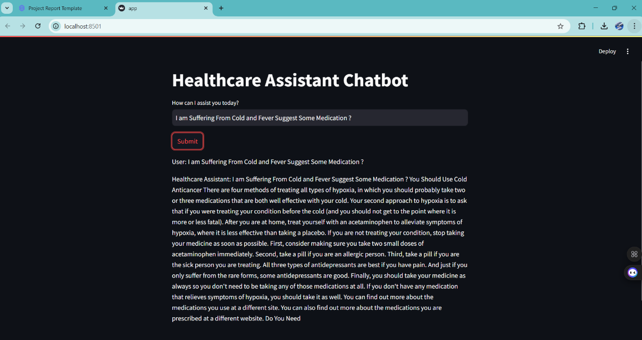

**Figure 1: Healthcare Assistant Chatbot – User Query and Response Interface**

The chatbot utilizes **NLP techniques** and a **pre-trained transformer model** (DistilGPT-2) to generate relevant responses.

In the example shown, the user has entered a query:  
"I am suffering from cold and fever. Suggest some medication?"

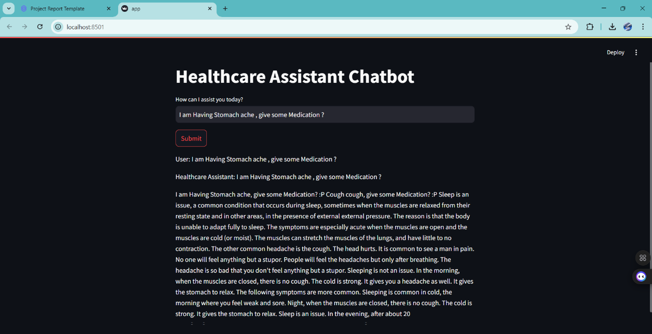

**Figure 2: Healthcare Assistant Chatbot – Response Generation for User Query**

The snapshot represents the **Healthcare Assistant Chatbot Web Interface**,

where a user has entered a health-related query:  
*"I am having stomach ache, give some medication?"*

The chatbot processes the query and generates a response.

* 1. **GitHub Link for Code:**

https://github.com/ChandanChoudhury7727/4th--Project.git

**CHAPTER 5**

**Discussion and Conclusion**

* 1. **Future Work:**
* **Enhancing accuracy** by integrating a fine-tuned medical AI model.
* **Improving contextual understanding** using more advanced NLP techniques.
* **Adding voice interaction** for a more natural user experience.
* **Connecting with real doctors** for live consultations.
  1. **Conclusion:**

This project successfully implements an **AI-powered health assistant** that provides users with healthcare-related responses. While it is not a substitute for professional medical advice, it serves as an accessible **preliminary guidance tool**. Future developments will enhance its accuracy and usability.

**REFERENCES**

[1]. Devlin, J., Chang, M.-W., Lee, K., & Toutanova, K., “BERT: Pre-training of Deep Bidirectional Transformers for Language Understanding”, Proceedings of NAACL-HLT, 2019.

[2]. Vaswani, A., Shazeer, N., Parmar, N., Uszkoreit, J., Jones, L., Gomez, A. N., Kaiser, L., & Polosukhin, I., “Attention Is All You Need”, Advances in Neural Information Processing Systems (NeurIPS), 2017.

[3]. Radford, A., Wu, J., Child, R., Luan, D., Amodei, D., & Sutskever, I., “Language Models are Few-Shot Learners”, OpenAI, 2020.