**Project Detail**

Project Name: FlyAway(An Airline Booking Portal)

**Project Version: 1.0**

**GitHub repository link:**

[**https://github.com/ChandanMallick302/FlyAway-FSD -Project-Phase-II**](https://github.com/ChandanMallick302/Learners_Academy-FSD-Project-Phase-II)

**Project Details:** This project is for the design and developing a backend administrative portal for the FlyAway(An Airline Booking Portal) using Java EE technologies

**Objective**: The Objective of this project is to apply Maven, servlet, Hibernate, and jsp concepts.

**Developer Detail**

Name: Chandan Kumar Mallick

Simplilearn user ID: [chandanmallick302@gmail.com](mailto:chandanmallick302@gmail.com)

**Technologies and tools Used:**

* Maven: Instant access to new features with little or no extra configuration
* Servlet: to do the business logic and works a controller for the project.
* JSP: to handle the presentation view.
* MySQL: to create and manage the database.
* Hibernate: to make operations on the database for the project.
* CSS: to format the contents.
* JavaScript: to format the contents.
* Eclipse: to write and run the code.
* Tomcat: to run and deploy servlet application.

**Flow Chart:**

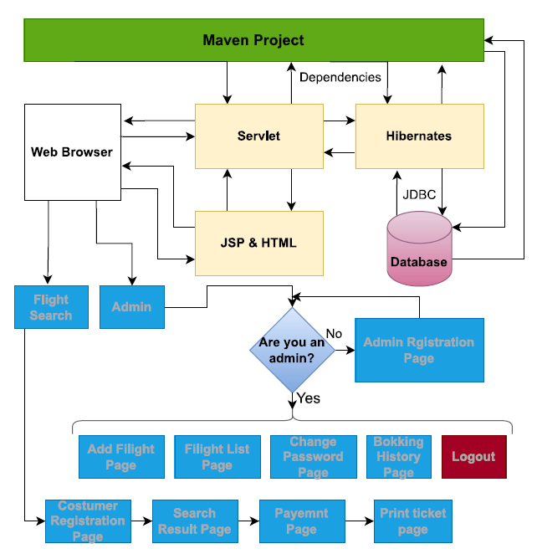

**Sprint Plan:**

Sprint1:

1. Create Maven Project.
2. Add Appropriate Plugin & Dependencies like Hibernate, MySql, servlet, maven-compiler-plugin 1.8 plugin.
3. Create new database in MySql.
4. Configure Database Connection in hibernate.cfg.xml file.
5. Create models, Dao, Utils classes.
6. Map Classes and Variables to database through Hibernate annotation mapping.
7. Create index as Home Page.

Sprint2:

1. Create JSP, HTML files for all page of the project.
2. Create a CSS & JS file to format the contents.
3. Debug & run the Project.

**Concept used in this programme:**

1. Object-Oriented: used to create and model objects for users and their credentials.
2. Databases: used to store and retrieve data.
3. Data Sources: used to define a set of properties required to identify and access the database.
4. Collections: used some collections such arraylist to store collection of data.
5. Exception Handling: used to catch problems that arises in the code.
6. Hibernate: used to connect to the database.
7. Maven: used for Instant access to new features with little or no extra configuration