**Admin Login Page**

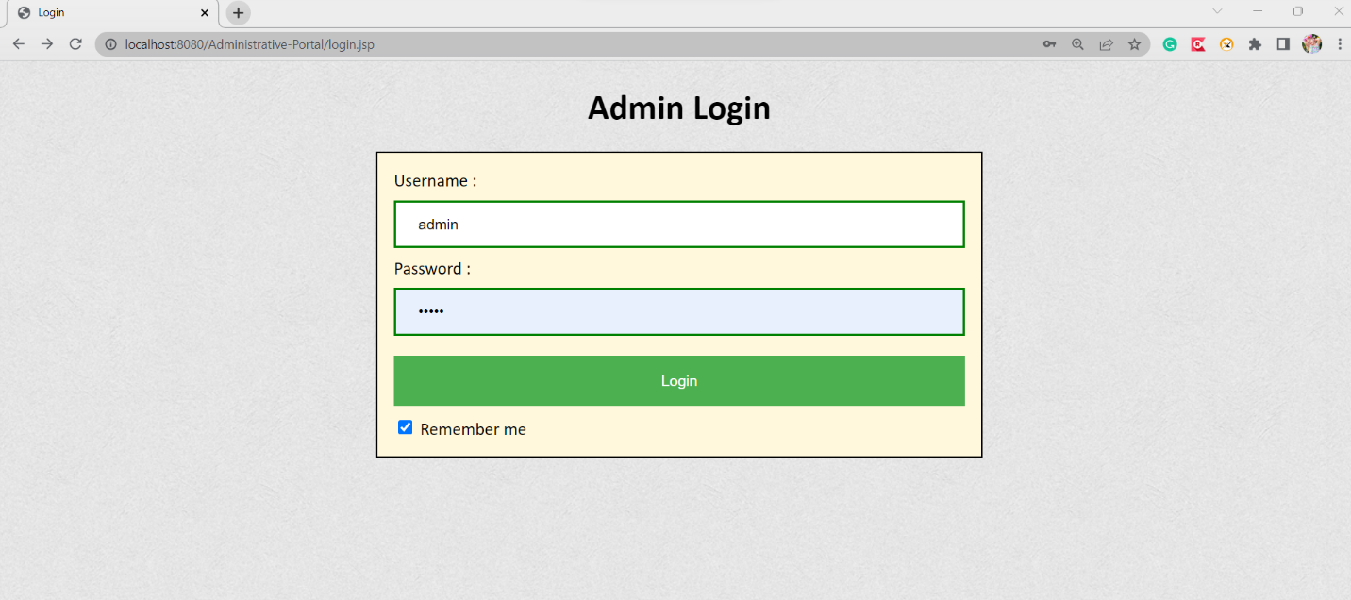

**Classes master list, after assigning with students, subjects & teachers**

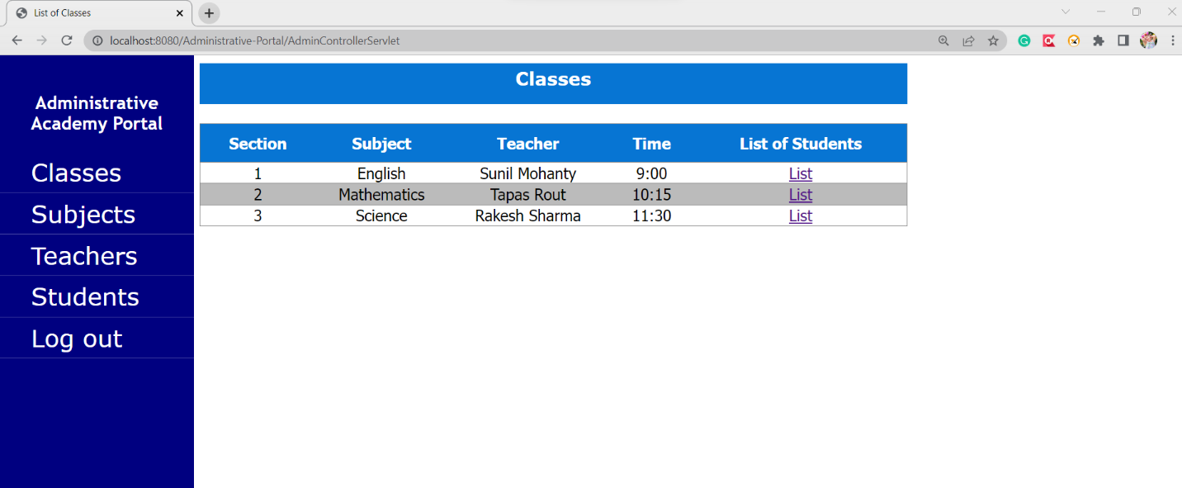

**Assigned students to section 1 Class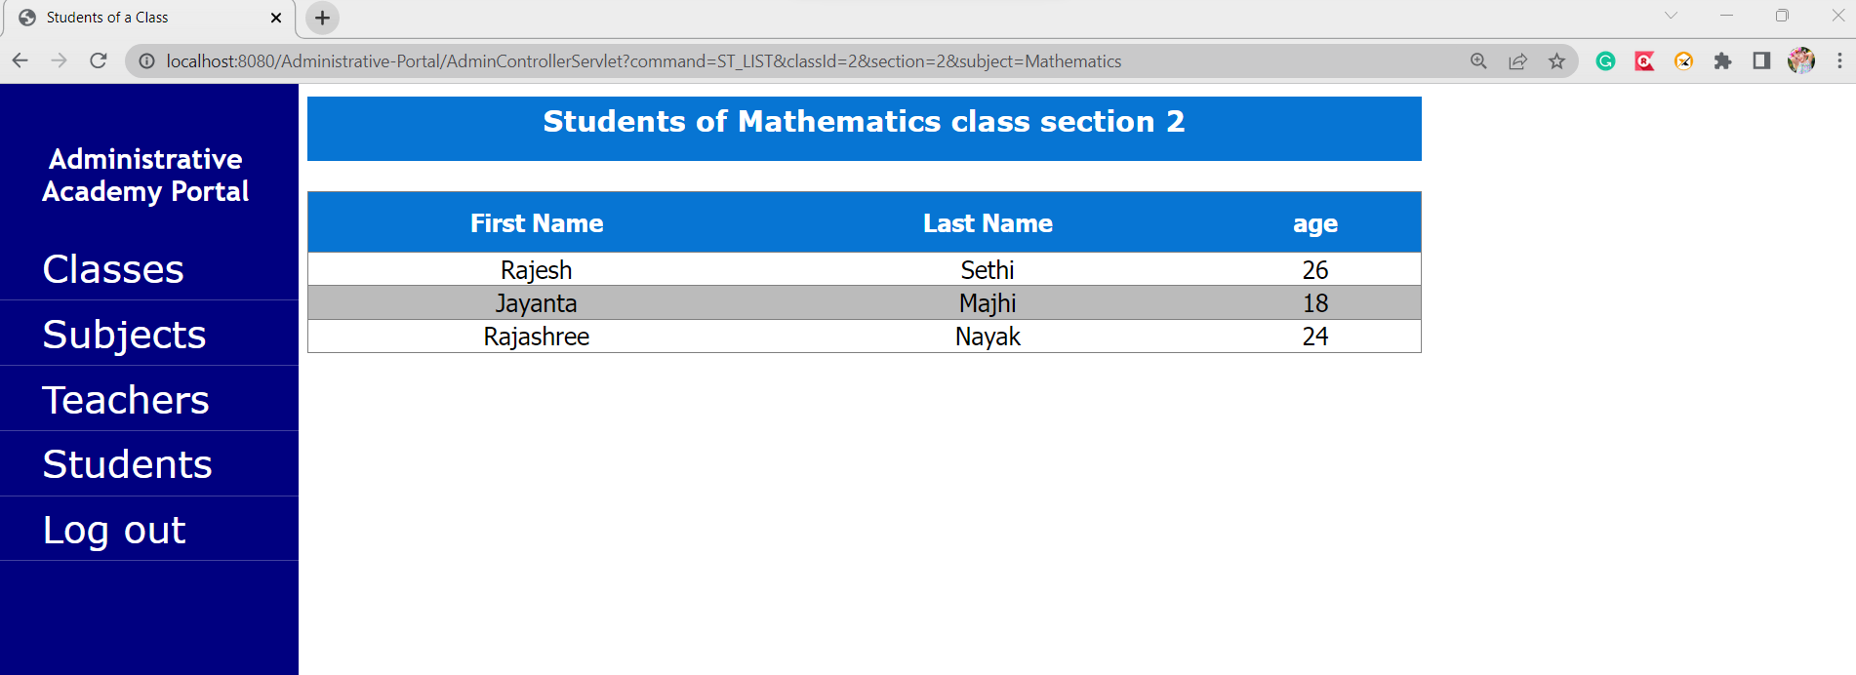 Assigned students to section 2 Class**



**Assigned students to section 3 Class**

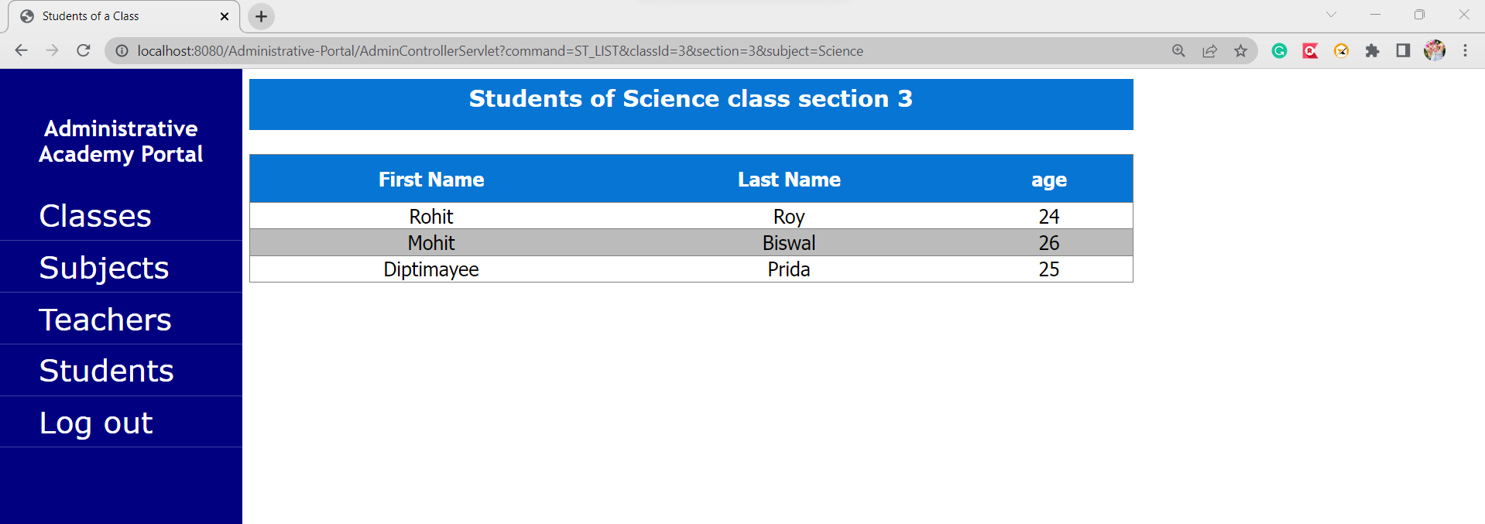

**Master List of Subject**

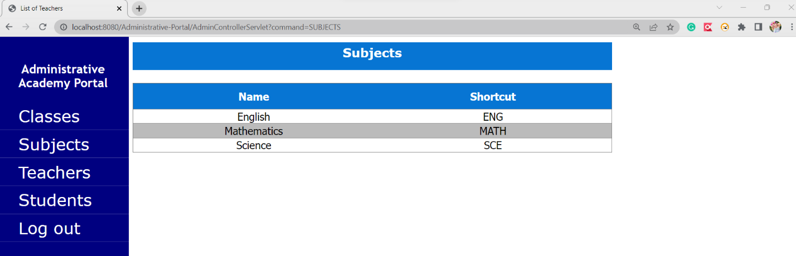

**Master List of Teachers**

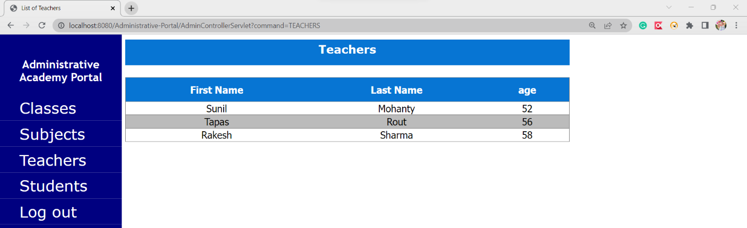

**Master List of Students**

