Q1. WQTD details of the employee who is working same job scott miler erning salary more thaten smither and allen hired after scott miler
SELECT *
FROM EMP
WHERE JOB IN (
SELECT JOB
FROM EMP
WHERE ENAME IN ('SCOTT', 'MILLER')
)
AND SAL > (
SELECT SAL
FROM EMP
WHERE ENAME = 'SMITH'
)
AND SAL > (
SELECT SAL
FROM EMP
WHERE ENAME = 'ALLEN'
)
AND HIREDATE > (
SELECT MAX(HIREDATE)
FROM EMP
WHERE ENAME IN ('SCOTT', 'MILLER')
);
Q2. WQTD details of the employee who are hired in the year 1981 earning salary less then healer and jens working in the same department as narthin
SELECT *FROM EMP
WHERE HIREDATE LIKE '%1981%'
AND SAL < (SELECT SAL FROM EMP WHERE ENAME = 'HELEN')
AND SAL < (SELECT SAL FROM EMP WHERE ENAME = 'JENS')
AND DEPTNO IN (SELECT DEPTNO FROM EMP WHERE ENAME = 'NARTHIN');

Q3. WQTD the department names of the employees who are working in the locations Chicago and Dallas and earning a salary more than the employee working in department no 10

SELECT DNAME
FROM DEPT
WHERE DEPTNO IN
(
SELECT DEPTNO
FROM EMP
WHERE DEPTNO IN
(
SELECT DEPTNO
FROM DEPT
WHERE LOC IN ('CHICAGO', 'DALLAS')
)
AND SAL > ALL
(
SELECT SAL
FROM EMP
WHERE DEPTNO = 10
)
);

Q4. WQTD name of Smith's manager’s manager
SELECT ENAME
FROM EMP
WHERE EMPNO = (SELECT MGR
FROM EMP
WHERE EMPNO = ( SELECT MGR
FROM EMP
WHERE ENAME =’SMITH) );
Q5. WAQTD name of allens managers manager
SELECT ENAME
FROM EMP
WHERE EMPNO =(SELECT MGR
FROM EMP
WHERE EMPNO=(SELECT MGR
FROM EMP
WHERE ENAME = ‘ALLEN’
));
Q6. WAQTD location of adams manager’s manager
SELECT LOC
FROM DEPT
WHERE DEPTNO = (SELECT DEPTNO
FROM EMP
WHERE EMPNO= (SELECT EMPNO
FROM EMP
WHERE ENAME =’ADAMS’));

Q7. WAQTD name of king’s manager
SELECT ENAM FROM EMP WHERE EMP NO =(SELECT MGR FROM EMP WHERE ENAME =’KING’);

Q8. WAQTD smiths reporting managers name

Q9. WAQTD Adam managers manager name

Q10. WAQTD name of the employee reporting to blank

Q11. WAQTD number of employees reporting to king

Q12. WAQTD details of the employee reporting to jones

Q13. WAQTD names of the employees reporting to blanks managers

Q14. WAQTD numbers of the employees reporting to frod’s manager

Q15. WAQTD department details of the employee who are working are reporting to mileer

JOINTS
IT IS USED TO RETRIVE THE DATA FROM MULTIPLE TABLE SIMULTANESOLY
TYPES OF JOIN
- CARTESIAN JOIN /CROSS JOIN
- INNER JOIN/ EQJI JOIN
- NATURAL JOIN
- OUTER JOIN
  - LEFT OUTER JOIN
  - RIGHT OUTER JOIN
  - FULL OUTER JOIN
- SELF JOIN
CARTESIAN JOIN/ CROSS JOIN
ALL THE TABLE1 RECORDS WILL BE MARGED TO ALL THE RECORDS OF TABLE 2 SO IN THE OUTPUT INSTEAD OF
MATCHING RECORDES WE GET MORE NUMBER OF UNMATCHED RECORDS

SYNTAX: ORACAL SELECT COLUMN / EXPRESSION
FROM TABLE1, TABLE2;

ANSI(AMERICAN NATIONAL, STANDARD INSTITUTE)
ANSI SYNTAX: SELECT COLUMN /EXPRESSION
FROM TABLE1 CROSS JOIN TABLE2;

INNER JOIN
TO OVERCOME THE PROBLEM OCURRED BY CROSS JOIN WE GO FOUR INNER JOIN
TABLE1 RECORDS WILL BE MERGED WITH TABLE 2 RECORDS BUT IN THE OUTPUT WE GET ONLY MACHING RECORDS BECAUSE OF JOIN CONDITION.

WHAT IS JOIN CONDITION??

SYNTAX: TABLE1.COLUMNNAME= TABLE 2 . COLUMN NAME

IN ORACAL SYNTAX WE WRIGHT JOIN CONDITION IN WHERE IN ANSI SYNTAX WE WRIGHT JOIN CONDITION ON CLAUSE SYNTAX FOR INNER JOIN

ORACLE SELECT COLNAME/ EXPRESSION
FROM TABLE1.COLUMNNAME=TABLE2.COLUMNNAME
WHERE < JOIN_CONDITION>;
ANSI SELECT COLUMNNAME/EXPRESSION
FROM TABLE1 INER JOIN TABLE2
ON< JOIN_CONDITION>;
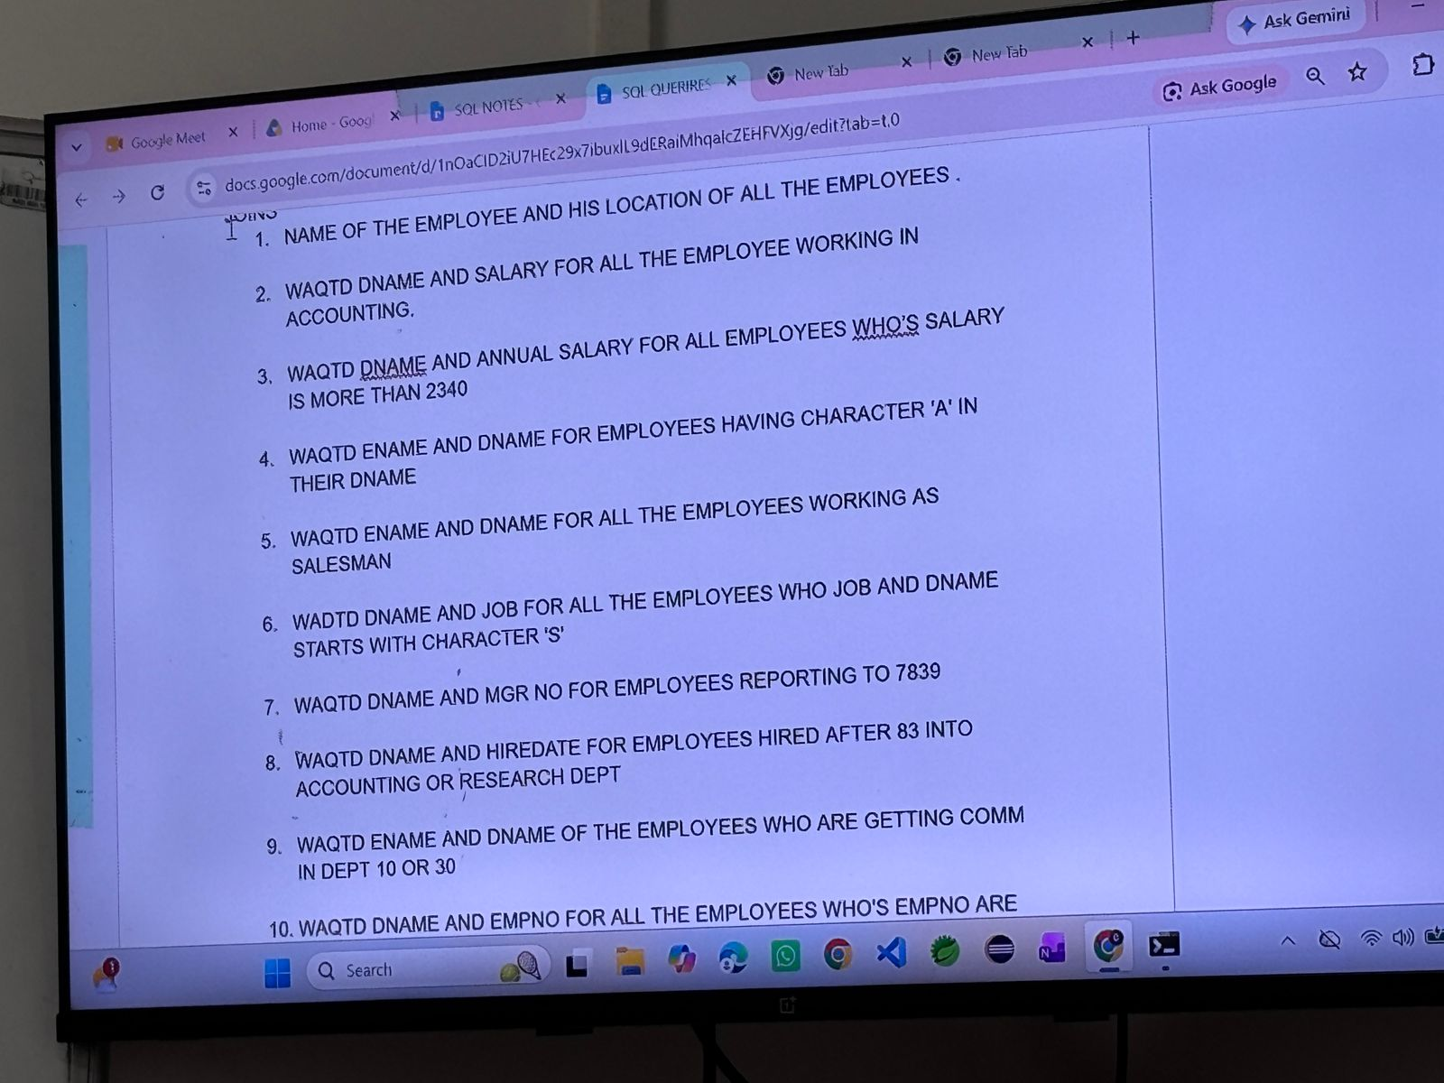

- SELECT ENAME,LOC
FROM EMP,DEPT
WHERE EMP.DEPTNO=DEPT.DEPTNO;
- SELECT DNAME,SAL
FROM EMP,DPT
WHERE EMP.DEPTNO=DEPT.DEPTNO;
- SELECT DNAME,
Q1.WATD details of the employee whos earning salary more then smith and alan in location new York
- SELECT ENAME
- FROM EMP
WHERE EMPLYEENO=( SELECT SAL >SMIT, SAL>ALAN
FROM EMP
WHERE EMPNO=(SELECT LOC
FROM dept
WHERE LOC=’NEW YOURK’
)
);

Q2. WAQTD ELANS MANAGER’S MANAGER
- SELECT ENAME
FROM EMP
WHERE EMPNO=(SELECT MGR
FROM EMP
WHERE
)
Q3. WAQTD NO OF EMPLOYEE WORKING IN EACH DEPATMENT
SELECT COUNT
FROM EMP
WHERE DEPTNO IS NOT NULL;
Display all employees earning more than 1500.
SELECT *
FROM EMP
WHERE SAL>1500;
Display employees working in department 30.
SELECT *
FROM EMP
WHERE DEPTNO=30;
Display employees whose job is CLERK.
SELECT *
FROM EMP
WHERE JOB=’CLERK’;
Display employees earning between 1000 and 3000.
SELECT *
FROM EMP
WHERE SAL>1000 AND SAL<3000;
Display employees working in department 20 and earning more than 2500.
SELECT *
FROM EMP
WHERE DEPTNO=20 AND SAL>2500;
Display employees whose job is SALESMAN and salary is greater than 1400.
SELECT *
FROM EMP
WHERE JOB=’SALESMAN ’ AND SAL>1000;
WAQTD OF EMPLOYEE THE EMPLOYEE MANAGERS SALARY AND MM COMM AND THER LOCATION
SELECT
FROM EMP E, EMP M, EMP MM, DEPT ED, DEPT

