**CS430 Lecture 6 Activities**

Opening Questions

1. Explain the difference between the Binary Search Tree Parent-Child value relationship and the Heap Property Parent-Child value relationship.

2. Binary search trees are a dynamic data structure that uses left-child and right-child pointers to represent the tree. How is this different in a heap?

Heaps

Since a heap is a nearly complete binary tree and will always grow and shrink in the rightmost bottom leaf you can implement a heap with an array instead of needing pointers (as is needed for a binary search tree which can grow/shrink at any node. Example of a MaxHeap showing array implementation:

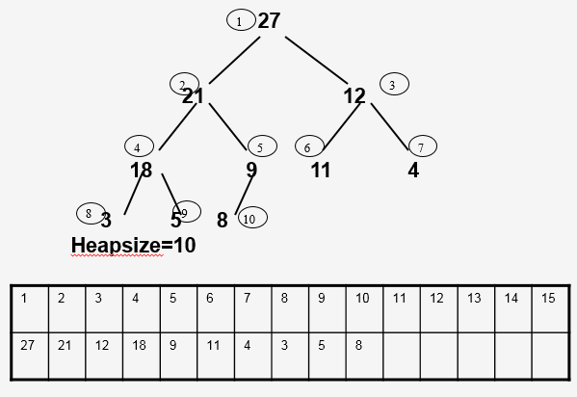

1. At what index position is the largest element in a MaxHeap? We have to know how to easily move around a Heap. Can you devise a formula to relate the index of a parent to the indexes of its children? How about a formula for the index of a child to the index of its parent?

2. If a heap was one larger, where does tree have to gain a node from when done? If a heap was one smaller, where does tree have to lose a node when done?

3. Considering your answer to #2, try to devise a way to ExtractMax from this maxheap. What is the runtime in terms of heapsize?

21

18 12

8 9 11 4

3 5

Heapsize=9 array A

|  |  |  |  |  |  |  |  |  |  |  |  |  |  |
| --- | --- | --- | --- | --- | --- | --- | --- | --- | --- | --- | --- | --- | --- |
| 21 | 18 | 12 | 8 | 9 | 11 | 4 | 3 | 5 |  |  |  |  |  |

4. Considering your answer to #2, try to devise a way to Insert(20) into this maxheap. What is the runtime in terms of heapsize?

21

18 12

8 9 11 4

3 5

Heapsize=9 array A

|  |  |  |  |  |  |  |  |  |  |  |  |  |  |
| --- | --- | --- | --- | --- | --- | --- | --- | --- | --- | --- | --- | --- | --- |
| 21 | 18 | 12 | 8 | 9 | 11 | 4 | 3 | 5 |  |  |  |  |  |

Both the above extractMax and Insert assumed we already had a heap. To efficiently build a heap we put all the items to insert in an array. Call MaxHeapify (walk value down) from index heapsize/2 up to root (index 1).

5. Write pseudocode for this BuildHeap algorithm and demonstrate on this data. What is the runtime in terms of n, the size of B?

B=[15 8 4 9 3 16]

6. Write the loop invariant for BuildHeap and prove that it works.

7. How can we use a maxHeap and extractMax to sort?

Show IIT Sort (Visual Sorting) available on [www.cs.iit.edu/~cs430/visualization.html](http://www.cs.iit.edu/~cs430/visualization.html)