MODULE 13:- Prometheus and Grafana
Continuous Monitoring using Prometheus and Grafana
SUBMITTED BY :- CHANDAN YADAV KS
SUBMITTED TO :- VIKUL
DATE OF SUBMISSION :- 25-07-2025

1. L1 - Create Grafana Dashboard to Monitor CPU and Memory Utilization of Jenkins Build Server using Prometheus Data source
Step 1: Launch 3 Ubuntu EC2 Instances
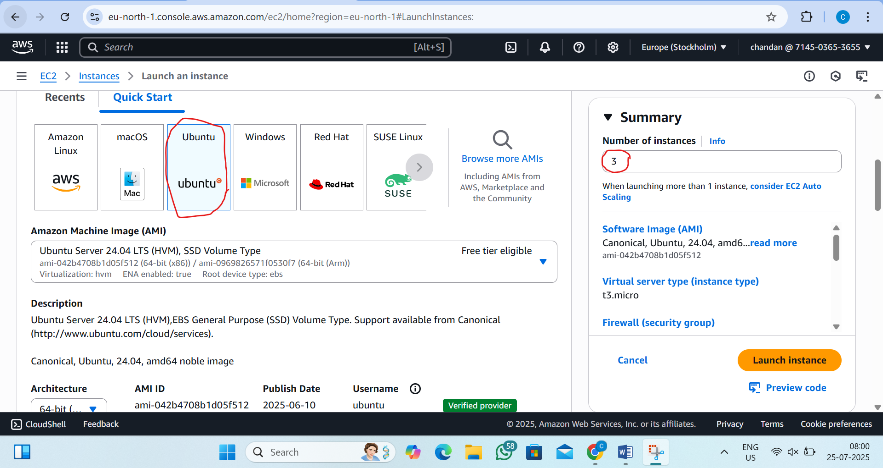

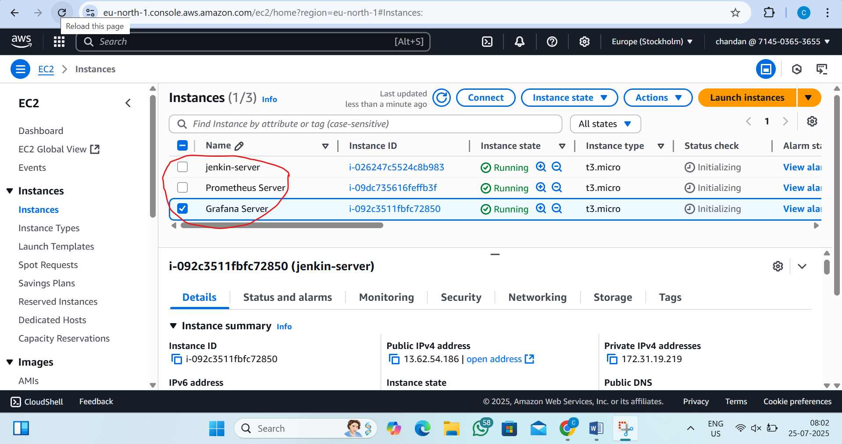

Go to security group add the inbound rule
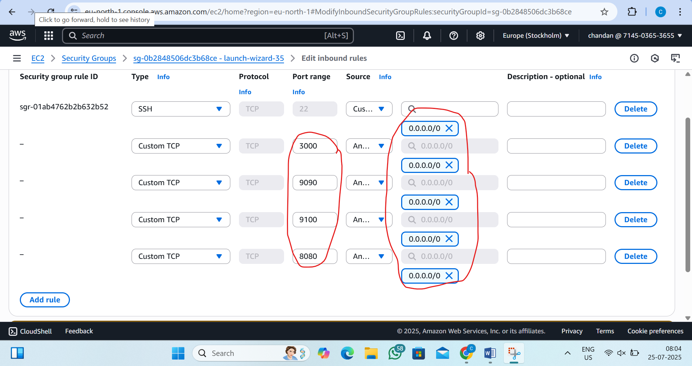
Step2:-connect the jenkin server and pass the command
by the command:-1)sudo su
2)sudo apt update
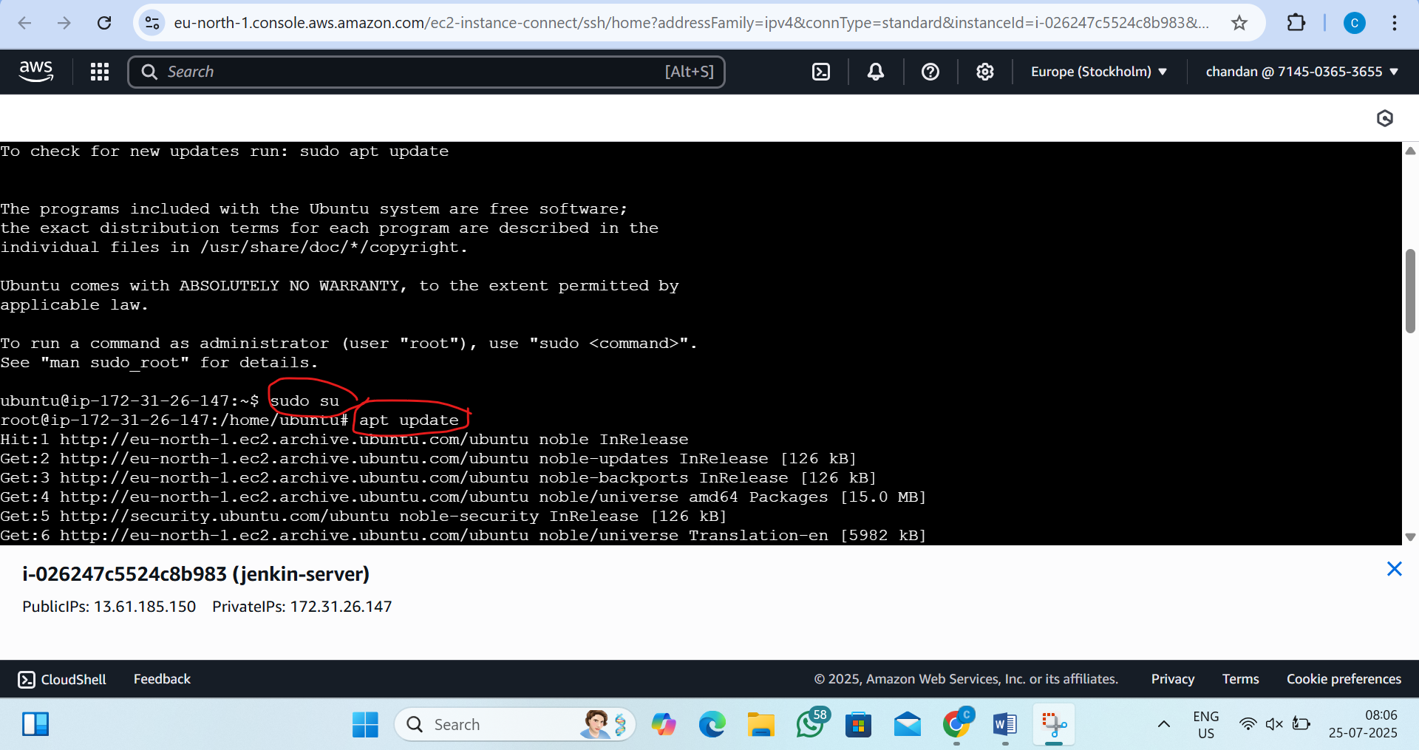

Step3:- Install Node Exporter
By the command:- cd /opt
wget https://github.com/prometheus/node_exporter/releases/download/v1.8.1/node_exporter-1.8.1.linux-amd64.tar.gz
tar -xvf node_exporter-1.8.1.linux-amd64.tar.gz
mv node_exporter-1.8.1.linux-amd64 node_exporter
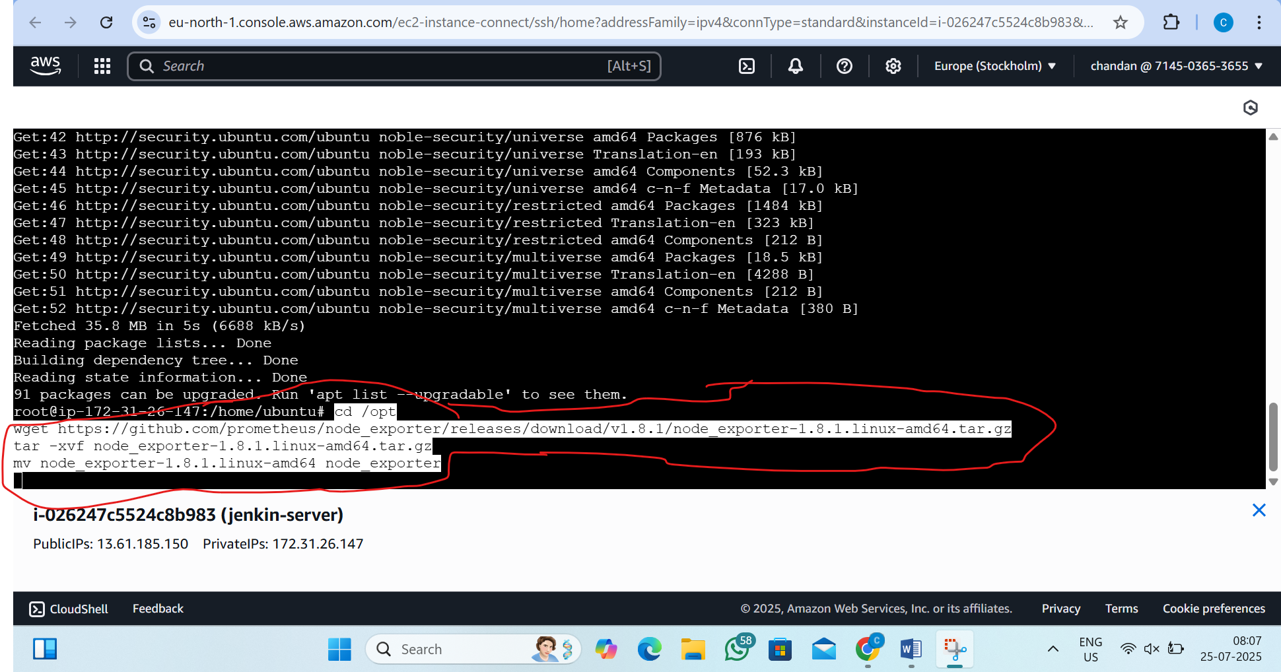

step4: Set Node Exporter as a Service
pass this command:-
sudo tee /etc/systemd/system/node_exporter.service > /dev/null <<EOF
[Unit]
Description=Node Exporter
[Service]
ExecStart=/opt/node_exporter/node_exporter
[Install]
WantedBy=default.target
EOF
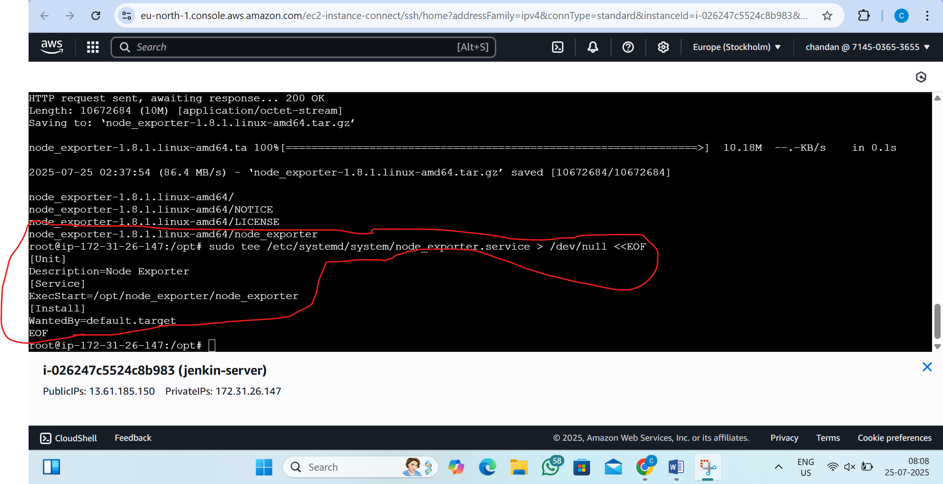

Step5:-start the node exporter
pass this command:-
sudo systemctl daemon-reload
sudo systemctl enable node_exporter
sudo systemctl start node_exporter
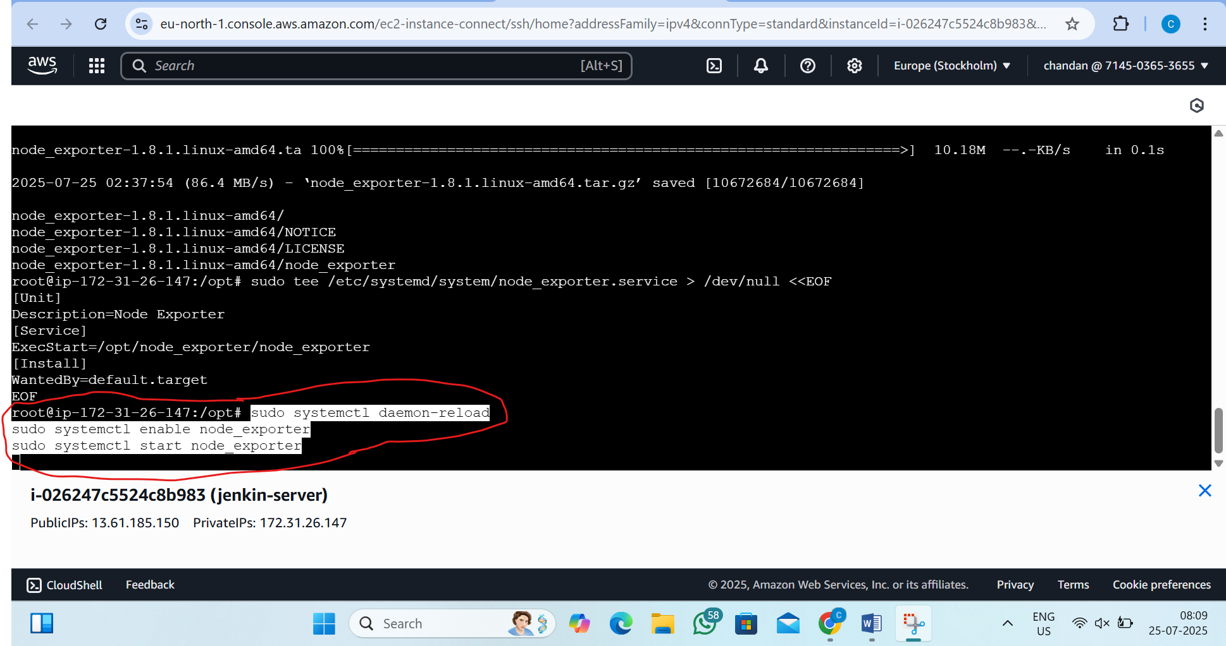

step6:-now open browser and see the output
in the browser type this:-http:publicip:9100/
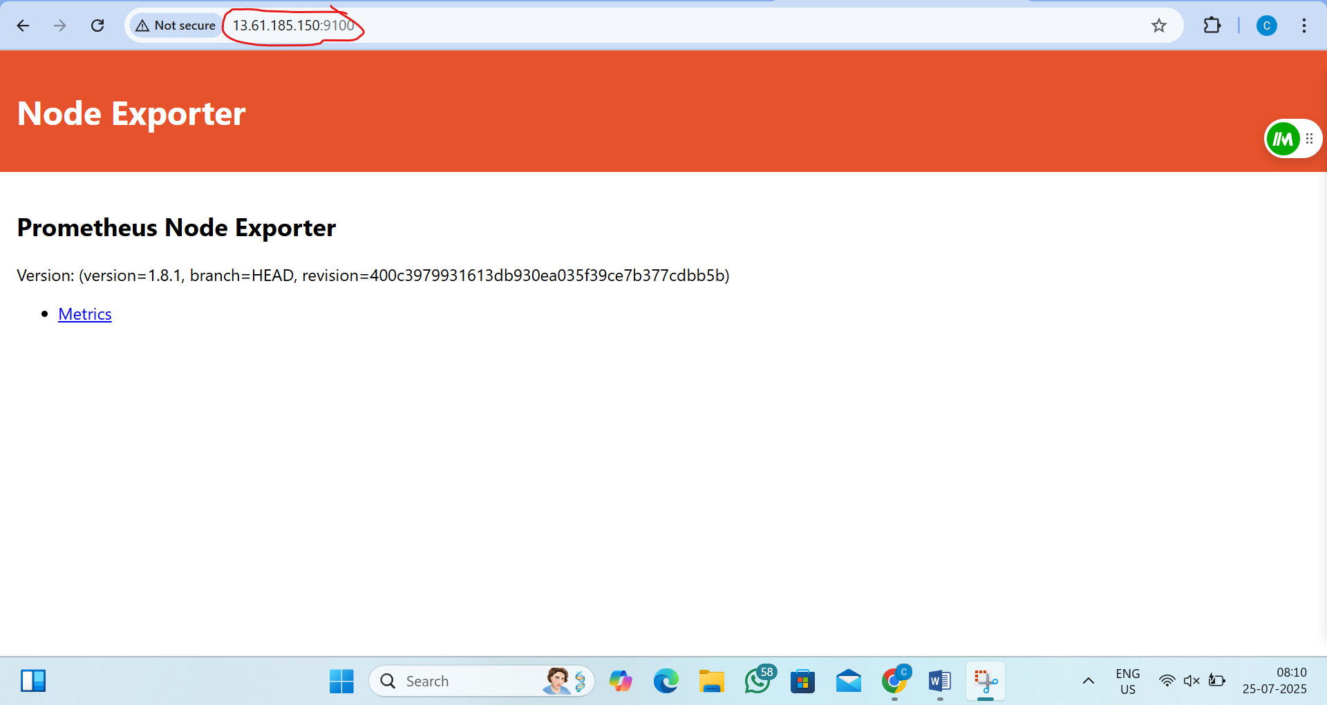
step7:now connect Prometheus server instance
pass the command:- sudo su and apt update
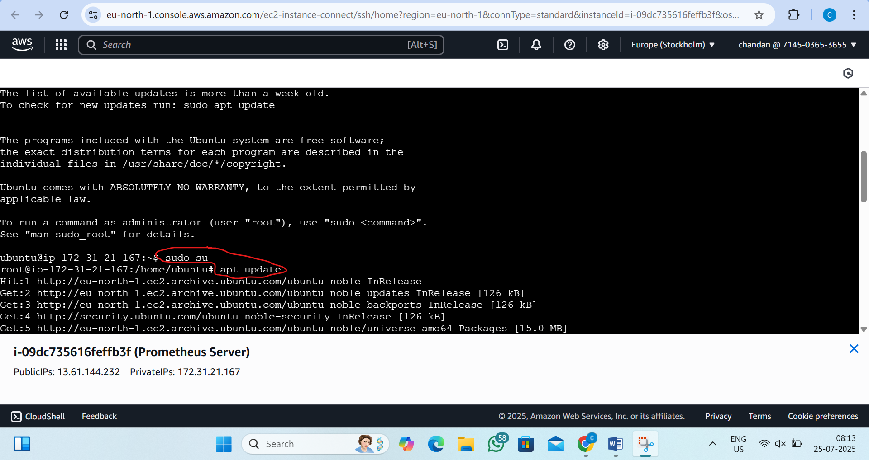
step8:- Install Prometheus
by the command:- cd /opt
wget https://github.com/prometheus/prometheus/releases/download/v2.52.0/prometheus-2.52.0.linux-amd64.tar.gz
tar -xvf prometheus-2.52.0.linux-amd64.tar.gz
mv prometheus-2.52.0.linux-amd64 prometheus
cd Prometheus
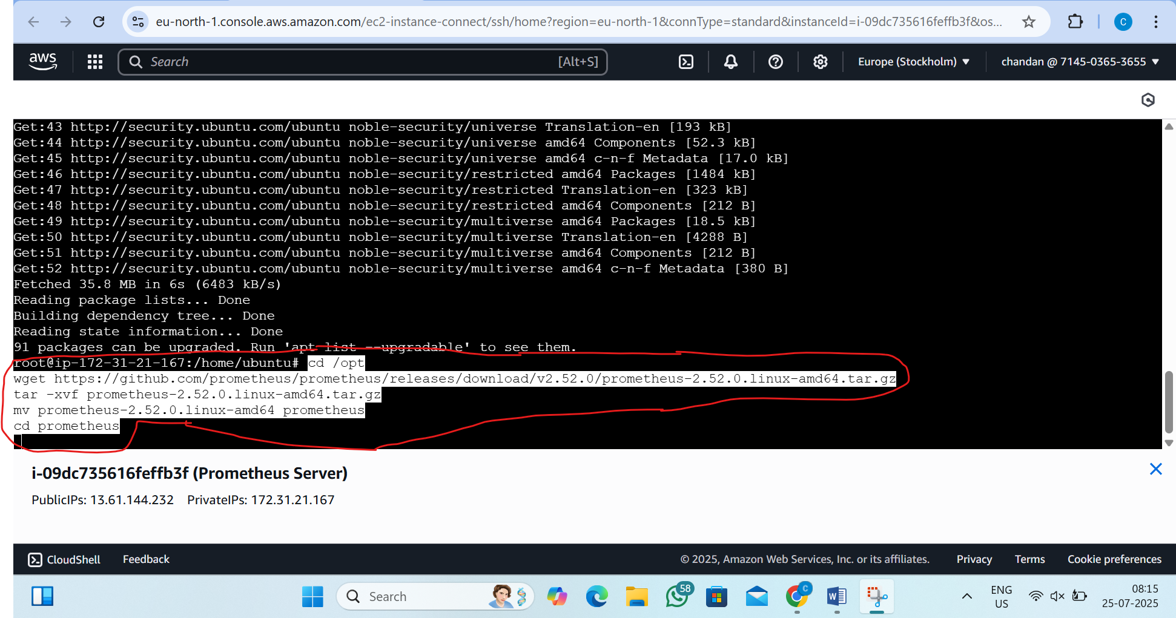
Step9:- Configure Prometheus
by the command:- vim prometheus.yml
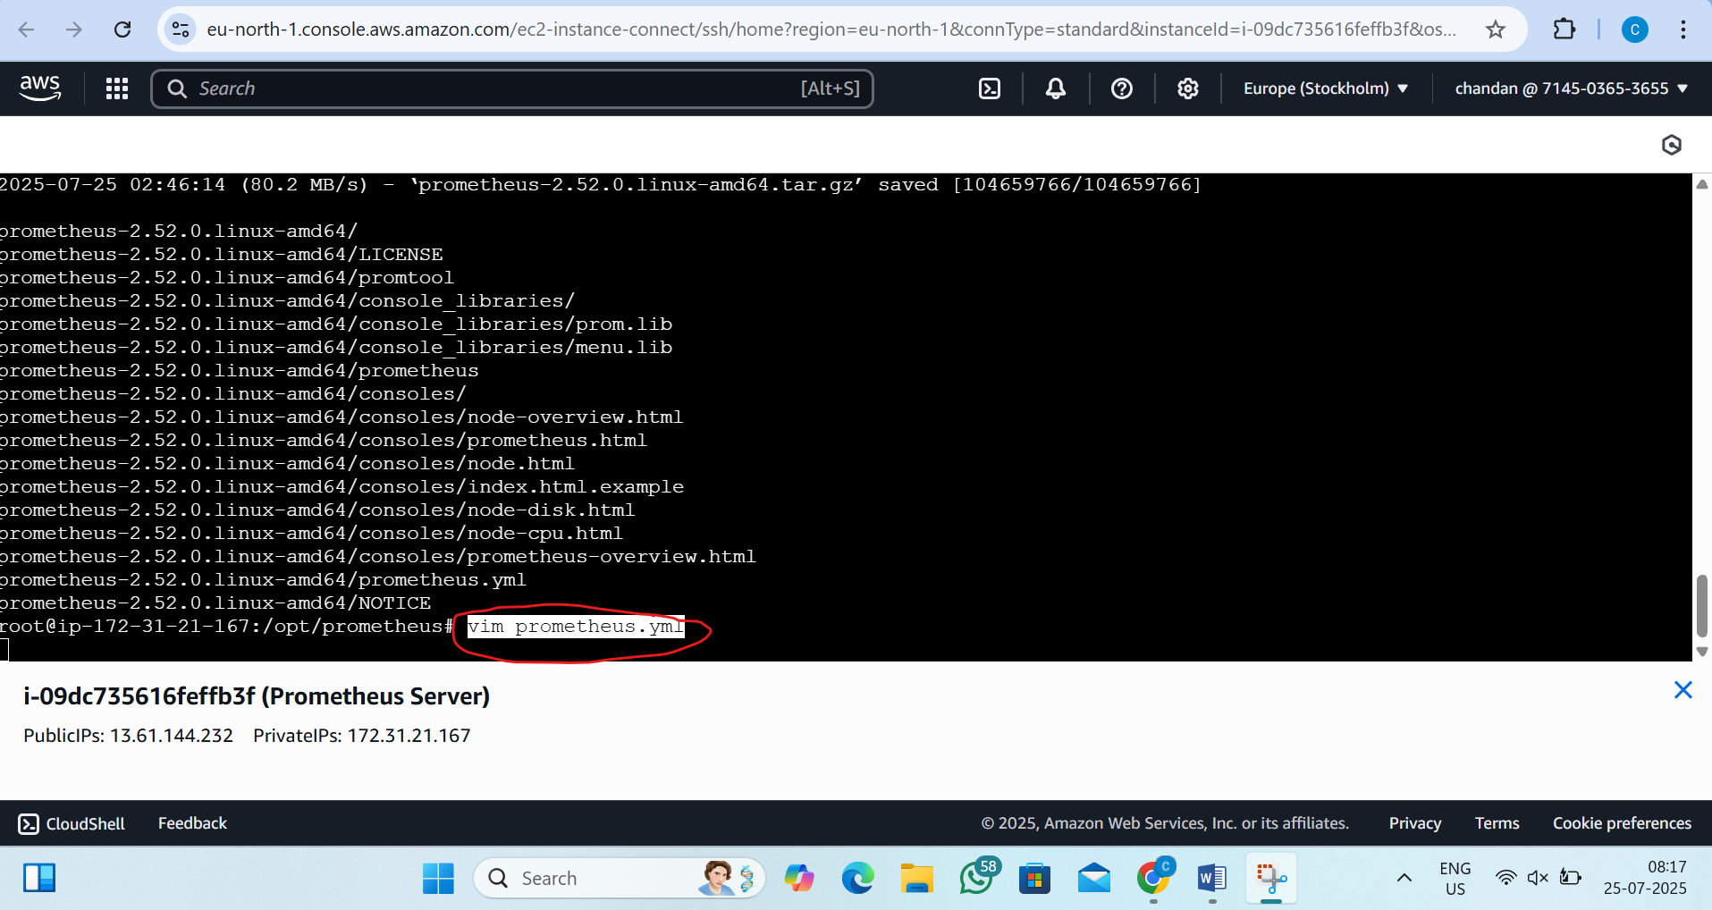
Step10:inside delete all script and paste this script(replace public ip of Jenkins)
global:
scrape_interval: 15s
evaluation_interval: 15s

alerting:
alertmanagers:
- static_configs:
- targets:
# - "alertmanager:9093" # Uncomment if you use Alertmanager later

rule_files:
# - "alert_rules.yml" # Uncomment if you create rules later

scrape_configs:
- job_name: "prometheus"
static_configs:
- targets: ["localhost:9090"]

- job_name: "jenkins-node-exporter"
static_configs:
- targets: ["13.61.185.150:9100"]
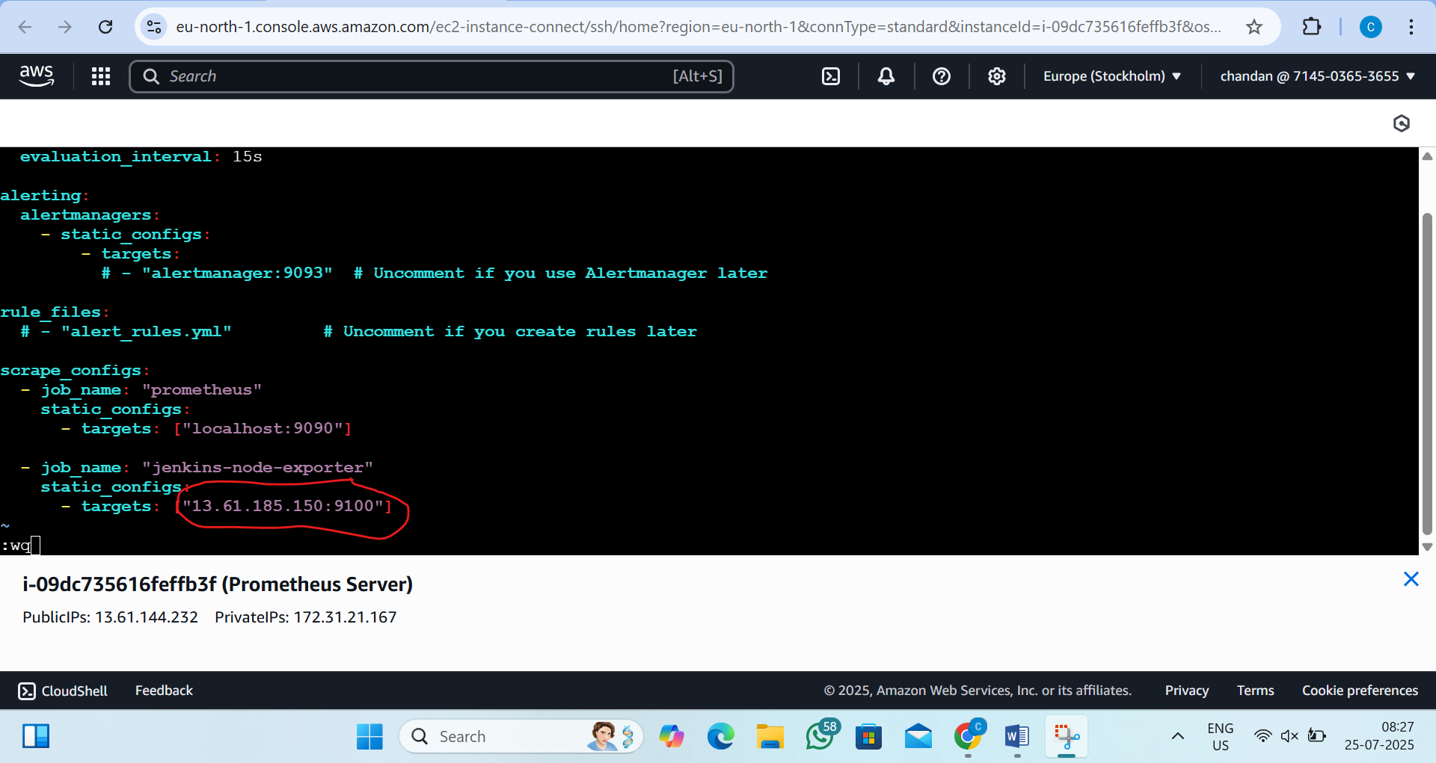
Step11: Run Prometheus
by the command:- ./prometheus --config.file=prometheus.yml &
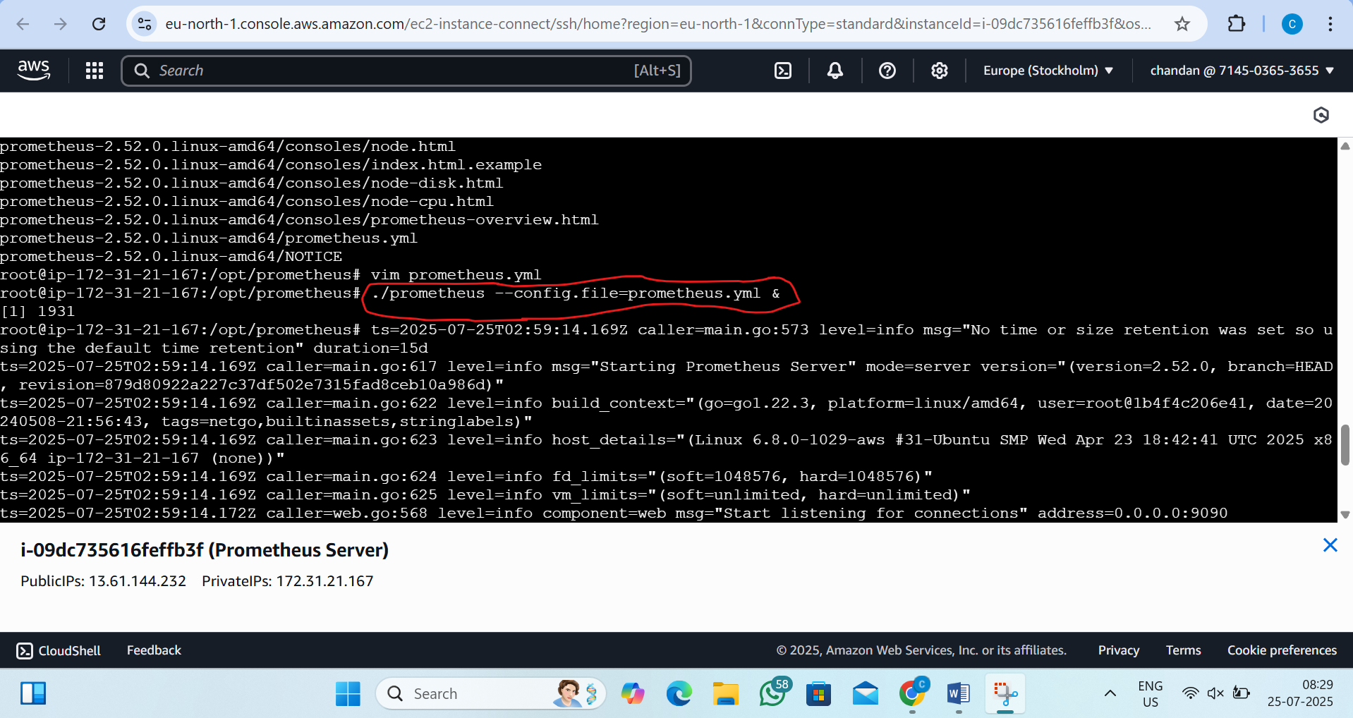

Step12:now go to browser and type(see the Prometheus is running)
http://<prometheus-public-ip>:9090
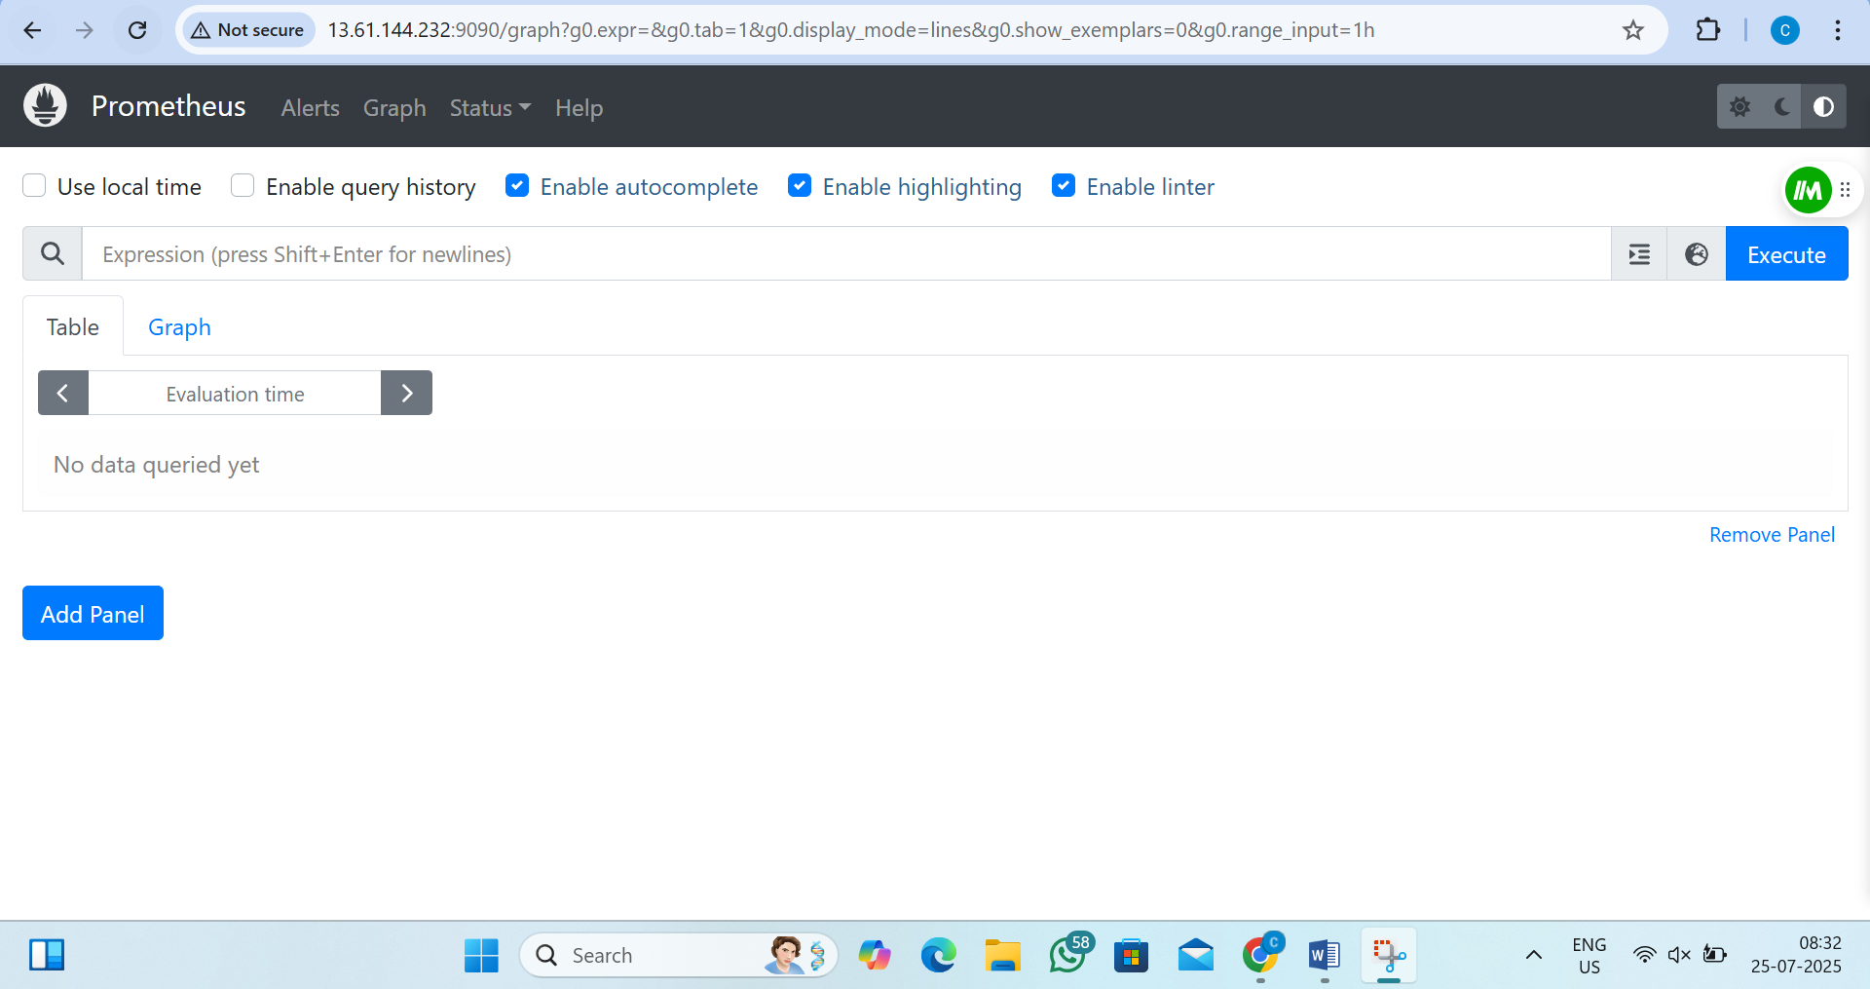

Step13:connect the Grafana instances
pass the command :-sudo su and apt update
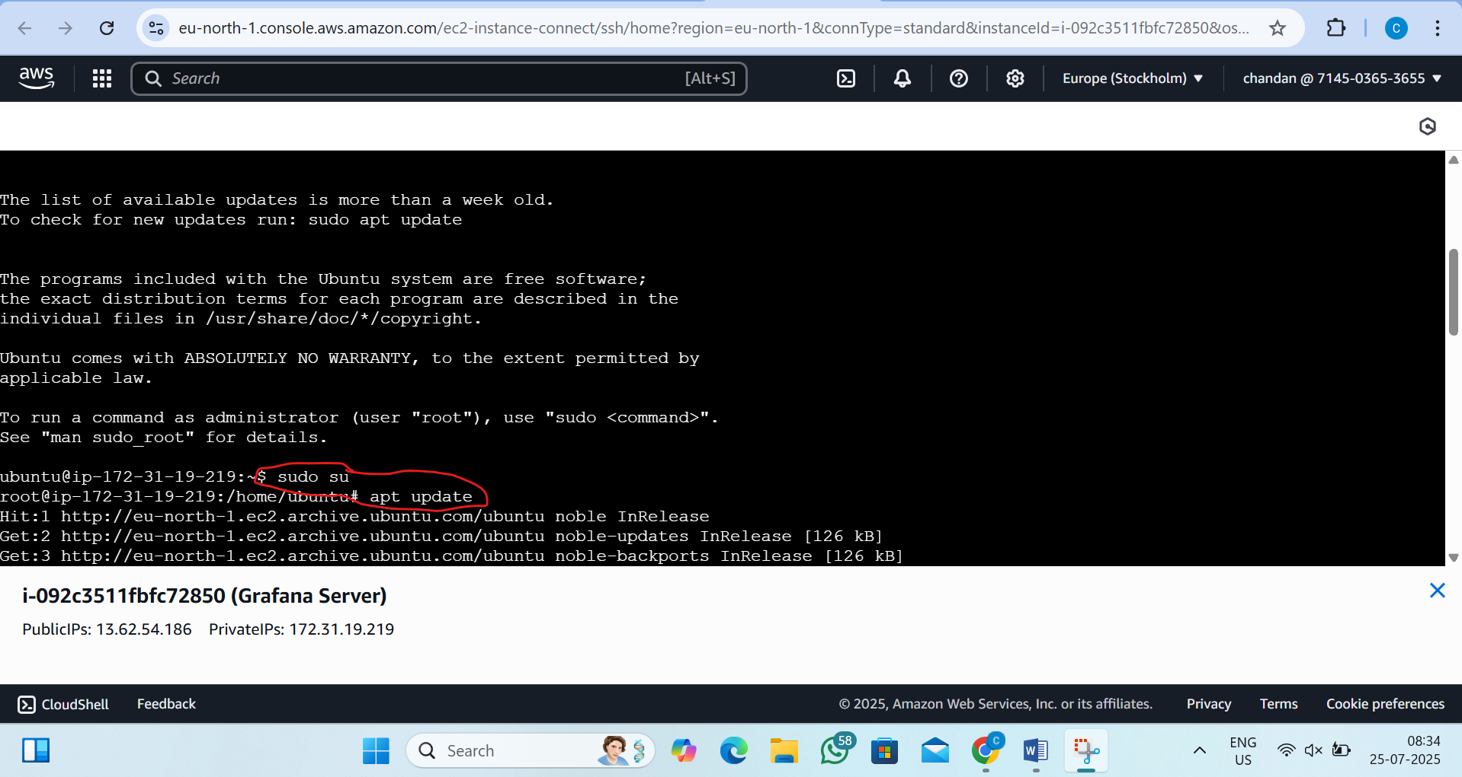

step14:-install Grafana(and press enter to continue at the middle)
by the command:- sudo apt install -y software-properties-common
sudo add-apt-repository "deb https://packages.grafana.com/oss/deb stable main"
wget -q -O - https://packages.grafana.com/gpg.key | sudo apt-key add -
apt update -y
apt install grafana -y
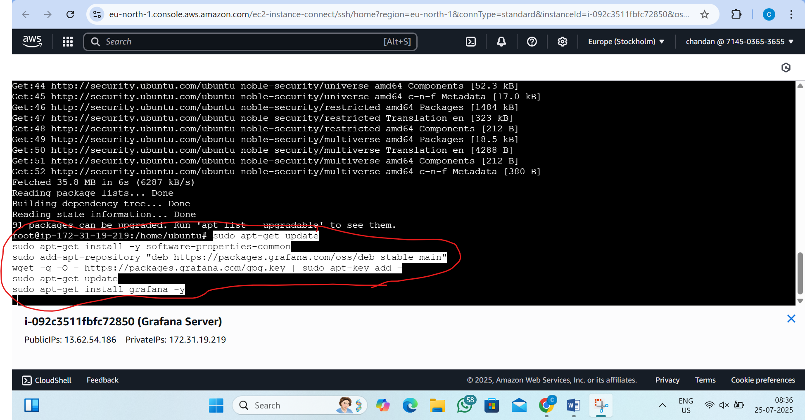

Step15:pass this
systemctl start grafana-server
systemctl enable grafana-server
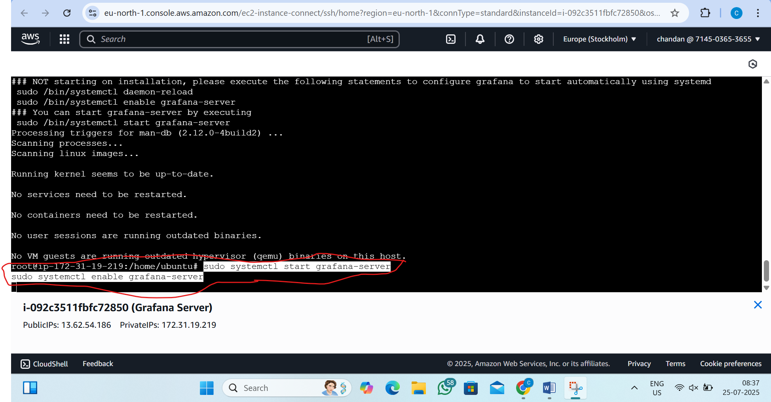
Step16:now go to browser and see the grafena
http://<your-ec2-public-ip>:3000
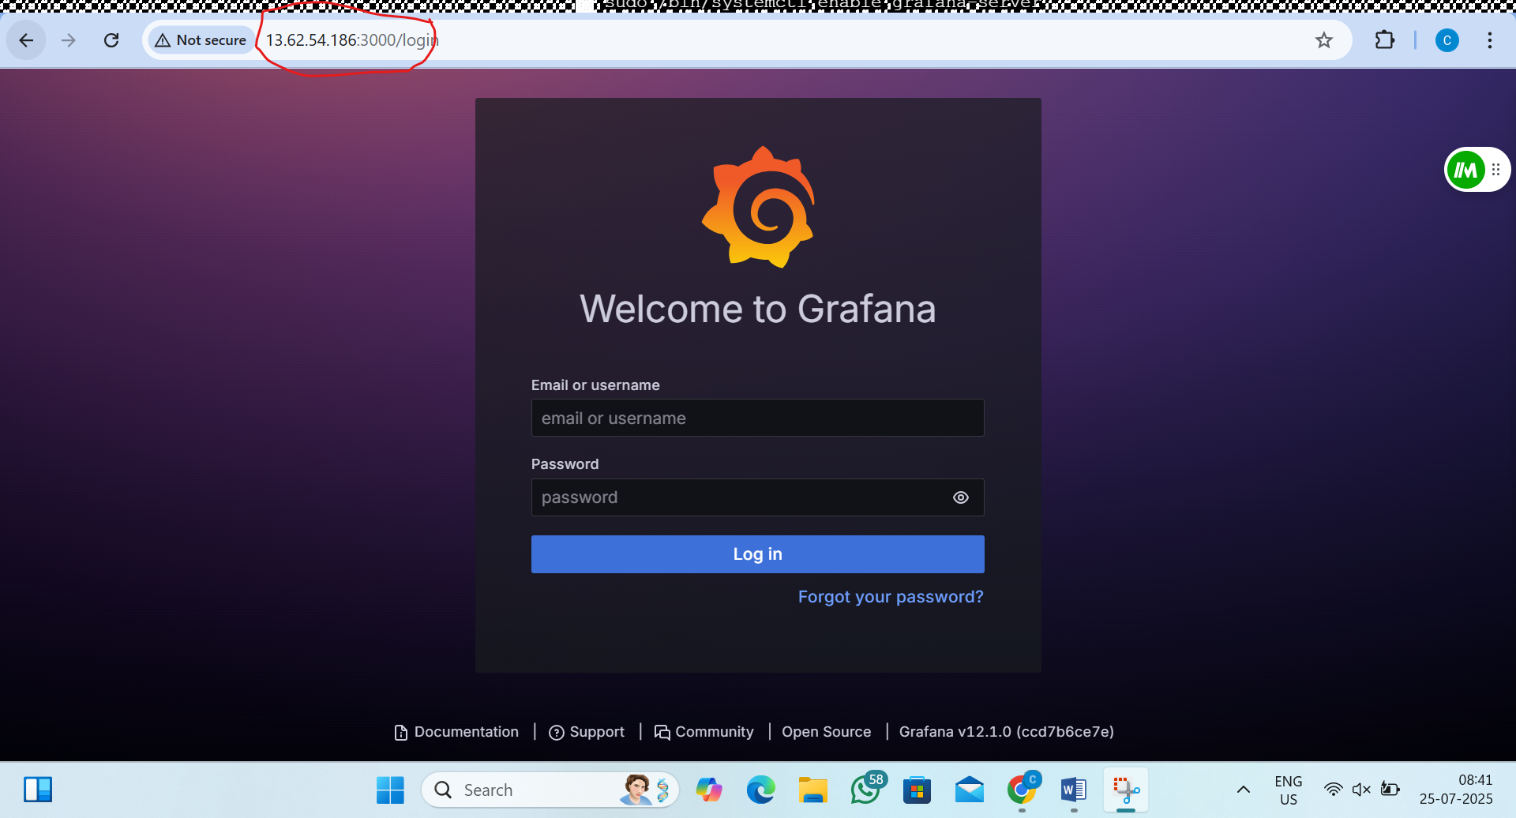

Step17:-now login deflut as admin and create new password
Username: admin
Password: admin
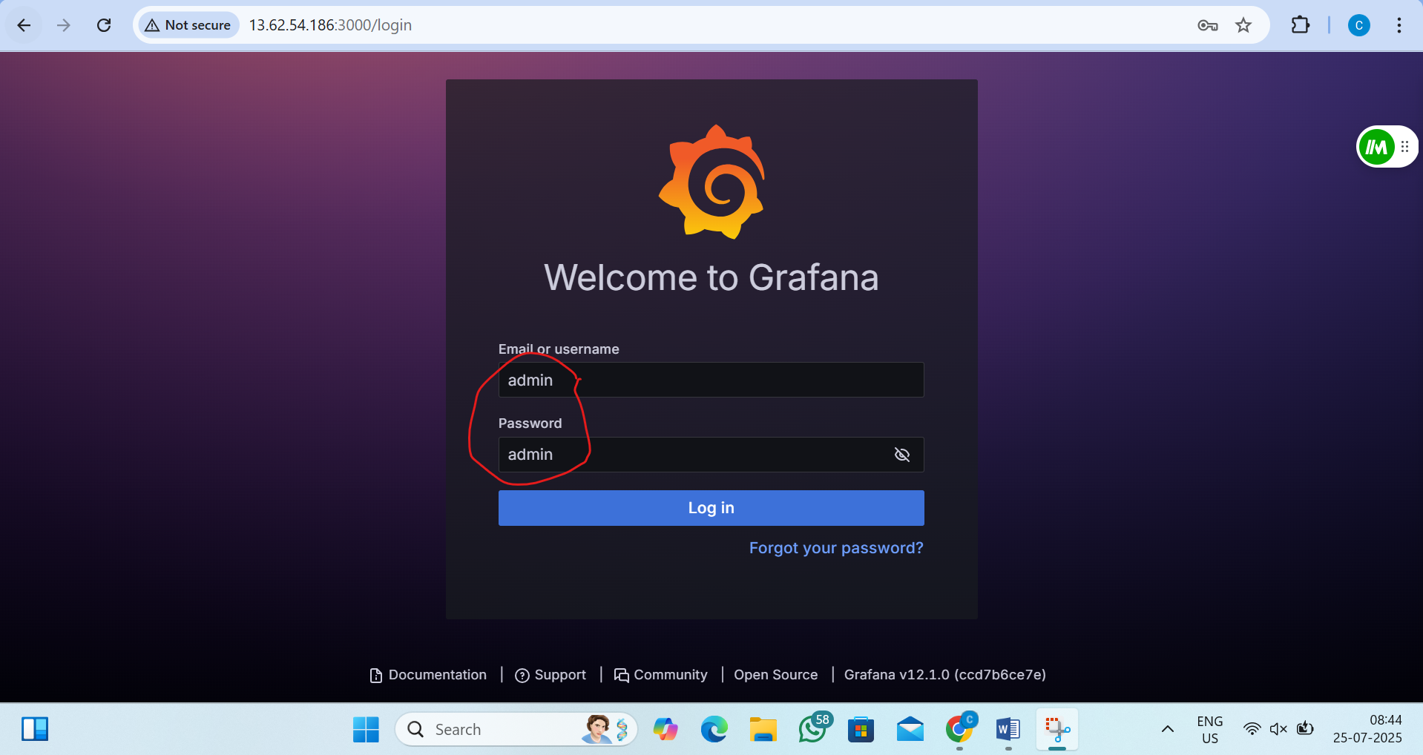
Step18:- Setup Grafana Dashboard
i) Add Prometheus as Data Source
1)go to search and type data source
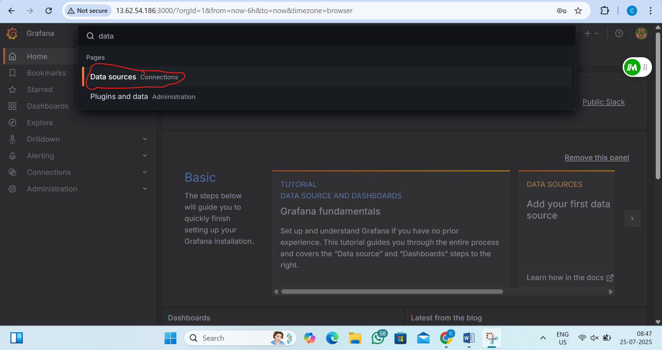
2)now click on add data source
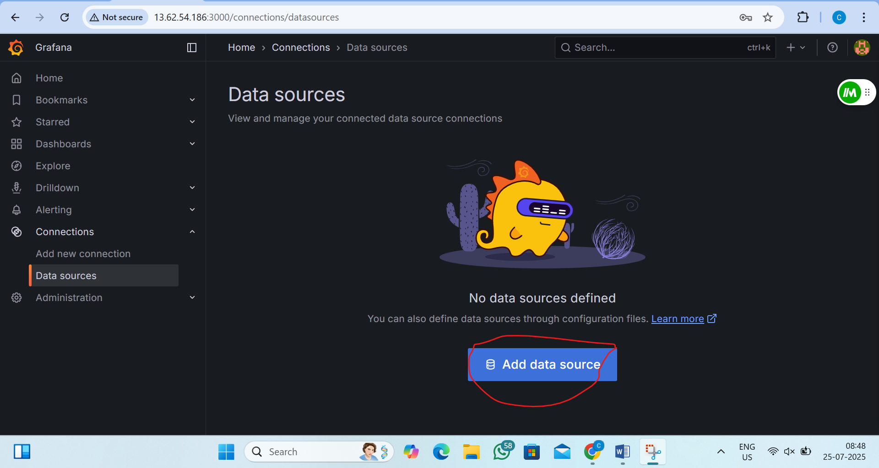
3)select Prometheus
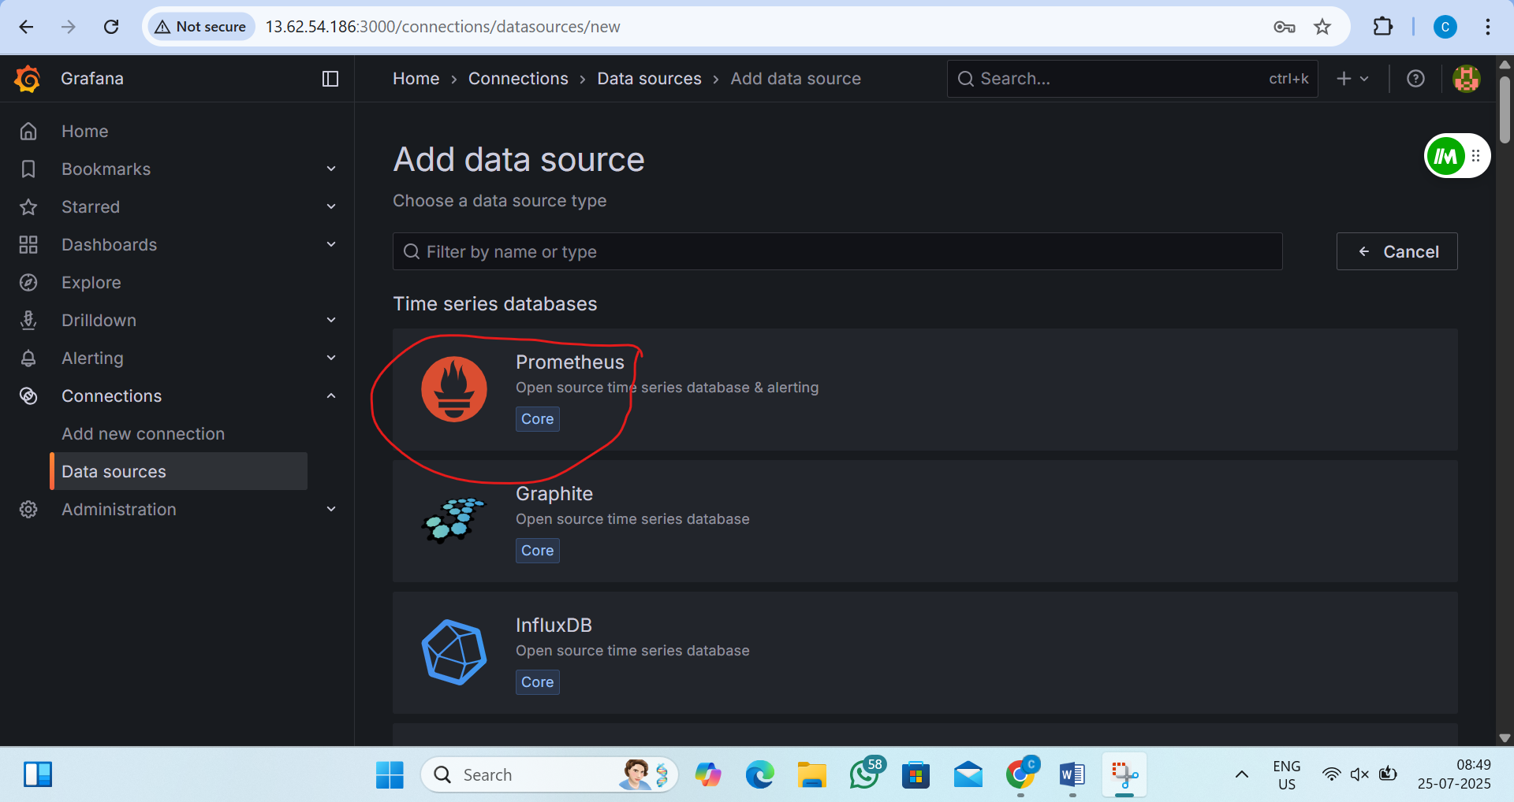

4)now add the promethus ip address
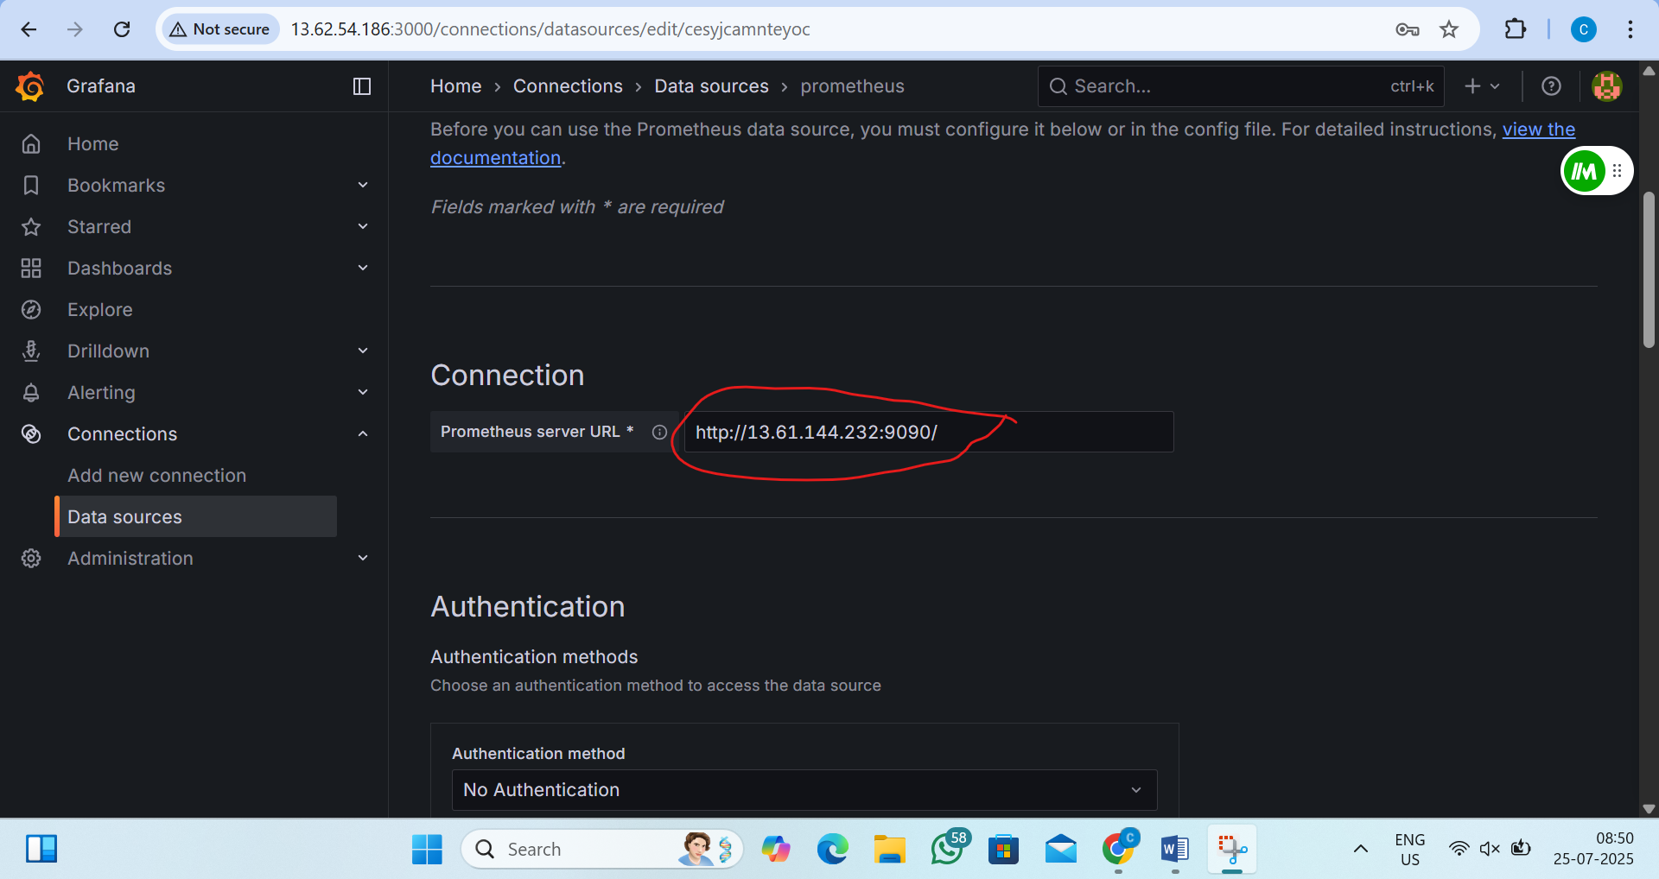
5)now click on save and test
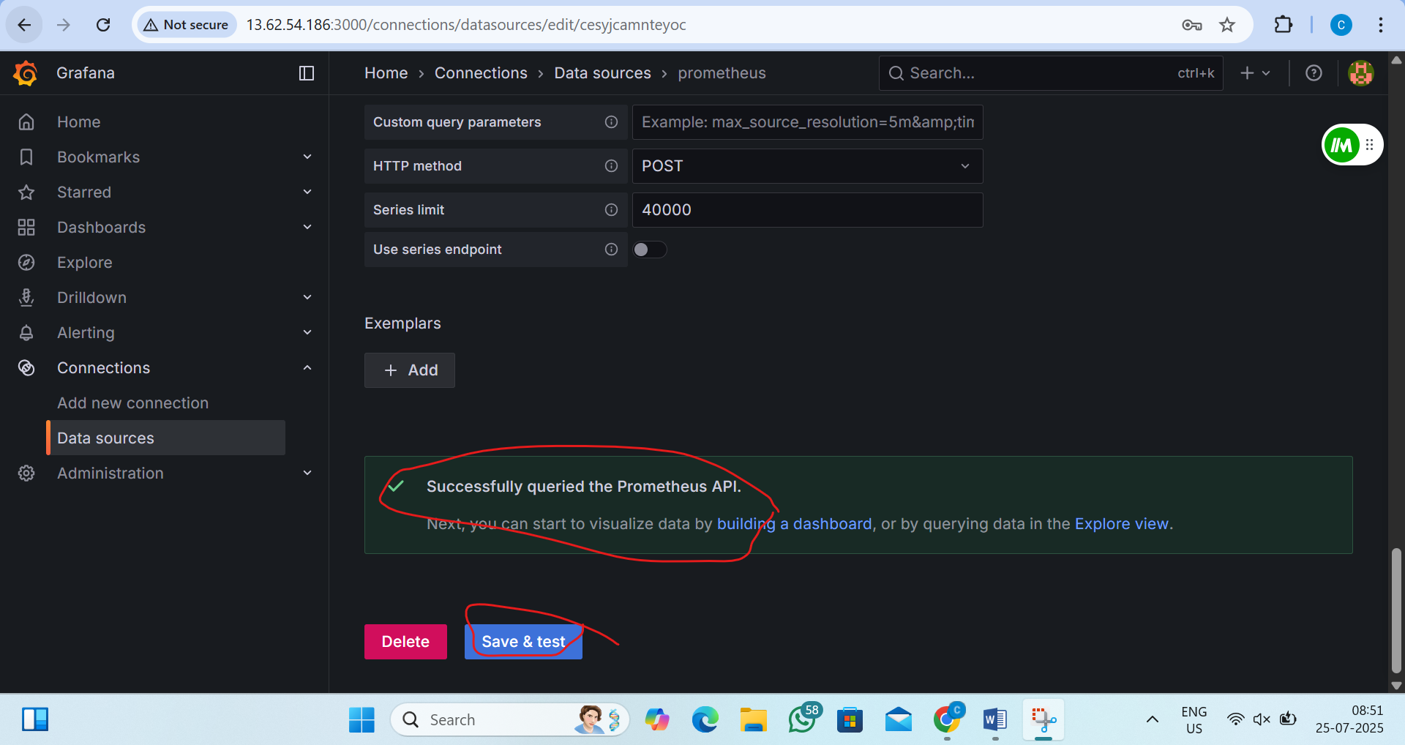

ii) Create Dashboard
1)go to + and create new dashboard
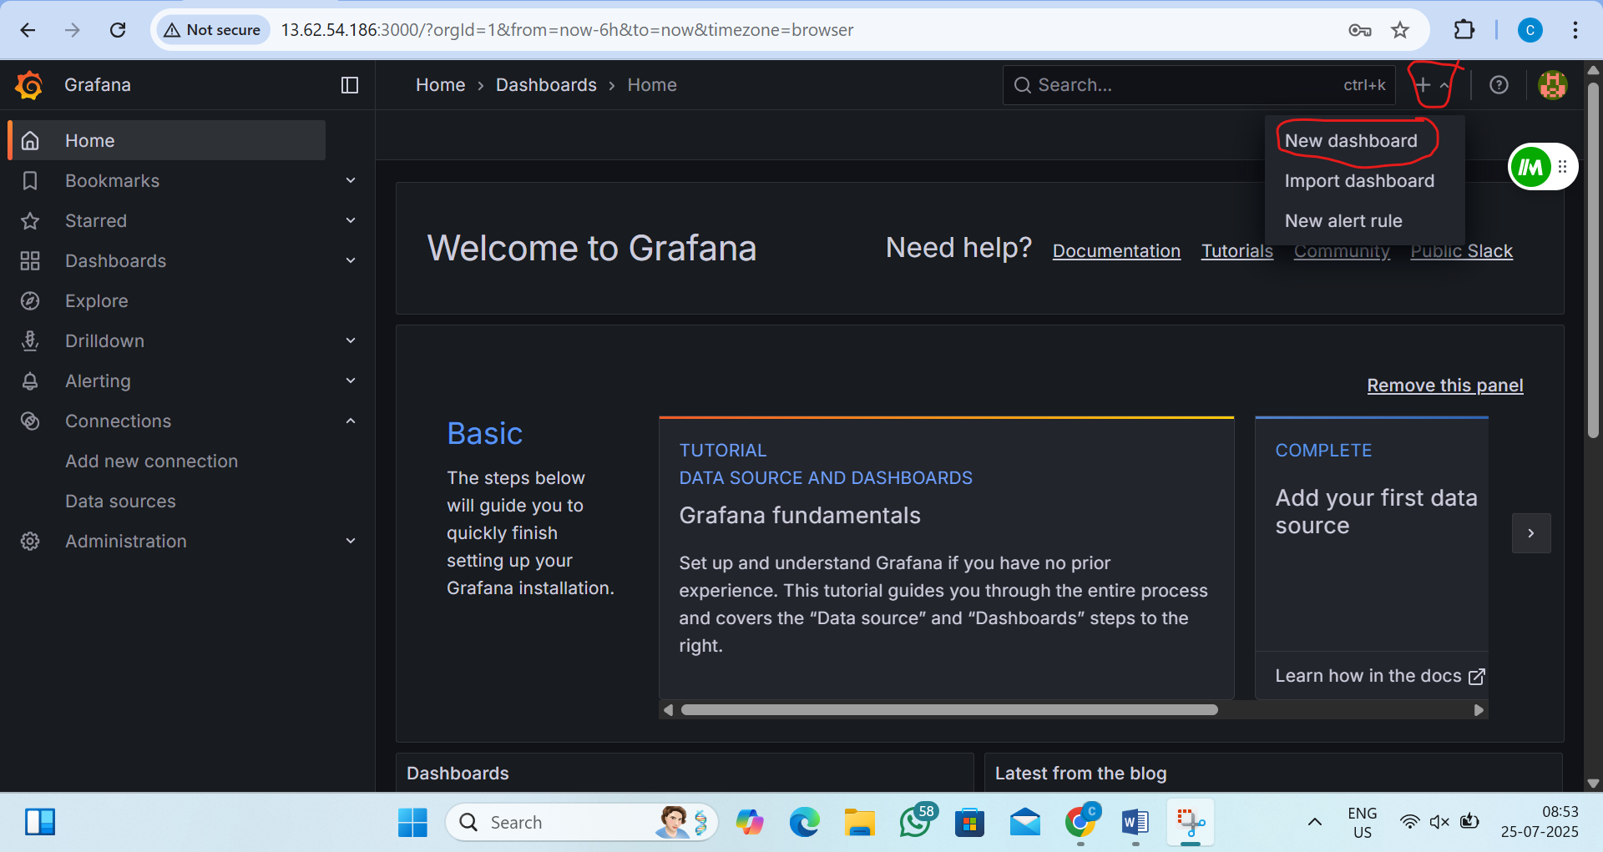
2)add new panneal
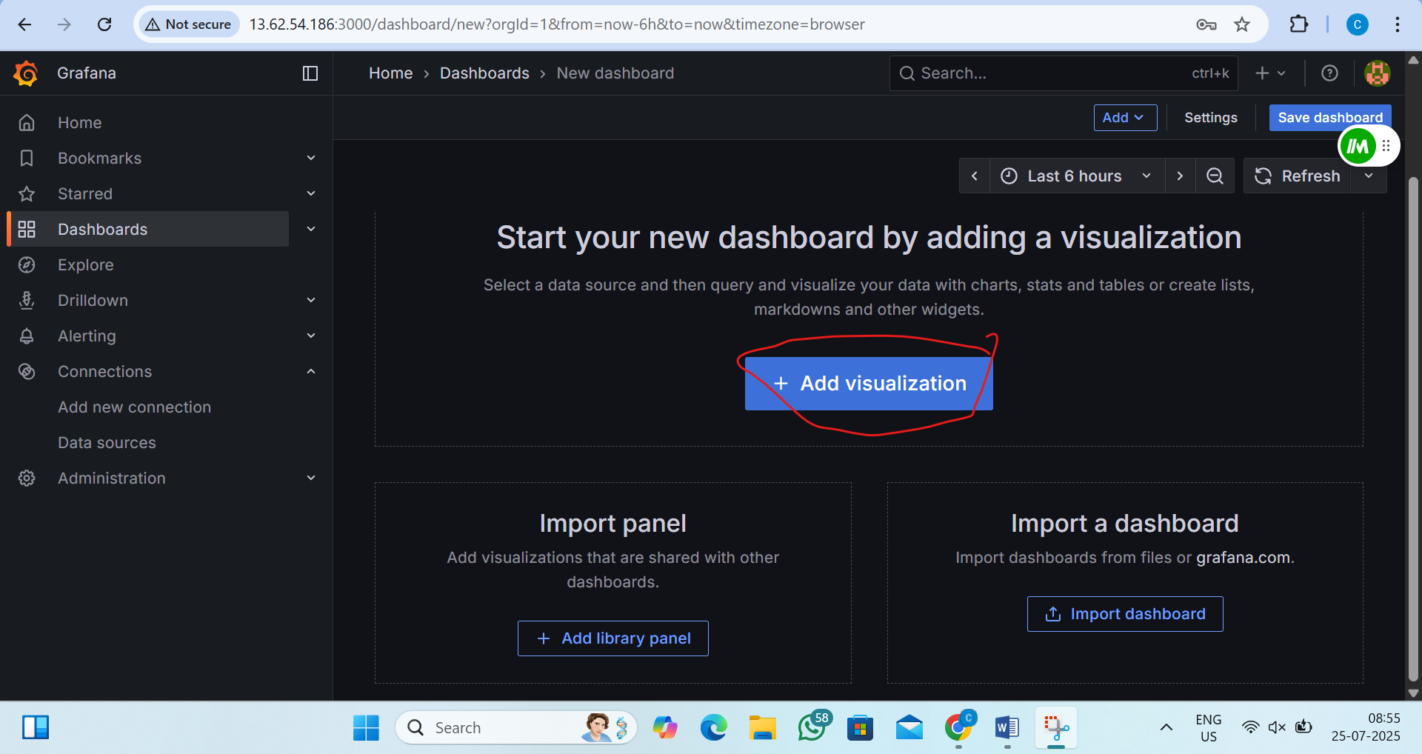

3)select data source
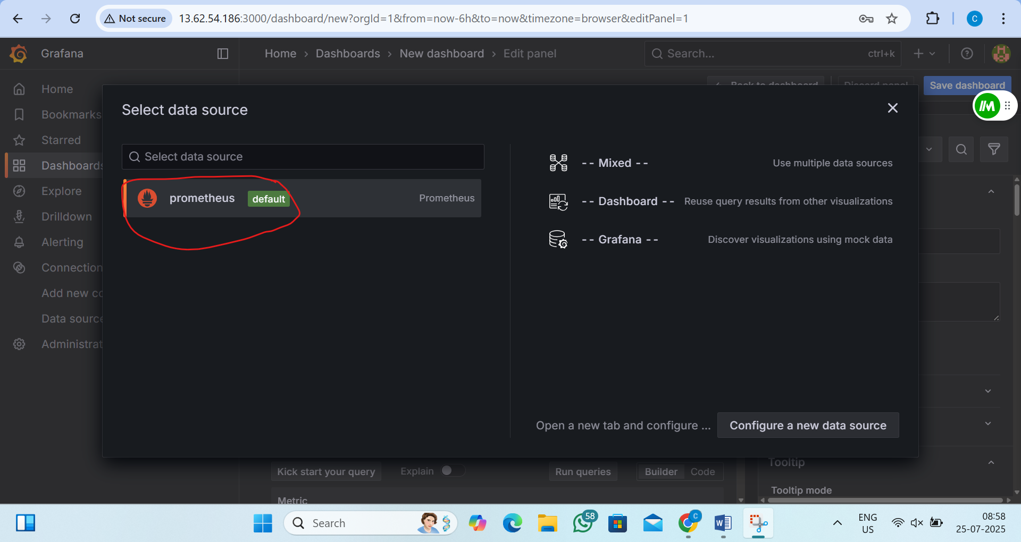
4)now click on code and add this (cpu queray)
100 - (avg by(instance)(rate(node_cpu_seconds_total{mode="idle"}[5m])) * 100)
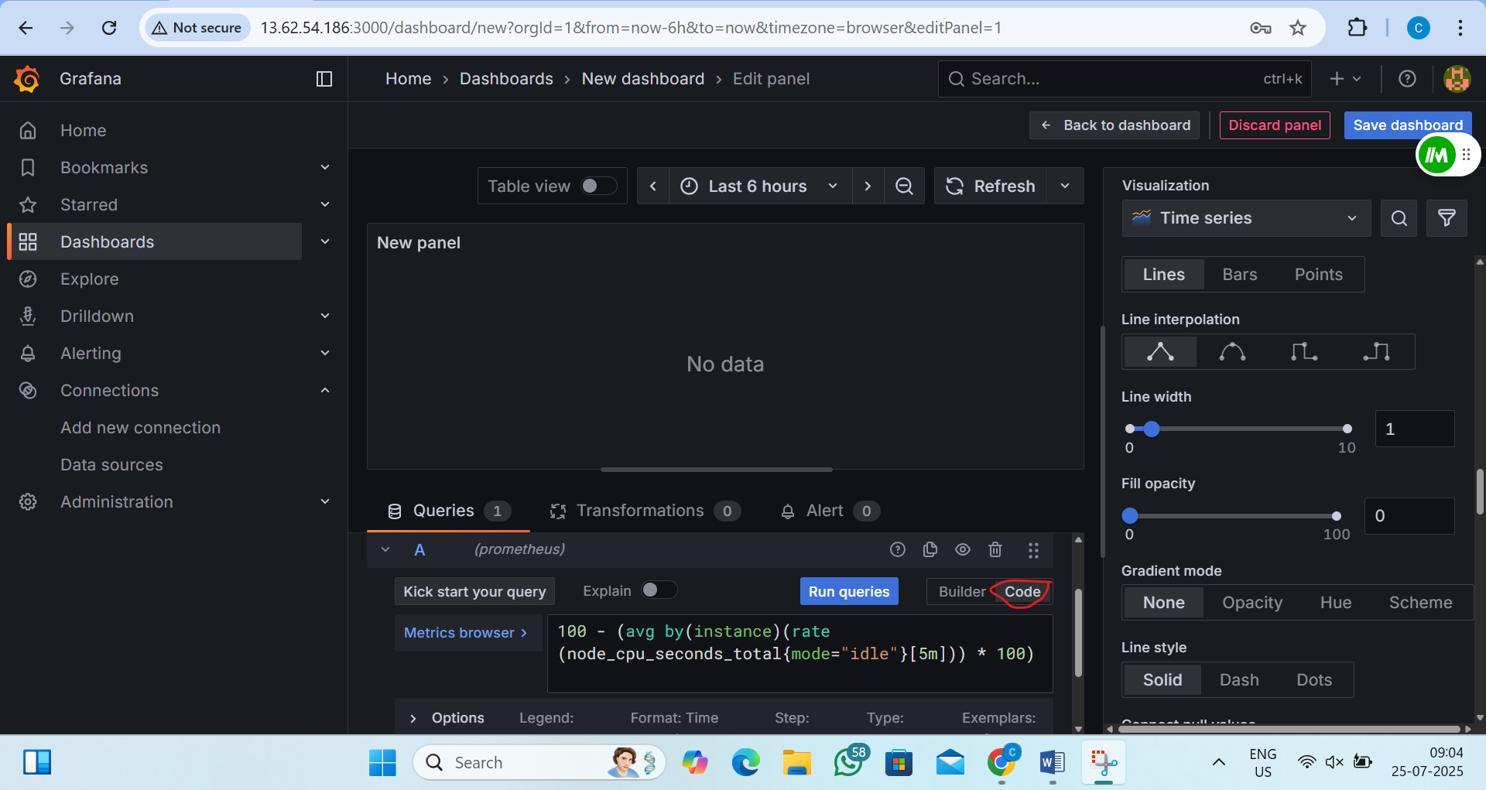

5)now click on add query and add this ( memory utilization)
(1 - (node_memory_MemAvailable_bytes / node_memory_MemTotal_bytes)) * 100
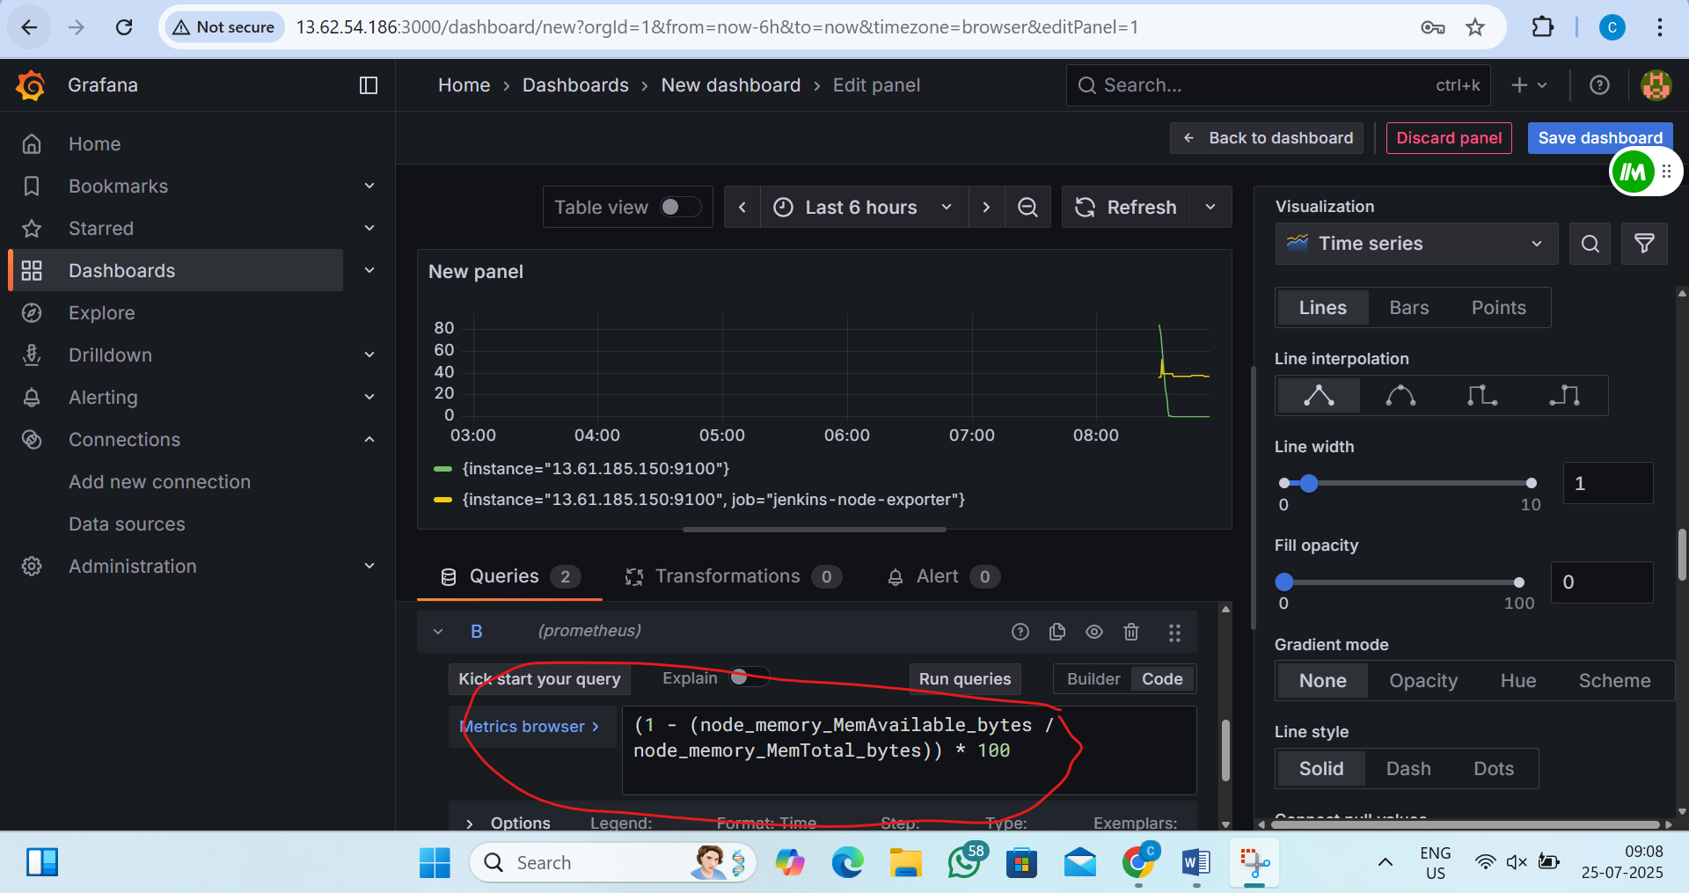

Output is
