**SLF4J EXERCISES**

**Exercise 1: Logging Error Messages and Warning Levels**

**LoggingExample.java**

package sl4j.exercises;

import org.slf4j.Logger;

import org.slf4j.LoggerFactory;

public class LoggingExample {

private static final Logger = LoggerFactory.*getLogger*(LoggingExample.class);

public static void main(String[] args) {

*logger*.error("This is an error message");

*logger*.warn("This is a warning message");

}

}

**OUTPUT**

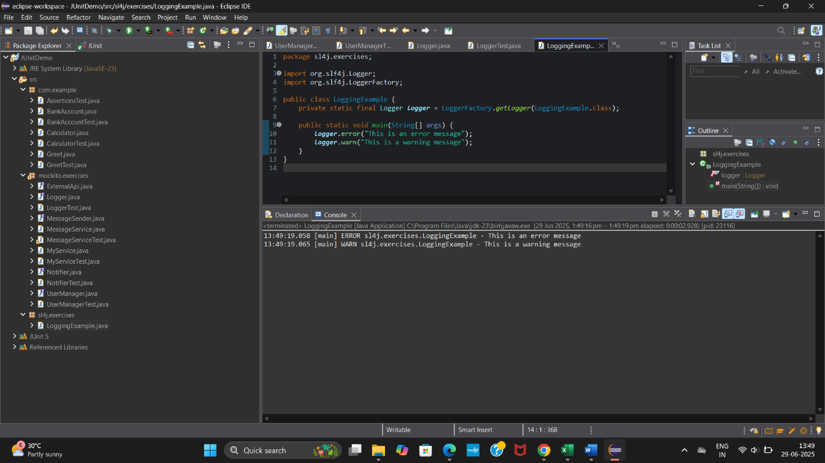

**Exercise 2: Parameterized Logging**

**ParameterizedLogging.java**

package sl4j.exercises;

import org.slf4j.Logger;

import org.slf4j.LoggerFactory;

public class ParameterizedLogging {

private static final Logger = LoggerFactory.*getLogger*(ParameterizedLogging.class);

public static void main(String[] args) {

String username = "Chandana";

int userId = 101;

*logger*.info("User {} with ID {} has logged in", username, userId);

*logger*.warn("User {} tried to access restricted page", username);

*logger*.error("Failed to fetch data for user ID: {}", userId);

}

}

**OUTPUT**

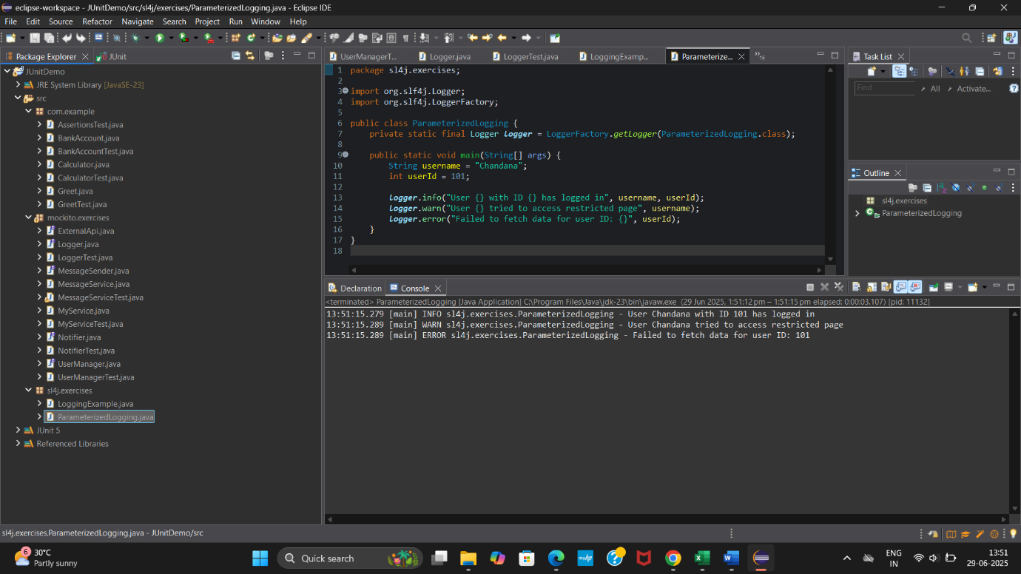

**Exercise 3: Using Different Appenders**

**AppenderDemo.java**

package sl4j.exercises;

import org.slf4j.Logger;

import org.slf4j.LoggerFactory;

public class AppenderDemo {

private static final Logger = LoggerFactory.*getLogger*(AppenderDemo.class);

public static void main(String[] args) {

*logger*.debug("This is a debug message");

*logger*.info("This is an info message");

*logger*.warn("This is a warning");

*logger*.error("This is an error");

}

}

**OUTPUT**

