**1.SPRING-REST HANDSON**

**Hands on 1**

**Create a Spring Web Project using Maven** 

**SpringLearnApplication.java**

package com.cognizant.spring_learn;

import org.slf4j.Logger;

import org.slf4j.LoggerFactory;

import org.springframework.boot.SpringApplication;

import org.springframework.boot.autoconfigure.SpringBootApplication;

*@SpringBootApplication*

public class SpringLearnApplication {

private static final Logger ***LOGGER*** = LoggerFactory.*getLogger*(SpringLearnApplication.class);

public static void main(String[] args) {

***LOGGER***.info("STARTING SPRINGLEARN APPLICATION");

SpringApplication.*run*(SpringLearnApplication.class, args);

***LOGGER***.info("SPRINGLEARN APPLICATION STARTED");

}

}

**OUTPUT**

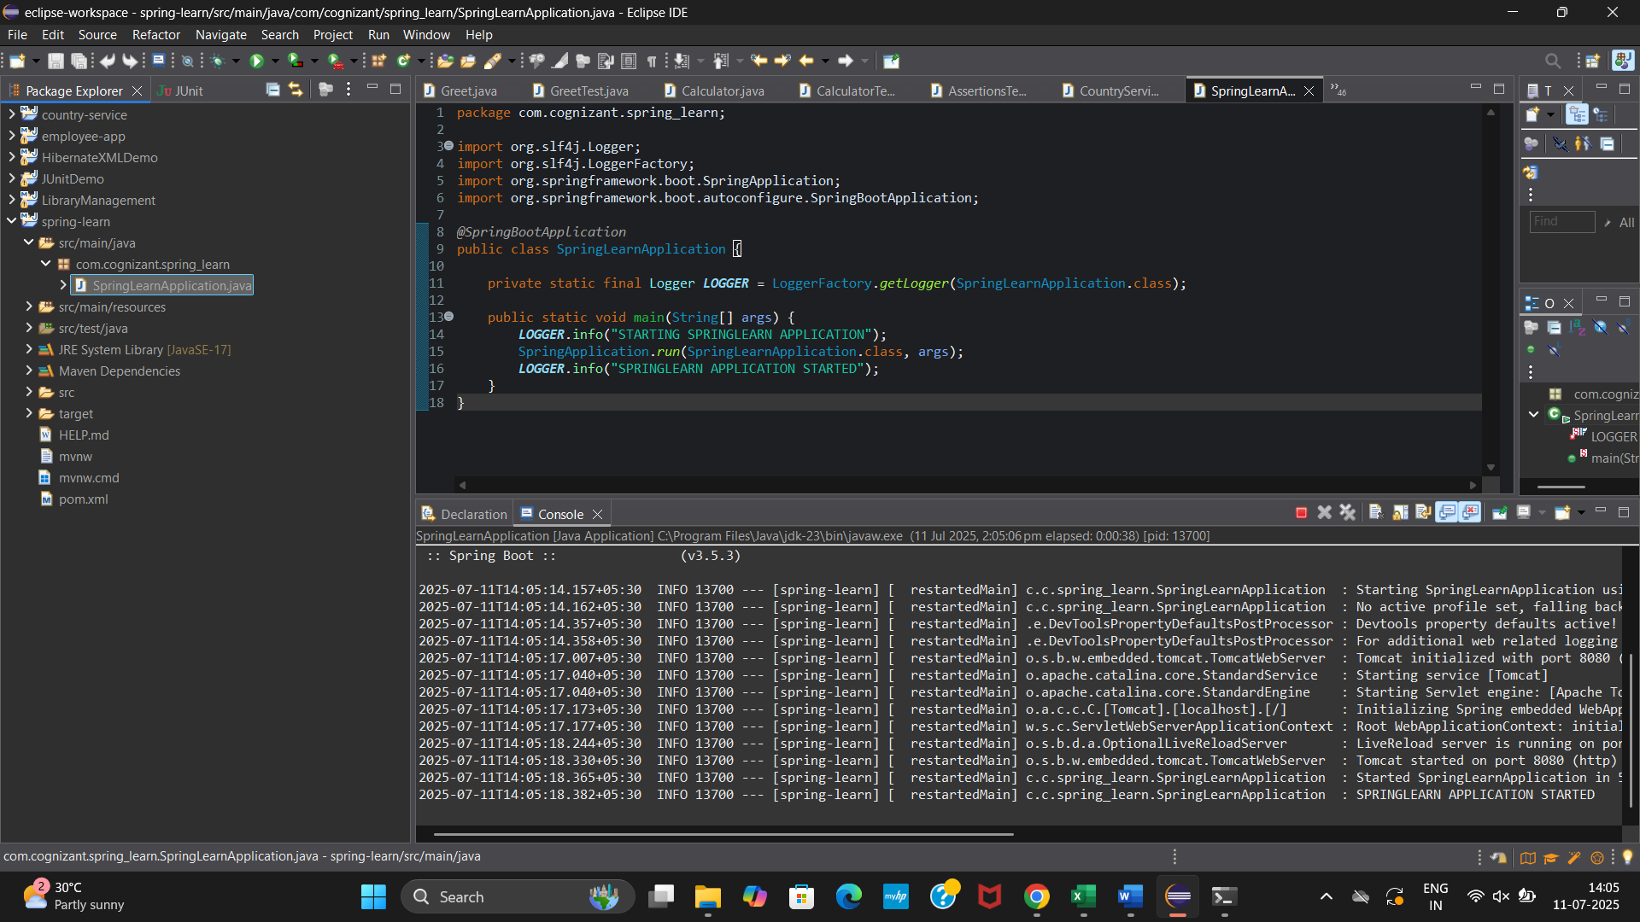

**Hands on 2**

**Spring Core – Load SimpleDateFormat from Spring Configuration XML**

**Date-format.xml**  
<?xml version="1.0" encoding="UTF-8"?>

<beans xmlns="http://www.springframework.org/schema/beans"

xmlns:xsi="http://www.w3.org/2001/XMLSchema-instance"

xsi:schemaLocation="

http://www.springframework.org/schema/beans

https://www.springframework.org/schema/beans/spring-beans.xsd">

<bean id="dateFormat" class="java.text.SimpleDateFormat">

<constructor-arg value="dd/MM/yyyy" />

</bean>

</beans>

**SpringLearnApplication.java**

package com.cognizant.spring_learn;

import org.slf4j.Logger;

import org.slf4j.LoggerFactory;

import org.springframework.context.ApplicationContext;

import org.springframework.context.support.ClassPathXmlApplicationContext;

import org.springframework.boot.autoconfigure.SpringBootApplication;

import org.springframework.boot.SpringApplication;

import java.text.SimpleDateFormat;

import java.text.ParseException;

import java.util.Date;

*@SpringBootApplication*

public class SpringLearnApplication {

private static final Logger ***LOGGER*** = LoggerFactory.*getLogger*(SpringLearnApplication.class);

public static void main(String[] args) {

***LOGGER***.info("START");

SpringApplication.*run*(SpringLearnApplication.class, args);

*displayDate*();

***LOGGER***.info("END");

}

public static void displayDate() {

ApplicationContext context = new ClassPathXmlApplicationContext("date-format.xml");

SimpleDateFormat format = context.getBean("dateFormat", SimpleDateFormat.class);

try {

Date parsedDate = format.parse("31/12/2018");

System.***out***.println("Parsed Date: " + parsedDate);

} catch (ParseException e) {

e.printStackTrace();

}

((ClassPathXmlApplicationContext) context).close();

}

}

**OUTPUT**

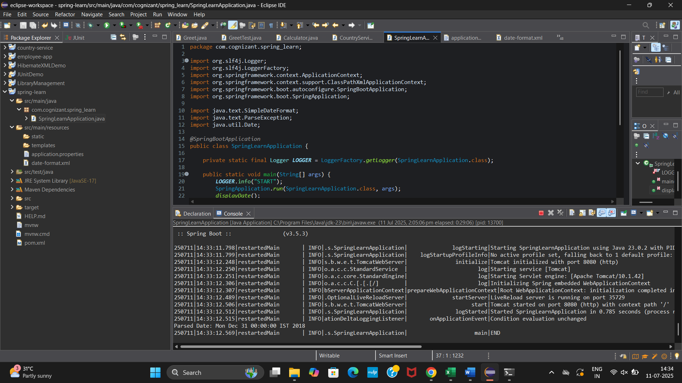

**Hands on 3**

**Spring Core - Incorporate Logging**

**application.properties**

spring.application.name=spring-learn

logging.level.org.springframework=info

logging.level.com.cognizant.spring_learn=debug

logging.pattern.console=%d{yyMMdd}|%d{HH:mm:ss.SSS}|%-20.20thread|%5p|%-25.25logger**{25}**|%25M|%m%n

server.port=0

**SpringLearnApplication.java**

package com.cognizant.spring_learn;

import org.slf4j.Logger;

import org.slf4j.LoggerFactory;

import org.springframework.boot.SpringApplication;

import org.springframework.boot.autoconfigure.SpringBootApplication;

import org.springframework.context.ApplicationContext;

import org.springframework.context.support.ClassPathXmlApplicationContext;

import java.text.ParseException;

import java.text.SimpleDateFormat;

import java.util.Date;

*@SpringBootApplication*

public class SpringLearnApplication {

private static final Logger ***LOGGER*** = LoggerFactory.*getLogger*(SpringLearnApplication.class);

public static void main(String[] args) {

***LOGGER***.info("START");

SpringApplication.*run*(SpringLearnApplication.class, args);

*displayDate*();

***LOGGER***.info("END");

}

public static void displayDate() {

***LOGGER***.info("START");

// Load the Spring XML configuration

ApplicationContext context = new ClassPathXmlApplicationContext("date-format.xml");

// Retrieve the dateFormat bean

SimpleDateFormat format = context.getBean("dateFormat", SimpleDateFormat.class);

try {

// Parse the date and log it

Date parsedDate = format.parse("31/12/2018");

***LOGGER***.debug("Parsed Date: {}", parsedDate);

} catch (ParseException e) {

***LOGGER***.error("Error while parsing date", e);

}

((ClassPathXmlApplicationContext) context).close();

***LOGGER***.info("END");

}

}

**OUTPUT**

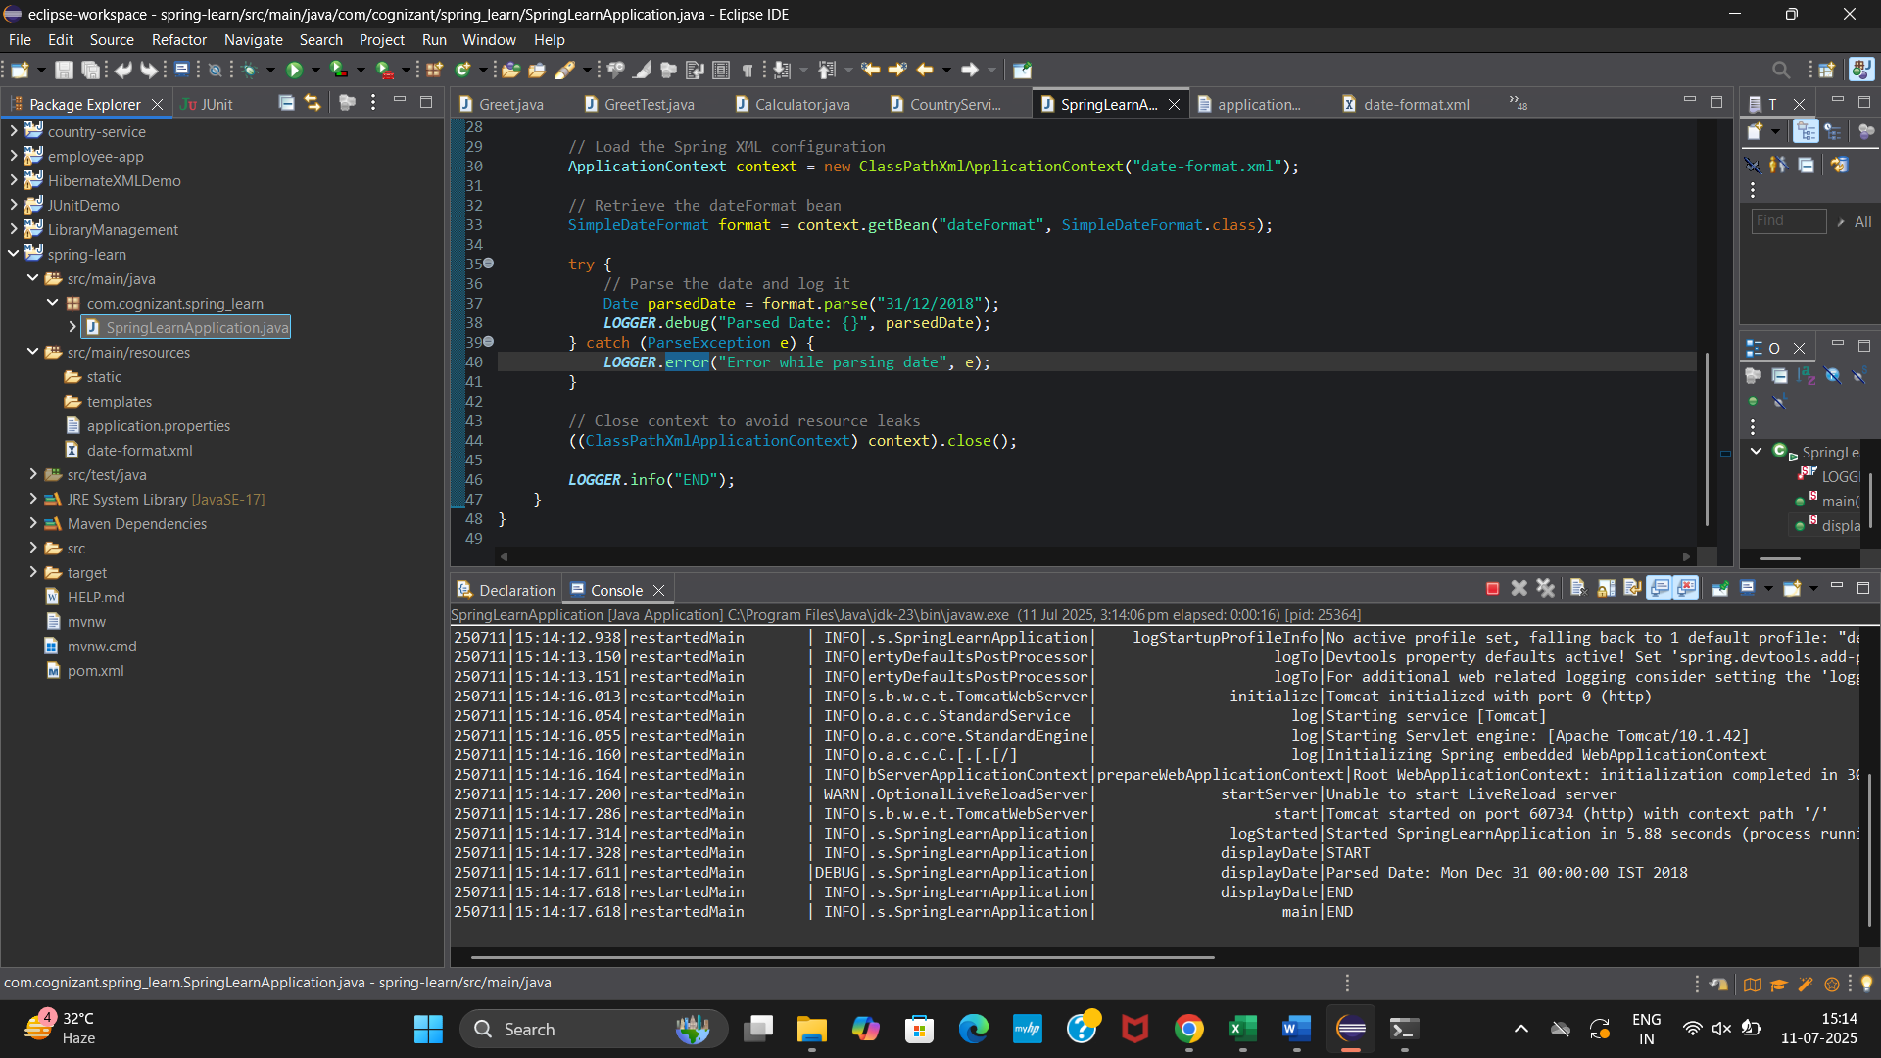

**Hands on 4**

**Spring Core – Load Country from Spring Configuration XML**

**country.xml**

<?xml version="1.0" encoding="UTF-8"?>

<beans xmlns="http://www.springframework.org/schema/beans"

xmlns:xsi="http://www.w3.org/2001/XMLSchema-instance"

xsi:schemaLocation="

http://www.springframework.org/schema/beans

https://www.springframework.org/schema/beans/spring-beans.xsd">

<bean id="country" class="com.cognizant.spring_learn.Country">

<property name="code" value="IN" />

<property name="name" value="India" />

</bean>

</beans>

**Country.java**

package com.cognizant.spring_learn;

import org.slf4j.Logger;

import org.slf4j.LoggerFactory;

public class Country {

private static final Logger ***LOGGER*** = LoggerFactory.*getLogger*(Country.class);

private String code;

private String name;

public Country() {

***LOGGER***.debug("Inside Country Constructor.");

}

public String getCode() {

***LOGGER***.debug("Inside getCode");

return code;

}

public void setCode(String code) {

***LOGGER***.debug("Inside setCode");

this.code = code;

}

public String getName() {

***LOGGER***.debug("Inside getName");

return name;

}

public void setName(String name) {

***LOGGER***.debug("Inside setName");

this.name = name;

}

*@Override*

public String toString() {

return "Country [code=" + code + ", name=" + name + "]";

}

}

**SpringLearnApplication.java**

package com.cognizant.spring_learn;

import org.slf4j.Logger;

import org.slf4j.LoggerFactory;

import org.springframework.boot.SpringApplication;

import org.springframework.boot.autoconfigure.SpringBootApplication;

import org.springframework.context.ApplicationContext;

import org.springframework.context.support.ClassPathXmlApplicationContext;

import java.text.ParseException;

import java.text.SimpleDateFormat;

import java.util.Date;

*@SpringBootApplication*

public class SpringLearnApplication {

private static final Logger ***LOGGER*** = LoggerFactory.*getLogger*(SpringLearnApplication.class);

public static void main(String[] args) {

***LOGGER***.info("START");

SpringApplication.*run*(SpringLearnApplication.class, args);

*displayDate*();

*displayCountry*();

***LOGGER***.info("END");

}

public static void displayDate() {

***LOGGER***.info("START");

ApplicationContext context = new ClassPathXmlApplicationContext("date-format.xml");

SimpleDateFormat format = context.getBean("dateFormat", SimpleDateFormat.class);

try {

Date parsedDate = format.parse("31/12/2018");

***LOGGER***.debug("Parsed Date: {}", parsedDate);

} catch (ParseException e) {

***LOGGER***.error("Error while parsing date", e);

}

((ClassPathXmlApplicationContext) context).close();

***LOGGER***.info("END");

}

public static void displayCountry() {

***LOGGER***.info("START");

ApplicationContext context = new ClassPathXmlApplicationContext("country.xml");

Country country = context.getBean("country", Country.class);

***LOGGER***.debug("Country : {}", country.toString());

((ClassPathXmlApplicationContext) context).close();

***LOGGER***.info("END");

}

}

**OUTPUT**

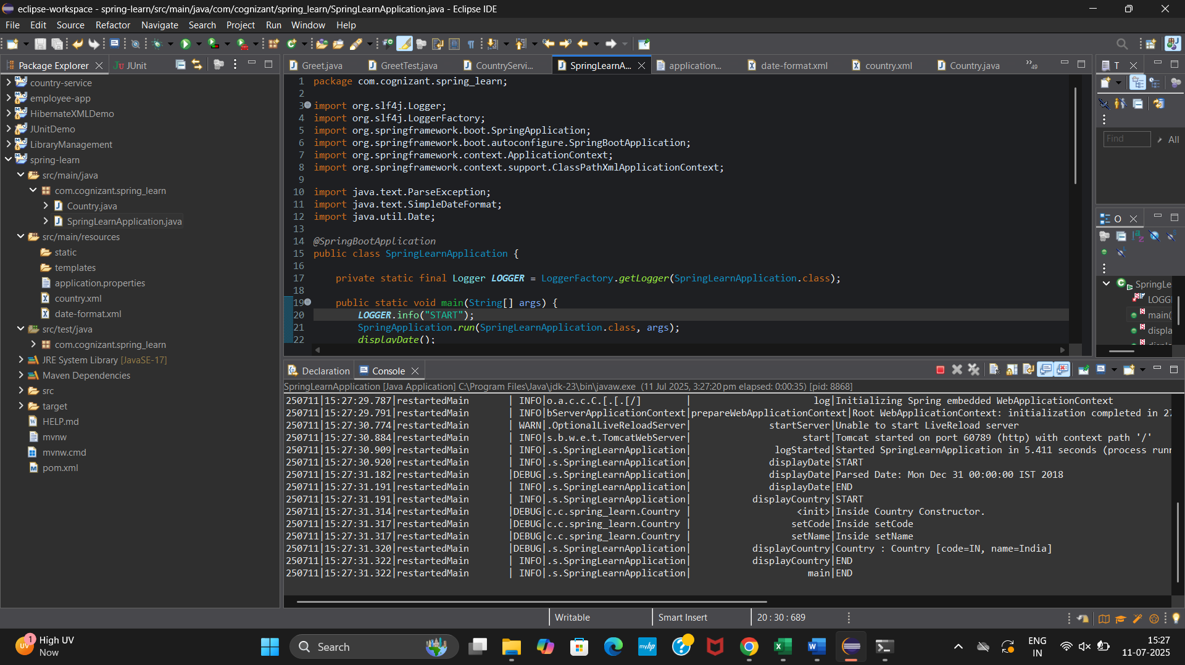

**Hands on 5**

**Spring Core – Demonstration of Singleton Scope and Prototype Scope**

**Singleton Scope:**

**Update country.xml**

<bean id="country" class="com.cognizant.spring_learn.Country" >

<property name="code" value="IN" />

<property name="name" value="India" />

</bean>

**Update displayCountry() in SpringLearnApplication.java**

public static void displayCountry() {

*LOGGER*.info("START");

ApplicationContext context = new ClassPathXmlApplicationContext("country.xml");

Country country = context.getBean("country", Country.class);

Country anotherCountry = context.getBean("country", Country.class);

*LOGGER*.debug("Country : {}", country.toString());

*LOGGER*.debug("Another Country : {}", anotherCountry.toString());

((ClassPathXmlApplicationContext) context).close();

*LOGGER*.info("END");

}

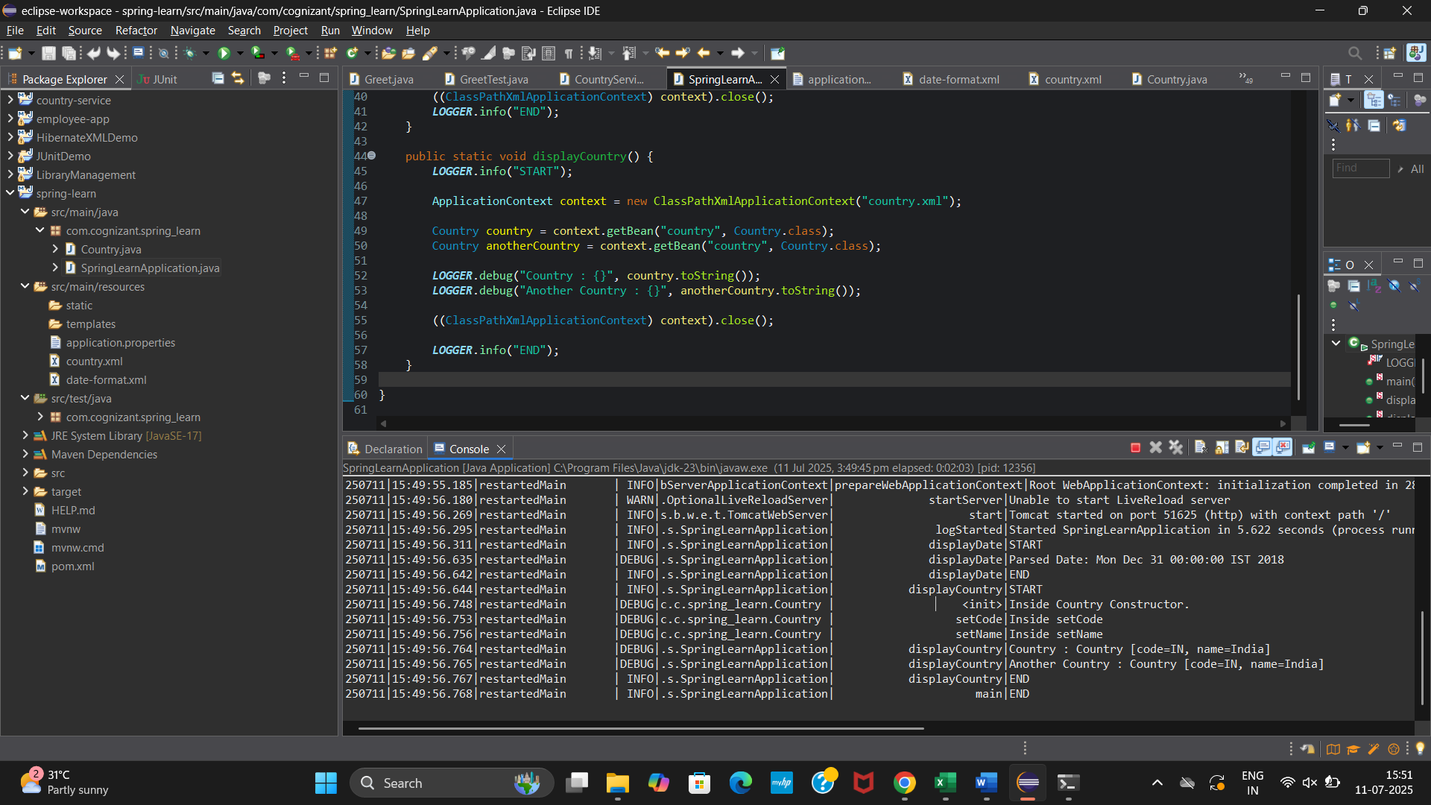

**Prototype Scope**:

**Modify country.xml**

<bean id="country" class="com.cognizant.spring_learn.Country" scope="prototype">

<property name="code" value="IN" />

<property name="name" value="India" />

</bean>

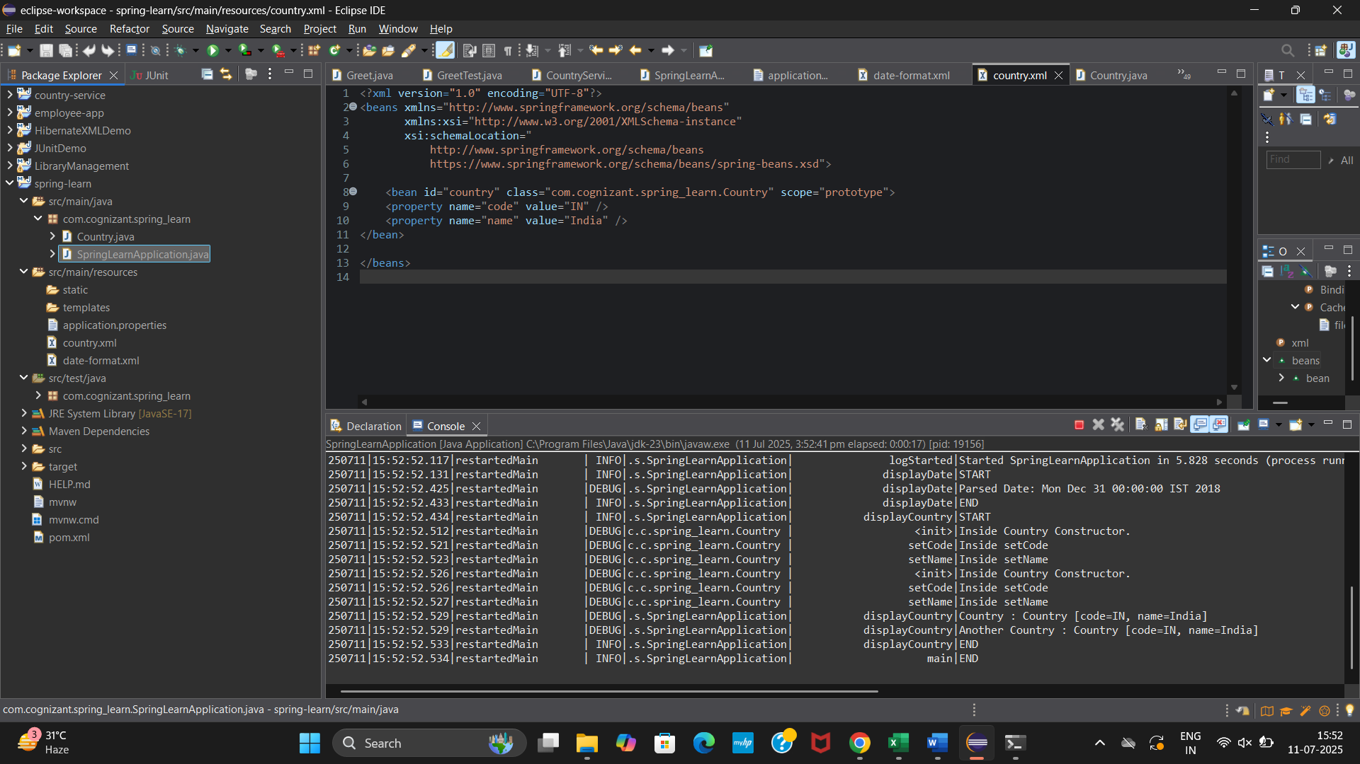

**Hands on 6**

**Spring Core – Load list of countries from Spring Configuration XML**

**country.xml**

<?xml version="1.0" encoding="UTF-8"?>

<beans xmlns="http://www.springframework.org/schema/beans"

xmlns:xsi="http://www.w3.org/2001/XMLSchema-instance"

xsi:schemaLocation="

http://www.springframework.org/schema/beans

https://www.springframework.org/schema/beans/spring-beans.xsd">

<!-- Default single country bean -->

<bean id="country" class="com.cognizant.spring_learn.Country">

<property name="code" value="IN" />

<property name="name" value="India" />

</bean>

<!-- Individual country beans -->

<bean id="in" class="com.cognizant.spring_learn.Country">

<property name="code" value="IN" />

<property name="name" value="India" />

</bean>

<bean id="us" class="com.cognizant.spring_learn.Country">

<property name="code" value="US" />

<property name="name" value="United States" />

</bean>

<bean id="de" class="com.cognizant.spring_learn.Country">

<property name="code" value="DE" />

<property name="name" value="Germany" />

</bean>

<bean id="jp" class="com.cognizant.spring_learn.Country">

<property name="code" value="JP" />

<property name="name" value="Japan" />

</bean>

<!-- List of countries -->

<bean id="countryList" class="java.util.ArrayList">

<constructor-arg>

<list>

<ref bean="in"/>

<ref bean="us"/>

<ref bean="de"/>

<ref bean="jp"/>

</list>

</constructor-arg>

</bean>

</beans>

**SpringLearnApplication.java**

package com.cognizant.spring_learn;

import org.slf4j.Logger;

import org.slf4j.LoggerFactory;

import org.springframework.boot.SpringApplication;

import org.springframework.boot.autoconfigure.SpringBootApplication;

import org.springframework.context.ApplicationContext;

import org.springframework.context.support.ClassPathXmlApplicationContext;

import java.text.ParseException;

import java.text.SimpleDateFormat;

import java.util.Date;

import java.util.List;

*@SpringBootApplication*

public class SpringLearnApplication {

private static final Logger ***LOGGER*** =LoggerFactory.*getLogger*(SpringLearnApplication.class);

public static void main(String[] args) {

***LOGGER***.info("START");

SpringApplication.*run*(SpringLearnApplication.class, args);

*displayDate*();

*displayCountries*();

***LOGGER***.info("END");

}

public static void displayDate() {

***LOGGER***.info("START");

ApplicationContext context = new ClassPathXmlApplicationContext("date-format.xml");

SimpleDateFormat format = context.getBean("dateFormat", SimpleDateFormat.class);

try {

Date parsedDate = format.parse("31/12/2018");

***LOGGER***.debug("Parsed Date: {}", parsedDate);

} catch (ParseException e) {

***LOGGER***.error("Error while parsing date", e);

}

((ClassPathXmlApplicationContext) context).close();

***LOGGER***.info("END");

}

public static void displayCountry() {

***LOGGER***.info("START");

ApplicationContext context = new ClassPathXmlApplicationContext("country.xml");

Country country = context.getBean("country", Country.class);

Country anotherCountry = context.getBean("country", Country.class);

***LOGGER***.debug("Country : {}", country.toString());

***LOGGER***.debug("Another Country : {}", anotherCountry.toString());

((ClassPathXmlApplicationContext) context).close();

***LOGGER***.info("END");

}

public static void displayCountries() {

***LOGGER***.info("START");

ApplicationContext context = new ClassPathXmlApplicationContext("country.xml");

List<Country> countryList = context.getBean("countryList", List.class);

***LOGGER***.debug("Country List: {}", countryList);

((ClassPathXmlApplicationContext) context).close();

***LOGGER***.info("END");

}

}

**OUTPUT**

