**Hello World RESTful Web Service**

**HelloController.java**

package com.cognizant.spring_hello_world.controller;

import org.slf4j.Logger;

import org.slf4j.LoggerFactory;

import org.springframework.web.bind.annotation.GetMapping;

import org.springframework.web.bind.annotation.RestController;

*@RestController*

public class HelloController {

private static final Logger ***LOGGER*** = LoggerFactory.*getLogger*(HelloController.class);

*@GetMapping*("/hello")

public String sayHello() {

***LOGGER***.info("START sayHello()");

String response = "Hello World!!";

***LOGGER***.info("END sayHello()");

return response;

}

}

**application.properties**

spring.application.name=spring-hello-world

server.port=8083

**Chrome Browser:**

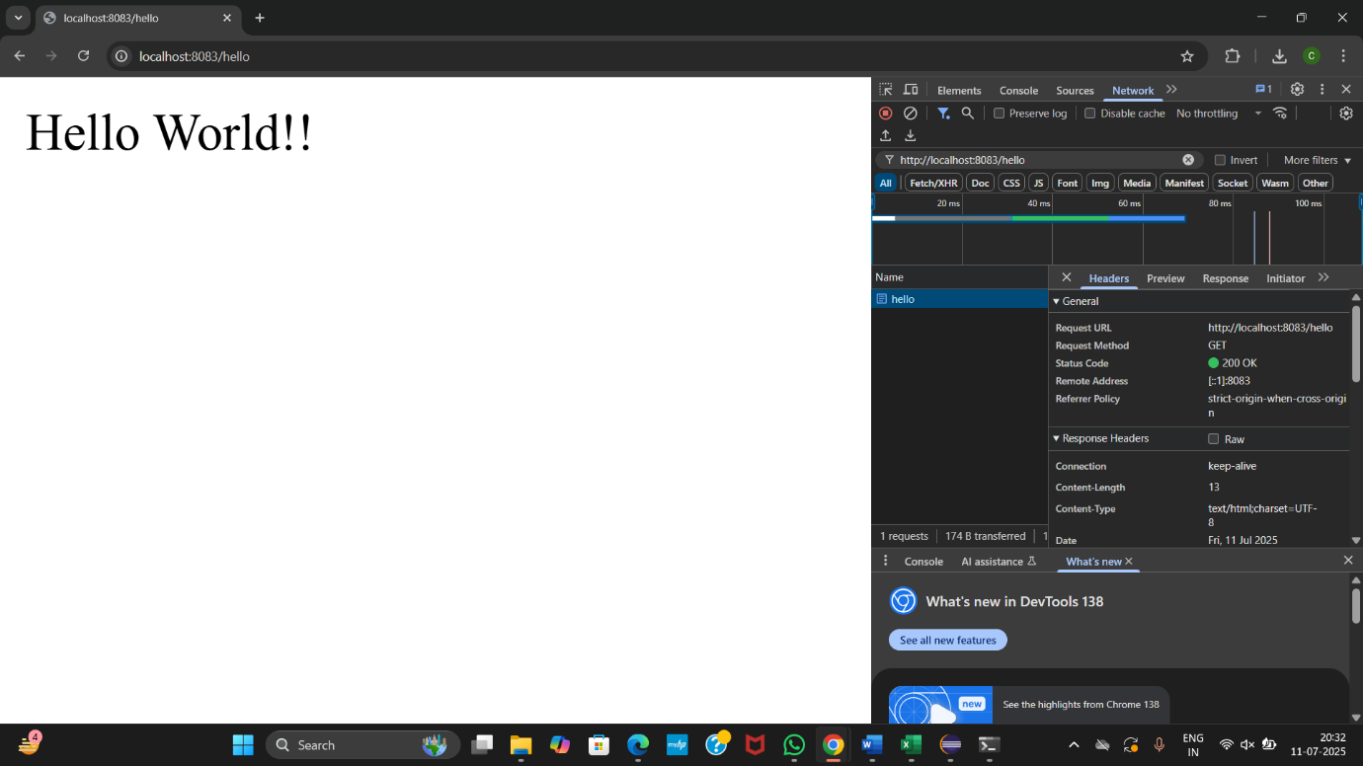

**Postman:**

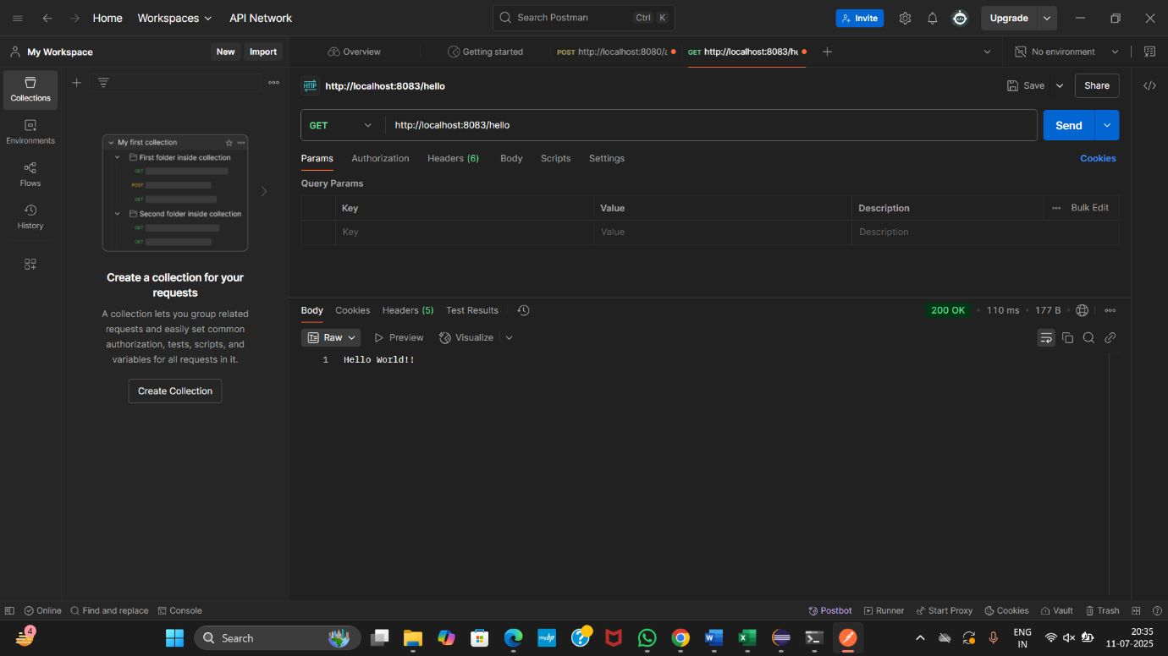

**REST - Country Web Service**

**Country.java**

package com.cognizant.spring_hello_world.model;

public class Country {

private String code;

private String name;

public String getCode() {

return code;

}

public void setCode(String code) {

this.code = code;

}

public String getName() {

return name;

}

public void setName(String name) {

this.name = name;

}

}

**country.xml**

<?xml version="1.0" encoding="UTF-8"?>

<beans xmlns="http://www.springframework.org/schema/beans"

xmlns:xsi="http://www.w3.org/2001/XMLSchema-instance"

xsi:schemaLocation="

http://www.springframework.org/schema/beans

http://www.springframework.org/schema/beans/spring-beans.xsd">

<bean id="country" class="com.cognizant.spring_hello_world.model.Country">

<property name="code" value="IN"/>

<property name="name" value="India"/>

</bean>

</beans>

**CountryController.java**

import org.slf4j.Logger;

import org.slf4j.LoggerFactory;

import org.springframework.context.ApplicationContext;

import org.springframework.context.support.ClassPathXmlApplicationContext;

import org.springframework.web.bind.annotation.RequestMapping;

import org.springframework.web.bind.annotation.RestController;

*@RestController*

public class CountryController {

private static final Logger ***LOGGER*** = LoggerFactory.*getLogger*(CountryController.class);

*@RequestMapping*("/country")

public Country getCountryIndia() {

***LOGGER***.info("START getCountryIndia()");

ApplicationContext context = new ClassPathXmlApplicationContext("country.xml");

Country country = (Country) context.getBean("country");

***LOGGER***.info("END getCountryIndia()");

return country;

}

}

**Chrome Browser**

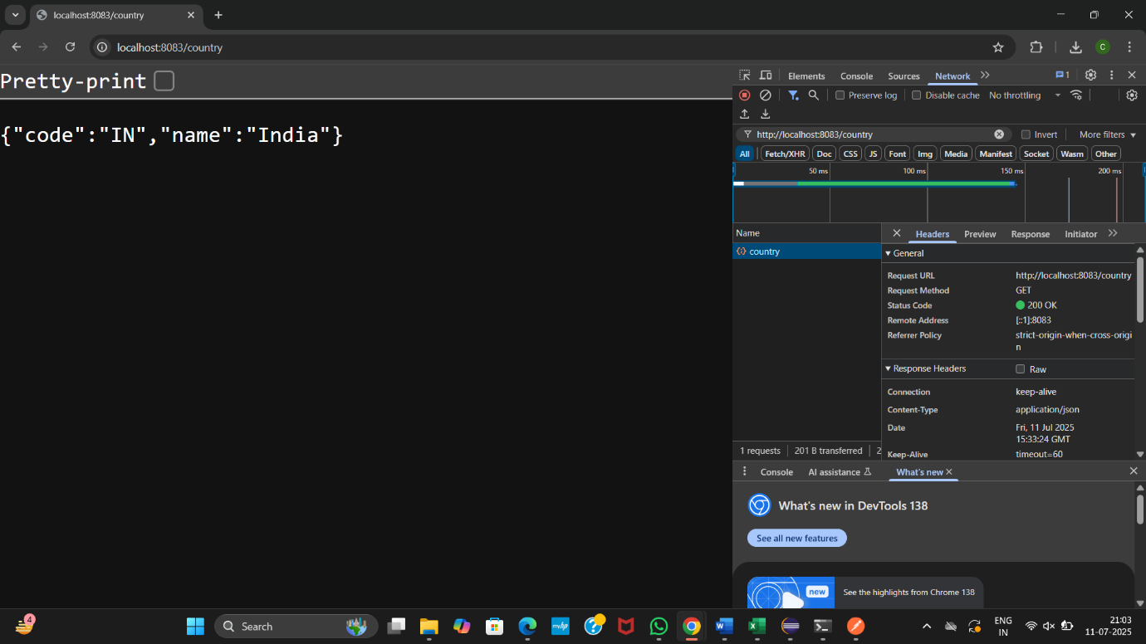

**Postman**

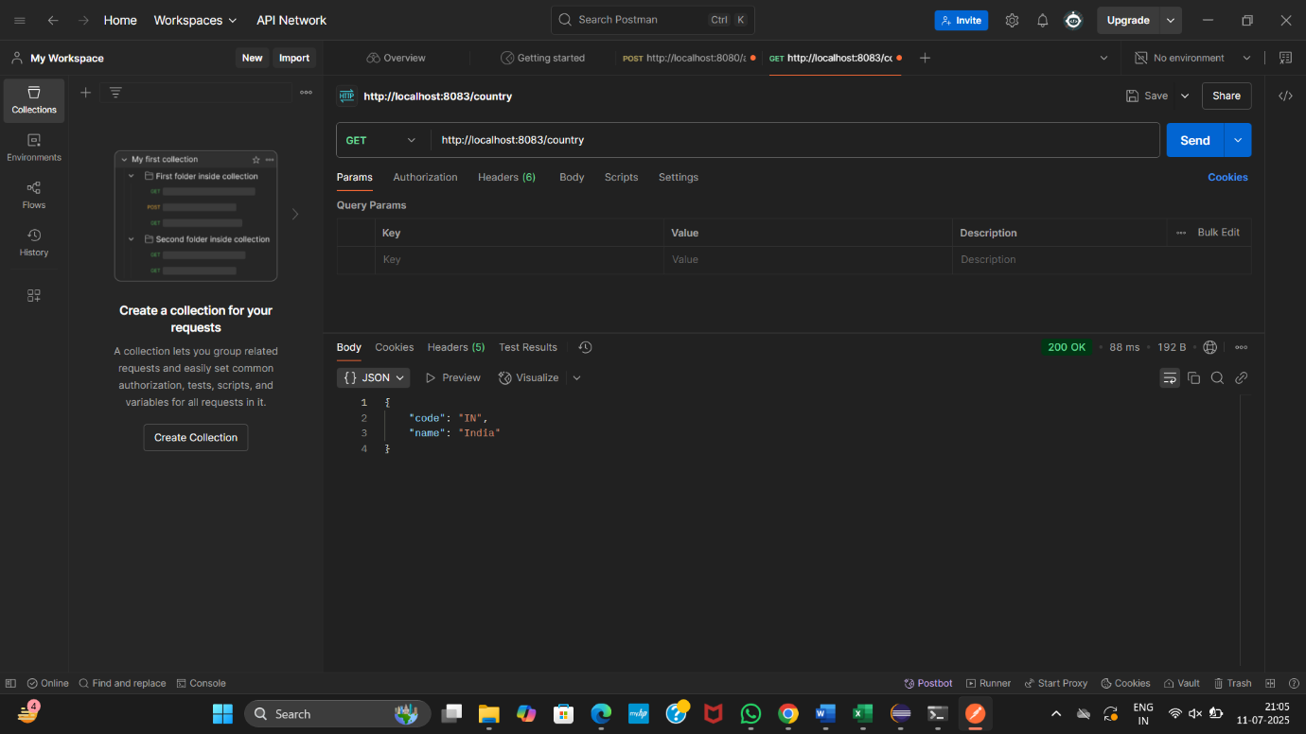

**REST - Get all countries**

**Update country.xml**

<?xml version="1.0" encoding="UTF-8"?>

<beans xmlns="http://www.springframework.org/schema/beans"

xmlns:xsi="http://www.w3.org/2001/XMLSchema-instance"

xsi:schemaLocation="

http://www.springframework.org/schema/beans

http://www.springframework.org/schema/beans/spring-beans.xsd">

<!-- Individual country beans -->

<bean id="in" class="com.cognizant.spring_hello_world.model.Country">

<property name="code" value="IN"/>

<property name="name" value="India"/>

</bean>

<bean id="us" class="com.cognizant.spring_hello_world.model.Country">

<property name="code" value="US"/>

<property name="name" value="United States"/>

</bean>

<bean id="jp" class="com.cognizant.spring_hello_world.model.Country">

<property name="code" value="JP"/>

<property name="name" value="Japan"/>

</bean>

<bean id="de" class="com.cognizant.spring_hello_world.model.Country">

<property name="code" value="DE"/>

<property name="name" value="Germany"/>

</bean>

<!-- List of all countries -->

<bean id="countryList" class="java.util.ArrayList">

<constructor-arg>

<list>

<ref bean="in"/>

<ref bean="us"/>

<ref bean="jp"/>

<ref bean="de"/>

</list>

</constructor-arg>

</bean>

</beans>

**Add getAllCountries() in CountryController**

*@GetMapping*("/countries")

public List<Country> getAllCountries() {

*LOGGER*.info("START getAllCountries()");

ApplicationContext context = new ClassPathXmlApplicationContext("country.xml");

List<Country> countryList = context.getBean("countryList", List.class);

*LOGGER*.info("END getAllCountries()");

return countryList;

}

**Chrome Browser**

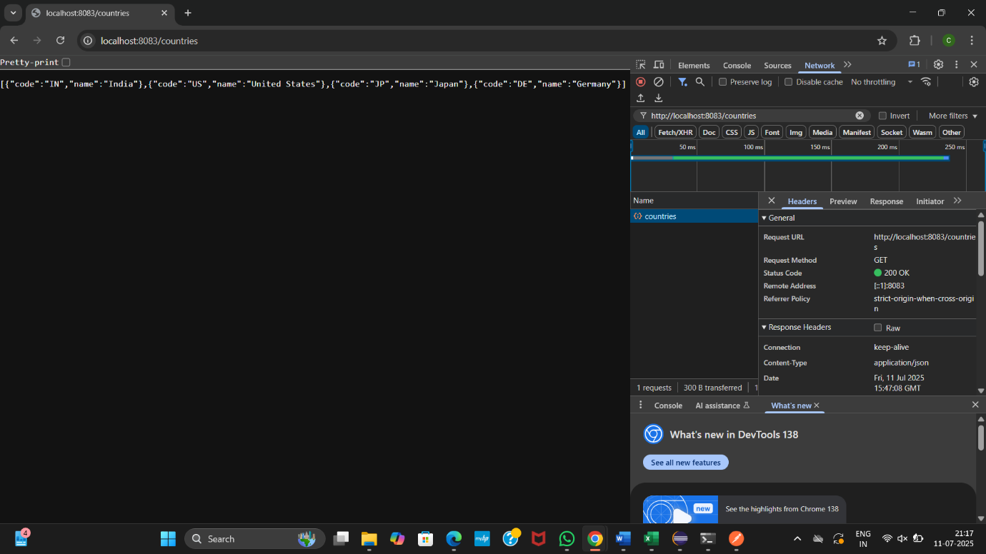

**Postman**

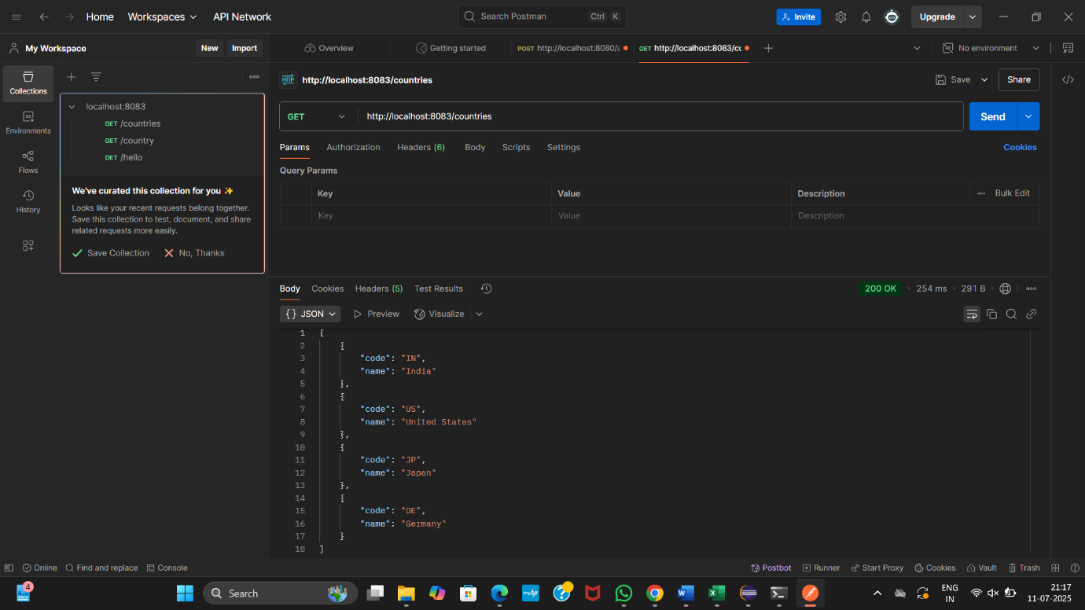

**REST - Get country based on country code**

**CountryService.java**

package com.cognizant.spring_hello_world.service;

import com.cognizant.spring_hello_world.model.Country;

import org.springframework.context.ApplicationContext;

import org.springframework.context.support.ClassPathXmlApplicationContext;

import org.springframework.stereotype.Service;

import java.util.List;

*@Service*

public class CountryService {

public Country getCountry(String code) {

ApplicationContext context = new ClassPathXmlApplicationContext("country.xml");

List<Country> countries = context.getBean("countryList", List.class);

// Using lambda for case-insensitive match

return countries.stream()

.filter(country -> country.getCode().equalsIgnoreCase(code))

.findFirst()

.orElse(null);

}

}

**CountryController.java**

package com.cognizant.spring_hello_world.controller;

import com.cognizant.spring_hello_world.model.Country;

import com.cognizant.spring_hello_world.service.CountryService;

import org.slf4j.Logger;

import org.slf4j.LoggerFactory;

import org.springframework.beans.factory.annotation.Autowired;

import org.springframework.web.bind.annotation.*;

*@RestController*

public class CountryController {

private static final Logger ***LOGGER*** = LoggerFactory.*getLogger*(CountryController.class);

*@Autowired*

private CountryService countryService;

*@GetMapping*("/countries/{code}")

public Country getCountry(*@PathVariable* String code) {

***LOGGER***.info("START getCountry(): " + code);

Country country = countryService.getCountry(code);

***LOGGER***.info("END getCountry()");

return country;

}

}

**Chrome Browser**

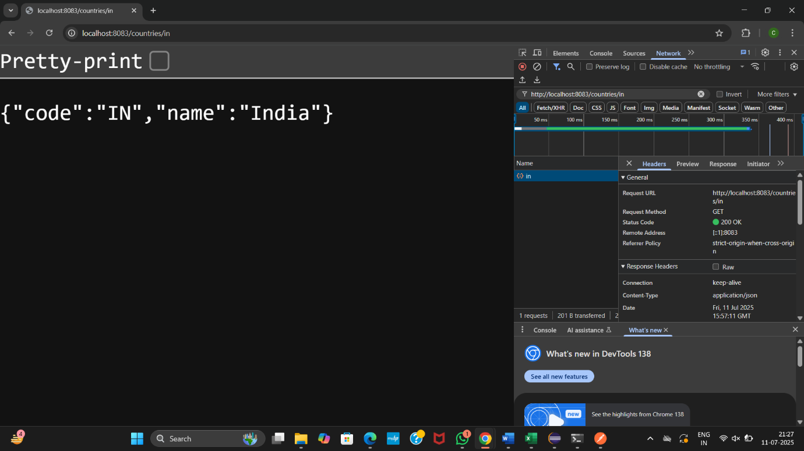

**Postman**

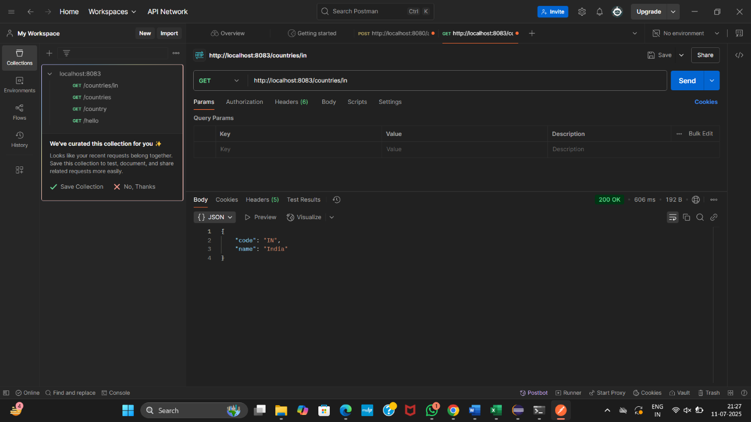

**REST - Get country exceptional scenario**

**CountryNotFoundException.java**

package com.cognizant.spring_hello_world.service.exception;

import org.springframework.http.HttpStatus;

import org.springframework.web.bind.annotation.ResponseStatus;

*@ResponseStatus*(value = *HttpStatus*.*NOT_FOUND*, reason = "Country not found")

public class CountryNotFoundException extends RuntimeException {

public CountryNotFoundException(String message) {

super(message);

}

}

**CountryService.java**

import com.cognizant.spring_hello_world.model.Country;

import com.cognizant.spring_hello_world.service.exception.CountryNotFoundException;

import org.springframework.context.ApplicationContext;

import org.springframework.context.support.ClassPathXmlApplicationContext;

import org.springframework.stereotype.Service;

import java.util.List;

*@Service*

public class CountryService {

public Country getCountry(String code) {

ApplicationContext context = new ClassPathXmlApplicationContext("country.xml");

List<Country> countries = context.getBean("countryList", List.class);

return countries.stream()

.filter(country -> country.getCode().equalsIgnoreCase(code))

.findFirst()

.orElseThrow(() -> new CountryNotFoundException("Country not found"));

}

}

**Update getCountry() to include throws CountryNotFoundException**

*@GetMapping*("/countries/{code}")

public Country getCountry(*@PathVariable* String code) throws CountryNotFoundException {

***LOGGER***.info("START getCountry(): " + code);

Country country = countryService.getCountry(code);

***LOGGER***.info("END getCountry()");

return country;

}

**Postman**

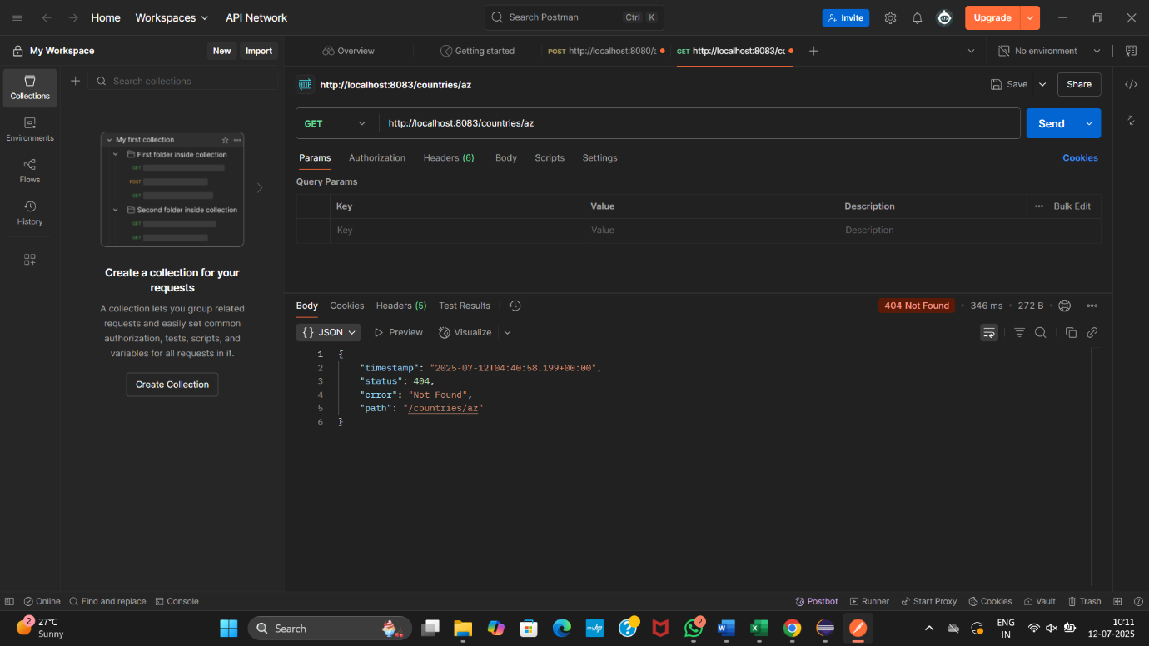

**MockMVC - Test get country service**

**SpringHelloWorldApplicationTests.java**

package com.cognizant.spring_hello_world;

import com.cognizant.spring_hello_world.controller.CountryController;

import org.junit.jupiter.api.Test;

import org.springframework.beans.factory.annotation.Autowired;

import org.springframework.boot.test.autoconfigure.web.servlet.AutoConfigureMockMvc;

import org.springframework.boot.test.context.SpringBootTest;

import org.springframework.test.web.servlet.MockMvc;

import org.springframework.test.web.servlet.ResultActions;

import static org.junit.jupiter.api.Assertions.*assertNotNull*;

import static org.springframework.test.web.servlet.request.MockMvcRequestBuilders.*get*;

import static org.springframework.test.web.servlet.result.MockMvcResultMatchers.*status*;

import static org.springframework.test.web.servlet.result.MockMvcResultMatchers.*jsonPath*;

*@SpringBootTest*

*@AutoConfigureMockMvc*

public class SpringHelloWorldApplicationTests {

*@Autowired*

private CountryController countryController;

*@Autowired*

private MockMvc mvc;

// Test 1: Check if controller is loaded into the Spring context

*@Test*

public void contextLoads() {

*assertNotNull*(countryController);

}

//Test 2: Test /country API and validate response JSON

*@Test*

public void testGetCountry() throws Exception {

ResultActions actions = mvc.perform(*get*("/countries/in"));

actions.andExpect(*status*().isOk());

actions.andExpect(*jsonPath*("$.code").exists());

actions.andExpect(*jsonPath*("$.code").value("IN"));

actions.andExpect(*jsonPath*("$.name").exists());

actions.andExpect(*jsonPath*("$.name").value("India"));

}

}

**OUTPUT**

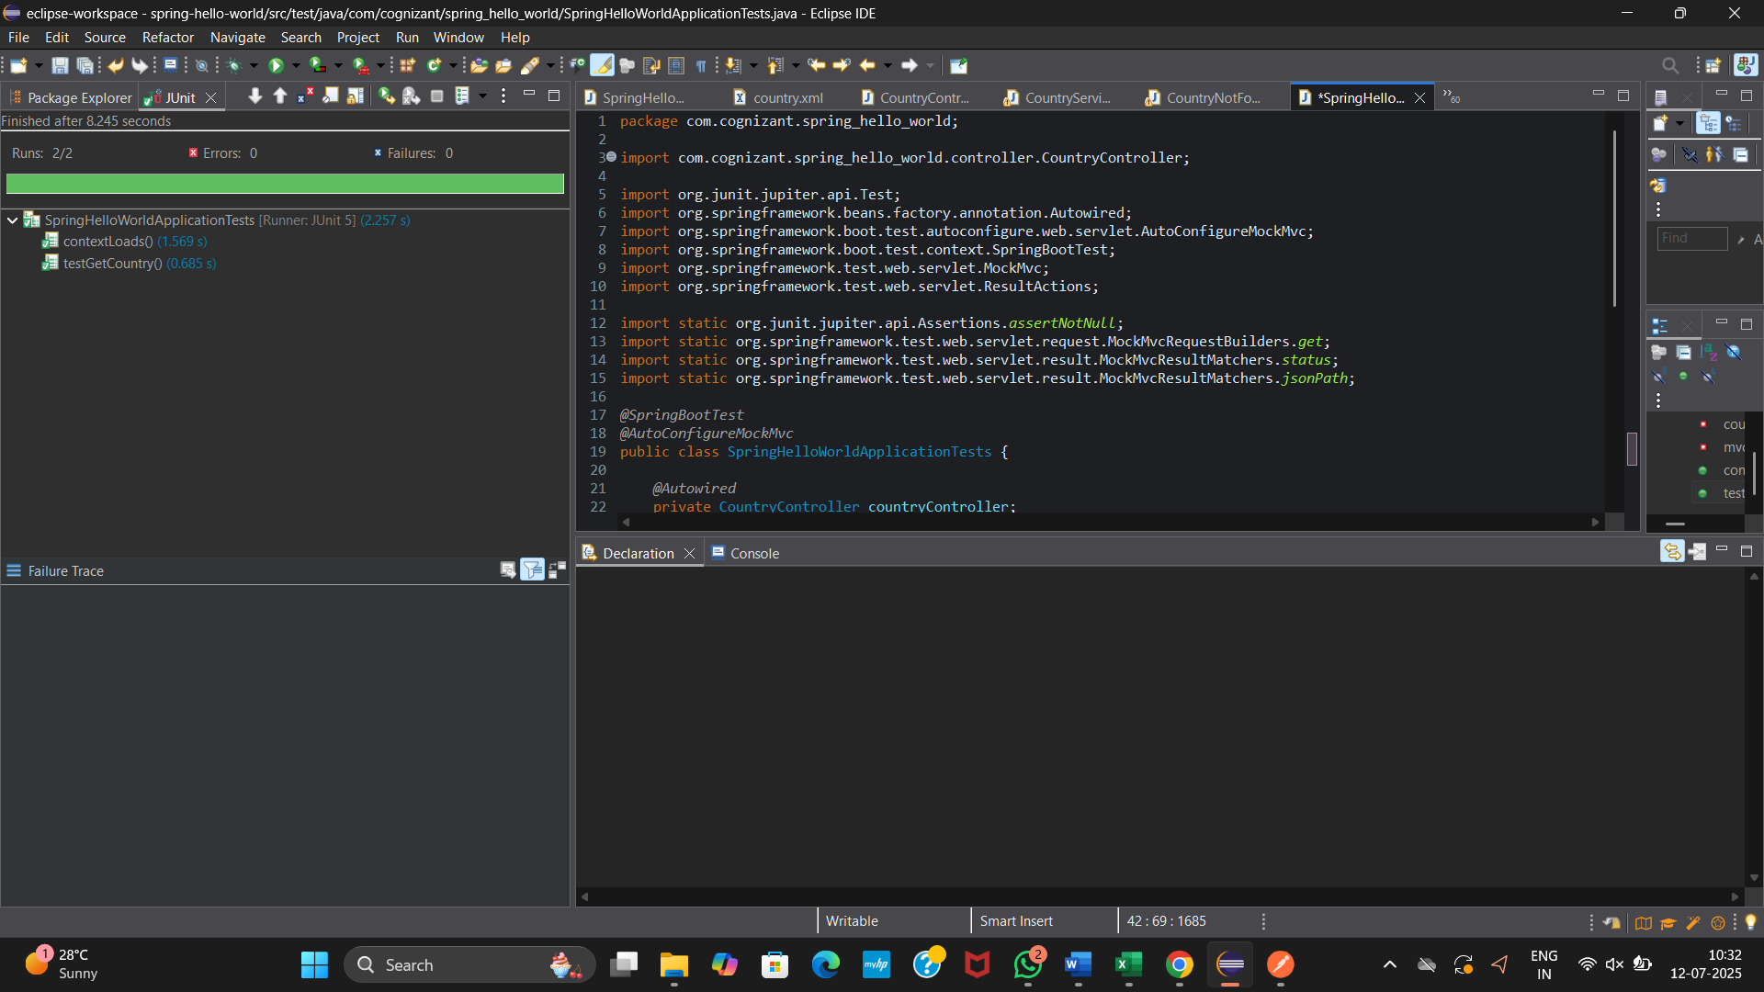

**MockMVC - Test get country service for exceptional scenario**

**SpringHelloWorldApplicationTests.java**

package com.cognizant.spring_hello_world;

import com.cognizant.spring_hello_world.controller.CountryController;

import org.junit.jupiter.api.Test;

import org.springframework.beans.factory.annotation.Autowired;

import org.springframework.boot.test.autoconfigure.web.servlet.AutoConfigureMockMvc;

import org.springframework.boot.test.context.SpringBootTest;

import org.springframework.test.web.servlet.MockMvc;

import org.springframework.test.web.servlet.ResultActions;

import static org.junit.jupiter.api.Assertions.*assertNotNull*;

import static org.springframework.test.web.servlet.request.MockMvcRequestBuilders.*get*;

import static org.springframework.test.web.servlet.result.MockMvcResultMatchers.*;

*@SpringBootTest*

*@AutoConfigureMockMvc*

public class SpringHelloWorldApplicationTests {

*@Autowired*

private CountryController countryController;

*@Autowired*

private MockMvc mockMvc;

*@Test*

public void contextLoads() {

*assertNotNull*(countryController);

}

*@Test*

public void testGetCountry() throws Exception {

ResultActions actions = mockMvc.perform(*get*("/countries/in"));

actions.andExpect(*status*().isOk());

actions.andExpect(*jsonPath*("$.code").value("IN"));

actions.andExpect(*jsonPath*("$.name").value("India"));

}

*@Test*

public void testGetCountryException() throws Exception {

ResultActions actions = mockMvc.perform(*get*("/countries/az"));

actions.andExpect(*status*().isNotFound());

actions.andExpect(*status*().reason("Country not found"));

}

}

**OUTPUT**

