**ReactJS Handson**

**Create a React Application named “cricketapp” with the following components:**

1. **ListofPlayers**

* **Declare an array with 11 players and store details of their names and scores using the map feature of ES6**
* **Filter the players with scores below 70 using arrow functions of ES6.**

**2.IndianPlayers**

* 1. **Display the Odd Team Player and Even Team players using the Destructuring features of ES6**
  2. **Declare two arrays T20players and RanjiTrophy players and merge the two arrays and display them using the Merge feature of ES6**

**Display these two components in the same home page using a simple if else in the flag variable.**

**ListofPlayers.js**

import React from 'react';

function ListofPlayers({ players }) {

  return (

    <div>

      <h1>List of Players</h1>

      <ul>

        {players.map((item, index) => (

          <li key={index}>Mr. {item.name} <span>{item.score}</span></li>

        ))}

      </ul>

      <h1>List of Players having Scores Less than 70</h1>

      <ul>

        {players.filter(item => item.score < 70).map((item, index) => (

          <li key={index}>Mr. {item.name} <span>{item.score}</span></li>

        ))}

      </ul>

    </div>

  );

}

export default ListofPlayers;

**IndianPlayers.js**

import React from 'react';

export function OddPlayers({ team }) {

  const [first, , third, , fifth] = team;

  return (

    <div>

      <h1>Odd Players</h1>

      <ul>

        <li>First : {first}</li>

        <li>Third : {third}</li>

        <li>Fifth : {fifth}</li>

      </ul>

    </div>

  );

}

export function EvenPlayers({ team }) {

    const [, second, , fourth, , sixth] = team;

    return (

      <div>

        <h1>Even Players</h1>

        <ul>

          <li>Second : {second}</li>

          <li>Fourth : {fourth}</li>

          <li>Sixth : {sixth}</li>

        </ul>

      </div>

    );

  }

export function ListofIndianPlayers({ IndianPlayers }) {

  return (

    <div>

      <h1>List of Indian Players Merged:</h1>

      <ul>

        {IndianPlayers.map((player, index) => (

          <li key={index}>Mr. {player}</li>

        ))}

      </ul>

    </div>

  );

}

**App.css**

.App {

  font-family: Arial, sans-serif;

  padding: 20px;

}

h1 {

  color: #333;

}

ul {

  list-style-type: disc;

  margin-left: 20px;

}

li {

  margin-bottom: 5px;

}

span {

  font-weight: bold;

  margin-left: 10px;

}

**App.js**

import React from 'react';

import ListofPlayers from './components/ListofPlayers';

import { OddPlayers, EvenPlayers, ListofIndianPlayers } from './components/IndianPlayers';

import './App.css';

function App() {

  const players = [

    { name: 'Jack', score: 50 },

    { name: 'Michael', score: 70 },

    { name: 'John', score: 40 },

    { name: 'Ann', score: 61 },

    { name: 'Elisabeth', score: 61 },

    { name: 'Sachin', score: 95 },

    { name: 'Dhoni', score: 100 },

    { name: 'Virat', score: 84 },

    { name: 'Jadeja', score: 64 },

    { name: 'Raina', score: 75 },

    { name: 'Rohit', score: 80 },  ];

  const T20Players = ['First Player', 'Second Player', 'Third Player'];

  const RanjiTrophyPlayers = ['Fourth Player', 'Fifth Player', 'Sixth Player'];

  const IndianPlayers = [...T20Players, ...RanjiTrophyPlayers];

  const IndianTeam = ['Sachin1', 'Dhoni2', 'Virat3', 'Rohit4', 'Yuvraj5', 'Raina6'];

  const flag = true;

  return (

    <div className="App">

      {flag ? (

        <div>

          <ListofPlayers players={players} />

        </div>

      ) : (

        <div>

          <h1>Indian Team</h1>

          <OddPlayers team={IndianTeam} />

          <hr />

          <EvenPlayers team={IndianTeam} />

          <hr />

          <ListofIndianPlayers IndianPlayers={IndianPlayers} />

        </div>

      )}

    </div>

  );

}

export default App;

**OUTPUTS**

**When flag=true:**

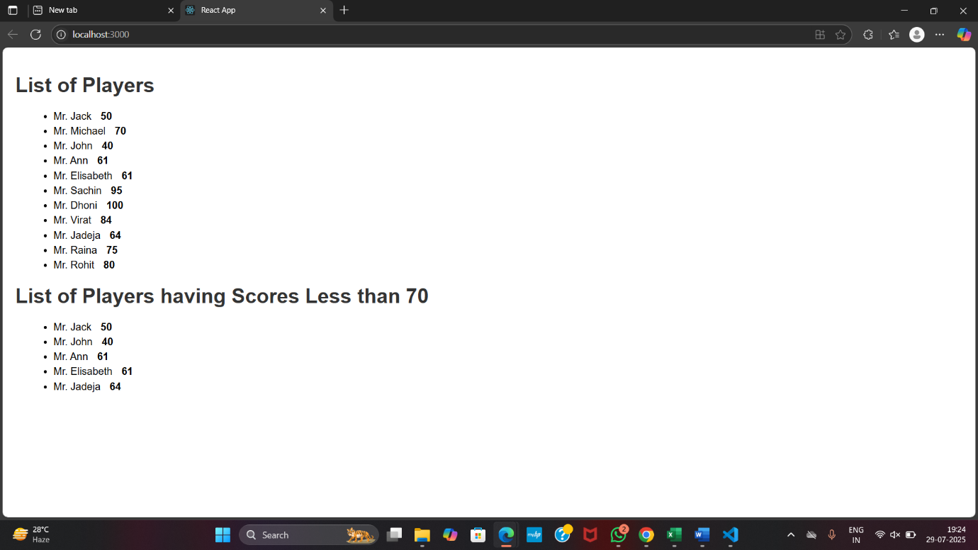

**When flag=false:**

