**Git Hands-On**

**Objectives:**

**Familiar with Git commands like git init, git status, git add, git commit, git push, and git pull.**

**In this hands-on lab,**

* **Setup your machine with Git Configuration**
* **Integrate notepad++.exe to Git and make it a default editor**
* **Add a file to source code repository**

**Summary of Commands Used:**

git config --global user.name "Chandana Mattipalli"

git config --global user.email "chandanamattipalli2004@gmail.com "

git config --global core.editor "notepad++ -multiInst -nosession"

mkdir GitDemo

cd GitDemo

git init

echo "Welcome to Git Hands-On Lab!" > welcome.txt

git status

git add welcome.txt

git commit -m "Initial commit: added welcome.txt"

git remote add origin https://github.com/Chandana2309/GitDemo.git

git branch -M main

git push -u origin main

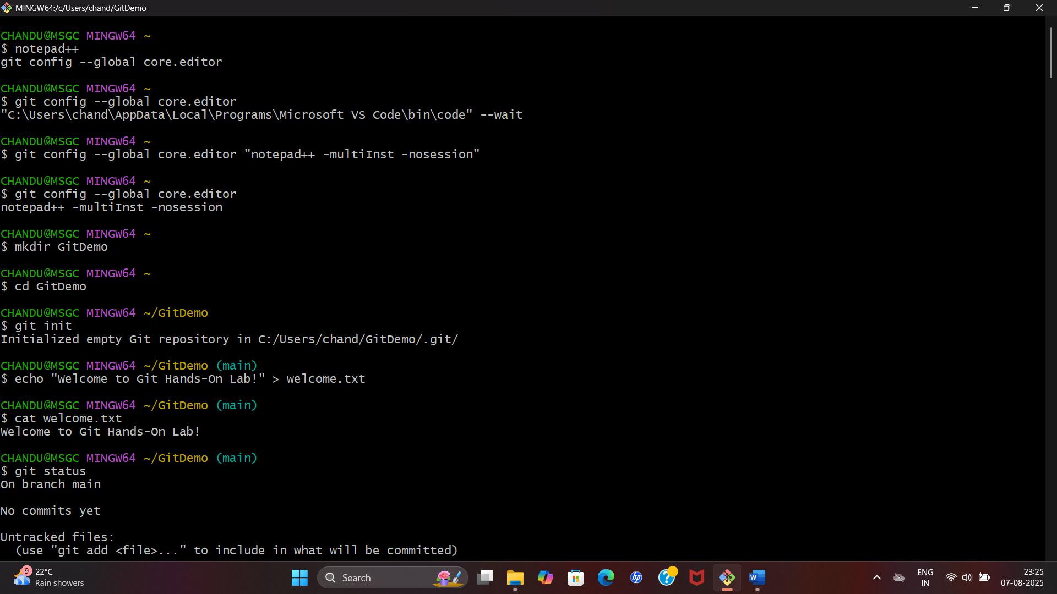

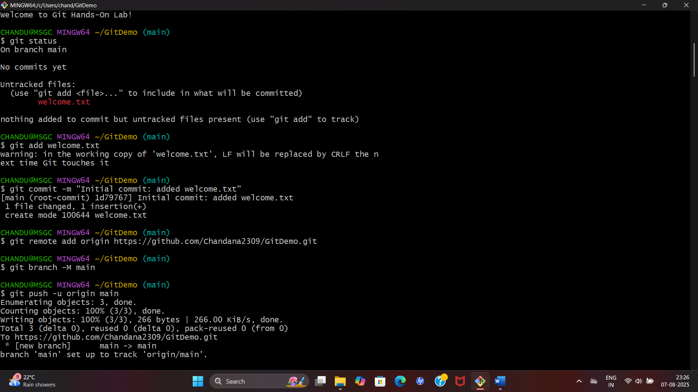

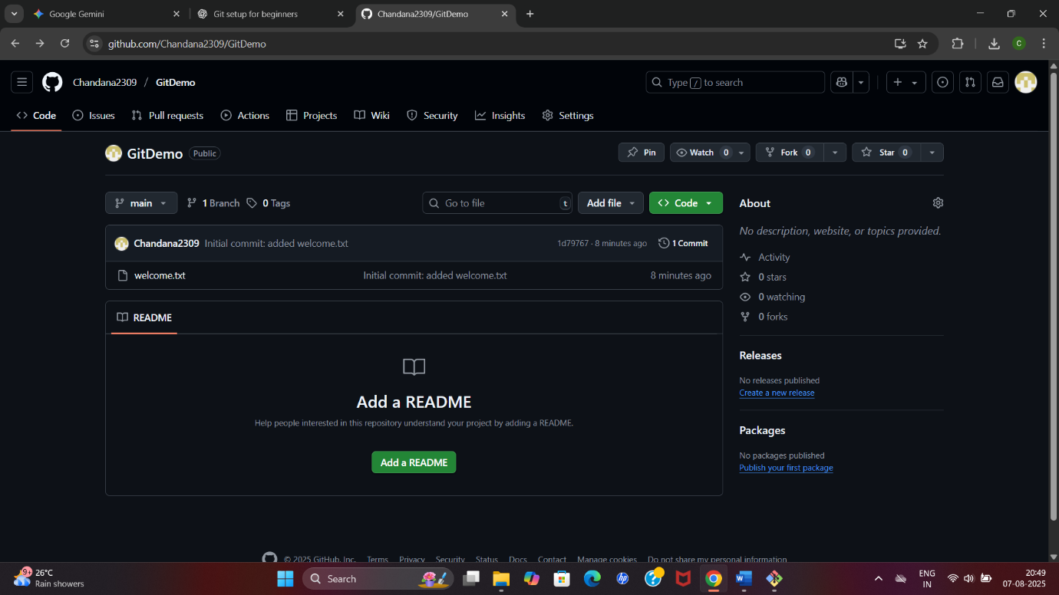

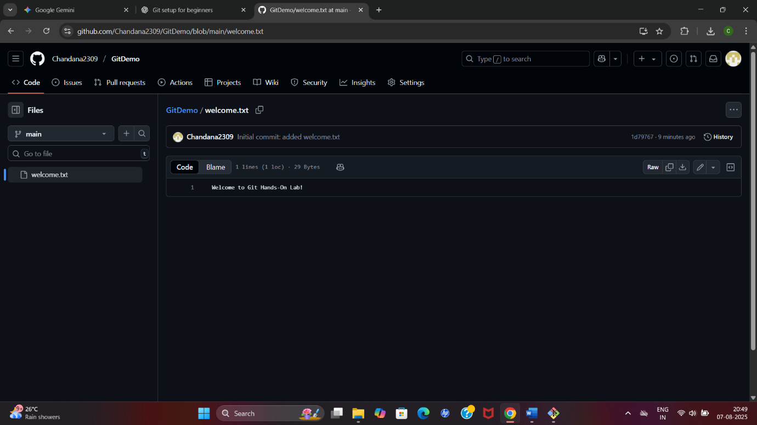

**welcome.txt is added to the local repository.**