**ABSTRACT**

Accidents occur due to many reasons mainly overspeed,bad road conditions,sudden turns,heavy traffic junctions.These accidents can be minimised upto an extent by alerting the people to slow down the vehicle speed whenever they are about to approach a accident zone.

This project is used to send alert messages to people who are heading towards an accident zone through a mobile application.This helps people to know about the accident zone and slow down the vehicle and can be able to avoid the accident.

The Architecture of this project consists of three components:

1. Backend algorithm
2. Database
3. Mobile application

An accident zone is an area that has more chances of an accident happening, based on some factors like: Bad road conditions,sharp turns,heavy traffic junctions,zebra crossings etc. Accident zones are classified into 3 categories :

1. **Red Zone**- where more than 20 accidents happened.

2. **Orange Zone**-accidents between 10-20.

3. **Yellow Zone**-accidents less than 10.

**Backend algorithm:**

Accident zones are determined by clustering the coordinates(latitude,longitude) of accident prone areas or most probable accident happening areas plotted on a map.This can be performed by unsupervised machine learning clustering techniques like DBSCAN.

**Database:**

A realtime database(nosql) is maintained to store the raw data (*coordinates (latitude,longitude) of various accident areas)* and processed data(*centroids (latitude,longitude) of the clusters formed by the clustering algorithm*).

**Mobile application :**

A mobile application is used to retrieve the current location of the vehicle by GPS and gets the nearby centroid coordinates from the database to calculate the distance from accident zone.Alert messages from the mobile application are sent based on the type of Accident zone as :

* **Red Zone**-before 800mts from the cluster centroid.
* **Orange Zone**-before 400mts from the cluster centroid.
* **Yellow Zone**-before 100mts from the cluster centroid.

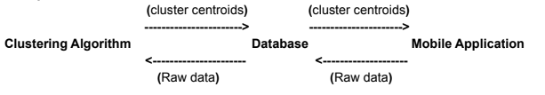

In this way this mobile application can be used to avoid the accidents upto an extent by alerting the person about the accident zone.