Java Doesn’t support multiple Inheritance to avoid complexity and ambiguity, especially in the problems like diamond issue. For example,

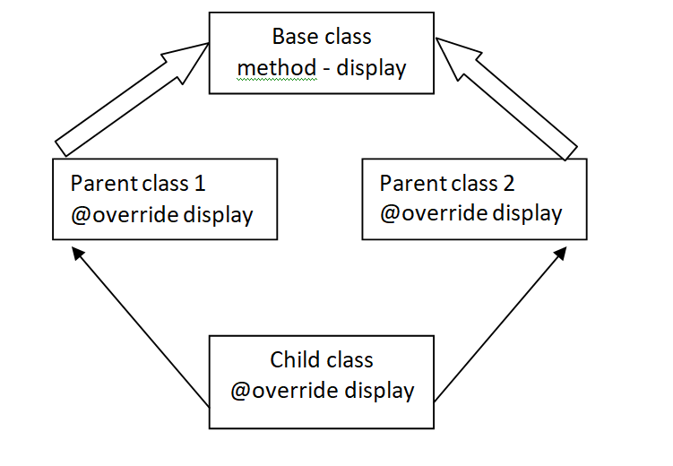

Multiple Inheritance – One child class is inheriting the properties from two parent classes. Here in the above example Child class is inheriting the properties from two parent classes (Parent class 1 and Parent class 2) which in turn inherits properties from the Base class. Each of the parent classes overrides a method display from the base class. The ambiguity arises when child class inherits the same method like from which Parent class it has to access the method either from Parent class 1 or Parent class 2.