**B9IS124_10539269**

**Read Me**

IONIC React capacitor RescueMed App

# Rescue Med

RescueMed app helps the ordinary person to inform about the patient who requires the medical support emergency because of any accidents or typical health conditions.

> A user shall log in to the app.

>A user shall share his location on the click of the help button on the home screen which will redirect to the camera.

>A photo of the incident shall be taken by the user and shared with the hospital so that the hospitals can revert based on the requirement.

>Along with this users can voluntarily donate money in the donate section.

>A user is provided with a form if he wishes to donate blood or his organs.

>A user has the option to update his details.

# Component details

Component: LocalLogin

* Description: Login screen for the app, uses Local storage for demo purpose

Component: Geo Location plugin

* Screen: RescueMed

* Description: This screen captures the location of the user using Geolocation plugin. The Latitude and longitude data of the location is fetched.

*Future Scope: Integrating google maps

Component: Camera Screen

*Description: This screen appears to take a picture of the accident/emergency scene when the user presses the Get Help button on the home screen of the app. Uses Camera plugin and makes the picture mandatory to move to a confirmation screen.

Component: Confirmation screen

* Description: This screen helps the user to notify that their request is under process. On click of revoke, the request can be reverted.

Component: Donate screen

* Description: This screen is for the user who wishes to donate the money.

Component: Medical Help

* Description: If the user wants to donate blood or organs, this form is used to take the user data.

* Component: User profile

* Description: This screen helps the user to edit their details and update the details. Also, the user can log out of the app using the Logout option on the screen.

Design considered

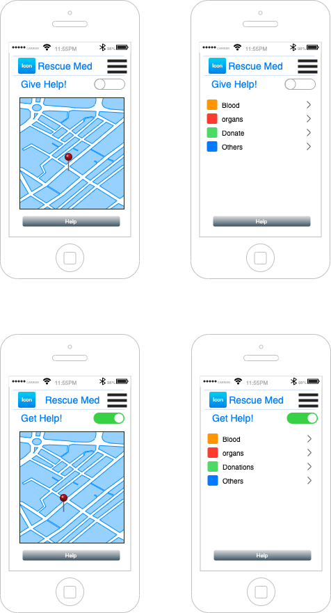

Deployed and tested on iphone11 device and other ios simultors through xcode.