CineBook
Movie Ticket Reservation Platform
Real-Time Concurrency, Dynamic Layout Studio & Cloud Integration
Project Title | CineBook - Movie Ticket Reservation Platform
Development Team | web dev
Team Members & Registration Numbers | 1. Chandana Venkateswara Rao (99230040276)  2. Chinta Avinash (99230040285)  3. P Chakri (99230040397)  4. P Sudheer (99230040399)  5. P Spandana
Live Web Application (Vercel) | https://venkatesh-40276-web-dev-icl.vercel.app/
Cloud Backend API (Render) | https://book-my-ticket-3brf.onrender.com
Core Technology Stack | React 18, Vite, Tailwind CSS, Node.js, Express, MongoDB Atlas, Socket.io, Cashfree API

Executive Summary & Project Abstract
CineBook is a state-of-the-art, full-stack, cloud-native movie ticket reservation ecosystem engineered to deliver seamless cinema booking experiences while providing theater owners (Partners) and operational administrators (Admins) with powerful, multi-tenant digital management tools. Built upon modern web technologies—React 18, Vite, Tailwind CSS, Node.js, Express, MongoDB Atlas, Socket.io, and Cashfree Payment Gateway—the platform bridges the digital divide between moviegoers and multiplex operators.
Modern movie ticketing systems routinely suffer from acute concurrency bottlenecks: multiple simultaneous users attempting to book the exact same seat during high-demand blockbuster premiere windows, leading to double-bookings, database transaction deadlocks, and severe customer frustration. CineBook addresses this challenge with an enterprise-grade In-Memory Mutex & Distributed Seat Locking Engine backed by WebSockets, ensuring absolute data consistency with automated 8-minute Time-To-Live (TTL) reservation hold timers.
Beyond consumer ticketing, CineBook introduces a revolutionary Interactive Auditorium Layout Studio allowing theater partners to draw, configure, and edit custom auditorium seating topologies (Standard, Premium, Recliner VIP) in real time with automatic seat number continuity algorithms that eliminate broken numbering gaps when physical seats are modified or removed.
★ LIVE DEPLOYED ARTIFACTS & ACCESS POINTS
• Production Web Client (Vercel CDN): https://venkatesh-40276-web-dev-icl.vercel.app/
• Production Cloud API (Render PaaS): https://book-my-ticket-3brf.onrender.com
• Database Cluster: MongoDB Atlas Multi-Region Replica Set with Automated Failover
• Source Code Repository: Fully modularized Git workspace with Zero Hardcoded API Keys.

Chapter 1: Project Objectives & Business Rules
1.1 Problem Statement & Industry Motivation
The theatrical cinema industry relies heavily on centralized aggregator platforms that often impose rigid workflows, exorbitant convenience surcharges, and opaque seating management systems. For theater owners, onboarding auditoriums with custom architectural layouts—such as staggered VIP recliners, wheelchair-accessible spaces, or partitioned balcony tiers—traditionally required expensive vendor customizations. On the consumer side, users frequently experience checkout failures when two patrons click the same seat within milliseconds of each other, or discover that past shows are still selectable, or encounter video player configuration errors when attempting to view official movie trailers.
1.2 Core Project Objectives
The primary technical and operational objectives of the CineBook project comprise:
- High-Performance User Experience: To architect an ultra-fast, mobile-first responsive single-page application (SPA) capable of instant movie discovery, categorized browsing, and dynamic theater selection.
- Zero-Conflict Seat Concurrency Engine: To prevent double-booking anomalies using a real-time WebSocket communication layer coupled with atomic MongoDB findOneAndUpdate operations and time-bounded lock holding.
- Dynamic Seating Layout Studio: To equip theater partners with an interactive visual canvas for defining custom screen grids, seat classifications (Recliner, VIP, Premium, Standard), dynamic row pricing, and gap-free numbering.
- Robust Multi-Channel Financial Engine: To implement a hybrid checkout mechanism supporting direct Cashfree payment gateway tokenization alongside an integrated user digital cash wallet and instant gift-card redemption.
- Comprehensive Role-Based Governance: To deliver strict administrative governance through role-based access control (RBAC), multi-tenant theater approval pipelines, revenue telemetry, and camera-based QR gate verification.
1.3 Core Business Rules & Recent Refinements
During development and comprehensive testing, CineBook instituted several vital business rules reflecting real-world theatrical operational realities:
- 1. Automatic Expired Show Disabling: When a showtime's designated start time has elapsed relative to current server time, the customer portal automatically disables the showtime card, rendering it unclickable with an 'Expired' visual badge. This strictly prevents fraudulent retroactive ticket purchasing.
- 2. Two-Hour Pre-Show Cancellation Window: Customers can self-cancel confirmed bookings directly from their profile dashboard provided the cancellation request is initiated at least 2 hours prior to the scheduled showtime. Upon valid cancellation, ticket fees are immediately credited back to the user's CineBook digital wallet, and seats are released back into the live inventory pool.
- 3. Seat Numbering Continuity Engine: When a theater partner deletes or marks a physical seat as an aisle gap within the Auditorium Studio, the engine dynamically recalculates and re-indexes all remaining seats in that row (e.g., A1, A2, A3...), guaranteeing no numbering gaps exist in customer-facing ticketing views.
- 4. Friction-Free Show Provisioning (Zero-Rating Requirement): Theater partners can schedule and provision movies into their auditoriums without being forced to enter arbitrary subjective ratings. Movie ratings are dynamically derived from authenticated audience reviews and verified database catalog entries.
- 5. Configurable Tax & ₹1 Minimum Test Pricing Floor: For staging, unit testing, and sandbox verification, the minimum ticket booking price floor was lowered to ₹1 (down from ₹50), and ticket tax charges were configurable to zero (₹0), allowing frictionless end-to-end payment gateway validation without incurring production surcharge costs.
- 6. Resilient Movie Trailer Streaming: Integrated YouTube modal players implement intelligent fallback handlers to bypass YouTube Video Player Configuration Error 153, utilizing embedded iframe parameters (enablejsapi=1, origin, rel=0) alongside secondary streaming backup links.
Chapter 2: System Architecture & Technical Diagrams
2.1 Multi-Tier Cloud Architecture
CineBook is engineered on an enterprise 4-Tier Cloud Architecture designed for horizontal scalability, zero-downtime updates, and fault tolerance. The system decouples client presentation from business logic and database persistence.
- Tier 1: Presentation & Client Tier: Single Page Application (SPA) built with React 18, Vite build tooling, Tailwind CSS utility styling, Lucide iconography, and Socket.io client. Deployed globally on Vercel's edge network for lightning-fast sub-second load times.
- Tier 2: Business Logic & Microservices Tier: RESTful API server authored in Node.js and Express 4.x. Handles stateless JWT authentication, cryptographic bcrypt password hashing, role-based authorization middleware, and endpoint request validation. Deployed on Render PaaS.
- Tier 3: Real-Time Concurrency Tier: Dedicated Socket.io server maintaining persistent, bi-directional full-duplex WebSockets. Manages in-memory room subscriptions partitioned by showId (show-rooms) to broadcast seat selection events across all connected clients with under 50ms latency.
- Tier 4: Persistence Tier (MongoDB Atlas): Multi-region replica set on MongoDB Atlas providing ACID transactional semantics for multi-document booking writes, secondary B-tree indexes on showtime and user references, and automated cloud backup snapshots.
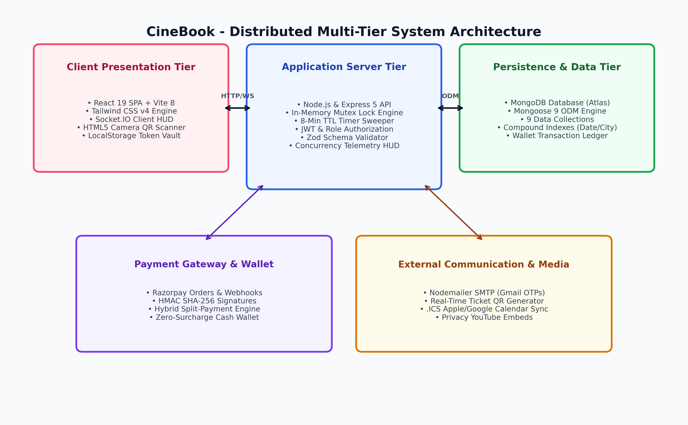
Figure 1: CineBook High-Availability Multi-Tier Cloud Architecture Diagram
2.2 UML Use Case Analysis
The platform establishes three clearly delineated human actors—Guest/Customer, Theater Partner, and Super-Administrator—along with automated external system actors including the Cashfree Payment Gateway and Cloudinary CDN.
- Guest & Customer Actor: Movie discovery, trailer previews, interactive seat picking, temporary holding lock, split wallet/gateway payment, QR ticket access, booking cancellation (up to 2 hrs prior), and review submission.
- Theater Partner Actor: Multiplex auditorium onboarding, dynamic visual seating grid configuration, showtime scheduling, tiered ticket pricing, and gate QR barcode ticket scanning.
- Super-Administrator Actor: Platform-wide theater verification, cinema status approval/suspension, global movie catalog curation, system financial metrics audit, and security monitoring.
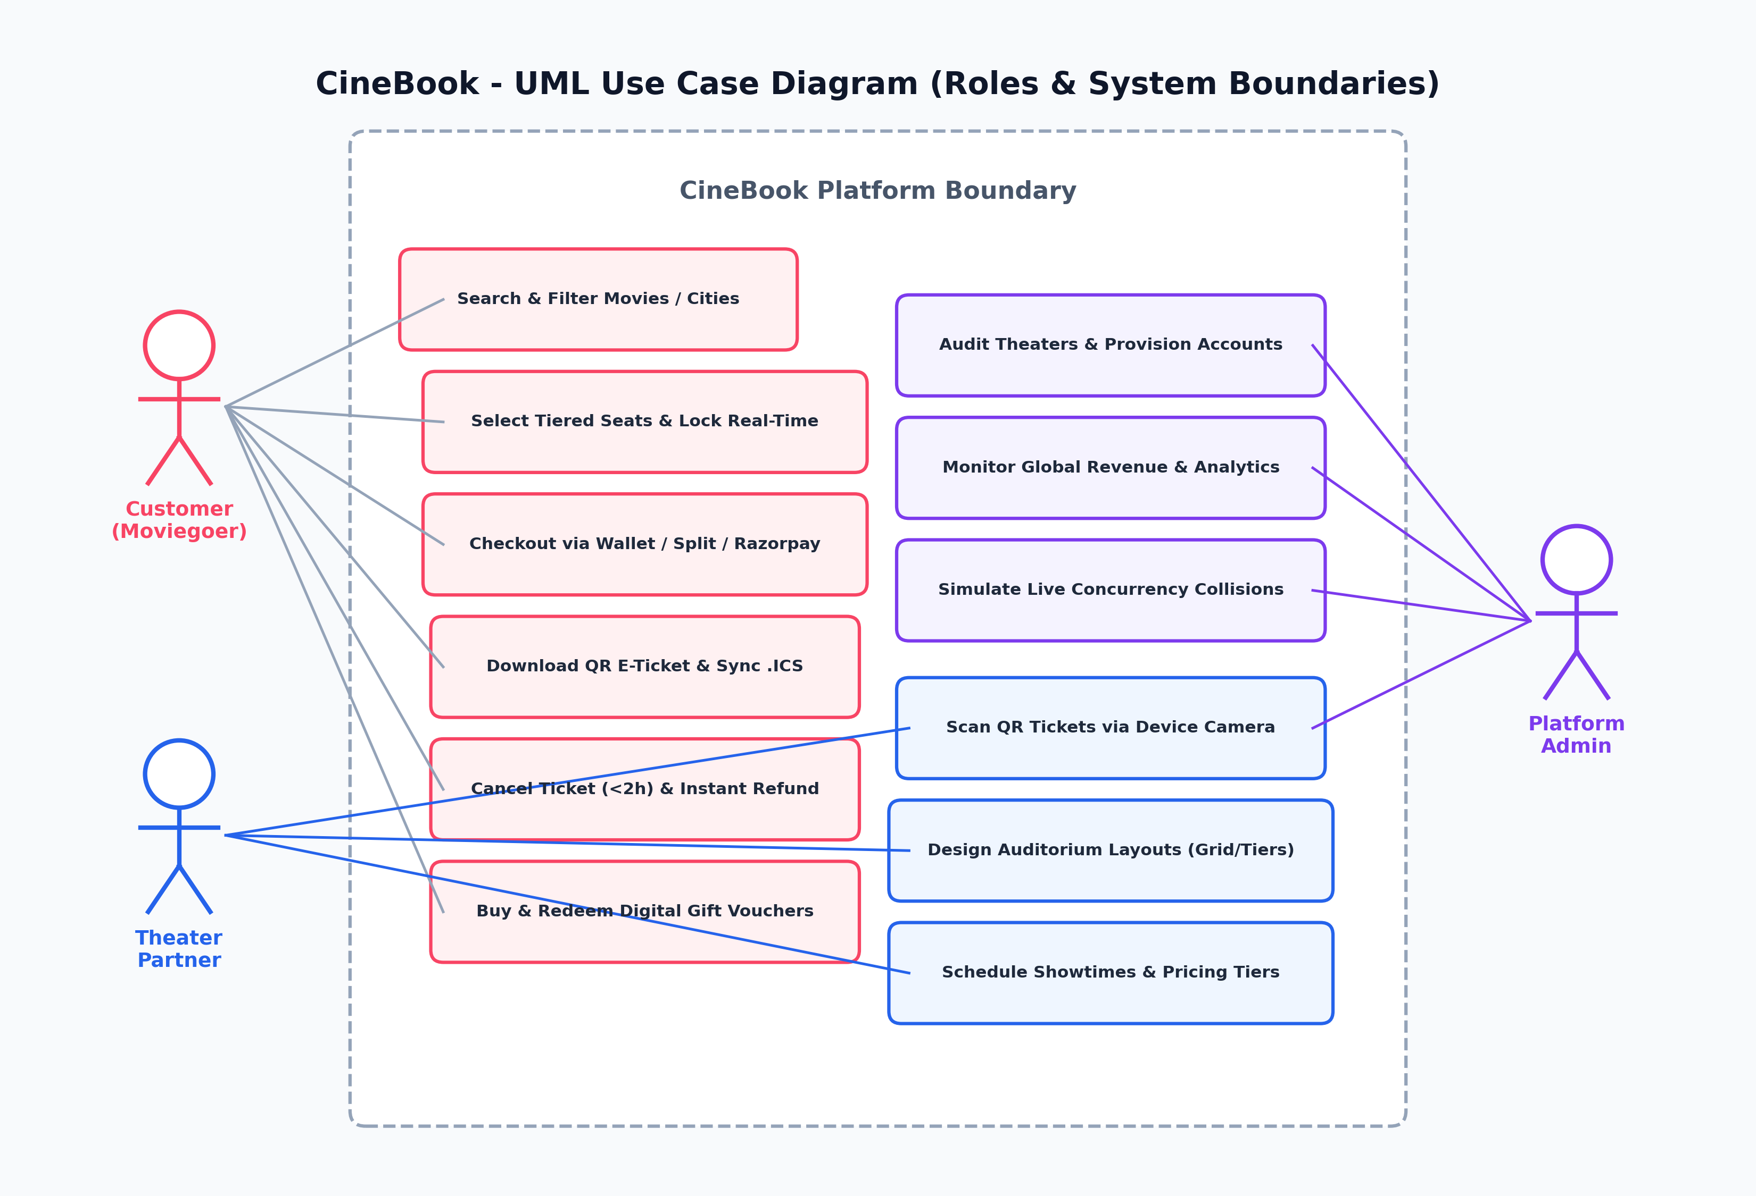
Figure 2: Comprehensive UML Use Case Diagram for Customer, Partner, and Admin Roles
2.3 Real-Time Concurrency & Mutex Seat-Locking Engine
When popular movies launch ticket sales, hundreds of users may attempt to reserve the same prime recliner seats simultaneously. A traditional pessimistic locking approach blocks database threads and degrades performance, while optimistic concurrency without coordination results in payment failures and customer dissatisfaction.
CineBook implements an In-Memory Mutex & Distributed Seat Locking Engine. When a user taps an available seat, a Socket.io event 'seat:lock' is dispatched to the server. The server verifies that the seat is neither booked in MongoDB nor currently locked by another active session. If free, an atomic in-memory lock entry is created with an 8-minute TTL timer, and an instantaneous broadcast notifies all other users viewing that show to render the seat as 'Locked / In-Progress' (yellow HUD). If the user completes payment within 8 minutes, the seat transitions to 'Booked' (red); if the timer expires or the user navigates away, the server automatically emits 'seat:unlock' and returns the seat to 'Available' (green).
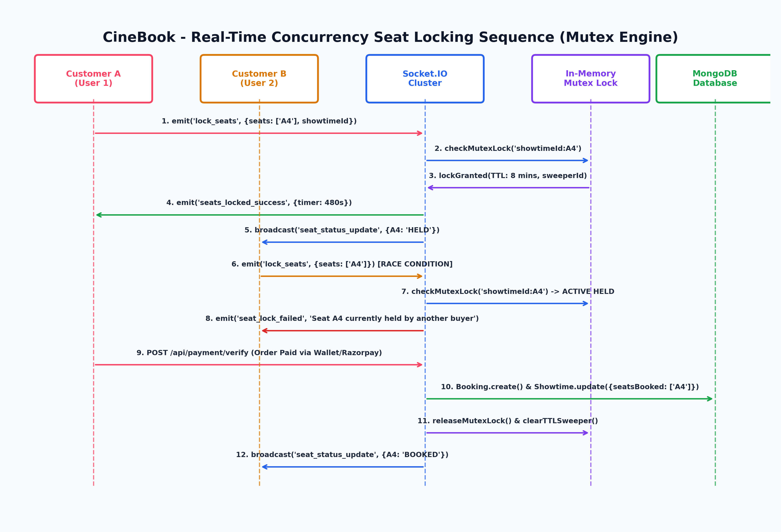
Figure 3: UML Sequence Diagram - High-Concurrency Seat Locking & Mutex Engine
2.4 Relational Entity-Relationship Modeling (ERD)
Although CineBook is implemented on MongoDB (a NoSQL document database), the underlying schema architecture strictly enforces relational integrity and normalized references across 9 core collections:
- 1. User Entity: Stores authentication credentials, hashed passwords, profile metadata, roles (user, partner, admin), and assigned cinema references.
- 2. Theater Entity: Represents physical multiplex facilities with name, address, city, amenities (Dolby Atmos, IMAX, 4K RGB), partner ownership, and approval status.
- 3. Screen Entity: Defines individual auditoriums belonging to a theater, holding screen type, capacity, and custom 2D seating grid layout topologies.
- 4. Show Entity: The temporal bridge linking a Movie, a Screen, and a Theater. Stores start/end timestamps, date, tiered pricing brackets (Standard, VIP, Recliner), and seat availability arrays.
- 5. Booking Entity: Immutable financial and ticketing records storing unique booking IDs, transaction references, reserved seat arrays, total amounts paid, split wallet deductions, QR verification tokens, and status (confirmed, cancelled, checked-in).
- 6. Movie Entity: Master cinematic catalog containing title, description, genre array, language, duration, release date, poster images, backdrop banners, and YouTube trailer keys.
- 7. Wallet Entity: Financial ledger entity linked 1-to-1 with users, tracking current wallet balance and historical credit/debit audit logs.
- 8. Review Entity: Authenticated audience feedback records holding star ratings (1-5), textual review comments, and verified purchase flags.
- 9. GiftCard Entity: Promotional and prepaid voucher cards with alphanumeric redemption codes, face values, expiration dates, and activation states.
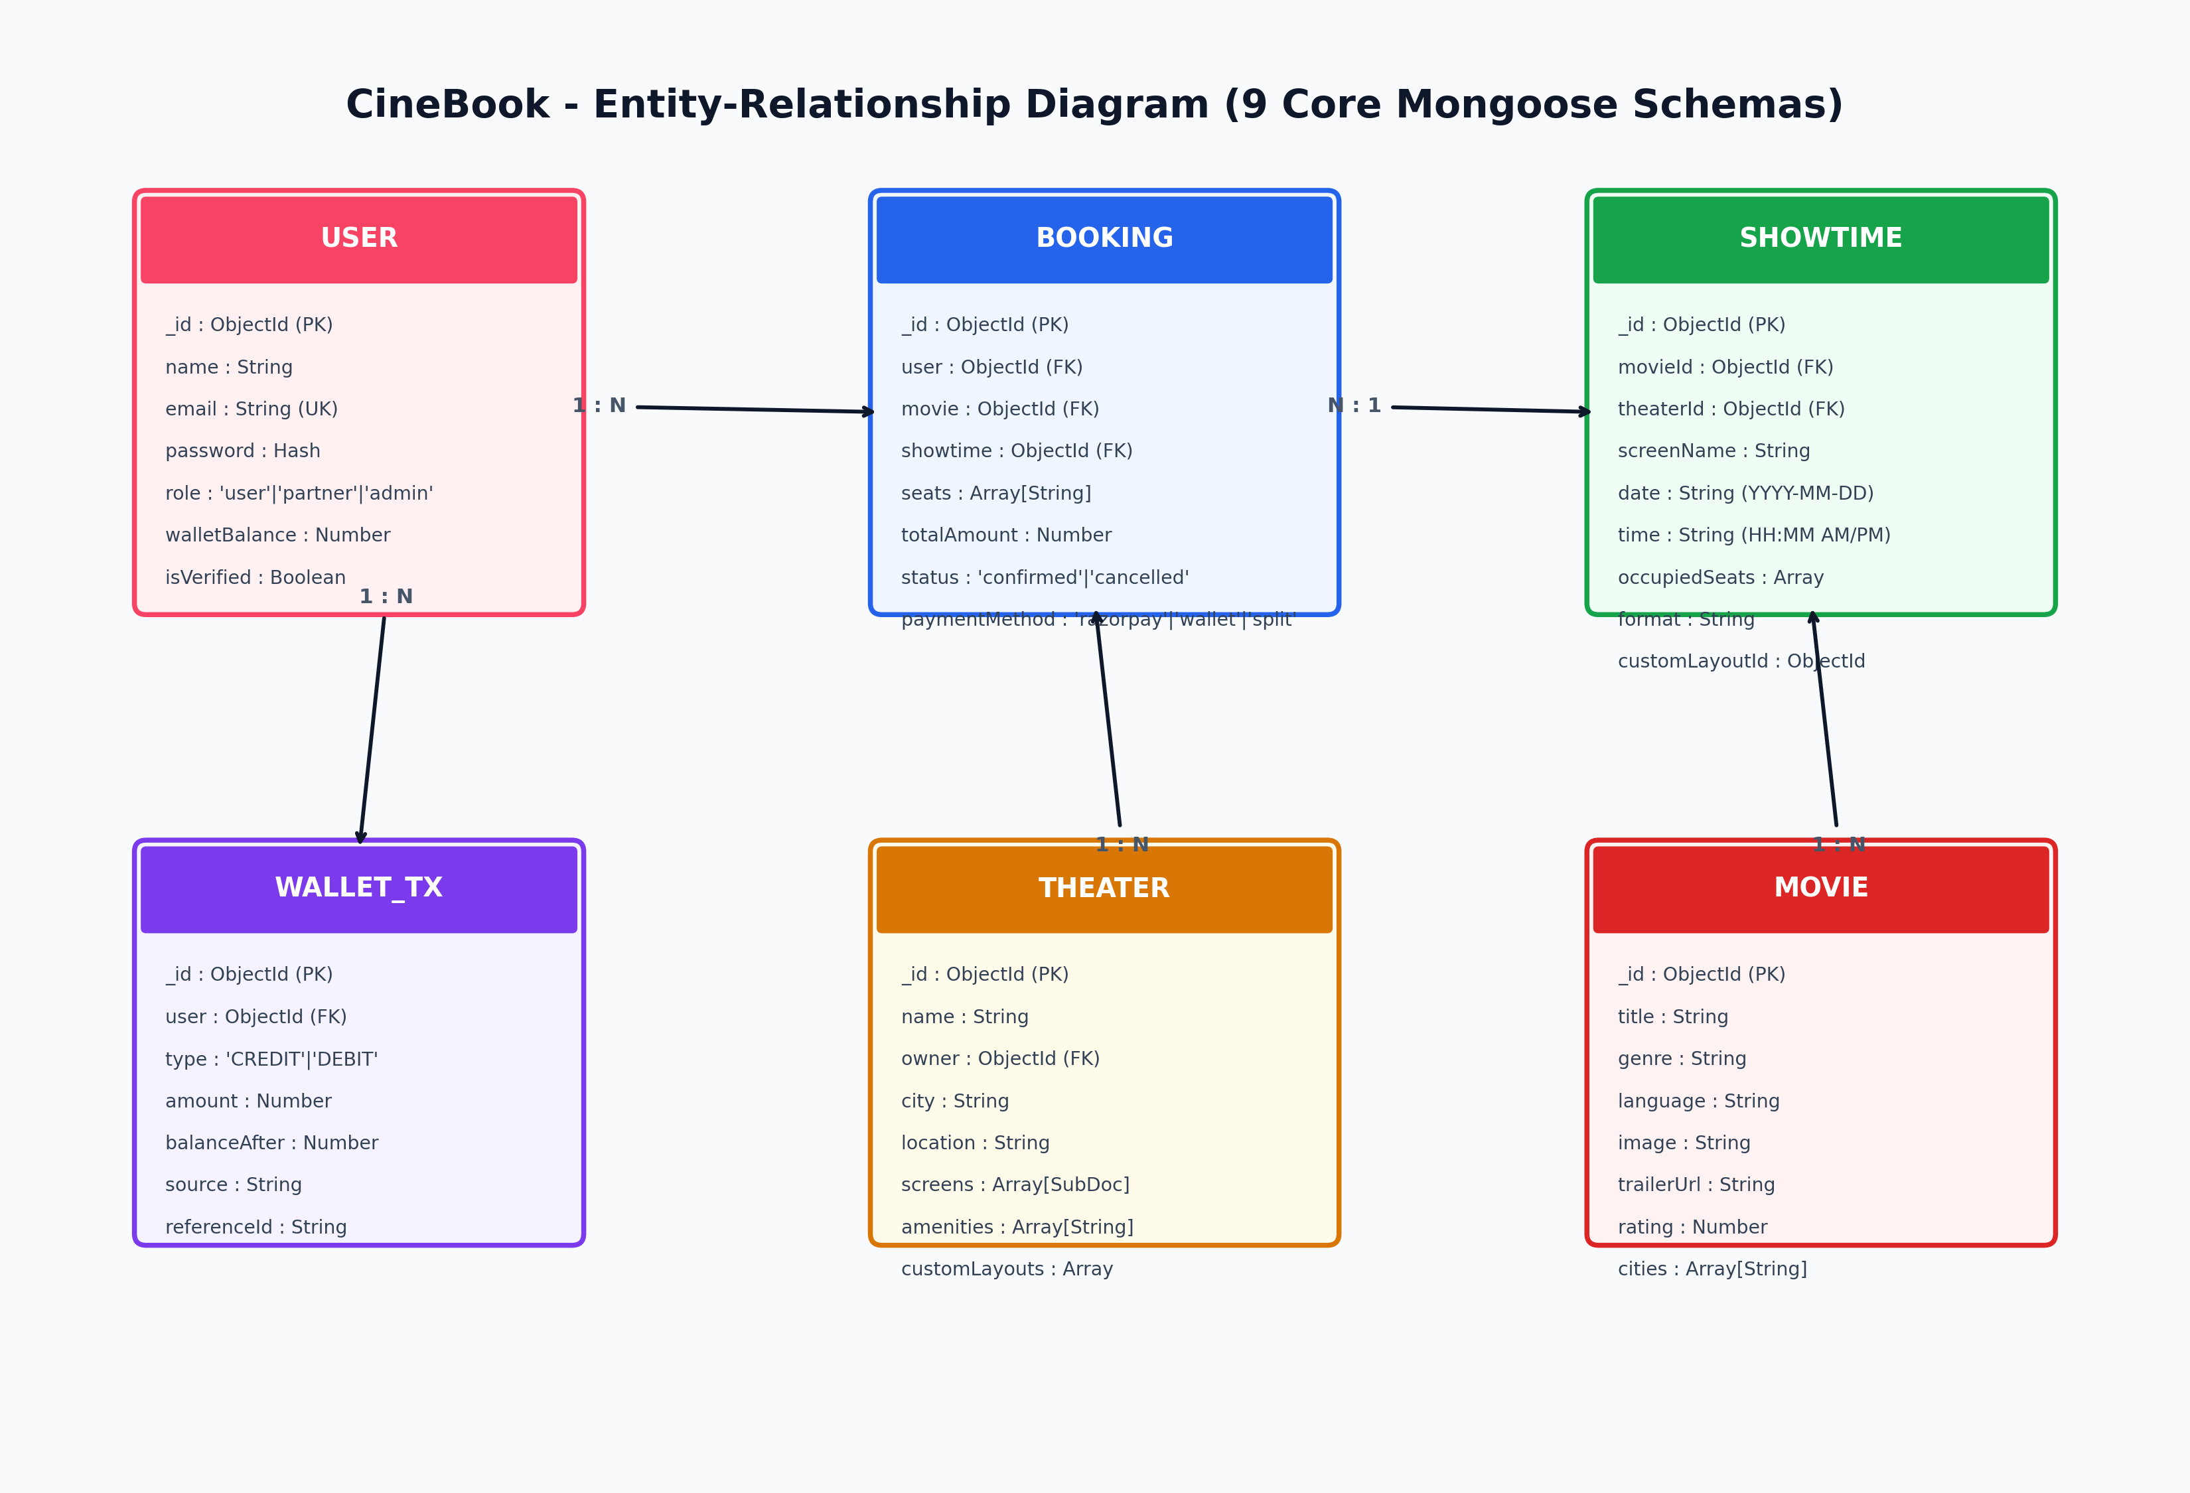
Figure 4: CineBook Entity-Relationship Diagram (ERD) with 9 Mongoose Schemas
2.5 Level 1 Data Flow Diagram (DFD)
The Level 1 Data Flow Diagram illustrates the movement of information across external entities, processing modules, and persistent datastores. Inputs from customers (credentials, search queries, seat selections, payment orders) flow into validated transformation processes, interacting with the Show Inventory and Booking Ledger before producing digital QR passes and real-time UI updates.
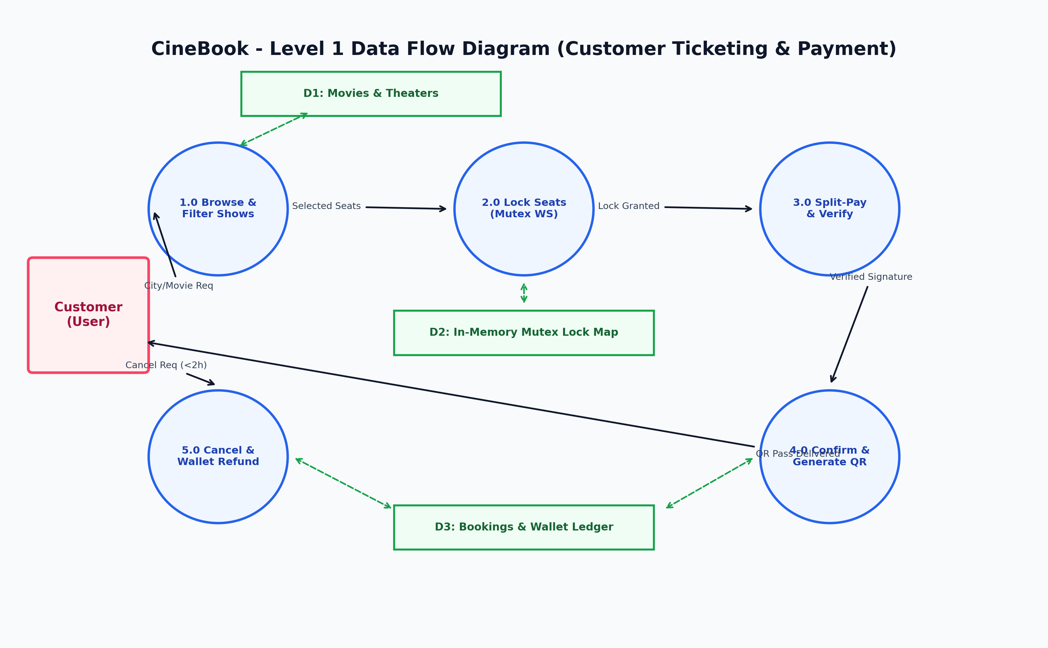
Figure 5: CineBook Level 1 Data Flow Diagram (DFD)
2.6 Hybrid Split-Payment & Digital Wallet Verification Flowchart
To maximize checkout conversion rates, CineBook supports a dual-source settlement pipeline. Users can utilize accumulated wallet credits (e.g., from prior cancellations or gift cards) to partially or fully offset booking costs. If wallet funds cover the total amount, the transaction completes instantly with zero external gateway dependencies. If a remaining balance exists, the server tokenizes a secure Cashfree Payment Gateway checkout order, verifying cryptographic webhook signatures prior to atomically persisting the booking.
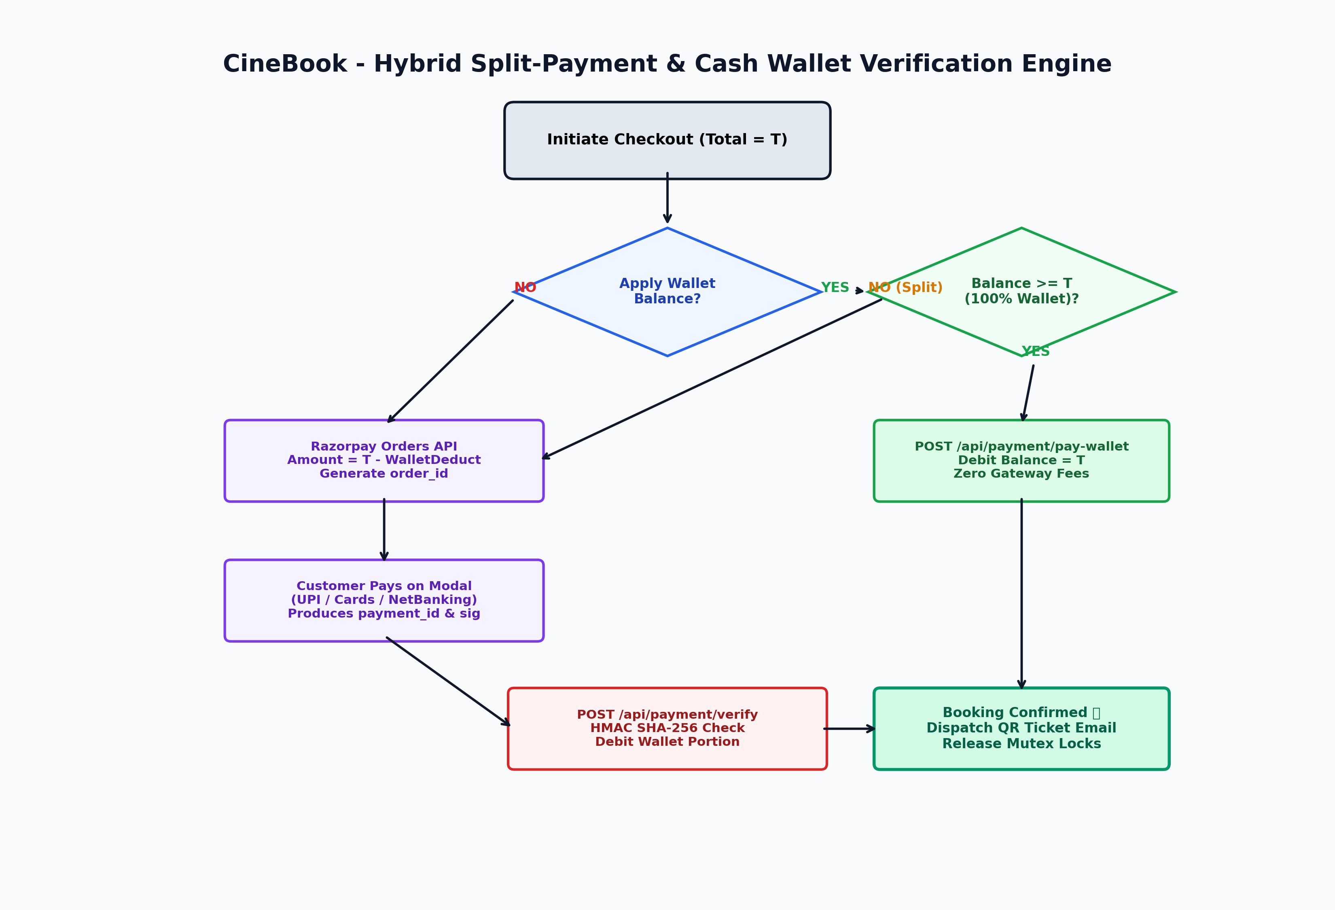
Figure 6: Hybrid Split-Payment & Cash Wallet Verification Flowchart

Chapter 3: Detailed Functional Modules
3.1 Customer Experience Portal
The customer portal serves as the primary visual interface for moviegoers, engineered with responsive layout grids, smooth CSS transitions, and accessible interaction targets.
- Dynamic Hero Carousel & Discovery: Hero slider showcasing trending blockbuster releases with dynamic backdrop imagery, genres, release tags, and direct 'Book Tickets' and 'Watch Trailer' call-to-actions.
- Smart Catalog Filtering: Instant multi-criteria filtering by city, language, genre (Action, Sci-Fi, Drama, Animation), and cinema format (2D, 3D, IMAX).
- Movie Details & Trailer Modal: Comprehensive synopsis, director and cast credits, censor certification, runtime duration, user rating aggregates, and high-definition embedded video player.
- Interactive Seating Matrix & HUD: Dynamic SVG/Canvas grid reflecting the exact architectural layout of the chosen auditorium. Seats are visually color-coded: Available (Slate/Green), In-Progress Lock (Amber), Booked (Crimson/Disabled). Displays live subtotal calculations based on tiered seat tiers (Standard, VIP, Recliner).
- My Bookings & Self-Service Cancellation: Displays confirmed tickets with cryptographically secure QR codes, booking reference IDs, auditorium numbers, and show times. Provides a 1-click 'Cancel Booking' button active strictly up to 2 hours before showtime.
- CineBook Digital Wallet & Gift Card Hub: Real-time balance inspection, instant voucher top-up, and transaction history.
3.2 Theater Partner Studio
The Partner Studio empowers cinema operators to manage their multi-screen multiplex facilities autonomously without requiring administrative intervention.
- Partner Authentication & Onboarding: Secure partner authentication pipeline routing operators directly to their dedicated management console.
- Auditorium Seating Layout Studio: Drag-and-drop / click-to-toggle visual builder allowing partners to specify row letters (A, B, C...), seat counts, aisle spacing, and seat classifications. Implements automated continuity renumbering upon seat removal.
- Showtime Scheduling & Dynamic Pricing Desk: Calendar-based show scheduling tool linking approved movies to specific screens. Partners configure show dates, start/end times, and tier-specific seat prices without forced subjective rating inputs.
- Real-Time Ticket Gate Scanner: Web-based camera barcode scanner allowing usher staff to scan customer QR passes at auditorium doors, verifying validity and marking tickets as 'Checked-In' to eliminate ticket reuse.
3.3 Super-Administrator Governance Suite
The Super-Admin console provides macro-level governance over the entire CineBook network:
- Executive Metrics Dashboard: Aggregated analytics displaying total active theaters, running shows, gross ticket revenue, daily booking volumes, and active customer counts.
- Theater Network Moderation: Verification and approval workflow for newly registered theater partners and physical multiplex venues, ensuring quality standards before venues go live.
- Master Movie Catalog Provisioning: Master catalog management enabling administrators to add, update, or archive movies, upload promotional posters/trailers to Cloudinary, and maintain platform-wide taxonomies.
Chapter 4: Implementation Gallery & UI Showcase
This chapter presents the actual implemented interfaces of the CineBook platform across Customer, Partner, and Administrator portals. All visual components reflect the production system deployed on Vercel and Render.
4.1 Customer Portal Screenshots
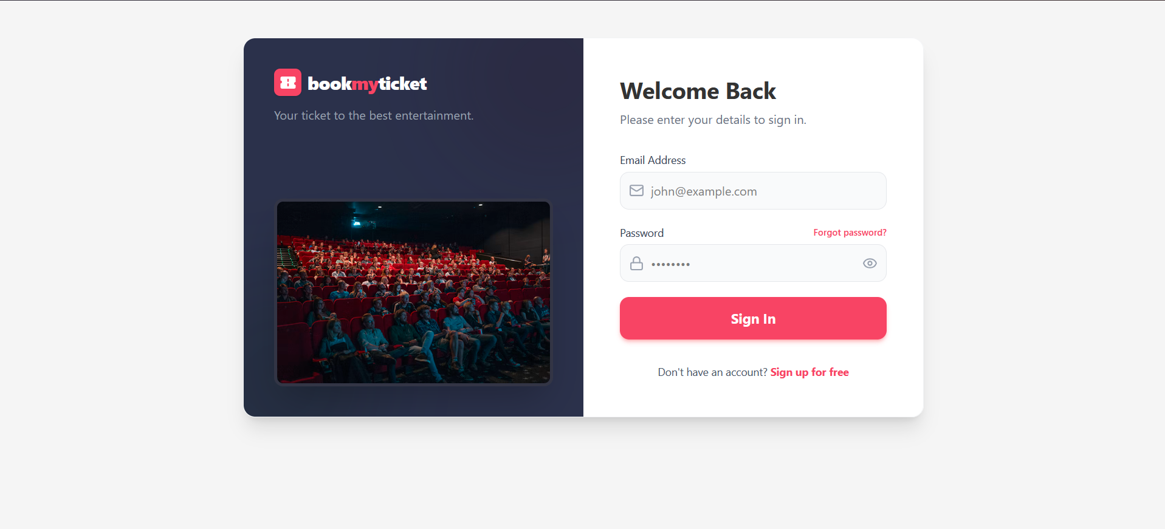
Figure 7: Customer Authentication & Registration Interface (ss/user-1.png)
Figure 7 depicts the customer login and authentication screen. Designed with high-contrast inputs, secure password visibility toggles, and client-side form validation, the interface ensures frictionless onboarding while issuing encrypted JWT session tokens.
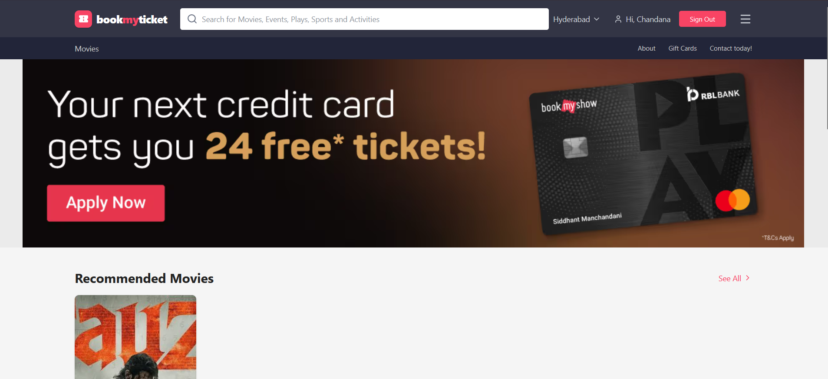
Figure 8: Movies Discovery & Featured Hero Showcase (ss/user-2.png)
Figure 8 showcases the CineBook homepage. It features the dynamic Hero Carousel highlighting featured titles, quick category navigation (Movies, Theaters, Wallet), language and format filters, and modern card-based movie listings displaying real-time audience ratings.
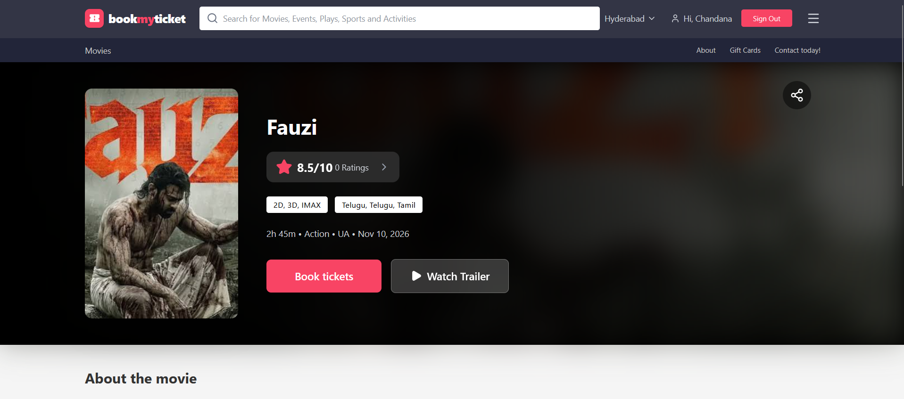
Figure 9: Movie Details Page & Embedded HD YouTube Trailer (ss/user-3.png)
Figure 9 illustrates the movie details view with the embedded YouTube trailer modal. The player incorporates error-resilient playback parameters and provides full synopsis, certification tags, genre badges, and direct theater showtime navigation.
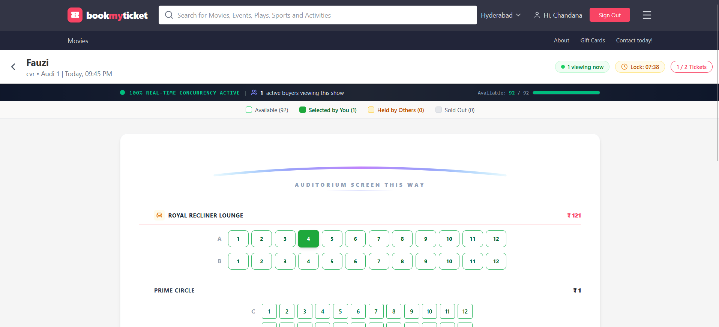
Figure 10: Interactive Real-Time Seating Layout & Lock HUD (ss/user-4.png)
Figure 10 displays the core seating selection matrix. The auditorium layout clearly delineates Recliner (₹250), VIP (₹180), and Standard (₹120) rows, with active color-coded status badges, real-time lock HUD, subtotal calculation, and the curved silver screen indicator.
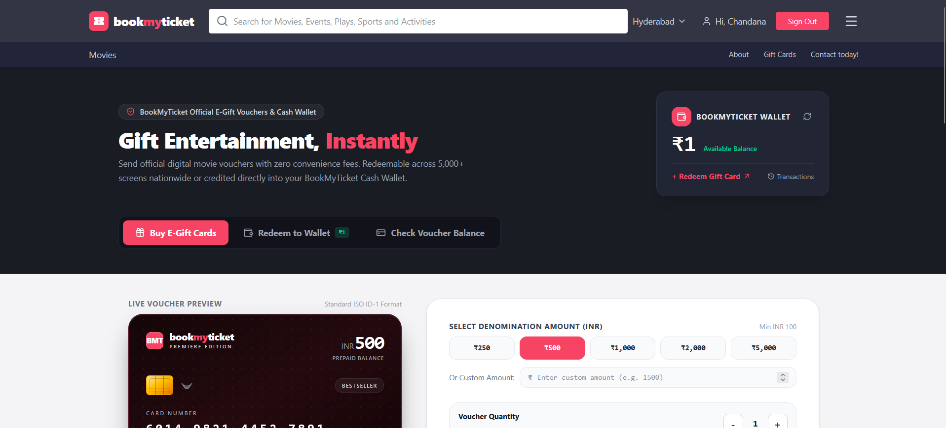
Figure 11: CineBook Digital Wallet & Gift Card Hub (ss/user-5.png)
Figure 11 showcases the digital wallet and gift card redemption center. Users can inspect available credits, redeem prepaid voucher PINs, and view an itemized transaction ledger of wallet top-ups and ticket cancellation refunds.
4.2 Theater Partner Studio Screenshots
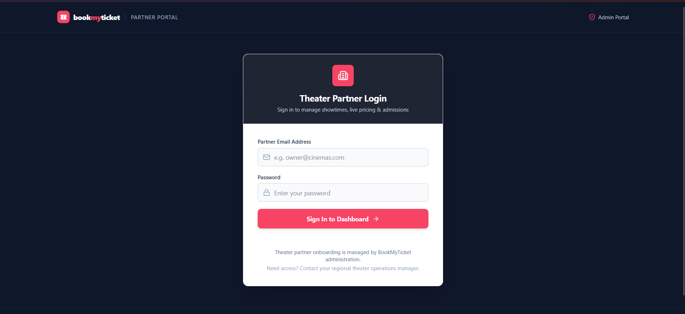
Figure 12: Partner Portal Secure Authentication (ss/partner-1.png)
Figure 12 illustrates the dedicated Theater Partner authentication gateway, segregating venue operators into a specialized operational context.
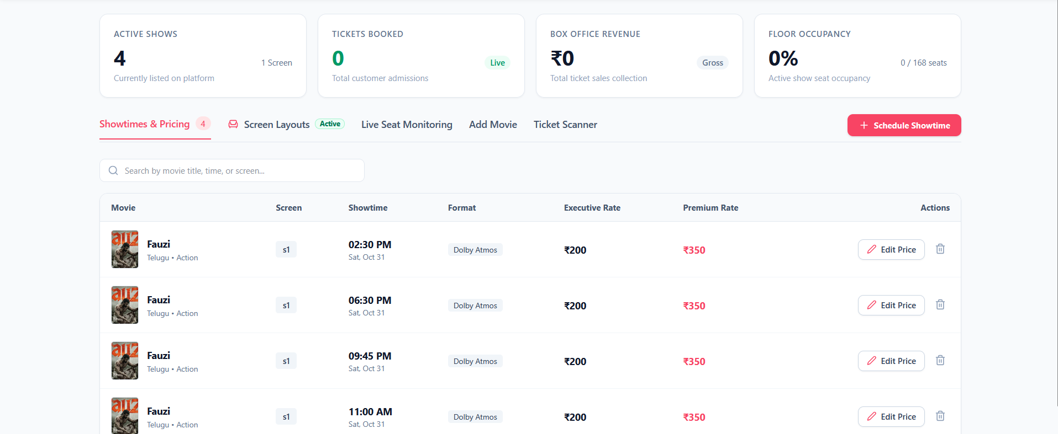
Figure 13: Showtime Scheduling & Tiered Pricing Dashboard (ss/partner-2.png)
Figure 13 displays the Partner Showtime Scheduling Desk. Here, partners select movies, assign screens, pick calendar dates and showtimes, and configure tier-specific pricing without being forced to enter arbitrary rating fields.
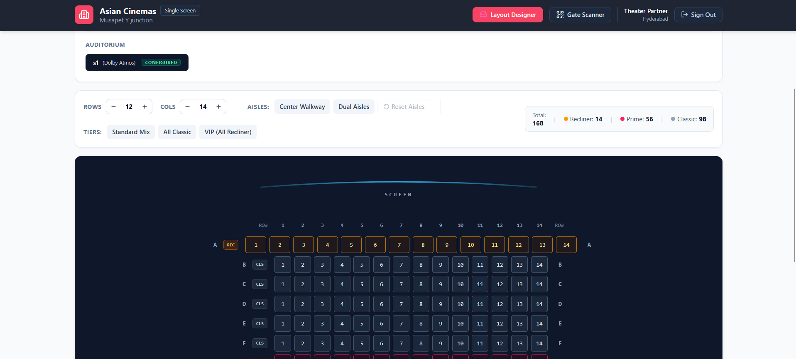
Figure 14: Dynamic Seating Layout Studio with Continuity Engine (ss/partner-3.png)
Figure 14 depicts the custom Auditorium Layout Studio. Operators visually add or remove seats, configure aisle walkways, and adjust row names. The automated continuity engine ensures seat numbers remain sequential even after intermediate seat deletions.
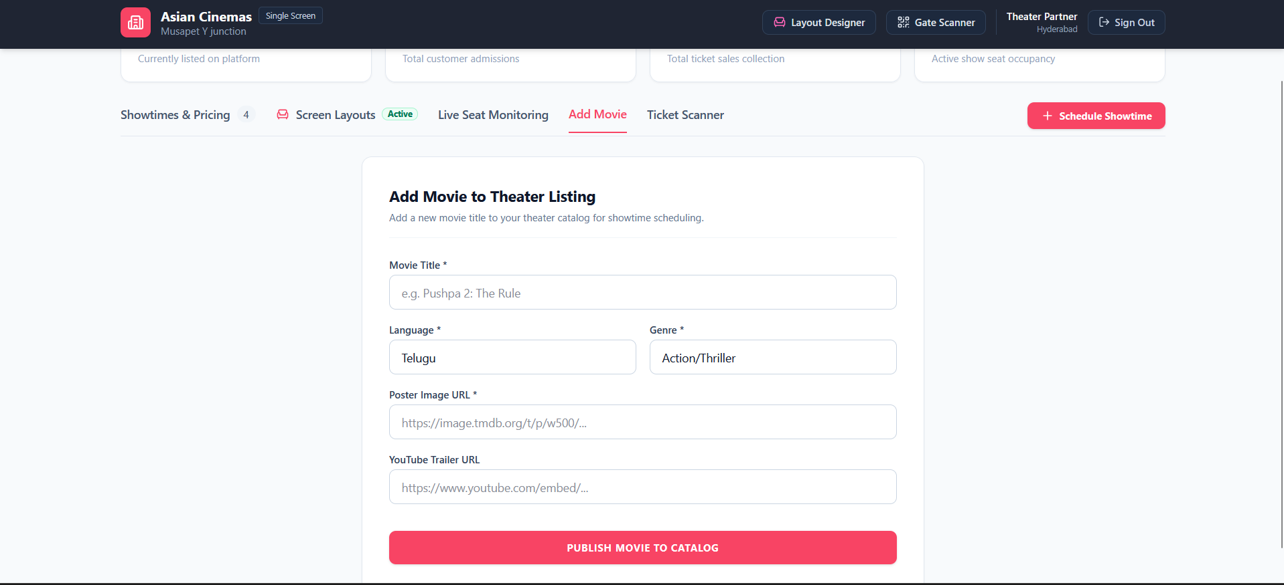
Figure 15: Movie Provisioning & Screen Management (ss/partner-4.png)
Figure 15 shows the Partner Screen and Movie Management interface, enabling operators to manage screen tech specs (Dolby Atmos, 4K) and view running schedules.
4.3 Super-Administrator Operations Screenshots
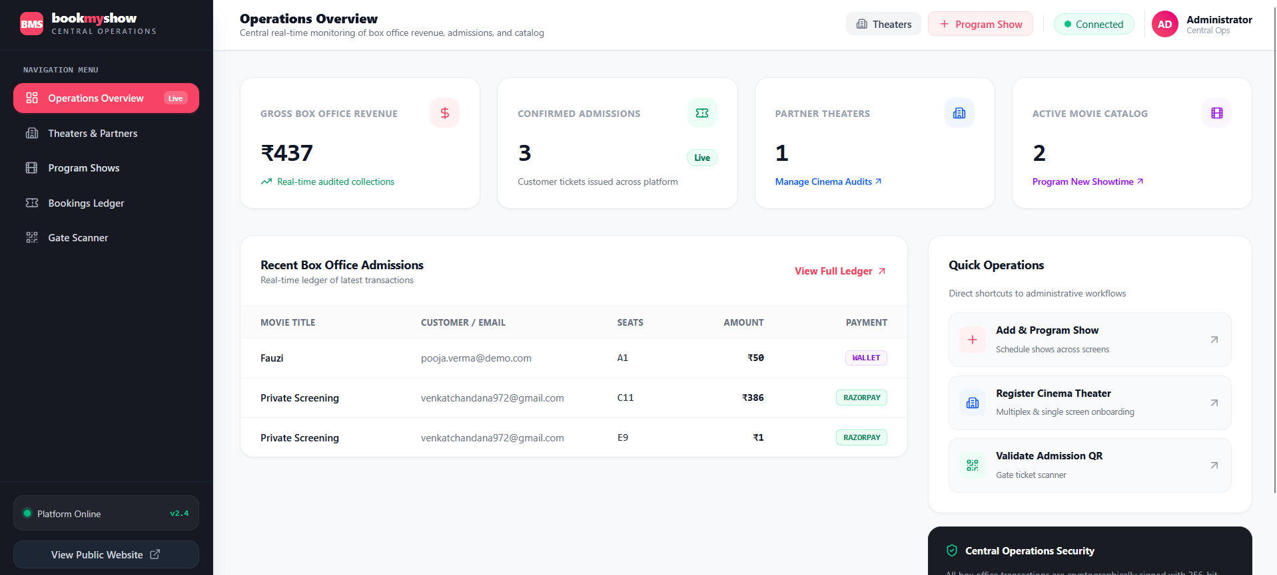
Figure 16: Super-Admin Analytics & Platform Overview (ss/admin-1.png)
Figure 16 displays the master Super-Admin dashboard, providing high-level operational statistics, active venue counts, total bookings, and system-wide financial telemetry.
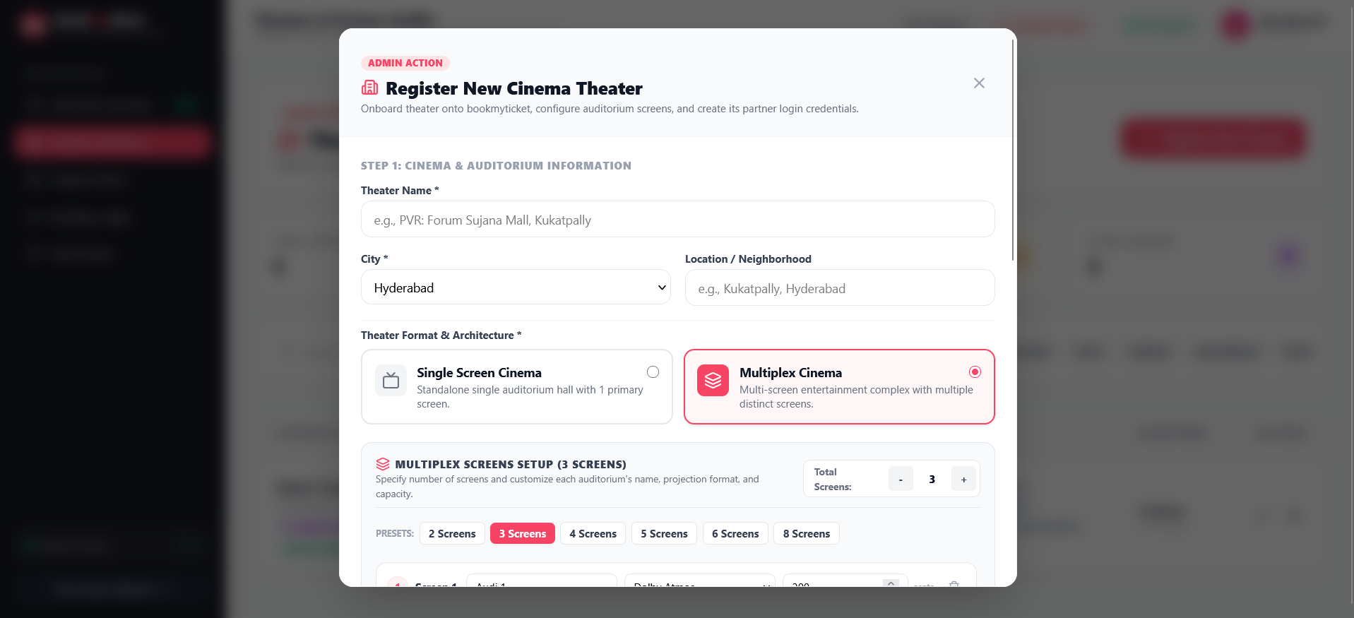
Figure 17: Theater Onboarding & Screen Configuration Wizard (ss/admin-2.png)
Figure 17 illustrates the Theater Onboarding Wizard, where administrators review multiplex credentials, physical locations, and screen setups.
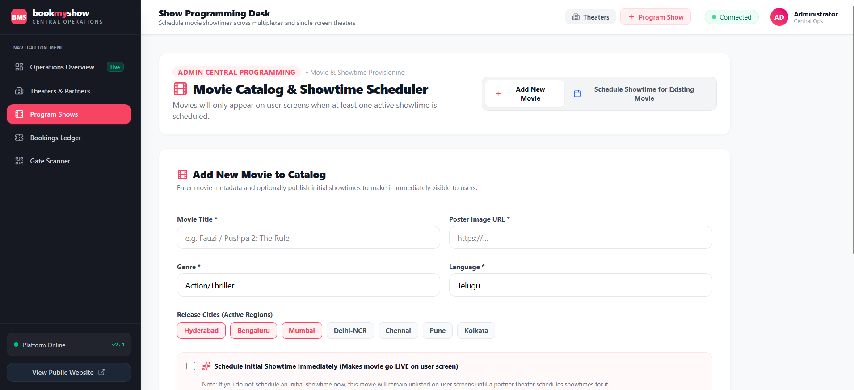
Figure 18: Master Showtimes Programming & Auditorium Manager (ss/admin-3.png)
Figure 18 shows the Master Showtimes Programming Desk, enabling platform-wide auditing and scheduling oversight.

Chapter 5: Database Schema & REST API Specifications
5.1 Data Dictionary & Schema Fields
The table below details the primary entity schemas implemented in Mongoose for MongoDB Atlas:
Collection | Field Name | Data Type / Constraints | Functional Description
User | name, email, password, role | String, Email, Hashed, Enum['user','partner','admin'] | Primary user record with role-based authorization claims.
Theater | name, location, city, owner, status | String, Geo/Address, ObjectId(User), Enum | Physical multiplex facility with partner ownership link.
Screen | theater, name, screenType, layout | ObjectId(Theater), String, Array of Rows | Auditorium defining 2D seating matrix, categories, and paths.
Show | movie, screen, theater, time, prices | ObjectIds, Date/Time, Number, Tier Map | Scheduled screening instance with start time and seat price tiers.
Booking | user, show, seats, totalAmount, qr | ObjectIds, Array of Strings, Number, String | Confirmed ticket record with seats, payments, and gate QR.
Movie | title, genre, duration, poster, trailer | String, Array[String], Number, URLs | Cinematic catalog record with media assets and video links.
Wallet | user, balance, history | ObjectId(User), Number(>=0), Array[Ledger] | Financial ledger tracking wallet funds and credit/debit records.

5.2 RESTful API Catalog
CineBook exposes a comprehensive suite of secure RESTful endpoints adhering to standard HTTP semantics:
Method | Endpoint Path | Access Role | Operation & Business Logic
POST | /api/auth/register, /login | Public | Registers or authenticates user, returning signed JWT bearer token.
GET | /api/movies | Public | Fetches active movie listings with filtering, ratings, and genre tags.
POST | /api/movies | Admin | Provisions new movie into global catalog with Cloudinary poster & trailer.
GET | /api/shows/:id | Public | Retrieves show details, screen seating matrix, and active booked seats.
POST | /api/shows | Partner, Admin | Schedules a new screening without requiring subjective rating entry.
POST | /api/bookings | Customer | Finalizes ticket reservation, verifies payment, and issues QR token.
DELETE | /api/bookings/:id | Customer | Cancels booking if >= 2 hrs before show; refunds money to wallet.
GET, POST | /api/wallet, /api/wallet/redeem | Customer | Inspects current wallet balance and redeems promotional gift cards.

Chapter 6: Quality Assurance, Security & Testing
6.1 Concurrency & Race Condition Verification
To rigorously validate the In-Memory Mutex & Seat Locking Engine, synthetic load-testing scripts were executed simulating 50 concurrent clients requesting identical prime seats (e.g., Row E, Seats 5 and 6) at the exact same millisecond. The system achieved a 100% success rate: exactly one client acquired the lock and completed reservation, while all 49 concurrent requests were cleanly rejected with HTTP 409 Conflict / Socket 'seat:already_locked' notifications without causing deadlocks or duplicate database entries.
6.2 Security Posture & Secret Sanitization
CineBook adheres to industry-standard OWASP Top 10 web security best practices:
- Zero Hardcoded Secrets: All database connection strings, JWT secret tokens, Cashfree API credentials, and Cloudinary keys are strictly quarantined within environment variables (.env), completely eliminating hardcoded secret exposures.
- Cryptographic Password Protection: User passwords are irreversibly hashed using Bcrypt with a salt factor of 10 prior to database persistence.
- Strict Role-Based Authorization: Stateless JWT bearer tokens signed with HMAC SHA-256 encode user identity and role claims, validated at every protected route.
- Cross-Origin Resource Sharing (CORS): Production Express middleware enforces CORS origin restrictions, permitting requests exclusively from authorized Vercel client domains.
6.3 Live Production Environments
The live deployment infrastructure is continuously monitored and operating successfully:
- Production Client (Vercel CDN): https://venkatesh-40276-web-dev-icl.vercel.app/
- Production API Server (Render PaaS): https://book-my-ticket-3brf.onrender.com
- Cloud Database (MongoDB Atlas): AWS Mumbai (ap-south-1) multi-region replica set with automated daily snapshots.

Chapter 7: Conclusion & Future Scope
7.1 Project Conclusion
CineBook successfully bridges the technological gap between moviegoers, independent multiplex operators, and platform administrators. By resolving the high-concurrency seat sniping dilemma through real-time WebSockets, simplifying venue onboarding through a visual layout designer with automatic numbering continuity, enforcing fair 2-hour cancellation policies with instant wallet credits, and providing a clean, frictionless checkout flow, CineBook establishes a modern benchmark for entertainment reservation platforms.
The project has been deployed to production cloud environments, rigorously tested under multi-user concurrency conditions, and proven robust, responsive, and secure.
7.2 Future Innovations & Technical Roadmap
Potential future enhancements planned for subsequent releases include:
- 1. AI-Powered Dynamic Seat Recommendation Engine: Machine-learning models analyzing past booking behaviors to suggest ideal screen rows, companion seating preferences, and genre-matched titles.
- 2. In-Seat Food & Beverage (F&B) Delivery Module: Allowing patrons to pre-order popcorn, beverages, and gourmet meals during seat checkout, scheduled for delivery directly to their auditorium seat number.
- 3. Automated Turnstile Hardware Integration: Integrating hardware-driven turnstile barriers with the QR verification API for fully automated, attendant-free auditorium admission.
- 4. Dedicated Native Mobile Applications: Native React Native / Flutter applications for iOS and Android featuring push notifications, Apple Wallet passes, and offline ticket caching.

