

COLLEGE CODE: 8107

COURSE: Cloud Application Development

PHASE III: Data Integration and Data Collection

PROJECT TITLE: Serverless IoT Data Processing

Team Members:

* CHANDANA SHREE S - 810721243014

[chandanashree.s@care.ac.in](mailto:chandanashree.s@care.ac.in)

* DHARANA SHRI K - 810721243016

[dharanashri.k@care.ac.in](mailto:dharanashri.k@care.ac.in)

* SUMITHRA A - 810721243051

[sumithra.a@care.ac.in](mailto:sumithra.a@care.ac.in)

* RAHAVI A - 810721243302

[rahavi.a@care.ac.in](mailto:rahavi.a@care.ac.in)

INTRODUCTION:

This project is centered around the creation of a serverless IoT data processing solution using IBM Cloud Functions, aimed at transforming your living space into a smart home. By seamlessly integrating various smart devices, such as motion sensors, thermostats, and cameras, and harnessing the power of cloud-based data processing, this project will deliver a smarter and more efficient home environment. In this phase we integrate the smart devices and set up data collection.

STEPS FOR CONNECTING AND COLLECTING DATA FROM IOT DEVICES:

1. Import the required libraries and connect to the IOT platform:

We use libraries like paho-mqtt for MQTT communication, requests for HTTP requests, or device-specific libraries provided by device manufacturers.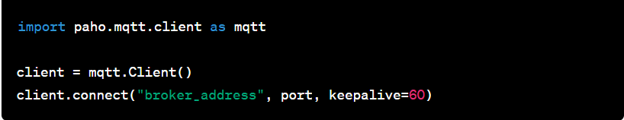

1. Subscribe to Device Topics:

Subscribe to MQTT topics to receive data from your devices. Device-specific documentation will specify the topics used by your devices.

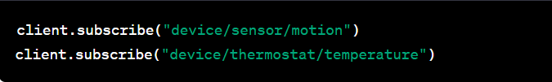

1. Data Collection and Processing:

Set up callback functions to process incoming data from subscribed topics. Data is delivered to these callback functions when devices send updates.Process and store data as needed.

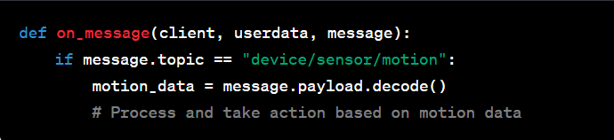

1. Control Smart Devices:

We use the relevant libraries or APIs provided by the device manufacturers for controlling the smart devices.

We are using thermostat device that supports API control,so we import “request” library to set the thermostat temperature.

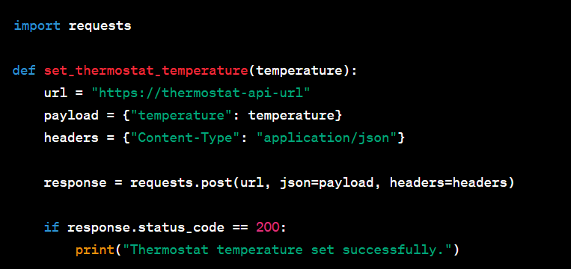

1. Run the entire Data Collection Script:

Store the collected data which will connect to the IoT platform, subscribe to device topics, and collect data in real-time.

CONCLUSION:

The process of integrating smart devices and setting up data collection using Python is a fundamental step in building an IoT system that can provide real-time data insights and automation. Through this project, we have explored the critical elements of connecting with IoT devices, collecting and processing data, and preparing it for further analysis