

COLLEGE CODE: 8107

COURSE: Cloud Application Development

PHASE IV: Real Time Process And Automate the Data

PROJECT TITLE: Serverless IoT Data Processing

Team Members:

* CHANDANA SHREE S - 810721243014

[chandanashree.s@care.ac.in](mailto:chandanashree.s@care.ac.in)

* DHARANA SHRI K - 810721243016

[dharanashri.k@care.ac.in](mailto:dharanashri.k@care.ac.in)

* SUMITHRA A - 810721243051

[sumithra.a@care.ac.in](mailto:sumithra.a@care.ac.in)

* RAHAVI A - 810721243302

[rahavi.a.ai@care.ac.in](mailto:rahavi.a.ai@care.ac.in)

INTRODUCTION:

This project is centered around the creation of a serverless IoT data processing solution using IBM Cloud Functions, aimed at transforming your living space into a smart home. By seamlessly integrating various smart devices, such as motion sensors, thermostats, and cameras, and harnessing the power of cloud-based data processing, this project will deliver a smarter and more efficient home environment.In this phase we integrate the smart devices and set up data collection.

REAL TIME PROCESSING:

Processing the thermostat data in real time

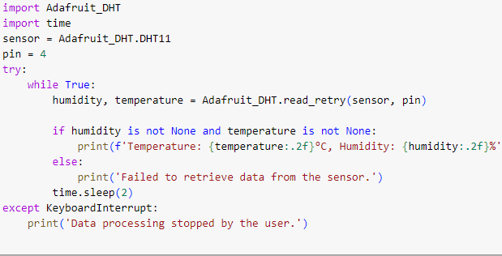

AUTOMATION :

Automate the data

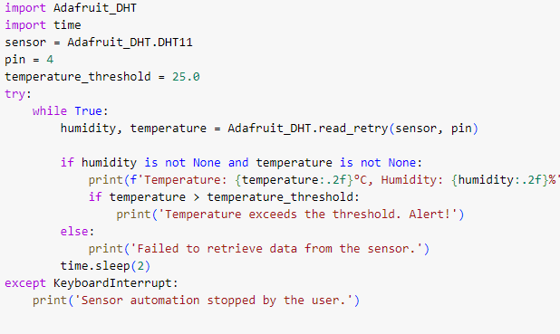

STORE THE DATA IN IBM CLOUD:

* Store the data in IBM Cloud with help of IBM Watson IOT Platform to store the data in IBM Cloud

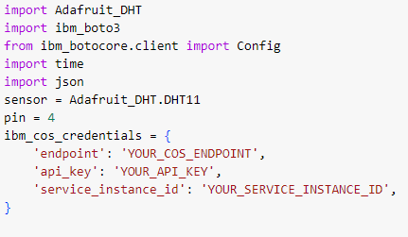

* Connect IBM Cloud Object Storage for analysis

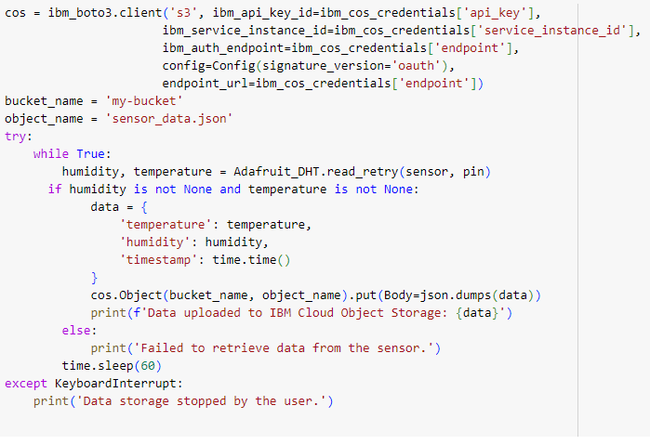

CONCLUSION:

* Serverless IoT data processing is a powerful approach for efficiently and cost-effectively handling data generated by Internet of Things (IoT) devices
* Serverless computing platforms, such as AWS Lambda, Azure Functions, and Google Cloud Functions, can automatically scale to handle varying workloads. This makes them well-suited for IoT applications where data volumes can fluctuate significantly.