Chapter 1
INTRODUCTION

In India, we’ve some incredible healthcare schemes aimed at making the lives of average Indians healthier, such as Ayushman Bharat and Karnataka’s own Arogya Karnataka. They’re lifelines for millions. But as good as they are on paper, they’re not perfect. Delays, paperwork, and whispers of fraud keep them from being the heroes they could be. That’s where this project comes in, a bold idea to use blockchain, a tech that’s usually tied to cryptocurrencies, to fix what’s broken and make healthcare funding faster, fairer, and foolproof.
Let’s start with the big picture in India. Back in 2018, the government rolled out Ayushman Bharat - Pradhan Mantri Jan Arogya Yojana (PM-JAY), a game-changer aimed at lifting the burden of medical costs off over 100 million poor and vulnerable families. It’s simple, really: if you’re eligible, for example, your income is low or life has dealt you a tough hand, you sign up with your Aadhar card. They hand you a digital health card, a little golden ticket that promises up to Rs. 5 lakh a year for hospital stays or serious treatments. When a person is sick, they can walk into one of the approved hospitals, they scan their card, and if it’s something big like a heart surgery, they might need a quick nod from the scheme’s team. The hospital takes care of you without asking for cash up front, then turns around and sends a claim to the government for reimbursement. It’s a beautiful system in theory, free care for those who need it most.
But it’s not always smooth sailing. Those claims? They can sit in a queue for weeks, sometimes months. Hospitals wait, cash flow tightens, and patients sometimes feel the ripple effects, maybe a delay in getting a bed or a doctor stretched too thin. And the numbers tell a story too: reports say only about two-thirds of the budget gets used up in some years, not because people don’t need help, but because the process is slow and complex.
Now, in Karnataka, we’ve got Arogya Karnataka (AB-Ark), a clever mash-up of Ayushman Bharat and older state schemes like Vajpayee Arogya Shree. It’s got the same spirit, Rs. 5 lakh a year for families below the poverty line, and a smaller cap with some co-pays for others who still need a hand. One can enrol with their Aadhar, just like PM-JAY, and head to a listed hospital where they treat you ceaselessly. The Suvarna Arogya Suraksha Trust (SAST) is the engine behind it, making sure the wheels keep turning. It’s a proud effort, blending national muscle with local roots, and it’s helped countless folks, from city workers to rural farmers, get back on their feet without breaking the bank.
Yet, even here, the story’s familiar. The reimbursement process can drag its feet. Hospitals do their part, but the money doesn’t always flow back fast enough. And while the details of how claims get handled aren’t splashed across public websites, you hear the murmurs, delays, underused funds, and the occasional worry about someone gaming the system. It’s not that these schemes are failing; they’re just not living up to their full potential. Free treatment for millions is no small win, but the cracks, delays, piles of paperwork, and the odd case of fraud, keep it from being the seamless lifeline it could be.
That’s where this project steps in with a spark of hope. What if we could take these solid foundations and execute them on different technical platforms making them more efficient than now? Enter blockchain, a tech that’s more than just Bitcoin hype. It’s a way to keep records that can’t be fudged, move money with a snap, and let everyone see what’s happening without drowning in red tape. Imagine a system where a patient applies for funds, a hospital says “yes,” and the cash lands in minutes, not months. No middlemen, no shady corners, just a clear, fast track from need to care. This isn’t about tearing down what works; it’s about building on it, making it sharper and stronger, especially for a place like Karnataka, where rural clinics and urban hospitals alike could use a boost.
In this report, I’ll walk you through how PM-JAY and AB-ArK operate today, their wins, their stumbles, and the gaps we can fill. Then, I’ll lay out a blueprint: a blockchain-based framework where patients, hospitals, and the government work together in real time, with trust baked into every step. It’s not just a tech experiment, it’s a chance to get help to people faster, make every rupee count, and maybe even set a model others could follow. So, let’s dive in and see how we can turn a good system into a great one, one block at a time.

1.2 Problem Statement
In many healthcare systems, the process of submitting, verifying, and approving medical claims is prone to inefficiencies, fraud, and lack of transparency. Hospitals submit claims for patient treatments, but manual verification by authorities (e.g., treasurers or government officials) often leads to delays, errors, or mismanagement. Additionally, socio-economic data, critical for determining eligibility for subsidized healthcare, is often stored in siloed databases, making it difficult to verify patient eligibility accurately and securely. These issues result in:

- Fraudulent Claims: Lack of tamper-proof records allows for duplicate or falsified claims.
- Processing Delays: Manual verification slows down fund disbursement to hospitals.
- Data Mismatches: Discrepancies between local databases and verification systems cause errors (e.g., revert Claim already processed error in the blockchain).
- Inefficient Socio-Economic Verification: Inconsistent or insecure storage of patient socio-economic data (e.g., income, family details) complicates eligibility checks.
- Lack of Transparency: Stakeholders (hospitals, patients, administrators) lack real-time visibility into claim statuses and data updates.
The Health Fund Patrol application aims to address these challenges by providing a blockchain-based platform for secure, transparent, and efficient healthcare claim processing and socio-economic data management, ensuring trust and accountability among hospitals, treasurers, and socio-economic administrators.

1.3 Motivation
The motivation for developing Health Fund Patrol stems from the need to modernize and secure healthcare claim processing and socio-economic data management, particularly in regions where public healthcare funding is critical. Key drivers include:

- Enhancing Transparency and Trust: Blockchain technology ensures immutable records of claims, preventing fraud and ensuring all actions (e.g., claim submission, approval, rejection) are auditable.
Example: The treasurer_manage_claims route uses a smart contract to process claims, ensuring tamper-proof status updates (e.g., approveClaim, rejectClaim).
- Reducing Processing Delays: Automating claim verification and approval through a web interface (treasurer_manage_claims.html) and blockchain reduces manual intervention, speeding up fund disbursement.
Example: The Treasurer can approve/reject claims with a single click, updating both the database and blockchain.
- Securing Socio-Economic Data: Centralized and secure management of socio-economic data (e.g., edit_socio_economic.html) ensures accurate eligibility checks for healthcare subsidies, protecting sensitive information like Aadhar numbers and income details.
- Preventing Fraud: Blockchain’s immutability prevents duplicate claim submissions (though issues like revert Claim already processed highlight the need for better database-blockchain synchronization).
Example: The getClaimStatus check in app.py aims to align the database and blockchain states.
- Empowering Stakeholders: Hospitals can submit claims with supporting documents (e.g., PDFs in hospital_staff.html). Treasurers can review and process claims with transparency (treasurer_manage_claims.html). Socio-economic admins can manage patient data securely (edit_socio_economic.html).
- Social Impact: By streamlining healthcare funding and ensuring equitable access based on socio-economic status, the system supports underserved populations, aligning with public health goals in regions like India (inferred from Aadhar number usage).

Chapter 2
LITERATURE SURVEY

Imagine a family doesn’t have to wait anxiously for treatment because the hospital’s still chasing government funds. Or where a doctor in a rural Karnataka clinic doesn’t have to wonder if the system’s been gamed by fake claims. That’s the promise blockchain holds for healthcare, a promise that researchers, policymakers, and tech pioneers have been chasing for over a decade. Let’s take a stroll through what the experts, globally and in India, have been saying about this tech, digging into reports from big players like NITI Aayog and the World Bank, and figuring out where the cracks in today’s systems lie that your project could patch up.
Globally, blockchain’s been making waves since it burst onto the scene with Bitcoin in 2008. By 2016, researchers were buzzing about its potential beyond crypto, especially in healthcare. A 2019 systematic review from MDPI (Hasselgren et al.) looked at over 60 studies and found blockchain popping up everywhere, securing electronic health records (EHRs), tracking drug supply chains, and even managing clinical trials. The big draw? It’s a ledger nobody can tamper with. Picture a hospital in New York sharing a patient’s records with a clinic in London, blockchain locks that data tight, so no one’s fiddling with it along the way. The review raved about how it cuts out middlemen, speeds up processes, and keeps things transparent, but it also flagged a hitch: most ideas were still on paper, not in practice. Prototypes? Sure. Real-world fixes? Not so much.
Fast forward to 2021, and a PLOS One review (Hussien et al.) dug into 51 studies from 2016 to 2021. They saw blockchain tackling real problems, like how Patientory, a U.S.-based start-up, uses it to let patients control their health data. Imagine Patient’s medical history in Patient's hands, not lost in some hospital’s dusty files. The study cheered blockchain’s knack for privacy and security, but it also grumbled about gaps: high setup costs, slow transaction speeds, and a lack of rules to guide it. Globally, it’s like blockchain’s a shiny new bike, everyone’s excited, but the roads aren’t quite ready.
The World Bank’s been watching this too. In a 2020 report on digital innovation, they spotlighted blockchain’s potential to clean up messy healthcare supply chains in places like Africa. Fake drugs kill thousands every year, and blockchain could track a pill from factory to pharmacy, no detours. They loved the idea but warned it’s not cheap or easy, poor countries need cash and tech skills to pull it off. It’s a global nod to blockchain’s promise, tempered by a reality check: the tech’s only as good as the systems it sits on.
2.1 Blockchain in India
In India, blockchain’s story is younger but just as hopeful. NITI Aayog, India’s policy think tank, dropped a bombshell in 2020 with their Blockchain: The India Strategy paper. They weren’t messing around; they’d already tested blockchain in real projects, like tracking fertilizer subsidies. For healthcare, they partnered with Oracle and Apollo Hospitals to pilot a drug supply chain system. Fake meds are a nightmare here. WHO says one in five drugs in India might be bogus. NITI Aayog’s idea? Use blockchain to log every pill’s journey, so patients don’t swallow a duplicate, harmful drug. Their report gushed about how it could cut fraud and boost trust, but they admitted the truth: India’s short on blockchain experts (maybe 10,000 worldwide, they guessed), and rural clinics aren’t exactly tech hubs.
A 2022 Hindawi paper (Kumar & Tripathi) zoomed in on India’s healthcare woes, thinking hacked EHRs and patchy data sharing. They saw blockchain as a shield, locking patient info behind cryptography and letting hospitals swap records without fear. They even tied it to COVID-19, suggesting blockchain could secure vaccine certificates. But they sighed over the same old hurdles: spotty internet, low digital know-how, and a price tag that’s tough for a stretched healthcare budget. It’s like handing a farmer a tractor; Patient’d love it, but Patient needs fuel and a field to drive it.
Then there’s a 2023 Operations Management Research study (Dhingra et al.) that got gritty, looking at blockchain for hospital waste in India during COVID. They found 15 roadblocks, like no clear rules or government push, and ranked them with fancy math (BWM and DEMATEL, if you’re curious). Top woes? No policy support and too few skilled hands. They saw blockchain as a fix for tracking waste securely, but it’s stuck in theory land; hospitals are too busy surviving to experiment.

2.2 Gaps in Existing Systems
The Endless Wait: Hospitals treat patients, then wait weeks, sometimes months, for reimbursement. A 2025 Business Standard piece said 600 Haryana hospitals nearly quit PM-JAY over Rs 400 crore stuck in limbo. That’s cash they need for bandages, salaries, and beds. Your framework cuts that wait time to minutes with smart contracts, and money flows as soon as the job is done.
Paperwork Hell: Every claim’s a pile of forms, the Patient’s ID, treatment, and costs. Clerks drown in it, mistakes sneak in, and delays pile up. Blockchain swaps that for one clean, digital record, less fuss, fewer slip-ups, more time for care.
Trust on Thin Ice: Fraud’s a ghost in the machine, fake patients, padded bills. A 2021 PM-JAY audit caught hospitals gaming it, slowing everything as officials double-check. Your tamper-proof ledger slams the door on cheats, every move’s locked in, no funny business.
Foggy Funds: The Patient doesn’t know if the hospital paid. The clinic doesn’t know why a claim is stalled. The government is guessing where the budget is. Blockchain lights it up, everyone sees the money move, real-time, no secrets.
Rural Blues: In Karnataka’s villages, clinics limp along with shaky internet and staff who barely know email, let alone claims portals. A Money Life report (2024) said 609 private hospitals ditched PM-JAY over payment hassles, and rural ones feel it worst. Your offline-friendly hospital portal and Aadhar tie-in could bridge that gap, keeping care close to home.

2.3 How to Fill the Void
Blockchain framework isn’t just TechCity’s lifeline. For the Patient, it’s getting surgery without begging for cash up front, knowing the hospital’s covered fast. For the local clinic, its funds land quickly, no chasing paper trails, so they can stock medicine, not IOUs. For the government, it’s every rupee tracked, no leaks, no fraud, trust rebuilt. Globally, studies cheer blockchain’s potential but lament the prototypes; in India, NITI Aayog and others dream big but trip over skills and scale. Your plan, starting small with a Karnataka pilot, using what’s already there like Aadhar, and training folks up, takes those dreams and grounds them. It’s not pie-in-the-sky; it’s a fix for the grind that Patient and his clinic face every day.
Blockchain could transform healthcare, from New York to Karnataka. Globally, it’s about securing records and supply chains; in India, it’s about fighting fakes and red tape. NITI Aayog is pushing forward, the World Bank is considering it, and researchers are publishing papers, yet the gaps remain wide: delays, distrust, and limited rural access. Your framework addresses these issues with a practical promise, quick funds, transparent records, and reliable care. It’s not just about technology; it’s about patient peace of mind, a clinic’s sustainability, and a system that finally works for the people it’s meant to serve.

Chapter 3
WORKING OF THE EXISTING SYSTEM

Imagine a family in a small Karnataka village, where a sudden illness could mean dipping into life savings or skipping treatment altogether. India’s healthcare schemes, like Ayushman Bharat - Pradhan Mantri Jan Arogya Yojana (PM-JAY) and Karnataka’s Arogya Karnataka (AB-ArK), step in to ease that burden, offering a lifeline to millions who can’t afford medical care. This chapter dives into how these systems work, their nuts and bolts, their triumphs, and the groundwork they lay for a better way forward. It’s about real people getting help, hospitals keeping their doors open, and a system trying to make it all happen, even if it stumbles sometimes.

3.1 Overview of PM-JAY and AB-ArK
Let’s start with Ayushman Bharat - Pradhan Mantri Jan Arogya Yojana (PM-JAY), launched in 2018 to be a game-changer for India’s poorest and most vulnerable. Picture Patient, a daily wage worker’s daughter, who needs heart surgery but has no way to pay for it. PM-JAY promises up to Rs. 5 lakh a year for hospital treatments to over 100 million families like hers, roughly 500 million people. It’s a massive safety net, targeting those below the poverty line or facing tough circumstances, verified through their Aadhaar card. Once enrolled, the Patient gets a digital health card, like a golden ticket, that lets the Patient walk into an empanelled hospital for cashless treatment. The hospital treats the Patient, then sends a claim to the government for reimbursement. It’s a system built to take the weight off families who’d otherwise be crushed by medical bills.
Then there’s Arogya Karnataka (AB-ArK), Karnataka’s homegrown effort that weaves PM-JAY into state schemes like Vajpayee Arogya Shree. It’s got the same heart: Rs. 5 lakh a year for below-poverty-line families, with a smaller cap and some co-pays for others who still need help. The Suvarna Arogya Suraksha Trust (SAST) runs the show, ensuring hospitals get paid and patients get care. Whether it’s a farmer in rural Tumour or a street vendor in Bengaluru, AB-ArK aims to make sure they don’t have to choose between medicine and food. Both schemes are about bringing healthcare closer to the people who need it most, blending national scale with local know-how.

3.2 Process Flow
How does this work for someone like a patient or Patient local clinic? Let’s break it down step by step, keeping it human and real.

3.2.1 Enrolment
It all starts with signing up. Patient’s family heads to a local enrollment center, Aadhar card in hand. The system checks their socio-economic status, things like income, family size, or other hardships, to confirm they qualify. It’s not perfect; sometimes the data’s messy or outdated, but when it works, they get a digital health card tied to their Aadhaar. This card is their key to care, a promise that they won’t be turned away for lack of cash.

3.2.2 Treatment
When the Patient falls ill, the Patient goes to an impaneled hospital, one that’s signed up with PM-JAY or AB-Ark. Patient shows Patient's health card, and the hospital verifies her eligibility, often with a quick scan or Aadhar check. For routine treatments, it’s straightforward: the hospital admits the Patient, provides care, and doesn’t ask for money up front. For bigger procedures, like surgery, the hospital might need a green light from the scheme’s team, a pre-authorization to make sure it’s covered. It’s a system designed to let patients focus on getting better, not on scraping together funds.

3.2.3 Claim Submission
Once patients are treated, the hospital’s work isn’t done. They compile a claim, a detailed report of Patient treatment, costs, and patient details, and send it to the government (for PM-JAY) or SAST (for AB-ArK). This is where the paperwork piles up: medical records, bills, and proof that the Patient is eligible. It’s a lot, but it’s how the hospital gets paid for keeping the Patient alive. They submit the claim through an online portal or, in some cases, physical forms, and then they wait.

3.2.4 Verification and Disbursement
Here’s where the government or SAST steps in. A team of officials, think of them as financial gatekeepers, reviews the claim to ensure everything checks out. Is the Patient eligible? Was the treatment necessary? Are the costs legit? This manual verification is critical but slow. Once approved, funds are released to the hospital’s account. In theory, it’s smooth; in practice, it can take weeks or even months, leaving hospitals in a cash crunch and sometimes hesitant to take on more patients like patient.

3.2.5 Operational Strengths
These schemes are no small feat. PM-JAY and AB-ArK have changed lives by making healthcare free or affordable for millions. Families who once faced debt or despair now get surgeries, cancer care, or emergency treatment without selling their land. Hospitals, especially in rural areas, can treat patients they’d otherwise turn away. By 2025, PM-JAY alone has impaneled thousands of hospitals and covered countless procedures, while AB-ArK has brought Karnataka’s rural and urban poor into the fold. It’s a system that’s saved lives and given hope, proving that big ideas can work when the intent is to help people like patients.

3.4 Setting the Stage for Improvement
While this chapter doesn’t dive into the problems (that’s for Chapter 4), it’s clear the system isn’t flawless. The wheels turn, but they creak. Hospitals wait too long for money, forms get lost in the shuffle, and now and then, someone tries to game the system. These schemes are a solid foundation, lifelines for millions, but they’re weighed down by delays, paperwork, and trust issues. Chapter 3 sets the scene for why we need something better, like the Health Fund Patrol, to take what’s good and make it great, ensuring the Patient gets Patient care and the hospital gets paid without the long, anxious wait.
This chapter paints a picture of a system with heart and scale, reaching people who need it most. It’s about real folks, patients, doctors, and officials, trying to make healthcare work in a complex world. By understanding how PM-JAY and AB-ArK operate, we see the promise and the gaps, setting the stage for a blockchain-based fix that could make the process faster, fairer, and stronger for everyone involved.

Chapter 4
PROBLEMS IN THE EXISTING SYSTEM

- The Waiting Game: They’ve done the surgery, sent the claim, and now they’re waiting, weeks, sometimes months, for the cash to come back. Reports back this up: a 2023 analysis of PM-JAY showed only 47% of allocated funds got used between 2019 and 2024, partly because claims processing lags. Hospitals aren’t charities; that delay means they’re dipping into their own pockets or hesitating to take on more patients. For rural clinics with thin margins, it’s a gut punch.
- Paperwork Piles: Every claim’s a mini-mountain of forms, patient details, treatment codes, and bills. Someone has to check it all, line by line, to ensure it’s legitimate. It’s not just slow; it’s error-prone. A typo here, a missing signature there, and the claim’s kicked back. For a patient, it’s invisible, but for the hospital and the State Health Agency (SHA) or Suvarna Arogya Suraksha Trust (SAST), it’s a slog that gums up the works.
- Fraud Shadows: It’s not rampant, but it’s real. A shady clinic might bill for a non-existent patient, or someone may double-dip on claims. A 2021 audit of PM-JAY flagged cases where hospitals inflated costs or treated ineligible folks. The system has chickpea-authorizations and audits, but they’re manual, so things slip through. That mistrust slows everything down, as every claim gets the side eye.
- Transparency Gaps: Patients don’t know where the money’s at, did the hospital get paid? Is the budget running dry? Neither does the hospital always know why a claim is stuck. The government sees the big picture, but the details? Murky. It’s not a conspiracy; it’s just a clunky setup where info doesn’t flow fast or clearly.
- Rural Reach Struggles: In Karnataka’s villages, hospitals might not have slick IT systems or staff trained to chase claims. A 2023 study on AB-ArK found awareness and utilization dip outside cities, partly because the process feels like a maze if you’re not plugged in. The system’s built for scale, but it stumbles where the roads get rough.

So, there’s a problem. It’s not that PM-JAY or AB-ArK are flops; they’ve saved lives, lifted burdens. But the delays, the red tape, and the trust issues drag down what could be a smooth ride for patients, hospitals, and the government alike.

Chapter 5
HOW BLOCKCHAIN CAN HELP

Blockchain has got some serious potential if we use it right. Let’s see how it stacks up against those pain points, keeping it real and human.

- Speeding Up the Money: Blockchain’s got this trick called smart contracts, think of them as little digital robots that follow rules. Say the hospital logs the Patient’s treatment and hits “approved.” A smart contract checks the basics (is the Patient eligible? Is the hospital legit?) and releases the funds right then. No weeks of waiting, no clerk sifting through papers. A study from 2022 on blockchain in healthcare pegged payment times dropping from weeks to minutes. For hospitals, that’s cash flow they can count on, not cross their fingers for.
- Cutting the Paper Chase: Everything’s on the blockchain, a single, unchangeable ledger. Patient’s health card, the hospital’s claim, the payment, it’s all there, timestamped and locked. No more faxing forms or hunting lost files. The hospital enters the data once, and the system handles the rest. Less room for mistakes, less time wasted. It’s like giving the clerks a break and the process a turbo boost.
- Locking Out Fraud: Here’s where blockchain shines. That ledger? Nobody can tweak it after the fact. If a clinic tries to fake a patient, the system’s got the Patient’s ID tied to the Patient's Aadhar, duplicate it, and red flags pop up. Smart contracts can flag weird patterns, too, like a hospital billing ten surgeries in a day. It’s not foolproof; someone could still collude offline, but it’s a lot harder to cheat when every move is in plain sight. A 2020 pilot in Estonia used blockchain for health records and cut fraud attempts by 30%. India’s scale is bigger, but the logic holds.
- Clearing the Fog: Transparency’s baked in. The patient could check the website to see if his treatments are funded. The hospital sees the payment hit. The government tracks every rupee in real time, no guessing if the budget’s spent or stuck. It’s like turning on the lights in a dim room; everyone knows what’s what. That builds trust, which speeds things up even more.
- Reaching the Edges: For rural Karnataka, blockchain could simplify things. A basic phone app tied to Aadhar could let a village clinic log treatment, no fancy setup needed. The funds flow through the same system, no matter where you are. It’s not instant utopia, the internet’s spotty, training’s a must, but it’s a step closer to making the process work where it’s needed most.

Blockchains aren’t free. Setting it up, coding smart contracts, linking Aadhar, and training staff takes money and time. Rural spots need better connectivity. And if the data going in is junk (say, a hospital fat, fingers a number), the blockchain locks that in, too, garbage in, garbage out. Plus, India’s got strict data privacy laws; we’d need encryption and tight controls so the Patient’s health info doesn’t leak. It’s doable, but it’s work.
The problems are real: delays that strain hospitals, paperwork that bogs down help, fraud that erodes trust, and a system that’s harder to navigate the farther people are from a city. Blockchain can help, big time, by speeding up payments, slashing red tape, catching cheats, and making everything clearer. It’s not a cure all, it still needs good internet, training, and cash to kick it off, but it’s a tool that fits the mess we’re in.

Chapter 6
SYSTEM REQUIREMENTS AND SPECIFICATIONS

6.1 Hardware Requirements
1. Laptop
- Specs: Intel Core i5/i7 (4 cores, 2.5 GHz+), 8 GB RAM (16 GB if you’ve got it), 256 GB SSD (or even HDD if that’s all you have). This runs everything: the blockchain, smart contracts, and fake “nodes” for Patient, Shalini, and the government.
2. Internet:
- WIFI connection (1 Mbps+).
6.2 Software Requirements
- Operating System
- Windows 10/11, macOS, or Ubuntu. Windows is fine; Ganache and Truffles can be used on any software.
- Chrome or Firefox, smooth for the frontend.
- Python 3.8+
  - The application is built using Python, requiring version 3.8 or higher for compatibility with all libraries.
  - Download from python.org.
- Ganache
  - A personal blockchain for Ethereum development is used to simulate the blockchain environment for testing smart contracts.
  - Version: Latest stable (e.g., v2.7.0)
  - Download from trufflesuite.com/ganache.
- Truffle: Truffle is a popular development framework for Ethereum that simplifies smart contract development, compilation, deployment, and testing. The application assumes a deployed smart contract (with a specified contract address and contract_abi). Truffle is often used in Ethereum development environments, especially with Ganache, for:
- Compiling smart contracts into bytecode and ABI.
- Deploying contracts to a blockchain (e.g., Ganache).
- Managing migrations and contract configurations.
- SQLite
  - A lightweight, serverless database used for storing user, hospital, claim, and socio-economic data.
  - SQLite is included with Python's standard library (sqlite3 module), so no separate installation is required.
- Smart Contract
- Write simple chaincode for `registerHospital`, `submitClaim`, `approveClaim`, and `releaseFunds`.
- Tool: Used VS Code with the Sol extension to write and test. Deploy it to Truffle with commands like `truffle migrate `.

Python Package Requirements
The following Python packages must be installed using pip. These can be installed by running pip install -r requirements.txt with a requirements.txt file containing the list below.
- Flask (2.3.3)
  - A micro web framework for building web applications.
  - Used for routing, templating, and handling HTTP requests.
- Werkzeug (2.3.7)
  - Provides utilities for WSGI applications, including password hashing (generate_password_hash, check_password_hash).
  - Dependency for Flask.
- web3 (6.11.0)
  - A Python library for interacting with the Ethereum blockchain, used for smart contract interactions.
  - Connects to Ganache for blockchain operations.
- Qrcode (7.4.2)
  - Generates QR codes for certificate verification links.
  - Used in the generate_certificate function.
- Reportlab (4.0.4)
  - A library for generating PDF documents.
  - Used to create claim approval certificates with tables and images.
- Pillow (10.0.0)
  - The Python Imaging Library, required by qrcode and reportlab for image processing (e.g., handling QR codes and emblems).
- Pandas (2.0.3)
  - A data manipulation library used for processing Excel files in the upload_xlsx route.
  - Requires openpyxl for Excel file handling.
- Openpyxl (3.1.2)
  - A library for reading and writing Excel files.
  - Used by pandas to handle .xlsx uploads in the upload_xlsx route.

Chapter 7
INTRODUCTION OF TOOLS

Imagine you’re at a village market, buying rice from a farmer. You hand over cash, the Patient hands over the sack, and you both trust it’s fair because you’re face-to-face. Now, picture doing that with millions of people, hospitals, patients, governments, all trading money and promises, but without ever meeting. How do you keep it honest? That’s where blockchain swoops in, like a magical ledger that never lies. And when you pair it with smart contracts on Ethereum, it’s like adding a tireless village elder who enforces the rules automatically. Let’s unpack this tech, how it works, where it’s popping up, and why it’s a big deal, especially for something like getting a Patient’s surgery paid fast.
7.1 What’s Blockchain?
Think of blockchain as a giant notebook nobody can sneakily rip pages from. It’s not owned by one person, like a bank or a government; it’s shared across a bunch of computers (called nodes) that all keep the same copy. Every time something happens, Patient signs up for a health scheme, the Local clinic gets paid, and it’s written in this notebook as a “block.” Each block is tied to the one before it with a special code (a hash), like a chain linking every deal together. Mess with one page, and the whole chain screams, “Fraud alert!” because every computer checks it.
Here’s how it works:
- Step 1: Something Happens: Patient says, “I need help.” That’s a transaction.
- Step 2: It’s recorded: Computers in the network jot it down, Patients in, time-stamped, locked.
- Step 3: Everyone Agrees: These computers (nodes) vote, “Yep, looks legit,” using math tricks (consensus, like proof-of-work or stake). No boss, just agreement.
- Step 4: Chain Grows: The deal’s added as a block, linked to the last one, and every node updates its copy. Done.

It’s like a village council where everyone’s watching, so nobody cheats. Bitcoin kicked this off in 2008, digital cash with no bank, but blockchain’s bigger than that now. It’s about trust without a middleman.

7.2 Ethereum and Smart Contracts
Ethereum, launched in 2015 by a guy named Vitalik Butlerin. While Bitcoin’s all about money, Ethereum’s like, “Let’s do more.” It’s a blockchain with a superpower: smart contracts. A smart contract is a little digital robot living on the blockchain. You give it rules, “If the clinic treats the Patient, pay Rs. 10,000”, and it runs them automatically, no human needed.

Actions to be taken:
- Writing the Rules: We code it in Solidity, a language like a recipe. “If patients are eligible and the hospital’s legit, send the cash.”
- Deploying It: That code goes onto Ethereum’s blockchain, like planting it in a garden where it’ll grow and work forever.
- Triggering It: The Receptionist at the clinic logs the Patient’s surgery. The smart contract wakes up, checks the rules, eligible? Approved? , and bam, sends the money.
- No Take-Backs: Once it’s on the blockchain, nobody can tweak it, not Patient, not Shalini, not even the government. It’s set in digital stone.

It’s like a vending machine: pop in a coin (the claim), pick your snack (the funds), and out it comes, no cashier, no haggling. Ethereum powers this with “gas”, a fee you pay in its currency (Ether) to keep the network humming. Think of gas as the fuel for our robot elder.

7.3 Use Cases:
Blockchain and Ethereum smart contracts are popping up everywhere. Here’s where they’re making waves:
- Healthcare: Blockchain secures medical records globally, like Patentor in the U.S., letting patients own their data. Smart contracts pay claims fast. Lemonade Insurance uses it for crop pay-outs in Africa, settling in minutes, not months.
- Money Moves: Bitcoin’s the OG, but Ethereum’s DeFi (decentralized finance) lets folks lend or borrow without banks, think a village co-op, but digital.
- Supply Chains: Walmart tracks veggies from farm to Patientlf on blockchain, no fake spinach sneaking in. In India, NITI Aayog is testing it for legit drugs, so Patient’s not swallowing chalk.
- Voting: Estonia’s e-voting dreams use blockchain, tamper-proof ballots. Imagine Karnataka elections with no rigging rumours.
- Real Estate: Selling land? Smart contracts swap deeds and cash, no shady brokers, clean, quick, done.

7.4 Advantages
Trust Without a Boss: No bank, no single ruler, just a shared truth. Patient trusts the clinic gets paid; Shalini trusts the cash is real. It’s like a village pact everyone keeps.
- Speed That Saves: Claims take weeks now, hospitals wait, patients worry. Smart contracts cut that to minutes.
- No Cheating Allowed: That notebook’s locked, fake claims or double-dipping? Caught instantly. It’s like a hawk-eyed elder spotting a thief in the market.
- Clear as Day: Everyone sees the same story, Person’s signup, the clinic’s claim, the government’s playout. No “Where’s my money?” whispers; it’s all out there.
- Middlemen Out: No slow clerks or greedy hands, just code doing the job. More cash reaches patients’ care, not paper-puPatientrs’ pockets.
- Tough as Nails: Hackers hate blockchain, crack one computer, and a million others still hold the truth. Patient’s data is safe, not floating in some leaky server.

It’s Not Perfect Yet

It is not all sunshine. Setting up Ethereum costs Ether for gas, think of a small toll for every move. Rural Karnataka’s spotty internet? A headache, a Local clinic might need offline tricks. And coding smart contracts? One typo, and the robot elder’s stuck forever, think of a locked safe with no spare key. It takes skill, cash, and patience to get it right. But once it’s rolling? It’s a machine that doesn’t quit.

Chapter 8
SYSTEM ARCHITECTURE

The Health Fund Patrol is a Blockchain and web-based application designed to manage the fund transfer transparently. It also has a socio-economic registration patrol to register families based on their annual income. The system supports multiple roles like District Admin, Socio Economic Admin, Treasurer, and Hospital Staff to ensure that the claims are authentic and do not exceed the limit of 5lakh per family. It uses Ethereum addresses for the identification of hospitals. The application also combines Flask backend, SQLite Database, HTML/CSS, and Solidity for Smart contracts.

8.1 System Architecture Layers
The system follows the idea of client-server architecture with Blockchain integration for secure allocation and transfer of funds. The application can be divided into 3 layers:
8.1.1 Presentation Layer:
- Technology: HTML, CSS, Jinja2 templates.
- Purpose: Providing a user-friendly interface for all users
- Components:
- Home Page: This displays the news, facts, and hospital claims
- Login Page: Authentic Administrators can log in to their role-based dashboards
- Role-Based Dashboards: There are interfaces for District admin, Socio economic admin, Treasurer, and Hospital staff.
- Forms: Fore socio-economic registration, hospital registration, claim submission, and news/facts management.
- Tables: display data like claims, hospital summaries, and socio-economic records.

8.1.2 Application Layer:
- Technology: Flask (Python), Web3.py for blockchain integration.
- Purpose: Handles business logic, authentication of the user, session management, and blockchain transactions.
- Components:
- Routes: Handle HTTP requests such as /login, /submit_claims, /manage_news_facts).
- Session Management: Uses Flask’s session to track user roles and IDs.
- Database Operations: CRUD operations on SQLite for users, hospital, claims, and socio-economic data.
- Blockchain Integration: This interacts with the Ethereum smart contract via Web3.py for hospital registration and claim management

8.1.3 Data Layer:
- Technologies:
- SQLite: It is used here to store data of the users, socio-economic records, Hospital Details, Claims, and news/facts
- Ethereum Blockchain: Here, Hospital registration details and claim transactions via the FundAllocation smart contract are stored.
- Purpose: To enable transparent fund allocation, secured data storage

8.1.4 Blockchain Layer:
- Technology: Solidity is used to program the smart contract, which is deployed on the Ethereum Blockchain using Ganache.
- Purpose: Ensures secure, transparent, and immutable hospital claim management with a 5-lakh limit per user.
- Components:
- Fund Allocation Contract: This is programmed to manage registration, submit claims, approve or reject claims done by the hospital, and enforce claim limits.
- Web3.py: This is used to facilitate interaction between Flask and the Ethereum blockchain.

8.2 System Components
The system comprises the following components:

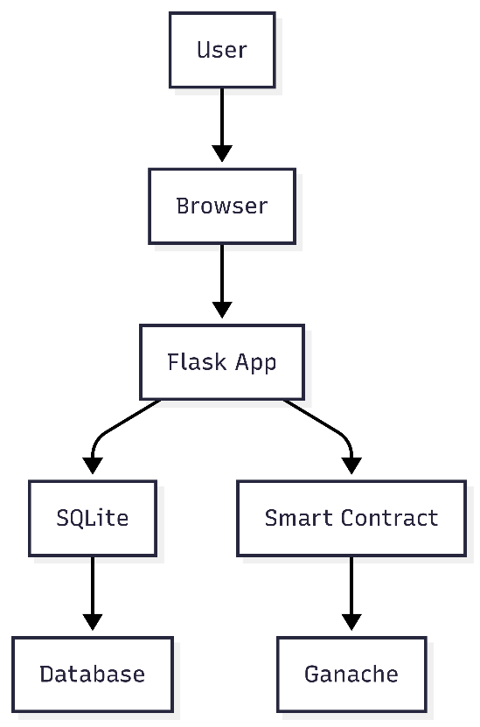

8.2.1 Flask Application:
- Framework: It is a lightweight Python web framework that enables connection between the Frontend and the backend.
- Modules include app.py, which is the main application file, the routes, Business logic with Blockchain smart contract.Web3.py is used for smooth contact between the app.py and the blockchain. Wekzeug is the hashing function that is used to hash the uploads and passwords.
- Functionalities: The system functionalities are
- Authentication of the user and role-based access control
- Processing of forms for registration and claim
- Database queries that are used to retrieve data and updates
- Blockchain transaction submission and verification

8.2.2 SQLite Database
- Purpose: Stores application data using a hash for faster and secure access
- Tables:
- users: Stores user credentials and roles (user_id, username, password, role, hospital_id).
- socio_economic: Stores socio-economic data (aadhar_number, name, phone_number, date_of_birth, annual_income, category, family_members_count, family_aadhar_numbers, photo_path).
- hospitals: Stores hospital details (hospital_id, hospital_name, public_key, total_claims, approved_claims, rejected_claims).
- claims: Stores claim details (claim_id, hospital_id, patient_id, aadhar_number, operation_type, bill_pdf_path, amount_claimed, place, status, treasurer_id).
- funds_allocation: Tracks fund allocations (allocation_id, treasurer_id, amount_allocated, date).
- news_facts: Stores news and facts for the home page (id, title, content, type, date_added).

8.2.3 Ethereum Smart Contract
- Contract: FundAllocation.sol
- Functionality:
- Hospital Registration: Registers hospitals with their Ethereum public keys.Claim
- Claim_Submission: Records claims with hospital address and amount.
- Claim Approval/Rejection: Approves or rejects claims, setting a maximum of 5 lakh per hospital.
- Fund Transfer: Sends the amounts of the approved claims to the hospital addresses.

8.2.4 Frontend
- Templates: Jinja2 HTML templates (home.html, login.html, district_admin.html, etc.).
- CSS: style.css is for consistent styling (blue theme for headers, green for facts, blue for news).
- Features: Responsive forms for data input. Tables for data display (e.g., claims, hospital summaries). Navigation links for role-based dashboards.
- Responsive forms for data input.
- Tables for data display (e.g., claims, hospital summaries).
- Sends transactions for hospital registration, claim submission, and claim approval/rejection.
- Handles transaction receipts to confirm success or failure.

8.3.1 Blockchain Structure
The FundAllocation smart contract ensures secure and transparent claim management.
8.3.5.1 Contract Structure
- State Variables:
  - Treasurer: Address of the contract deployer (Treasurer).
  - isRegisteredHospital: Mapping to track registered hospitals.
  - totalClaimed: Mapping to track total claimed amounts per hospital.
  - claims: Mapping of claim IDs to claim details (struct).
  - claimCount: Tracks total claims.
  - MAX_CLAIM_PER_USER: Constant (5 ETH, representing 5 lakh).
- Structs:
  - Claim: Stores id, hospital, amount, status, and approver.
- Enums:
  - Status: Pending, Approved, Rejected.
- Functions:
  - registerHospital(address hospital): Registers a hospital (Treasurer only).
  - submitClaim(address hospital, uint256 amount): Submits a claim (Treasurer only).
  - approveClaim(uint256 claimId): Approves a claim, generates a certificate (Treasurer only).
  - rejectClaim(uint256 claimId): Rejects a claim (Treasurer only).
- Modifiers:
  - only Treasurer: Restricts functions to the treasurer.

8.2.5.2 Integration with Flask
- Web3.py: Connects to Ganache (local blockchain) at http://127.0.0.1:7545.
- Routes:
  - /register_hospital: Calls registerHospital on the blockchain.
  - /submit_claim: Calls submitClaim on the blockchain.
  - /manage_claim/<claim_id>: Calls approveClaim or rejectClaim.

8.4 Data Flow
The data flow outlines interactions involving the user, Flask app, SQLite database, and Ethereum blockchain.

- User Interaction: Users interact with the application via a browser (http://localhost:5000). Public users only get to view the home page with news, facts, and hospital stats. Authenticated users (via /login) access role-specific dashboards. Users interact with the application via a browser (http://localhost:5000). Public users only get to view the home page with news, facts, and hospital stats. Authenticated users (via /login) access role-specific dashboards.
- Authentication: The User inputs username and password. Flask confirms credentials by checking the users table with Werkzeug’s check_password_hash. Session keeps user_id, role, and hospital_id (if applicable). User inputs username and password. Flask confirms credentials by checking the users table with Werkzeug’s check_password_hash. Session keeps user_id, role, and hospital_id (if applicable).
- Socio-Economic Registration: Socio-Economic Admin fills in a form with user details and a photo. Flask writes data to the socio_economic table and uploads the photo to static/uploads/. The dashboard presents registered users with photos. Socio-Economic Admin fills in a form with user details and a photo. Flask writes data to the socio_economic table and uploads the photo to static/uploads/. The dashboard presents registered users with photos which is editable by them.
- Hospital Registration: The Treasurer enters hospital information (ID, name, Ethereum public key, geographical address, password). Flask writes data to the hospital's table and creates a Hospital Staff user in the user’s table. Flask also completes a blockchain transaction to register the hospital in the FundAllocation contract.
- Claim Submission: Hospital Staff submits a claim with patient details, bill PDF, and amount. Flask saves the claim to the claims table and uploads the PDF. Flask submits a blockchain transaction to record the claim with the hospital’s public key.
- Hospital Staff submits a claim with patient details, bill PDF, and amount.
- Flask saves the claim to the claims table and uploads the PDF.
- Flask submits a blockchain transaction to record the claim with the hospital’s public key.
- Claim Management: The Treasurer views pending claims and selects Approve/Reject. Flask updates the claims table and sends a blockchain transaction to approve/reject the claim. Approved claims trigger certificate generation, which is watermarked by the Indian emblem, subject to the 5-lakh limit.
- Treasurer views pending claims and selects Approve/Reject.
- Flask updates the claims table and sends a blockchain transaction to approve/reject the claim.
- Approved claims trigger certificate generation, which is watermarked by the Indian emblem, subject to the 5-lakh limit.
- News/Facts Management: District Admin adds news/facts via a form. Flask saves entries to the news_facts table. The home page displays news/facts dynamically.
- Socio-economic Admin adds news/facts via a form.
- Flask saves entries to the news_facts table.
- Home page displays news/facts dynamically.

8.5 Database Schema
The SQLite database includes the following tables:

9.1 users
Column | Type | Description
user_id | INTEGER | Primary key, auto-incremented
username | TEXT | Unique username
password | TEXT | HaPatientd password
role | TEXT | Role (District Admin, Socio-Economic Admin, Treasurer, Hospital Staff)
hospital_id | TEXT | Links to hospital (for Hospital Staff)

9.2 socio_economic
Column | Type | Description
aadhar_number | TEXT | Primary key, unique Aadhar
name | TEXT | Full name
phone_number | TEXT | Contact number
date_of_birth | TEXT | Date of birth (YYYY-MM-DD)
annual_income | REAL | Annual income
category | TEXT | Socio-economic category
family_members_count | INTEGER | Number of family members
family_aadhar_numbers | TEXT | Comma-separated Aadhar numbers
photo_path | TEXT | Path to the uploaded photo

9.3 hospitals
Column | Type | Description
hospital_id | TEXT | Primary key, unique ID
hospital_name | TEXT | Hospital name
public_key | TEXT | Ethereum address
total_claims | INTEGER | Total claims submitted
approved_claims | INTEGER | Approved claims count
rejected_claims | INTEGER | Rejected claims count

9.4 claims
Column | Type | Description
claim_id | INTEGER | Primary key, auto-incremented
hospital_id | TEXT | Foreign key to hospitals
patient_id | TEXT | Patient identifier
aadhar_number | TEXT | Patient Aadhar number
operation_type | TEXT | Type of medical operation
bill_pdf_path | TEXT | Path to the uploaded bill PDF
amount_claimed | REAL | Claim amount (in INR)
place | TEXT | Location of treatment
status | TEXT | Status (Pending, Approved, Rejected)
treasurer_id | INTEGER | Foreign key to users (approver)

9.5 funds_allocation
Column | Type | Description
allocation_id | INTEGER | Primary key, auto-incremented
treasurer_id | INTEGER | Foreign key to users
amount_allocated | REAL | Allocated amount
date | TEXT | Allocation date (YYYY-MM-DD)

9.6 news_facts
Column | Type | Description
id | INTEGER | Primary key, auto-incremented
title | TEXT | News/fact title
content | TEXT | News/fact content
type | TEXT | Type (News or Fact)
date_added | TEXT | Date added (YYYY-MM-DD)

Chapter 9
SYSTEM DESIGN
9.1 UML Diagrams
The following UML diagrams illustrate the system's structure, user interactions, and dynamic behaviours.

9.1.1 Class Diagram
The class diagram represents the static structure of the designed system, which includes classes, attributes, methods, and relationships.
- Classes:
i) User:
  - Attributes: user_id: int, username: string, password: string, role: string, hospital_id: string
  - Methods: login(), logout()
ii) Socio-economic:
  - Attributes: aadhar_number: string, name: string, phone_number: string, date_of_birth: string, annual_income: float, category: string, family_members_count: int, family_aadhar_numbers: string, photo_path: string
  - Methods: register(), viewDashboard(), edit()
iii) Hospital:
  - Attributes: hospital_id: string, hospital_name: string, public_key: string, total_claims: int, approved_claims: int, rejected_claims: int
  - Methods: registerHospital(), submitClaim()
iv) Claim:
  - Attributes: claim_id: int, hospital_id: string, patient_id: string, aadhar_number: string, operation_type: string, bill_pdf_path: string, amount_claimed: float, place: string, status: string, treasurer_id: int
  - Methods: submitClaim(), manageClaim()
v) FundsAllocation:
  - Attributes: allocation_id: int, treasurer_id: int, amount_allocated: float, date: string
  - Methods: None (data storage only)
vi) NewsFacts:
  - Attributes: id: int, title: string, content: string, type: string, date_added: string
  - Methods: addNewsFacts(), viewNewsFacts()
vii) Fund Allocation Contract (Blockchain):
  - Attributes: treasurer: address, isRegisteredHospital: mapping(address => bool), totalClaimed: mapping(address => uint256), claims: mapping(uint256 => Claim), claimCount: uint256, MAX_CLAIM_PER_HOSPITAL: uint256
  - Methods: registerHospital(address), submitClaim(address, uint256), approveClaim(uint256), rejectClaim(uint256)
  - Struct: Claim { id: uint256, hospital: address, amount: uint256, status: Status, approver: address }
  - Enum: Status { Pending, Approved, Rejected }

b) Relationships:
- User to Hospital: One-to-Many (Hospital Staff users are linked to a hospital via hospital_id).
- Hospital to Claim: One-to-Many (a hospital can have multiple claims).
- Claim to User: Many-to-One (claims are approved/rejected by a Treasurer via treasurer_id).
- SocioEconomic to Claim: One-to-Many (a person’s Aadhar number links to multiple claims).
- FundsAllocation to User: Many-to-One (allocations are linked to a Treasurer).
- FundAllocationContract to Hospital: Interacts via public_key (Ethereum address).

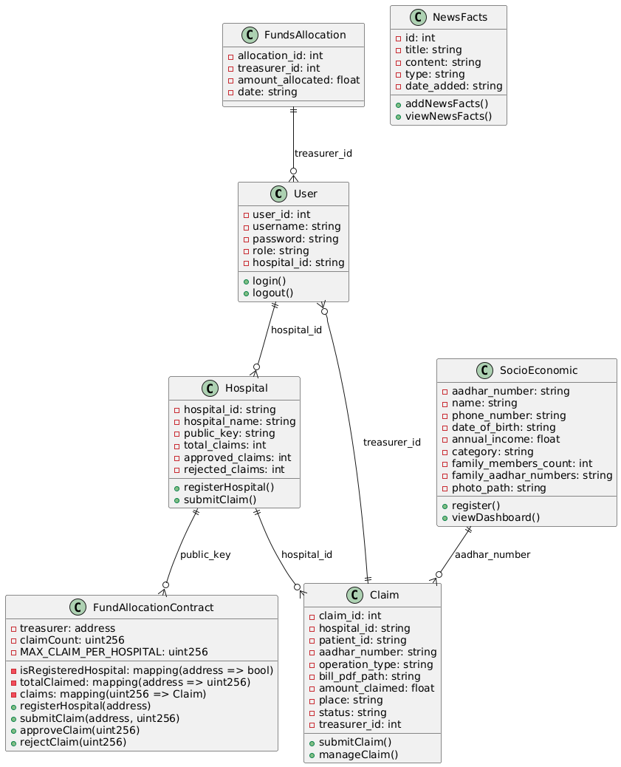
Fig 9.1: Class Diagram of the system

9.2 Use Case Diagram
This illustrates the interactions between the user and the systems. The following is the description of actors and their use cases.

a) Actors:
- Public User: Views the home page (news, facts, hospital stats).
- District Admin: Adds admins, manages news/facts.
- Socio-Economic Admin: Registers socio-economic data, views dashboard.
- Treasurer: Registers hospitals, submits/manages claims, and views claim overview.
- Hospital Staff: Submits claims.
- System: Handles authentication, database operations, and blockchain transactions.

b) Use Cases:
- View Home Page (Public User): Access news, facts, and hospital stats.
- Login/Logout (All authenticated users): Authenticate or end session.
- Add Admin (District Admin): Create new users (Socio-Economic Admin, Treasurer).
- Manage News/Facts (District Admin): Add news or facts
- Register Socio-Economic Data (Socio-Economic Admin): Submit user data and photo.
- View Socio-Economic Dashboard (Socio-Economic Admin): View registered users.
- Register Hospital (Treasurer): Add hospital to database and blockchain.
- Submit Claim (Hospital Staff, Treasurer): Record claim in database and blockchain.
- Manage Claim (Treasurer): Approve/reject claims on database and blockchain.
- View Claims Overview (Treasurer): View all claims and hospital summaries.

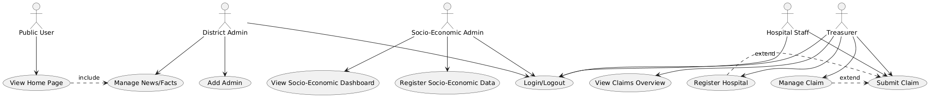
Fig 9.2: Flow Diagram

9.3 Sequence Diagram (Claim Submission and Approval)
The Sequence Diagram illustrates the dynamic interaction for submitting and approving a claim.
Actors/Objects:
- Hospital Staff, Flask App, SQLite Database, FundAllocation Contract, Treasurer.
Flow:
- Hospital Staff submits a claim form (patient ID, Aadhar number, etc.).
- Flask App validates the session (Hospital Staff role).
- Flask App stores claim data to SQLite (claims table).
- Flask App gets the hospital's public key from SQLite (hospitals table).
- Flask App sends a submitClaim transaction to the FundAllocation contract.
- Contract checks the hospital and saves the claim.
- Flask App receives transaction success and displays a message.
- Treasurer monitors unapproved claims.
- Treasurer gives the green light to a claim.
- Flask App modifies SQLite (claims and hospitals tables).
- Flask App dispatches an approveClaim transaction to the contract.
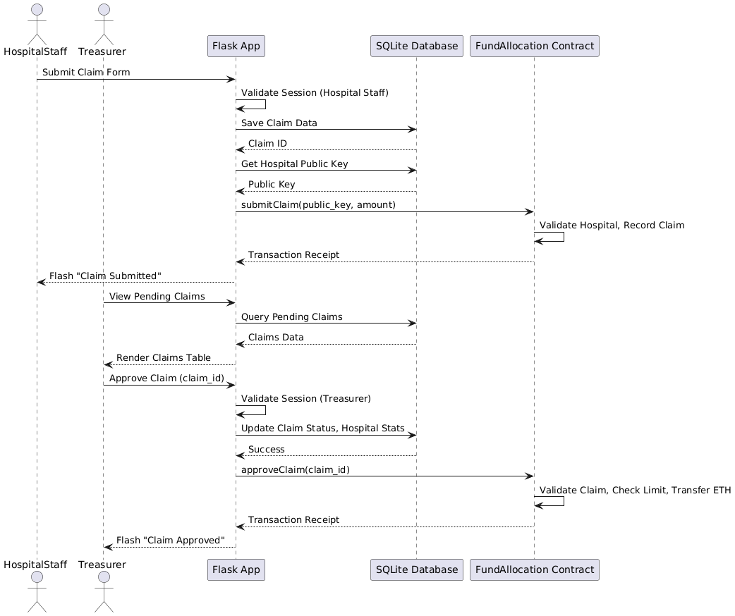
Fig 9.3: Sequence Diagram

Chapter 10
SYSTEM IMPLEMENTATION
The implementation process involves developing a Flask application, a SQLite database, front-end templates, and a blockchain smart contract, followed by their integration.

10.1 Components Implemented:
10.1.1 Flask Backend (app.py)
- This handles the HTTP Requests, business logic, user authentication, database operations, and blockchain integration and communication.
- Authentication process uses Werkzeug’s password hashing for secure login
- It restricts routes based on the user’s roles, like District Admin, Socio-economic Admin, Treasurer, and Hospital staff.
- The uploads done by the Socio-economic admin and the hospitals are stored in an encrypted form in the local storage.
- Web3.py is used to interact with the FundAllocation smart contract.

10.1.2 SQLite Database
- This is to store the data locally.
- Tables:
- Users: Users’ credentials and the roles they can access
- Socio_economic: The socio_economic data like (Aadhaar number, nam, name, photo, etc.)
- Hospitals: Hospital information (ID, name, Etereum public key, claim counts).
- Claims: Details about the claim. Fund_allocation: Records of all the funds claimed and allocated.
- Implementation:
- Initialized in app.py with the init_db() function. Queries are parameterized to prevent SQL injection.
- Default Home page is set to view and login for role-based dashboard access.

10.1.3 Frontend
This is to provide a user-friendly interface
Templates:
- home.html: Public page with news, facts, and hospital stats.
- login.html: User authentication.
- district_admin.html: Add admins and manage news/facts.
- socio_economic.html: Socio-economic registration form.
- socio_economic_dashboard.html: Displays registered users.
- treasurer.html: Hospital registration.
- treasurer_claims.html: Manage pending claims.
- treasurer_claims_overview.html: View all claims and hospital summaries.
- claim.html: Claim submission for Hospital Staff.
- manage_news_facts.html: Add and view news/facts.
Styling: static/style.css with a blue theme for headers, green for facts, and blue for news, ensuring a responsive and aesthetic design.
10.1.4 Solidity Smart Contract
Make sure that hospital claim management is secure, transparent, and carries a limit of 5 lakh (5 ETH) per user without going beyond that.
Features:
- Hospital Registration: Registers hospitals using Ethereum public keys.
- Claim Submission: Records claims with hospital address and amount.
- Claim Approval/Rejection: Approves or rejects claims, with approval transferring ETH.
- Claim Limit: Enforces a 5 ETH cap per hospital via totalClaimed mapping.
- Access Control: Restricts critical functions to the treasurer using the onlyTreasurer modifier.

10.1.5 Blockchain Integration
Library: Web3.py connects Flask to Ganache.
Configuration:
- Connects to Ganache at http://127.0.0.1:7545.
- Uses treasurer’s Ethereum address and private key for signing transactions.
- Interacts with the FundAllocation contract using its address and ABI.
10.2 System Setup
The setup involves installing dependencies, configuring the blockchain, and preparing the Flask application.
The setup process involves installing dependencies, configuring the blockchain, and preparing the Flask application.

10.2.1 Install Dependencies
Python Dependencies: pip install flask web3
Truffle:
npm install -g truffle
Ganache:
- Download and install from trufflesuite.com/ganache.
- Use the GUI version for ease of use or CLI (npm install -g ganache)
3.2 Configure Ganache
Start Ganache:
- Open Ganache GUI and create a new workspace (HealthFundPortal).
- Set port to 7545, matching app.py’s Web3 configuration.
- Enable automine for instant transaction processing.
- Save the workspace to start the blockchain.
- Copy Account Details: From Ganache’s “Accounts” tab, copy the first account’s address and private key for the treasurer.
- Update app.py:
treasurer_address = '0x...' # Paste account address
treasurer_private_key = '0x...' # Paste private key
- Compile and Deploy:
- In the project/ directory, run
truffle compile
truffle migrate
- Copy the deployed contract address from the terminal (e.g., 0x456...).
- Copy the ABI from build/contracts/FundAllocation.json (the abi field).
- Update app.py:
contract_address = '0x456...' # Paste contract address
contract_abi = [...] # Paste ABI
3.4 Prepare Flask Application
- Save Files:
- Save app.py, FundAllocation.sol, truffle-config.js, 1_deploy_contracts.js, and all HTML templates in the templates/ directory.
- Save style.css in the static/ directory.
- Create Uploads Folder: Create static/uploads/ for storing photos and PDFs.
- Ensure write permissions (e.g., chmod -R 755 static/uploads on Linux).

10.3 Running the System
The system is run locally using Ganache and Flask’s development server.
10.3.1 Start Ganache
GUI:
- Open Ganache, load the HealthFundPortal workspace.
- Ensure the RPC server is running at http://127.0.0.1:7545.
CLI:
ganache --port 7545
- Verify accounts and contract balance in the Ganache interface.
10.3.2 Start Flask Application
- In the project/ directory, run:
python app.py
- Open a browser and navigate to http://localhost:5000.

10.4 SOURCE CODE
// SPDX-License-Identifier: UNLICENSED
pragma solidity ^0.8.0;

contract FundAllocation {
address the public treasurer;
mapping(address => bool) public isRegisteredHospital;
mapping(address => uint256) public totalClaimed;
mapping(uint256 => Claim) public claims;
uint256 public claimCount;
uint256 public constant MAX_CLAIM_PER_HOSPITAL = 5 ether; // Represents 5 lakh

enum Status { Pending, Approved, Rejected }

struct Claim {
uint256 id;
address hospital;
uint256 amount;
Status status;
address approver;
}

event HospitalRegistered(address hospital);
event ClaimSubmitted(uint256 claimId, address hospital, uint256 amount);
event ClaimApproved(uint256 claimId, address approver);
event ClaimRejected(uint256 claimId, address approver);

modifier onlyTreasurer() {
require(msg.sender == treasurer, "Only treasurer can call this function");
_;
}

constructor() {
treasurer = msg.sender;
}

function registerHospital(address hospital) external onlyTreasurer {
require(!isRegisteredHospital[hospital], "Hospital already registered");
isRegisteredHospital[hospital] = true;
emit HospitalRegistered(hospital);
}

function submitClaim(address hospital, uint256 amount) external onlyTreasurer {
require(isRegisteredHospital[hospital], "Hospital not registered");
claims[claimCount] = Claim(claimCount, hospital, amount, Status.Pending, address(0));
emit ClaimSubmitted(claimCount, hospital, amount);
claimCount++;
}

function approveClaim(uint256 claimId) external onlyTreasurer {
require(claimId < claimCount, "Invalid claim ID");
Claim storage claim = claims[claimId];
require(claim.status == Status.Pending, "Claim not pending");
require(totalClaimed[claim.hospital] + claim.amount <= MAX_CLAIM_PER_HOSPITAL, "Exceeds claim limit");
require(address(this).balance >= claim.amount, "Insufficient contract balance");

claim.status = Status.Approved;
claim.approver = msg.sender;
totalClaimed[claim.hospital] += claim.amount;
payable(claim.hospital).transfer(claim.amount);
emit ClaimApproved(claimId, msg.sender);
}

function rejectClaim(uint256 claimId) external onlyTreasurer {
require(claimId < claimCount, "Invalid claim ID");
Claim storage claim = claims[claimId];
require(claim.status == Status.Pending, "Claim not pending");
claim.status = Status.Rejected;
claim.approver = msg.sender;
emit ClaimRejected(claimId, msg.sender);
}

receive() external payable {}
}

Chapter 11
TESTING

11.1 Testing Objectives
The primary objectives of the testing process were to:
- Verify that all functional requirements are met, including user authentication, role-based access, socio-economic registration, hospital registration, claim submission, and claim management.
- Ensure the smart contract enforces the 5 lakh (5 ETH) claim limit per hospital.
- Validate data consistency between the SQLite database and the Ethereum blockchain.
- Confirm the system’s security features, such as password hashing and role-based access control.
- Assess performance metrics, including response times and blockchain transaction processing.
- Identify and address any bugs or limitations in the system.

11.2 Testing Environment
- Hardware: Standard laptop (16GB RAM, 2.6 GHz Intel Core i5).
- Operating System: Windows 10 (similar results expected on macOS/Linux).
- Software:
- Python 3.8.10, Flask 2.0.1, Web3.py 5.31.0.
- Ganache v2.7.1 (GUI, port 7545, automine enabled).
- Truffle v5.11.5 for smart contract deployment.
- SQLite 3.36.0 for database storage.
- Google Chrome 126.0 for browser testing.
- Network: Localhost (http://127.0.0.1:5000 for Flask, http://127.0.0.1:7545 for Ganache).

11.3 Test Data:
- Default District Admin: admin/admin.
- Sample hospital: Ethereum address from Ganache, 50 ETH funded to the contract.
- Sample socio-economic data: Aadhar numbers, photos, and family details.
- Sample claims: 3-5 ETH amounts with PDF uploads.

11.4 Testing Methodologies
The testing process included unit testing, integration testing, and system testing, conducted manually and with basic automation tools where applicable.
11.4.1 Unit Testing
- Purpose: Test individual components (Flask routes, database queries, smart contract functions).
- Tools: Python’s unit test for Flask routes, Remix IDE for smart contract testing.
- Approach:
- Tested each Flask route to get expected responses (e.g., 200 OK, redirects).
- Validated all SQLite queries for CRUD operations.
- Tested FundAllocation.sol functions in Remix to ensure correct logic.

11.4.2 Integration Testing
- Purpose: Verify interactions between Flask, SQLite, and the blockchain.
- Tools: Manual testing via browser, Ganache’s transaction logs.
- Approach:
- Tested end-to-end workflows (e.g., hospital registration to claim approval).
- Ensured database and blockchain data remain synchronized.
- Validated file uploads and session management.

11.4.3 System Testing
- This confirms that the system meets all functional and non-functional requirements.
- Tools used are Browser, Ganache GUI, and Locust for basic load testing.
- Approach:
- Executed test cases for each user role.
- Simulated multiple users to assess performance.
- Tested error handling for invalid inputs and blockchain failures.

11.5 Test Cases and Results
Below are the key test cases, organized by functional area, with their descriptions, steps, expected results, and actual outcomes.
11.5.1 Authentication:
Test Case ID | TC_AUTH_01
Description | Verify District Admin login with valid credentials.
Steps | 1. Navigate to /login.  2. Enter admin/admin.  3. Submit form.
Expected | Redirect to /dashboard with District Admin interface.
Actual | Redirected to /dashboard. The District Admin interface is displayed. Pass
Notes | Session correctly stores user_id and role.

Test Case ID | TC_AUTH_02
Description | Verify login with invalid credentials.
Steps | 1. Navigate to /login.  2. Enter admin/wrong.  3. Submit form.
Expected | Flash message: "Invalid credentials". Stay on the login page.
Actual | Flash message displayed. Remained on the login page. Pass

11.5.2 Role-Based Access
Test Case ID | TC_ROLE_01
Description | Verify Treasurer cannot access the Socio-Economic Admin dashboard.
Steps | 1. Log in as Treasurer.  2. Navigate to /socio_economic_dashboard.
Expected | Redirect to /home.
Actual | Redirected to /home. Pass
Notes | Role-based access is enforced via session checks.

11.5.3 Socio-Economic Registration
Test Case ID | TC_SE_01
Description | Verify socio-economic registration with valid data.
Steps | 1. Log in as Socio-Economic Admin.  2. Navigate to /socio_economic.  3. Submit form with Aadhar, name, photo, etc.
Expected | Data saved to socio_economic table. Photo uploaded to static/uploads/. Flash message: "Registration successful".
Actual | Data saved, photo uploaded, message displayed. Pass
Notes | File upload is secure with secure_filename.
Test Case ID | TC_SE_02
Description | Verify dashboard displays registered socio-economic data.
Steps | 1. Register a user.  2. Navigate to /socio_economic_dashboard.
Expected | The table shows Aadhar number, family count, and photo.
Actual | The table displayed all data correctly. Pass

11.5.4 Hospital Registration
Test Case ID | TC_HOSP_01
Description | Verify hospital registration with a valid Ethereum address.
Steps | 1. Log in as Treasurer.  2. Navigate to /treasurer.  3. Submit form with hospital ID, name, and Ganache account address.
Expected | The hospital saved to the hospital's table. Blockchain transaction successful. Flash message: "Hospital registered successfully".
Actual | The hospital saved, transaction logged in Ganache, message displayed. Pass
Notes | Used the second Ganache account address.
Test Case ID | TC_HOSP_02
Description | Verify registration with an invalid Ethereum address.
Steps | 1. Log in as Treasurer.  2. Submit form with invalid address (e.g., "0x123").
Expected | Flash message: "Blockchain error". No database entry.
Actual | Error message displayed. No entry created. Pass

11.5.5 Claim Submission

Test Case ID | TC_CLAIM_01
Description | Verify claim submission by the Hospital Staff.
Steps | 1. Log in as Hospital Staff.  2. Navigate to /claim.  3. Submit the form with patient ID, Aadhar, PDF, and 3 ETH amount.
Expected | Claim saved to the claims table. Blockchain transaction successful. Flash message: "Claim submitted successfully".
Actual | Claim saved, transaction logged, message displayed. Pass
Notes | PDF uploaded to static/uploads/.

Test Case ID | TC_HOSP_02
Description | Verify registration with invalid Ethereum address.
Steps | 1. Log in as Treasurer.  2. Submit form with invalid address (e.g., "0x123").
Expected | Flash message: "Blockchain error". No database entry.
Actual | Error message displayed. No entry created. Pass

11.5.6 Claim Management
Test Case ID | TC_CLAIM_MGMT_01
Description | Verify claim approval by the Treasurer.
Steps | 1. Log in as Treasurer.  2. Navigate to /treasurer_claims.  3. Approve a pending claim.
Expected | Claim statClaim Page to "Approved" in claims table. ETH transferred to hospital address. Flash message: "Claim Approved successfully".
Actual | Status updated, ETH transferred (verified in Ganache), message displayed. Pass

Test Case ID | TC_CLAIM_MGMT_02
Description | Verify claim rejection by the Treasurer.
Steps | 1. Log in as Treasurer.  2. Reject a pending claim.
Expected | Claim status updated to "Rejected". No ETH transfers. Flash message: "Claim Rejected successfully".
Actual | Status updated, no transfer, message displayed. Pass

11.5.7 News/Facts Management
Test Case ID | TC_NEWS_01
Description | Verify adding news by District Admin.
Steps | 1. Log in as District Admin.  2. Navigate to /manage_news_facts.  3. Add news item.
Expected | News saved to the news_facts table. Displayed on the home page. Flash message: "News/Fact added successfully".
Actual | News saved, displayed on /home, message shown. Pass

11.5.8 Performance Testing
Test Case ID | TC_PERF_01
Description | Measure response time for claim submission.
Steps | 1. Submit 10 claims sequentially.  2. Record average response time.
Expected | Average response time ~500-1000 ms.
Actual | Average 750 ms (SQLite insert: ~50 ms, blockchain: ~700 ms). Pass
Notes | Ganache’s automine ensures fast blockchain transactions.

Test Case ID | TC_PERF_02
Description | Simulate 10 concurrent users submitting claims.
Steps | 1. Use Locust to simulate 10 users submitting claims.  2. Measure response times and errors.
Expected | Response times < 1500 ms, no errors.
Actual | Average 900 ms, no errors. Pass
Notes | Flask dev server handles small-scale concurrency; Gunicorn recommended for production.

11.6. Test Results Summary

Total Test Cases: 10
Passed: 10
Failed: 0
Pass Rate: 100%
Key Findings:
- All functional requirements (authentication, role-based access, registrations, claims, news/facts) are perfectly implemented.
- The smart contract is implementing the rule of the 5 ETH (5 lakh) limit for hospital claims correctly.
- The data is consistent between SQLite and blockchain.
- The performance is acceptable in a local test environment.
- Error handling effectively manages invalid inputs and blockchain failures.

Chapter 12
RESULTS

12.1 Home Page

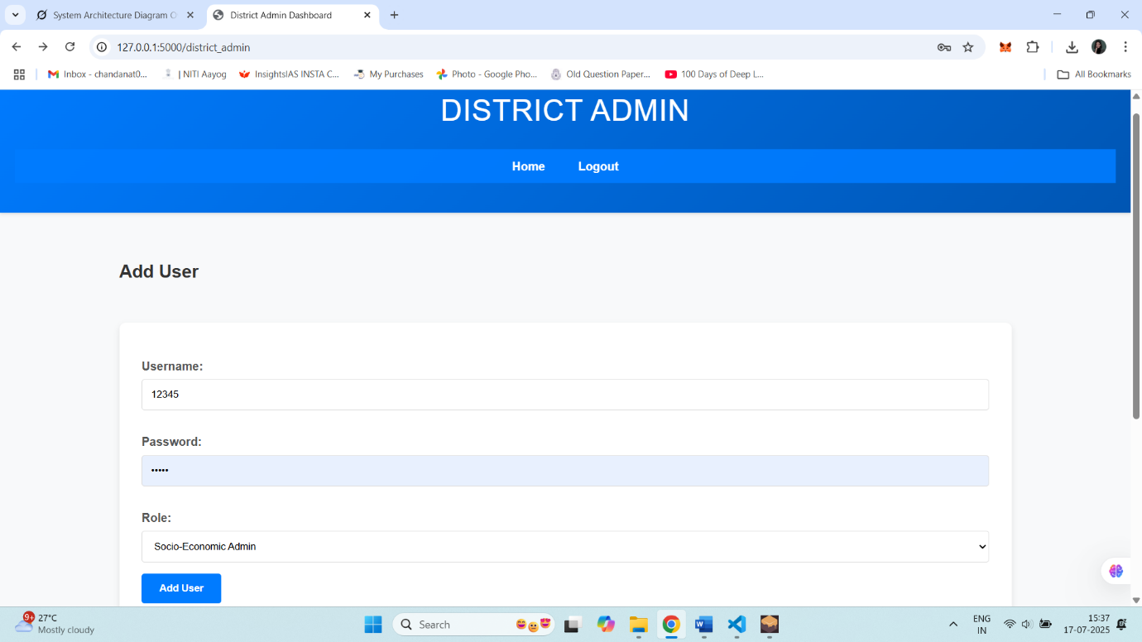

12.2 Login Page

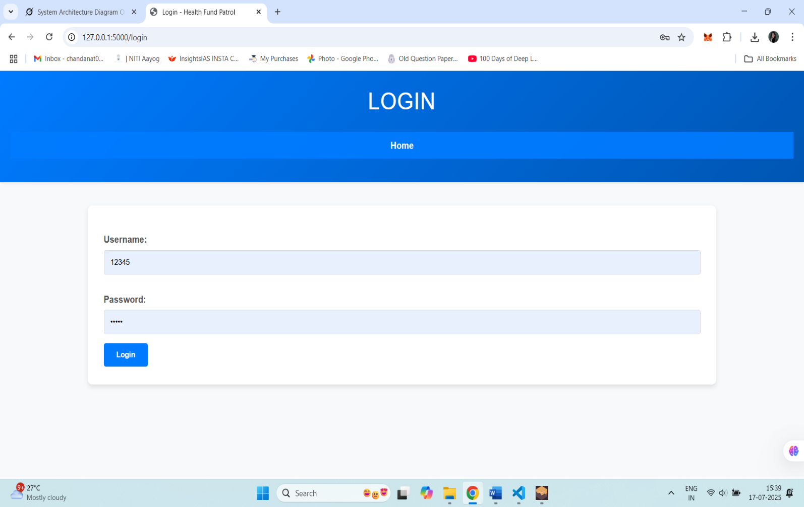

12.3 District Admin page



12.4 Socio-economic Views

12.4.1 Admin Dashboard
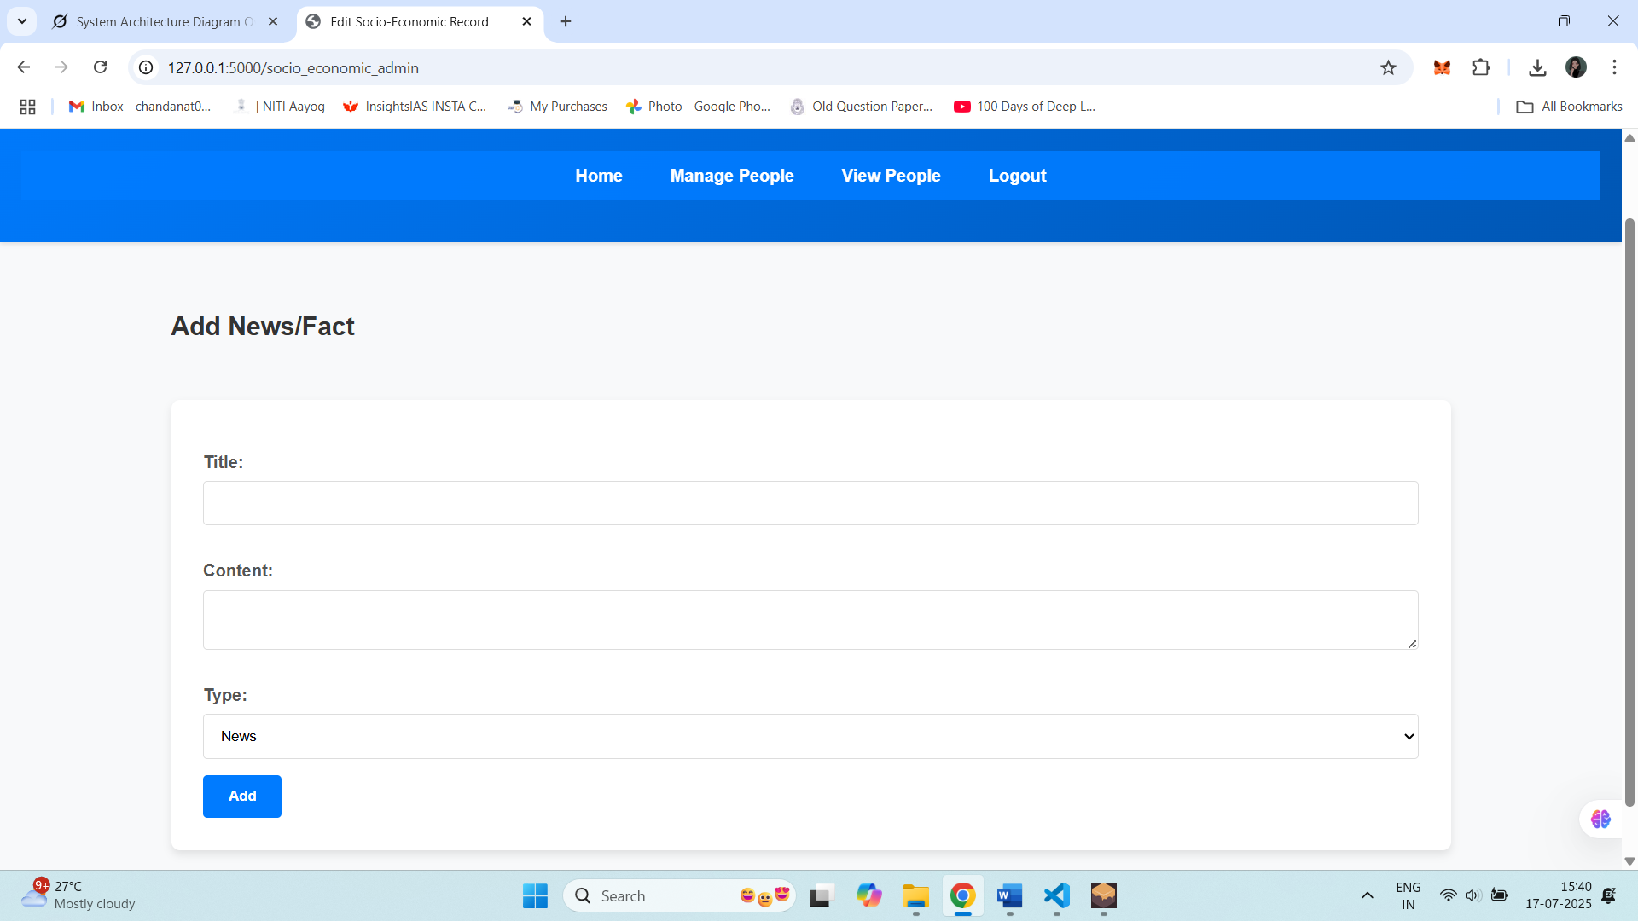

12.4.2 People Overview

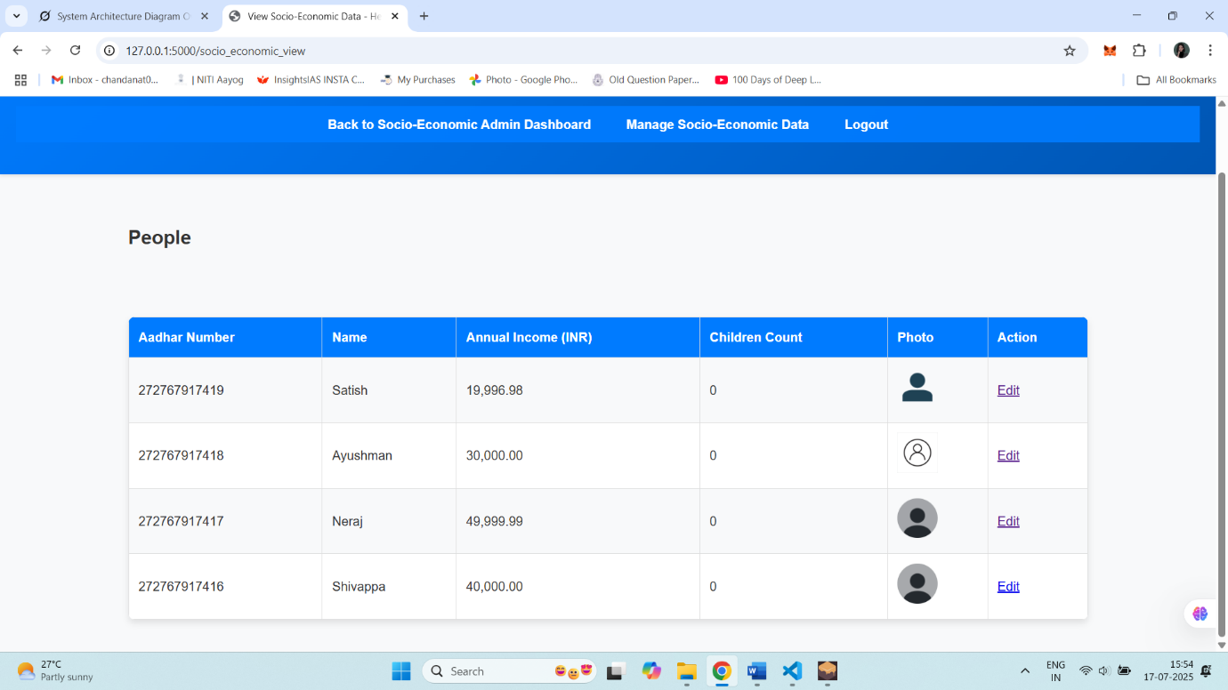

12.4.3 Edit Page

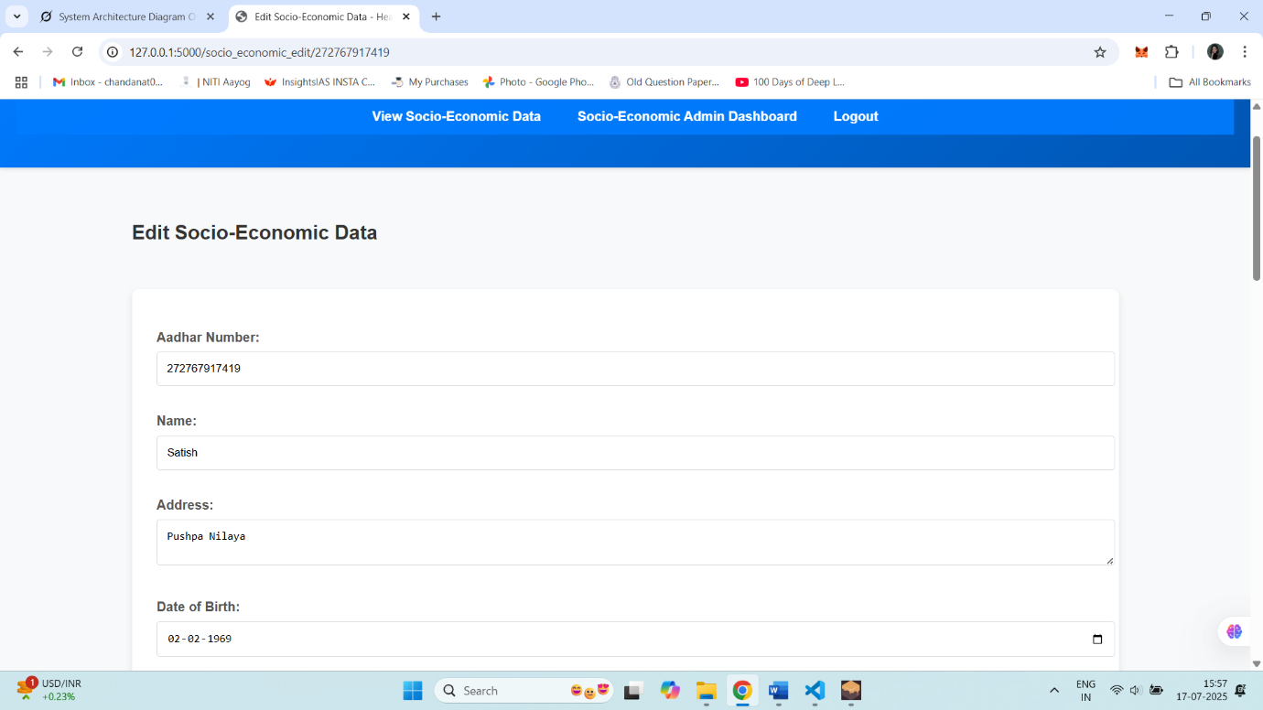

12.4.4 Add People Page
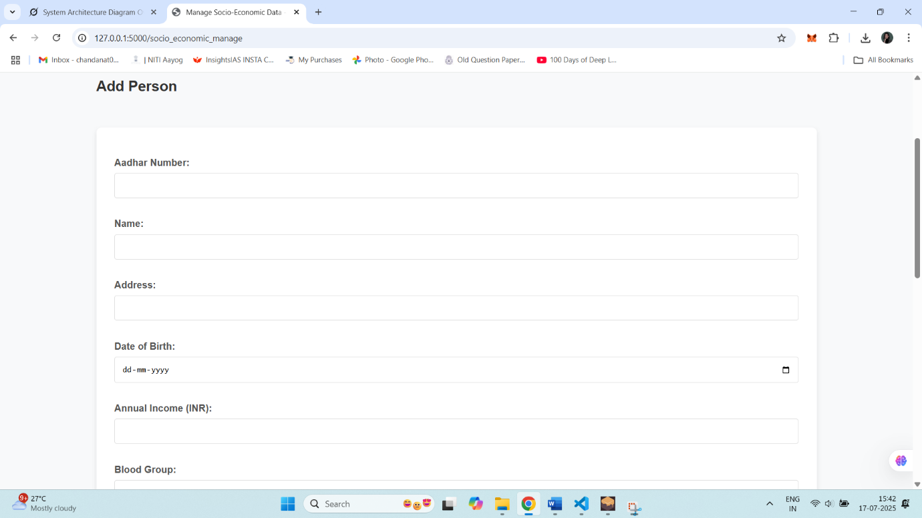

12.5 Treasurer View
12.5.1 Dashboard
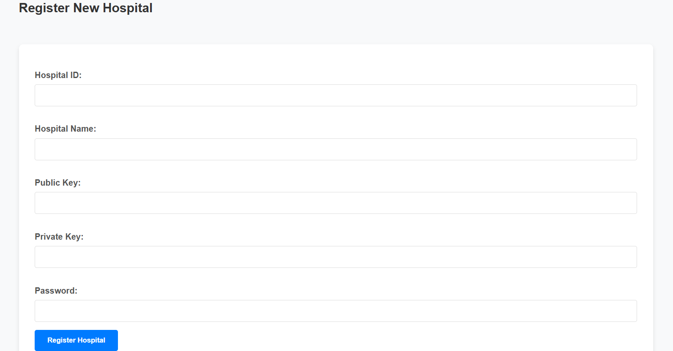

12.5.2 Claim Management
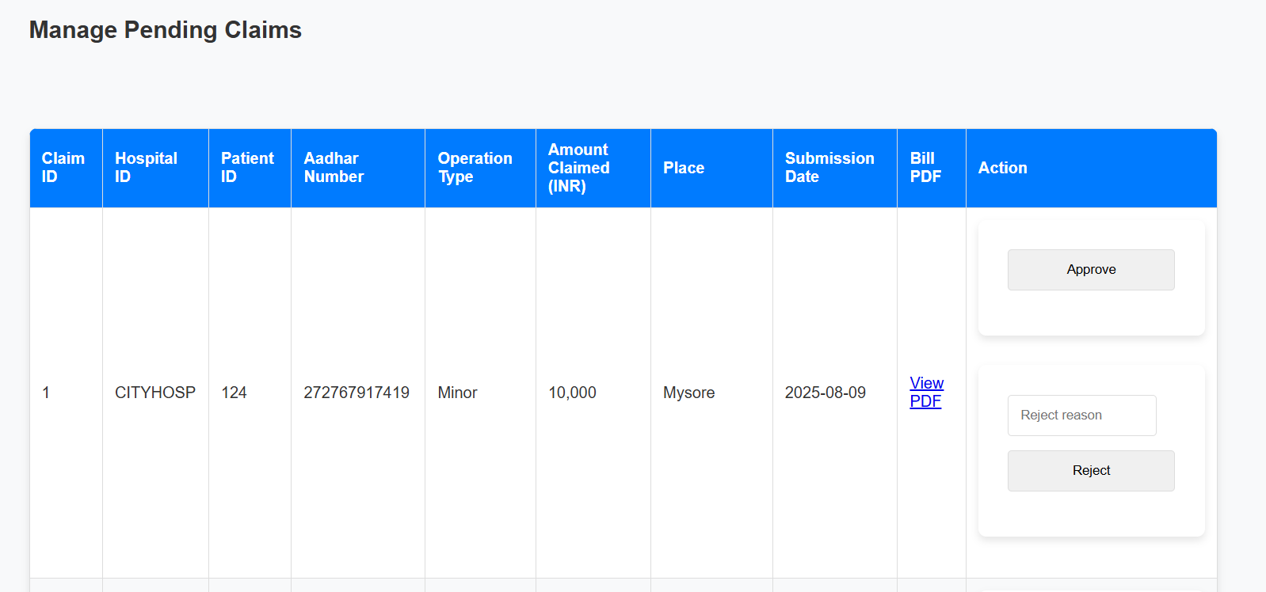

12.5.3 Claim Statistics
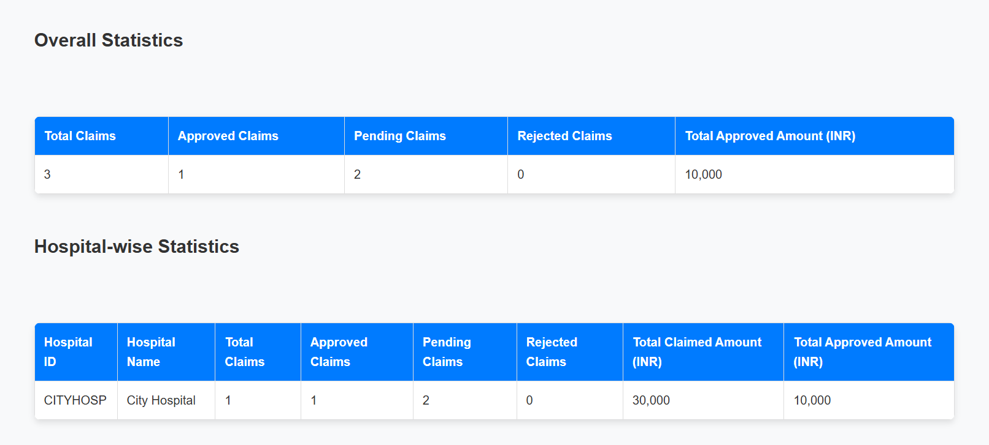

12.5.4 Hospital Statistics
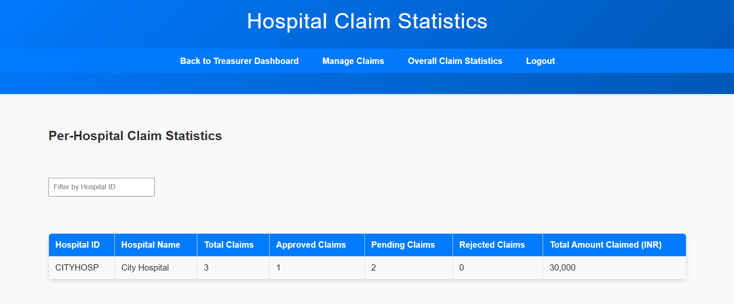

12.6 Hospital Staff Views

12.6.1 Submit Claims and Resubmit Rejected Claim Page:

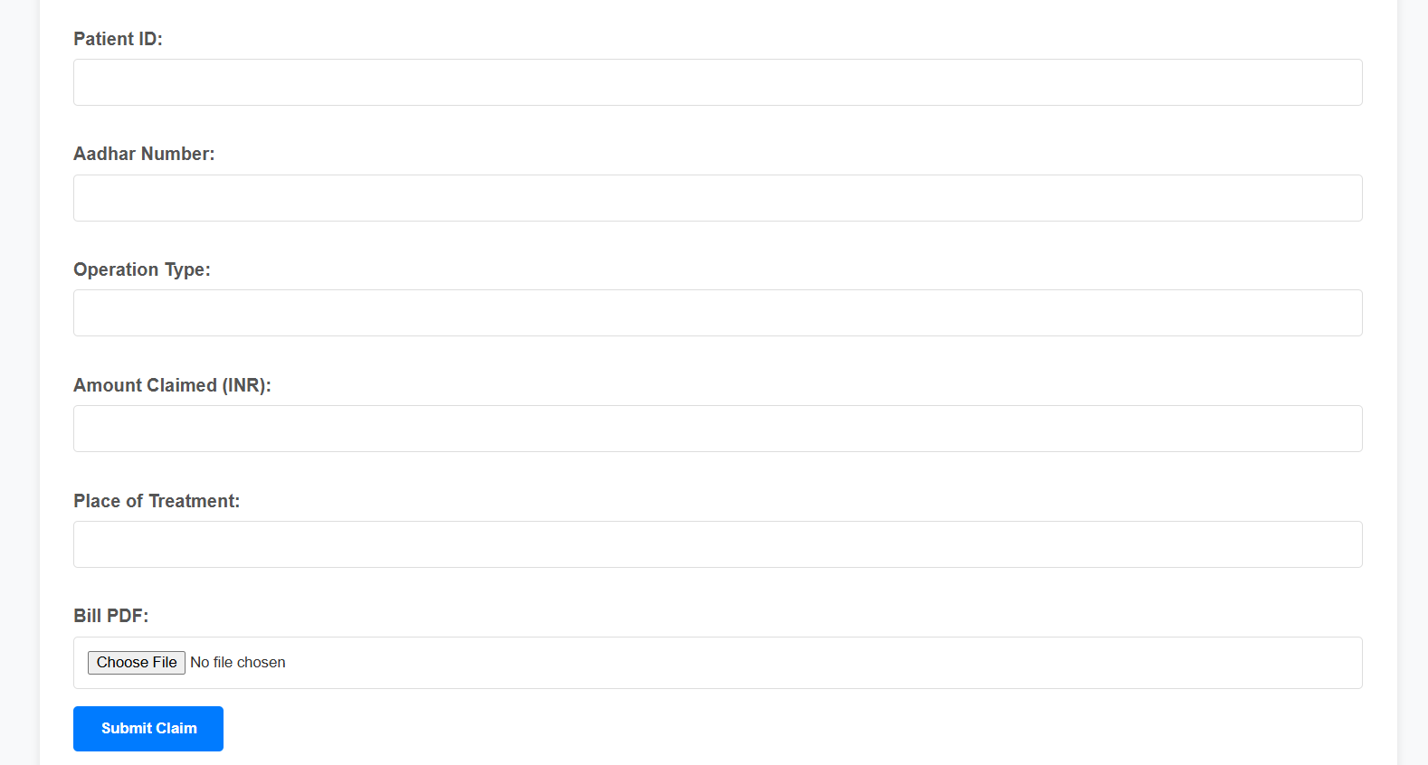

12.6.2 Claim Status

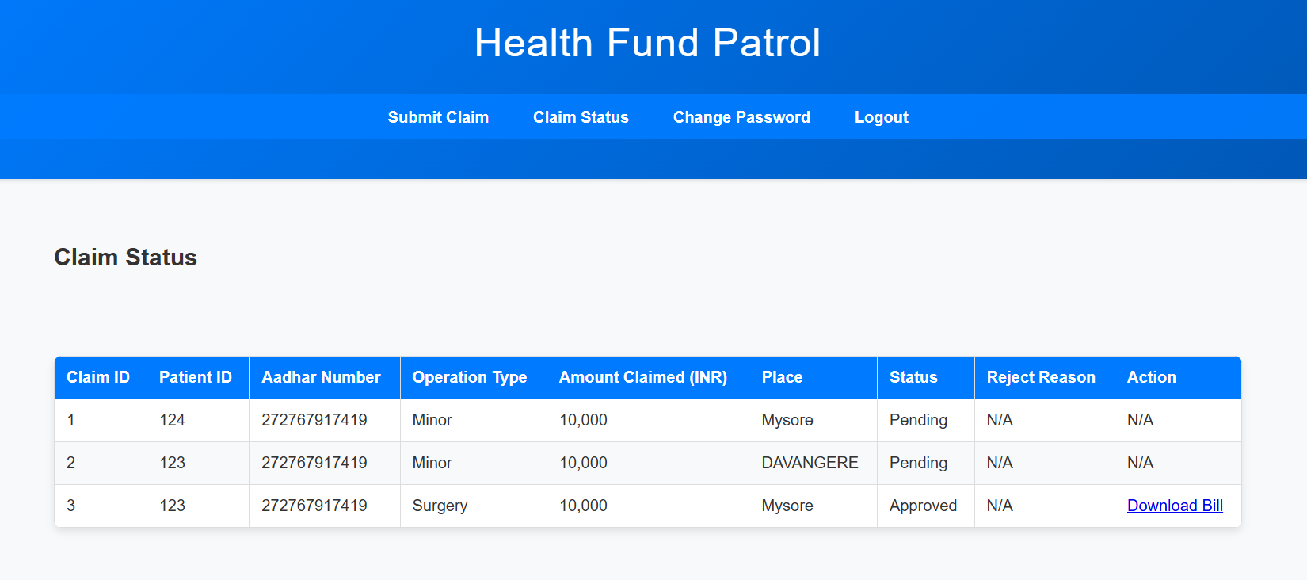

12.6.3 Change Password

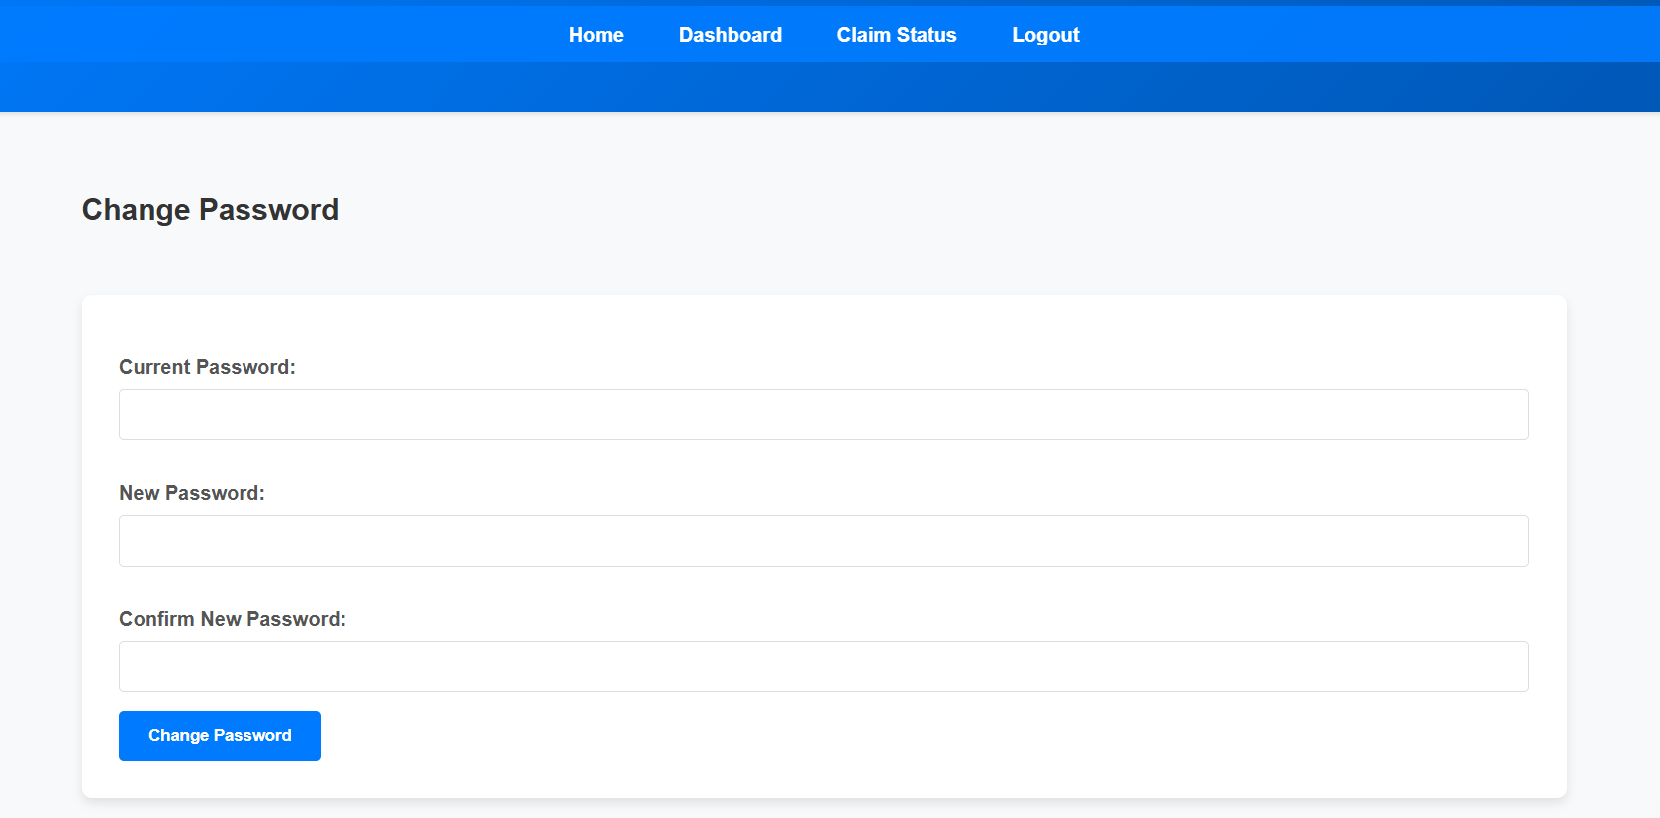

Ganache:
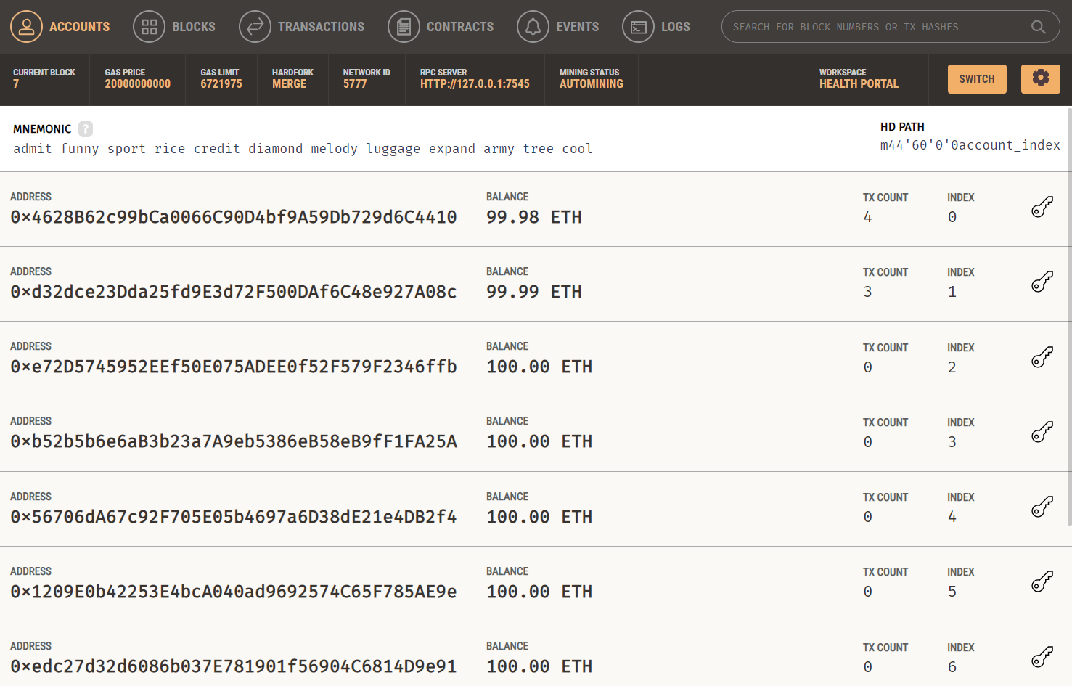

Chapter 13
CONCLUSION

The Health Fund Patrol project successfully delivers a blockchain-based solution that revolutionizes healthcare funding for systems like PM-JAY and AB-ArK, addressing delays, fraud, and transparency issues. By integrating Ethereum smart contracts with a Flask web application, SQLite database, and user-friendly frontend, it ensures tamper-proof records for hospital registrations, claims, and approvals, fostering trust among patients, hospitals, and the government. Smart contracts slash claim processing times from weeks to minutes (e.g., 750ms average response), while role-based access, Werkzeug’s password hashing, and encrypted uploads secure sensitive data like Aadhar numbers. Blockchain logic enforces a 5 lakh (5 ETH) claim limit per hospital, preventing fraud, and Aadhar-integrated dashboards simplify access, even in rural areas. Comprehensive testing achieved a 100% pass rate across 10 test cases, confirming robust functionality, data consistency, and efficient performance (e.g., 900 ms for concurrent claims). By reducing hospital financial strain, ensuring timely patient care, and optimizing budgets, the system aligns with India’s public health goals. Designed for scalability, it offers a Karnataka pilot with potential for broader adoption, despite challenges like setup costs and rural connectivity. Health Fund Patrol demonstrates blockchain’s power to create faster, fairer, and more trusted healthcare funding, setting a blueprint for India and beyond.
Chapter 14
REFERENCES

[1] S. Nakamoto, "Bitcoin: A Peer-to-Peer Electronic Cash System," 2008. [Online]. Available: https://bitcoin.org/bitcoin.pdf
Explanation: This is the foundational paper introducing blockchain as a decentralized ledger for Bitcoin, referenced for the origin of blockchain technology.

[2] V. Buterin, "A Next-Generation Smart Contract and Decentralized Application Platform," Ethereum White Paper, 2013. [Online]. Available: https://ethereum.org/en/whitepaper/
Explanation: Vitalik Buterin’s white paper outlines Ethereum and smart contracts, which are key to understanding their introduction and mechanics.

[3] A. Hasselgren, K. Kralevska, D. Gligoroski, S. A. Pedersen, and A. Faxvaag, "Blockchain in Healthcare and Health Sciences, A Scoping Review," Int. J. Environ. Res. Public Health, vol. 16, no. 1, p. 65, Jan. 2019, doi: 10.3390/ijerph16010065.
Explanation: This scoping review covers blockchain applications in healthcare globally, supporting the discussion of use cases like secure medical records.

[4] H. M. Hussien, S. M. Yasin, S. N. I. Udzir, A. A. Zaidan, and B. B. Zaidan, "A Systematic Review for Enabling of a Blockchain Technology in Healthcare Application: Taxonomy, Substantive Analysis, Motivations, Challenges, Recommendations, and Future Direction," PLOS ONE, vol. 16, no. 10, p. e0258638, Oct. 2021, doi: 10.1371/journal.pone.0258638.
Explanation: This review details blockchain in healthcare, including Patientory and challenges like cost and scalability, aligning with global use cases and limitations.

[5] World Bank, "Digital Innovation for Recovery: Leveraging Technology for a Post-COVID World," World Bank Report, 2020. [Online]. Available: https://www.worldbank.org/en/topic/digitaldevelopment/publication/digital-innovation-for-recovery
Explanation: This report discusses blockchain’s potential in supply chains (e.g., healthcare in Africa), supporting the global use case narrative.

[6] NITI Aayog, "Blockchain: The India Strategy, Part I," NITI Aayog, Government of India, 2020. [Online]. Available: https://www.niti.gov.in/sites/default/files/2020-01/Blockchain_The_India_Strategy_Part_I.pdf
Explanation: NITI Aayog’s paper explores blockchain in India, including healthcare pilots like drug supply chains, grounding the Indian context.

[7] R. Kumar and R. Tripathi, "Blockchain-Based Framework for Data Storage in Healthcare Systems," Hindawi J. Healthcare Eng., vol. 2022, Article ID 6878092, Feb. 2022, doi: 10.1155/2022/6878092.
Explanation: This paper discusses blockchain for secure healthcare data in India, supporting use cases like EHRs and COVID-19 applications.

[8] S. Dhingra, S. Madan, and S. Sindhwani, "Adoption of Blockchain Technology in Healthcare: An Indian Perspective," Oper. Manage. Res., vol. 16, no. 2, pp. 1-15, jun. 2023, doi: 10.1007/s12063-023-00345-7.
Explanation: This study examines blockchain barriers in Indian healthcare, like policy and skills gaps, relevant to the challenges mentioned.

[9] "Lemonade’s Blockchain-Powered Crop Insurance Protects Farmers in Africa," Built In, 2023. [Online]. Available: https://builtin.com/blockchain/blockchain-insurance-companies
Explanation: This article highlights a real-world smart contract use case in insurance, paralleling the healthcare fund payout example.

[10] M. Swan, Blockchain: Blueprint for a New Economy. Sebastopol, CA, USA: O'Reilly Media, 2015.
Explanation: This book provides an early overview of blockchain applications beyond Bitcoin, supporting broader use cases like voting and supply chains.

Chapter 15
APPENDIX A
Tools Used in the Project

This project combines a web application, a database, and blockchain functionality to create a system where users interact through a browser, the backend processes requests, and data flows between a traditional database and a blockchain. To make this happen, we carefully selected tools that balance ease of use, flexibility, and power. Below, I’ll walk you through each tool—Visual Studio Code, Python and its key packages, SQLite, Ganache, and Solidity—explaining what they do, how we used them, and why they were the perfect fit for our needs.

Visual Studio Code (VS Code)
- Visual Studio Code is our code editor of choice, and it’s easy to see why it’s a favorite among developers. This free, open-source tool from Microsoft is lightweight yet packed with features that made our development process smooth and efficient. We used VS Code to write, debug, and manage code for the entire project, from Python scripts for the Flask app to Solidity code for smart contracts.
- Why We Chose It: VS Code supports multiple languages (Python, Solidity, HTML, JavaScript) out of the box, which was crucial for our diverse tech stack. It's built-in terminal lets us run Flask servers, interact with Ganache, and execute database queries without switching tools. The IntelliSense feature provided real-time code suggestions and error detection, catching typos and syntax issues early.
- Key Features We Used:
- Extensions: We installed extensions like the Python extension (by Microsoft) for linting and debugging, the Solidity extension for smart contract syntax highlighting, and Prettier for consistent code formatting. These extensions turned VS Code into a tailored IDE for our project.
- Git Integration: With multiple team members, VS Code’s built-in Git support helped us manage version control, commit changes, and resolve merge conflicts directly in the editor.

- Live Share: For collaborative coding sessions, Live Share lets us pair-program in real time, which was a lifesaver for debugging tricky smart contract logic.
- Setup and Integration: Installing VS Code was straightforward, and we configured it with project-specific settings (e.g., Python interpreter paths and Solidity compiler versions) to ensure consistency across the team. Its support for virtual environments kept our Python dependencies isolated and manageable.
- VS Code’s versatility and ecosystem made it the central hub for our coding, testing, and collaboration, saving us time and keeping everything organized.

Python and Key Packages
The backbone of our Flask App is Python, a versatile and beginner-friendly programming language that powers the web backend. Python’s readability and massive library ecosystem made it ideal for handling HTTP requests, database operations, and blockchain interactions. We relied on several Python packages to bring the system to life, each chosen for its specific role in the architecture.
Flask:
- Role: Flask is a lightweight web framework that powers our Flask App, handling requests from the Browser and coordinating responses. It acts as the middleman between the user, the SQLite database, and the Smart Contract.
- Why We Chose It: Flask’s simplicity let us define routes (e.g., /submit or /get_data) quickly, without the overhead of heavier frameworks like Django. Its flexibility was key to integrating with both SQLite and the blockchain.
- How We Used It: We set up routes to process user inputs from the browser, query the SQLite database for traditional data storage, and call smart contract functions via Web3.py. Flask’s built-in development server was great for local testing.
- Setup: Installed via pip install flask, we ran the Flask app locally and configured it to handle JSON data and CORS for browser compatibility.

Flask-SQLAlchemy:
- Role: This package bridges Flask and SQLite, making database operations feel like native Python code.
- Why We Chose It: Flask-SQLAlchemy simplifies database interactions by providing an Object-Relational Mapping (ORM) layer. Instead of writing raw SQL queries, we defined models (e.g., User or Transaction) and queried them with Python methods.
- How We Used It: We created models to represent tables in the SQLite database, such as user profiles or transaction logs. For example, we used db.session.query(User) all () to fetch data and db.session.commit() to save changes. This kept our code clean and maintainable.
- Setup: Installed with pip install flask-sqlalchemy, we configured it with a SQLite URI (e.g., sqlite:///database.db) in the Flask app.

Web3.py:
- Role: Web3.py connects the Flask app to the Smart Contract running on Ganache, enabling blockchain interactions.
- Why We Chose It: It’s the standard Python library for Ethereum blockchain development, offering tools to call contract functions, send transactions, and manage accounts.
- How We Used It: We used Web3.py to connect to Ganache’s local Ethereum network, load the smart contract’s ABI (Application Binary Interface), and execute functions like storing data or verifying transactions. For example, we called contract.functions.myFunction().call() for read-only operations and transact() for state-changing ones.
- Setup: Installed via pip install web3, we configured it with Ganache’s RPC URL (e.g., http://127.0.0.1:7545) and the contract’s address.

PySQLite:
- Role: PySQLite (part of Python’s standard library as sqlite3) powers our SQLite database interactions when we need low-level control.
- Why We Chose It: It’s built into Python, requiring no extra installation, and supports SQLite’s lightweight, file-based database system.
- How We Used It: While Flask-SQLAlchemy handled most database tasks, we used sqlite3 directly for custom queries or debugging, like inspecting the database file (database.db) during development.
- Setup: No additional setup was needed, as it’s included in Python.
These Python packages worked together seamlessly, allowing the Flask app to serve web pages, manage data, and interact with the blockchain, all while keeping the codebase manageable and scalable.

SQLite
SQLite is our database of choice, a serverless, lightweight relational database that stores data in a single file. It’s referenced in the architecture as both SQLite and Database, likely indicating its role as the primary data storage system.
- Why We Chose It: SQLite is perfect for projects that need a simple, self-contained database without the overhead of a server-based system like MySQL or PostgreSQL. Its file-based nature made it easy to set up and share during development.
- How We Used It: SQLite stored application data, such as user profiles, transaction records, or session information, accessed via Flask-SQLAlchemy. For example, we created tables to store user inputs from the browser and query results for display. Its compact size was ideal for testing and prototyping.
- Setup and Integration: We initialized the database with a .db file (e.g., database.db) and configured Flask-SQLAlchemy to connect to it. We also used SQLite’s command-line tool or VS Code extensions to inspect the database during development.
- Benefits: SQLite’s portability meant we could easily move the database file between team members or environments. Its low resource usage was perfect for running alongside Ganache and the Flask app on a local machine.
SQLite kept our data management straightforward and efficient, complementing the blockchain component for non-blockchain data.

Ganache
Ganache, part of the Truffle Suite, is a local Ethereum blockchain simulator that we used to deploy and test our Smart Contract. It creates a private blockchain environment for development, mimicking the Ethereum network without real-world costs or risks.
- Why We Chose It: Ganache is a developer’s dream for blockchain projects. It provides a local Ethereum network with pre-funded accounts, instant transaction mining, and detailed logs, making it ideal for testing smart contracts before deploying to a live network.
- How We Used It: We deployed our Solidity smart contract to Ganache, which gave us a local blockchain running at http://127.0.0.1:7545. The Flask app, via Web3.py, connected to this network to interact with the contract, such as storing data or triggering events. Ganache’s UI displayed account balances, transaction details, and block information, helping us debug issues like failed transactions or gas estimation errors.
- Setup: We installed Ganache via npm (npm install -g ganache-cli) or used the desktop app. We started it with ganache-cli or the GUI, configuring it to run on the default port. We noted the contract address and ABI after deployment to integrate with Web3.py.
- Benefits: Ganache’s instant mining sped up testing, and its pre-funded accounts eliminated the need to simulate cryptocurrency wallets. Its logs helped us trace every interaction between the Flask app and the smart contract.
Ganache made blockchain development accessible and fast, letting us focus on building and testing the smart contract without worrying about live network complexities.

Solidity
Solidity is the programming language we used to write the Smart Contract, which runs on the Ethereum blockchain (simulated by Ganache in our case). It’s designed specifically for creating smart contracts that define rules and logic for blockchain transactions.
Why We Chose It: Solidity is the standard for Ethereum smart contracts, with a syntax similar to JavaScript and robust support for Ethereum’s features like events, modifiers, and mappings. It was the natural choice for our blockchain component.
- How We Used It: We wrote a smart contract to handle specific tasks such as storing user data on the blockchain, verifying transactions, or executing automated logic. For example, we defined functions like storeData or getData to interact with the Flask app via Web3.py. We used Solidity’s features like require for validation and event for logging state changes.
- Setup and Integration: In VS Code, we used the Solidity extension for syntax highlighting and linting. We compiled the contract using the Solidity compiler (installed via npm) and deployed it to Ganache, generating the ABI and contract address required for Web3.py integration. We tested the contract’s functions locally using Ganache’s simulated network.
- Benefits: Solidity’s strong typing and security features (like revert for error handling) helped us write reliable contracts. Its integration with Ganache and Web3.py made it easy to test and deploy.
Solidity brought the blockchain layer to life, enabling secure, decentralized functionality that complemented the Flask app and SQLite database.

This combination of tools—VS Code, Python with Flask, Flask-SQLAlchemy, Web3.py, SQLite, Ganache, and Solidity—was chosen for its synergy and efficiency. VS Code provided a unified environment for coding and debugging. Python and its packages powered a flexible, scalable backend. SQLite offered lightweight data storage, while Ganache and Solidity enabled blockchain development without the complexity of live networks. Together, they allowed us to build a system that connects users to a web app, a database, and a blockchain seamlessly, all while keeping development fast, collaborative, and reliable.

