Gossip Simulator(Project-2)
Distributed Operating Systems

Group Members:
Chandan Chowdary (UFID-6972-9002)
Gayathri Manogna Isireddy (UFID-9124-0699)

Project Description and Approach:
Gossip algorithm is implemented using the topologies line, full, Random2d, 3D torus, Honeycomb and Random Honeycomb. At first topology is built on the number of nodes that is given as input. The built topology is sent to algorithm which is either Gossip or Push-sum.
We have run the algorithm by changing the input number of nodes and by changing the topology. Below are the visual diagrams of both algorithms run on different number of nodes.

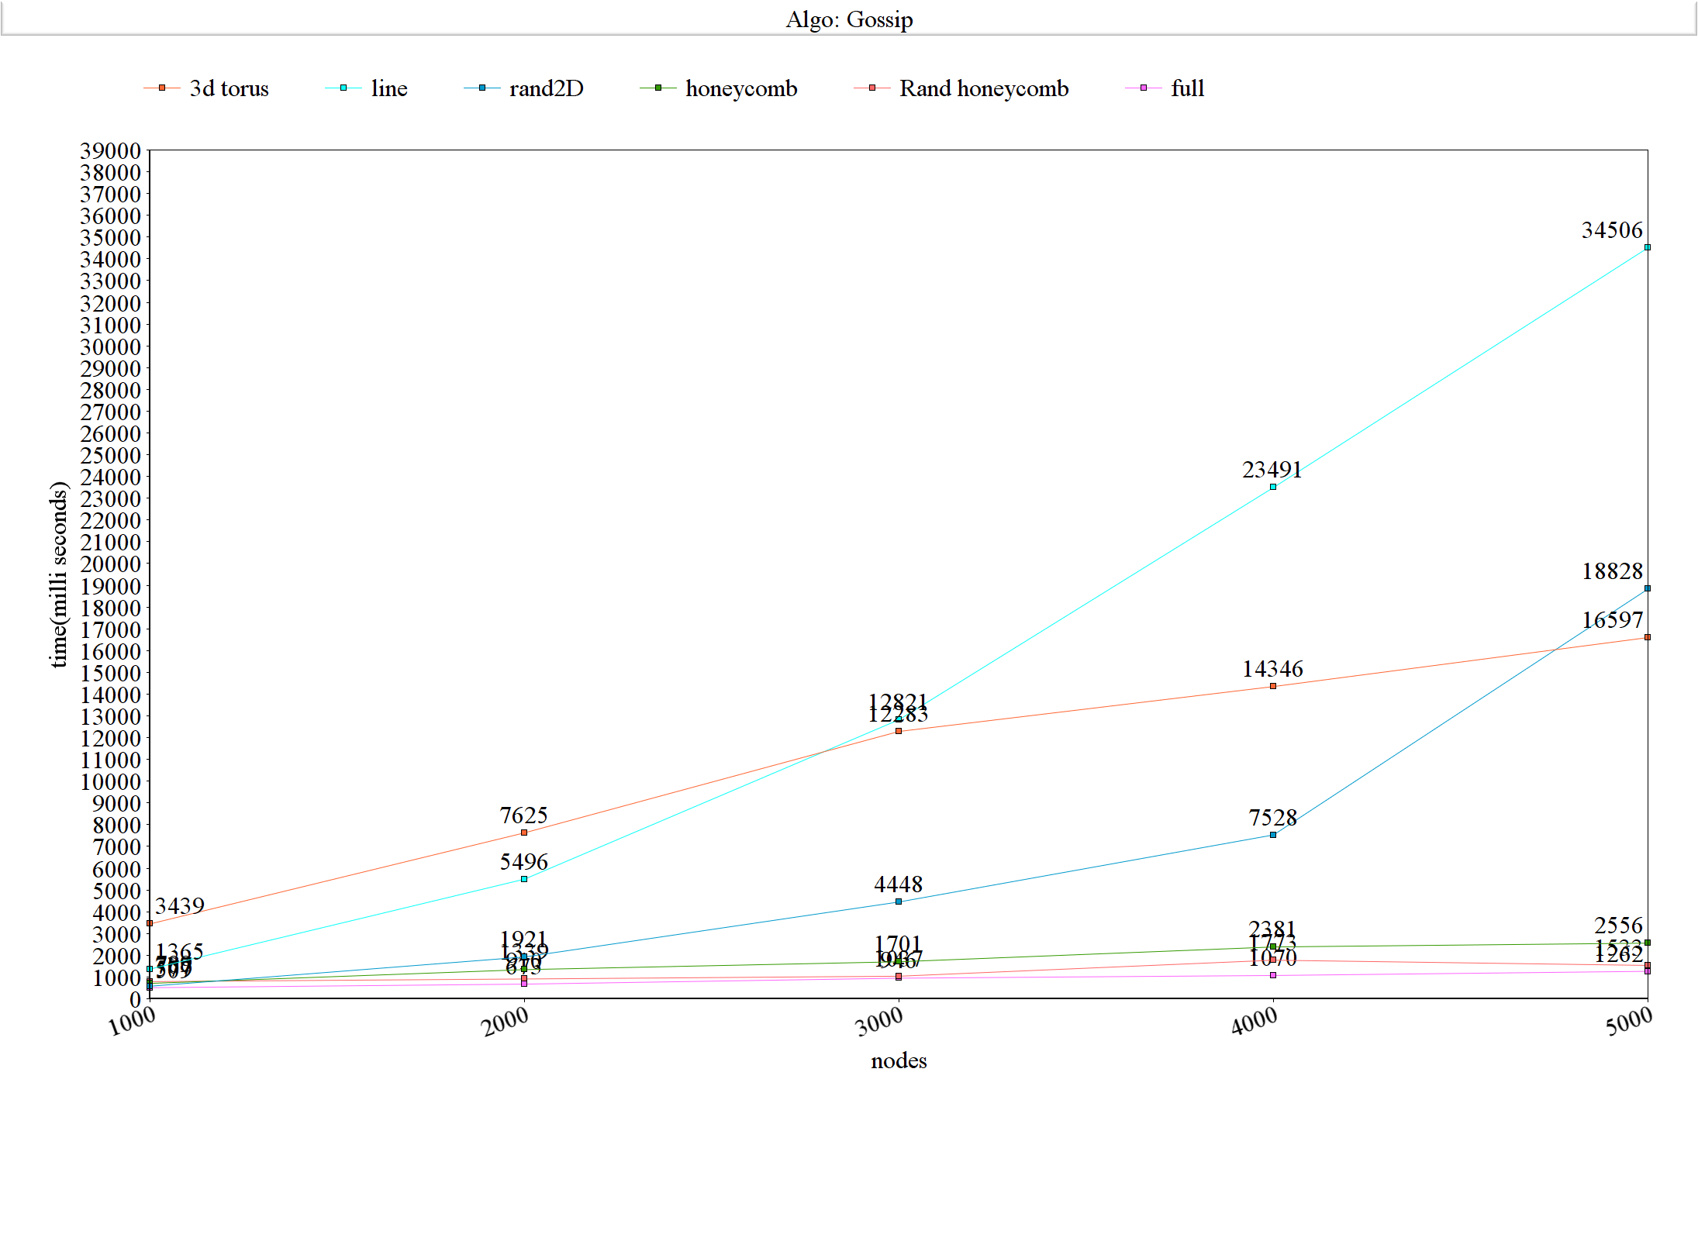
Gossip:

Logarithmic values:
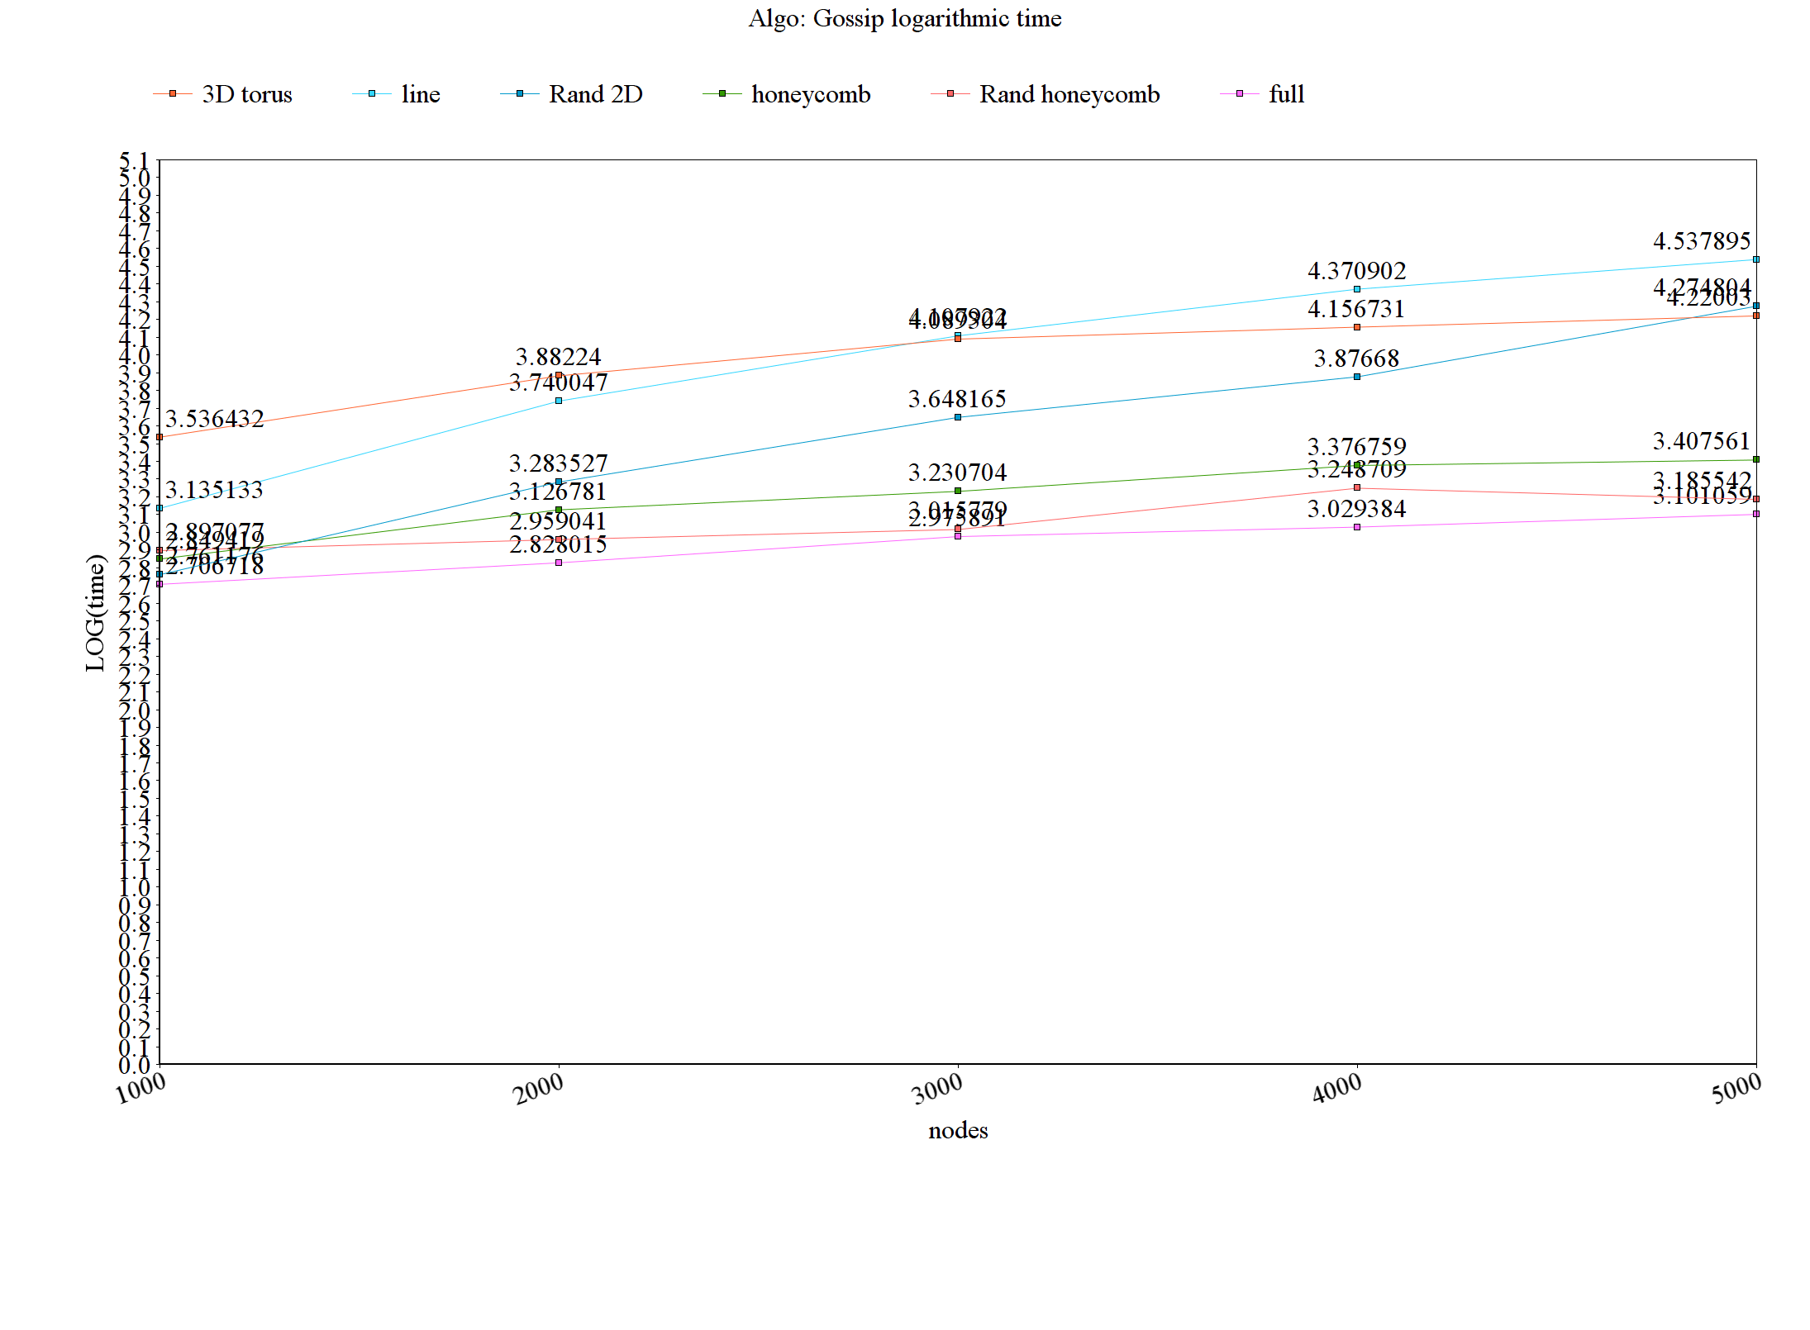
Interesting facts:
From the above graph it can be said that the relationship between number of nodes given as input and time taken to converge is logarithmic. As the nodes increases the time taken to converge increases.
On the whole we can say that the line topology is taking more time to converge than all other networks.
When the number of nodes is small the order is full network performs better and line takes more time.
The order is full<rand2D<honeycomb<randhoneycomb<line<3Dtorus
When the number of nodes are large the line topology still takes more time and honeycomb and rand honeycomb started performing better.
The order is full<randhoneycomb<honeycomb<3Dtorus<rand2D<line
Also we can say that the performance doesn’t depend entirely on nodes but also on the topology. The line topology takes more time as it has only 2 neighbour nodes and full takes less time as it has many neighbour nodes and message will spread fastly.

Push-Sum:
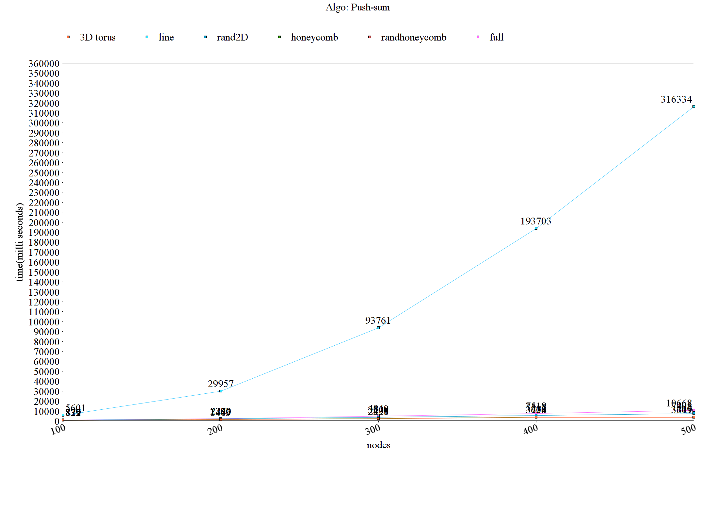
Logarithmic values:
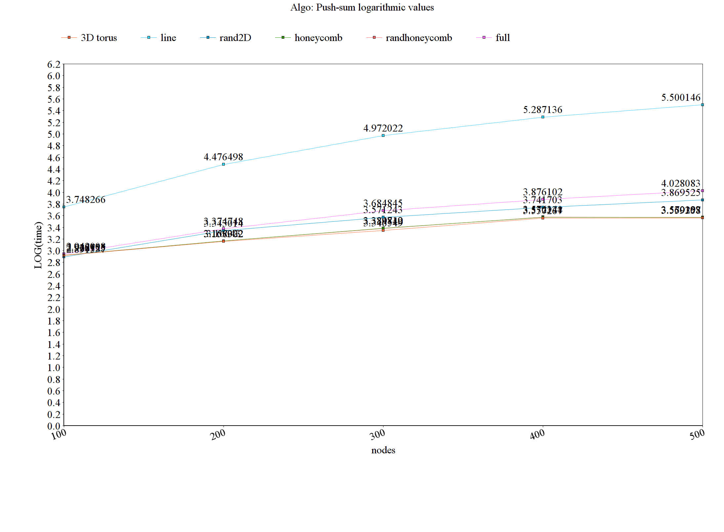

Interesting facts:
Push-sum takes more time when compared with gossip. The message that is transmitted from the node is done only when it receives a message from other node. As the convergence entirely depends on the messages that are coming to the node it takes more time in converging. Also from the plots above we can say that even in push-sum line topology is taking more time and it is also proved that all other topologies are performing in the similar way independent of the network. But when we compare all, randhoneycomb and 3dtorus takes less time.
It can also be seen that if connectivity is more, the convergence rate will also be more. Also gossip convergence rate is higher than the push-sum convergence rate.

