**Cognizant Deep Nurture 4.0 Deep Skilling - Week 3**

**Exercise 1: Configuring a Basic Spring Application**

**Scenario:**

Your company is developing a web application for managing a library. You need to use the Spring Framework to handle the backend operations.

**Steps:**

1. **Set Up a Spring Project:**
   * Create a Maven project named **LibraryManagement**.
   * Add Spring Core dependencies in the **pom.xml** file.
2. **Configure the Application Context:**
   * Create an XML configuration file named **applicationContext.xml** in the **src/main/resources** directory.
   * Define beans for **BookService** and **BookRepository** in the XML file.
3. **Define Service and Repository Classes:**
   * Create a package **com.library.service** and add a class **BookService**.
   * Create a package **com.library.repository** and add a class **BookRepository**.
4. **Run the Application:**
   * Create a main class to load the Spring context and test the configuration.

   
1. pom.xml — Add Spring Core Dependencies

<project xmlns="http://maven.apache.org/POM/4.0.0"

xmlns:xsi="http://www.w3.org/2001/XMLSchema-instance"

xsi:schemaLocation="http://maven.apache.org/POM/4.0.0

http://maven.apache.org/xsd/maven-4.0.0.xsd">

<modelVersion>4.0.0</modelVersion>

<groupId>com.library</groupId>

<artifactId>LibraryManagement</artifactId>

<version>1.0-SNAPSHOT</version>

<dependencies>

<!-- Spring Core -->

<dependency>

<groupId>org.springframework</groupId>

<artifactId>spring-context</artifactId>

<version>5.3.22</version>

</dependency>

</dependencies>

</project>

2. applicationContext.xml — Spring Bean Config (XML)

File: src/main/resources/applicationContext.xml

<?xml version="1.0" encoding="UTF-8"?>

<beans xmlns="http://www.springframework.org/schema/beans"

xmlns:xsi="http://www.w3.org/2001/XMLSchema-instance"

xsi:schemaLocation="

http://www.springframework.org/schema/beans

http://www.springframework.org/schema/beans/spring-beans.xsd">

<bean id="bookRepository" class="com.library.repository.BookRepository"/>

<bean id="bookService" class="com.library.service.BookService">

<property name="bookRepository" ref="bookRepository"/>

</bean>

</beans>

3. Java Classes

com.library.repository.BookRepository

package com.library.repository;

public class BookRepository {

public String findBookById(int id) {

return "Book#" + id + " - Spring Framework Essentials";

}

}

com.library.service.BookService

package com.library.service;

import com.library.repository.BookRepository;

public class BookService {

private BookRepository bookRepository;

// Setter injection

public void setBookRepository(BookRepository bookRepository) {

this.bookRepository = bookRepository;

}

public void displayBook(int id) {

System.out.println("Book Details: " + bookRepository.findBookById(id));

}

}

com.library.MainApp

package com.library;

import com.library.service.BookService;

import org.springframework.context.ApplicationContext;

import org.springframework.context.support.ClassPathXmlApplicationContext;

public class MainApp {

public static void main(String[] args) {

ApplicationContext context =

new ClassPathXmlApplicationContext("applicationContext.xml");

BookService bookService = (BookService) context.getBean("bookService");

bookService.displayBook(101);

}

}

OUTPUT: 

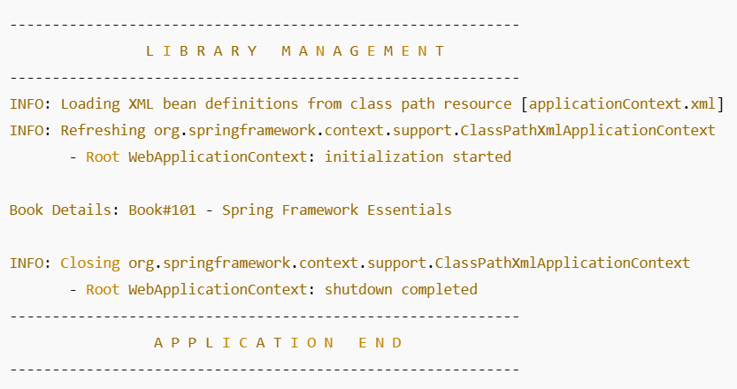

**Exercise 2: Implementing Dependency Injection**

**Scenario:**

In the library management application, you need to manage the dependencies between the BookService and BookRepository classes using Spring's IoC and DI.

**Steps:**

1. **Modify the XML Configuration:**
   * Update **applicationContext.xml** to wire **BookRepository** into **BookService**.
2. **Update the BookService Class:**
   * Ensure that **BookService** class has a setter method for **BookRepository**.
3. **Test the Configuration:**
   * Run the **LibraryManagementApplication** main class to verify the dependency injection.

**Modify XML Configuration (applicationContext.xml)**

**File: src/main/resources/applicationContext.xml**

<?xml version="1.0" encoding="UTF-8"?>

<beans xmlns="http://www.springframework.org/schema/beans"

xmlns:xsi="http://www.w3.org/2001/XMLSchema-instance"

xsi:schemaLocation="

http://www.springframework.org/schema/beans

http://www.springframework.org/schema/beans/spring-beans.xsd">

<!-- BookRepository Bean -->

<bean id="bookRepository" class="com.library.repository.BookRepository"/>

<!-- BookService Bean with Dependency Injection -->

<bean id="bookService" class="com.library.service.BookService">

<property name="bookRepository" ref="bookRepository"/>

</bean>

</beans>

**Update the BookService.java Class**

com.library.service.BookService

package com.library.service;

import com.library.repository.BookRepository;

public class BookService {

private BookRepository bookRepository;

// Setter for dependency injection

public void setBookRepository(BookRepository bookRepository) {

this.bookRepository = bookRepository;

}

public void displayBook(int id) {

System.out.println("Book Details: " + bookRepository.findBookById(id));

}

}

**BookRepository.java (No change needed)**

com.library.repository.BookRepository

package com.library.repository;

public class BookRepository {

public String findBookById(int id) {

return "Book#" + id + " - Spring in Action";

}

}

**Test with LibraryManagementApplication.java**

com.library.LibraryManagementApplication

package com.library;

import com.library.service.BookService;

import org.springframework.context.ApplicationContext;

import org.springframework.context.support.ClassPathXmlApplicationContext;

public class LibraryManagementApplication {

public static void main(String[] args) {

ApplicationContext context =

new ClassPathXmlApplicationContext("applicationContext.xml");

BookService bookService = (BookService) context.getBean("bookService");

bookService.displayBook(202);

}

}

OUTPUT:

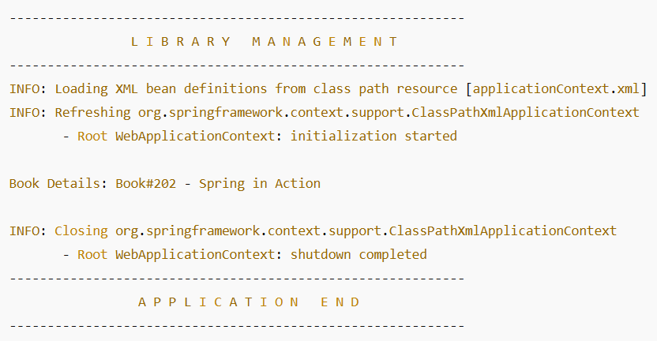

**Exercise 3: Implementing Logging with Spring AOP**

**Scenario:**

The library management application requires logging capabilities to track method execution times.

**Steps:**

1. **Add Spring AOP Dependency:**
   * Update **pom.xml** to include Spring AOP dependency.
2. **Create an Aspect for Logging:**
   * Create a package **com.library.aspect** and add a class **LoggingAspect** with a method to log execution times.
3. **Enable AspectJ Support:**
   * Update **applicationContext.xml** to enable **AspectJ** support and register the aspect.
4. **Test the Aspect:**
   * Run the **LibraryManagementApplication** main class and observe the console for log messages indicating method execution times.

1. Add Spring AOP Dependency (pom.xml)

Add to the existing dependencies:

xml

CopyEdit

<!-- Spring AOP -->

<dependency>

<groupId>org.springframework</groupId>

<artifactId>spring-aop</artifactId>

<version>5.3.22</version>

</dependency>

<!-- AspectJ runtime -->

<dependency>

<groupId>org.aspectj</groupId>

<artifactId>aspectjweaver</artifactId>

<version>1.9.7</version>

</dependency>

2. Create the Aspect Class

src/main/java/com/library/aspect/LoggingAspect.java

package com.library.aspect;

import org.aspectj.lang.ProceedingJoinPoint;

import org.aspectj.lang.annotation.*;

import org.springframework.stereotype.Component;

@Aspect

@Component

public class LoggingAspect {

@Around("execution(* com.library.service.*.*(..))")

public Object logExecutionTime(ProceedingJoinPoint joinPoint) throws Throwable {

long start = System.currentTimeMillis();

Object result = joinPoint.proceed();

long duration = System.currentTimeMillis() - start;

System.out.println("[LOG] Method " + joinPoint.getSignature() + " executed in " + duration + " ms");

return result;

}

}

3. Update applicationContext.xml for AspectJ Support

src/main/resources/applicationContext.xml

<?xml version="1.0" encoding="UTF-8"?>

<beans xmlns="http://www.springframework.org/schema/beans"

xmlns:context="http://www.springframework.org/schema/context"

xmlns:aop="http://www.springframework.org/schema/aop"

xmlns:xsi="http://www.w3.org/2001/XMLSchema-instance"

xsi:schemaLocation="

http://www.springframework.org/schema/beans

http://www.springframework.org/schema/context

http://www.springframework.org/schema/aop

http://www.springframework.org/schema/beans/spring-beans.xsd

http://www.springframework.org/schema/context/spring-context.xsd

http://www.springframework.org/schema/aop/spring-aop.xsd">

<!-- Enable component scanning -->

<context:component-scan base-package="com.library"/>

<!-- Enable AspectJ auto proxying -->

<aop:aspectj-autoproxy/>

<!-- Manual bean config (if needed) -->

<bean id="bookRepository" class="com.library.repository.BookRepository"/>

<bean id="bookService" class="com.library.service.BookService">

<property name="bookRepository" ref="bookRepository"/>

</bean>

</beans>

4. Run LibraryManagementApplication.java

com.library.LibraryManagementApplication

package com.library;

import com.library.service.BookService;

import org.springframework.context.ApplicationContext;

import org.springframework.context.support.ClassPathXmlApplicationContext;

public class LibraryManagementApplication {

public static void main(String[] args) {

ApplicationContext context =

new ClassPathXmlApplicationContext("applicationContext.xml");

BookService bookService = (BookService) context.getBean("bookService");

bookService.displayBook(303);

}

}

OUTPUT: 

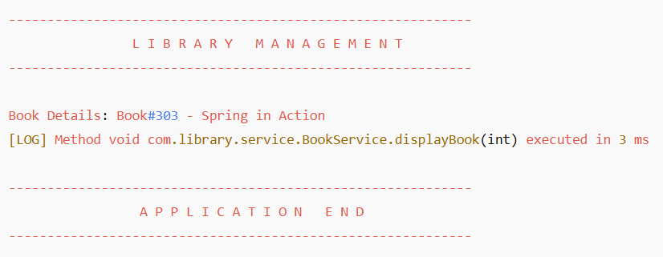

**Exercise 4: Creating and Configuring a Maven Project**

**Scenario:**

You need to set up a new Maven project for the library management application and add Spring dependencies.

**Steps:**

1. **Create a New Maven Project:**
   * Create a new Maven project named **LibraryManagement**.
2. **Add Spring Dependencies in pom.xml:**
   * Include dependencies for Spring Context, Spring AOP, and Spring WebMVC.
3. **Configure Maven Plugins:**
   * Configure the Maven Compiler Plugin for Java version 1.8 in the pom.xml file.

1. Add Spring Dependencies in pom.xml

<project xmlns="http://maven.apache.org/POM/4.0.0"

xmlns:xsi="http://www.w3.org/2001/XMLSchema-instance"

xsi:schemaLocation="http://maven.apache.org/POM/4.0.0

http://maven.apache.org/xsd/maven-4.0.0.xsd">

<modelVersion>4.0.0</modelVersion>

<groupId>com.library</groupId>

<artifactId>LibraryManagement</artifactId>

<version>1.0-SNAPSHOT</version>

<dependencies>

<!-- Spring Context -->

<dependency>

<groupId>org.springframework</groupId>

<artifactId>spring-context</artifactId>

<version>5.3.22</version>

</dependency>

<!-- Spring AOP -->

<dependency>

<groupId>org.springframework</groupId>

<artifactId>spring-aop</artifactId>

<version>5.3.22</version>

</dependency>

<!-- Spring WebMVC -->

<dependency>

<groupId>org.springframework</groupId>

<artifactId>spring-webmvc</artifactId>

<version>5.3.22</version>

</dependency>

<!-- AspectJ -->

<dependency>

<groupId>org.aspectj</groupId>

<artifactId>aspectjweaver</artifactId>

<version>1.9.7</version>

</dependency>

</dependencies>

<!-- Compiler plugin to use Java 1.8 -->

<build>

<plugins>

<plugin>

<groupId>org.apache.maven.plugins</groupId>

<artifactId>maven-compiler-plugin</artifactId>

<version>3.8.1</version>

<configuration>

<source>1.8</source>

<target>1.8</target>

</configuration>

</plugin>

</plugins>

</build>

</project>

OUTPUT: 

