**Kathmandu University**

**Department of Computer Science and Engineering**

**Dhulikhel, Kavre**



A Report on ‘**Lab Work 1** [COMP 306]

**Submitted by:**

Chandan Kumar Mahato (31)

III-year, II semester

**Submitted to**:

Prof. Dr. Sudan Jha

Department of Computer Science and Engineering

**Submission Date**: Mar 28, 2023

***Qlab1***

1. ***Design AND, OR, NOT, XOR, NAND & NOR using proteus simulation.***

**Objective:**

To Design AND, OR, NOT, XOR, NAND, NOR Gates

**Components Required:**

* Probe
* Wire
* Gates (AND, OR, NOT, XOR, NAND and NOR)
* Digital Constant

**Circuit Diagram**

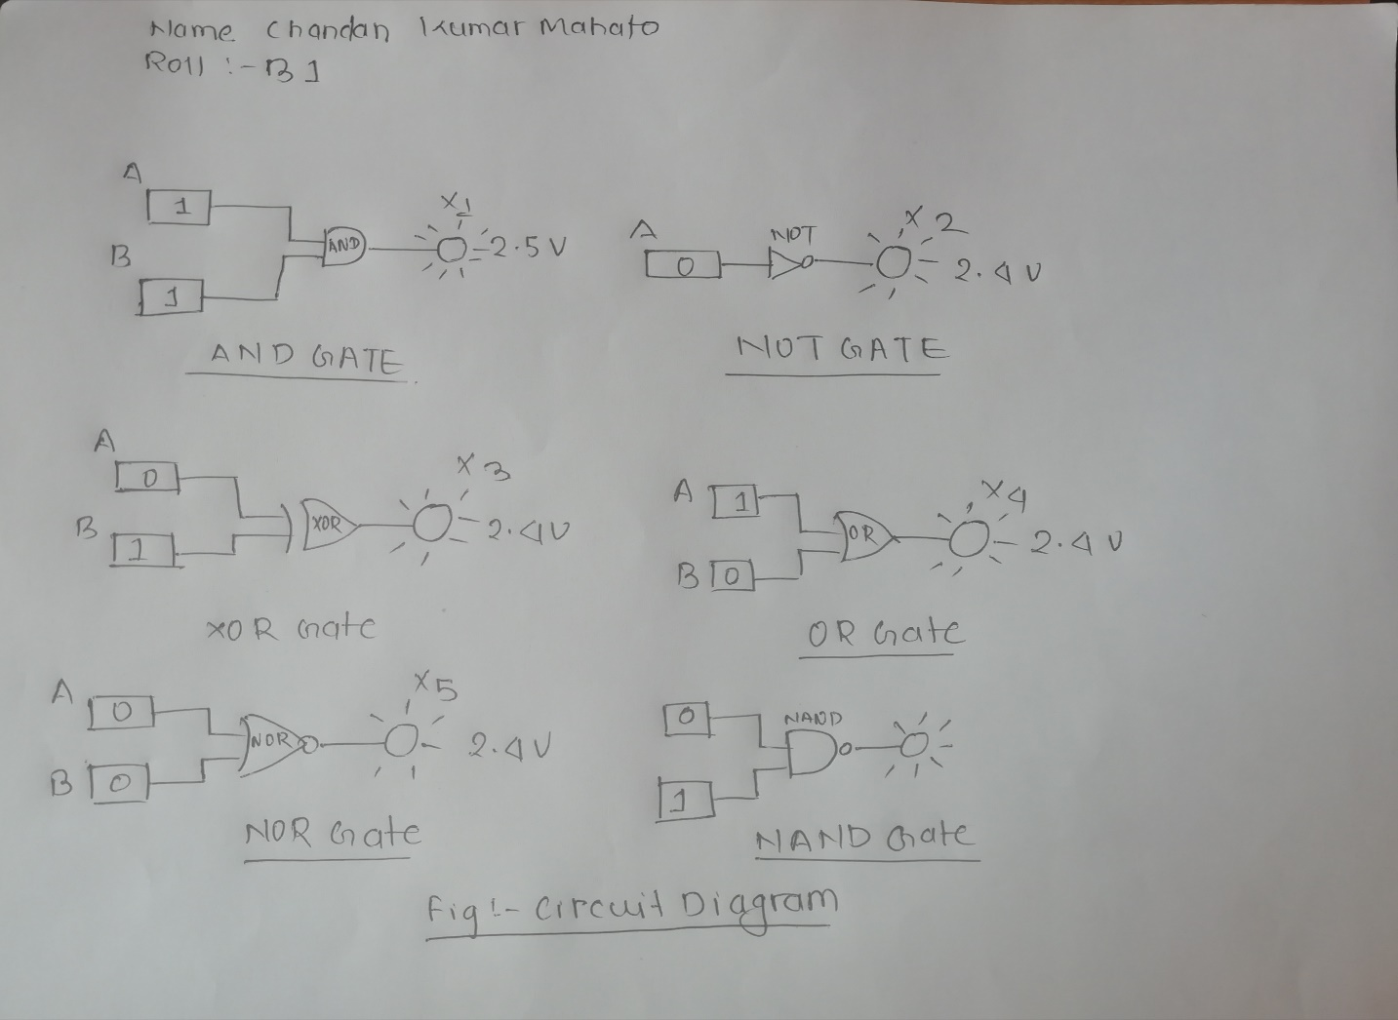

***Fig: Circuit Diagram***

**Truth Table:**

The truth table obtained for the different gates after varying their input parameters during simulation are show in the table below:

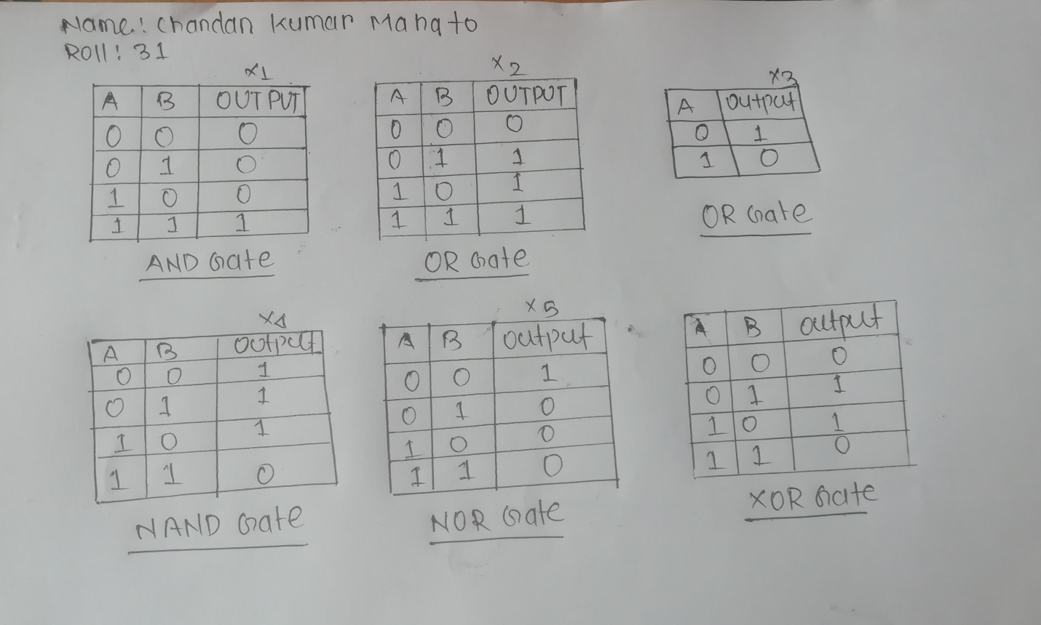

***Fig: Truth Table***

**Conclusion:**

All Six gates were successfully simulated using proteus simulation and the truth table were determined by checking multiple combinations of inputs and their effect on the probe.

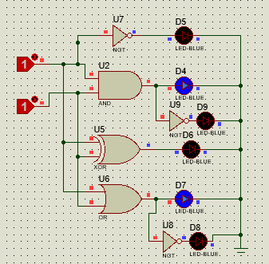**Screen Shots**

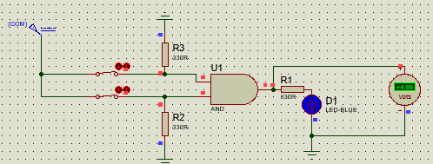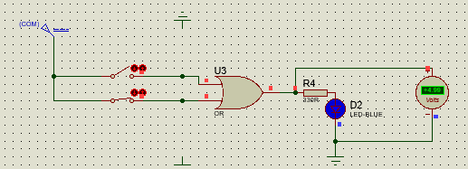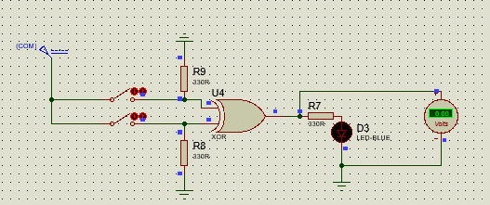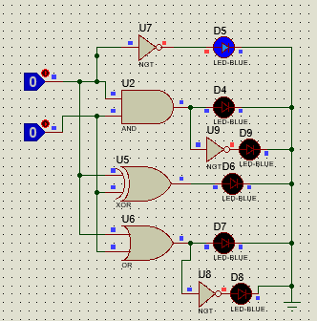

***Fig: Circuit showing AND, OR, NOT, XOR, NAND, NOR GATES***